Massachusetts Department o f Public Health

C O V I D - 1 9 C O M M U N I T Y I M P A C T S U R V E Y :
O L D E R A D U LT S

C o au t h o r s : C ar o lin e S t ac k , L is a P o t r at z , an d R e b e c c a D aw s o n

Results as of August 10, 2022

1

C C I S
T E A M
M E M B E R S

CCIS Project Leads
W.W. Sanouri Ursprung, Lauren Cardoso, Beth Beatriz, Glory Song, Caroline Stack, Kathleen Fitzsimmons, Emily Sparer-Fine, Ta-wei Lin, Lisa Potratz, Heather Nelson, Amy Flynn, Lisa Arsenault, Abby Atkins

CCIS Steering Committee
Lauren Cardoso, W.W. Sanouri Ursprung, Beth Beatriz, Abbie Averbach, Ruth Blodgett, Ben Wood, Sabrina Selk, Jessica del Rosario Nicole Daley, Lisa Potratz

CCIS Analytic Team, Data to Action Team, Data Dissemination Team, Communications Team Allison Guarino, Andrea Mooney, Angela Laramie, Ann Marie Matteucci, Anna Agan, Arielle Coq, Barry Callis, Beatriz Pazos Vautin, Ben Wood, Brittany Brown, Chelsea Orefice, Dana Bernson, David Hu, Dawn Fukuda, Ekta Saksena, Elise Pechter, Emily White, Fareesa Hasan, Frank Gyan, Glennon Beresin, Hanna Shephard, Hannah Walters, Hermik Babkhanlou-Chase, James Laing, Jena Pennock, Jennica Allen, Jennifer Halstrom,
Justine Egan, Kathleen Grattan, Kim Etingoff, Kirby Lecy, Lamar Polk, Lauren Fogarty, Lauren Larochelle,
Mahsa Yazdy, Marianne Mabida, Matthew Tumpney, Megan Hatch, Megan Young, Melody Kingsley, Michelle Reid, Miriam Scrivener, Nassira Nicola, Nicole Daniels, Nicole Roos, Rebecca Berger, Rebecca Dawson, Rebecca Han, Robert Leibowitz, Susan Manning, Thomas Brigham, Timothy St. Laurent, Vera Mouradian, Victoria Nielsen, Ziming Xuan, Elizabeth Showalter, Priyokti Rana, Mayowa Sanusi, Emily Lawson, Alana LeBrón
2

Many groups that were critical in the success of this effort and gave important input on the development and deployment of the survey:

- Health Resources in Action (HRiA)
- John Snow International (JSI)
- Academic Public Health Volunteer Corps and their work with local boards of health and on social media
- Mass in Motion programs, including Springfield, Malden, and Chelsea
- Cambodian Mutual Assistance
- The Mashpee Wampanoag Tribe
- The Immigrants’ Assistance Center, Inc
- Families for Justice as Healing
- City of Lawrence Mayor’s Health Task Force
- The 84 Coalitions, including the Lawrence/Methuen Coalition
- Boys and Girls Clubs, including those in Fitchburg and Leominster and the Metro South area
- Chinatown Neighborhood Association
- Father Bill’s
- UTEC
- MassCOSH
- Stavros Center for Independent Living
- Greater Springfield Senior Services
- Center for Living and Working
- DEAF, Inc.
- Massachusetts Commission for the Deaf and Hard of Hearing
- Viability, Inc.

3
C C I S
C O M M U N I T Y
P A R T N E R S

“ As the pandemic has raised awareness of inequities based on race, gender, class, and income, we should not allow it to cement ageist stereotypes and attitudes. Rather, we should embrace this new-found awareness of ageism’s inequities and the dangers it poses to society as a launching pad from which we can initiate the processes necessary to defeat this dangerous
phenomenon.”
-Susan J. Douglas, Catherine Neafie Kellogg Professor of Communication
and the Media at the University of Michigan

4

Framing Matters

Using equity focused frames allows us to understand the unique experiences, needs, and strengths of older adults

Dominant frames
According to these frames:

  - Older adults are all the same
  - Older adults are frail and vulnerable and need to be protected
  - The value of someone’s life is age- dependent
  - Aging is associated with decline and loss

Equity-focused frames
According to these frames:

- Older adults are diverse and have multiple identities
- Older adults play essential roles in society, the economy, and community
- Ageism can increase the inequities these populations face
- Structural barriers prevent older adults from maximizing health and well-being

5

Older Adults Are a Growing Population
1The Growing Cost of Aging in America Part 1: An Aging Population and Rising Health Care Costs. (2018, April 6). GW-UMT. https://onlinepublichealth.gwu.edu/resources/cost-of-aging-healthcare/

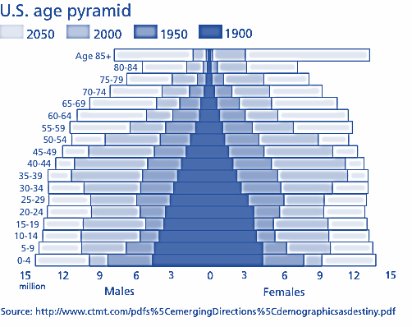
Americans are living longer than ever
- In 1900, people aged 65+ composed of 4% of the U.S. population
- By 2050, they will make up 20%1

6

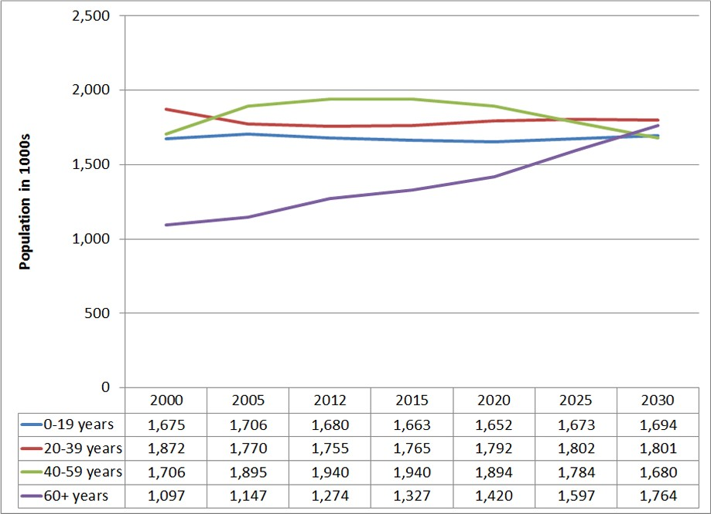Older Adults Are a Growing Population in MA
PHC

The proportion of MA's population that is 60 years and older is growing more rapidly than other components of the population.

Source: https://acl.gov/sites/default/files/programs/2016-11/Massachusetts%20Epi%20Profile%20Final.pdf
7

Education

Job Opportunity

Socioeconomic Status
Ageism

Environmental Exposure

Health Behaviors

Health Outcomes

Systems of Oppression Impact the Social Determinants of Health Inequities

Access to Health Services

Safe & Affordable Housing

Reducing Violence 8
Classism, racism, ableism

Ageism Acts at Multiple Levels

INTERNALIZED INTERPERSONAL

Denial & exclusion from insurance, work, housing
Antiaging messaging & lack of funding to support inclusion of older adults
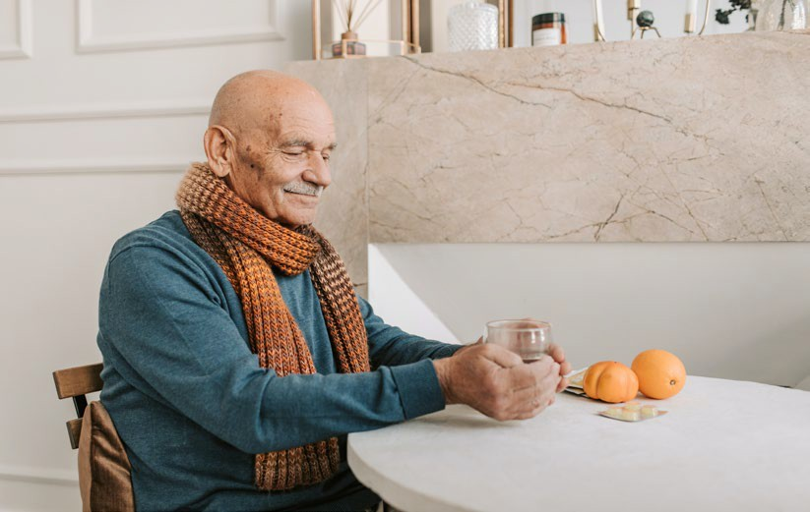

Acceptance of ageist stereotypes
Physical, emotional, sexual, financial abuse
INSTITUTIONAL STRUCTURAL

9

CCIS Older Adult Respondent Profile1

‘Older adult’ in this presentation refers to individuals 60 years old or older.
CCIS was an online survey and those without internet or technology access may not be
represented in the sample. Therefore, this sample of older adults may not be representative of all MA adults 60+ and their needs. It is important to keep this in mind when interpreting and generalizing results from this survey.

8,336 adults aged 60+ took the survey
- 172 of those adults are 85+

15% reported income <$35K

45% are retired

31% reported living alone
- 50% reported living with 1 other person
10
1 Respondent Profile percentages are unweighted.

Disability Profile of Respondents by Age Group

Under 60 60+

Persons with disabilities experienced unique impacts and structural barriers to maintaining health during the pandemic.

For more information
about experiences of MA residents with disabilities during the pandemic, see the CCIS Spotlight: Persons with Disabilities report.

Self-care/Independent living*
3%
6%
4%
15%
7%
4%
0.7%
2%
1%
8%
11%

Mobility*

Cognitive*

Blind or vision impairment*

Deaf or hard of hearing*

1+ disability*
23%

Percent
Older adults were more likely to report a disability compared to younger adults.
Disability Status Among Older Adults

11
*Difference is statistically significant at p. < .05

Number of Reported Chronic Conditions by Age Group

Adults aged 60+ were twice as likely to report having 3+ chronic conditions than the under 60 age group.
Under 60 60+

60%

50%

40%

30%

20%

10%
54%

0%
35%
26%
27%
20%
18%
12%
8%
0* 1

2* 3+*
*Difference is statistically significant at p. < .05
Note: Chronic conditions include asthma, COPD, lung condition, cancer, diabetes, heart disease, high blood pressure,

Number of Chronic Conditions
Chronic Conditions Among Older Adults
immune compromised, kidney disease, liver disease, obesity.

12

13

I M P A C T S O F C O V I D O N O L D E R A D U LT S

MA Population2

Older adults aged 60+ make up 23% of the MA population but have accounted for 91% of all MA COVID deaths.1

1,964
MA COVID-19 Deaths
23%
19,006
91%
77%
9%

Population Under 60
Population 60+
14

1. Current as of July 4, 2022; includes confirmed and probable COVID-19 deaths. COVID-19 Response Reporting | Mass.gov. (n.d.). Retrieved July 4, 2022, from https://www.mass.gov/info-details/covid-19-response-reporting
The COVID-19 Pandemic Impacted Older Adults Disproportionately
2. S0102: POPULATION 60 YEARS AND OVER... - Census Bureau Table. (n.d.). Retrieved July 24, 2022, from https://data.census.gov/cedsci/table?q=massachusetts%20age&tid=ACSST5Y2020.S0102

17%

of Massachusetts hospital, nursing/residential care facilities, and ambulatory healthcare services employees are aged 60 or older.1

Older Adults Played Essential Roles in the Workforce

In CCIS, older adults who were employed were less likely to be able to work from home (43%* vs. 48%).

15
*Difference is statistically significant at p. < .05
1 Data Source: 2014-2019 Current Population Survey, NIOSH ELF. Includes Census Industry Codes: 7970-8180 (Ambulatory Health Care Services), 8190 (Hospital), 8270-8290 (Nursing and Residential Care Facilities.

Older Adults Played Essential Roles in Their Communities

- 6% of older adults identified as a parent/guardian of a child with special needs
- 5% as caregiver for an adult with special needs
- Many took care of grandchildren when daycares closed

“Most of my friends are helping with childcare.”

Despite these risks and responsibilities, older adults:
- Were equally as likely to report being “very worried about getting COVID” as younger adults (30%)
- Were less likely to report persistent poor mental health (22%* vs 38%) and 3+ symptoms of PTSD attributed to COVID (18%* vs. 31%) than younger adults

16
*Difference is statistically significant at p. < .05

1 in 5
reported persistent poor mental health.
1 in 5
reported 3+ PTSD- like reactions to COVID.
1 in 4
older adults using substances reported an increase in substance use during the pandemic.
1 in 3
were ‘very worried’ about getting COVID.
1 in 4
reported worry about any expense.
1 in 4
reported worry about a healthcare need.
3 in 5
reported worry about a household need.
Access to Basic Needs & Health Among Older Adults

1 in 5
reported persistent poor mental health.
1 in 5
reported 3+ PTSD- like reactions to COVID.
1 in 4
older adults using substances reported an increase in substance use during the pandemic.
1 in 3
were ‘very worried’ about getting COVID.
1 in 4
reported worry about any expense.
1 in 4
reported worry about a healthcare need.
3 in 5
reported worry about a household need.
17

Older adults were 3x as likely as younger adults to report living alone.
33%

10%

What would be helpful right now?
“Some sense of community for old people who have to mostly stay home."

“Socialization, exercise, activities to assist me in maintaining my level of cognition”

“Companionship. I am lonely and isolated”

*Difference is statistically significant at p. < .05
Older adults living alone were more likely to report persistent poor mental health (25%) than older adults living with others (21%)*.
Older Adults Struggled with Social Isolation
Living alone*

Under 60 60+

18

Older adults represent a diversity of identities and experiences.
Some groups may need greater access to resources tailored for their needs.
Some Older Adults Reported Higher Rates of Poor Mental Health
DISABILITY

MA Older Adult Populations Reporting 15+ Past-Month Poor Mental Health Days
Older adults identifying as.:
- Having a disability
- A caregiver to a child or adult with special needs
- Multi-racial or Hispanic/Latinx
…were up to 3x as likely to report persistent poor mental health in the past month.
AGE
COGNITIVE DISABILITY* |  |  | 64%
NO COGNITIVE DISABILITY (REF) | 20%
SELF-CARE/INDIVIDUAL LIVING DISABILITY* |  | 45%
NO SELF-CARE/INDIVIDUAL LIVING DISABILITY (REF) | 21%

BLIND/PEOPLE WITH VISION IMPAIRMENT* |  |  |  | 43%
NOT BLIND (REF) | 22%
MOBILITY DISABILITY* |  |  | 36%
NO MOBILITY DISABILITY (REF) | 20%
DEAF/HARD OF HEARING* |  | 27%
NOT DEAF (REF) | 22%
PARENT/GUARDIAN OF CHILD W/SPECIAL HEALTH NEEDS* |  |  | 36%
NOT PARENT/GUARDIAN OF CHILD W/SPECIAL HEALTH NEEDS (REF) | 20%

FIGURE NOTES:
ALL RESPONDENTS AGED 60+
85+
60-84 (REF)
22%
26%
22%
WHITE NH (REF)
AMERICAN INDIAN/ALASKA NATIVE
ASIAN NH
22%
17%
17%
RACE/ETHNICITY CAREGIVER
CAREGIVER TO ADULT IN HOUSEHOLD* |  |  | 34%
NOT CAREGIVER TO ADULT IN HOUSEHOLD (REF) | 22%
MULTIRACIAL* |  |  | 34%
HISPANIC* |  | 28%
BLACK NH | 23%

- nH/nL = non-Hispanic/non-Latinx;
- American Indian/Alaska Native includes respondents who identify as Hispanic/Latinx.
- Percentages are weighted to the statewide age and educational distribution of those 25 years old or older in Massachusetts
19
*Difference is statistically significant at p. < .05

Older adults represent a diversity of identities and experiences.
Some groups may need greater access to resources tailored for their needs.
Some Older Adults Reported Higher Rates of Poor Mental Health

MA Older Adult Populations Reporting 15+ Past-Month Poor Mental Health Days (cont.)
Older adults identifying as.:
- Having lower income
- Gay or lesbian
- Female
- Residing in Berkshire, Hampden, Essex, Hampshire, Suffolk, and Middlesex counties
…were up to 2x as likely to report persistent poor mental health in the past month.
SEXUAL
GENDER ORIENTATION INCOME

FIGURE NOTES:.
LESS THAN $35K*
$35-99,999K* GREATER THAN $100K (REF)
GAY OR LESBIAN* BI/PANSEXUAL
ASEXUAL STRAIGHT (REF)
FEMALE* MALE (REF) NONBINARY BERKSHIRE* HAMPDEN*
ESSEX* HAMPSHIRE* SUFFOLK* MIDDLESEX*
NORFOLK (REF)
32%
22%
16%
31%
29%
26%
21%
23%
18%
.
25%
24%
23%
23%
22%
20%
16%
COUNTY
  - Non-binary gender identity includes respondents identifying as non-binary, genderqueer, and not exclusively male or female. Percentage is not presented due to sample size.
  - Percentages are weighted to the statewide age and educational distribution of those 25 years
old or older in Massachusetts. Geographic rates are unweighted. 20
*Difference is statistically significant at p. < .05

Basic Needs Worried About for You and Your Family by Age
17%
13% *
20%

Technology

Healthcare

Household

26% *
25% *
34%

57% *
53% *

70%

Under 60 (REF)
60-84
85+

Medications
15%
11% *
10%*

30%

Adults aged 85+ worried about obtaining technology and food/groceries more than adults aged 60-84* and at similar rates to younger adults.
Older Adults Worried About Accessing Basic Needs

*Difference is statistically significant at p. < .05

Food/Groceries
22% *
32% 21

Healthcare Needs Differed Amongst Older Adults

MA Older Adult Populations Reporting Concern for Obtaining a Healthcare Need

The following groups of adults aged 60+ were more likely to report any healthcare needs:
ALL RESPONDENTS AGED 60+
85+
60 - 84 (REF) AMERICAN INDIAN/ALASKA NATIVE*
MULTIRACIAL, NH/NL* HISPANIC / LATINX* BLACK, NH/NL WHITE, NH/NL (REF)
ASIAN, NH/NL GAY OR LESBIAN* QUESTIONING/NOT SURE
ASEXUAL BISEXUAL OR PAN SEXUAL
STRAIGHT (REF) BLIND OR VISION IMPAIRED*
NOT BLIND OR VISION IMPAIRED (REF)
26%
24%
24%
49%
44%
39%
27%
25%
21%
34%
33%
30%
25%
25%
57%
25%
NO MOBILITY DISABILITY (REF)
DEAF OR HARD OF HEARING* NOT DEAF OR HARD OF HEARING (REF)
23%
34%
25%
RACE/ ETHNICITY
AGE
- Am. Indian/Alaska Native, Multiracial, and Hispanic/Latinx respondents
- Gay or lesbian respondents
SEXUAL
ORIENTATION
- Respondents with disabilities

FIGURE NOTES:
DISABILITY
COGNITIVE DISABILITY* |  |  |  | 56%
NO COGNITIVE DISABILITY (REF) | 24%
SELFCARE DISABILITY* |  |  | 51%
NO SELFCARE DISABILITY (REF) | 24%
MOBILITY DISABILITY* |  | 40%

    - nH/nL = non-Hispanic/non-Latinx;
    - American Indian/Alaska Native includes respondents who identify as Hispanic/Latinx.
    - Percentages are weighted to the statewide age and educational distribution of those 25 years old or older in Massachusetts.

*Difference is statistically significant at p. < .05
22

MA Older Adult Populations Reporting Concern for Obtaining a Healthcare Need (cont.)
LANG-
UAGE
INCOME

HAMPSHIRE* | 27%
HAMPDEN* | 26%
PLYMOUTH* | 26%
BERKSHIRE* | 26%
SUFFOLK* | 25%

The following groups of adults aged 60+ were more likely to report any healthcare needs:
ALL RESPONDENTS AGED 60+
<$35K*
26%
38%
$35K-99,999*
24%
$100K+ (REF)
LANGUAGE OTHER THAN ENGLISH*
ENGLISH ONLY (REF) PARENT/GUARDIAN OF CHILD W/ SPECIAL NEEDS*
NOT PARENT/GUARDIAN OF CHILD W/ SPECIAL NEEDS (REF) CAREGIVER TO ADULT W/SPECIAL NEEDS*
NOT CAREGIVER TO ADULT W/SPECIAL NEEDS (REF)
BARNSTABLE*
20%
32%
25%
40%
24%
40%
25%
29%
ESSEX*
FRANKLIN*
25%
24%
NORFOLK (REF)
19%
- Respondents with lower incomes
- Respondents who speak languages other than English
- Caretakers of adults or children with special needs
- Residents of certain counties including Barnstable, Hampshire, Hampden, Plymouth, and Berkshire

FIGURE NOTES:
- Percentages are weighted to the statewide age and educational distribution of those 25 years old or older in Massachusetts. Geographic rates are unweighted.
- Rates not presented for Suffolk (25%), Essex (25%) and Franklin (24%) counties were significantly higher than the rate of Norfolk county (reference).

Healthcare Needs Differed Amongst Older Adults
CAREGIVER
*Difference is statistically significant at p. < .05
COUNTY
23

24

B A R R I E R S

Compared to adults under 60, adults aged 85+ were more likely to identify:

News outlets (2x)
- Friends and family (8x)

…as top trusted sources of COVID information.

100

90

80

70

60

50

40

30

20

10
Top Resources for COVID-19 Information

Communication strategies must be tailored for older adults’ needs to ensure access to timely, accurate information.
Older Adults Rely on Different Sources of Information
0
Aged 85+ Aged 60-84 Aged 25-59 (REF)
.
.
0
Government
websites
Community
partners
Social media
Government
officials
25
Friends and
family
News outlets
5
7*
9*
14
16*
18*
20
21
25*
40*
53*
57
60
71*
90*

*Difference is statistically significant at p. < .05.
. Indicates cell suppression due to low sample size.

Technology Needs Among Older Adults
American Community Survey Estimates(2016-2020)

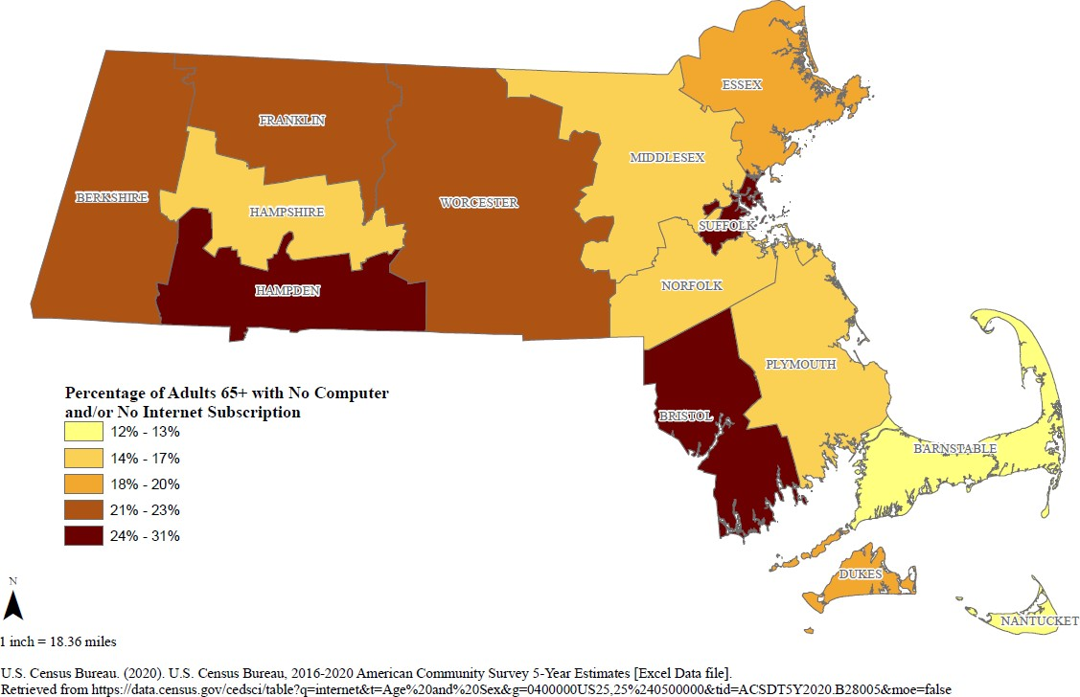
Adults aged 65+ were over 3x as likely to report not having a computer with an internet subscription as younger (6%).

Older adults living in Suffolk, Hampden, and Bristol county are least likely to have a computer with an internet subscription.
Percentage of Massachusetts Adults Aged 65+ with
No Computer and/or No Internet Subscription, 2016-2020
26

Which technology needs are you worried about getting?

Any technology
14%
11% *
15%
6%
6% *
15% *
6%
7%*
16% *
17%
13% *
20%
The pandemic increased reliance on technology– impacting access to healthcare, basic needs, COVID information, and connection to family and friends.

Cell phones

Computer or tablet

Internet

85+
Older Adults Were Worried about Access to Technology
60-84
Under 60 (REF)
27
*Difference is statistically significant at p. < .05

Some Groups of Older Adults Reported Even Greater Technology Needs
RACE/ETHNICITY

Percentage of MA Older Adults Who Reported Worry About Technology Needs
The following groups of adults aged 60+ were more likely to report any technology needs:
- Respondents of aged 85+
- Multiracial, Hispanic/Latinx, Am. Indian/Alaska Native, Other Race, and Black respondents
- Respondents with disabilities
AGE

HISPANIC / LATINX* |  |  |  |  |  | 32%
AMERICAN INDIAN/ALASKA NATIVE* |  |  |  |  | 29%
OTHER RACE, NH/NL* |  |  | 19%
BLACK, NH/NL* |  |  | 18%
ASIAN, NH/NL |  | 15%
WHITE, NH/NL (REF) | 12%
COGNITIVE DISABILITY* |  |  |  | 27%

FIGURE NOTES:
ALL RESPONDENTS AGED 60+
85+*
13%
20%
60-84 (REF)
MULTIRACIAL, NH/NL*
13%
33%
NO COGNITIVE DISABILITY (REF)
BLIND OR VISION IMPAIRED*
12%
25%
NOT BLIND OR VISION IMPAIRED (REF)
MOBILITY DISABILITY*
13%
22%
NO MOBILITY DISABILITY (REF)
SELFCARE DISABILITY*
12%
22%
NO SELFCARE DISABILITY (REF)
DEAF OR HARD OF HEARING*
12%
20%
NOT DEAF OR HARD OF HEARING (REF)
12%
DISABILITY
- nH/nL = non-Hispanic/non-Latinx;
- American Indian/Alaska Native includes respondents who identify as Hispanic/Latinx.
- Non-binary gender identity includes respondents identifying as non-binary, genderqueer, and not exclusively male or female.
- Percentages are weighted to the statewide age and educational distribution of those 25 years old or older in Massachusetts
*Difference is statistically significant at p. < .05. 28

Some Groups of Older Adults Reported Even Greater Technology Needs
INCOME

Percentage of MA Older Adults who Reported Worry About Technology Needs (cont.)
The following groups of adults aged 60+ were more likely to report any technology needs:
- Respondents who speak languages other than English
- Respondents with lower income
- Respondents living certain counties including Berkshire, Hampden, Franklin, and Suffolk
LANG-
UAGE

FIGURE NOTES:
ALL RESPONDENTS AGED 60+
13%
LANGUAGE OTHER THAN ENGLISH*
25%
ENGLISH ONLY (REF)
12%
<$35K*
22%
$35K-99,999*
12%
$100K+ (REF)
7%
BERKSHIRE*
18%
HAMPDEN*
17%
FRANKLIN*
13%
SUFFOLK*
13%
BARNSTABLE
12%
ESSEX*
12%
BRISTOL
11%
WORCESTER*
11%
NORFOLK (REF)
8%
COUNTY
- nH/nL = non-Hispanic/non-Latinx;
- American Indian/Alaska Native includes respondents who identify as Hispanic/Latinx.
- Non-binary gender identity includes respondents identifying as non-binary, genderqueer, and not exclusively male or female.
- Percentages are weighted to the statewide age and educational distribution of those 25 years old or older in Massachusetts
*Difference is statistically significant at p. < .05. 29

21%

16% *

23%

What would be helpful?
- “Grocery delivery… I live one town too far away, there is no grocery delivery”
- ”I live in a rural area, there is no delivery services out here”
- “Price of food has gone up and senior citizens have not received additional financial help
- “PLEASE MAKE EBT AVAILABLE FOR CURBSIDE PICKUP”
- “Ability to use EBT for online food order”

Adults aged 85+ were concerned about access to delivery of food and basic goods.
Older Adults Struggled to Access Food

Free or discount delivery of food and other supplies would be helpful
Older adults with one or more disabilities were 2x* as likely to be worried about getting food and groceries as those without a disability.
Under 60 (REF) 60-84 85+

*Difference is statistically significant at p. < .05.
30

Behind not having symptoms/perceived exposure, the top reasons older adults named for never having been tested were:
Older adults were less likely to be tested for COVID-19 than younger adults (38% vs. 46%)*
Older Adults Struggled to Access COVID Testing

1. Didn’t know where to go
“Could not finish online application for CVS“

“I would like to get tested but would have to travel to a city I am not familiar with, it would be hard for
me to find, and I work full-time and can't run around.”

“Info to get tested was very confusing from federal state and local governments”

2. Testing location was not accessible1

…highlighting structural barriers that continue to impact vaccination access.

1. Indicates agreement with, “The test wasn’t available where I wanted to get tested”.

“I have no way to get to a test site”

“Having to wait in line in my car made it hard for me. I am 72 and nothing comes easy these days, so I pretty much stay home!”

“Nearest site is too far for elderly to drive to over 20 miles“

31

Older adults:
Older Adults & COVID-19

Continue to account for the majority of COVID deaths and hospitalizations.

Continue to play important roles in pandemic mitigation efforts.

Reported significant economic, healthcare, and household, and behavioral health needs.

Were more likely to live alone than younger adults; living alone was associated with poorer mental health.

Relied on different communication channels for health information.

Were less likely to have accessible technology and internet access.

Highlighted both cost AND the need for delivery as barriers to food and resource access.

Were less likely to get tested for COVID, and more likely to cite structural barriers to testing, including lack of information and transportation.

32

Older adults…
Key Takeaways
- Comprise a diverse group who were both severely impacted by COVID and continue to participate in and lead mitigation efforts.
- Experienced significant social and economic impacts, including social isolation and interruptions to food access
- Reported structural barriers to accessing resources with implications for continued pandemic mitigation responses:
  - Communication channels
  - Technology
  - Transportation
  - Cost AND delivery of resources

- Must be included in policy, program development, and community planning to ensure:
  - Recognition of the diversity of needs
  - Tailoring of programming, resources, and the built environment
  - Leveraging of the strengths, leadership, and contributions of older adults
33

  - Through outreach and alternative data collection methods, improve ability for older adults for whom traditional online survey methods are less accessible to participate in CCIS
Older Adults & CCIS: Looking Ahead

  - Collaborate with local older-adult focused organizations and local boards of health to:
    - Increase dissemination of CCIS 2.0 survey among older adults to improve representation of the diversity of older adult needs and experiences
    - Utilize CCIS data to inform programming, resource allocation, outreach, and future crisis prevention planning
34

