# Community Case Management and ForHealth Consulting

## Community Case Management (CCM) is a service provided by ForHealth Consulting at UMass Chan Medical School.

CCM provides coordination of MassHealth (Massachusetts Medicaid) long-term services and supports (LTSS) to MassHealth Members with complex medical needs and their caregivers.

## One person to call to help with MassHealth LTSS.

1-800-863-6068

At ForHealth Consulting at UMass Chan Medical School,

we leverage world-class expertise and deep experience to create transformational solutions across the health and human services system, from payment and financing to clinical practice and information management.

We believe in diversity and inclusion, and the power of a shared purpose; together, we can make healthcare better.

Better for all of us.

Managing Long-Term Services and Supports for Eligible MassHealth

Members

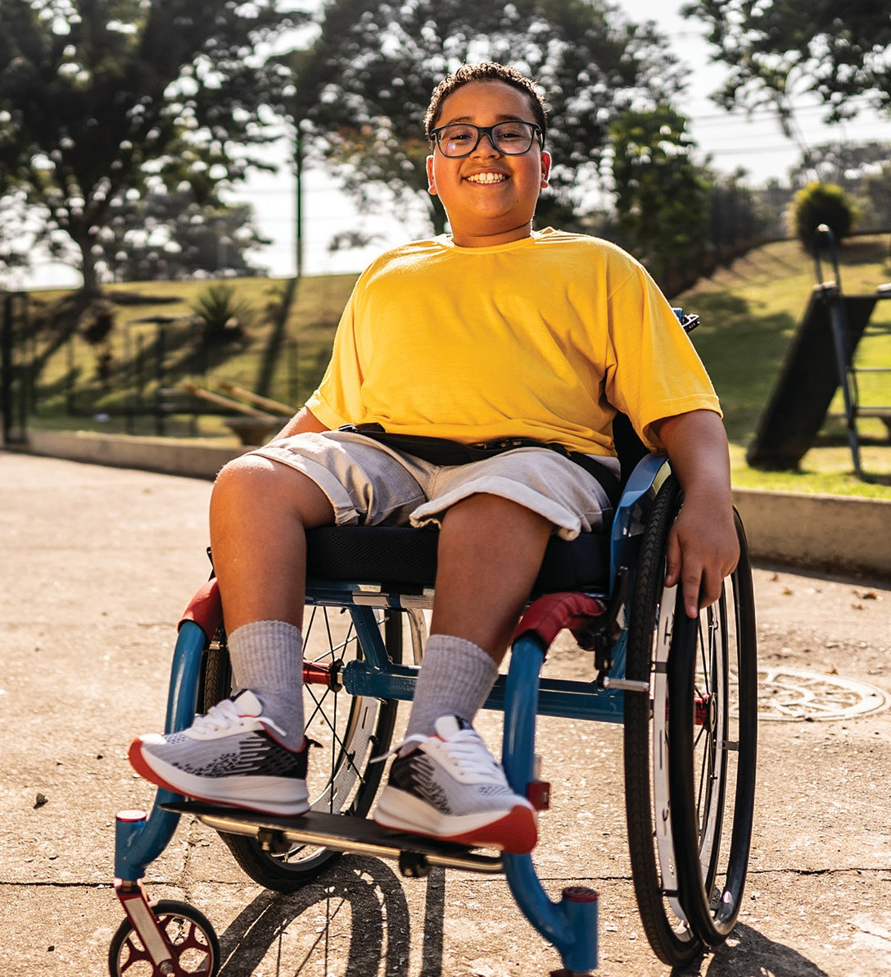

# Community Case Management

Visit the MassHealth CCM webpage:

[www.mass.gov/ccm](http://www.mass.gov/ccm)

Community Case Management

333 South Street, Shrewsbury, MA 01545

Tel: 1-800-863- 6068

MassHealth Members with complex medical conditions face many challenges. They may need long-term services and supports

# How CCM helps Members with MassHealth LTSS services

## CCM works with the Member to find the LTSS services they need. With CCM, the Member gets:

(LTSS) to live at home with their family. Having one contact to help with LTSS makes it a little easier.

Some MassHealth Standard or CommonHealth Members can get MassHealth continuous skilled nursing (CSN) services and be enrolled in Community Case Management (CCM). CCM approves and coordinates the MassHealth LTSS for these Members and builds a MassHealth Service Record based on each Member’s complex medical needs. CCM talks to the Member, the Member’s family as appropriate, and the Member’s care team to do this.

The Member calls one person for help to get medically necessary services. These include continuous skilled nursing, durable medical equipment, oxygen and respiratory equipment, personal care attendant (PCA), home health aide (HHA), complex care assistant (CCA), and rehabilitation services.

Individual Service Support

Each Member has a Clinical Manager to help them.



The CCM Clinical Manager

is a registered nurse. They can give the Member information about other MassHealth and community-based

services and programs. Clinical Managers can attend hospital and nursing facility discharge planning meetings. They support Members and the people who care for them to coordinate LTSS services as they move back home.

In-Person Assessments and the Service Record



The Clinical Manager meets with the Member and their care

team to learn about the Member’s needs. CCM then builds a MassHealth Service Record.

Health Care Professional Team



The Clinical Manager works with respiratory, physical,

occupational and speech therapists, pharmacists, and social workers. Together the team reviews for and determines the medical necessity for requested services and equipment for each Member.

Multi-Agency Coordination

CCM staff connects the Member with state agencies, community-based services,

and MassHealth providers. These include the Massachusetts Department of Developmental Services, the Massachusetts Department of Public Health, the Massachusetts Commission for the Blind, and MassAbility.

Insurance Identification



Sometimes Members have their own insurance as well as MassHealth. Some of their

LTSS may be covered by that insurance. CCM can help figure that out with the insurance company.

Support in Filling Authorized Services



CCM staff can assist Members by working with MassHealth

providers to help fill authorized hours and through the use of the CCM Nurse Directory, an online directory that supports matching CCM members with available CSN providers. CCM is available to help Members access the CCM Nurse Directory. If Members are still having difficulty filling their authorized hours, CCM clinical managers can assist by connecting them with other available services for CCM Members.