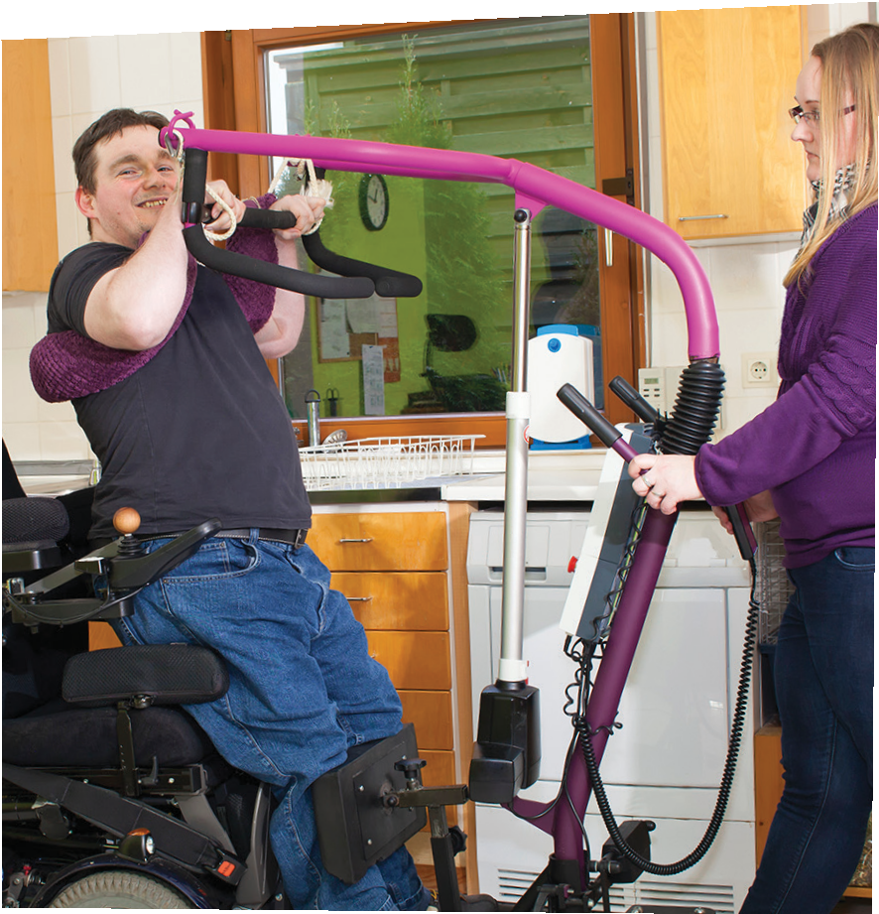

MANAGING LONG TERM SERVICES & SUPPORTS

FOR MASSHEALTH MEMBERS

Community Case Management

One person to call to help with MassHealth Long Term Services and Supports (LTSS).

MassHealth Members with serious medical conditions face many challenges. Having one person to contact to help with LTSS makes it a little easier.

Community Case Management (CCM) approves and manages MassHealth LTSS for Members with complex medical needs. Some MassHealth Standard
or CommonHealth Members can get continuous skilled nursing services. CCM approves and manages the MassHealth LTSS services for them. These include home health, durable medical equipment, oxygen and respiratory equipment, personal care attendant, and rehabilitation services.

CCM helps Members live at home by managing the LTSS services that are medically necessary. Members who need continuous skilled nursing along with other LTSS, are given a MassHealth Service Record. CCM builds this Record based on each Member’s medical needs. CCM talks to the Member’s care team to do this.

CCM is part of Commonwealth Medicine, a division of the UMass Chan Medical School.
CCM approves and manages LTSS services for eligible MassHealth Members. The Member calls one person for help. CCM works with the Member to find the
LTSS services they need.

CWMCCMV4 08/19-4

Community Case Management
333 South Street, Shrewsbury, MA 01545 l Tel: (800) 863-6068 or (508) 421-6129 (TTY) l Fax: (508) 421-5905 I Email: Commcase@umassmed.edu

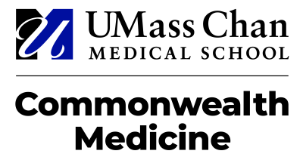
Community Case Management Commonwealth Medicine
University of Massachusetts Medical School 333 South Street
Shrewsbury, MA 01545
Office: 800-863-6068 TTY: 508-421-6129
Fax: 508-421-5905 E-mail: CommCase@umassmed.edu

Community Case Management (CCM) Complaint, Dispute & Appeals Process

Filing a Complaint
If at any time during your participation in Community Case Management (CCM) you are not happy with the way you were treated or the assistance you received from a CCM staff member, you may file a complaint with the appropriate manager via telephone (please refer to the contact information below) or in writing. Written complaints should be sent to Kerri Ikenberry at the address above. CCM will respond to your complaint within one (1) business day and resolve your issue within seven (7) business days.

Requesting a Fair Hearing with the Board of Hearings

If you disagree with the services authorized on your CCM Service Record during your Community Long Term Care Needs Assessment visit or any CCM prior authorization decision, you can file a request for fair hearing with the Board of Hearings by completing the Fair Hearing Request Form provided to you and forwarding it to the address on the form. You must file a request for fair hearing with the Board of Hearings within thirty (30) calendar days of the Service Record date or prior authorization decision notice date (received via mail from MassHealth), if a Service Record wasn’t provided. If you need an additional copy of the Fair Hearing Request Form please contact your Clinical Manager, or you may download the form from the MassHealth website at https://www.mass.gov/how-to/how-to-appeal-a-masshealth-decision .

In addition, following your request for a fair hearing, the Associate Director of Appeals & Regulatory Compliance will contact you prior to your scheduled fair hearing to ask if you would like to participate in an informal review.

Community Case Management: Contact Information
Virdany Ruiz, BS,  RRT | Clinical Coordinator, Allied Health Services: Manager - CCM  Specialists: Occupational, Physical and Respiratory Therapy | (774) 455-5185
Terri Podgorni, RN,  BSN | Associate Director, Care Management: Manager – CCM Clinical  Managers (Nurses) | (508) 856-3982
Linda Phillips, RN | Associate Director, Appeals & Regulatory Compliance | (508) 856-1641
Kerri Ikenberry, RN | Executive Director, Clinical Services, Disability & Community-based  Services (DCS) | (508) 421-5901

Rev. 7/13/2021

HOW TO ASK FOR A FAIR HEARING
Your Right to Appeal: If you disagree with the action taken by MassHealth, you have the right to appeal and ask for a hearing before an impartial hearing officer. You can also request a hearing if MassHealth did not act on your request in a reasonable time.
How to Appeal: You can fill out this hearing request form and send it with a copy of the notice you are appealing to the Board of Hearings, Office of Medicaid, 100 Hancock Street, 6th floor, Quincy, MA 02171 or you can fax or efax these materials to (617) 887-8797. You can also call (800) 841-2900 to fill out your request for a hearing form by telephone. If you have a question about your hearing, call (617) 847-1200 or (800) 655-0338.
The Board of Hearings must receive your completed, signed request within 30 calendar days from the date you received the notice of our action. If you did not receive a written notice of the action to be taken, or MassHealth did not take an action on your application, you must file your request no later than 120 calendar days from the date the action took place or the date of the application.
If You Are Now Getting MassHealth Benefits: You may be eligible to keep your benefits between the time you appeal and the time that the Board of Hearings makes a decision to approve or deny your appeal. If you decide to keep your benefits between the time the appeal is pending, and then you lose your appeal, you may have to pay back the cost of the benefits you received. If you do not get benefits, and then you win your appeal, we will restore your benefits. You will keep your benefits if the hearing form is received either before the benefit stops or within 10 calendar days from the mailing date of the MassHealth notice, whichever is later. Please mark your choice in the Other Information section of the form.
Date of Fair Hearing: At least 10 days before the hearing, we will send you a notice telling you the date, time, and place of the hearing. Your hearing may be conducted by phone. You can ask us to reschedule a hearing, but you must have good cause. If you do not reschedule or appear on time to the hearing without documented good cause, your appeal will be dismissed.
Your Right to Be Helped at the Hearing: At the hearing, you may have a lawyer or other person represent you, or you may represent yourself. We will not pay for anyone to represent you. You may contact a local legal aid service or community agency to see if you can receive advice or representation at no cost. A hearing request can also be filed on your behalf by an individual authorized to act on your behalf. If someone other than a lawyer is acting on your behalf, please attach a copy of the document(s) authorizing that person to file a hearing request on your behalf (for example, Power of Attorney, Guardian, invoked Health Care Proxy).
If You Need an Interpreter, Assistive Device, or Other Accommodation: If you do not understand English or if you are hearing or sight impaired, we will provide an interpreter or assistive device at the hearing at no cost to you. We will also make other reasonable accommodations a person with a disability may need to participate in the hearing. Please tell us what you need in the Other Information section of the form.
Your Right to Review Your Case File: You and/or your representative can review your case file before the hearing. If you wish to review your case file, call (800) 841-2900, TTY: (800) 497-4648 (for people who are deaf, hard of hearing, or speech disabled).
Your Right to Ask to Subpoena Witnesses and Your Right to Question: You or your representative may write to ask that witnesses or documents be subpoenaed to the hearing. You or your representative may present evidence and cross-examine witnesses at the hearing. This means you can ask questions of witnesses. The hearing officer will make a decision based on all evidence presented at the hearing.
Impact on Other Household Members: Note that an appeal decision for one household member may change eligibility for other household members. If that happens, affected household members will receive a new eligibility notice explaining the changes.

FAIR HEARING REQUEST FORM
First Name: Middle Initial:

Last Name:

Mailing Address:

City: State: Zip:

Phone Number:

Member ID: Date of Birth:

Reason For Your Appeal (Circle any reason(s) that may apply.)
Income • Citizenship/Immigration status • Access to other insurance Family size • Residency • Incarceration status • Other (see below)

Please explain why you are appealing.
Attach any documents that support your reason.

Other Information (Check all that apply.)
- I accept the proposed change in my coverage during the appeal process. If you check this line and you win your appeal, we will restore your original level of benefits.
- I want to keep the benefits during the appeal process that I was receiving before. If you check this line and you lose your appeal, you may have to pay back the cost of the benefits you received during your appeal.
- I need an interpreter. My language is (We will provide the interpreter for the hearing.)
- I need an assistive device to communicate at a hearing. (Describe what type of device you need, and we will provide an assistive device for the hearing.)

- I need another accommodation for a disability. (Describe the accommodation needed.)

- I need an expedited hearing.
- I want a phone hearing. My number is
Appeal Representative, if you have one
Name:

Phone number:

Mailing Address:

City: State: Zip:

Signature
The information on this form is true and accurate, to the best of my knowledge. I authorize MassHealth to provide me and my representative, if I have one, with my individual information, including federal and state tax information used in the determination of my eligibility, for purposes of this appeal process.
Signature: Date:

First & Last Name (Print):

If this is signed by someone other than an appellant 18 years of age or older who has authority to file, please attach a copy of your authority to file the appeal on behalf of the appellant (for example, a copy of your power of attorney document or evidence of court appointment as a personal representative).

FHR-1-(05/20)

Community Case Management and Commonwealth Medicine
Community Case Management (CCM) approves and manages MassHealth Long Term Services and Supports. CCM is part of Commonwealth Medicine, a division of the University of Massachusetts Medical School.
Commonwealth Medicine

For more information about CCM, please contact us by calling
1-800-863-6068 or
(508) 421-6129 (TTY).

CWMCCMV4 08/19-1

Commonwealth Medicine

Commonwealth Medicine Community Case Management
333 South Street, Shrewsbury, MA 01545
Tel: (800) 863-6068 or (508) 421-6129 (TTY)
Fax: (508) 421-5905
Email: commcase@umassmed.edu
MANAGING LONG TERM SERVICES & SUPPORTS FOR MASSHEALTH MEMBERS

Community Case Management

Managing Long Term Services and Supports for eligible MassHealth Members.
How CCM helps Members with MassHealth LTSS services.

CCM works with the Member to find the LTSS services they need. With CCM, the Member gets:

MassHealth Members with complex medical conditions face many challenges. They may need Long Term Services and Supports (LTSS) to live at home with their family. Having one contact to help with LTSS makes it a little easier.
Some MassHealth Standard or CommonHealth Members can get MassHealth continuous skilled nursing services. Community Case Management (CCM) approves and manages the MassHealth LTSS services for them.
The Member calls one person for help to get medically necessary services. These include continuous skilled nursing, durable medical equipment, oxygen and respiratory equipment, personal care attendant, and rehabilitation services.
Members who need continuous skilled nursing along with other LTSS are given MassHealth Service Records. CCM builds this Record based on each Member’s medical needs. CCM talks to the Member’s care team to do this.

One person to call to help with MassHealth Long Term Services and Supports (LTSS).
- Individual Care Coordination – Each member has a Clinical Manager to help them. The CCM Clinical Manager is a nurse.The Clinical Manager can give the Member information about other MassHealth and community-based services and programs. Clinical Managers can be at hospital and nursing facility discharge planning meetings. They support Members and the people who care for them as they move back home.

- In-Person Assessments and the Service Record – The Clinical Manager meets with the Member and their care team to learn about the Member’s needs. CCM then builds a MassHealth Service Record.

Health Care Professional Team –
The Clinical Manager works with respiratory, physical, occupational and speech therapists, pharmacists, and social workers. Together the team decides what medically necessary services and equipment the Member needs.

Multi-Agency Coordination –
CCM staff connects the Member with state agencies, community-based services and MassHealth providers. These include the Department of Disability Services (DDS), Department of Public Health (DPH), Massachusetts Commission for the Blind (MCB), and Massachusetts Rehabilitation Commission (MRC).

- Insurance Identification – Sometimes Members have their own insurance as well as MassHealth. Some of their LTSS may be covered by that insurance. CCM can help figure that out with the insurance company.

- Resource Materials – Members are given materials to help them find providers for their LTSS needs.

What is Community Case Management (CCM)?

Frequently Asked Questions (FAQ)
About Community Case Management
Community Case Management (CCM) is a service provided by the University of Massachusetts Medical School (UMMS). CCM provides coordination of MassHealth community long term services and supports (LTSS) to MassHealth Members with complex medical needs and their caregivers. UMMS hires Clinical Managers, who are registered nurses, to be your single point of contact and coordinate and approve services on behalf of MassHealth.

Who is eligible to have their MassHealth services coordinated and approved by CCM?
CCM coordinates and approves services for MassHealth Standard or CommonHealth Members who qualify for MassHealth continuous skilled nursing (CSN) services.

What are Continuous Skilled Nursing (CSN) Services?
A continuous skilled nursing (CSN) service is a nurse visit of more than two hours of nursing services.

What is the CCM Clinical Manager’s role?
The CCM Clinical Manager’s role is to complete an in-person assessment (a review of your care needs) to determine if you qualify for MassHealth CSN services. If you are eligible for CSN services then the Clinical Manager will develop a plan based on your needs (a Service Record). The CCM Clinical Manager will coordinate and approve other MassHealth services. These services may include personal care attendant (PCA), home health aide (HHA), durable medical equipment (DME), oxygen and respiratory equipment, medical supplies and therapy services. The Clinical Manager works with
other CCM clinicians, which include physical, occupational, respiratory, and speech therapists, pharmacists, and
social workers.

Will the CCM Clinical Manager have a relationship with the nursing provider in my home?
Yes. Your CCM Clinical Manager will work closely with the nursing provider in your home. The Clinical Manager will work with any other of your providers. An important
part of the assessment process is talking with the providers who know your care needs. Most importantly, you and, if appropriate, your caregiver(s), will be included in the review process that leads to your approved MassHealth services.

I also have a case manager from the Department of Public Health. What will happen to that relationship?
Many families have a case manager from other state agencies or insurances. These may include the Department of Public Health (DPH), the Department of Developmental Services (DDS), the Massachusetts Commission for the Blind (MCB), Early Intervention, the Massachusetts Rehabilitation Commission (MRC) and/or a private insurance company.
These relationships will continue. The CCM Clinical Manager will, if you agree, communicate and work closely with all of these other agencies as necessary.

What is a Personal Care Attendant (PCA)?
A Personal Care Attendant (PCA) is a person who can help you with the daily activities that you need support with because of your condition or illness. For example, a PCA can provide help with bathing, dressing, and eating. They may also be able to help you with other household services. These may include laundry, shopping and housekeeping.
PCA services require a separate assessment by CCM and must follow MassHealth Regulations. The MassHealth PCA Consumer Handbook, available through your Clinical
Manager, can provide you with more information about the PCA program.

What is a Home Health Aide (HHA)?
A Home Health Aide (HHA) is a person who works for a Home Health Agency to help you with your care needs. These may include bathing, eating, changing a wound dressing, providing medications that do not require a nurse, or therapy exercises. Home health aide services are provided under a plan of care from the home health agency and your physician. A nurse from the home health agency supervises the home health aide activities.

I cannot get my approved nursing hours filled. What do I do?
First, talk with your CCM Clinical Manager. The Clinical Manager may have ideas. These may include working with many MassHealth nursing providers to help fill those nursing hours or using other MassHealth services (CSN/PCA Option, skilled nursing visits, HHA) until a nurse can be found.

What is the CSN/PCA Option?
The CSN/PCA Option is another service that may be offered if you are unable to fill your approved nursing hours because nursing is not available. A PCA may be used for the number of unfilled nursing hours when appropriate and as approved by the Clinical Manager. These services are only approved until nursing can be found. A separate assessment will not be needed.

What can I expect from the nursing provider(s) in my home?
Your nursing provider(s) will get physician orders and provide hands-on skilled nursing care, as approved by your CCM Clinical Manager. Any care provided by the nurses should be documented and left in the home for
review by you, your caregiver(s), or other nursing providers.

I am concerned that the CCM Clinical Manager will perform a MassHealth LTSS assessment on a day when I do not appear to be sick.
The CCM Clinical Managers are nurses who have experience with individuals who have special health
care needs. They are very aware that your condition may change from day to day. The CCM Clinical Manager will review nursing/medical records, and talk with you, your nursing providers, and, if necessary, your physician.

How often will the CCM Clinical Manager come to my home and contact me?
The CCM Clinical Manager will provide an in-person assessment in your home at least once per year. You may request a visit at any time if you feel it would be helpful. During the first year, the CCM Clinical Manager will call every 3 months to talk about whether your approved MassHealth services are meeting your needs. Of course, you may call your Clinical Manager at any time with questions or concerns regarding your MassHealth services.

What happens if I do not use all my nursing hours?
Approved nursing hours can be used only during your Prior Authorization (PA) period. When a PA ends, any remaining hours are no longer available. It is important to keep track of your unfilled nursing hours.

Can I use my nurse if I am in the hospital or nursing facility?
No. A nursing provider cannot provide services for you if you are in a hospital or nursing facility.

What should I do with unused PCA hours? Can they be saved?
Unused PCA hours cannot be saved. PCAs cannot work more than the approved number of hours per week or per night.

Can I use my PCA hours if I am in the hospital or nursing facility or during the time I am in a day or foster care program?
A PCA cannot be paid to work for you if you are in a hospital or nursing facility, or during the time you are in a MassHealth-funded adult day health, day habilitation, adult foster care, or group adult foster care program.

How does the nursing care I receive at school or at a day program affect my MassHealth services?
Many CCM Members receive nursing services in school or at a day program. The CCM Clinical Manager will ask during the assessment process what other services you are receiving and the payment source. For example, if you are in school,
the Clinical Manager will request a copy of your Individualized Education Plan (IEP). The Clinical Manager will review the IEP to see what services the school has agreed to provide when you are in school.

How can CCM help me get the equipment I need?
Your CCM Clinical Manager, along with CCM’s therapists review the equipment requests submitted to MassHealth by your providers. CCM Clinical Managers and therapists understand your care needs, and MassHealth regulations. They can discuss the PA process with you and work with your health care providers and equipment vendors for your equipment needs.

How long does it take to obtain a Prior Authorization (PA) decision for equipment or supplies from CCM?
As long as all required information is included with the request, a decision will be made within 14 days.

CWMCCMV4 08/19-5
Commonwealth Medicine
Commonwealth Medicine l Community Case Management
333 South Street, Shrewsbury, MA 01545 l Tel: (800) 863-6068 or (508) 421-6129 (TTY)
Fax: (508) 421-5905 l Email: Commcase@umassmed.edu
If you have any further questions, please call CCM at (800) 863-6068 or TTY at (508) 421-6129, or e-mail us at commcase@umassmed.edu. Also, please visit the MassHealth website at www.mass.gov/masshealth.

Specialist Team
The Community Case Management (CCM) Specialists are available to help CCM Members, MassHealth providers, and staff. The team includes licensed Occupational, Physical, Respiratory, and Speech Therapists, and Social Workers. They can help you better understand your medical and community service needs. They will give you more information to help with those needs. They can:
  - Attend your annual assessment visit with your CCM Clinical Manager
  - Visit your home to talk about equipment and/or other community supports you may need
  - Assist your CCM Clinical Manager in evaluating your personal care needs
  - Explain to you and those who help you how the prior authorization (PA) process works
  - Help you understand the MassHealth system
  - Work with your providers and other community partners to get the services and equipment you need so you can live safely at home

The specialists that may help you include:
Occupational Therapists (OT)
The CCM OTs can answer questions about PAs for some durable medical equipment (DME). These include things like bathing systems, car seats, and occupational therapy services. The CCM OTs also work with the CCM Clinical Manager, and may come to your home to complete a personal care attendant evaluation.

Physical Therapists (PT)
Our PTs can answer questions about PAs for other DME needs. This can include things like wheelchairs and other mobility/seating systems, hospital beds, lift systems, and physical therapy services.

Respiratory Therapists (RT)
The CCM RTs help with PA requests for breathing supports. This includes oxygen and respiratory equipment such as suction machines, ventilators, and tracheostomy tubes
and supplies.

Speech-Language Pathologist or Speech Therapist (ST)
The ST helps with PA requests for communication devices and accessories, and speech and language therapy services.

Social Work (SW)
Our SWs help CCM Members and their families understand what state agency/community programs and services
are available. They can also help CCM Members to get behavioral health support, learn about and get public benefits, and figure out what other supports could pay for items or services not covered by MassHealth.

About Us
Community Case Management (CCM) approves and manages MassHealth long term services and supports. CCM is part of Commonwealth Medicine, a division of the University of Massachusetts Medical School.

Commonwealth Medicine

Commonwealth Medicine l Community Case Management
333 South Street, Shrewsbury, MA 01545 l Tel: (800) 863-6068 or (508) 421-6129 (TTY)
Fax: (508) 421-5905 l Email: Commcase@umassmed.edu

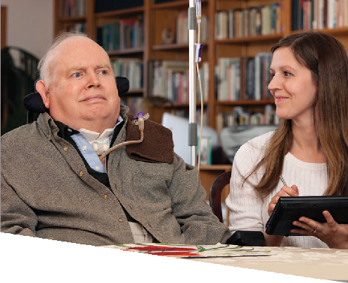CWMCCMV4 08/19-7

CCM Specialist Roles
Supporting Community Case Management Members

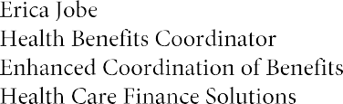
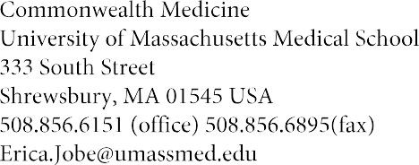

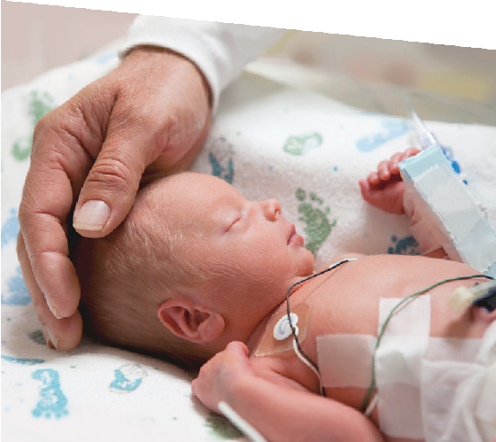Who We Are
The Enhanced Coordination of Benefits Unit (ECOB), a specialized UMass Medical School program, works with Massachusetts Medicaid Program (MassHealth) members to ensure they receive the most comprehensive insurance coverage available. MassHealth members may have access to additional insurance benefits through an employer, spouse, parent, or COBRA. We help members and their families get or maintain private health insurance.
The ECOB Program is a free service provided by Massachusetts for eligible MassHealth members.

How We Can Help

Our ECOB Health Benefit Coordinators are available to:
- Act as your direct contact to MassHealth
- Investigate private and public benefits to which you may be eligible
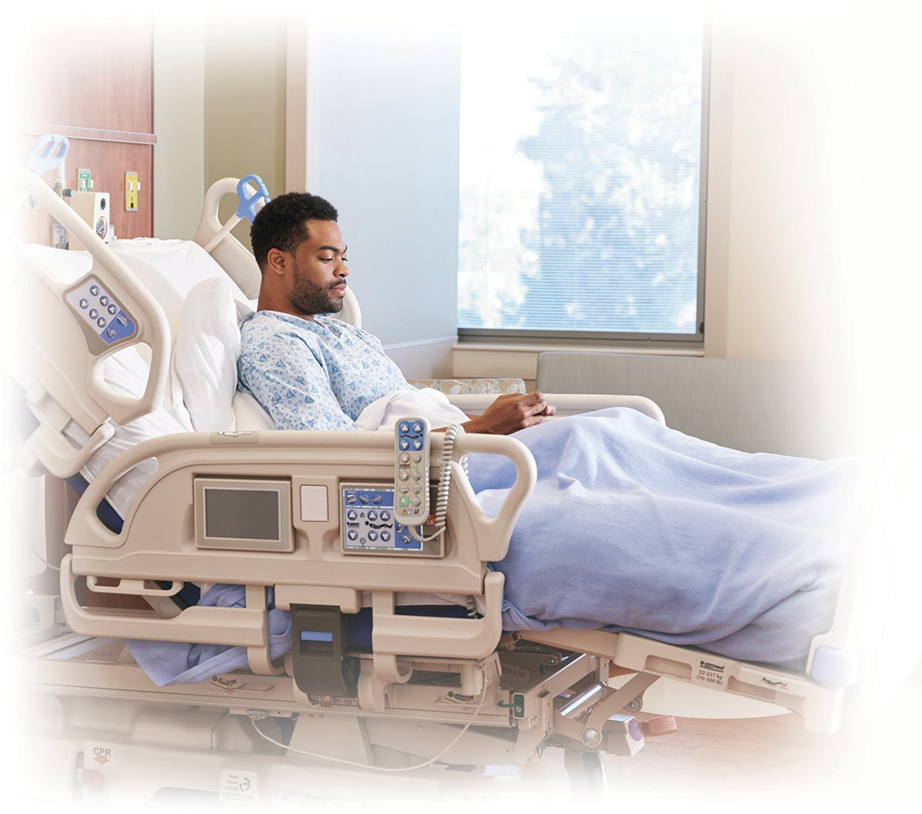
- Advocate for health insurance benefits that you are entitled to, and help resolve any coverage issues you may have with your employer, insurer, or MassHealth

Eligibility

We work with families and individuals dealing with:
- Catastrophic Illness
- Chronic Disease
- Complex Prescription Needs
- Lengthy or Repeated Hospitalizations

Contact us if you are:
- Under Age 65 and
- A MassHealth member or awaiting a decision on your MassHealth eligibility
We can investigate your eligibility and options. Every situation is different.

Premium Assistance
For MassHealth members, having both private insurance and MassHealth may mean access to a larger selection of providers and benefits. ECOB Health Benefit Coordinators help identify available coverage, and work with the MassHealth Premium Assistance Program to reimburse eligible MassHealth members for the cost of private group health insurance.

COMMUNITY CASE MANAGEMENT

’S CALENDAR
Member Name
Month/Year: |  |  |  | Approved Services:
Sunday | Monday | Tuesday | Wednesday | Thursday | Friday | Saturday | Weekly Tally
CNS Hours Used: PCA Hours Used:
PDN/PCA Hours Used: Unused Hours:
CNS Hours Used: PCA Hours Used:
PDN/PCA Hours Used: Unused Hours:
CNS Hours Used: PCA Hours Used:
PDN/PCA Hours Used: Unused Hours:
CNS Hours Used: PCA Hours Used:
PDN/PCA Hours Used: Unused Hours:
CNS Hours Used: PCA Hours Used:
PDN/PCA Hours Used: Unused Hours:

CCM encourages you to use this calendar to track Nursing Hours, Unused Nursing Hours, PDN/PCA Hours, and PCA Hours (if applicable).

CSN/PCA Option

The Continuous Skilled Nursing (CSN)/Personal Care Attendant (PCA) Option provides MassHealth members who are authorized to receive Continuous Skilled Nursing services, but cannot fill the authorized nursing hours, with streamlined access to MassHealth PCA services. Members who elect the CSN/PCA Option will maintain their existing authorization for Continuous Skilled Nursing services and will receive a prior authorization (PA) for PCA services for the same number of hours/week and duration as the Continuous Skilled Nursing authorization. For example, a member is authorized for 50 hours per week of Continuous Skilled Nursing services, with a PA expiration date of December 5, 2008. The PA for PCA services would be for 50 hours per week of PCA with an expiration date of December 5, 2008. The member is unable to fill 25 of the nursing hours in a given week. The member may then use 25 hours of PCA services to fill the unfilled nursing hours. The total number of combined PCA and CSN hours that a member uses in a given week cannot exceed the Continuous Skilled Nursing authorization per week (in this case 50 hours per week).

La Opción de Enfermería Especializada Continua (CSN)/Asistente de Cuidado Personal (PCA) proporciona a los miembros de MassHealth que están autorizados a recibir servicios de Enfermería Especializada Continua, pero no pueden llenar las horas de enfermería autorizadas, con acceso optimizado a los servicios de PCA de MassHealth. Los miembros que elijan la Opción CSN/PCA mantendrán su autorización existente para los servicios de Enfermería Especializada Continua y recibirán una autorización previa (PA) para los servicios de PCA por el mismo número de horas/semana y duración que la autorización de Enfermería Especializada Continua. Por ejemplo, un miembro está autorizado por 50 horas por semana de servicios de Enfermería Especializada Continua, con una fecha de vencimiento de PA del 5 de diciembre de 2008. La PA para los servicios de PCA sería por 50 horas por semana de PCA con una fecha de vencimiento del 5 de diciembre de 2008. El miembro no puede llenar 25 de las horas de enfermería en una semana determinada. El miembro puede entonces utilizar 25 horas de servicios de PCA para llenar las horas de enfermería sin llenar. El número total de horas combinadas de PCA y CSN que un miembro utiliza en una semana determinada no puede exceder la autorización de Enfermería Especializada Continua por semana (en este caso 50 horas por semana).

huµnµ . 7u u4nlgnl4L tµuµtµnl4  MassHealth- nn4g tq 4unlgn
uRunlnl44tµ4  щtр  u44puщtu  nuuµ u: bt tq o4nlnl4  huµnunµ uu u4nlgnl4L uµ4u4tLnl hu4uµ nu4 tt huµgtµ nl4tр
4цµnl4 t4р ц4tL 4nµtµ nuµunµ4u4 hu4u4рu4 µuut4un4 (Community Case Management) 800-863-6068 htRunuuhu4uµn:
Данное изbещение содержи� инфор�ацию о предлогае�ых bа� организацией MassHealth услуг и �ребуе� не�едленного расс�о�рения. По bсе� bозникнуbши� к содержанию bопроса� и спраbка� просьба обраща�ься b упраbление по дела� населения (Community Case Management) по �елефону 800 – 863 – 6068.
Σηµαντιnό! Αυτή η αναкοίνωση αφοpá τις υπηpεσίες MασXέλθ (MassHealth) кαι απαιτεί áµεση πpοσοχή. Αν χpειá3εστε βοήθεια µε την µετáφpαση αυτής της αναкοίνωσης ή αν έχετε εpωτήσεις, παpαкαλείσθε να επιкοινωνήσετε µε την υπηpεσία
�ιαχείpισης Υποθέσεων της Κοινότητας (Community Case Management) στο 800-863-6068.
Znacajno! Ova obavijest je o vasim MassHealth uslugama i zahtijeva neodloznu pozornost. Ako trebate pomoc kod prijevoda ove obavijesti ili imate pitanja, molimo kontaktirajte Community Case Management na broj 800-863-6068.
Importante! Questo avviso riguarda i servizi MassHealth e richiede un’immediata attenzione. Se si desidera ricevere ulteriori informazioni per comprendere questo avviso, rivolgersi al Community Case Management al numero 800-863-6068.
Enpòtan! Avi sa a konsène Sèvis MassHealth ou epi li mande atansyon ou touswit. Si ou bezwen èd pou entèprete avi sa a oubyen si ou gen kesyon, souple kontakte Community Case Management (biwo jesyon ka kominotè) a 800-863-6068.
¡Importante! Este aviso es sobre sus servicios de SaludGlobal (MassHealth) y requieren de su atención inmediata. Si necesita ayuda interpretando este aviso o tiene preguntas, favor de comunicarse con el Community Case Management al teléfono 800-863-6068.
Importante! Este aviso é relativo ao MassHealth Services (Serviços de MassHealth) e requer a sua atenção imediata. Caso precise de ajuda para interpretar este aviso ou caso tenha dúvidas, é favor contactar Community Case Management através do telefone
800-863-6068.
Important! Ce message concerne votre MassHealth Service de soins de santi et requiert votre attention immidiate. Si vous avez besoin d’aide pour interpreter ce message ou si vous avez des question, veuillez contacter le Community Case Management au 800-863-6068.

Ðieàu quan tro.ng! Quyù vị caàn löu yù ñeán thoâng baùo naøy laø veà Dịch Vu. MassHealth. Neáu coù thaéc maéc hay caàn ñöô.c giuùp ñôõ ñeå hieåu baûn thoâng baùo naøy, xin lieân la.c vôùi Ban Quaûn Lyù Hoà Sô Coäng Ðoàng theo soá 800-863-6068.

��� ������������(MassHealth)������������
�������������������� 800-863-6068 ��������
�(Community Case Management)�
s Mxan; enHKWCaRbkasTak;TgnwgesvakmµsuxPaBTUeTArbs;Gñk ehIyTamTanUvkarykcitþTukdak;CabnÞan;1 RbsinebIelakGñkRtUvkarCMnYyTak;TgkarbkERbesckþIRbkasenH b¤ elakGñkmannUvsMNYr/ sUmTak;Tg karRKb;RKgkrNIrbs;shKm (Community Case Management) tamry:elxTUrs½BÞ 800-8g3-g0g81

