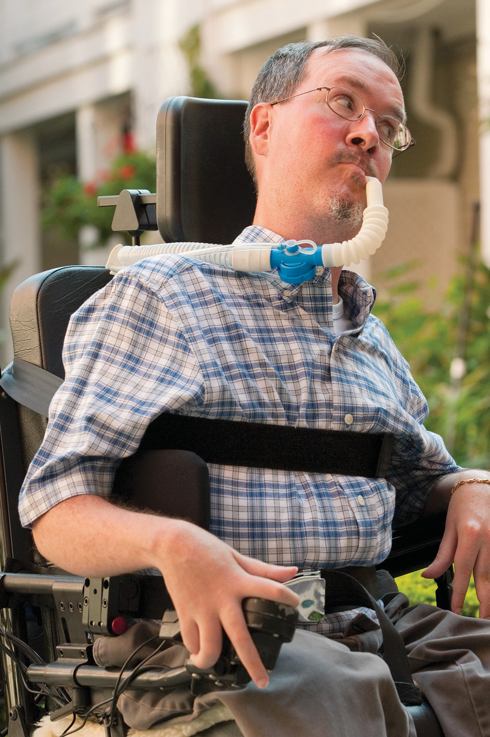Register today!



Need Help

Do You

a Nurse?

Finding

The CCM Nurse Directory can help.

Scan:

QR Code to access

 Website:

[https://ccmnursedirectory.org](https://ccmnursedirectory.org/)

 Call CCM for assistance:

1-800-863-6068

How the CCM Nurse Directory Can Help

Having a nurse come into your home to provide care for you or a loved one can be life changing. It can also be hard to find the

right nurse. The CCM Nurse Directory can

help you and your family find MassHealth nursing providers who have the needed nursing skills, meet your scheduling requirements, and other preferences you have for a nurse.



# What is the CCM Nurse Directory?

The CCM Nurse Directory is an online resource that helps MassHealth Members who are part of the Community Case Management (CCM) Program, and Members’ families and caregivers find nurses. Using your identified preferences and needs, the CCM Nurse Directory is designed to match MassHealth CCM Members with MassHealth nursing providers. Any MassHealth Members enrolled in the CCM Program can use the CCM Nurse Directory. If a Member needs help accessing the CCM Nurse Directory, CCM Members’ families can use the CCM Nurse Directory on behalf of the CCM Member or a Project Coordinator at CCM can assist you.

# How Does the CCM Nurse Directory Work?

CCM Members or their families create a profile in the CCM Nurse Directory. You identify your nursing schedule, nursing care needs, and other preferences unique to your needs. MassHealth nursing providers also create profiles, noting their skill sets, towns, or cities they work in, and their availability.

Once your profile is complete, CCM Members and families can search for available MassHealth nursing providers who match their preferences. Once a MassHealth nursing provider creates their profile, they can search for CCM Members who are looking for a nurse. CCM Members and families and CSN Providers can communicate directly through the online portal.

# More Information on Getting Started

How long does it take to set up a profile?

* Most CCM Members report it takes about 15 minutes to set up a profile.
* If you don’t have time to finish your profile, save it and complete it later.

How do I connect with a potential provider?

* You may use the CCM Nurse Directory to search for available MassHealth nursing providers, and once you have found a potential match, you can send them a message through the CCM Nurse Directory.
* Additionally, MassHealth nursing providers can search for CCM Members using the CCM Nurse Directory and send messages to potential matches. When you have matched with a potential provider, you will receive an email letting you know you have a message and directing you to log in to your CCM Nurse Directory account.

Is the CCM Nurse Directory only available during certain times?

* The CCM Nurse Directory is available 24/7, allowing you to access it based on your availability.

How do I access the CCM Nurse Directory?

* You can access the CCM Nurse Directory by going to the following website: [https://ccmnursedirectory.org](https://ccmnursedirectory.org/) or scan the QR Code.
* If you need help, talk with your CCM Clinical Manager, or call 1-800-863-6068.