[ForHealthConsulting.umassmed.edu](http://forhealthconsulting.umassmed.edu/)

Community Case Management (CCM) Nurse Directory

CCM Member Job Aid

### Prepared for: MassHealth



### Prepared by:

### Santa Diaz

### UMass Chan Medical School

### October 2024

Table of Contents

*CCM Member Registration* *3*

*CCM Member Log In* *6*

*Forgot Password* *8*

*CCM Member Landing Page* *10*

*Edit CCM Member Profile* *11*

*Home Function* *24*

*Search Function* *25*

*Access Messages* *32*

*Change Password* *37*

*Survey* *38*

If you need assistance accessing or using the directory, please contact: [CSNAccessSupport@umassmed.edu](mailto:CSNAccessSupport@umassmed.edu)

# CCM Member Registration

A CCM Member will need to access the Community Case Management (CCM) Nurse Directory webpage to create an account and profile for the CCM Nurse Directory. [https://ccmnursedirectory.org](https://ccmnursedirectory.org/)

After the CCM Member accesses the CCM Nurse Directory webpage, the CCM Member needs

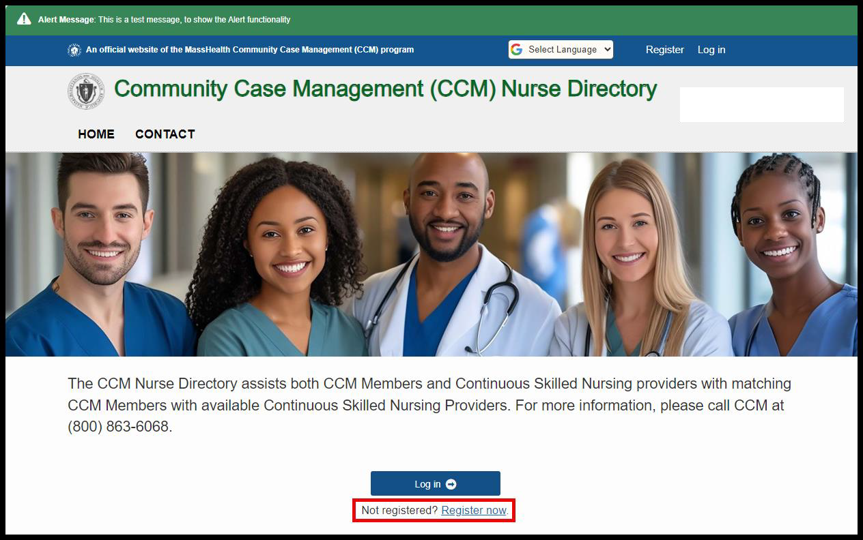to click on “Register Now” just below the Log in menu item.

The CCM Member will need to click on “Member Registration” (can click anywhere on the picture).

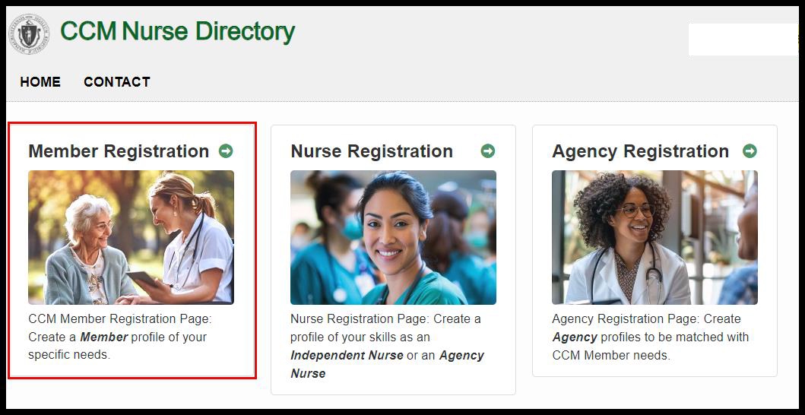

The CCM Member will enter the information for their family member and click “Register.” An email will be sent to the CCM Member’s email address for them to authenticate into the CCM Nurse Directory.

## Helpful Hints

* The following fields are required: CCM Member First Name, CCM Member Last Name, Street Address, City, State, Zip Code, CCM Member Date of Birth, MassHealth Number, Email, Password, Confirm Password. The system will provide a message and highlight the corresponding field if NOT populated when the “Register” button is clicked. These fields are also identified with a red asterisk before each field.
* The email address and password entered in the registration will be used by the CCM Member to log into the CCM Nurse Directory.
* The CCM Member will have the ability to update their account (registration) information after they authenticate into the CCM Nurse Directory.

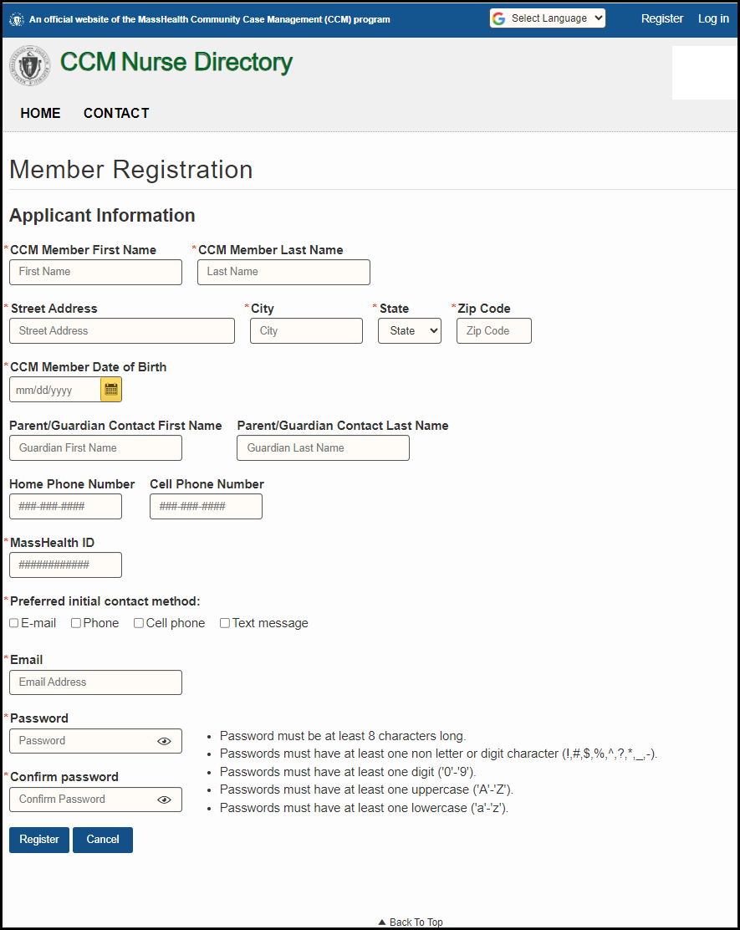

The CCM Member will receive the Confirmation in Progress message as shown below and an email will be sent to the CCM Members email address for them to authenticate into the CCM Nurse Directory.

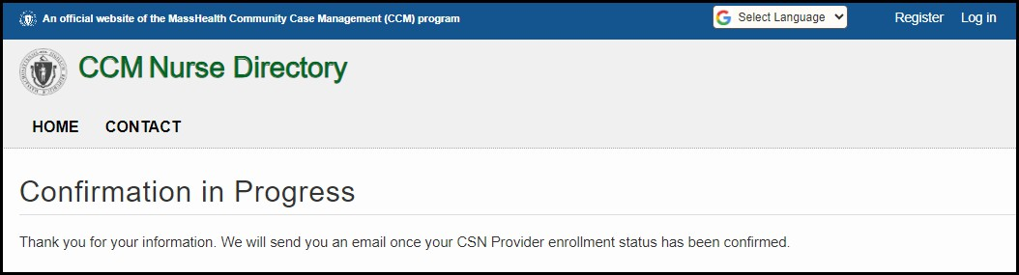

# CCM Member Log In

After the CCM Member authenticates their account, they will be able to log into the CCM Nurse Directory. The CCM Member can use the “Log In” menu item on the upper right corner of the screen or the “Log In” menu item on the bottom of the screen to log into the CCM Nurse Directory.

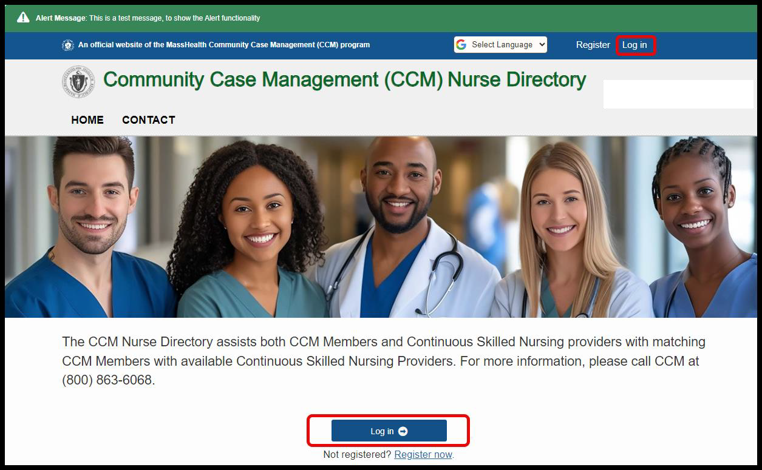

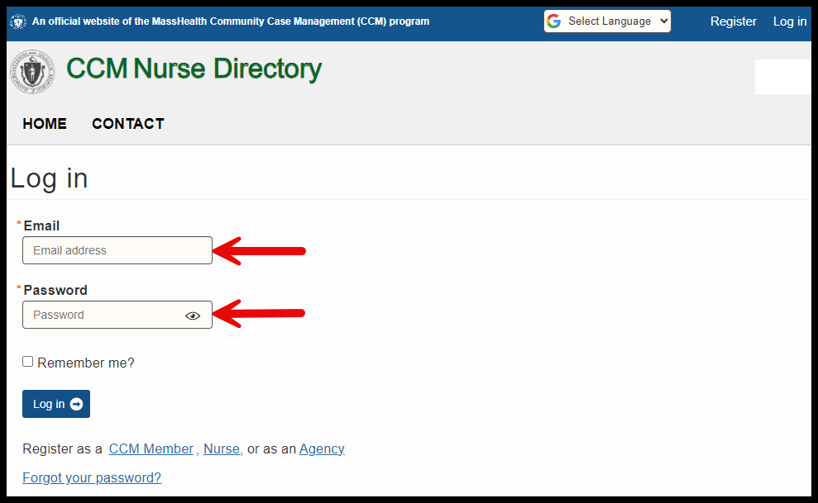

The CCM Member needs to use the email address and password that they entered at the time of registration.

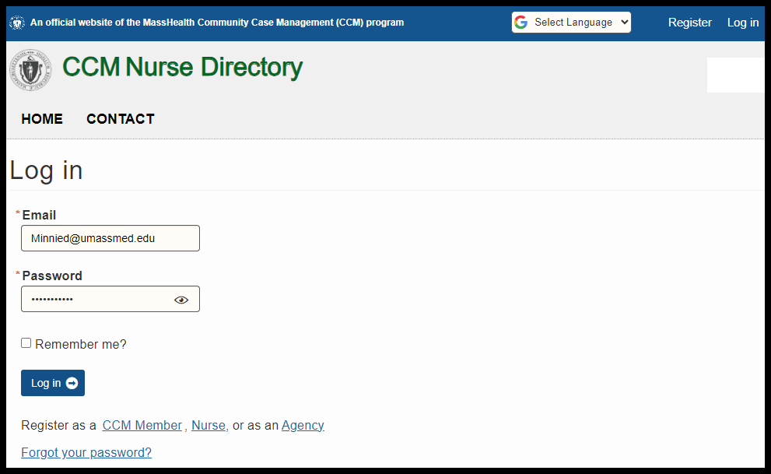

Once logged in, the CCM Member will be brought to the CCM Member home page.

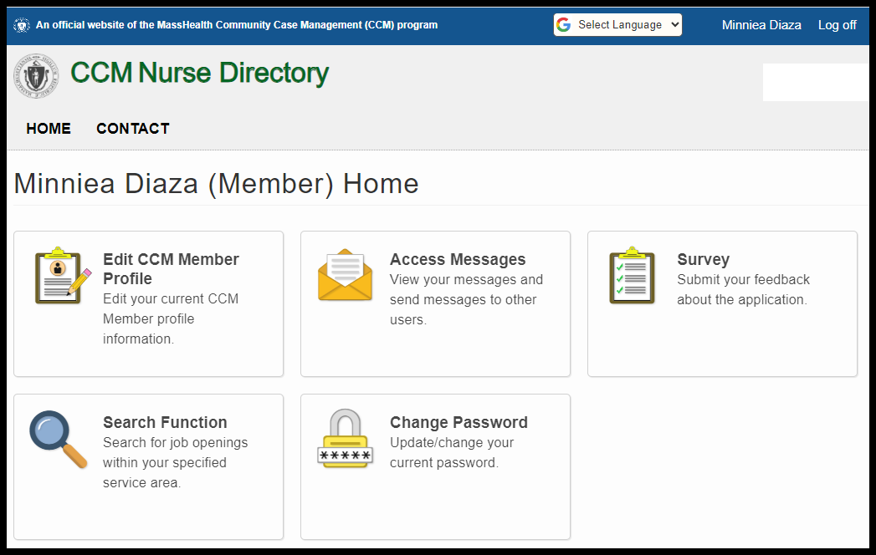

# Forgot Password

If the CCM Member does not remember their password, they can click on “Forgot your password?” on the “Log in” page.

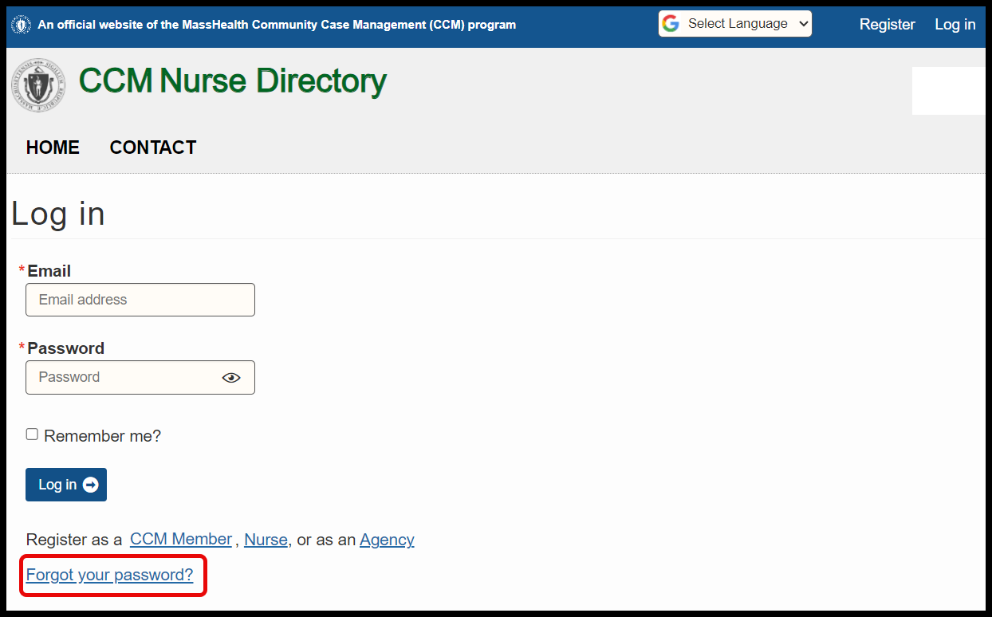

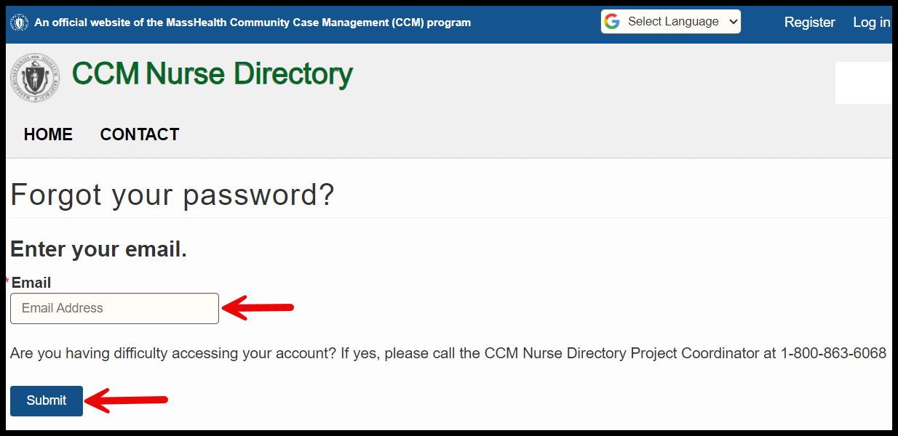The CCM Member will enter the email address for their registration and click the “Email Link” button.

The CCM Member will be brought to the “Forgot Password Confirmation” screen and will receive an email to reset their password.

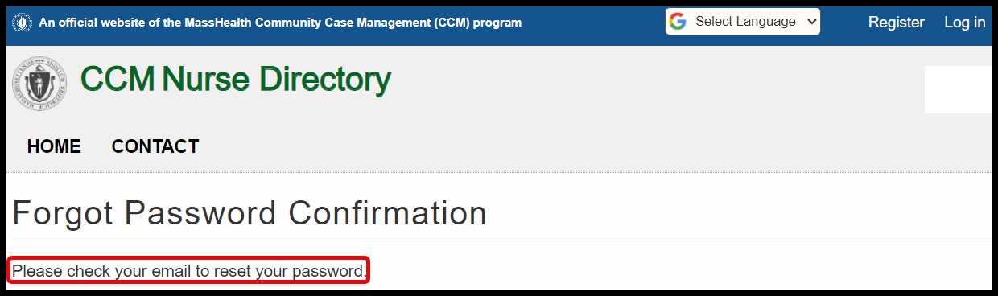

# CCM Member Landing Page

When a CCM Member logs into the CCM Nurse Directory, they will be brought to the CCM Member home page. The five functions that can be performed using this page are: “Edit CCM Member Profile,” “Access Messages,” “Survey”, “Search Function, and “Change Password”.



# Edit CCM Member Profile

The first time the CCM Member selects the “Edit CCM Member Profile” option, the

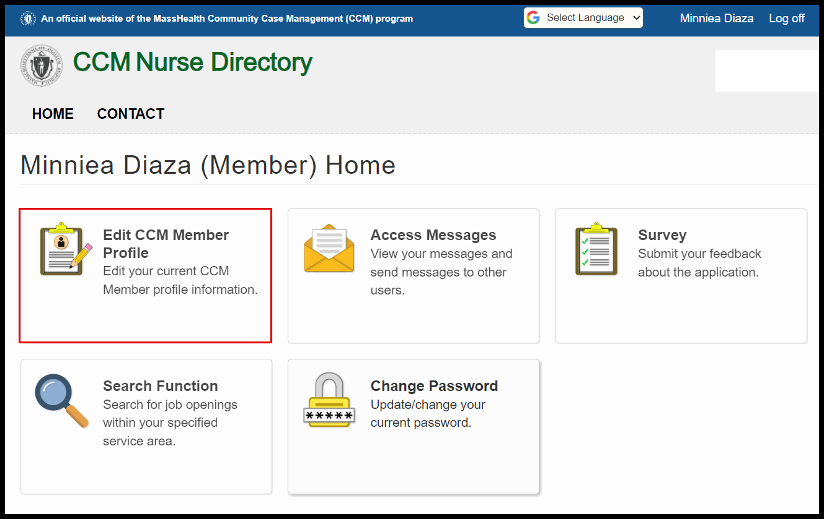“Member Demographics” screen will appear and will need to be populated.

The required fields have a red asterisk “*.”

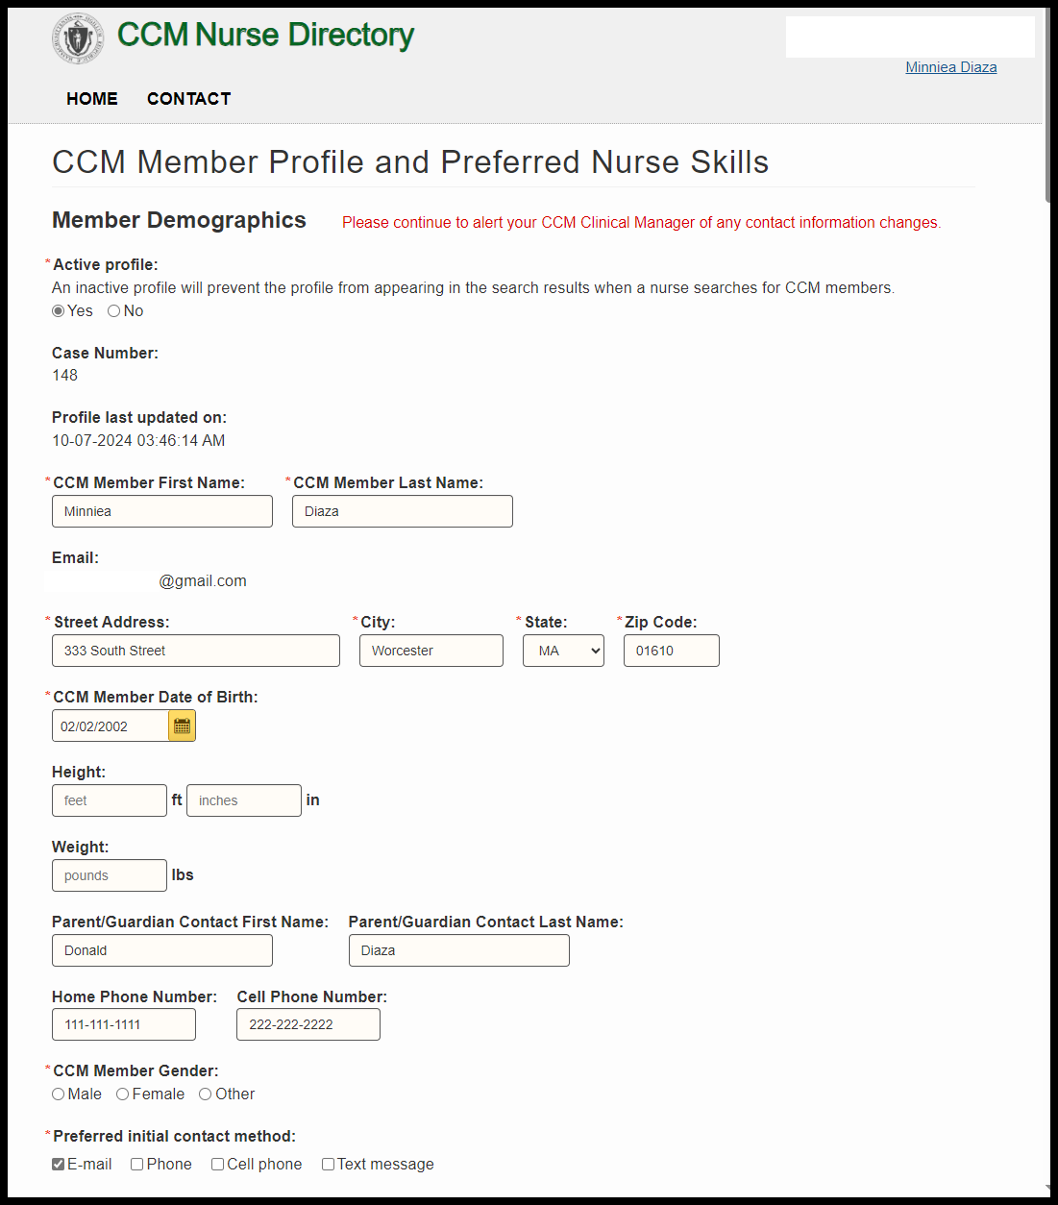

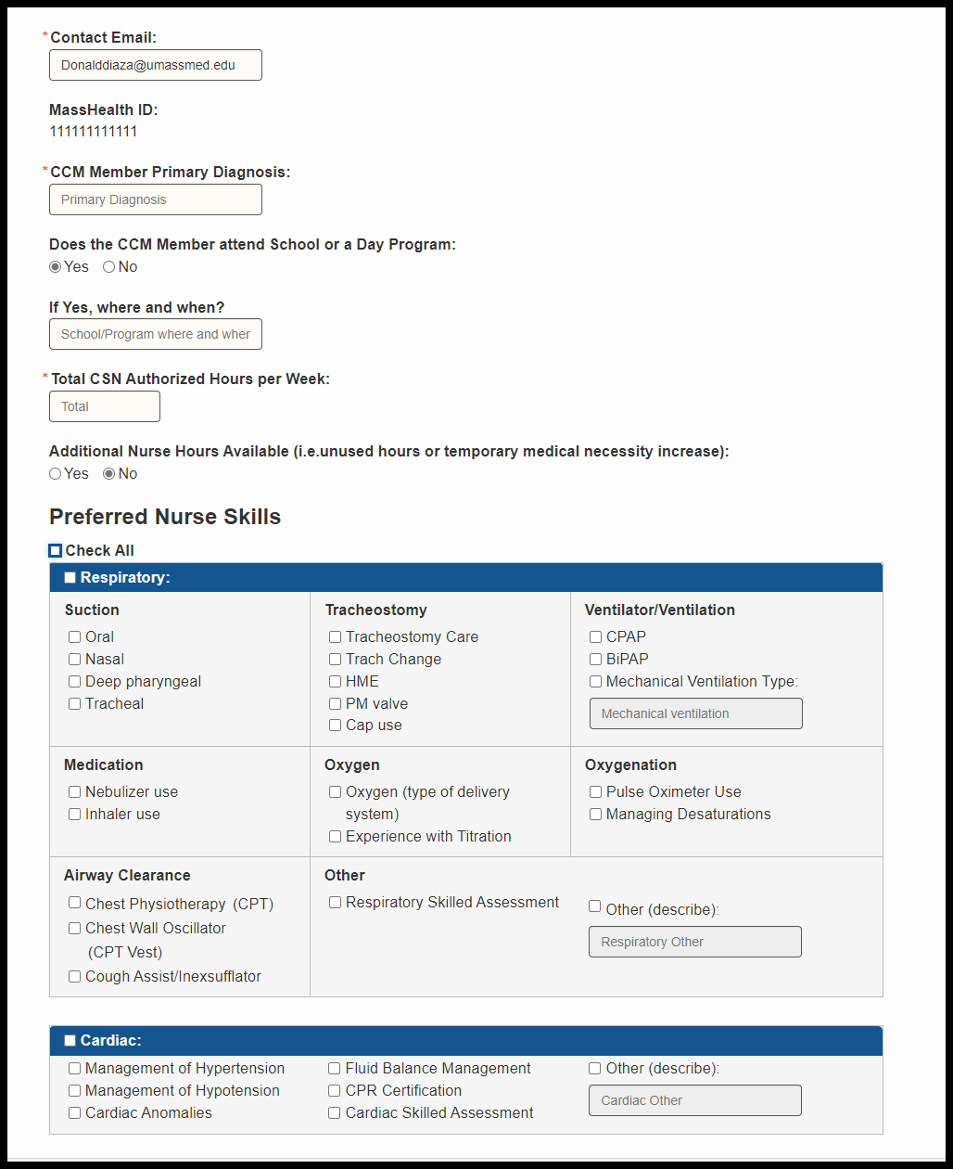

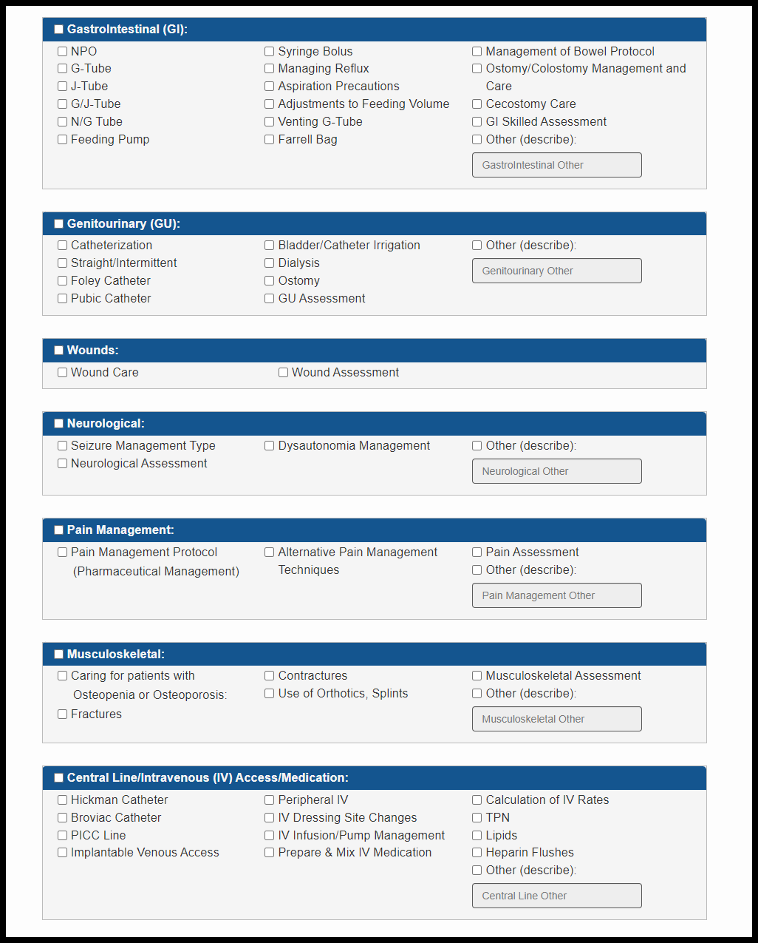

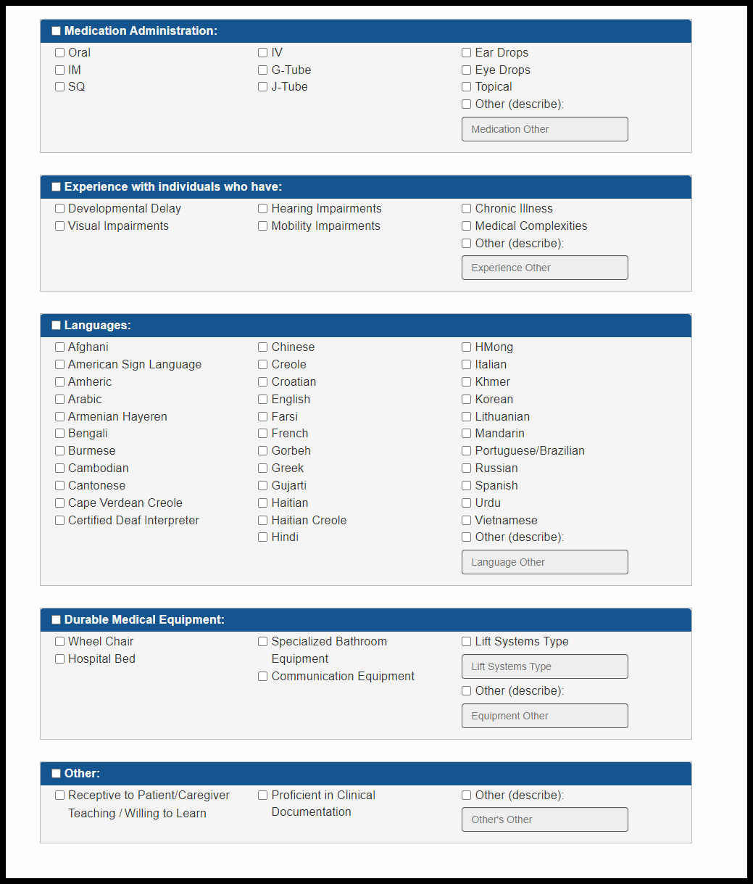

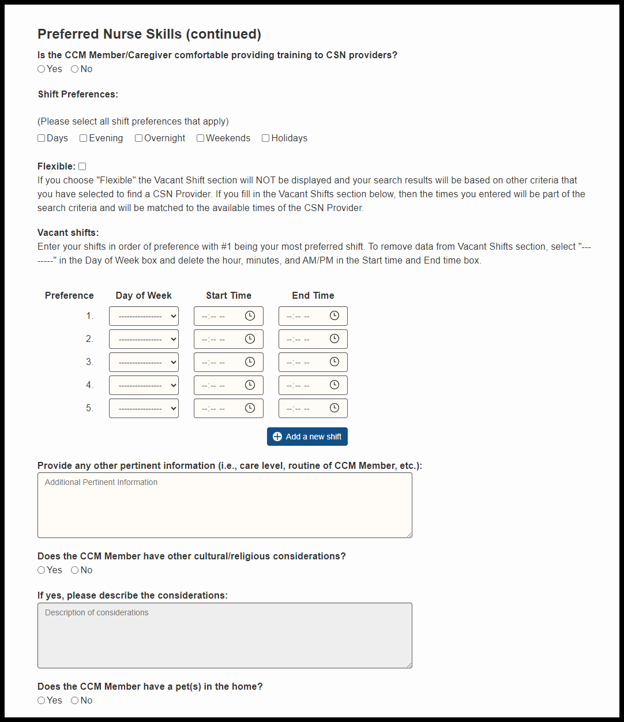

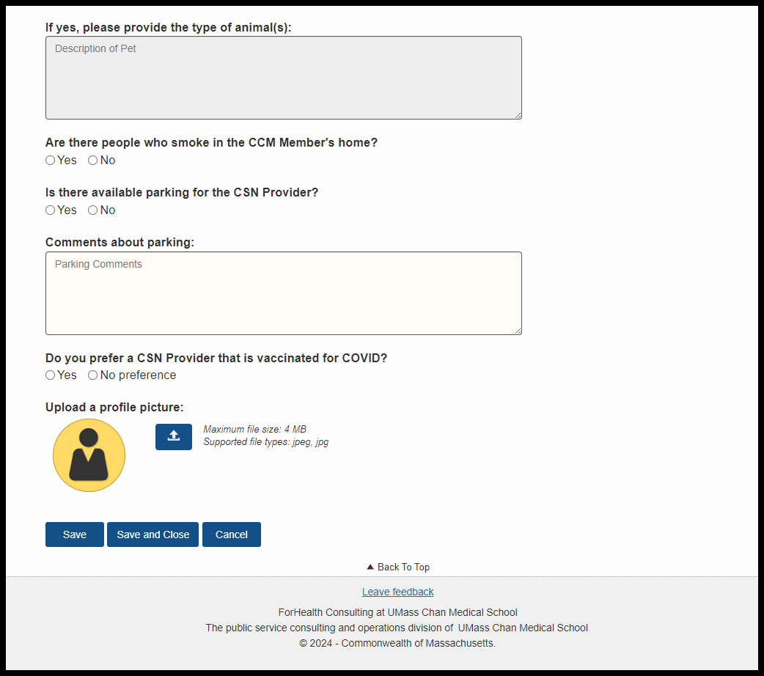

## Helpful Hints

* The CCM Member needs to select at minimum one (1) skill within the Preferred Nurse Skills section to perform a search.
* The CCM Member profile needs to be approved by the CCM team PRIOR to performing a search.
* If the “No” button for “Active Profile” has been selected, the CCM Member Profile WILL NOT appear in the search results for CSN Providers.
* The application will provide messages if there is any information that needs to be populated. For example, if the CCM Member clicks “Mechanical Ventilation Type,” “Other” or “Lift Systems Type” in the CSN Skills table without entering data in the required text box, the system will prompt the user to do so.

After completing and saving the CCM Member Profile, when the CCM Member logs into the CCM Nurse Directory, and selects the “Edit CCM Member Profile” option on the home page, the CCM Member will be brought to the completed CCM Member profile.

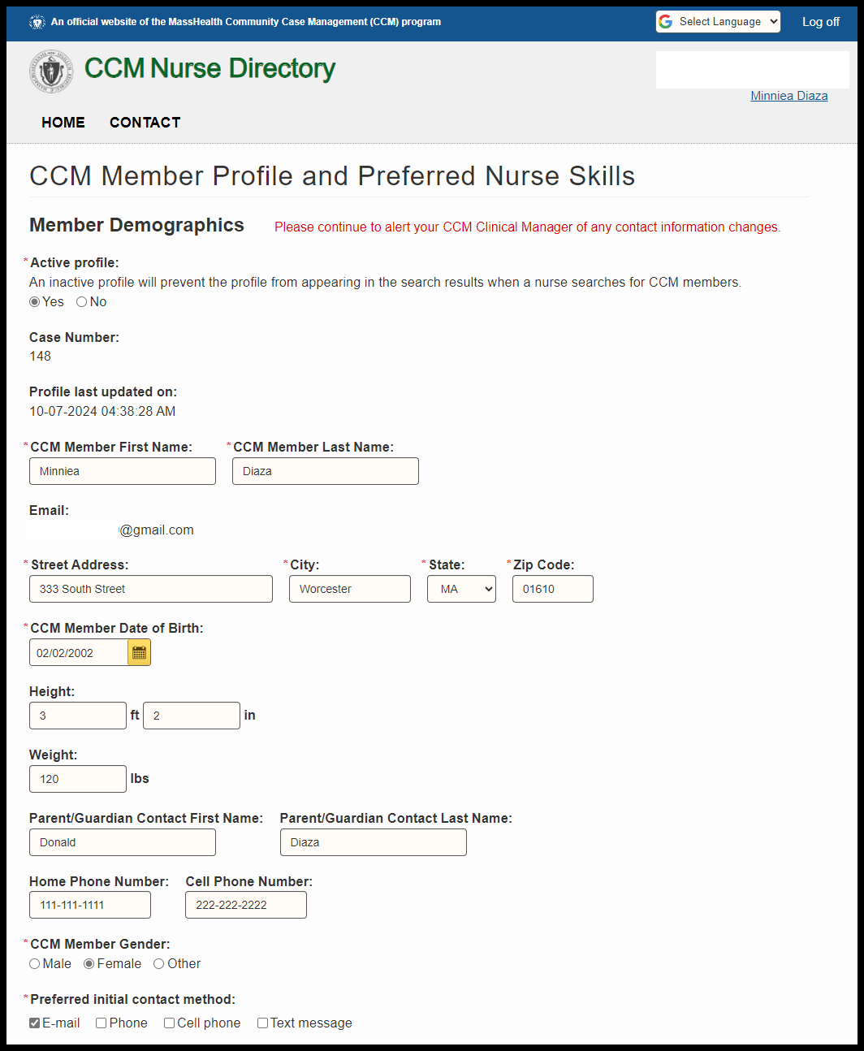

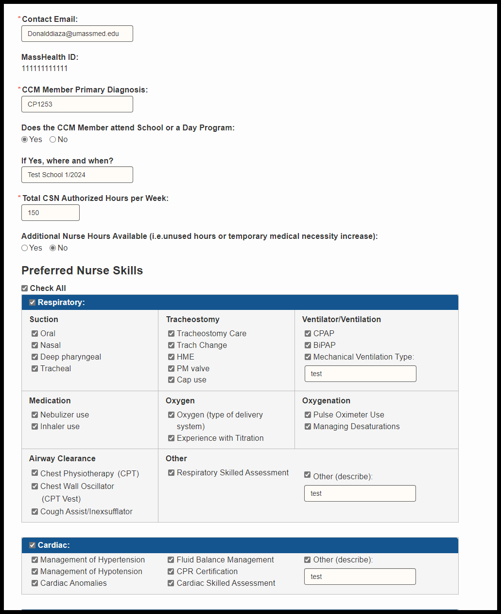

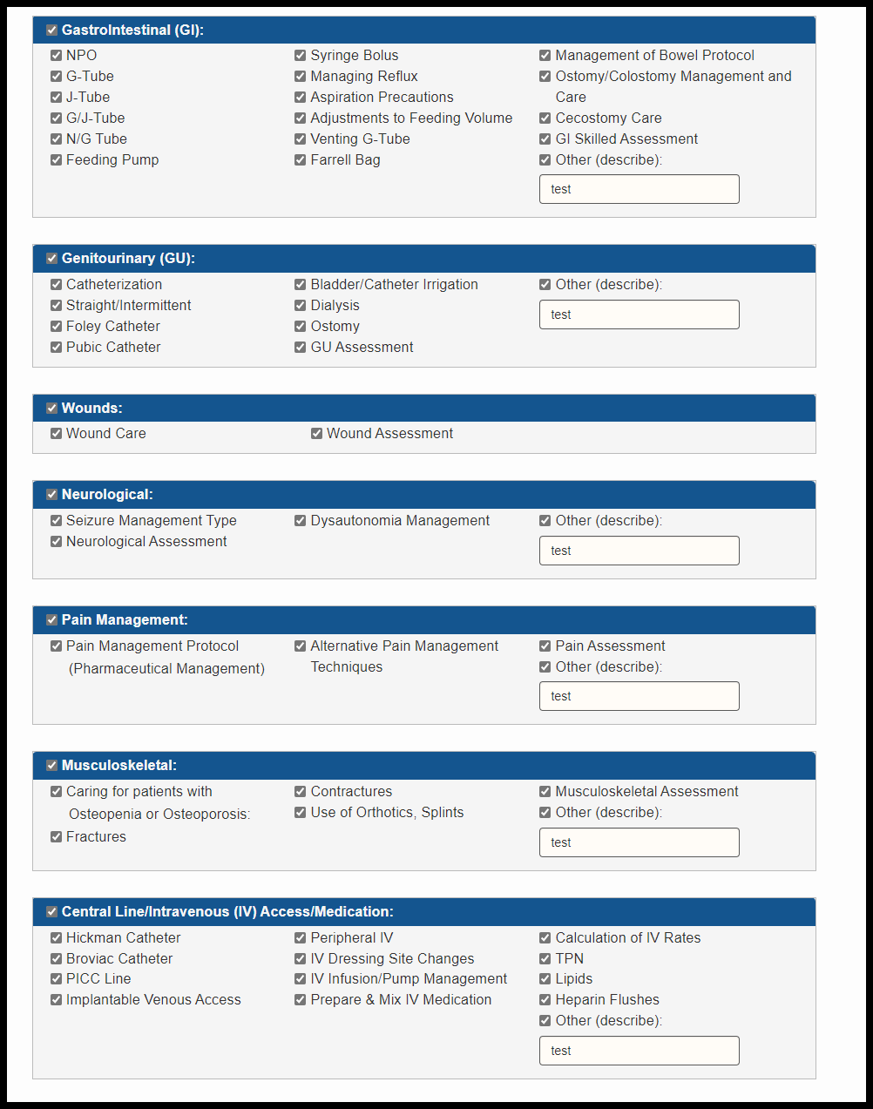

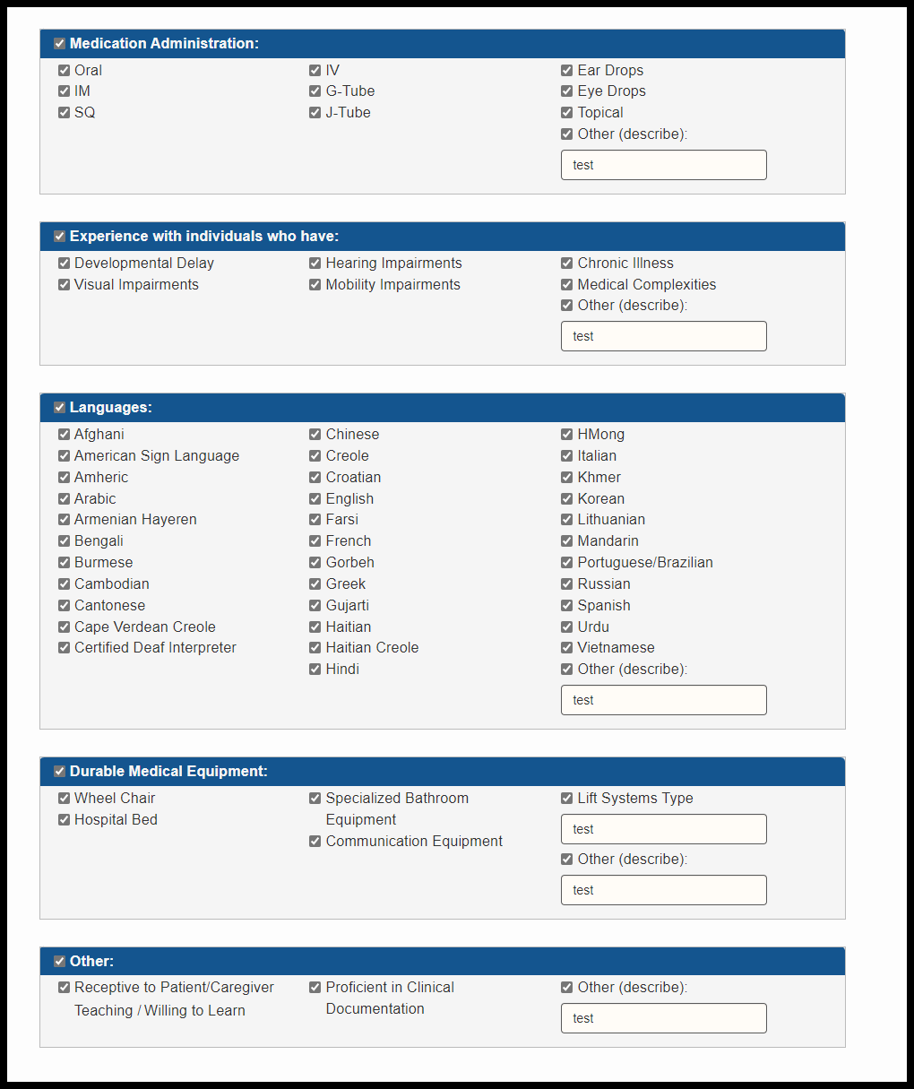

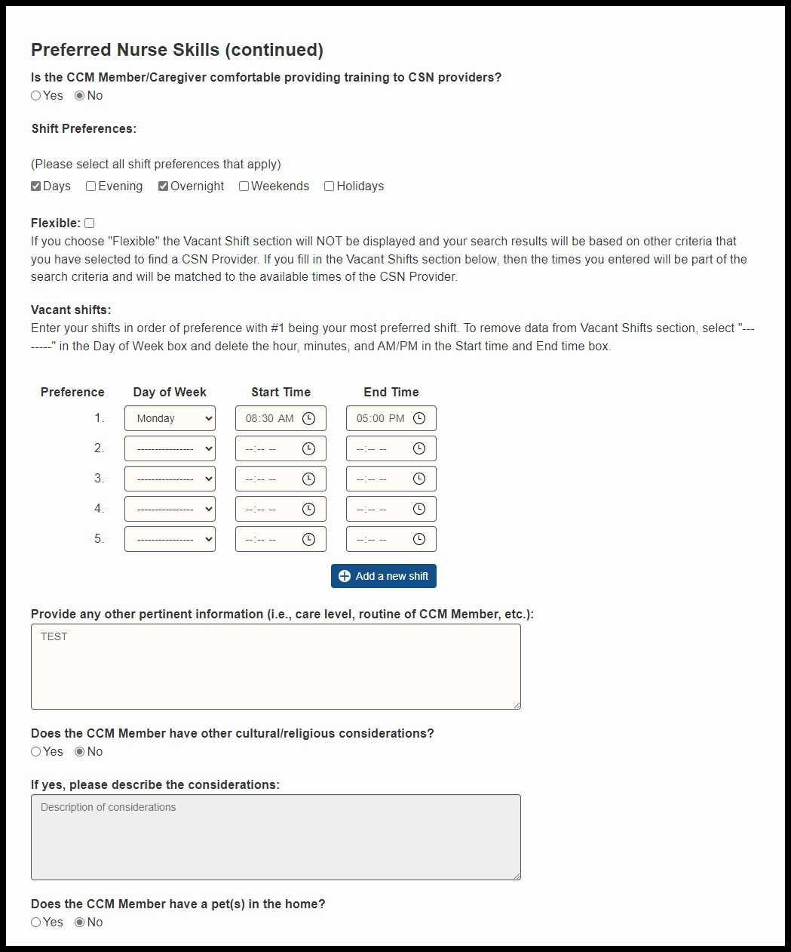

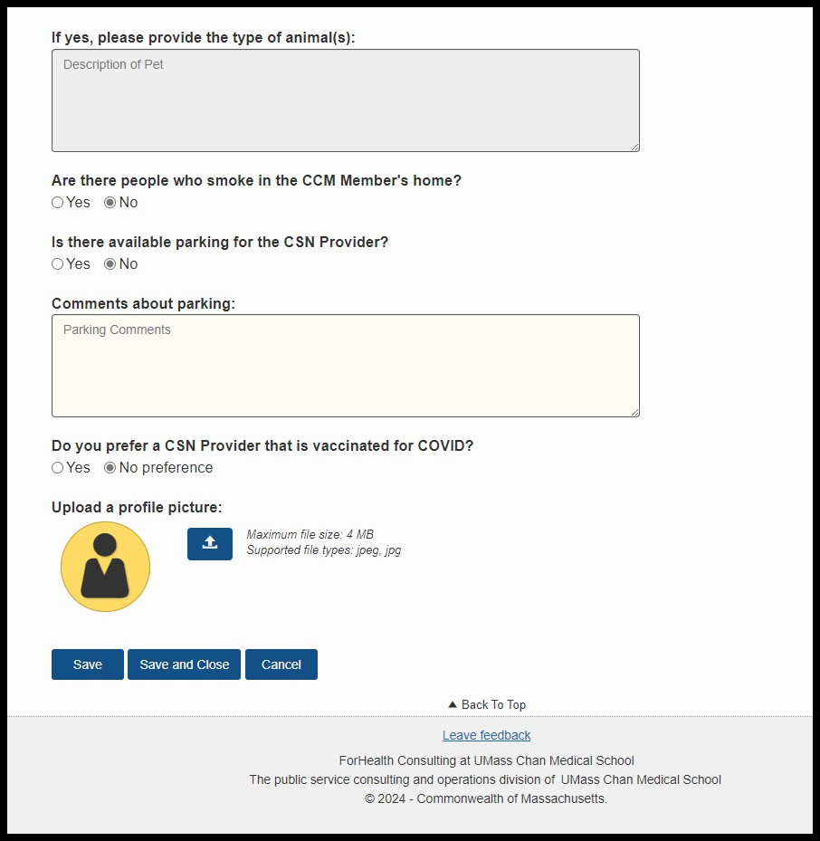

While in the profile, the CCM Member can edit any of the fields within the profile and click the “Save” or “Save and Close” button to save all changes. The CCM Member can also click on “Cancel” to discard any changes they made to the profile.

# Home Function

By selecting “Home,” the CCM Member will be brought back to the CCM Member home page.

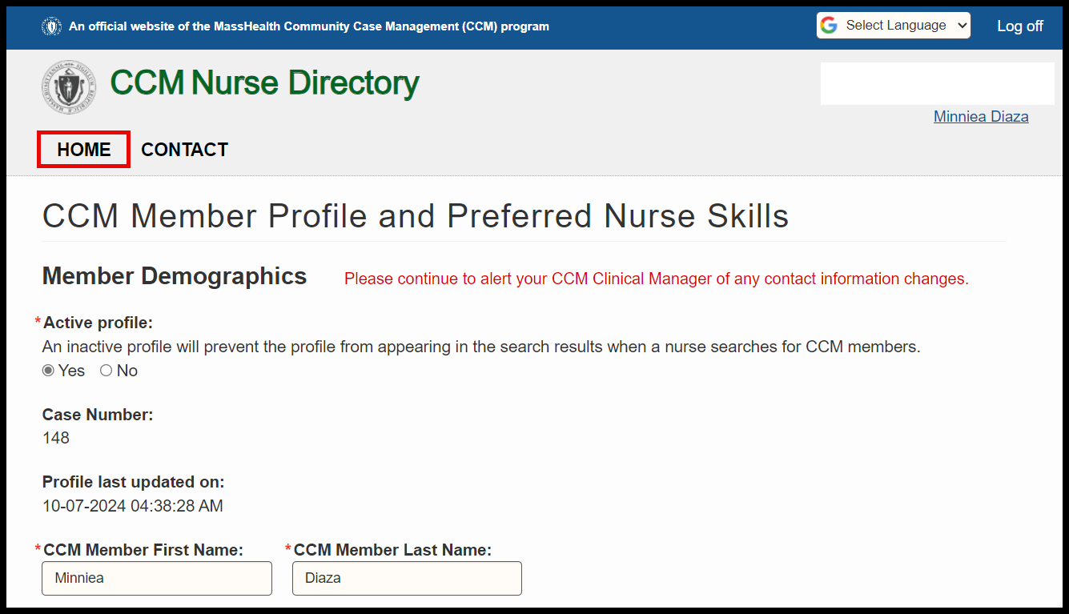

# Search Function

Once the CCM Member profile has been approved by the CCM Project Coordinator, the CCM Member may use the Search Function to search for CSN Providers by clicking on “Search Function”.

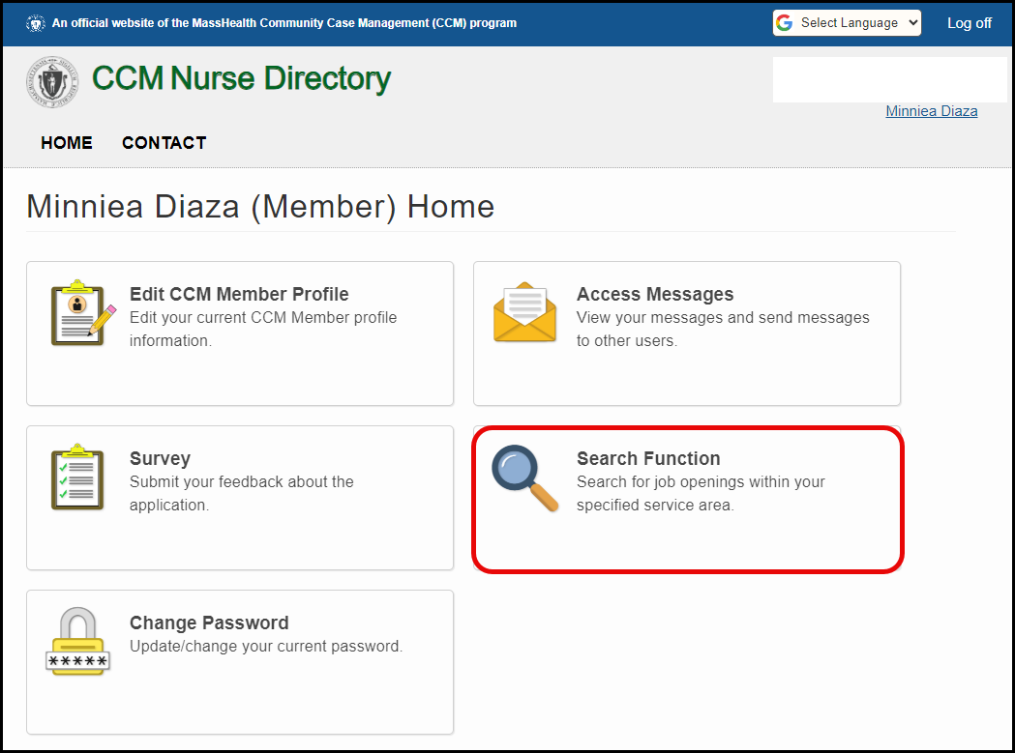

By clicking on the Search Function, search criteria will show along with any results that match the criteria listed.

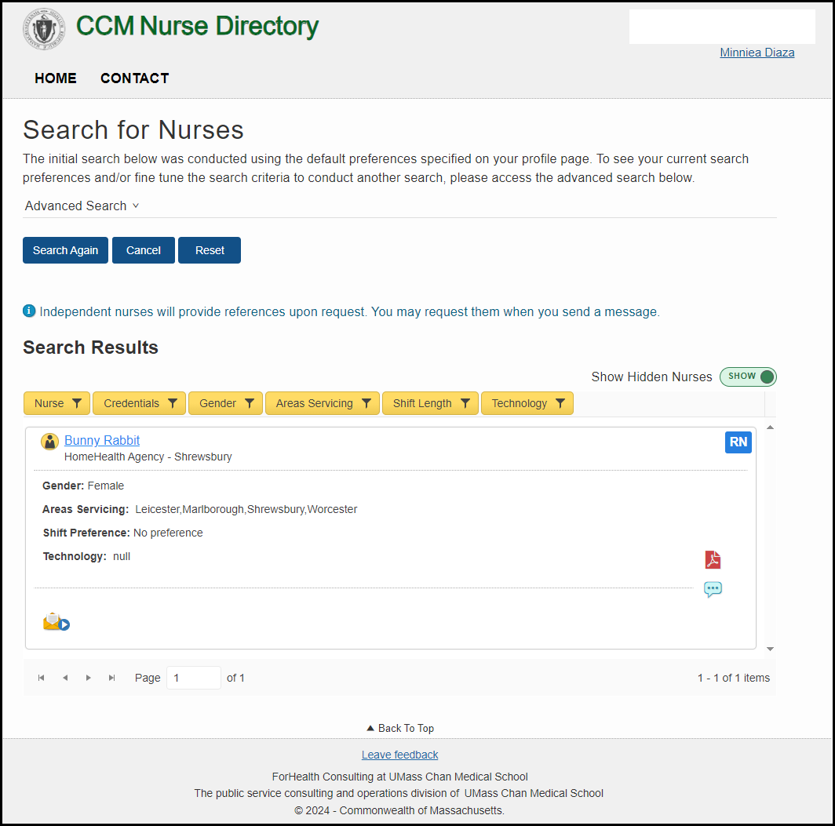

If the CCM Member gets minimal results or Search Results displays zero, the CCM Member can adjust the search criteria by clicking on the dropdown arrow for “Advanced Search”.

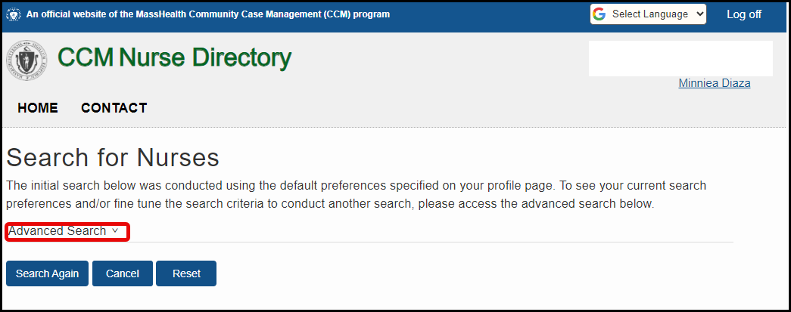

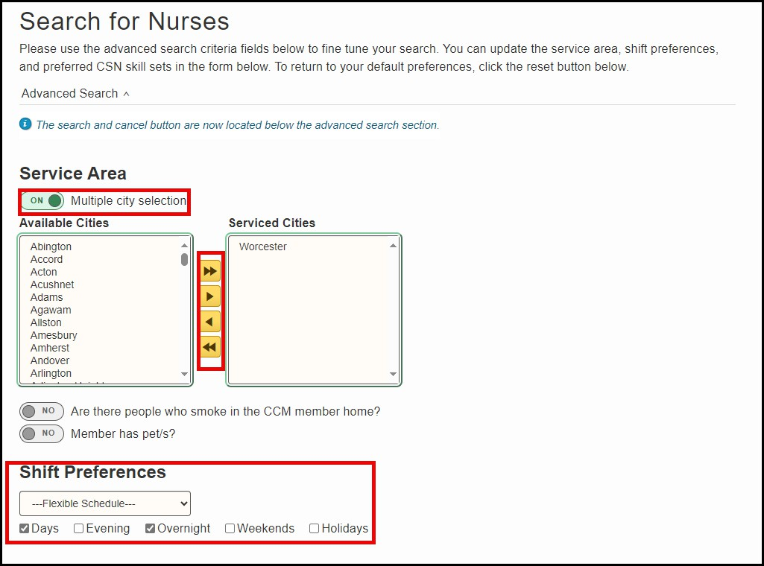Using the arrows highlighted in orange, the CCM member can edit their Service Area by selecting one or more cities from the Available Cities box and moving them to the Serviced Cities box. Shift preferences can also be edited by selecting “Flexible Schedule” or a schedule from the dropdown list and/or by checking/unchecking any of the shift checkboxes.

CSN Skills Set Preferences may be edited by:

* Selecting the “Skill Search Type” of “Match any skills” or “Match exact skills”.
* Checking/unchecking the “Select all CSN skill sets” checkbox.
* Checking/unchecking any of the main skill sets, i.e. Respiratory, Cardiac, etc.
* Removing any of the existing skill sets by clicking on the “x” next to each label.

Once the fields are updated, the CCM member can click “Search Again” to get the new results, “Cancel” to cancel any changes, or “Reset” to reset all of the data on this page.

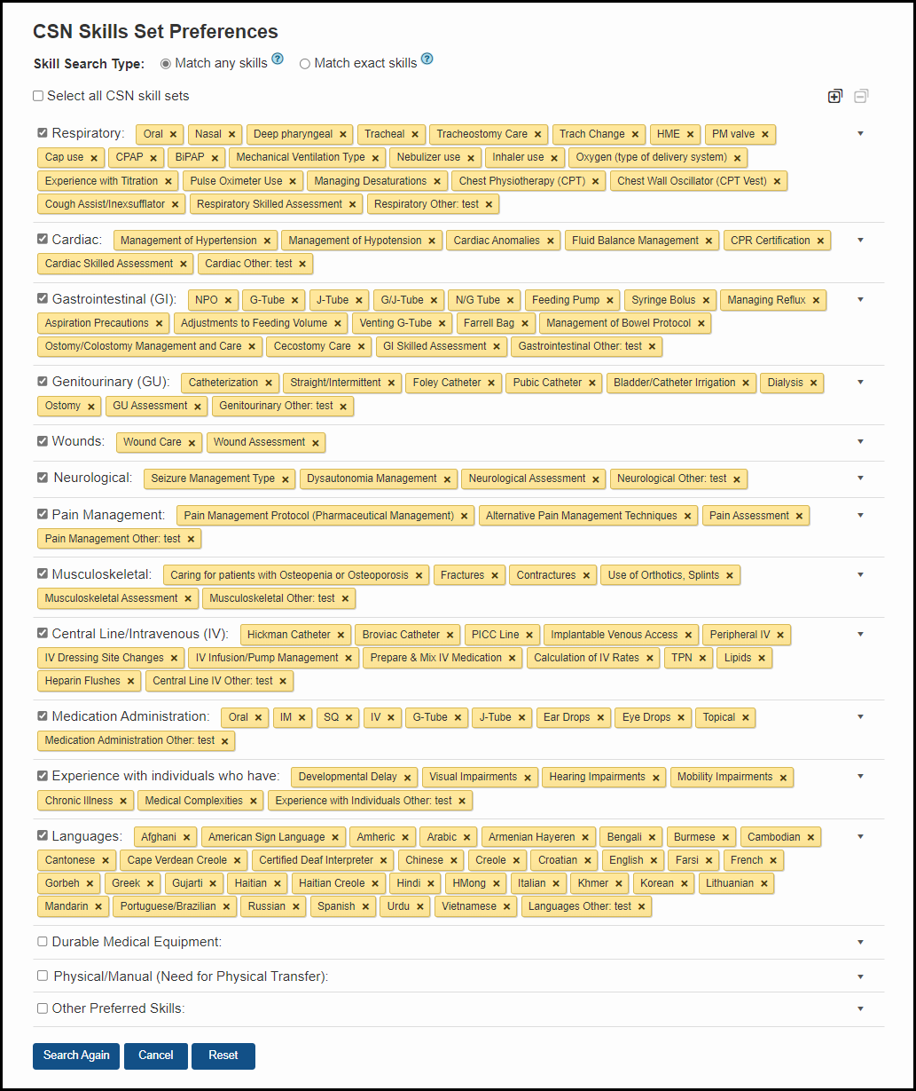

Upon clicking on “Search Again”, the CCM member will see any matches under the “Search Results” section.

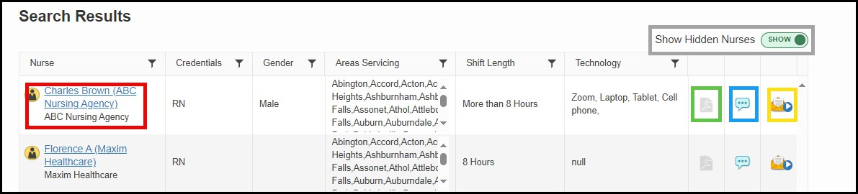

## Helpful Hints

* The CCM member can show or hide any provider they have selected to hide from search results by using the “Show Hidden Nurses” slider (outlined in gray).
* The CCM Member can view the Independent Nurse or Agency Nurse profiles by clicking on the Nurse Name hypertext in the search results table (outlined in red).
* The CCM Member can click and open an attached resume (outlined in green).
* The CCM Member can enter a private comment (viewable to member only) regarding a

provider by clicking on the “Enter a private comment” icon (outlined in blue).

* The CCM Member can send a message to the CSN Provider by clicking on the “Send Private Message” envelope icon in the search results table (outlined in yellow).

The CCM member can view the Independent Nurse or Agency Nurse profile by clicking on the Nurse Name hypertext in the search results table (outlined in red).

When viewing the Nurse profile, the CCM member can also view the Independent Nurse or Agency Nurse resume (if uploaded) by clicking on the uploaded document link.

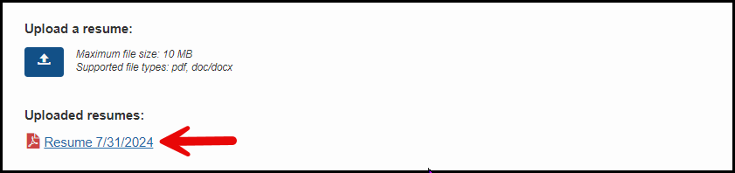

The CCM member can also hide a nurse from their search results by clicking on the “Hide Nurse from Search Results” checkbox and add a comment within the “Comment” text box that is only viewable by the CCM member.

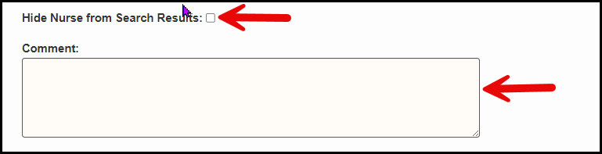

## Sending Private Message

The CCM Member can contact an Independent Nurse or Agency using the “Send Private Message” icon in the results table (outlined in yellow). The message will go to that specific independent nurse or agency.

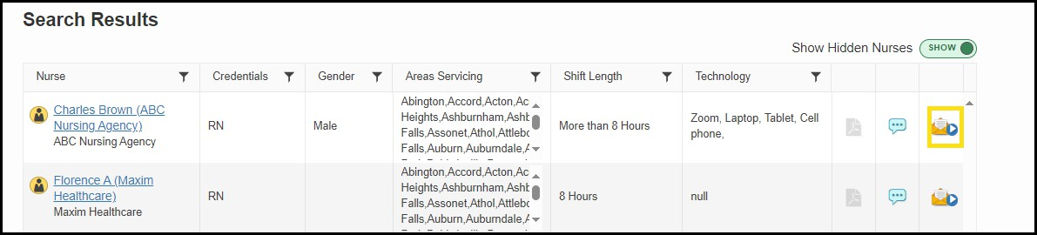

When the CCM Member clicks on the “Send Private Message” icon, the “Send Private Message” screen will appear with the providers name in the “Subject” field. The CCM Member will enter text in the message text box and click the “Send” button.

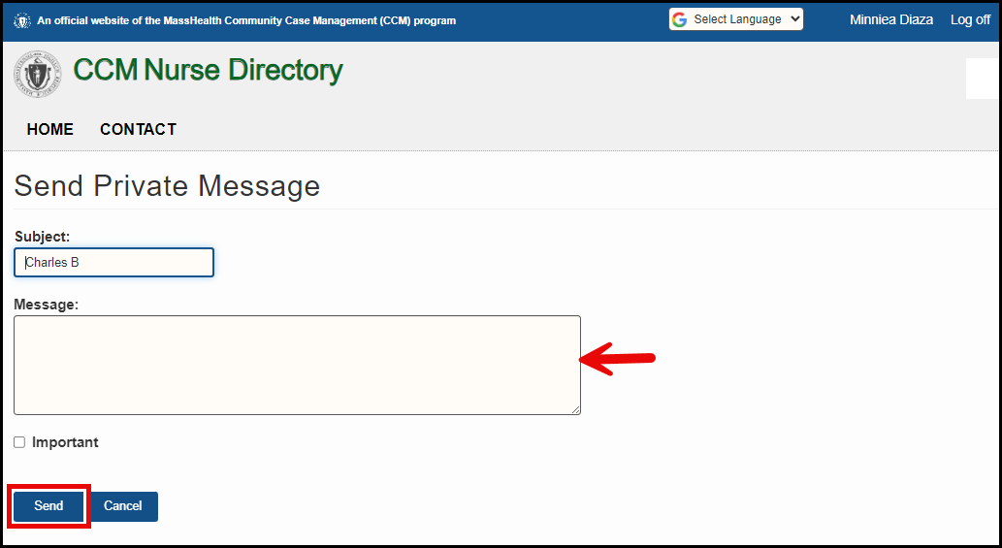

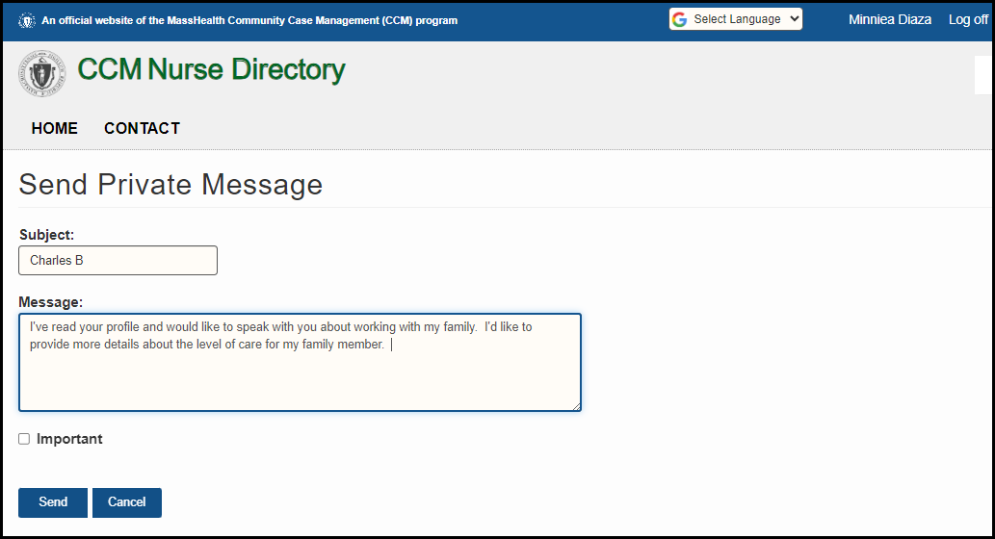Example:

The message will be sent to the CSN Provider, and a confirmation message will appear. The CSN Provider will receive email notification that a message is waiting for their response in the CCM Nurse Directory.

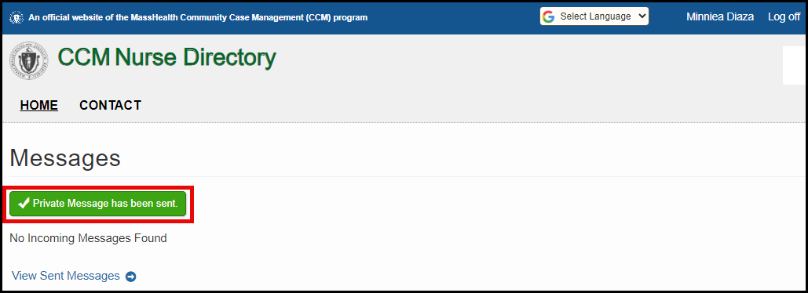

# Access Messages

Members can click on “Access Messages” to view messages that have been sent to/from a CSN Provider.

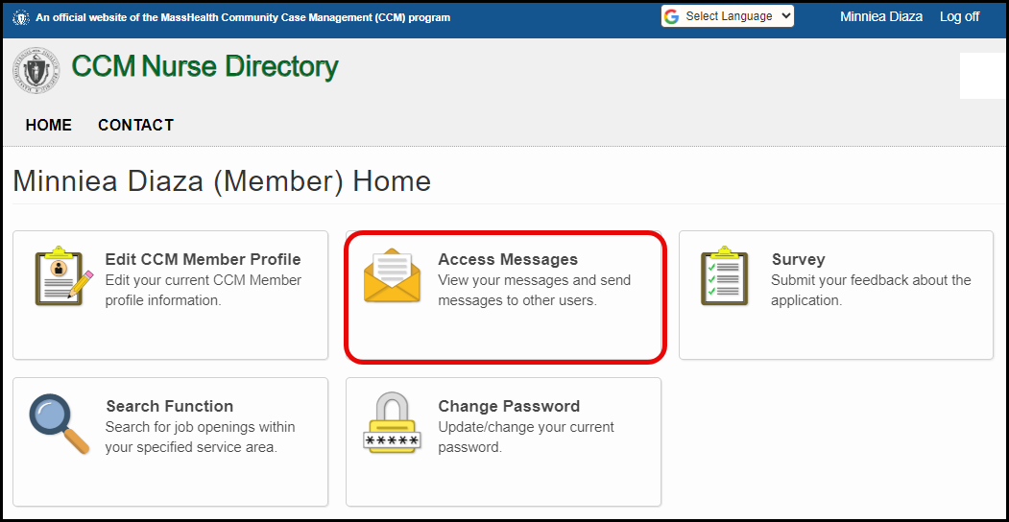

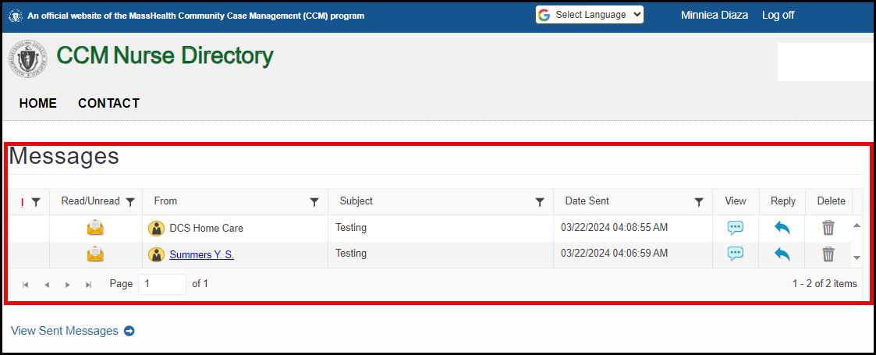

CCM Members have three (3) options for received messages: “View,” “Reply,” or “Delete.”

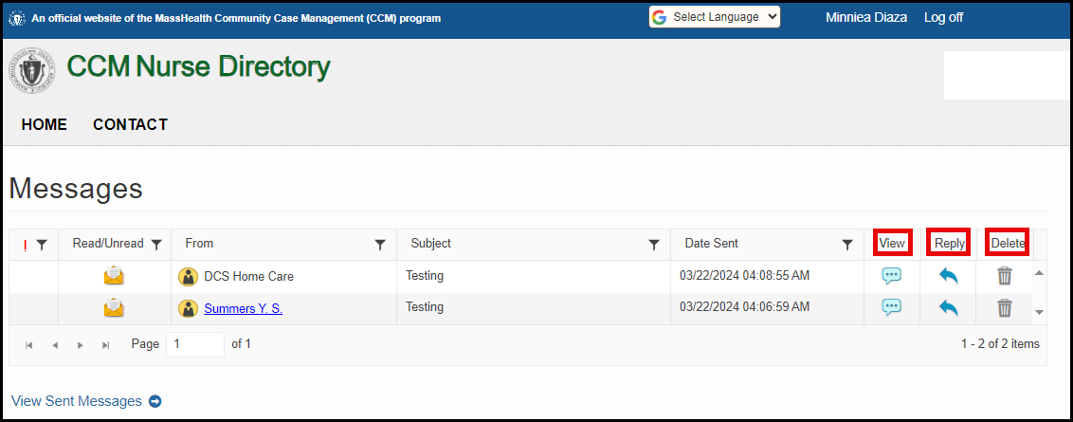

When the CCM Member selects the “View” button, the message will open and the CCM Member can read the message and have the option to “Reply”, “Decline” or “Return to Messages”. When the CCM Member clicks on the “Return to Messages” hypertext, they will be returned to the “Messages” screen.

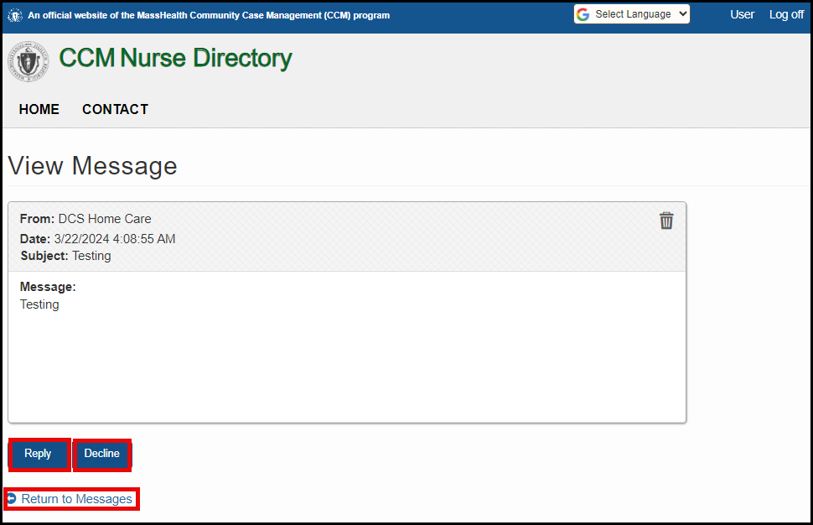

When the CCM Member selects “Reply,” the “Message Reply” screen will be displayed, and the CCM Member can enter a subject, message and click “Send” to reply. However, if the CCM Member selects the “Reply” button in error, they can select the “Cancel” button and be returned to the “View Message” screen.

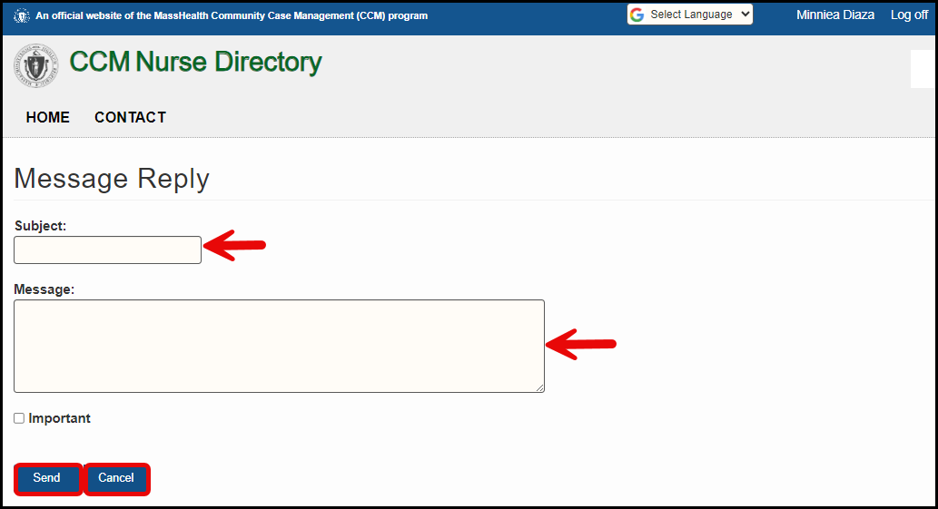

The CCM Member can select the “View Sent Message(s)” button to view the messages that they sent to CSN Providers.

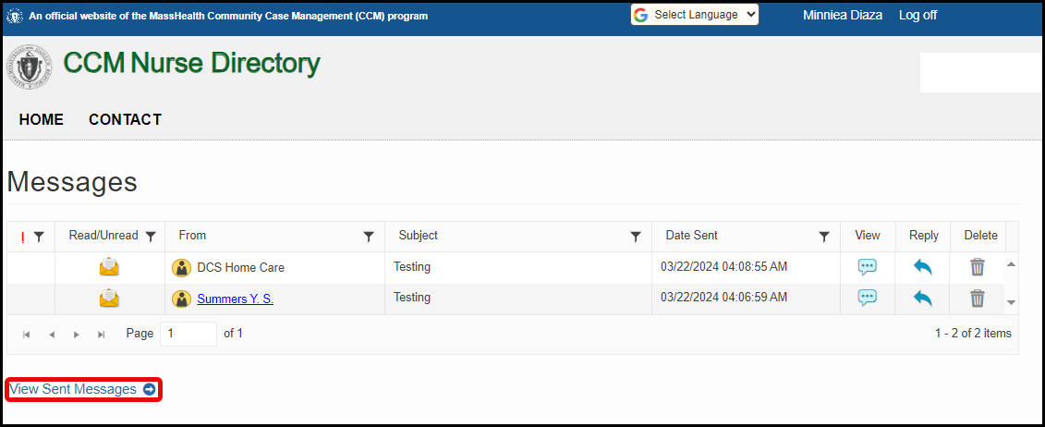

If the CSN Provider has viewed the message, an open envelope icon is displayed within the Read/Unread column. Messages that have not been read will display a closed envelope icon.

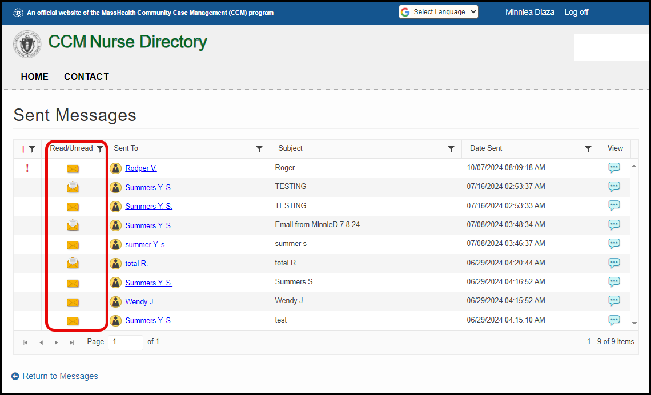

From the Messages screen, the CCM Member can delete a message by clicking on the “Delete”

trash can icon displayed in the “Delete” column for that particular provider.

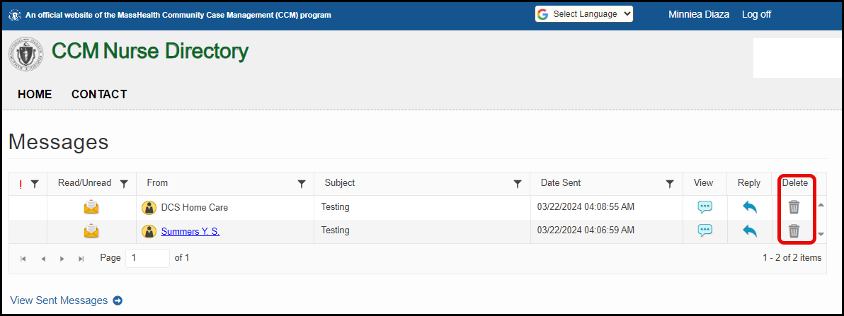

A confirmation message will appear to ask if the CCM Member wants to delete the message.

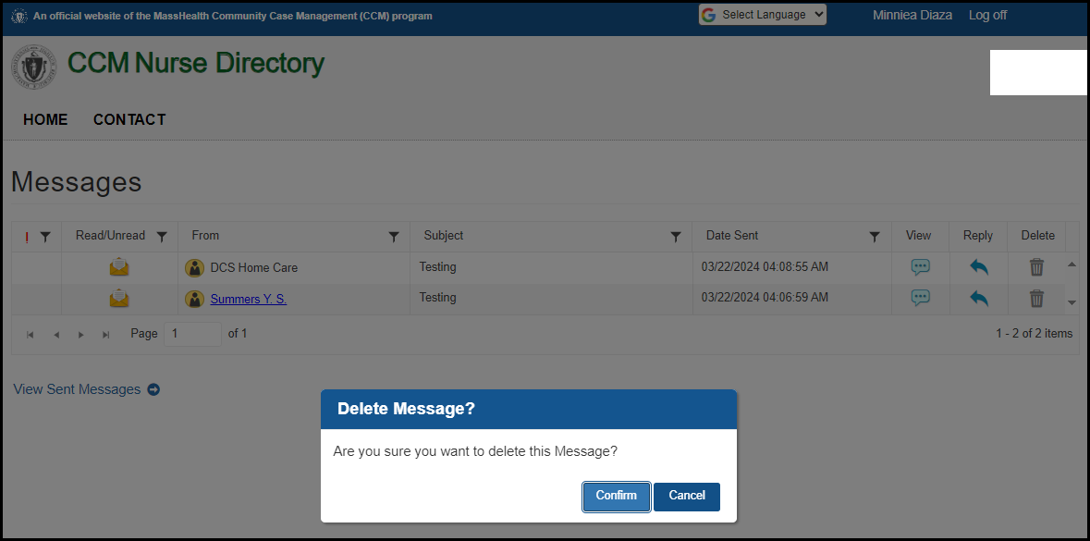

If the CCM Member selects the “Confirm” button, the message will be deleted, and a confirmation of deletion will appear on the “Messages” screen.

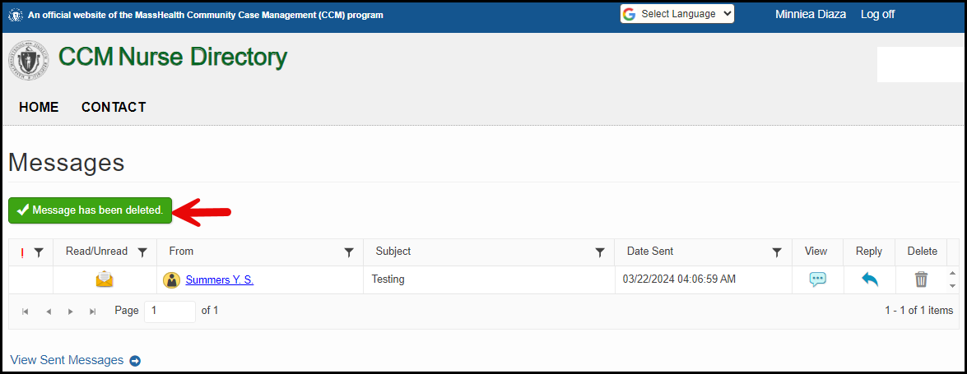

# Change Password

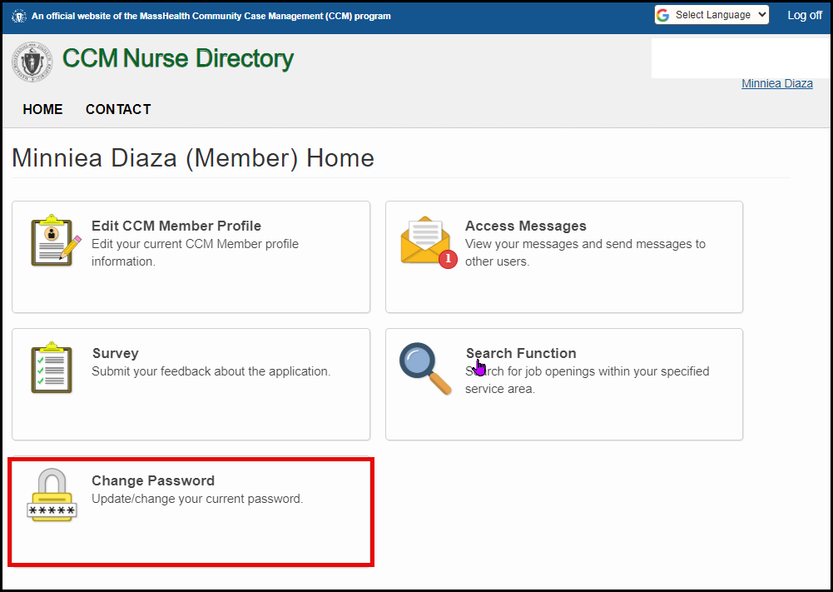The CCM Member can change their password by clicking on “Change Password”.

The “Change Password” screen will display and the CCM Member will enter the required fields: “Current password,” “New password,” and “Confirm new password,” then click on the “Change password” button or “Cancel” to return to the home page.

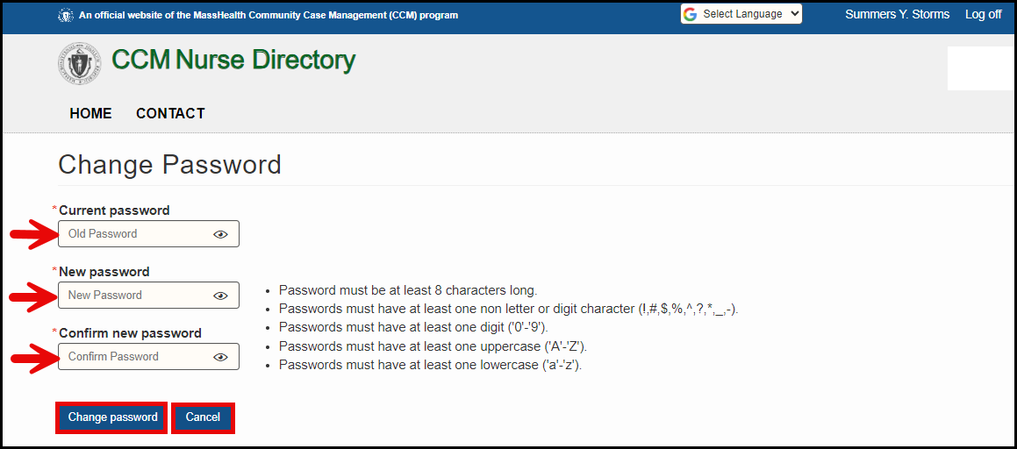

# Survey

The CCM Member can complete a survey by clicking on “Survey”.

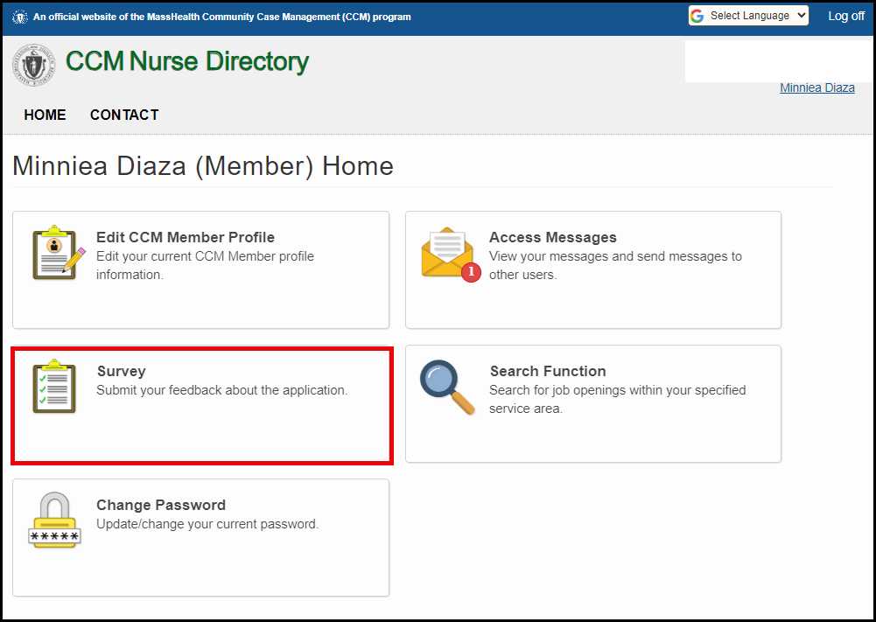

The Survey screen is displayed. The Independent Nurse will answer the questions and click

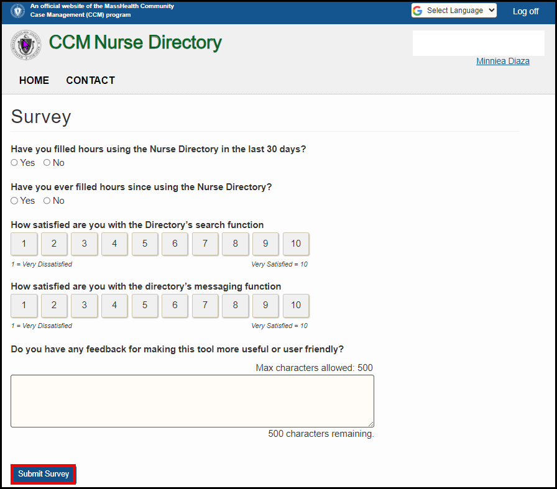“Submit Survey” once completed.

Once the survey is submitted, the CCM Member will see the screen below and will click “Return To

Home” to return to the home page.

