INDOOR AIR QUALITY ASSESSMENT

C.D. Hunking Middle School
98 Winchester Street
Haverhill, MA 01835



Prepared by:
Massachusetts Department of Public Health
Bureau of Environmental Health
Indoor Air Quality Program
October 2008

Background/Introduction
At the request of a concerned parent, the Massachusetts Department of Public Health (MDPH), Bureau of Environmental Health (BEH) provided assistance and consultation regarding indoor air quality concerns at the C.D. Hunking Middle School (HMS), 98 Winchester Street, Haverhill, Massachusetts. The request was prompted by indoor air quality issues and musty odors in the building.
On June 16, 2008, a visit to conduct an assessment was made to the HMS by Susan Koszalka and James Tobin, Environmental Analysts/Inspectors within BEH’s Indoor Air Quality (IAQ) Program. During this assessment, BEH staff were accompanied by Mark Barnes, Head Custodian of the HMS.
On July 25, 2008, Ms. Koszalka and Mike Feeney, Director of BEH’s IAQ Program, returned to HMS to conduct a visual inspection of the building. Ms. Koszalka and Mr. Feeney were accompanied by Jeff Dill, Supervisor of Energy and Maintenance, Haverhill Public Schools.
The HMS is a one-level brick and concrete building constructed in 1959. The school contains general classrooms, an art room, a computer room, gymnasium, kitchen, cafeteria/auditorium, library, music room and office space. The school consists of three wings: 6th and 7th grade classrooms; 7th and 8th grade classrooms; and the cafetorium and music room. A catwalk connects the two classroom wings to the cafeteria/auditorium (Map 1). The gymnasium is at the end of the 7th and 8th grade hallway.
The roof was completely replaced in the early 1990s with polyvinyl chloride (PVC) material. In 2007, there was a steam leak in the 6th and 7th grade classroom wing. At the time of the repairs to address the steam leak, univents were examined and the overall airflow capacity of each unit was increased.

Methods
Air tests for carbon monoxide, carbon dioxide, temperature and relative humidity were conducted with the TSI, Q-Trak, IAQ Monitor, Model 7565. Air tests for airborne particle matter with a diameter less than 2.5 micrometers were taken with the TSI, DUSTTRAK™ Aerosol Monitor Model 8520. BEH staff also performed visual inspection of building materials for water damage and/or microbial growth.

Results
The HMS houses approximately 450 students in grades 6 through 8 and approximately 45 staff members. The tests were taken during normal operations at the school and results appear in Table 1.

Discussion
Ventilation
It can be seen from Table 1 that carbon dioxide levels were above 800 parts per million (ppm) of air in 21 of 31 areas surveyed, indicating poor air exchange in the majority of areas at the time of the assessment. Elevated levels of carbon dioxide were largely the result of deactivated mechanical ventilation equipment. It is also important to note that several classrooms had open windows and/or were empty/sparsely populated. Each of these factors can result in reduced carbon dioxide levels. Carbon dioxide levels would be expected to increase with full occupancy and windows closed.
Fresh air in classrooms is supplied by a unit ventilator (univent) system (Figure 1). Univents draw air from outdoors through a fresh air intake located on the exterior walls of the building and return air through an intake located at the base of each unit. The mixture of fresh and return air is drawn through a filter and heating coil, and is then expelled from the univent by motorized fans through fresh air diffusers. Univents were found obstructed by papers, books, furniture and other stored materials (Table 1). Further, a heavy buildup of dust and debris was observed in the air diffusers of several univents. In order for univents to provide fresh air as designed, air diffusers, intakes and returns must remain free of obstructions. Importantly, these units must remain “on” and be allowed to operate while rooms are occupied.
As previously mentioned, there was a steam leak in the 6th and 7th grade wing in 2007. Classroom and hallway walls, ceilings and floors damaged by the steam leak were repaired. At that time, the overall airflow capacity of each univent was increased from 400-500 CFM (cubic feet per minute) to approximately 700 CFM. There was no evidence of a steam leak at the time of the MDPH assessment.
Exhaust ventilation in classrooms is provided by wall-mounted vents ducted to rooftop motors (Picture 1). Several exhaust vents were found blocked by newspapers and other items. In addition, exhaust ventilation was found deactivated in a number of areas during the assessment (Table 1). As with univents, in order to function properly, exhaust vents must be activated and allowed to operate while rooms are occupied. Without adequate supply and exhaust ventilation, excess heat and environmental pollutants can build up leading to indoor air/comfort complaints.
To maximize air exchange, the MDPH recommends that both supply and exhaust ventilation operate continuously during periods of school occupancy. In order to have proper ventilation with a mechanical supply and exhaust system, the systems must be balanced to provide an adequate amount of fresh air to the interior of a room while removing stale air from the room. It is recommended that HVAC systems be re-balanced every five years to ensure adequate air systems function (SMACNA, 1994). According to a school department official, the date of the last balancing of these systems was in 1959.
The Massachusetts Building Code requires a minimum ventilation rate of 15 cubic feet per minute (cfm) per occupant of fresh outside air or have openable windows in each room (SBBRS, 1997; BOCA, 1993). The ventilation must be on at all times that the room is occupied. Providing adequate fresh air ventilation with open windows and maintaining the temperature in the comfort range during the cold weather season is impractical. Mechanical ventilation is usually required to provide adequate fresh air ventilation.
Carbon dioxide is not a problem in and of itself. It is used as an indicator of the adequacy of the fresh air ventilation. As carbon dioxide levels rise, it indicates that the ventilating system is malfunctioning or the designated occupancy of the room is being exceeded. When this happens, a buildup of common indoor air pollutants can occur, leading to discomfort or health complaints. The Occupational Safety and Health Administration (OSHA) standard for carbon dioxide is 5,000 parts per million parts of air (ppm). Workers may be exposed to this level for 40 hours/week, based on a time-weighted average (OSHA, 1997).
The MDPH uses a guideline of 800 ppm for publicly occupied buildings. A guideline of 600 ppm or less is preferred in schools due to the fact that the majority of occupants are young and considered to be a more sensitive population in the evaluation of environmental health status. Inadequate ventilation and/or elevated temperatures are major causes of complaints such as respiratory, eye, nose, and throat irritation, lethargy and headaches. For more information concerning carbon dioxide, consult Appendix A.
Temperature measurements in the HMS ranged from 71° F to 75° F, which were within the MDPH recommended comfort range in the all areas surveyed (Table 1). The MDPH recommends that indoor air temperatures be maintained in a range of 70º F to 78º F in order to provide for the comfort of building occupants. In many cases concerning indoor air quality, fluctuations of temperature in occupied spaces are typically experienced, even in a building with an adequate fresh air supply. It is difficult to control temperature and maintain comfort without operating the ventilation equipment as designed (e.g., univents/exhaust vents deactivated/obstructed).
The relative humidity measured in the building ranged from 58 to 68 percent, which was above the MDPH recommended comfort range in the majority of areas surveyed (Table 1). The MDPH recommends a comfort range of 40 to 60 percent for indoor air relative humidity. Relative humidity levels in the building would be expected to drop during the winter months due to heating. The sensation of dryness and irritation is common in a low relative humidity environment. Low relative humidity is a very common problem during the heating season in the northeast part of the United States.

Microbial/Moisture Concerns
Several potential sources of water damage/water infiltration were observed in the building. Water-damaged materials, including gypsum wallboard, were observed in several classrooms and offices. Numerous areas had water-damaged ceiling tiles which can indicate leaks from either the roof or plumbing system (Pictures 2 and 3). Water-damaged ceiling tiles can provide a source for mold growth and should be replaced after a water leak is discovered and repaired.
Some water-damaged ceiling tiles were constructed of 9” by 9” interlocking mineral tiles that may contain asbestos mastic. It was reported to BEH staff that this water damage occurred many years ago and the leaks have been repaired. These tiles should be left in place or removed by a licensed asbestos remediation contractor.
Caulking around the exterior windowpanes was crumbling, missing, or damaged (Picture 4). Air infiltration was noted around windows and wall/window-mounted air conditioning units (Picture 5), which can result in water penetration through the window frames and air conditioning unit gaps. Water penetration through window frames can lead to mold growth under certain conditions. Repair of window sealant and weather stripping around air conditioning units is necessary to prevent water penetration.
The US Environmental Protection Agency (US EPA) and the American Conference of Governmental Industrial Hygienists (ACGIH) recommend that porous materials be dried with fans and heating within 24 to 48 hours of becoming wet (US EPA, 2001; ACGIH, 1989). If not dried within this time frame, mold growth may occur. Once mold has colonized porous materials, they are difficult to clean and should be removed/discarded.
Plants were located in a number of classrooms. Plants, soil and drip pans can serve as sources of mold growth and should be properly maintained. Over-watering of plants should be avoided and drip pans should be inspected periodically for mold growth. In addition, flowering plants can be a source of pollen. Therefore, plants should be located away from the air stream of univents to prevent aerosolization of mold, pollen and particulate matter.
BEH staff examined the building exterior to identify breaches in the building envelope that could provide a source of water penetration. Several potential sources were identified at the time of the assessment:
- Missing/damaged sealant between expansion joints (Picture 6);
- Exterior wall cracks in cement and brick (Picture 6);
- Gutter/downspout buried below ground (Picture 7 and 8);
- Wood exterior doors were damaged/rotted and light could be seen penetrating through the spaces around the doors from the outdoors(Pictures 9 and 10)
- Exterior brickwork was visibly moist and had moss growth on the surface indicating heavy/continuous water exposure (Picture 11).
- Open utility holes with exposed electrical wires (Picture 12); and
- Plants/debris in/near univent fresh air intakes (Picture 13).
The conditions listed above can undermine the integrity of the building envelope and create/provide a means of water entry by capillary action into the building through exterior walls, foundation concrete and masonry (Lstiburek & Brennan, 2001). The freezing and thawing action of water during the winter months can create cracks and fissures in the foundation. In addition, they can serve as pathways for insects, rodents and other pests into the building.

Other IAQ Evaluations
Indoor air quality can be negatively influenced by the presence of respiratory irritants, such as products of combustion. The process of combustion produces a number of pollutants. Common combustion emissions include carbon monoxide, carbon dioxide, water vapor and smoke (fine airborne particle material). Of these materials, exposure to carbon monoxide and particulate matter with a diameter of 2.5 micrometers (μm) or less (PM2.5) can produce immediate, acute health effects upon exposure. To determine whether combustion products were present in the school environment, BEH staff obtained measurements for carbon monoxide and PM2.5.

Carbon Monoxide
Carbon monoxide is a by-product of incomplete combustion of organic matter (e.g., gasoline, wood and tobacco). Exposure to carbon monoxide can produce immediate and acute health affects. Several air quality standards have been established to address carbon monoxide and prevent symptoms from exposure to these substances. The MDPH established a corrective action level concerning carbon monoxide in ice skating rinks that use fossil-fueled ice resurfacing equipment. If an operator of an indoor ice rink measures a carbon monoxide level over 30 ppm, taken 20 minutes after resurfacing within a rink, that operator must take actions to reduce carbon monoxide levels (MDPH, 1997).
The American Society of Heating Refrigeration and Air-Conditioning Engineers (ASHRAE) has adopted the National Ambient Air Quality Standards (NAAQS) as one set of criteria for assessing indoor air quality and monitoring of fresh air introduced by HVAC systems (ASHRAE, 1989). The NAAQS are standards established by the US EPA to protect the public health from six criteria pollutants, including carbon monoxide and particulate matter (US EPA, 2006). As recommended by ASHRAE, pollutant levels of fresh air introduced to a building should not exceed the NAAQS levels (ASHRAE, 1989). The NAAQS were adopted by reference in the Building Officials & Code Administrators (BOCA) National Mechanical Code of 1993 (BOCA, 1993), which is now an HVAC standard included in the Massachusetts State Building Code (SBBRS, 1997). According to the NAAQS, carbon monoxide levels in outdoor air should not exceed 9 ppm in an eight-hour average (US EPA, 2006).
Carbon monoxide should not be present in a typical, indoor environment. If it is present, indoor carbon monoxide levels should be less than or equal to outdoor levels. On the day of assessment, outdoor carbon monoxide concentrations were non-detect (ND) (Table 1). Carbon monoxide levels measured in the school were also ND.
The US EPA has established NAAQS limits for exposure to particulate matter. Particulate matter is airborne solids that can be irritating to the eyes, nose and throat. The NAAQS originally established exposure limits to particulate matter with a diameter of 10 μm or less (PM10). According to the NAAQS, PM10 levels should not exceed 150 micrograms per cubic meter (μg/m³) in a 24-hour average (US EPA, 2006). These standards were adopted by both ASHRAE and BOCA. Since the issuance of the ASHRAE standard and BOCA Code, US EPA established a more protective standard for fine airborne particles. This more stringent PM2.5 standard requires outdoor air particle levels be maintained below 35 μg/m³ over a 24-hour average (US EPA, 2006). Although both the ASHRAE standard and BOCA Code adopted the PM10 standard for evaluating air quality, MDPH uses the more protective PM2.5 standard for evaluating airborne particulate matter concentrations in the indoor environment.

Particulate Matter (PM2.5)
Outdoor PM2.5 concentrations the day of the assessment were measured at 15 μg/m³. PM2.5 levels measured inside the school ranged from 3 to 24 μg/m³ (Table 1). Both indoor and outdoor PM 2.5 levels were below the NAAQS PM2.5 level of 35 μg/m³. Frequently, indoor air levels of particulates (including PM2.5) can be at higher levels than those measured outdoors. A number of mechanical devices and/or activities that occur in schools can generate particulate during normal operations. Sources of indoor airborne particulates may include but are not limited to particles generated during the operation of fan belts in the HVAC system, cooking in the cafeteria stoves and microwave ovens; use of photocopiers, fax machines and computer printing devices; operation of an ordinary vacuum cleaner and heavy foot traffic indoors.

Volatile Organic Compounds
Indoor air concentrations can be greatly impacted by the use of products containing volatile organic compounds (VOCs). VOCs are carbon-containing substances that have the ability to evaporate at room temperature. Frequently, exposure to low levels of total VOCs (TVOCs) may produce eye, nose, throat and/or respiratory irritation in some sensitive individuals. For example, chemicals evaporating from a paint can stored at room temperature would most likely contain VOCs. In an effort to identify materials that can potentially increase indoor VOC concentrations, BEH staff examined classrooms for products containing these respiratory irritants.
Dry erase boards and related materials were observed in a number of classrooms. Materials such as dry erase markers and dry erase board cleaners may contain VOCs, such as methyl isobutyl ketone, n-butyl acetate and butyl-cellusolve (Sanford, 1999), which can be irritating to the eyes, nose and throat.
Cleaning products were found on countertops and sinks in a number of classrooms. Like dry erase materials, cleaning products contain VOCs and other chemicals that can be irritating to the eyes, nose, and throat and should be kept out of reach of children. Unlabeled/poorly labeled chemical bottles were noted in several classrooms throughout the building. Products should be clearly labeled as to their contents for identification purposes in an emergency. Further, material data safety sheets (MSDS) for all cleaning products must be available at a central location in the building.
In an effort to reduce noise from sliding chairs, tennis balls had been spliced open and placed on chair legs (Picture 14). Tennis balls are made of a number of materials that are a source of respiratory irritants. Constant wearing of tennis balls can produce fibers and cause TVOCs to off-gas. Tennis balls are made with a natural rubber latex bladder, which becomes abraded when used as a chair leg pad. Use of tennis balls in this manner may introduce latex dust into the school environment. Some individuals are highly allergic to latex (e.g., spina bifida patients) (SBAA, 2001). It is recommended that the use of materials containing latex be limited in buildings to reduce the likelihood of symptoms in sensitive individuals (NIOSH, 1997).

Other Conditions
Missing and/or damaged floor tiles were observed in the catwalk area, in the café, and in various classrooms in the 6th and 7th grade wings. BEH staff were informed that these tiles were due to be replaced during summer vacation 2008 (Picture 15). At the time of BEH’s second visit, these tiles were being replaced.
In several classrooms, items were observed on the floors, windowsills, tabletops, counters, bookcases and desks (Picture 16). The large number of items stored in classrooms provides a source for dusts to accumulate. These items (e.g., papers, folders, boxes) make it difficult for custodial staff to clean. Items should be relocated and/or be cleaned periodically to avoid excessive dust build up. In addition, these materials can accumulate on flat surfaces (e.g., desktops, shelving and carpets) in occupied areas and subsequently be re-aerosolized causing further irritation.
A couch with a fabric cover was in room 174 (Picture 17). Upholstered furniture is covered with fabric that comes in contact with human skin. This type of contact can leave oils, perspiration, hair and skin cells. Dust mites feed upon human skin cells and excrete waste products that contain allergens. In addition, if relative humidity levels increase above 60 percent, dust mites tend to proliferate (US EPA, 1992). It is also recommended that upholstered furniture (if present in schools), be professionally cleaned on an annual basis or every six months if dusty conditions exist (IICRC, 2000).
A number of exhaust/return vents, univent air diffusers and personal fans were observed to have accumulated dust/debris (Picture 18). Dust can be a source for eye and respiratory irritation. If exhaust vents are not functioning, backdrafting can occur, which can re-aerosolize accumulated dust particles. Re-activated univents and fans can also aerosolize dust accumulated on vents/fan blades. In addition, an accumulation of chalk dust was observed in some classrooms. When windows are opened or univents are operating, chalk dust can become airborne. Once aerosolized, it can act as irritants to eyes and the respiratory system.
Open utility holes and ajar ceiling tiles were observed in several areas (Table 1), which can provide pathways for drafts, dust and particulates to migrate into occupied areas.
Finally, a number of classrooms had window-mounted air conditioners (ACs) or wall-mounted units. ACs are normally equipped with filters, which should be cleaned or changed as per manufacturer’s instructions to avoid the build-up and re-aerosolization of dirt, dust and particulate matter.

Conclusions/Recommendations
In view of findings at the time of assessment, the following recommendations are made:
- Operate both supply and exhaust ventilation continuously during periods of school occupancy independent of classroom thermostat control to maximize air exchange.
- Use openable windows in conjunction with mechanical ventilation to facilitate air exchange. Care should be taken to ensure windows are properly closed at night and weekends to avoid the freezing of pipes in the winter and potential flooding.
- Remove all blockages from univents and exhaust vents to ensure adequate airflow.
- Ensure classroom doors are closed to maximize air exchange.
- Consider adopting a balancing schedule of every 5 years for all mechanical ventilation systems, as recommended by ventilation industrial standards (SMACNA, 1994).
- Examine each univent for function. Survey classrooms for univent function to ascertain if adequate air supply exists for each room.
- Change filters for air-handling equipment (e.g., univents, AHUs and ACs) per the manufacturer’s instructions or more frequently if needed. Vacuum interior of units prior to activation to prevent the aerosolization of dirt, dust and particulates. Ensure filters fit flush in their racks with no spaces in between allowing bypass of unfiltered air into the unit.
- Contact an HVAC engineering firm for an assessment of the ventilation system’s control system (e.g., controls, air intake louvers, thermostats). Based on the age, physical deterioration and availability of parts for ventilation components, such an evaluation is necessary to determine the operability and feasibility of repairing/replacing the equipment.
- For buildings in New England, periods of low relative humidity during the winter are often unavoidable. Therefore, scrupulous cleaning practices should be adopted to minimize common indoor air contaminants whose irritant effects can be enhanced when the relative humidity is low. To control for dusts, a high efficiency particulate arrestance (HEPA) filter equipped vacuum cleaner in conjunction with wet wiping of all surfaces is recommended. Avoid the use of feather dusters. Drinking water during the day can help ease some symptoms associated with a dry environment (throat and sinus irritations).
- Remove or replace water damaged ceiling tiles, if feasible, and repair interior water damaged surfaces. Sources of water damage should be identified and remedied.
- Replace/repair caulking around windows to prevent air infiltration and water penetration.
- Consider replacing window systems to prevent air infiltration and water penetration.
- Replace damaged/rotted wood exterior doors.
- Install gutters/downspout system to direct water away from the building to prevent water from pooling at the base of the school.
- Seal open utility holes to prevent water penetration and block insect and rodent pathways into the building.
- Clear plants/debris away from the exterior of univent fresh air intakes.
- Repair cracks in the exterior cement walls and brick work
- Consider having exterior walls re-pointed and waterproofed to prevent water intrusion. This measure should include a full building envelope evaluation.
- Store cleaning products properly and out of reach of students. Ensure spray bottles are properly labeled. All cleaning products used at the facility should be approved by the school department with MSDS’ available at a central location.
- Replace latex-based tennis balls with latex-free tennis balls or glides.
- Replace damaged/missing floor tiles in the 6th and 7th grade wing and catwalk.
- Relocate or consider reducing the amount of materials stored in classrooms to allow for more thorough cleaning of classrooms. Clean items regularly with a wet cloth or sponge to prevent excessive dust build-up.
- Clean personal fans, univent air diffusers, return vents and exhaust vents periodically of accumulated dust.
- Clean chalk and dry erase trays to prevent accumulation of materials.
- Consider adopting the US EPA (2000) document, “Tools for Schools”, as an instrument for maintaining a good indoor air quality environment in the building. This document is available at: http://www.epa.gov/iaq/schools/index.html.
- Refer to resource manual and other related indoor air quality documents located on the MDPH’s website for further building-wide evaluations and advice on maintaining public buildings. These documents are available at: http://mass.gov/dph/indoor_air.
References

ACGIH. 1989. Guidelines for the Assessment of Bioaerosols in the Indoor Environment. American Conference of Governmental Industrial Hygienists, Cincinnati, OH.
ASHRAE. 1989. Ventilation for Acceptable Indoor Air Quality. American Society of Heating, Refrigeration and Air Conditioning Engineers. ANSI/ASHRAE 62-1989
Berry, M.A. 1994. Protecting the Built Environment: Cleaning for Health, Michael A. Berry, Chapel Hill, NC.
BOCA. 1993. The BOCA National Mechanical Code/1993. 8th ed. Building Officials and Code Administrators International, Inc., Country Club Hill, IL.

IICRC. 2000. IICRC S001 Reference Guideline for Professional On-Location Cleaning of Textile Floor Covering Materials Institute of Inspection, Cleaning and Restoration Certification. Institute of Inspection Cleaning and Restoration, Vancouver, WA.

Lstiburek, J. & Brennan, T. 2001. Read This Before You Design, Build or Renovate. Building Science Corporation, Westford, MA. U.S. Department of Housing and Urban Development, Region I, Boston, MA

MDPH. 1997. Requirements to Maintain Air Quality in Indoor Skating Rinks (State Sanitary Code, Chapter XI). 105 CMR 675.000. Massachusetts Department of Public Health, Boston, MA.
NIOSH. 1997. NIOSH Alert: Preventing Allergic Reactions to Natural Rubber Latex in the Workplace. National Institute for Occupational Safety and Health, Atlanta, GA.
OSHA. 1997. Limits for Air Contaminants. Occupational Safety and Health Administration. Code of Federal Regulations. 29 C.F.R 1910.1000 Table Z-1-A.
Sanford. 1999. Material Safety Data Sheet (MSDS No: 198-17). Expo 9® Dry Erase Markers Bullet, chisel, and Ultra Fine Tip. Sanford Corporation. Bellwood, IL.
SBAA. 2001. Latex in the Home and Community. Updated Spring 2001. Spina Bifida Association of America, Washington, DC.
SBBRS. 1997. Mechanical Ventilation. State Board of Building Regulations and Standards. Code of Massachusetts Regulations. 780 CMR 1209.0
SMACNA. 1994. HVAC Systems Commissioning Manual. 1st ed. Sheet Metal and Air Conditioning Contractors’ National Association, Inc., Chantilly, VA.

US EPA. 1992. Indoor Biological Pollutants. US Environmental Protection Agency, Environmental Criteria and Assessment Office, Office of Health and Environmental Assessment, Research Triangle Park, NC. EPA 600/8-91/202. January 1992.

US EPA. 2000. Tools for Schools. Office of Air and Radiation, Office of Radiation and Indoor Air, Indoor Environments Division (6609J). EPA 402-K-95-001, Second Edition. http://www.epa/gov/iaq/schools/tools4s2.html

US EPA. 2001. “Mold Remediation in Schools and Commercial Buildings.” Office of Air and Radiation, Indoor Environments Division, Washington, DC. EPA 402-K-01-001. March 2001. Available at: http://www.epa.gov/iaq/molds/mold_remediation.html

US EPA. 2006. National Ambient Air Quality Standards (NAAQS). US Environmental Protection Agency, Office of Air Quality Planning and Standards, Washington, DC. http://www.epa.gov/air/criteria.html

Picture 1

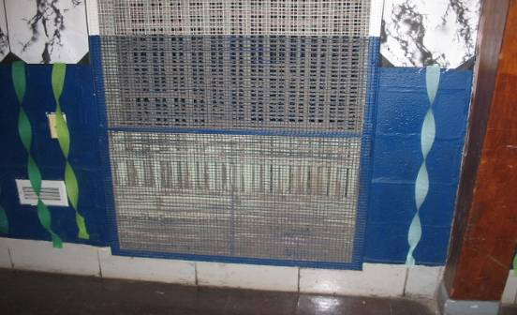

Exhaust Vent

Picture 2

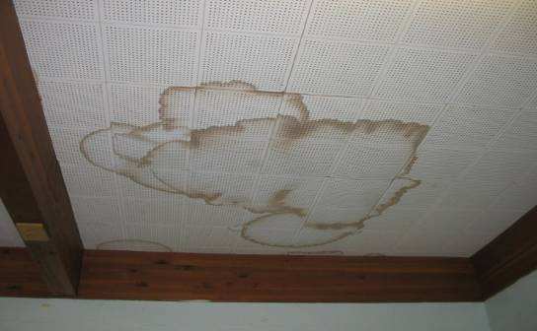

Water-Damaged Ceiling Tiles

Picture 3

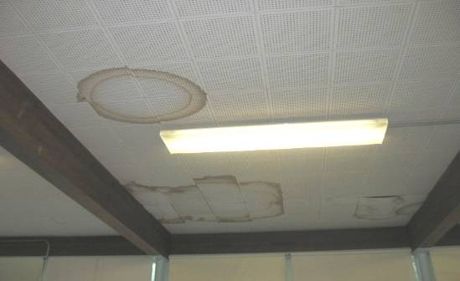

Water-Damaged Ceiling Tiles

Picture 4

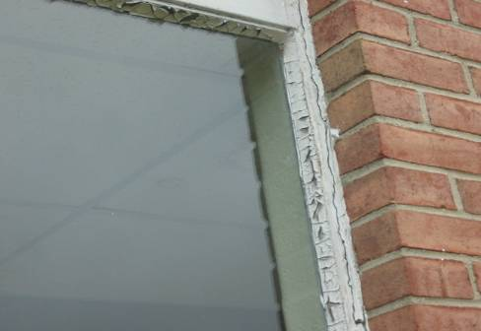

Crumbling/damaged Window Caulking

Picture 5

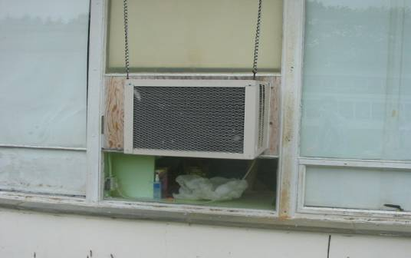

Air Infiltration around Window-Mounted AC

Picture 6

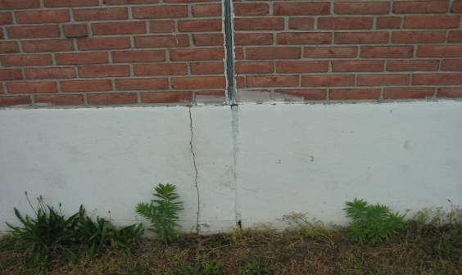

Missing/damaged sealant between Expansion Joints, Note Wall Cracks

Picture 7

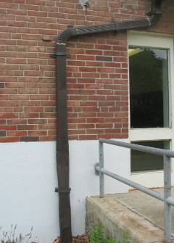

Gutter/downspout

Picture 8

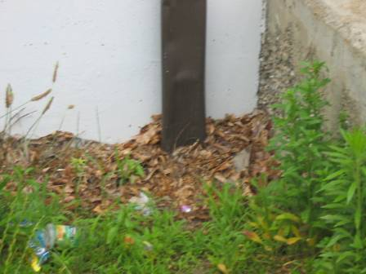

Gutter/downspout buried below ground

Picture 9

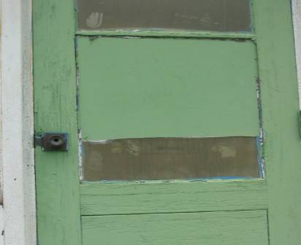

Damaged/Rotted Wood Exterior Door

Picture 10



Space around Damaged/Rotted Wood Exterior Door

Picture 11

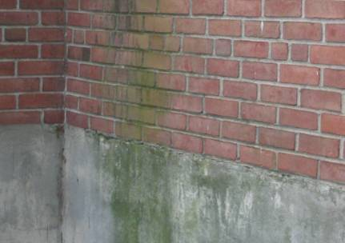

Moss Growth on Exterior Wall

Picture 12

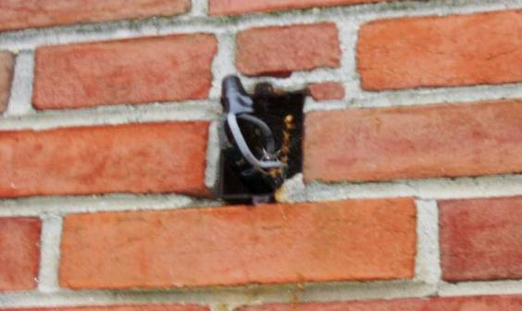

Open Utility Hole with Exposed Wires

Picture 13

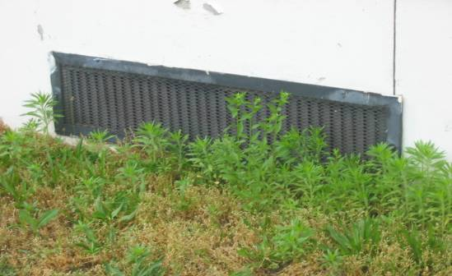

Plants near Univent Fresh Air Intake

Picture 14

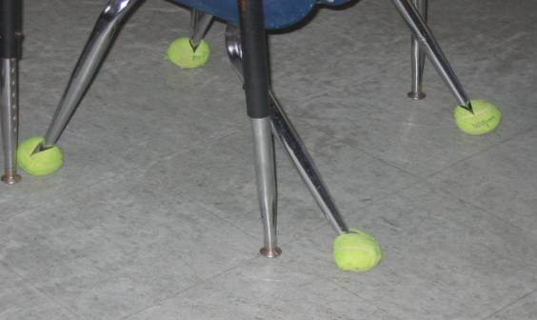

Spliced Tennis Balls on Chair Legs

Picture 15

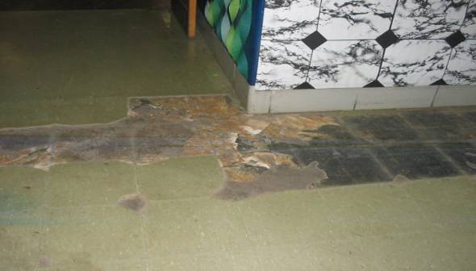

Missing/damaged Floor Tiles

Picture 16

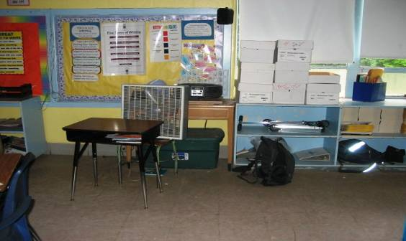

Store Items in Classroom

Picture 17

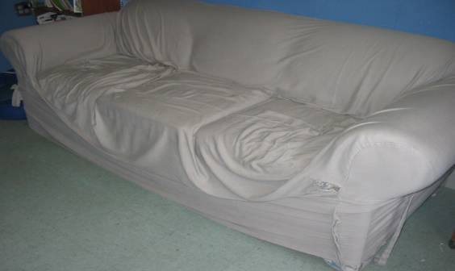

Couch with Fabric Cover

Picture 18

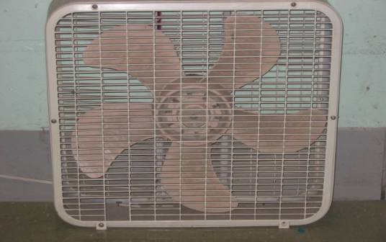

Personal Fan with Accumulated Dust and Debris
Location/ Room | Occupants  in Room | Temp  (°F) | Relative  Humidity  (%) | Carbon  Dioxide  (ppm) | Carbon Monoxide  (ppm) | PM2.5  (µg/m³) | Windows  Openable | Ventilation |  | Remarks
 |  |  |  |  |  |  |  | Supply | Exhaust | Remarks
background |  | 71 | 67 | 490 | ND | 15
Admin. Office | 2 | 74 | 62 | 1071 | ND | 16 | N | N | N | CT-1 over ceiling fan
Café | 100+ | 73 | 66 | 1218 | ND | 15 | N | Y | Y  dust, debris | WD CTs, damaged/missing floor tiles.
Catwalk to Café | 0 | 72 | 60 | 702 | ND | 10 | N | N | N | Damaged/missing floor tiles
Gym | 24 | 71 | 65 | 654 | ND | 9 | N | Y  dust, debris | Y  dust, debris | DO
Library | 5 | 73 | 59 | 780 | ND | 17 | Y | Y  off | Y | Rug cut in corner exposing hole in concrete floor
Nurse’s Office | 1 | 72 | 64 | 942 | ND | 17 | Y | Y | Y  weak | Radiator, Musty odor.
Principal’s Office | 1 | 73 | 62 | 1067 | ND | 16 | Y | Y | Y | Wall AC, WD CTs
1 | 0 | 74 | 62 | 1391 | ND | 18 | Y | Y  off | Y  off | wall AC, WD CTs, DEM, CD
2 | 0 | 73 | 60 | 1182 | ND | 14 | Y | Y  off,  blocked | Y  off  blocked | Occupants gone 30 minutes; Plants near windows, DEM, CD, 6 CTs
4 | 23 | 73 | 64 | 1411 | ND | 15 | Y | Y  off | Y  off | CD, DEM
5 | 32 | 73 | 66 | 1355 | ND | 15 | Y  open | Y  off, blocked | Y  off | CT-11 (spray painted white)
6 | 1 | 73 | 62 | 970 | ND | 8 | Y  open | Y  off | Y  off | wall AC, CT-17, DEM, CD
7 | 21 | 74 | 65 | 1733 | ND | 23 | Y | Y  off | Y  off, blocked | WD CT, DEM
8 | 31 | 73 | 65 | 1224 | ND | 13 | Y  open | Y  off | Y  off | CD, DEM, 1 AT, cleaners
9 | 26 | 74 | 64 | 1391 | ND | 13 | Y | Y  off | Y  off, blocked | DEM, CD, WD CTs, wall mounted A/C
10 | 20 | 72 | 68 | 1779 | ND | 15 | Y | Y  off | Y  off | DEM, wall AC, 1 AT
11A Music Room | 0 | 73 | 61 | 631 | ND | 10 | Y  open | Y  off | Y  off | (Exhaust is one fan in wall venting to outside), damaged floor tiles, PF-on, DEM, CT-1, visible roof drain inside classroom.
51 | 0 | 73 | 62 | 685 | ND | 12 | Y | Y  off, blocked | Y  weak | Windows blocked by clutter, DEM, CD, PF, CT-12, plants, chemicals on sink.
52 | 0 | 73 | 63 | 976 | ND | 16 | Y  open | Y  off, blocked | Y  weak | CD, DEM, PF, cleaners.
53 | 0 | 73 | 63 | 622 | ND | 12 | Y  open | Y  off | Y  dust, debris | CD, DEM, CT-34, PF
54 | 21 | 73 | 64 | 720 | ND | 13 | Y  open | Y  off | Y  dust, debris, blocked | PFs, DEM, CT-2
55 | 29 | 74 | 61 | 998 | ND | 24 | Y | Y  off | Y  dust, debris | CD, DEM, cleaners, CT-8, wall AC
56 | 0 | 75 | 58 | 878 | ND | 11 | Y | Y  off | Y  off, dust, debris | AT-2, CT-5, PF, damaged floor tiles
57 | 0 | 73 | 61 | 843 | ND | 12 | Y | Y  off | Y | wall AC, DEM, CT-1, CD
58 | 8 | 73 | 63 | 873 | ND | 17 | Y | Y  off | Y  dust, debris | repaired steam leak in 2007, wall AC, DEM, CD, CT-5, musty odor.
59 | 0 | 73 | 62 | 778 | ND | 10 | Y | Y  off | Y  weak | Wall AC, CD, DEM, CT-25, clothes line across room, chemicals on sink.
60 | 0 | 72 | 62 | 770 | ND | 11 | Y | Y  off | Y  dust, debris | CD, DEM, CT-11, ceiling repair, wall AC
131 Shop | 25 | 72 | 58 | 1072 | ND | 13 | Y | N | N | Windows blocked with clutter. PFs, 2 ceiling heating fans, CD, wooden slat ceiling
148 Art | 7 | 73 | 62 | 842 | ND | 15 | Y | Y  off | Y | DEM. PF, radiator, CD, AT-1
150 Computer Lab | 0 | 74 | 60 | 963 | ND | 3 | Y | Y  off | Y  an to outside | 2 Univents, 26 computers, DEM, wall AC on
174 | 0 | 73 | 63 | 504 | ND | 14 | Y  open | Y | Y  weak | Radiator, PFs, DEM, couch with cover, hole in concrete wall containing a clock, TB

