Vaccine Administration: Intramuscular (IM) Injection Adults 19 years of age and older

Administer these vaccines by IM injection:

- Haemophilus influenzae type b (Hib)
- Hepatitis A (HepA)
- Hepatitis B (HepB)
- Hepatitis A and hepatitis B (HepA-HepB)
- Human papillomavirus (HPV vaccine)
- Influenza vaccine, inactivated (IIV)
- Influenza vaccine, recombinant (RIV4)
- Meningococcal conjugate (MenACWY)
- Meningococcal serogroup B (MenB)
- Pneumococcal conjugate (PCV13)
- Pneumococcal polysaccharide (PPSV23)*
- Tetanus and diphtheria toxoid (Td)
- Tetanus toxoid, reduced diphtheria toxoid, and acellular pertussis (Tdap)
- Zoster, recombinant (RZV)

*May also be administered by subcutaneous injection

To ensure vaccines are safe and effective, it’s important to prepare and administer them correctly:

- Follow aseptic technique.
- Use a new needle and syringe for each injection.
- Perform hand hygiene before vaccine preparation, between patients, when changing gloves (if worn), and any time hands become soiled.‡

‡Gloves are not required unless the person administering the vaccine is likely to come in contact with potentially infectious body fluids or has open lesions on the hands. If worn, perform hand hygiene and change gloves between patients.
- Use the correct syringe and needle.
- Administer vaccine using either a 1-mL or 3-mL syringe.
- Use a 22- to 25-gauge needle.
- Use the correct needle length based on the patient’s gender and weight. For adults, use a 1- to 1.5-inch needle.

1.5 in (38 mm) OR

1 in (25 mm)
Men and women,
less than 60 kg* (130 lbs)

Men and women,
60–70 kg (130–152 lbs)

1 in (25 mm)
Men,
70–118 kg (152–260 lbs)
Women,
70–90 kg (152–200 lbs)

1.5 in (38 mm)
Men, greater than 118 kg (>260 lbs)
Women, greater than 90 kg (>200 lbs)

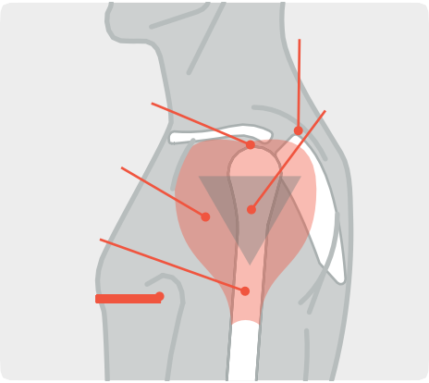*Some experts recommend a 5/8-inch needle for men and women who weigh less than 60 kg (130 lbs). If used, the skin must be stretched fully and the subcutaneous tissues must not be bunched.
Scapula
Acromion process

Deltoid muscle
Injection site
Humerus

Axillary
fold/ armpit

- Identify the injection site.
- Recommended site: Deltoid muscle in the upper arm
- Use anatomical landmarks to determine the injection site. The deltoid muscle is a large, rounded, triangular shape. Find the acromion process, which is the bony point at the end of the shoulder. The injection site will be approximately 2 inches below the bone and above the axillary fold/armpit.
- Administer the vaccine correctly.
- Inject the vaccine into the middle and thickest part of the muscle. Insert the needle at a 90-degree angle and inject all of the vaccine in the muscle tissue.
- If administering more than one vaccine in the same arm, separate the injection sites by 1 inch if possible.

For additional information, go to CDC's vaccine administration resource library at
www.cdc.gov/vaccines/hcp/admin/resource-library.html.

11/16/20

