Intro to Special Commission on State Institutions

Emily Lauer, PhD, MPH

Associate Professor, Director of CDDER

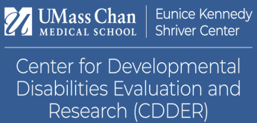

## Eunice Kennedy Shriver Center

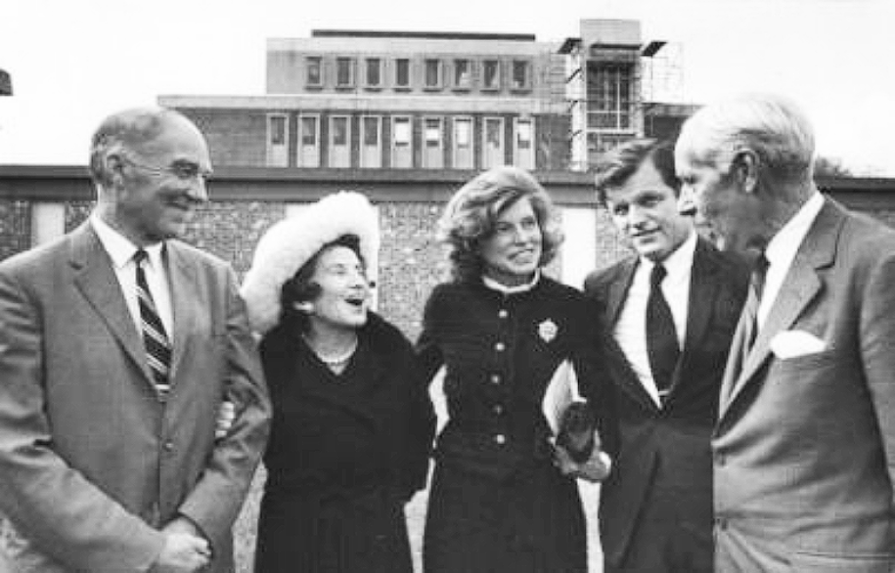

* Part of the University of Massachusetts Chan Medical School
* Dedicated to understanding and improving the challenges faced by individuals with intellectual and developmental disabilities (IDD) and/or behavioral health disorders as well as supporting their families.
* Our comprehensive experience and expertise have established the Shriver Center as an international leader, devoted to supporting the full participation of people with disabilities in community life.

## Our Mission

To transform systems, policy, and practice by engaging in innovative research, education, training, and service so that people with intellectual/developmental disabilities and/or behavioral health conditions may lead self-determining lives.

## Examples of relevant prior work

* Fostering Social Inclusion and Community Engagement among people with IDD
* MA Healthy People 2020 Autism Roadmap Report: Understanding Needs & Measuring Outcomes
* Experiences of Aging Caregivers in Supporting Family Members
* Evaluation of new service models with Person-Centered Evaluation
* Creation of advocacy tools for self-advocates and family members on preventive health screenings
* Teaching medical students about the lived experiences of people with disabilities – including people with disabilities
* Studying when and how people with IDD died

## Areas we can support

* Support in running commission
  + Meetings
  + Updates/Reporting
* Lists of places where they were buried, information about cemeteries
* Papers
  + Where are the papers? Who has them?
    - We can do as much as we can during the time we have
  + Process of requesting papers, what happens when you try, how do other places give access to papers

## Areas that may be challenging

* Legally related processes to find papers and who has what; what papers are gone
  + It may take a long time to get this information (after report is due)
* You asked to find:
  + - *Tell us how people were buried when they died. What were the rules? Were their families told? Did they get a gravestone with their name? Was there a funeral?*
    - *Find out if anybody was buried in a place they were not supposed to be buried.*
  + This may be up to where the info is, who has it, how we can get it, and whether we need the help of lawyers to do so.