ODOR INVESTIGATION/
INDOOR AIR QUALITY ASSESSMENT

Center Elementary School
11 Ash Street
Hopkinton, Massachusetts

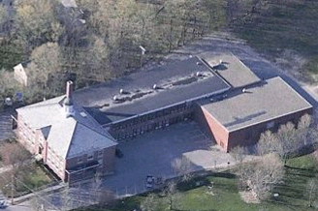

Prepared by:
Massachusetts Department of Public Health
Bureau of Environmental Health
Indoor Air Quality Program
April 2008

Background/Introduction
At the request of Mr. Al Rogers, Director of Maintenance, Hopkinton Public Schools, the Massachusetts Department of Public Health (MDPH), Bureau of Environmental Health (BEH) provided assistance and consultation regarding indoor air quality (IAQ) concerns at the Center Elementary School (CES), 11 Ash Street, Hopkinton, Massachusetts. On February 6, 2008, a visit to conduct an IAQ assessment was made to the CES by Cory Holmes, a Regional IAQ Inspector in BEH’s IAQ Program. Mr. Holmes was accompanied by Deputy Fire Chief Ken Clark and Mr. Rogers, during the assessment. The request was prompted by concerns related to occupant concerns of gas/cooking odors in the building.
At the time of assessment, Mr. Rogers reported that the odors occur nearly daily, around the time the ovens in the kitchen are used to warm prepared lunches (approximately 10:00 to 10:30 am). The CES is a multi-level red brick building that was constructed in 1928. Additions were made to the building in 1954 and 1986. The lower level of the 1928 portion of the building houses the kitchen, cafeteria and classrooms. The main level contains general classrooms and office space. The upper level contains general classrooms. Odor complaints originated from classrooms situated above the kitchen and cafeteria, in the main and upper levels; therefore, the assessment focuses on these areas of the building.

Methods
BEH staff performed a visual inspection for potential sources of odors as well as any pathways that could provide a means of migration of odors into occupied areas. In addition, general indoor air quality tests for carbon monoxide, carbon dioxide, temperature and relative humidity were conducted with the TSI, Q-Trak, IAQ Monitor, Model 8551. Air tests for airborne particle matter with a diameter less than 2.5 micrometers were taken with the TSI, DUSTTRAK™ Aerosol Monitor Model 8520.

Results
The school houses approximately 480 kindergarten and first grade students and approximately 70 staff members. The tests were taken during normal operations at the school and results appear in Table 1.

Discussion
Ventilation
It can be seen from Table 1 that carbon dioxide levels were above 800 parts per million (ppm) in one classroom and in the cafeteria during lunchtime, indicating less optimal air exchange in these areas. These measurements were likely due to the deactivation/condition of mechanical ventilation components. It is also important to note that several classrooms had open windows and/or were empty/sparsely populated, which can greatly reduce carbon dioxide levels. Carbon dioxide levels would be expected to be higher with full occupancy and with windows closed.

Kitchen/Cafeteria
The cafeteria was designed to be ventilated by a ceiling-mounted air handling unit (AHU) (Picture 1). The AHU draws fresh outside air from an air intake on the exterior of the building (Picture 2) and heats and filters it prior to distributing via ducted vents to the kitchen and cafeteria (Pictures 3 and 4). The AHU was not operating during the assessment and appeared to have been deactivated for some time. At the time of the assessment, the cafeteria had no means of mechanical supply ventilation but relies solely on openable windows for air exchange. All windows were closed during the assessment.
Exhaust ventilation in the kitchen is provided by a local exhaust hood (Picture 4). Exhaust ventilation for the cafeteria is drawn into a large wall-mounted vent (Picture 5), where it is ducted to a motor located in the attic and exhausted out of the building (Picture 6). These exhaust vents were operating during the assessment.

Classrooms
The school’s original ventilation system consists of a series of louvered wall vents (Picture 7). Each classroom has a louvered air diffuser approximately 3 feet by 3 feet in size, located near the center of an interior wall in proximity to the ceiling. Ductwork connects the classroom air diffusers to a large axial fan located in a basement mechanical room (Picture 8); this fan creates air movement . The system is designed to draw fresh air from an air intake on the exterior wall of the lower level (Picture 9). Fresh air is mixed in the mechanical room prior to being drawn into the heating elements (Picture 10) and up the shaft. Fresh air is then mixed in the basement prior to being drawn into the heating elements. The percentage of fresh air is controlled by the hinged louver system (Picture 11). Unfortunately, this system was also not operating during the assessment and appeared to have been deactivated for some time, due to mechanical issues with the fan. Therefore, the only method to introduce fresh air into classrooms was via openable windows. During the assessment, all but one classroom had windows shut, further limiting air exchange.
Exhaust ventilation is provided by a natural gravity system. This system draws air into a ducted ventilation shaft through ungrated “cubby” holes located at floor level in classrooms (Picture 12). Air is exhausted at the top of the shaft through vents located in a cupola (Picture 13). These vents were drawing air at the time of the assessment, however, without the introduction of fresh air via the supply system the rooms were essentially operating with half of the intended ventilation. Classrooms are designed to be under slight pressurization, in this case rooms were depressurized, which can draw air and odors from other parts of the building (e.g., the kitchen/cafeteria).
To maximize air exchange, the MDPH recommends that both supply and exhaust ventilation operate continuously during periods of school occupancy. In order to have proper ventilation with a mechanical supply and exhaust system, the systems must be balanced to provide an adequate amount of fresh air to the interior of a room while removing stale air from the room. It is recommended that HVAC systems be re-balanced every five years to ensure adequate air systems function (SMACNA, 1994). The date of the last balancing of these systems was not available at the time of the assessment. Please note that several components of the mechanical ventilation system cannot be balanced in their current condition.
The Massachusetts Building Code requires a minimum ventilation rate of 15 cubic feet per minute (cfm) per occupant of fresh outside air or have openable windows in each room (SBBRS, 1997; BOCA, 1993). The ventilation must be on at all times that the room is occupied. Providing adequate fresh air ventilation with open windows and maintaining the temperature in the comfort range during the cold weather season is impractical. Mechanical ventilation is usually required to provide adequate fresh air ventilation.
Carbon dioxide is not a problem in and of itself. It is used as an indicator of the adequacy of the fresh air ventilation. As carbon dioxide levels rise, it indicates that the ventilating system is malfunctioning or the design occupancy of the room is being exceeded. When this happens, a buildup of common indoor air pollutants can occur, leading to discomfort or health complaints. The Occupational Safety and Health Administration (OSHA) standard for carbon dioxide is 5,000 parts per million parts (ppm). Workers may be exposed to this level for 40 hours/week, based on a time-weighted average (OSHA, 1997).
The MDPH uses a guideline of 800 ppm for publicly occupied buildings. A guideline of 600 ppm or less is preferred in schools due to the fact that the majority of occupants are young and considered to be a more sensitive population in the evaluation of environmental health status. Inadequate ventilation and/or elevated temperatures are major causes of complaints such as respiratory, eye, nose and throat irritation, lethargy and headaches. For more information concerning carbon dioxide, consult Appendix A.
Temperature measurements in occupied areas the day of the assessment ranged from 70º F to 79º F (the kitchen was 81º F), which were within or slightly above the MDPH recommended comfort range. The MDPH recommends that indoor air temperatures be maintained in a range of 70º F to 78º F in order to provide for the comfort of building occupants. In many cases concerning indoor air quality, fluctuations of temperature in occupied spaces are typically experienced, even in a building with an adequate fresh air supply. In addition, it is difficult to control temperature and maintain comfort without operating the ventilation equipment as designed (e.g., supply deactivated/inoperable, exhaust obstructed).
The relative humidity ranged from 31 to 38 percent, which was below the MDPH recommended comfort range in all areas surveyed during the assessment. The MDPH recommends a comfort range of 40 to 60 percent for indoor air relative humidity. Relative humidity would be expected to drop below comfort levels during the heating season. The sensation of dryness and irritation is common in a low relative humidity environment. Low relative humidity is a very common problem during the heating season in the northeast part of the United States.

Odor Investigation
As previously mentioned, the assessment was prompted by complaints of gas/cooking odors by occupants in classrooms on the main and upper levels directly above the kitchen/cafeteria. The main sources of these odors appeared to be gas-fired cooking equipment in the kitchen on the lower level. Although the kitchen area is equipped with an operating exhaust hood, there was no source of make-up (i.e., supply air) for the kitchen. As discussed, the supply system for the kitchen and cafeteria (Pictures 1 and 4) was not operational, and windows were closed at the time of the assessment.
In order to explain how gas/cooking odors/particulates may be impacting adjacent areas, the following concepts concerning heated air and creation of air movement must be understood.
- Heated air will create upward air movement (called the stack effect).
- Cold air moves to hot air, which creates drafts.
- As heated air rises, negative pressure is created, which draws cold air to equipment creating heat.
- Combustion of fossil fuels generates heat, gases and particulates that will rise in the air. In addition, the more heated air becomes the greater airflow increases.
- The operation of ventilation system components (e.g., classroom exhaust vents) can entrain and distribute cooking odors/particulates to other areas of the building.
Each of these concepts influences the movement of combustion products, particulates and odors associated with cooking. BEH staff conducted air monitoring to determine whether measurable levels of cooking by-products were migrating into occupied areas of the building.
Indoor air quality can be negatively influenced by the presence of respiratory irritants, such as products of combustion. The process of combustion produces a number of pollutants. Common combustion emissions include carbon monoxide, carbon dioxide, water vapor and smoke (fine airborne particle material). Of these materials, exposure to carbon monoxide and particulate matter with a diameter of 2.5 micrometers (μm) or less (PM2.5) can produce immediate and acute health effects upon exposure. To determine whether combustion products were present in the school environment, BEH staff obtained measurements for carbon monoxide and PM2.5.
Carbon monoxide is a by-product of incomplete combustion of organic matter (e.g., gasoline, wood and tobacco). Exposure to carbon monoxide can produce immediate and acute health affects. Several air quality standards have been established to address carbon monoxide and prevent symptoms from exposure to these substances. The MDPH established a corrective action level concerning carbon monoxide in ice skating rinks that use fossil-fueled ice resurfacing equipment. An operator of an indoor ice must take actions to reduce carbon monoxide levels, if those levels exceed 30 ppm, 20 minutes after resurfacing within a rink (MDPH, 1997).
The American Society of Heating Refrigeration and Air-Conditioning Engineers (ASHRAE) has adopted the National Ambient Air Quality Standards (NAAQS) as one set of criteria for assessing indoor air quality and monitoring of fresh air introduced by HVAC systems (ASHRAE, 1989). The NAAQS are standards established by the US EPA to protect the public health from six criteria pollutants, including carbon monoxide and particulate matter (US EPA, 2006). As recommended by ASHRAE, pollutant levels of fresh air introduced to a building should not exceed the NAAQS levels (ASHRAE, 1989). The NAAQS were adopted by reference in the Building Officials & Code Administrators (BOCA) National Mechanical Code of 1993 (BOCA, 1993), which is now an HVAC standard included in the Massachusetts State Building Code (SBBRS, 1997). According to the NAAQS, carbon monoxide levels in outdoor air should not exceed 9 ppm in an eight-hour average (US EPA, 2006).
Carbon monoxide should not be present in a typical, indoor environment. If it is present, indoor carbon monoxide levels should be less than or equal to outdoor levels. Outdoor carbon monoxide concentrations were non-detect (ND) (Table 1). Carbon monoxide levels measured in the school were also ND during the assessment.
The US EPA has established NAAQS limits for exposure to particulate matter. Particulate matter is airborne solids that can be irritating to the eyes, nose and throat. The NAAQS originally established exposure limits to particulate matter with a diameter of 10 μm or less (PM10). According to the NAAQS, PM10 levels should not exceed 150 microgram per cubic meter (μg/m³) in a 24-hour average (US EPA, 2006). These standards were adopted by both ASHRAE and BOCA. Since the issuance of the ASHRAE standard and BOCA Code, US EPA established a more protective standard for fine airborne particles. This more stringent PM2.5 standard requires outdoor air particle levels be maintained below 35 μg/m³ over a 24-hour average (US EPA, 2006). Although both the ASHRAE standard and BOCA Code adopted the PM10 standard for evaluating air quality, MDPH uses the more protective PM2.5 standard for evaluating airborne particulate matter concentrations in the indoor environment.
Outdoor PM2.5 concentrations the day of the assessment were measured at 12 μg/m³. Indoor levels in classroom areas ranged from 15 to 22 μg/m³. PM2.5 levels measured in the occupied areas of the cafeteria peaked at 118 μg/m³ during cooking operations (Table 1); these levels are over three times the NAAQS PM2.5 level of 35 μg/m³. In order to reduce levels of PM2.5, BEH staff along with Mr. Rogers and Deputy Clark opened cafeteria windows (Picture 14). Opening windows served a dual purpose to both dilute airborne pollutants by introducing fresh outside air as well as providing a source of make-up air to facilitate air exchange and removal of pollutants via the kitchen exhaust hood. Measurable levels of PM2.5 were reduced below the NAAQS PM2.5 level of 35 μg/m³ in approximately 20 minutes (32 μg/m³/Table 1). In 30 minutes with windows open, PM2.5 levels in the cafeteria dropped to 23 μg/m³.
Frequently, indoor air levels of particulates (including PM2.5) can be at higher levels than those measured outdoors. A number of mechanical devices and/or activities that occur in schools can generate particulate during normal operations. Sources of indoor airborne particulates may include but are not limited to particles generated during the operation of fan belts in the HVAC system, cooking in the cafeteria stoves and microwave ovens; use of photocopiers, fax machines and computer printing devices; operation of an ordinary vacuum cleaner and heavy foot traffic indoors.
A number of pathways for gas/cooking odors and associated particulates to migrate through the building were identified during the assessment. These included:
- The door between the cafeteria and stairwell, which was ajar (Pictures 15 and 16);
- The stairwell, which itself acts as a shaft to transport odors (Pictures 17 and 18);
- classroom doors that are open (Pictures 17 through 19);
- Breaches in kitchen exhaust ductwork in the attic (Picture 20), which pressurizes and empties cooking odors into the attic, which can then migrate into classrooms via utility holes and or other spaces in ceilings and walls.
Each of these factors can allow for the movement of air, odors and particulates from the kitchen/cafeteria into adjacent areas. Once outside the kitchen and cafeteria, gas/cooking odors can migrate via the stack effect (in stairwells), air currents (in hallways) or be distributed through the building via depressurization/pressurization from ventilation components (e.g., classroom exhaust vents).

Other IAQ Evaluations
Other conditions that can affect indoor air quality were observed during the assessment. The air mixing room and surrounding area was being used for storage of items and cleaning chemicals (Pictures 21 and 22). Unless the ductwork/shafts are completely abandoned and properly sealed, the shafts can serve as pathways for cleaning/chemical odors to migrate into classrooms and other adjacent areas.
Finally, several classrooms contained dry erase boards and dry erase board markers. Materials such as dry erase markers and dry erase board cleaners may contain volatile organic compounds (VOCs), such as methyl isobutyl ketone, n-butyl acetate and butyl-cellusolve (Sanford, 1999), which can be irritating to the eyes, nose and throat. Cleaning products were also found on open shelves in reach of children in some classrooms (Picture 13). Like dry erase materials, cleaning products contain VOCs and other chemicals that can be irritating to the eyes, nose and throat of sensitive individuals.

Conclusions/Recommendations
The conditions noted at the CES raise a number of indoor air quality issues. The activities in the kitchen/cafeteria in combination with the building design and lack of operation of the mechanical ventilation systems in both the cafeteria and classrooms can create conditions for cooking related odors to migrate to different areas of the building. Some conditions can be remedied by actions taken by building occupants. Other efforts will require alteration to the building structure and equipment.
In view of the findings at the time of this visit, the following recommendations are made to reduce/prevent the migration of cooking odors and to improve indoor air quality:
- Contact an HVAC engineering firm for a ventilation systems assessment, primarily for the kitchen/cafeteria and classrooms. Based on the age, physical deterioration and availability of parts for ventilation components, such an evaluation is necessary to determine the operability and feasibility of repairing/replacing the equipment.
- Contact an HVAC engineer to determine if existing supply vent in kitchen (Picture 4) is sufficient to provide make-up air for kitchen local exhaust hood. Develop a preventative maintenance program for this equipment.
- Continue to open cafeteria windows prior to/during hours of food preparation until a mechanical source of make-up air can be provided to the kitchen.
- Ensure all doors to the cafeteria and classrooms remain closed during hours of operation/preparation.
- Ensure cafeteria doors fit completely flush with threshold. Seal doors on all sides with foam tape, and/or weather-stripping. Consider installing weather-stripping/door sweeps on both sides to provide a dual barrier. Ensure tightness of doors by monitoring for light penetration and drafts around doorframes.
- Ensure breaches/holes in attic exhaust ductwork are properly sealed to eliminate potential pollutant paths of odor migration.
- Examine the feasibility of restoring mechanical supply ventilation to classrooms. If feasible:
- Make repairs or replace axial fan in the air mixing room,
- Restore fresh air intake/louver system, and
- Remove stored items and conduct a through cleaning of air mixing room and surrounding areas.
- Remove stored items from exhaust cubbies to facilitate airflow.
- Use openable windows in conjunction with classroom exhaust vents to increase air exchange. Care should be taken to ensure windows are properly closed at night and weekends to avoid the freezing of pipes and potential flooding.
- Ensure classroom doors are closed, to maximize air exchange.
- Consider adopting a balancing schedule of every 5 years for all mechanical ventilation systems, as recommended by ventilation industrial standards (SMACNA, 1994).
- For buildings in New England, periods of low relative humidity during the winter are often unavoidable. Therefore, scrupulous cleaning practices should be adopted to minimize common indoor air contaminants whose irritant effects can be enhanced when the relative humidity is low. To control for dusts, a high efficiency particulate arrestance (HEPA) filter equipped vacuum cleaner in conjunction with wet wiping of all surfaces is recommended. Avoid the use of feather dusters. Drinking water during the day can help ease some symptoms associated with a dry environment (throat and sinus irritations).
- Store cleaning products properly and out of reach of students.
- Consider adopting the US EPA (2000) document, “Tools for Schools”, as an instrument for maintaining a good indoor air quality environment in the building. This document is available at: http://www.epa.gov/iaq/schools/index.html.
- Refer to resource manual and other related indoor air quality documents located on the MDPH’s website for further building-wide evaluations and advice on maintaining public buildings. These documents are available at: http://www.state.ma.us/dph/MDPH/iaq/iaqhome.htm.

References
ASHRAE. 1989. Ventilation for Acceptable Indoor Air Quality. American Society of Heating, Refrigeration and Air Conditioning Engineers. ANSI/ASHRAE 62-1989
BOCA. 1993. The BOCA National Mechanical Code/1993. 8th ed. Building Officials & Code Administrators International, Inc., Country Club Hills, IL.
MDPH. 1997. Requirements to Maintain Air Quality in Indoor Skating Rinks (State Sanitary Code, Chapter XI). 105 CMR 675.000. Massachusetts Department of Public Health, Boston, MA.
OSHA. 1997. Limits for Air Contaminants. Occupational Safety and Health Administration. Code of Federal Regulations. 29 C.F.R 1910.1000 Table Z-1-A.
Sanford. 1999. Material Safety Data Sheet (MSDS No: 198-17). Expo® Dry Erase Markers Bullet, Chisel, and Ultra Fine Tip. Sanford Corporation. Bellwood, IL.
SBBRS. 1997. Mechanical Ventilation. State Board of Building Regulations and Standards. Code of Massachusetts Regulations. 780 CMR 1209.0
SMACNA. 1994. HVAC Systems Commissioning Manual. 1st ed. Sheet Metal and Air Conditioning Contractors’ National Association, Inc., Chantilly, VA.
US EPA. 2000. Tools for Schools. Office of Air and Radiation, Office of Radiation and Indoor Air, Indoor Environments Division (6609J). EPA 402-K-95-001, Second Edition. http://www.epa.gov/iaq/schools/tools4s2.html
US EPA. 2006. National Ambient Air Quality Standards (NAAQS). US Environmental Protection Agency, Office of Air Quality Planning and Standards, Washington, DC. http://www.epa.gov/air/criteria.html.

Picture 1

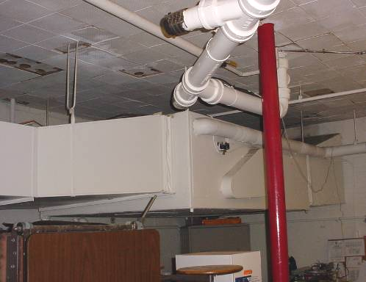

Ceiling-Mounted AHU in Cafeteria

Picture 2

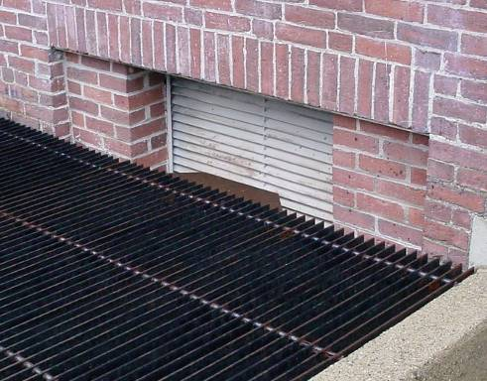

Fresh Air Intake for Cafeteria AHU
Picture 3

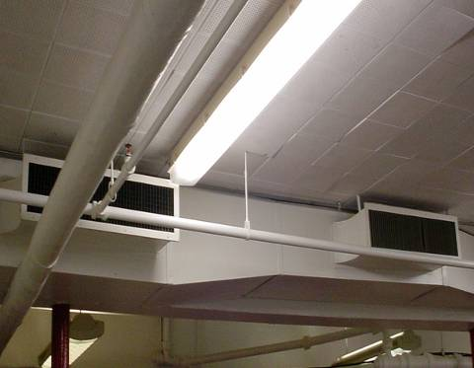

Ducted Supply Vents for Cafeteria

Picture 4

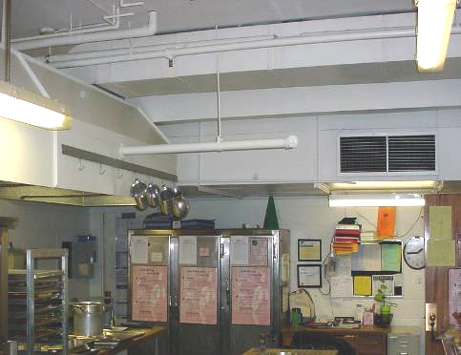

Local Exhaust Hood (left) and Ducted Supply Vent for Kitchen (right)
Picture 5

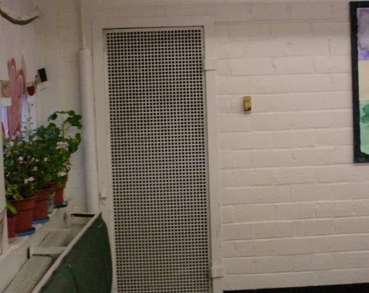

Wall-Mounted Exhaust Vent for Cafeteria

Picture 6

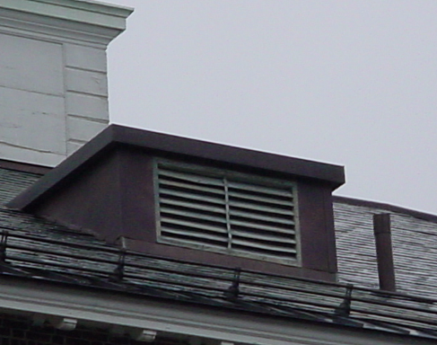

Rooftop Exhaust Vent
Picture 7

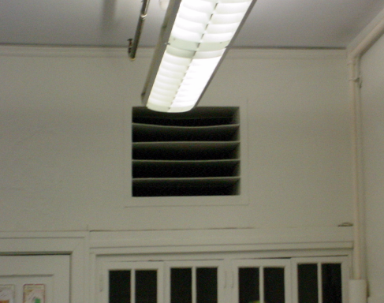

Louvered Supply Vent in Classroom

Picture 8

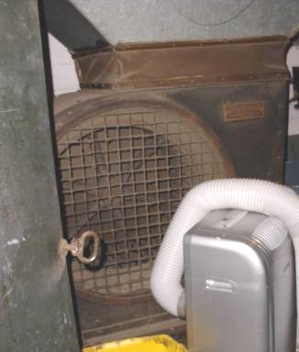

Vintage 1920s Axial Fan in Lower Level Mechanical Room
Picture 9

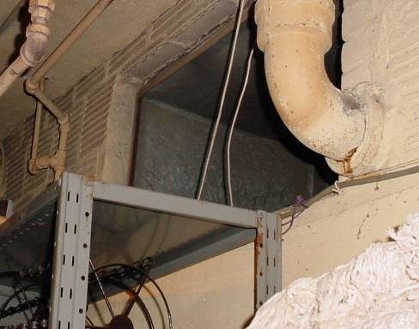

Fresh Air Intake Shaft for Mechanical Ventilation System in Lower Level Mechanical Room

Picture 10

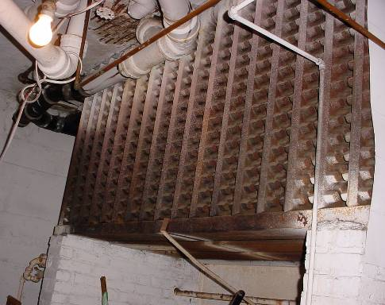

Large Radiant Heating Element for Mechanical Ventilation System in Lower Level Mechanical Room
Picture 11

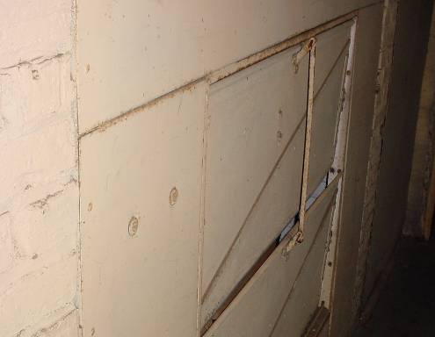

Louvered Vents Controlling Percentage of Fresh outside Air into Lower Level Mechanical Room

Picture 12

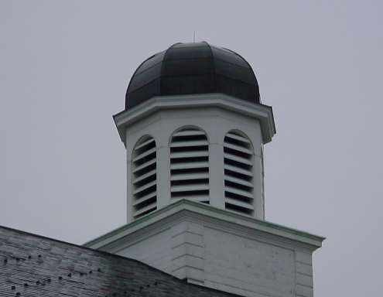

Cupola Exhaust Vents
Picture 13

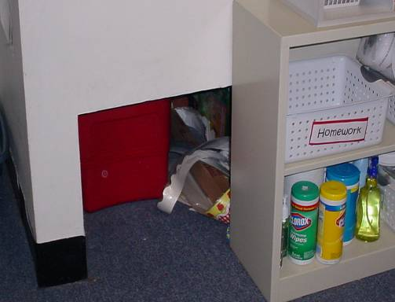

“Cubby” Exhaust Vent in Classroom, Note Items Stored in Vent
and Cleaning Products on Open Shelf in Reach of Children

Picture 14



Openable Windows in Cafeteria
Picture 15

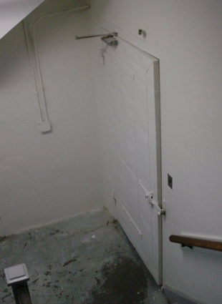

Ajar Door between Cafeteria and Stairwell

Picture 16

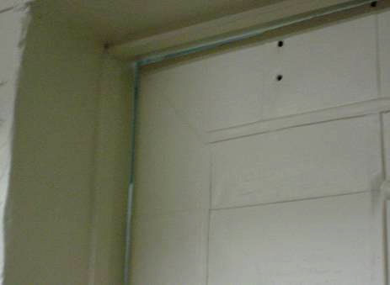

Ajar Door between Cafeteria and Stairwell, Note Space/Light around Door/Threshold
Picture 17

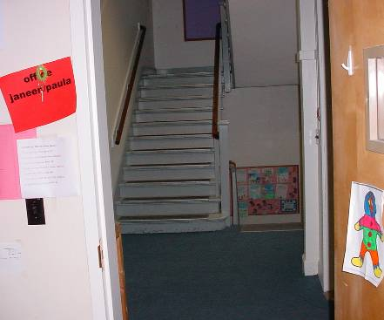

Main Stairwell to Cafeteria, Note Open Door

Picture 18

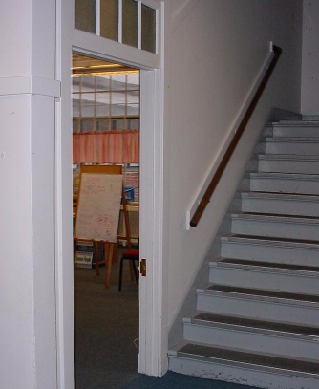

Open Classroom Door on Main Level to Cafeteria Stairwell
Picture 19

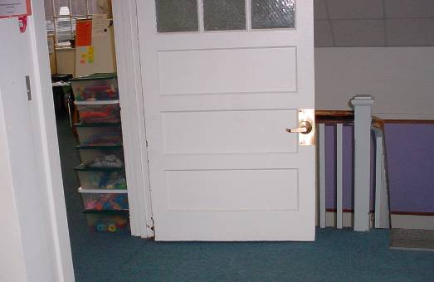

Open Classroom Door on Upper Level to Cafeteria Stairwell

Picture 20

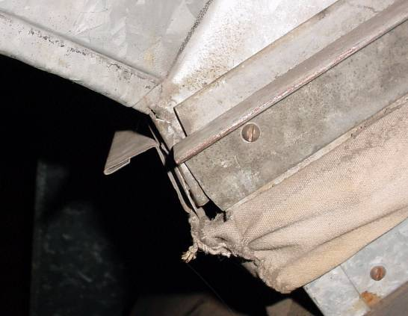

Hole/Breach in Kitchen Exhaust Ductwork (Attic)
Picture 21

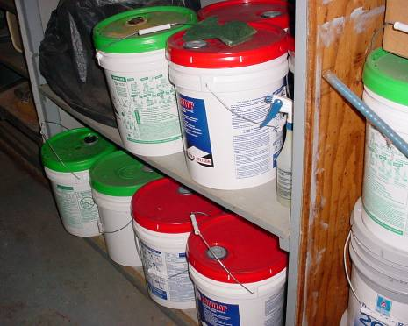

5-Gallon Containers of Cleaning Chemicals Stored near Air Mixing Room, Lower Level

Picture 22

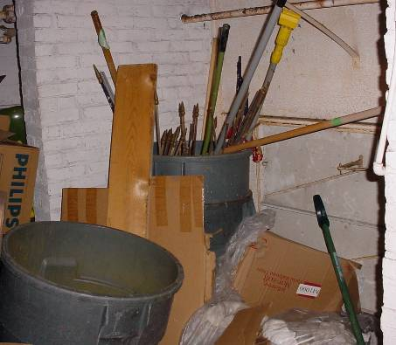

Various Items Stored in Air Mixing Room, Lower Level
Location | Occupants | Carbon  Dioxide  (*ppm) | Carbon  Monoxide  (*ppm) | Temp  (°F) | Relative  Humidity  (%) | PM2.5  (µg/m3) | Windows  Openable | Ventilation |  | Remarks
 |  |  |  |  |  |  |  | Supply | Exhaust | Remarks
Background |  | 324 | ND | 37 | 96 | 12 |  |  |  | Heavy rain, winds 8-17 mph with gusts up to 32 mph
Main floor above cafeteria |  | 446 | ND |  | 31 | 15 | Y | N | N
Cafeteria/  kitchen | 0 | 1137 | ND | 79/81 | 38 | 118 | Y | Y | Y | ~100 occupants, left after first lunch. Gas/cooking odors, windows shut, door to stairwell not closed completely, spaces under door, supply ventilation-not operable, exhaust-on
Cafeteria | 0 |  | ND |  |  | 45 |  |  |  | Windows opened to introduce fresh air and to reduce PM2.5 dropped to 45 in 10 mins
Cafeteria | 0 |  | ND |  |  | 32 |  |  |  | Windows opened to introduce fresh air and to reduce PM2.5 dropped to 32 in 20 mins
Cafeteria | 0 |  | ND |  |  | 23 |  |  |  | Windows opened to introduce fresh air and to reduce PM2.5 dropped to 23 in 30 mins
Stairwell | 0 | 536 | ND | 70 | 32 | 23 | Y | N | N | Cooking odors, classroom doors off stairwell-open
21 | 5 | 555 | ND | 71 | 34 | 22 | y | Y | Y | Windows shut, ventilation-off
Tech Room | 2 | 568 | ND | 71 | 35 | 15 | Y | N | N | Computer network
25 | 19 | 990 | ND | 73 | 38 | 18 | Y | Y | Y | Window open, ventilation-off, door open
26 | 0 | 644 | ND | 74 | 36 | 22 | Y | Y | Y | Occupants @ lunch, door open
24 | 20 | 555 | ND | 72 | 34 | 13 | Y | Y | Y | Window open, food odors, door open
Attic |  |  |  |  |  |  |  |  |  | Local exhaust ductwork for kitchen hood-spaces in ductwork-gas/cooking odors being released into attic space-pressurization
23 | 0 | 789 | ND | 72 | 34 | 10 | N | Y | Y

