INDOOR AIR QUALITY ASSESSMENT

Amherst Center for Extended Care
150 University Drive
Amherst, Massachusetts

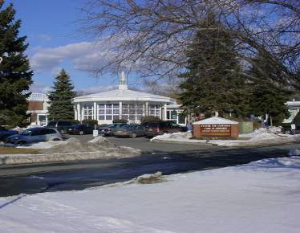

Prepared by:
Massachusetts Department of Public Health
Center for Environmental Health
Emergency Response/Indoor Air Quality Program
April 2007

Background/Introduction
At the request of Sherman Lohnes, Massachusetts Department of Public Health, Division of Health Care Quality (DHCQ), the Massachusetts Department of Public Health (MDPH), Center for Environmental Health (CEH) provided assistance and consultation regarding indoor air quality at the Center for Extended Care (CEC), 150 University Drive, Amherst, Massachusetts. Concerns about lack of opening windows and adequacy of mechanical ventilation equipment prompted the assessment. On February 28, 2007, a visit to conduct an indoor air quality assessment was made to the CEC by Michael Feeney, Director of CEH’s Emergency Response/Indoor Air Quality (ER/IAQ Program. Mr. Feeney revisited the CEC on March 23, 2007 to conduct further air testing in the Dharma A and C units of the building after receiving an e-mail from CEC personnel who indicated that the heating, ventilating and air-conditioning (HVAC) system equipment in these areas was repaired (CEC, 2007).
The CEC is a multi-wing facility (Figures 1 and 2). The wing housing the Dharma unit was constructed in 1967 (1967 wing). In 1992, a second wing was constructed to the north of the original building (1992 wing). A second floor was added to the 1992 wing in 1997 (1992/1997 wing). Windows are openable; however, reportedly due to a recommendation from the building’s ventilation systems contractor, the means to open windows (e.g., window cranks) were removed to prevent occupants from opening windows when the heating, ventilating and air-conditioning (HVAC) system is operating (Action Air, Inc., 2005). Two rooftop heating and air conditioning unit (RTUs) above the 1992/1997 experienced “burn out” during the winter of 2006-2007; both units were replaced on March 21, 2007 (Action Air, Inc., 2007). According to the facility’s operator, replacement of these RTUs was necessitated by stress placed on these units from increased heating calls made to the equipment when windows are opened in the 1992/1997 wing.
According to the MDPH regulations, long-term care facilities are required to provide ventilation by the following method:
“In order to furnish natural fresh air, the windows in each patient bedroom shall be operable so that the area of the opening will be at least 4% of the floor area in the room. Exceptions to this standard will be considered in cases of fully air conditioned facilities or areas” [105 CMR 151.640].
As reported by the facility’s operator, DHCQ required that the CEC file a request for a waiver (DPH, 2005; Appendix A) with regard to the removal of the window cranks. This waiver was subsequently granted (DPH, unknown; Appendix A).

Methods
Air tests for carbon dioxide, temperature and relative humidity were taken with the TSI, Q-Trak, IAQ Monitor Model 8551.

Results
The CEC has approximately 75 staff and can be visited by up to 150 people daily. The tests were taken during normal operations. Test results appear in Tables 1 and 2. Please note that this assessment was conducted during the heating season. No conclusion can be made regarding the ability of the CEC’s HVAC systems to provide adequate fresh air and/or temperature control during hot, humid weather based on this assessment.

Discussion
Ventilation
1992/1997 Wing
It can be seen from Table 1 that during the February 28, 2007 the carbon dioxide levels were below 800 parts per million (ppm) in all areas of the 1992/1997 wing assessment, indicating adequate air exchange. As previously discussed, ventilation in patient rooms is provided by RTUs that each service between six to eight rooms. As the carbon dioxide measurements suggest, each RTU appears to have an air intake that draws fresh air. Each RTU is connected to a wall mounted supply vent located near floor level (Picture 1). A return vent for the room is located in the ceiling tiles system near the hallway door (Picture 2). Each restroom also contains an exhaust vent. AHUs were activated during the time of this assessment.

1967 Wing (Dharma Unit)
The HVAC system for the 1967 wing is configured in a manner that differs from that of the 1992/1997 wing. The 1967 wing is outfitted with ceiling-mounted unit ventilators (univents) (Figure 3, Picture 3). A univent draws air from outdoors through a fresh air intake located on the roof (Picture 4) and returns air through an air intake located at the base of each unit. Fresh air and return air are mixed, filtered, heated and provided to the interior of the building through fresh air diffusers located in the top of the units. The wing layout is the shape of an inverted “t” (Figure 2), and ceiling-mounted univents are stationed near the terminus of each corridor. The univent in the Dharma A hallway of the 1967 wing was deactivated, which may indicate a broken fan belt of motor malfunction. The univent in the Dharma C hallway of the 1967 wing was producing a warmer air stream (note temperature measurements in Table 1), than the other functioning univents, which likely indicates a closed/frozen fresh air supply louver. Subsequent correspondence indicated that malfunctioning relays to these units were replaced (CEC, 2007).
It appears the ventilation for the building was originally designed to pressurize the hallway, forcing air into each patient room. By forcing air into each patient’s room, airborne microbes would be prevented from entering the hallways and instead would remain in each patient’s room. This design would enhance the ability of CEC staff to isolate patients with infectious disease from the general population. Each patient room is equipped with a bathroom exhaust vent which appears to be connected to a wind-driven turbine on the roof (Picture 5). Air is drawn into restrooms through the overcut/undercut sections of the restroom door (Picture 6). Each restroom exhaust vent fan is activated by the light switch. Each patient room contains a restroom. Common areas in the 1967 wing (i.e. dining room, nurse’s station, activity rooms) had either wall- or ceiling-mounted fresh air supply and return vents. These vents are ducted to RTU.
It can be seen from Table 1 that during the February 28, 2007 assessment the carbon dioxide levels were above 800 parts per million (ppm) in 19 of 33 areas in the 1967 wing, indicating inadequate air exchange which was attributed to a malfunction of the ventilation system. A reassessment conducted in March 23, 2007, carbon dioxide levels sampling in the Dharma A and C section were all above 800 ppm, a result of the HVAC system deactivating by thermostats once the set temperature was achieved (Table 2).

Ventilation Evaluation
In order to have proper ventilation with a mechanical supply and exhaust system, the systems must be balanced to provide an adequate amount of fresh air to the interior of a room while removing stale air. The date of the last servicing and balancing of these systems was not available at the time of the assessment. It is recommended that HVAC systems be rebalanced every five years to ensure adequate air systems function (SMACNA, 1994).
To maximize air exchange, the MDPH recommends that both supply and exhaust ventilation operate continuously during periods of occupancy. In order to have proper ventilation with a mechanical supply and exhaust system, the systems must be balanced to provide an adequate amount of fresh air to the interior of a room while removing stale air from the room. It is recommended that HVAC systems be re-balanced every five years to ensure adequate air systems function (SMACNA, 1994). The date of the last balancing of these systems was not available at the time of the assessment.
Both the Massachusetts State Building Code and laws regulating nursing homes contain a section known as the “grandfather” clause. Under this clause, buildings should comply with the building codes and nursing homes laws that were in existence at the time the structure was completed. In this instance, the original building (1967 wing) would be required to comply with the building codes and nursing home laws that existed when it was completed in 1967. As reported by DHCQ staff, the nursing home requirements were enacted in 1968, which means the original building would be considered outside M.G.L. c. 111 sec. 72 and the Massachusetts State Building Code requirements concerning building components. If this is the case, the 1967 wing would be outside the scope of the nursing home regulatory compliance and would not need a waiver with regard to providing openable windows. Please note, the HVAC equipment for the 1967 wing contains components needed for providing “a fully air-conditioned facilities or areas”, as required in the current nursing home regulation. Whether this equipment can provide the mandated temperature conditions during the cooling season [105 CMR 151.700(D)] could not be determined at the time of assessment, since it was conducted during the winter and HVAC equipment was operating in the heating mode.
The 1992/1997 wing appears to be subject to the current standards of the Massachusetts State Building Code and the nursing home regulations; thus, it would be subject to the exception indicated in 105 CMR 151.640(B). As with the 1967 wing, a determination relative to the capacity of this equipment can meet the mandated temperature conditions during the cooling season [105 CMR 151.700(D)] could not be determined at the time of assessment, since it was conducted during the winter and HVAC equipment was operating in the heating mode.
The Massachusetts Building Code requires that each area have a minimum ventilation rate of 25 cubic feet per minute (cfm) per occupant of fresh outside air or openable windows (SBBRS, 1997; BOCA, 1993). The ventilation must be on at all times that the room is occupied. Providing adequate fresh air ventilation with open windows and maintaining the temperature in the comfort range during the cold weather season is impractical. Mechanical ventilation is usually required to provide adequate fresh air ventilation.
Carbon dioxide is not a problem in and of itself. It is used as an indicator of the adequacy of the fresh air ventilation. As carbon dioxide levels rise, it indicates that the ventilating system is malfunctioning or the design occupancy of the room is being exceeded. When this happens a buildup of common indoor air pollutants can occur, leading to discomfort or health complaints. The Occupational Safety and Health Administration (OSHA) standard for carbon dioxide is 5,000 parts per million parts of air (ppm). Workers may be exposed to this level for 40 hours/week, based on a time-weighted average (OSHA, 1997).
The MDPH uses a guideline of 800 ppm for publicly occupied buildings. A guideline of 600 ppm or less is preferred in schools due to the fact that the majority of occupants are young and considered to be a more sensitive population in the evaluation of environmental health status. Inadequate ventilation and/or elevated temperatures are major causes of complaints such as respiratory, eye, nose and throat irritation, lethargy and headaches. For more information concerning carbon dioxide refer to Appendix B.
The temperature measured during the February 28, 2007 assessment ranged from 75º F to 80º in all but the following areas rooms 55 (72º), 58 (74º), 59 (74º) and 66 (74º) (Table 1), which was within the MDPH recommended comfort range. The temperature ranged from 75º F to 77º in all areas during the March 23, 2007 assessment (Table 2), which was within the MDPH recommended comfort range. The MDPH regulations mandates that “[e]very facility shall be equipped with a heating system which is sufficient to maintain a minimum temperature of 75°F throughout the facility at all times at winter design temperatures” [105 CMR 151.700(A)].
The relative humidity measurements during the February 28, 2007 assessment ranged from 18 to 26 percent, which was below the MDPH recommended comfort range during the March 23, 2007 assessment the relative humidity ranged from 26 to 29 percent, which was below the MDPH recommended comfort range in most of the areas surveyed. The MDPH recommends a comfort range of 40 to 60 percent for indoor air relative humidity. Relative humidity levels in the building would be expected to drop during the winter months due to heating. The sensation of dryness and irritation is common in a low relative humidity environment. Low relative humidity is a very common problem during the heating season in the northeast part of the United States.

Conclusions/Recommendations
Based on the observations made, it appears that the CEC contains all of the HVAC system components necessary to provide adequate fresh air during the heating season. At the time of the assessment, CEC staff committed to contact their HVAC contractor to examine and repair the malfunctioning univents in the 1967 wing as needed. CEH staff agree with the HVAC contractor’s recommendation regarding closing of windows, particularly during hot, humid weather as a method to preventing mold growth within the building. If windows are opened during heat wave conditions, hot moist air enters the building, which can result in condensation subsequently moistening building components, resulting in mold growth. The prevention of mold growth inside of a medical facility is needed to protect the health and safety of the facility patients. These types of conditions conducive to mold growth may result in an indoor environment that could adversely affect the health of patient’s with respiratory disease, asthma, immuno-suppression and/or sensitivity to fungal microorganisms. Therefore, based on the air measurements conducted in the 1993/1997 wing, it is advised that these windows remain closed to maintain the integrity of function of the HVAC system.
Please note that there are a number of limitations to these findings:
- CEH staff could not access the rooftop AHUs since the roof was covered with snow. Accessing the roof during winter/cold weather conditions can cause roof damage resulting in water leaks, since the rubber membrane is brittle and can be easily damaged. The safety of personnel accessing the roof is also of concern. An examination of rooftop HVAC equipment can be completed once the roof is free and clear of ice/snow.
- No conclusions from this evaluation can be made with regard to the function of the HVAC system during hot, humid weather, since this evaluation involved assessments conducted on February 28, 2007 and March 23, 2007. An evaluation of the HVAC system’s cooling system should occur during the summer months.
- No conclusion can be reached concerning the rate of exhaust air removed from patient restroom. While carbon dioxide levels would indicate that the provision of fresh air is adequate in this facility, no direct measurements of vent air velocity were conducted.
Based on the observations made at this facility, the following recommendations are made:
- In order to ascertain whether the chilling component of the HVAC system is adequate to meet the temperature requirements of 105 CMR 151.700(D), an evaluation of the CEC should be conducted during of July/August, 2007.
- To alleviate the concerns of building operators, CEH staff recommends that the waiver be granted for the section of the facility subject to 105 CMR 151.000 et al. (1992/1997), pending the receipt of the following information from the facility operator:
  - In order to meet the ventilation rates listed in 105 CMR 151.710, the exhaust ventilation system must be examined by a licensed engineer (or individuals under the direct supervision of such individual) with a calibrated balometer. Once exhaust vent velocity is function, the fresh air supply should be adjusted to balance the system in accordance to SMACNA guidelines.
  - A licensed engineer (or individuals under the direct supervision of such a professional) must determine if air cooling components are functioning properly. This activity would include temperature measurements in all areas of the building when the HVAC system is operating during warm weather (June 15 through September 15).
- For sections of the building outside of 105 CMR 151.000 et al. compliance, consult a ventilation engineer to maximize the operation of the building’s HVAC system. Have HVAC firm fully evaluate existing ductwork system for function to ensure proper distribution of fresh outside air to occupied areas.
- For buildings in New England, periods of low relative humidity during the winter are often unavoidable. Therefore, scrupulous cleaning practices should be adopted to minimize common indoor air contaminants whose irritant effects can be enhanced when the relative humidity is low. To control for dusts, a high efficiency particulate arrestance (HEPA) filter equipped vacuum cleaner in conjunction with wet wiping of all surfaces is recommended. Drinking water during the day can help ease some symptoms associated with a dry environment (throat and sinus irritations).

References

Action Air, Inc. 2007. Invoice #9926. Action Air, Inc. Feeding Hills, MA.
Action Air., Inc. 2005. Letter to Center for Extended Care from Paul Chevalier, Action Air, Inc concerning window opening, dated February 25, 2005. Action Air, Inc. Feeding Hills, MA.
BOCA. 1993. The BOCA National Mechanical Code-1993. 8th ed. Building Officials & Code Administrators International, Inc., Country Club Hills, IL. M-308.1

CEC. 2007. Email to Michael Feeney, Director, ER/IAQ Program from Jim Longobardo
Plant Operations Manager, CEC, concerning Air Quality, dated March 14, 2007. Center for Extended Care, Amherst, MA.

MDPH. Unknown. Letter to Healthcare Provider from Jill Mazzola, Assistant Director Survey Operations DHCQ and Sherman Lohnes, Assistant Director, Complaints and Compliance, Massachusetts Department of Public Health, concerning waiver request. Massachusetts Department of Public Health, Boston, MA.

MDPH. 2005. Waiver Request Form DPH-CQAC-DHCQ, 10 West Street. 5th Floor, Boston, MA 02111 for Amherst Nursing Home, Inc. DBA Center for Extended Care at Amherst, dated April, 2005. Massachusetts Department of Public Health, Boston, MA.

OSHA. 1997. Limits for Air Contaminants. Occupational Safety and Health Administration. Code of Federal Regulations. 29 C.F.R 1910.1000 Table Z-1-A.

SBBRS. 1997. Mechanical Ventilation. State Board of Building Regulations and Standards. Code of Massachusetts Regulations. 780 CMR 1209.0

SMACNA. 1994. HVAC Systems Commissioning Manual. 1st ed. Sheet Metal and Air Conditioning Contractors’ National Association, Inc., Chantilly, VA.
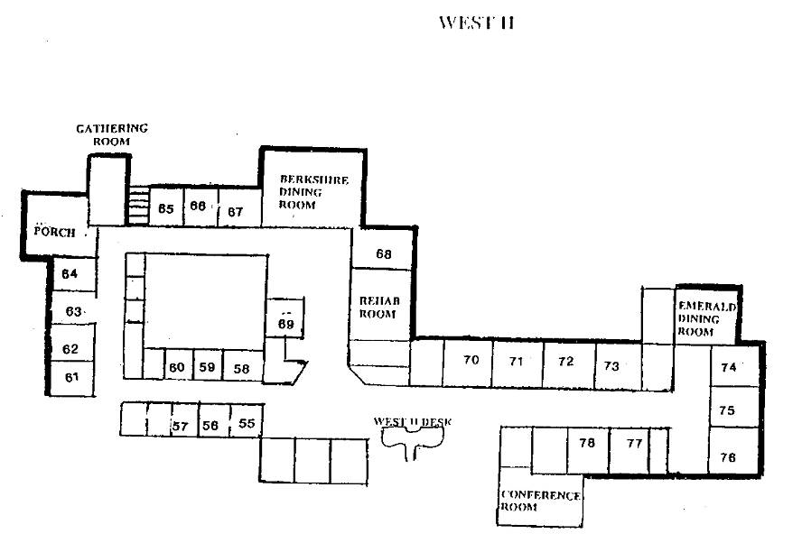
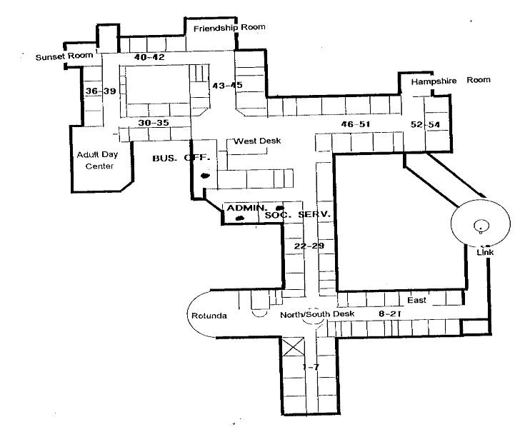
1992/1997 Wing, 1st Floor (area within dotted line box)
1967 Wing Dharma Unit (area within solid line) box)
Picture 1

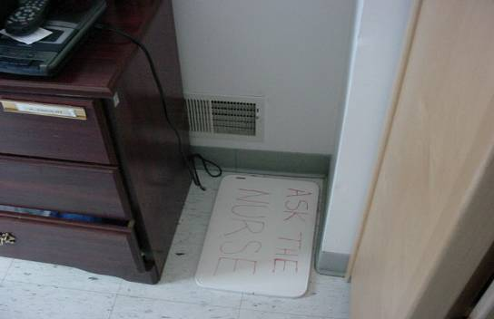

Fresh Air Supply Vent, 1992/1997 Wing

Picture 2

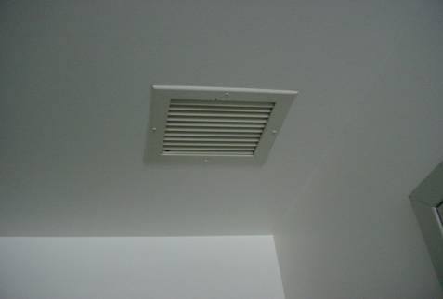

Return Air Vent, 1992/1997 Wing

Picture 3

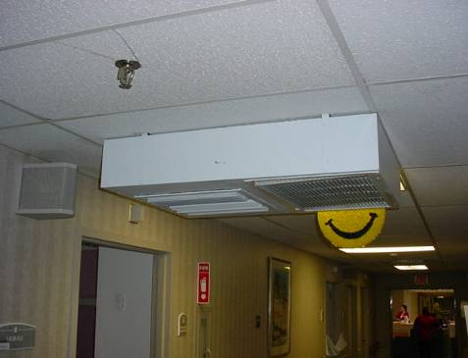

Ceiling Mounted Univent, 1967 Wing

Picture 4

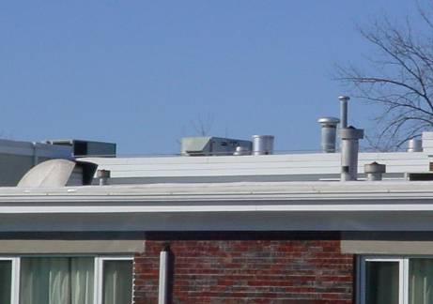

Likely Rooftop Univent Fresh Air Supply Vent, 1967 Wing
Picture 5

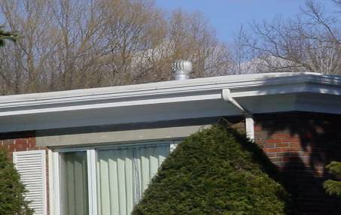

Wind Driven Turbine Vent, 1967 Wing

Picture 6

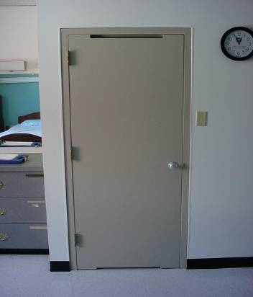

Example of Bathroom Door, 1967 Wing
Location | Carbon  Dioxide  (*ppm) | Temp  (°F) | Relative  Humidity  (%) | Occupants  in Room | Window  Openable | Ventilation |  | Remarks
 |  |  |  |  |  | Supply | Exhaust | Remarks
Outside  (Background) | 366 | 43 | 36
74 | 645 | 75 | 20 | 0 | N | Y | Y | Door open
75 | 619 | 75 | 20 | 0 | N | Y | Y | Door open
30 | 733 | 76 | 21 | 1 | N | Y | Y | Door open
33 | 767 | 76 | 21 | 0 | N | Y | Y | Door open
31 | 711 | 76 | 21 | 1 | N | Y | Y | Door open
34 | 715 | 76 | 21 | 1 | N | Y | Y | Door open
32 | 727 | 77 | 23 | 0 | N | Y | Y | Vent closed  Door open
35 | 714 | 75 | 21 | 0 | N | Y | Y | Door open
Dining room | 627 | 76 | 19 | 25 | N | Y | Y | Door open
36 | 637 | 75 | 20 | 0 | N | Y | Y | Door open
34 | 626 | 76 | 19 | 0 | N | Y | Y | Door open
33 | 726 | 77 | 21 | 1 | N | Y | Y | Door open
67 | 547 | 75 | 18 | 1 | N | Y | Y | Door open
Berkshire room | 623 | 75 | 19 | 1 | N | Y | Y | Door open
68 | 601 | 75 | 19 | 1 | N | Y | Y | Door open
Rehabilitation room | 643 | 75 | 19 | 3 | N | Y | Y
69 | 678 | 75 | 19 | 1 | N | Y | Y | Door open
70 | 698 | 75 | 20 | 1 | N | Y | Y | Door open
71 | 716 | 75 | 20 | 0 | N | Y | Y | Door open
78 | 736 | 75 | 21 | 1 | N | Y | Y | Door open
72 | 740 | 75 | 21 | 1 | N | Y | Y | Door open
73 | 731 | 75 | 20 | 1 | N | Y | Y | Door open
77 | 705 | 75 | 20 | 1 | N | Y | Y | Door open
ER | 616 | 75 | 20 | 1 | N | Y | Y | Door open
39 | 709 | 77 | 21 | 0 | Y | Y | Y | Door open
Sunset room | 932 | 77 | 22 | 13 | N | Y | Y | Door open
Keating room | 695 | 77 | 20 | 0 | N | Y | Y
40 | 647 | 76 | 20 | 1 | N | Y | Y | Door open
41 | 620 | 75 | 19 | 0 | N | Y | Y | Door open
42 | 651 | 76 | 20 | 0 | N | Y | Y | Door open
Friendship room | 636 | 76 | 20 | 0 | N | Y | Y | Door open
43 | 647 | 76 | 21 | 0 | N | Y | Y | Door open
44 | 744 | 77 | 20 | 0 | N | Y | Y | Door open
45 | 668 | 77 | 20 | 0 | N | Y | Y | Door open
47 | 687 | 78 | 20 | 0 | N | Y | Y | Door open
54 | 722 | 79 | 21 | 0 | N | Y | Y | Door open
48 | 676 | 80 | 19 | 0 | N | Y | Y | Door open
49 | 635 | 80 | 18 | 0 | N | Y | Y | Door open
53 | 653 | 80 | 18 | 1 | N | Y | Y | Door open
HR | 665 | 79 | 19 | 0 | N | Y | Y
50 | 641 | 78 | 18 | 0 | N | y | Y | Door open
51 | 645 | 78 | 18 | 0 | N | Y | Y | Door open
52 | 661 | 78 | 19 | 0 | N | Y | Y | Door open
Dining room | 693 | 79 | 18 | 0 | N | Y | Y | Door open
55 | 738 | 72 | 26 | 1 | N | Y | Y | Door open
58 | 699 | 74 | 24 | 0 | N | Y | Y | Door open
59 | 659 | 74 | 22 | 0 | N | Y | Y | Door open
56 | 657 | 75 | 22 | 0 | N | Y | Y | Door open
60 | 658 | 75 | 21 | 0 | N | Y | Y | Door open
61 | 564 | 75 | 20 | 0 | N | Y | Y | Door open
62 | 582 | 76 | 20 | 0 | N | Y | Y | Door open
63 | 516 | 76 | 18 | 0 | N | Y | Y | Door open
64 | 497 | 76 | 18 | 0 | N | Y | Y | Door open
Dining room | 532 | 75 | 18 | 0 | N | Y | Y | Door open
65 | 591 | 75 | 18 | 1 | N | Y | Y | Door open
66 | 543 | 74 | 19 | 0 | N | Y | Y | Door open
24 | 812 | 78 | 20 | 0 | N | N | Y | Door open
25 | 816 | 77 | 21 | 0 | N | N | Y | Door open
23 | 876 | 79 | 21 | 0 | N | N | Y | Door open
26 | 877 | 78 | 21 | 0 | N | N | Y | Door open
22 | 917 | 78 | 21 | 0 | N | N | Y | Door open
27 | 989 | 79 | 21 | 1 | N | N | Y | Door open
28 | 886 | 78 | 21 | 0 | N | N | Y | Door open
29 | 1093 | 78 | 22 | 0 | N | N | Y | Door open
Kentfield | 1113 | 77 | 23 | 25+ | N | Y | Y | Door open
Front desk –Nurse’s station | 1097 | 77 | 22 | 12 | N | Y | Y | Door open
2 | 1019 | 77 | 22 | 0 | N | N | Y | Door open
3 | 916 | 78 | 22 | 0 | N | N | Y | Door open
4 | 881 | 78 | 21 | 0 | N | N | Y | Door open
5 | 839 | 78 | 20 | 0 | N | N | Y | Door open
6 | 862 | 78 | 21 | 0 | N | N | Y | Door open
7 | 1176 | 77 | 22 | 1 | N | N | Y | Door open
Area off north section | 1508 | 77 | 25 | 12 | N | N | Y
14 | 545 | 75 | 18 | 0 | N | N | Y | Door open
15 | 607 | 75 | 18 | 0 | N | N | Y | Door open
16 | 602 | 76 | 20 | 0 | N | N | Y | Door open
13 | 547 | 75 | 19 | 0 | N | N | Y | Door open
17 | 579 | 75 | 20 | 0 | N | N | Y | Door open
12 | 676 | 76 | 20 | 0 | N | N | Y | Door open
11 | 653 | 77 | 20 | 0 | N | Y | Y | Door open

Location | Carbon  Dioxide  (*ppm) | Temp  (°F) | Relative  Humidity  (%) | Occupants  in Room | Windows  Openable | Ventilation |  | Remarks
 |  |  |  |  |  | Supply | Exhaust | Remarks
Outside  (Background) | 375 | 52 | 33
24 | 987 | 75 | 26 | 0 | N | N | Y | Door open  Hall ceiling univent off
25 | 1065 | 75 | 27 | 2 | N | N | Y | Door open  Hall ceiling univent off
23 | 1091 | 75 | 27 | 1 | N | N | Y | Door open  Hall ceiling univent off
26 | 1127 | 75 | 28 | 1 | N | N | Y | Door open  Hall ceiling univent off
27 | 1168 | 76 | 29 | 0 | N | N | Y | Door open  Hall ceiling univent off
2 | 1195 | 76 | 29 | 1 | N | N | Y | Door open  Hall ceiling univent off
3 | 1191 | 77 | 27 | 1 | N | N | Y | Door open  Hall ceiling univent off
4 | 1241 | 76 | 28 | 0 | N | N | Y | Door open  Hall ceiling univent off
5 | 1081 | 77 | 27 | 1 | N | N | Y | Door open  Hall ceiling univent off
6 | 1195 | 77 | 28 | 1 | N | N | Y | Door open  Hall ceiling univent off

M. G. L. c. 111: section 72. Classification of convalescent and nursing homes, infirmaries, etc.; rules and regulations; inspections; records of violations; jurisdiction.
A provision in a new law or regulation exempting those already in or a part of an existing system which is being regulated (Black’s Law Dictionary, 1979).

