INDOOR AIR QUALITY ASSESSMENT

**Centerville Elementary School**

658 Bay Lane

Centerville, MA

**November 2024**

Exterior view of Centerville Elementary School
658 Bay Lane
Centerville, MA


Prepared by:

Massachusetts Department of Public Health

Bureau of Climate and Environmental Health

Division of Environmental Health Regulations and Standards

Contents

EXECUTIVE SUMMARY 3

BACKGROUND 5

RESULTS AND DISCUSSION 6

Ventilation 6

HVAC System Maintenance 7

HVAC Types and Specific Conditions 8

Water Damage and Moisture Concerns 8

Sources of Respiratory Irritants/Possible Asthma Triggers 11

Other IAQ Issues 12

CONCLUSIONS AND RECOMMENDATIONS 13

Short-term Recommendations 13

Long-term Recommendations 18

REFERENCES 19

FIGURES 20

PICTURES 21

Ventilation Pictures 21

Water Damage pictures 28

Respiratory Irritants pictures 42

Table 1 43

Table 2A 47

Table 2B 48

Table 2C 49

Table 3 50

Table 4 52

# EXECUTIVE SUMMARY

The Massachusetts Department of Public Health’s (MDPH) Division of Environmental Health, Regulations and Standards (DEHRS) conducted an Indoor Air Quality (IAQ) assessment of Centerville Elementary School located at 658 Bay Lane in Centerville (Barnstable) on October 25, 2024. This assessment was requested by the Barnstable School District.

Any building can have IAQ issues. These issues can be made worse through conditions common to marginalized communities (Environmental Justice communities or EJ) such as inequitable exposure to outdoor air pollution and a greater likelihood of poor building conditions leading to deterioration of IAQ resulting in higher asthma rates. Centerville Elementary School is not within an EJ community, however the town of Barnstable contains 9 EJ communities (<https://matracking.ehs.state.ma.us/Environmental-Data/ej-vulnerable-health/environmental-justice.html>). Note that the pediatric asthma rate for this school as of 2023 is 7.3%. While this rate is not statistically significantly different from the statewide pediatric asthma prevalence rate, it is, however, lower than the statewide rate of 9.9% (MAEPHT, 2024).

The assessment was conducted by evaluating several key elements within the school: a visual inspection of the heating, cooling, and ventilation (HVAC) systems, water/microbial damage, cleanliness, point sources of respiratory irritants such as chemicals, and electronic measurement of carbon dioxide (CO2), carbon monoxide (CO), temperature, relative humidity (RH), and small particulate matter (PM2.5) all taken with a Qtrak XP monitor. Data is collected in this manner to identify potential asthma triggers, allergens, and other environmental factors that can cause indoor air quality symptoms. Please refer to the [Indoor Air Quality Manual](https://www.mass.gov/lists/indoor-air-quality-manual-and-appendices#indoor-air-quality-manual-) on the MDPH website for methods, sampling procedures, and interpretation of results.

It is important to note that since this school was last visited in 2013 (<https://www.mass.gov/info-details/indoor-air-quality-reports-cities-and-towns-b#barnstable->), the Barnstable School District has made the single most important commitment to improving IAQ by replacing all classroom unit ventilators. However, this school building lacks operational *mechanical ventilation* in the majority of rooms. That means limited capacity to remove both typical indoor pollutants as well as outdoor pollutants, such as vehicle exhaust, pollen, mold spores, and wildfire smoke. In addition, excess water vapor during hot, humid weather may also build up in the building and lead to water damage/mold growth to building materials. No obvious signs of mold, including visible mold growth were noted during the assessment, although a number of areas had water-damaged ceiling tiles from current or historic roof or plumbing leaks. Many of the materials used in construction of schools of this age, such as concrete, hard wood, floor tile, and brick, are resistant to mold growth. (Results and Discussion)

It is also important to note that the roof, exterior doors/frames, and many of the windows are past their service life and in need of replacement. Another noteworthy issue was the condition of the building envelope, which showed signs of damage in many areas, which can allow drafts, pests, and moisture into the building.

As a result of this assessment, there are several findings typical of elementary schools of this age and type, Upon review of these findings, a number of primary recommendations are made to optimize existing systems and improve air exchange. (Conclusions and Recommendations)

* Have the exhaust system evaluated and repaired by a professional HVAC engineering firm to increase air exchange, remove airborne pollutants, lower humidity, and increase effectiveness of HVAC systems in all rooms.
* Until the HVAC system becomes fully operational, keep at least some windows open in occupied classrooms without mechanical ventilation unless there are outdoor weather (e.g., high relative humidity > 70%; freezing weather) or pollutant conditions causing odors or occupant discomfort.
* Use air purifiers in occupied rooms that lack mechanical ventilation. Facility staff should work with occupants to place air purifiers where they will be most effective, including placing them so the filtered airstream is in the breathing zone of occupants. Units that use HEPA filters with or without carbon filters are good choices for occupied areas; units that may produce ozone should not be used. Maintain all in accordance with manufacturer’s instructions.
* Move classroom materials away from univents and exhaust vents in all rooms to ensure proper air circulation and temperature control.
* Replace the roof.
* Replace single-paned windows with modern energy efficient ones.
* Replace ill-fitting/damaged exterior doors and frames.
* Make repairs to the building envelope to restore watertight integrity.
* Install/replace gutters and downspouts to direct water away from the building.

As climate change and global warming intensifies, the urgent need for modern, energy-efficient solutions becomes clear, without significant repair of the building envelope and repair/upgrade of interior HVAC components, building conditions and indoor air quality will continue to degrade.

(Conclusions and Recommendations)

Please note: this report contains a series of recommendations that should serve as Best Practices that apply to most public-school buildings across the Commonwealth and should be shared amongst other buildings in the school district.

# BACKGROUND

|  |  |
| --- | --- |
| Building: | Centerville Elementary School (CES) |
| Address: | 658 Bay Lane,  Centerville, Massachusetts |
| Coordinated Via: | Barnstable School District, Barnstable, MA |
| Reason for Request: | General indoor air quality (IAQ) issues |
| Date of Assessment: | October 25, 2024 |
| Massachusetts Department of Public Health/Bureau of Climate and Environmental Health (MDPH/BCEH) Staff Conducting Assessment: | Cory Holmes, Environmental Analyst, Division of Environmental Health, Regulations and Standards |
| Building Description: | The CES is a one-story brick building that was built the 1950s; a two-story addition was constructed in the 1970s. The building contains general classrooms, library, kitchen, cafeteria, gymnasium, faculty workrooms/lounge and office space. |
| Windows: | Windows in the building are openable. |

# RESULTS AND DISCUSSION

The following is a summary of indoor air testing results (Table 1)

|  |  |  |
| --- | --- | --- |
| * ***Carbon dioxide (CO2)*** | *a measure of the adequacy of ventilation* | Levels were above the MDPH guideline of 800 parts per million (ppm) in 12 of the 31 areas surveyed, indicating a lack of air exchange in some areas. This is likely due to the lack of operational mechanical ventilation in most areas of the school. |
| * ***Temperature*** | *a measure of comfort* | Was mostly within/close to the MDPH recommended range of 70°F to 78°F in occupied areas. |
| * ***Relative humidity*** | *a measure of comfort and, when in excess for an extended period, a way to reflect the potential for mold and fungal growth* | Was within the MDPH recommended range of 40 to 60% in most areas tested. This is reflective of outdoor conditions. Relative humidity would be expected to be higher during hot, humid weather, with a non-operational mechanical ventilation system. |
| * ***Carbon monoxide***   ***(CO)*** | *a product of combustion that can result in acute and long term cardiovascular, respiratory, and neurological symptoms* | Levels were non-detect (ND) in all areas tested. |
| * ***Particulate matter (PM2.5)*** | *a way to measure inhalable particle distribution in the air* | Concentrations were below the National Ambient Air Quality Standard (NAAQS) of 35 micrograms per cubic meter (μg/m3) in all areas tested. |

## Ventilation

Ventilation refers to both the supply of fresh air and the removal of stale air from a room. The introduction of fresh air into an occupied space will dilute normally occurring pollutants that are generated by occupancy and other activities. In addition, an HVAC system will remove pollutants from a building if operating appropriately. All ventilation systems throughout the building should operate continuously during periods of occupancy.

Most classrooms are equipped with unit ventilators (univent, Picture 1). Univents bring in fresh air from a vent on the outside of the building (Picture 2), filter, heat it, and supply the air through a vent on the top. Some room air is recirculated along with the fresh air through a vent at the bottom (Figure 1). The univents are reported to be controlled by a computerized management system.

Digital thermostats mounted near the hallway door had several parameters listed including carbon dioxide, and relative humidity (Picture 3). The measurement of carbon dioxide is important to adjust outdoor air intake by opening dampers and increasing the fresh air percentage. It was not known at what “trigger” the carbon dioxide sensors were set to. In addition, it is important to note that gas-measuring sensors should be calibrated or replaced per the manufacturers’ instructions to ensure accuracy. It was not clear when the last date of calibration was.

Mechanical ventilation to the gymnasium is provided by an air handling unit located in the corner of the gym (Picture 4). The AHU draws in air from the outside, heats it and distributes it via a wall-mounted vent near the ceiling. A corresponding return vent draws air back into the unit at the floor level. With both supply and return air being introduced and removed from the same corner of the gymnasium, it leads to an issue called short-circuiting (Picture 5). However, across the gym is a wall-mounted exhaust vent that was not functioning (Picture 6). If this exhaust vent could be activated, it would help pull air across the room for more even distribution.

At the time of assessment, exhaust ventilation in most rooms was not operating. It was not known whether these vents were not functional or just deactivated. Exhaust vents in classrooms are located in coat closets (Picture 7) or are wall-mounted (Picture 8). In a number of areas wall mounted exhaust vents were found obstructed by classroom furniture and other items (Pictures 8 and 9). Without proper supply and exhaust ventilation, normally occurring environmental pollutants can build up and lead to indoor air quality/comfort complaints. In addition, without proper exhaust ventilation, excess moisture cannot be removed from the building, which can lead to mold growth conditions over the summer.

One area that did not have upgraded mechanical ventilation was the kitchen. MDPH staff found the unit located at the rear of the cafeteria disconnected and abandoned (Picture 10). Without mechanical ventilation, the only way to introduce fresh air into the kitchen area is via openable windows, which can be limited during periods of heat and high relative humidity, or during winter months due to freezing temperatures.

Cooling is provided in some rooms by wall-mounted mini-split/ductless air conditioners (Picture 11), and in others by portable air conditioners.

The various types of ventilation components as well as devices that can move/redirect airflow that were identified in the building are listed in Table 2A, Table 2B and Table 2C.

### HVAC System Maintenance

* MDPH recommends that filters of at least a Minimum Efficiency Rating Value (MERV) 8 be used as these are adequate to filter out pollen, mold, and similar particulates (ASHRAE, 2012). A univent was opened and the filter examined. Filters used in univents are pleated MERV 8, (Picture 12).
* **It was reported that MERV filters are replaced annually**. MDPH recommends that filters be changed two to four times a year or as per the manufacturers’ recommendations.
* **Some of the univents were obstructed by items in front of return vents** (Picture 13) or along the top. To provide mechanical ventilation as designed and to prevent damage to machinery, both the supply and return vents (along the front/bottom of the unit) should be free and clear of obstructions.

**Balancing**

To have proper ventilation with a mechanical supply and exhaust system, a system must be balanced to provide an adequate amount of fresh air to the interior of a room while also removing stale air from the room. It is recommended that HVAC systems be re-balanced every five years to ensure adequate air systems function (SMACNA, 1994).

### HVAC Types and Specific Conditions

(see Ventilation pictures)

**Additional HVAC Conditions:**

* **The newly created lactation room does not have an openable window and is not equipped with mechanical supply and exhaust ventilation.** MDPH staff recommend installing a passive make-up air vent in the door and tapping into the ceiling exhaust in the adjacent custodial closet for air exchange**.**
* **It was not clear if the local exhaust hood for the kitchen was operable.**
* **Air purifiers were also found in classrooms (Picture 14).** Air purifiers should be placed away from walls to ensure proper air intake.
* **An abandoned local exhaust vent was observed in the ceiling of the Teacher’s Room (Picture 15).** This vent possibly served as a smoking vent from decades ago (as suggested by reports of cigarette odors). Although the vent is likely not operational, replacement with a *local exhaust* vent should be considered for the photocopiers and lamination machines that are in use in this area to remove excess heat, particulates, and odors**.**

## Water Damage and Moisture Concerns

Please note that the MDPH does not recommend conducting mold testing in a typical water damage remediation. For details, please consult [Guidance Regarding Testing for Mold in Water-Damaged Public Buildings](https://www.mass.gov/info-details/guidance-regarding-testing-for-mold-in-water-damaged-public-buildings) | Mass.gov

The application of a mildewcide to moldy porous materials is not recommended.

Molds are found naturally in our environment both indoors and outdoors. Inside, mold growth may occur when items, particularly porous products such as paper or gypsum wallboard, are exposed to moisture. Typical water sources include leaks, floods, and condensation. To avoid mold growth, dry all water-damaged items and affected areas within 24-48 hours and reduce indoor humidity. Some people with chronic respiratory conditions, such as asthma, are more likely to experience health symptoms associated with molds, including allergic reactions and respiratory irritation. Controlling moisture is the key to preventing mold growth and potential health symptoms.

Hot humid summers are becoming more frequent due to climate change. Massachusetts has experienced hot, humid, and rainy summers in 2018, 2021, and 2023. July of 2021 was the wettest ever recorded in Massachusetts, and the three-month period from June through August, known as the meteorological summer, was the fourth wettest on record, according to the National Oceanic and Atmospheric Administration’s (NOAA) Centers for Environmental Information (NOAA, 2021). The summer of 2023 was also hot, and wet, being measured as the second rainiest on record (WBUR, 2023). The summer of 2024 has also had significant stretches of hot, humid weather. These conditions are challenging for buildings, particularly those without central air conditioning.

During these hot and wet summers, extended periods of outdoor relative humidity above 70% occurred. Under these weather periods, public buildings experienced extended periods of water vapor exposure from high relative humidity. When exposed to these conditions, porous materials such as gypsum wallboard, cardboard, and other materials may become prone to developing mold colonization, particularly if located in areas that are prone to developing condensation on floors and walls (e.g., below grade space).

It was reported that a number of proactive actions were taken recently and over the summer by Administrative and Custodial staff to reduce moisture/leaks, monitor conditions, and help prevent mold growth in the building. These included:

* Frequent walkthroughs of the building, particularly after rain events;
* The deployment of dehumidifiers in classrooms most susceptible to moisture. These dehumidifiers are stationed on countertops to allow continous drainage into sink drains;
* Professional cleaning of area rugs;
* The use of MERV 8 filters in univents, which is adequate to filter out pollen and mold spores (ASHRAE, 2012);
* Making high-efficiency particulate arrestance (HEPA) air purifiers available for use. These remove up to 99% of airborne contaminants as small as 0.1 microns including airborne mold spores;
* Replacement of leaking plumbing fixtures and remediation of water-damaged materials in the 1st floor boys bathroom;
* Trimming back of shrubbery, trees, and large branches around the building, and
* Adding a new roof for this building to a capital repair list.

In addition to these steps, the digital thermostats are part of a computerized management system. This computerized system should be utilized to monitor *real-time measurements* for temperature and relative humidity to track trends and take actions to prevent excess moisture conditions that can lead to mold growth over summer months.

All rooms were assessed for the presence of either mold or visible water damage and an exterior evaluation was conducted to identify potential pathways for water penetraion. The following issues were noted.

* **Water-damaged ceiling tiles were found in several locations (Table 1),** which can indicate current/historic roof/plumbing leaks or other water infiltration. Water-damaged ceiling tiles can provide a source of mold and should be replaced after a water leak is discovered and repaired. Suspended ceiling tiles (Picture 16) should be discarded and replaced. Some ceiling tiles are of a type that are adhered directly to the ceiling substrate (Picture 17). These tiles are difficult to replace and necessitate the destruction of the tile. Furthermore, replacement tiles are most likely obsolete and difficult to obtain.
* **Bowed or sagging ceiling tiles were found in some locations** (Picture 18), particularly along the rear (shaded) side of the building.This is likely the result of moisture exposure from elevated relative humidity conditions. While bowing tiles are not a direct IAQ issue, it is a reminder that long periods of high relative humidity may lead to water damage to other materials, particularly those stored in contact with cooler temperatures such as on uninsulated floors, and in the airstream of air conditioning.
* **Ductless mini-split air conditioners create condensation which needs to be drained.** Drain tubing and associated pumps should be checked periodically to prevent leaks due to clogs or malfunctions. Porous items should not be stored underneath these units.
* **Room 6 had missing/damaged caulking around the sink** (Picture 19), which can lead to water damage and mold growth underneath.
* **The gymnasium had accumulations of dust and debris along the surface of the wall panels near the ceiling** (Picture 20). Although these wall panels are made of a non-porous material that would be resistant to mold growth, the textured surface of the panels make them prone to accumulate debris, including naturally occurring mold spores that can grow if moistened repeatedly, such as during elevated relative humidity conditions over the summer.
* **Musty odors were detected in the gymnasium, which may be due to the curtain mounted on the stage** (Picture 21). It was not known when the last time the curtain was removed and laundered. Porous materials can accumulate dust/debris and absorb moisture over summer months and provide a source for mold growth or musty odors.
* **Missing/damaged mortar around brickwork needs repointing** in several areas (Picture 22).
* **A breach exists around the exterior access door underneath the stairs across from the Staff Room.** This breach was temporarily sealed with tape (Picture 23), to prevent uncontrolled drafts, moisture, and pest entry.
* **Exterior doors/frames were corroded and damaged** creating gaps that allow for uncontrolled drafts, moisture, and pest entry (Pictures 24 through 26). These conditions can make it difficult to control temperature leading to comfort complaints and condensation issues that can lead to mold growth.
* **The** **roof is past its life expectancy and is need of replacement** (Pictures 27 and 28).
* **Window frames along the front of the building have been replaced.** The remainder of the building has original, single-paned windows that are not energy efficient and in need of replacement.
* **Damaged wood and delaminating paint were found along the roof eaves, trim, and exterior walls**, which can accelerate water damage and rot (Pictures 29 through 35) allowing a pathway for drafts, moisture, and pest entry into the building.
* **Clogged gutters and overhanging branches** were noted near the roof/exterior walls (Pictures 36 and 37).
* **Missing/damaged gutters and downspouts were noted** (Pictures 38 through 40).
* **A clogged drain was found at the bottom of the boiler room stairwell** (Picture 41).
* **Missing/damaged caulking/sealant around univent fresh air intakes was noted in several areas** (Picture 42).

A list of water damage issues identified inside and outside the building is included as Table 3.

(see Water Damage Pictures)

**Mold Growth**

Porous materials (e.g., gypsum wallboard, ceiling tiles and carpeting) can be dried with fans and heating within 24 to 48 hours of becoming wet (US EPA, 2008).

If porous materials are not dried within this time frame, mold growth may occur.

## Sources of Respiratory Irritants/Possible Asthma Triggers

Asthma is a lung disease that can make breathing difficult. Without careful management of asthma, some people can have symptoms, like a tight feeling in the chest, shortness of breath, coughing, or wheezing. Although there is no cure for asthma, people with asthma can live healthy, active lives. A safe and healthy environment helps to reduce asthma symptoms.

**Comparison of Local and State-wide Asthma Rates (2023)**

7.3% of children

have asthma.

**Centerville ES**

9.9% of children

have asthma.

**Massachusetts**

7.4% of children

have asthma.

**Barnstable**

* **Sometimes, learning tools and personal items in a classroom can be a source of irritants.** For example, a bird or insect nest is a great learning tool for students but may harbor microbes and allergens, as does a fish tank which could be a source of odors. Similarly, food-based projects can attract pests that carry disease or trigger allergies.
* **Dust, a common respiratory and eye irritant, can collect on surfaces and items.** Although janitorial and maintenance staff perform routine cleaning in classrooms, they may not be able to clean as effectively if classroom items are not picked up or surfaces are cluttered.
* Even with a properly functioning ventilation system, it is necessary to reduce the use of materials that can be a source of respiratory irritants to prevent symptoms in individuals who have sensitivity to such pollutants. **Without operational mechanical exhaust in most areas, irritants can linger.**

For guidance on maintaining an asthma-friendly healthy school environment, please consult the MDPH Asthma Prevention and Control Program’s [Clearing the Air: An Asthma Toolkit for Healthy Schools](https://www.maasthma.org/schooltoolkit).

Possible asthma triggers and/or airborne pollutants exist in the building. These are listed below as well as in (Table 4).

(see Sources of Respiratory Irritant Pictures)

* **Many classrooms had area rugs (Table 1), which are reportedly cleaned over summer months.** Area rugs need to be cleaned regularly to remove dust, debris, and odors. Area rugs should be stored off the floor in a climate-controlled area during the summer to prevent moistening by condensation. Used area rugs should not be brought into the school as they may harbor allergens such as pet dander.
* **An emergency generator was stationed outside the building awaiting hookup** (Picture 43). It is important to note the area of installation and its proximity to openable windows and fresh air intakes. The generator should be set using automatic startup timers for after hours or weekends to prevent exposure to exhaust emissions and noise.
* **Classroom 4 (OT/PT) had damage to the base of the exterior wall** (Picture 44). This breach can serve as a pathway for drafts, particulates, or odors from the wall cavity into the building.
* **Exposure to low levels of total volatile organic compounds (TVOCs)** may produce eye, nose, throat, and/or respiratory irritation in some sensitive individuals. Testing for TVOCs was not conducted, however MDPH staff examined rooms for products containing VOCs. MDPH staff noted hand sanitizers, cleaners, and dry erase materials (Table 1) in use within the building. These products have the potential to be irritants to the eyes, nose, throat, and respiratory system of sensitive individuals. Consult “[Clean Air Is Odor Free](https://www.mass.gov/doc/clean-air-is-odor-free-removing-fragrances-to-improve-indoor-air-quality-in-schools-and-offices-0/download)” for more information on fragrances in schools and other building.

## Other IAQ Issues

*Radon*

Radon is a naturally occurring radioactive gas that seeps into buildings from the surrounding soil and at elevated levels can increase the risk of lung cancer.

The Environmental Protection Agency (EPA) conducted a National School Radon Survey “in which it discovered nearly one in five schools has at least one schoolroom with a short-term radon level above the action level of 4pCi/L (picocuries per liter) – the level at which the EPA recommends that schools take action to reduce the level” (US EPA, 1993).

**The MDPH therefore recommends that every school be tested for radon, and that this testing be conducted during the heating season while school is in session in a manner consistent with US EPA radon testing guidelines**. Radon measurement specialists and other information can be found at [www.nrsb.org](http://www.nrsb.org) and <http://aarst-nrpp.com/wp>, with additional information at: <https://www.mass.gov/radon>.

# CONCLUSIONS AND RECOMMENDATIONS

Please note: this report contains a series of recommendations that should serve as *Best Practices* that apply to most public-school buildings across the Commonwealth and should be shared amongst other buildings in the Barnstable School District.

Issues typical to many schools were found in this building. However, the lack of operational mechanical ventilation in most classrooms makes controlling temperature, humidity, and airborne contaminants significantly more difficult. Facility staff and occupants need to remain aware of the limitations of the system and use open windows and portable air conditioners to the best that they can be used. If the HVAC system becomes operational, the age of the equipment will make controlling the temperature and airflow more difficult as time goes on.

**Short-term recommendations** can be implemented as soon as practicable, however **long-term measures** are more complex and will require planning and resources to adequately address overall indoor air quality issues within the building.

|  |  |  |  |
| --- | --- | --- | --- |
| Short-term Recommendations | | | |
|  | **HVAC System** | | **Helpful Links** |
|  | Have the mechanical exhaust systems evaluated building-wide (e.g., classrooms, kitchen hood, restrooms) for operation and repair. |  | |
|  | Reactivate exhaust vent on wall of gym opposite the AHU/stage area to facilitate air exchange. |  | |
| 1. If | Ensure all univents are on and operating continuously during occupied periods. If univent fan operation is linked to thermostat, work with HVAC vendor to determine a set point to introduce outside air (e.g., 800 ppm carbon dioxide). |  | |
|  | Ensure carbon dioxide sensors are calibrated or replaced periodically per the manufacturers’ recommendations to ensure accuracy. |  | |
|  | Operate windows in occupied classrooms without operational mechanical ventilation unless contraindicated by outdoor conditions or occupant concerns. Such conditions may include heavy precipitation, extreme cold, poor outdoor air quality, high pollen counts, idling vehicles, or excessive noise. | <https://www.airnow.gov/> | |
|  | Ensure windows are closed tightly at the end of the day as well as during periods of elevated relative humidity (70%) and during freezing weather to prevent pipe bursts. |  | |
|  | Use air purifiers, and place them so the filtered airstream is in the breathing zone of occupants. |  | |
|  | Air purifiers that use HEPA filters, with or without carbon filters, are good choices for occupied areas. Units that may produce ozone should not be used. Maintain all in accordance with manufacturer’s instructions. | <https://www.epa.gov/indoor-air-quality-iaq/ozone-generators-are-sold-air-cleaners> | |
|  | Change HVAC filters 2-4 times a year using MERV 8 or the best MERV-rating that can work with current equipment. | [ANSI/ASHRAE Standard 52.2-2017](https://www.ashrae.org/File%20Library/Technical%20Resources/COVID-19/52_2_2017_COVID-19_20200401.pdf) | |
|  | During filter changes, clean dust and debris from the inside of HVAC system cabinets. |  | |
|  | Clean dust and debris from vents and personal fans periodically. |  | |
|  | Clean and maintain mini-splits in accordance with manufacturers’ instructions. |  | |
|  | Restore local exhaust vent in Staff Room to remove access heat and odors from photocopiers and lamination machines. |  | |
|  | Remove blockages from univents and exhaust vents. |  | |
|  | Restore mechanical ventilation to kitchen area. |  | |
|  | Consider providing mechanical supply and exhaust ventilation in the lactation room. As an interim measure consider installing a passive make-up air vent in the door and tapping into the adjacent exhaust vent for the custodial closet to provide air exchange. |  | |
|  | Close classroom doors for more effective operation of exhaust vents/air exchange. |  | |
|  | Once mechanical exhaust systems are repaired/activated, have the HVAC system balanced if it has been more than 5 years since the last balancing. |  | |

|  |  |  |
| --- | --- | --- |
|  | **Water damage** | |
|  | Replace water-damaged suspended ceiling tiles. Repeated water damage to ceiling tiles indicates leaks from the roof or plumbing/HVAC system which should be repaired. | <http://www.epa.gov/mold/mold-remediation-schools-and-commercial-buildings-guide> |
|  | Until roof can be replaced continue to monitor for roof leaks and make repairs as needed. |  |
|  | Use the computerized HVAC management system to monitor real-time measurements for temperature and relative humidity to track trends and take actions to prevent excess moisture conditions that can lead to mold growth. |  |
|  | Do not store books, cardboard, or other porous items directly on ground-level floors or up against walls to prevent mold growth due to condensation on cool surfaces, Elevate items with pallets or store on shelving. |  |
|  | Seal spaces in and around exterior doors with weatherstripping, to prevent drafts, moisture, and pest entry. |  |
|  | Properly maintain plants to avoid mold and odors. Keep plants away from airflow. |  |
|  | Use these guidelines to control for moisture and increase comfort in a non-air-conditioned school especially during heatwaves. | * Mold Growth Prevention During Hot, Humid Weather <https://www.mass.gov/service-details/preventing-mold-growth-in-massachusetts-schools-during-hot-humid-weather> * Remediation and Prevention of Mold Growth and Water Damage in Public Schools <https://www.mass.gov/service-details/remediation-and-prevention-of-mold-growth-and-water-damage-in-public-schools-and> * Methods for Increasing Comfort in Non-air-conditioned Schools <https://www.mass.gov/doc/methods-for-increasing-comfort-in-non-air-conditioned-schools/download> |
|  | While bowed/sagging ceiling tiles are not a source of mold, they indicate extended exposure to high humidity. Therefore, care should be taken with storage of materials in these areas during hot, humid weather and over the summer. |  |
|  | During summer months, pull furniture away (1 to 2 inches) from walls to prevent mold growth due to lack of airflow and remove impermeable wall coverings that can trap moisture such as laminated posters. |  |
|  | Clean tabletop water fountains regularly to prevent odors and use water with low minerals such as deionized or distilled water so as not to leave mineral particles in the air. |  |
|  | Trim trees, branches, and shrubbery at least 5 feet away from the building. |  |
|  | Conduct a thorough building envelope evaluation to make repairs/repointing efforts to eliminate leaks. Building occupants should ensure they report active leaks to building management for investigation and repairs. |  |
|  | Replace missing/damaged caulking around univent air intakes. |  |
|  | Install/replace weather-stripping around exterior doors. |  |
|  | Clean out gutters and inspect periodically for proper drainage. |  |
|  | Make repairs to breach around access door across from Staff Room (Picture 23). |  |
|  | Make repairs to caulking around sink in Classroom 6. |  |
|  | Ensure boiler room drain at bottom of stairwell is clear and draining properly. |  |
|  | **Respiratory Irritants/Possible Asthma Triggers** | |
|  | Clean dust from surfaces, including chalk and dry erase dust, frequently using methods that do not aerosolize the dust, including HEPA-equipped vacuuming or wet wiping. Avoid using feather dusters or sweeping dust into the air. |  |
|  | Replace or launder gym curtain. |  |
|  | Clean accumulated dust/debris from gym wall panels near ceiling. |  |
|  | Reduce clutter. Periodically remove unwanted items. Store remaining items neatly and off the floor. Where rooms have a history of moisture issues, consider storing items in waterproof totes. |  |
|  | Reduce use of products and equipment that create irritating volatile organic compounds (VOCs) and only use in well-ventilated areas. Minimize the use of air fresheners (e.g., plug-ins), deodorizers and scented products. | <https://www.mass.gov/cleaner-greener-healthier-schools>  [Clean Air Is Odor Free](https://www.mass.gov/doc/clean-air-is-odor-free-removing-fragrances-to-improve-indoor-air-quality-in-schools-and-offices-0/download) |
|  | Use only District-approved cleaning products. Keep spray bottles properly labeled and out of the reach of children. |  |
|  | Clean area rugs frequently using a HEPA-equipped vacuum cleaner. Avoid bringing used area rugs into the school. |  |
|  | Clean classroom learning tools like fish tanks regularly to prevent odors. |  |
|  | Set timer for emergency generator to test during unoccupied periods to prevent entrainment of exhaust emissions during occupied periods. |  |
|  | Make repairs to damaged wall in Classroom 4 (OT/PT). |  |
|  | **Other Recommendations to Improve Air Quality Conditions** | |
|  | Test the school for radon by a certified radon measurement specialist during the heating season when school is in session. | Radon measurement specialists and other information can be found at: [www.nrsb.org](http://www.nrsb.org), and <http://aarst-nrpp.com/wp> |
|  | To learn more about radon, review the MDPH’s Radon in Schools and Childcare Programs factsheet. | <https://www.mass.gov/radon>. |
|  | Utilize the US EPA’s (2000), “Tools for Schools” as an instrument for maintaining a good IAQ environment in the building. | <https://www.epa.gov/iaq-schools>. |
|  | For guidance on maintaining an asthma-friendly healthy school environment, please consult the MDPH Asthma Prevention and Control Program’s Clearing the Air: An Asthma Toolkit for Healthy Schools. | <https://www.maasthma.org/schooltoolkit> |
|  | Include an IAQ component in the school’s Wellness Advisory Committee program. An IAQ plan should have an IAQ liaison/teacher representative, a member of maintenance/facilities and administration that conduct regular walk-throughs to identify on-going and/or potential environmental issues. |  |
|  | Long-term Recommendations | |
|  | Continue with plans for roof replacement. |  |
|  | Replace single-paned windows that are beyond their service life. |  |
|  | Replace exterior doors and frames that are damaged and/or beyond their service life. |  |
|  | Replace gutters and downspouts to provide proper drainage away from the building. |  |

# REFERENCES

ASHRAE. 2012. American Society of Heating, Refrigeration and Air Conditioning Engineers (ASHRAE) Standard 52.2-2012 -- Method of Testing General Ventilation Air-Cleaning Devices for Removal Efficiency by Particle Size (ANSI Approved).

MAEPHT. 2024. Massachusetts Environmental Public Health Tracking. Massachusetts Department of Public Health – Bureau of Climate and Environmental Health. <https://matracking.ehs.state.ma.us/>

NOAA. 2021. Summer 2021 neck and neck with Dust Bowl summer for hottest on record. National Oceanic and Atmospheric Administration, 1401 Constitution Avenue NW, Room 5128, Washington, DC 20230 <https://www.noaa.gov/news/summer-2021-neck-and-neck-with-dust-bowl-summer-for-hottest-on-record>

SMACNA. 1994. HVAC Systems Commissioning Manual. 1st ed. Sheet Metal and Air Conditioning Contractors’ National Association, Inc., Chantilly, VA.

US EPA. 1993. Radon Measurement in Schools, Revised Edition. Office of Air and Radiation, Office of Radiation and Indoor Air, Indoor Environments Division (6609J). EPA 402-R-92-014.

US EPA. 2000. Tools for Schools. Office of Air and Radiation, Office of Radiation and Indoor Air, Indoor Environments Division (6609J). EPA 402-K-95-001, Second Edition. <https://www.epa.gov/iaq-schools>.

US EPA. 2008. Mold Remediation in Schools and Commercial Buildings. US Environmental Protection Agency, Office of Air and Radiation, Indoor Environments Division, Washington, D.C. EPA 402-K-01-001. <http://www.epa.gov/mold/mold-remediation-schools-and-commercial-buildings-guide>.

WBUR. 2023. “It’s been a summer of rain and flooding misery in Mass.” WBUR local news. September 12, 2023. <https://www.wbur.org/news/2023/09/12/summer-flooding-rain-massachusetts>

(Click to link back to report)

# FIGURES

**Figure 1**

**Unit Ventilator (Univent)**

Mixed Air

Air Diffuser

**Outdoors Indoors**

Fan

Heating/Cooling Coil

Air Mixing Plenum

Filter

Outdoor Return

Air Air

Air

Flow

Control

Louvers

**Air Flow**

= Fresh Air/Return Air

= Mixed Air

# PICTURES

## Ventilation Pictures

**Picture 1**

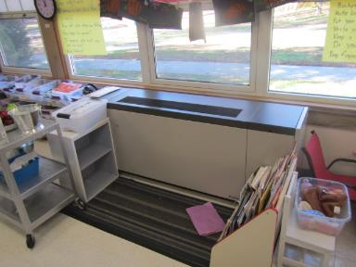

**Univent in classroom**

**Picture 2**

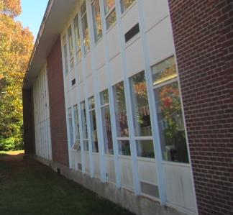

**Univent fresh air intakes (arrows)**

**Picture 3**

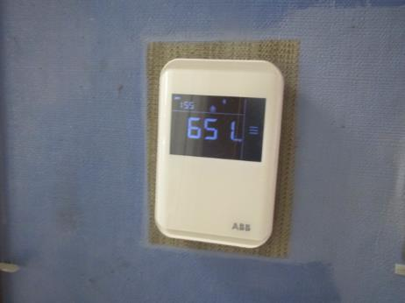

**Digital Thermostat displaying carbon dioxide measurement in parts per million**

**Picture 4**

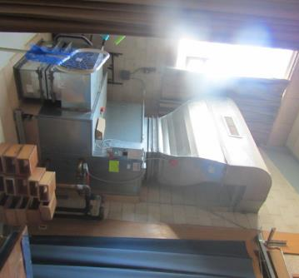

**Air handling unit in corner of gymnasium (stage view)**

**Picture 5**

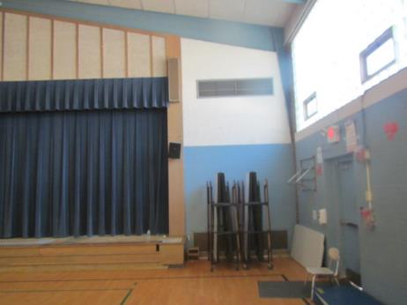

**Short-circuiting of AHU in gymnasium, arrow shows airflow**

**Picture 6**

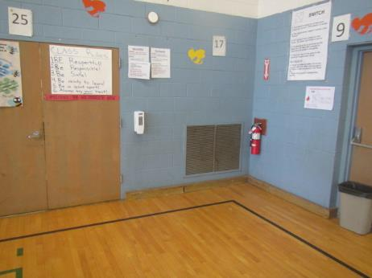

**Exhaust vent on wall of Gym across from the AHU**

**Picture 7**

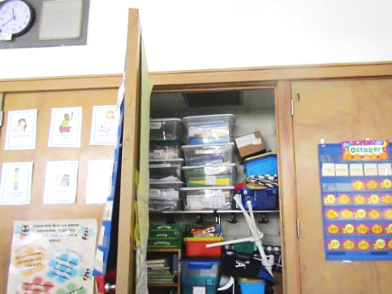

**Exhaust vent in the top of coat closet (arrow)**

**Picture 8**

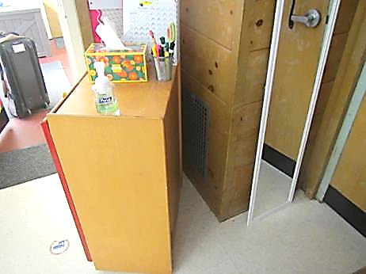

**Wall-mounted exhaust vent (arrow) behind bookcase in classroom**

**Picture 9**

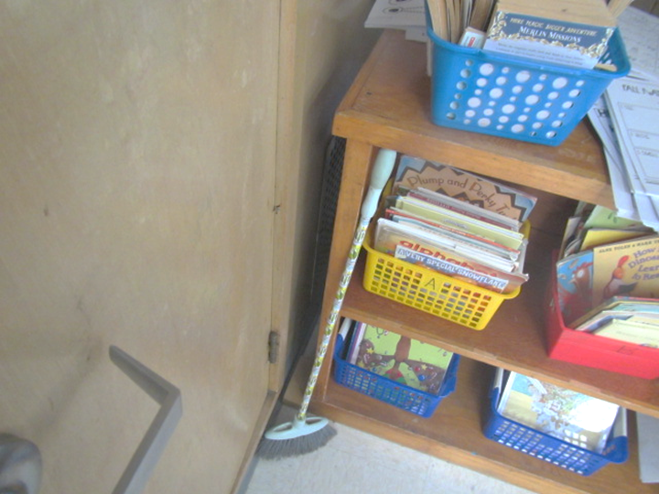

**Exhaust vent behind shelf in classroom (arrow)**

**Picture 10**

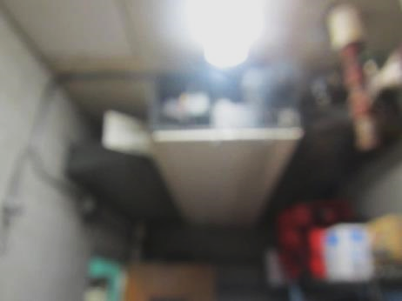

**Abandoned/disconnected univent in kitchen area**

**Picture 11**

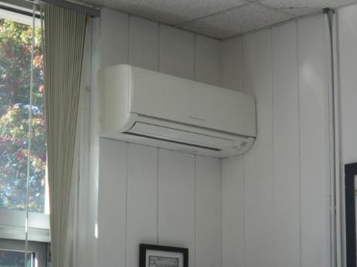

**Wall-mounted mini-split**

**Picture 12**

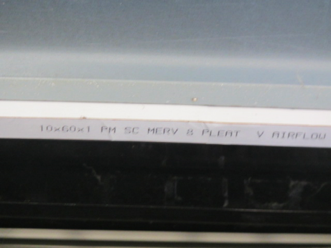

**MERV 8 filter in classroom univent**

**Picture 13**

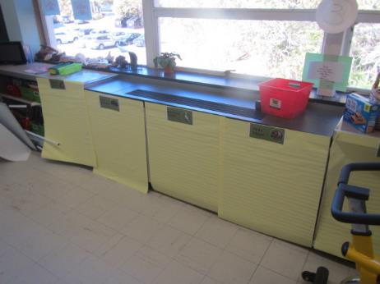

**Univent return vent (bottom front) obstructed by paper preventing airflow into unit**

**Picture 14**

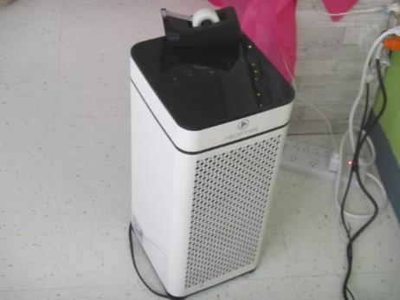

**Air purifier in classroom**

**Picture 15**

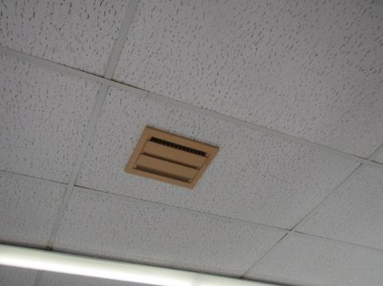

**Abandoned vent in ceiling of Teacher’s Room (possible former *smoking* vent)**

## Water Damage pictures

Picture 16

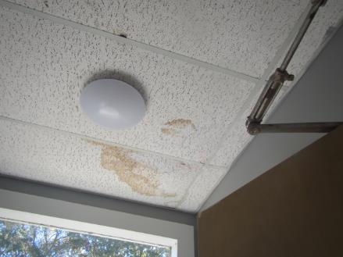

Water-damaged *suspended* ceiling tile

Picture 17

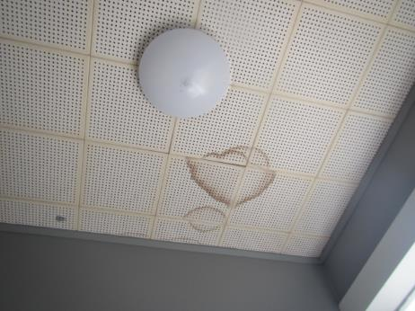

Water-damaged original ceiling tiles *adhered directly* to ceiling substrate

Picture 18

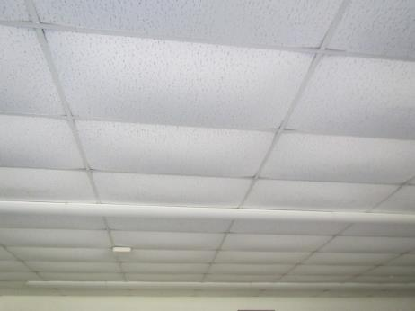

Bowed ceiling tiles in classroom

Picture 19

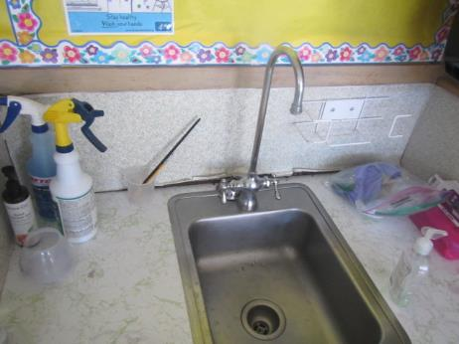

Missing/damaged caulking around sink in Classroom 6

Picture 20

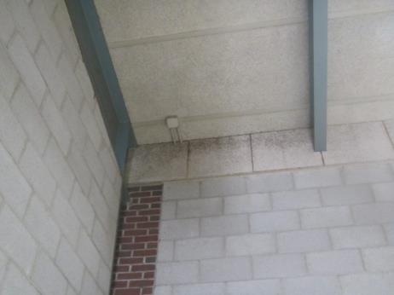

Dark staining on wall panels indicating accumulated dust/debris near ceiling of gymnasium

Picture 21

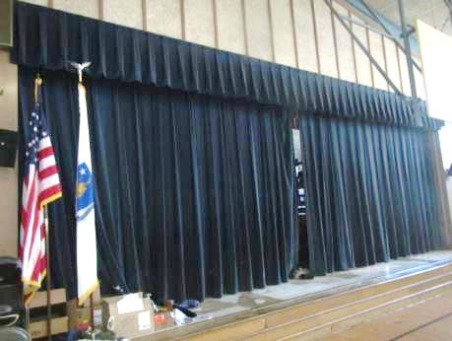

Curtain in gymnasium

Picture 22

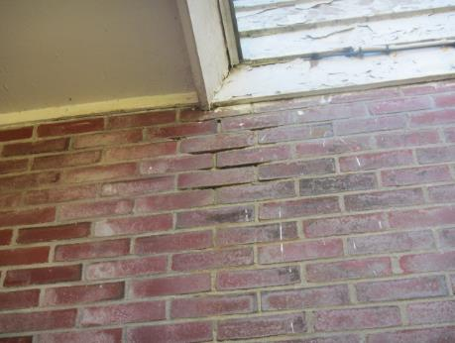

Missing/damaged mortar around exterior brick

Picture 23

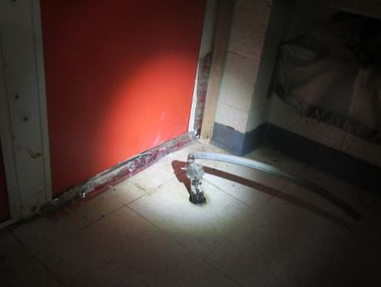

Breach around exterior door under stairwell across from Staff Room

Picture 24

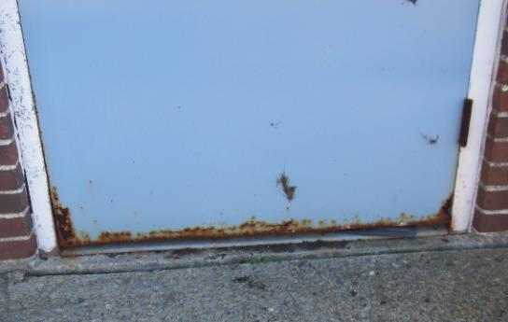

Corroded exterior door, note damaged weatherstripping below (arrow)

Picture 25

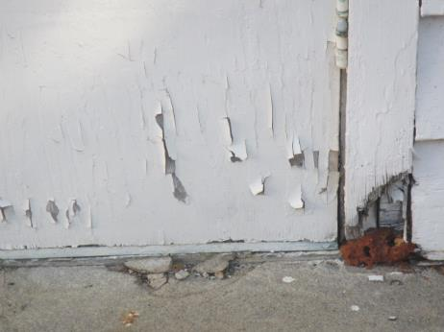

Rotted door frame (filled with foam) and delaminating exterior door

Picture 26

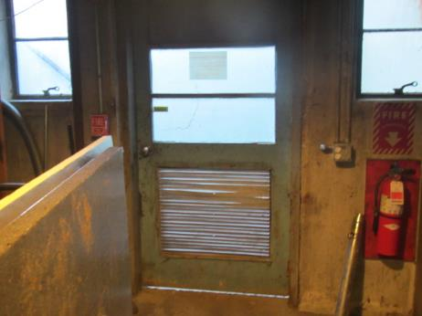

Light penetrating through damaged vent and below exterior door

Picture 27

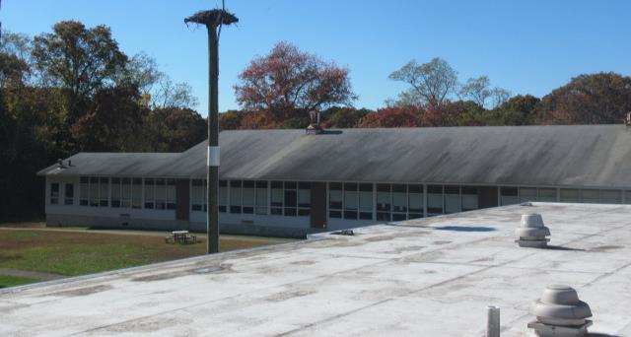

Roof is past its life expectancy and is need of replacement

Picture 28

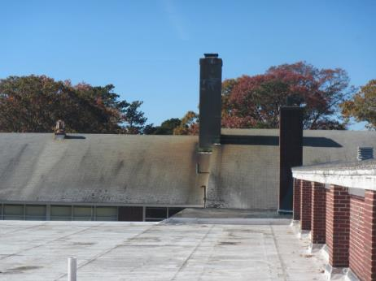

Roof is past its life expectancy and is need of replacement

Picture 29

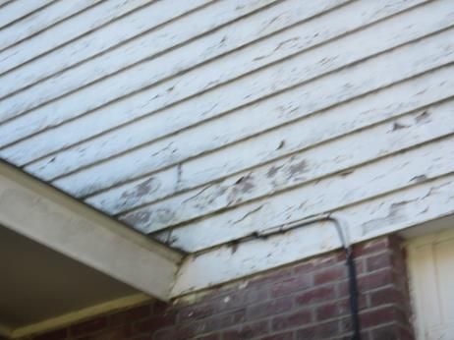

Rotted/delaminating wood along roof/exterior walls

Picture 30

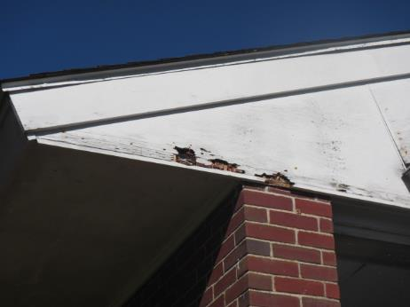

Rotted/delaminating wood along roof

Picture 31

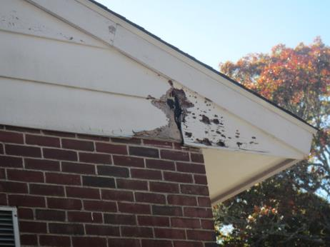

Rotted/delaminating wood along roof

Picture 32

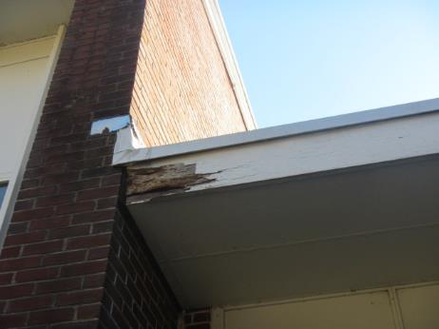

Rotted/delaminating wood along roof

Picture 33

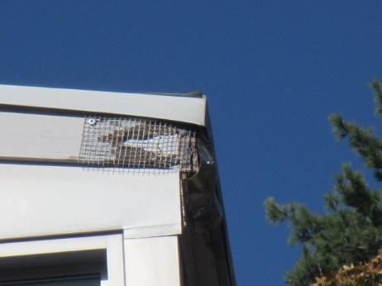

Rotted/delaminating wood along roof

Picture 34

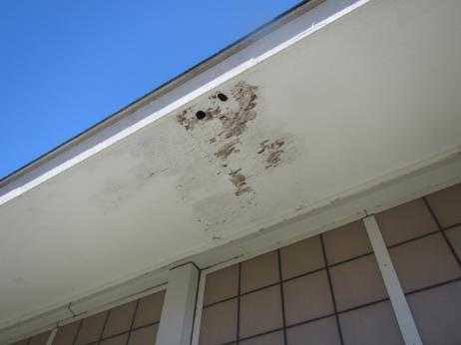

Rotted/delaminating wood along roof

Picture 35

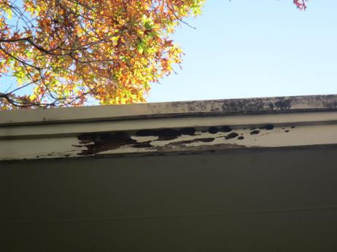

Rotted/delaminating wood along roof

Picture 36

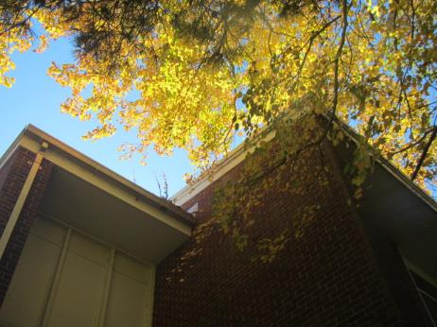

Branches overhanging roof/close proximity to exterior walls

Picture 37

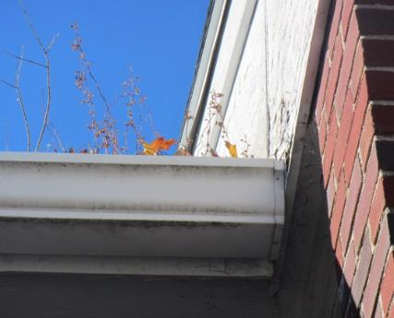

Gutter clogged with debris

Picture 38

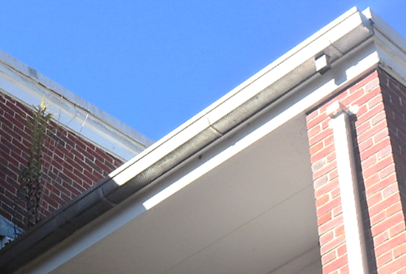

Missing/damaged downspout, note plant growth in gutter (arrows)

Picture 39

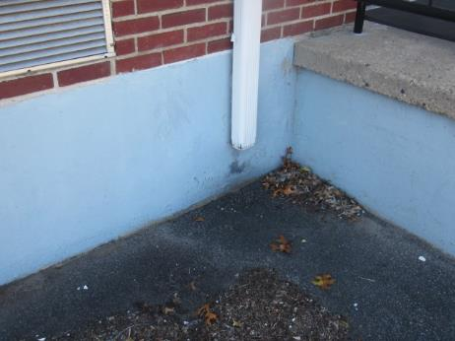

Missing elbow extension at bottom of downspout to drain water *away* from building

Picture 40

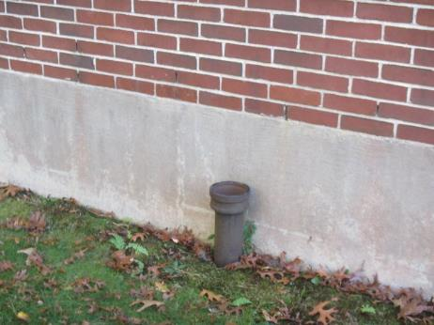

Abandoned drainage pipe for gutter/downspout system

Picture 41

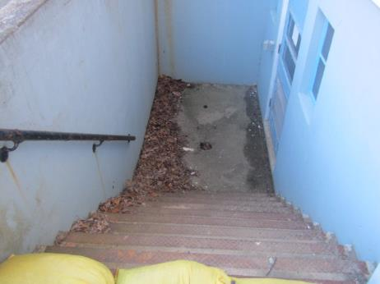

Clogged drain at bottom of boiler room stairwell

Picture 42

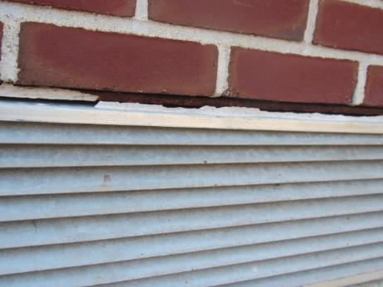

Missing/damaged sealant/caulking around univent fresh air intake

## Respiratory Irritants pictures

**Picture 43**

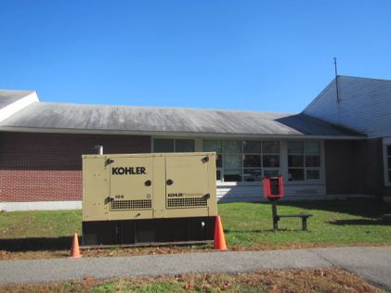

**Emergency Generator**

**Picture 44**

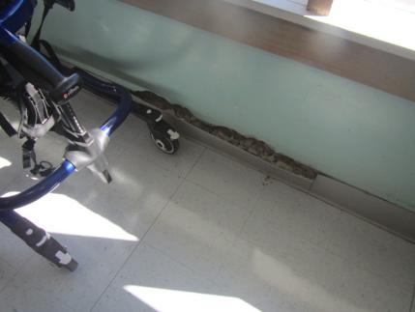

**Wall damage in Classroom4 (OT/PT Room)**

Click to link back to report

# Table 1

| **Location** | **Carbon**  **Dioxide**  **(ppm)** | **Carbon Monoxide**  **(ppm)** | **Temp**  **(°F)** | **Relative**  **Humidity**  **(%)** | **PM2.5**  **(µg/m3)** | **Occupants**  **in Room** | **Windows**  **Openable** | **Ventilation** | | **Remarks** |
| --- | --- | --- | --- | --- | --- | --- | --- | --- | --- | --- |
| **Supply** | **Exhaust** |
| Background (outside) | 430 | ND | 57 | 57 | 1 |  |  |  |  | Clear, cool & sunny |
| Health Office | 629 | ND | 69 | 49 | ND | 2 | Y  Open | N | Y  off | Minisplit, exhaust not functioning |
| 1 | 826 | ND | 69 | 51 | 2 | 19 | Y | Y | Y  Blocked | Loose CT, 6 WD CTs, AP |
| 2 | 1260 | ND | 69 | 52 | ND | 22 | Y | Y  Off | Y  Off | Area rug, AP, 2 WD CTs in classroom, 2 WD CT in boys’ restroom, 5 WD CT in girls’ restroom, possible RR wall exhausts-sealed |
| 3 | 790 | ND | 67 | 48 | ND | 11 | Y | Y | Y  Off | AP, CP-countertop, area rug, PF, upholstered furniture |
| 4 OT/PT | 904 | ND | 69 | 51 | ND | 4 | Y | Y | Y | Interior wall damage, AP |
| 5 | 908 | ND | 68 | 49 | ND | 17 | Y | Y  Blocked front | Y  Off/weak | AP, area rug, WD CT, PF |
| 6 | 935 | ND | 68 | 49 | ND | 13 | Y | Y | Y  Off/weak | WD near sink, 2 WD CTs, PF, CP-countertop, AP, PF |
| Gym | 794 | ND | 67 | 53 | ND | 0 | Y | Y | Y | Space under exterior door, dark/dusty debris along ceiling/wall junction -rec cleaning, musty odors – old curtain? |
| Gym Hallway |  |  |  |  |  |  |  |  |  | WD CTs |
| Boys Restroom |  |  |  |  |  |  |  | N | Y  Off |  |
| ESL | 692 | ND | 69 | 47 | ND | 1 | Y | Y | Y  Off | AP, area rug, bowed CTs |
| 12 | 606 | ND | 74 | 41 | ND | 1 | Y | Y | Y | 17 occupants gone ~6 minutes, PF, area rug, AP, bowed CTs |
| 14 | 820 | ND | 76 | 42 | ND | 13 | Y  Open | Y | Y | Area rug, AP, PF, bowed CTs |
| 15 | 828 | ND | 69 | 47 | ND | 15 | Y  Open | Y | Y  Off | Area rug, dehumidifier (draining in sink), AP, bowed CTs |
| 16 | 609 | ND | 73 | 44 | ND | 0 | Y | Y | Y | Area rug, AP, CP sink, bowed CTs |
| 17 | 683 | ND | 69 | 48 | ND | 0 | Y | Y | Y  Off | AP, area rug, AP, bowed CTs |
| 19 | 701 | ND | 68 | 49 | ND | 7 | Y | Y  Blocked front | Y  Off | AP, bowed CTs |
| Staff Room | 941 | ND | 75 | 44 | ND | 4 | Y | Y | Y  Off | Restroom exhaust off, AP, laminator and photocopier, abandoned exhaust vent (old smoking vent) in ceiling-source of possible odors |
| Reading Room | 702 | ND | 74 | 43 | ND | 1 | Y | N | N |  |
| Library | 717 | ND | 74 | 44 | ND | 2 | Y | Y | Y, Off | Bowed CTs, AP |
| Councilors Office | 1027 | ND | 73 | 47 | ND | 1 | Y | N | N | PF, area rug |
| Stairwell Access across from Staff room |  |  |  |  |  |  |  |  |  | Breach in wall, temporarily sealed-moisture/drafts |
| Lactation Room | 776 | ND | 70 | 50 | ND | 0 | N | N | N | PF, AP, area rug, open CT, recommend louvered vent in door (supply), tapping into adjacent exhaust |
| 20 | 612 | ND | 71 | 44 | ND | 1 | Y  Open | Y | Y  Off | AP, PF-dusty, bowed CTs |
| 21 | 1229 | ND | 68 | 49 | ND | 24 | Y | Y | Y | AP, PF, bird nest, DO aquarium |
| 22 | 649 | ND | 71 | 44 | ND | 17 | Y  Open | Y | Y  Off | PF, AP, DO, bowed CTs |
| 23 | 697 | ND | 67 | 47 | ND | 20 | Y | Y  Blocked front | Y  Off | Area rug, AP – on, bowed CTs, PF, items in front of UV, DO |
| 24 | 794 | ND | 72 | 44 | ND | 21 | Y  Open | Y | Y | AP, PF-on, area rug, DO, CP |
| 2nd Floor Hallway |  |  |  |  |  |  |  |  |  | WD CTs |
| 25 | 509 | ND | 68 | 43 | ND | 22 | Y | Y | Y | AP, area rug, aquarium, bowed CTs, class just returned from lunch |
| 26 | 786 | ND | 73 | 44 | ND | 20 | Y | Y | Y | PF, area rug, DO, bowed CTs |
| 27 | 475 | ND | 67 | 41 | ND | 1 | Y | Y | Y | AF, AP, DO, bowed CT |
| Conference Room | 788 | ND | 71 | 51 | ND | 0 | Y | N | N | 9 WD CTs (former stage area) |
| Cafeteria | 939 | ND | 70 | 51 | 7 | 3 | Y | Y | Y | Lunch just ended |
| Kitchen | 996 | ND | 72 | 50 | 14 | 2 | Y | N* | N | Floor drains, Kitchen Hood-not operating, univent abandoned* |

(Click to link back to report)

# Table 2A

|  |  |  |  |  |  |
| --- | --- | --- | --- | --- | --- |
| **Equipment Present in Building**  **(X = Yes)** | **Type of Heating/Cooling Ventilation**  **Equipment** | **Fresh**  **Air**  **Supply**  **(X = Yes)** | **Type of Location(s)** | **Air Filters Installed**  **MERV Rating**  **(1-15, U*)**  **(X = Yes)** | **Comments** |
| X | Univents | X | Classrooms | X, U |  |
|  | Rooftop Air Handling Units |  |  |  |  |
|  | Outdoor, Ground-Installed Air Handling Units |  |  |  |  |
|  | Attic/Crawlspace Air Handling Units |  |  |  |  |
| X | Ceiling-Mounted Air Handling Units (including inside plenum) |  | Kitchen |  | Abandoned, not functional |
|  | Basement/Crawlspace-Installed Air Handling Units |  |  |  |  |
|  | Mechanical Room-installed Air Handling Units |  |  |  |  |
|  | Fan Coil Units |  |  |  |  |
|  | Window-Mounted Air Conditioners |  |  |  |  |
| X | Portable air conditioners | X | Classrooms |  |  |
|  | Wall Louver-Controlled Gravity Air Supply |  |  |  |  |
| X | Windows | X | Most rooms |  |  |
|  | Fan in window (blowing in) |  |  |  |  |
| X | Built in wall fan (switched) | X | Staff Room |  | Former smoking vent? |
|  | Heat recovery ventilator unit |  |  |  |  |
|  | Energy recovery ventilator unit |  |  |  |  |
|  | Chilled Beam |  |  |  |  |
|  | Passive combustion supply vent in basement/boiler room |  |  |  |  |

*U = Filter Rating underdetermined due to inaccessibility during building visit

# Table 2B

|  |  |  |  |  |
| --- | --- | --- | --- | --- |
| **Equipment Present in Building**  **(X = Yes)** | **Type of Exhaust Ventilation**  **Equipment** | **Ducted**  **To Outdoors**  **(X = Yes)** | **Type of Location(s)** | **Comments** |
| X | Rooftop Motors/Fans | X | Classrooms and common areas | Not functioning |
|  | Unit Exhaust |  |  |  |
|  | Ceiling Return Vent |  |  |  |
|  | Ceiling Return Vent, Plenum |  |  |  |
|  | Wall Return Vent |  |  |  |
| X | Kitchen Stove Hood | X |  | Not able to determine if operational |
| X | Restroom Exhaust Vent | X |  | Not functioning |
| X | Photocopier Exhaust Vent |  |  |  |
|  | Garage |  |  |  |
|  | Chemical Hood(s) |  |  |  |
|  | Locker Rooms |  |  |  |
|  | Showers |  |  |  |
|  | Clothes Dryers |  |  |  |
|  | Gas Water Heaters |  |  |  |
|  | Furnace-Flue to Chimney |  |  |  |
|  | Furnace/Boiler direct vent or power vent (no combustion air supply) |  |  |  |
|  | Kiln, Pottery |  |  |  |
|  | Dark Room |  |  |  |
|  | Generator Room |  |  |  |
|  | Wood Shop Dust Collector |  |  |  |
|  | Spray Paint Booths |  |  |  |
|  | Fan in window (blowing out) |  |  |  |

# Table 2C

|  |  |  |  |
| --- | --- | --- | --- |
| **Equipment Present in Building**  **(X = Yes)** | **Type of Equipment** | **Type of Location(s)** | **Comments** |
|  | Floor Fans, pedestal |  |  |
| X | Floor Fans, portable | Classrooms, offices |  |
| X | Air Purifier (HEPA, other) | Classrooms, offices |  |
|  | Floor heaters, portable |  |  |
| X | Refrigerators, Cold Beverage Vending Machines |  |  |
|  | Radiator, wall-mounted |  |  |
|  | Radiator, floor-mounted |  |  |
|  | Passive Vents (Wall/Door) |  |  |

(Click to link back to report)

# Table 3

| **Found in Building**  **X = Yes** | **Water-Damaged Materials, Building Components or Stored Materials** | **Location** | **Visible Microbial Growth?**  **X = Yes** | **Musty odor detected?**  **X = Yes** | **Comments** |
| --- | --- | --- | --- | --- | --- |
|  | Books-other bound materials |  |  |  |  |
| X | Brick walls – broken, missing mortar | exterior |  |  |  |
|  | Brick walls – blocked weep holes |  |  |  |  |
|  | Cardboard boxes |  |  |  |  |
|  | Carpet tiles |  |  |  |  |
| X | Carpet - Area rugs |  |  |  |  |
|  | Carpet wall-to-wall |  |  |  |  |
|  | Ceiling tiles - affixed directly to ceiling surface |  |  |  |  |
| X | Ceiling tiles - bowing-in suspended ceiling | Classrooms | No | No | Particularly in rear/shaded part of building of |
| X | Ceiling tiles - water-stained in splined ceiling | Classrooms and common areas | No | No |  |
| X | Ceiling tiles - water-stained in suspended ceiling | By windows in a few classrooms | No | No |  |
|  | Chairs - laminated |  |  |  |  |
| X | Cloth | Classrooms | No | No |  |
| X | Countertops (around sinks) | Classroom 6 |  |  |  |
|  | Curtains | Gym | No | Yes |  |
|  | Dust/debris within AHU, uninvent, HVAC, chilled beam units, etc. (WD through condensation, humidity, or leaks) |  |  |  |  |
|  | Efflorescence (i.e., mineral deposits) |  |  |  |  |
|  | Engineered woods - particleboard, plywood, Masonite |  |  |  |  |
|  | Flooring – loosened tiles |  |  |  |  |
|  | Flooring - wooden |  |  |  |  |
|  | Furniture - laminated |  |  |  |  |
| X | Furniture - upholstered | Classrooms | No | No |  |
|  | Gypsum wallboard - ceiling |  |  |  |  |
|  | Gypsum wallboard - restroom wall |  |  |  |  |
|  | Gypsum wallboard - interior wall |  |  |  |  |
|  | Gypsum wallboard – located on exterior wall |  |  |  |  |
|  | HVAC drain pan – lack of draining |  |  |  |  |
|  | HVAC filters |  |  |  |  |
|  | Insulation- attic (paper-backed) |  |  |  |  |
|  | Insulation - inside air handling unit |  |  |  |  |
|  | Insulation - on pipe(s) fiberglass |  |  |  |  |
|  | Insulation - on pipe(s) other/plaster-like material |  |  |  |  |
|  | Insulation - wall cavity |  |  |  |  |
|  | Insulation – ceiling plenum |  |  |  |  |
|  | Modular furniture – walls/cloth partitions |  |  |  |  |
|  | Musical instrument cases |  |  |  |  |
|  | Plaster ceilings |  |  |  |  |
|  | Records/files |  |  |  |  |
|  | Refrigerator - door gasket |  |  |  |  |
|  | Refrigerator - drip pan |  |  |  |  |
|  | Refrigerator - Interior surfaces |  |  |  |  |
|  | Room divider - ceiling-mounted, sliding |  |  |  |  |
| X | Sink backsplash | Classroom 6 | No | No |  |
|  | Tables – laminated |  |  |  |  |
|  | Wallpaper |  |  |  |  |
|  | Wood - attic/roof materials |  |  |  |  |
|  | Wood - floor joists in basement ceiling |  |  |  |  |
|  | Wood - wall framing |  |  |  |  |
|  | Wood - window sills |  |  |  |  |
|  | Wood - window-mounted air conditioner framing |  |  |  |  |
| X | OTHER | Exterior trim |  |  | Damage in many areas |

WHAT ARE ENVIRONMENTAL ASTHMA TRIGGERS?

Asthma triggers are any chemical, pollutant, or allergen that can make your asthma worse. Asthma triggers can also be strong chemical smells, dust, or pets. Your asthma triggers may be different from those of other people. Not all asthma triggers affect people the same way. Environmental asthma triggers are found both indoors and outdoors. DPH link: [Asthma and Your Environment (mass.gov)](https://www.mass.gov/doc/asthma-and-your-environment-english/download)

(click to link back to report)

# Table 4

| **Condition Present**  **X = Yes** | **Possible asthma symptom-inducing environmental pollutant** | **Recommendation to reduce or eliminate the pollutant** |
| --- | --- | --- |
| X | Water Damage and/or Mold  (allergen) | Identify water source and repair to eliminate.  Clean non-porous materials.  Remove and replace porous materials susceptible to mold growth.  Perform regular water damage assessments as a tool to ensure timely mitigation as needed.  Use NIOSH water damage assessment protocol as a guide: [NIOSH water damage assessment guideline](https://www.cdc.gov/niosh/docs/2019-115/pdfs/2019-115.pdf?id=10.26616/NIOSHPUB2019115&inf_contact_key=241b5c2ed98c27d94b530dedc36f1623f651f238aa2edbb9c8b7cff03e0b16a0). |
|  | Moistening of building components during hot, humid weather (>2 days in length) (mold, allergen) | Remove materials not dried in <2 days in a manner consistent with [US EPA Mold Removal in Commercial Buildings guideline](https://www.epa.gov/mold/pdf-version-checklist-mold-remediation-mold-remediation-schools-and-commercial-buildings).  Use dehumidification in occupied basement areas and other areas with chronic dampness. |
| X | Vegetation against exterior of building (water damage-mold) | Remove all vegetation preventing building exterior drying.  Remove all vegetation capable of falling onto a building or depositing debris onto the roof. |
|  | Personal humidifiers (lack of proper maintenance)  (pollutant and allergen) | Clean and maintain properly.  Use distilled water to eliminate metal and water treatment odors.  Maintain hydration by increasing water consumption. |
|  | Drains: Floor drains, Sink drains (abandoned use)  Water bubblers (abandoned use) | If in use, pour water into drain at least twice a week.  If not in use, seal the drain with an appropriate material in accordance with Massachusetts Plumbing Code (248 CMR 10.00). |
|  | Live Animals (turtles, gerbils, birds, rabbits, etc.) | Ensure cleanliness or remove animals from the location. |
|  | Improperly maintained aquariums and terrariums (allergen) | Maintain such equipment properly to eliminate odor.  Discontinue use. |
| X | Plants and flowers  (allergen and mold) | Keep indoor plants well maintained and not overwatered. Monitor for signs of mold and pests.  Ensure water for cut flowers does not become stagnant.  Ensure dried plant material is free of odors, mold, and pests and handled carefully  If asthma risks are high, eliminate plants and flowers. |
| X | HVAC system moisture issues  (mold, allergen) | Consult ASHRAE’s minimum standards for HVAC maintenance and inspection of commercial HVAC systems (<https://www.ashrae.org/technical-resources/bookstore/standards-180-and-211>). |
|  | HVAC system contaminant issues (allergen) | Consult ASHRAE’s minimum standards for HVAC maintenance and inspection of commercial HVAC systems (<https://www.ashrae.org/technical-resources/bookstore/standards-180-and-211>). |
|  | Indoor swimming pool odors outside of swimming pool (mold, chemical) | Maintain and operate pool HVAC systems to vent odors from building.  Ensure locker room exhaust vents are operating during building hours.  All doors leading to pool should be rendered airtight and be closed. |
| X | Pollen (allergen) | Recommend installation of MERV 8 or better filters if HVAC engineer confirms HVAC system can be so equipped without adversely affecting function.  Cut grass after hours.  Cut grass in a pattern to direct clippings away from exterior wall.  Remove trees and shrubs from in front of windows and air intakes. |
|  | Dry air | Maintain hydration.  Avoid overheating of air. |
|  | Dust mites  (allergen) | Recommendation to remove non-official upholstered furniture, area rugs, pillows, cushions, etc.  Cleaning with use of HEPA-filtered vacuum cleaner.  Eliminating clutter, storing items in dust and moisture-proof containers, and regularly removing dust through wet wiping. |
|  | Pests, including rodents and cockroaches  (allergen) | Use of integrated pest management guidelines, including:   * Proper disposal of food containers * Proper storage of food products in airtight containers * Elimination of use of food as art projects * Remove pest harborages/clutter * Regular monitoring for pests   [EPA IPM guideline link](https://www.epa.gov/ipm/introduction-integrated-pest-management) |
|  | Latex-containing materials | Remove tennis balls from furniture legs. |
|  | Fragrances  (chemical) | Eliminate point sources, such as:   * Plug-in air fresheners * Aroma/oil reed diffusers * Scented sprays * Discontinue use of other scented materials * Consult DPH fragrance guideline: [*Clean air is odor-free*](https://www.mass.gov/doc/clean-air-is-odor-free-removing-fragrances-to-improve-indoor-air-quality-in-schools-and-0/download) |
|  | Strong smells from /use of Chemicals (such as cleaning products)  (chemical) | Use building-issued cleaning products.  Use products in accordance with manufacturer’s instructions including dilution, application, and ventilation.  Avoid using products that are stronger than needed for the situation. |
|  | Strong odors from new building materials (carpeting/furniture)  (chemical) | Use low VOC-emitting materials.  Air out materials (outside or in unoccupied area) prior to installation. |
|  | Tobacco smoke  Secondhand Smoke  (pollutant) | Eliminate tobacco smoking.  Seal all shared wall penetrations. |
|  | Products with a strong odor such as paint, perfume, hairspray, air fresheners, bug-spray, laminators, candles, wax melters, dry erase markers and other VOC-containing products  (chemical) | If essential:   * Provide proper exhaust ventilation to eject aerosolized product directly outdoors. * Avoid/reduce use during occupied hours.   If not necessary, remove and eliminate. |
|  | Vehicle exhaust  (pollutant) | Enforce anti-idling regulations and post signs to give notice.  Relocate vehicles away from fresh air intakes.  Require cars to park face-in at building walls.  [MA anti-idling law FAQs](https://www.mass.gov/files/documents/2018/02/20/idling-faq.pdf#:~:text=The%20Massachusetts%20Anti-Idling%20Law%20The%20goal%20of%20the,sometime%20wonder%20when%20idling%20might%20be%20considered%20necessary.) |
|  | Vapors and or fumes from gas, oil, or kerosene stoves  (pollutant) | Operate stove hood when stove in use.  Install stove hood if not present.  Ensure equipment is in good working order. |
|  | Ozone (pollutant) | Eliminate use of ozone generating equipment. |
|  | Window Air Conditioners (if not properly maintained) (allergen) | Equip with proper filter and clean periodically.  Clean drip pans.  Install in window with weathertight, non-mold-growth sustaining material. |
|  | Pottery (pollutant) | Do not operate kiln during occupied hours.  Operate kiln with exhaust system activated.  Seal all seams and holes in kiln vent.  Ensure kiln exhaust discharge terminates outdoors. |
| X | Carpeting (allergen) | Clean carpeting in a manner consistent with IICRC standards, including regular vacuuming with a high efficiency particulate air (HEPA) filtered vacuum in combination with annual cleaning or semi-annual cleaning in soiled high traffic areas. |
|  | Sweeping/dusting vs HEPA vacuuming/wet wiping  (allergen or pollutant) | Refrain from using feather dusters or brooms.  Utilize HEPA vacuums and wet wiping to minimize aerosolizing particulate matter. |
| X | Lack of adequate air exchange/mechanical ventilation | Make repairs as necessary and ensure all HVAC system components are operating continuously when building is occupied. |
|  | Lack of local exhaust at source of pollution (vocational shop activities, kitchen exhaust hood) (all) | Recommend installation of exhaust ventilation to direct pollutants directly outdoors. |
|  | Renovating buildings while occupied  (chemical) | Use all SMACNA guidelines for Renovation While Buildings Are Occupied. For information, visit <https://www.mass.gov/service-details/construction-and-renovation-generated-pollutants-in-occupied-buildings>. |
|  | Chemistry program chemical storage  (chemical) | Repair (if needed) and operate chemical storeroom vents appropriately.  Reduce or eliminate unneeded or overstocked chemicals.  Store all chemicals in a manner to separate incompatible chemicals.  Keep chemical storerooms clean. |
| X | Photocopiers/duplicating machines | All machines should have dedicated exhaust vents. |