INDOOR AIR QUALITY ASSESSMENT

Central Elementary School
New Stoneham Middle School Construction Project
36 Pomeworth Street
Stoneham, Massachusetts

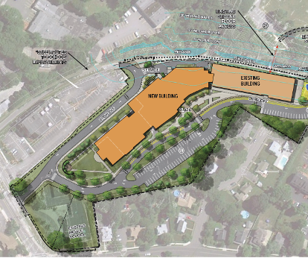

Prepared by:
Massachusetts Department of Public Health
Bureau of Environmental Health
Indoor Air Quality Program
June 2013

Background/Introduction
In response to a request by a parent, the Massachusetts Department of Public Health (MDPH), Bureau of Environmental Health (BEH) provided assistance and consultation regarding indoor air quality (IAQ) at the Central Elementary School (CES), 36 Pomeworth Street, Stoneham, Massachusetts. Potential IAQ concerns related to renovation/construction activities at the school prompted the request for an inspection.
On May 20, 2013, Cory Holmes, Environmental Analyst/Regional Inspector, and Ruth Alfasso, Environmental Engineer/Inspector, from BEH’s IAQ Program visited the CES to conduct a preliminary assessment. The assessment was coordinated through Dr. Les Olson, Superintendant for Stoneham Public Schools (SPS). During the assessment, BEH/IAQ staff were accompanied by Sharon Bird, Principal; John Savino, Administrator of School Facilities; and Dr. Olson. At the completion of the assessment, BEH/IAQ staff provided verbal recommendations to improve on methods for separating construction areas from occupied areas. These recommendations are detailed later in the report.
The CES is a three-story school building that was originally completed in 2002. The current building/renovation project involves the construction of a large addition on the west side of the CES (Figure 1), which will connect the existing Middle School to the CES forming one consolidated school serving grades 5 through 8. The project began in April of 2013 and is scheduled for completion sometime in 2015. The SPS has created a website called “Building the New Stoneham Middle School” to inform residents of the schedule and progress of construction activities, which can be accessed at http://sdcstoneham.com/project-schedule/. In addition, the SPS posted a recent IAQ testing report from Universal Environmental Consultants (UEC), Dated May 3, 2013, on its website. The UEC report recommended that outside air introduction/circulation be increased in occupied rooms where carbon dioxide levels exceeded 800 parts per million (ppm); and that the heating, ventilating and air conditioning (HVAC) exhaust systems be evaluated and adjustments be made to reduce airborne particulate matter (PM10) levels (UEC, 2013).
It is important to note that in 2010, the Massachusetts School Building Authority (MSBA) amended their regulations 963 CMR 2.04 to address concerns associated with school renovation projects in Massachusetts. The regulations specifically state that “[e]ligible Applicants shall implement containment procedures for dusts, gases, fumes, and other pollutants created during construction of an Approved Project if the building is occupied by students, teachers or school department staff while such renovation and construction is occurring. Such containment procedures shall be consistent with the “IAQ Guidelines for Occupied Buildings Under Construction” published by the Sheet Metal and Air Conditioning Contractors National Association, Inc. (SMACNA), in effect at time of project approval. All bids and proposals received for an Approved Project shall include the cost of planning and execution of containment of construction/renovation pollutants consistent with such SMACNA guidelines” (MSBA, 2010).

Methods
Air tests by MDPH for carbon dioxide, carbon monoxide, temperature and relative humidity were taken with the TSI, Q-TRAK™ IAQ Monitor, Model 7565. Air tests for airborne particle matter with a diameter less than 2.5 micrometers (PM2.5) were taken with the TSI, DUSTTRAK™ Aerosol Monitor Model 8520. Screening for total volatile organic compounds (TVOCs) was conducted using a Thermo Environmental Instruments Inc., Model 580-B Series Photo Ionization Detector (PID). MDPH staff also performed a visual inspection of the building abutting the construction zone to assess isolation of occupied school areas.

Results
The school building currently has approximately 345 students in grades K through 5 and an employee population of approximately 60. The assessment focused on classrooms/areas adjacent to construction areas. A few areas away from construction were also evaluated for comparison purposes. Tests were taken during normal operations and appear in Table 1.

Discussion

Ventilation
It can be seen from Table 1 that carbon dioxide levels were below 800 parts per million (ppm) in all areas, indicating adequate air exchange in the majority of areas at the time of assessment. However, it is important to note that several classrooms were empty/sparsely populated, which can greatly reduce carbon dioxide levels. Carbon dioxide levels would be expected to increase with higher occupancy.
Fresh air in classrooms is supplied by unit ventilators (“univents”; Picture 1). A univent draws air from the outdoors through a fresh air intake located on the exterior wall of the building (Picture 2) and returns air through an air intake located at the base of the unit. Fresh and return air are mixed, filtered, heated and provided to classrooms through an air diffuser located in the top of the unit (Figure 2). Univents have fan settings of “low” and “high”. Several of the univents were found deactivated or obstructed by classroom items at the time of assessment. In order to provide fresh air as designed, univents must be operating and free of obstructions. Mesh-style filters examined from univents in classrooms adjacent to the construction area were lightly soiled.
It is important to note that no univent fresh air intakes are located on the west wall of the building, adjacent to the construction site. Intakes are located on the north and south walls (Picture 1; Figure 1); the nearest intakes are approximately 40-50 feet from the edge of the west wall/construction area. Under certain wind/weather conditions, it may be possible for construction-generated pollutants to be entrained into the ventilation system, therefore it is important for staff to be informed both of activities that may generate airborne pollutants and when they are scheduled as well as to be aware of any activities being conducted in close proximity to their classrooms.
Mechanical ventilation for several non-classroom areas on the 2nd and 3rd floors adjacent to the construction zone is provided by a rooftop air handling unit (AHU), the distance of which from the west wall makes it unlikely to be significantly impacted by construction activities. However, monitoring of filters for this AHU, and increasing filter changes and AHU maintenance as needed, should be performed to minimize any impacts.
Minimum design ventilation rates are mandated by the Massachusetts State Building Code (MSBC). Until 2011, the minimum ventilation rate in Massachusetts was higher for both occupied office spaces and general classrooms, with similar requirements for other occupied spaces (BOCA, 1993). The current version of the MSBC, promulgated in 2011 by the State Board of Building Regulations and Standards (SBBRS), adopted the 2009 International Mechanical Code (IMC) to set minimum ventilation rates. Please note that the MSBC is a minimum standard that is not health-based. At lower rates of cubic feet per minute (cfm) per occupant of fresh air, carbon dioxide levels would be expected to rise significantly. A ventilation rate of 20 cfm per occupant of fresh air provides optimal air exchange resulting in carbon dioxide levels at or below 800 ppm in the indoor environment in each area measured. MDPH recommends that carbon dioxide levels be maintained at 800 ppm or below. This is because most environmental and occupational health scientists involved with research on IAQ and health effects have documented significant increases in indoor air quality complaints and/or health effects when carbon dioxide levels rise above the MDPH guidelines of 800 ppm for schools, office buildings and other occupied spaces (Sundell, J. et al., 2011). The ventilation must be on at all times that the room is occupied. Providing adequate fresh air ventilation with open windows and maintaining the temperature in the comfort range during the cold weather season is impractical. Mechanical ventilation is usually required to provide adequate fresh air.
Carbon dioxide is not a problem in and of itself. It is used as an indicator of the adequacy of the fresh air ventilation. As carbon dioxide levels rise, it indicates that the ventilating system is malfunctioning or the design occupancy of the room is being exceeded. When this happens, a buildup of common indoor air pollutants can occur, leading to discomfort or health complaints. The Occupational Safety and Health Administration (OSHA) standard for carbon dioxide is 5,000 parts per million parts of air (ppm). Workers may be exposed to this level for 40 hours/week, based on a time-weighted average (OSHA, 1997).
The MDPH uses a guideline of 800 ppm for publicly occupied buildings. A guideline of 600 ppm or less is preferred in schools due to the fact that the majority of occupants are young and considered to be a more sensitive population in the evaluation of environmental health status. Inadequate ventilation and/or elevated temperatures are major causes of complaints such as respiratory, eye, nose and throat irritation, lethargy and headaches. For more information concerning carbon dioxide, consult Appendix A.
Temperature measurements ranged from 74°F to 77°F, which were within the MDPH recommended comfort range at the time of assessment (Table 1). The MDPH recommends that indoor air temperatures be maintained in a range of 70°F to 78°F in order to provide for the comfort of building occupants. In many cases concerning indoor air quality, fluctuations of temperature in occupied spaces are typically experienced, even in a building with an adequate fresh air supply. Classrooms and common areas at the CES are equipped with air-conditioning. However, at the time of the BEH/IAQ assessment, the chiller was reportedly disabled as a result of a lightning strike. To assist in addressing temperature concerns in the building without air conditioning, attached as Appendix B is the MDPH/BEH guidance document Increasing Comfort in Non-Air-Conditioned Schools.
The relative humidity measured in the building ranged from 53 to 62 percent, which was within or very close to the MDPH recommended comfort range the day of assessment (Table 1). The MDPH recommends a comfort range of 40 to 60 percent for indoor air relative humidity. Relative humidity levels in the building would be expected to drop during the winter months due to heating. The sensation of dryness and irritation is common in a low relative humidity environment. Low relative humidity is a very common problem during the heating season in the northeast part of the United States.

Construction/Renovations
Renovation activities can produce a number of pollutants, including dirt, dust, particulate matter, and combustion products such as carbon monoxide from construction equipment. Materials generated from construction activities can settle on horizontal surfaces in classrooms. Dusts can be irritating to the eyes, nose and respiratory tract. At the time of the BEH/IAQ site visit, heavy construction activities were being conducted along the west side of the school (Pictures 3 and 4). Windows along the west wall were observed to be closed and appeared tight; no obvious signs of accumulated dust and debris along interior windowsills/flat surfaces adjacent to construction activities were noted.
A solid wood board was placed over an existing door along the west wall to create a temporary barrier separating the construction area from the school (Picture 5). Upon close examination, a breach was observed along the bottom of the barrier and light could be seen penetrating from the exterior (Pictures 5 and 6). BEH/IAQ staff recommended sealing the door on both the interior and the exterior side to provide a dual barrier; the barrier should be inspected for integrity regularly (e.g., daily).
BEH/IAQ staff inspected filters installed in unit ventilators (univents) at the CES. Although the filters were only lightly soiled at the time of assessment, the filters installed are a mesh-type that provide minimal filtration of respirable dusts (Picture 7). BEH/IAQ staff recommended that higher efficiency filters be installed in classrooms along the west wall adjacent to construction.
Disposable filters with an increased dust spot efficiency can be installed to decrease aerosolized particulates. The dust spot efficiency is the ability of a filter to remove particulates of a certain diameter from air passing through the filter. Filters that have been determined by ASHRAE to meet its standard for a dust spot efficiency of a minimum of 40 percent (Minimum Efficiency Reporting Value equal to 9) would be sufficient to reduce many airborne particulates (Thornburg, 2000; MEHRC, 1997; ASHRAE, 1992). Note that increasing filtration can reduce airflow (called pressure drop), which can subsequently reduce the efficiency of the unit due to increased resistance. Prior to any increase of filtration, each univent should be evaluated by a ventilation engineer to ascertain whether it can maintain function with more efficient filters.

IAQ Evaluations/Air Testing
The primary purpose of air testing at the school was to identify and reduce/prevent pollutant pathways. Air monitoring was conducted in areas that may be directly impacted due to close proximity to renovation sites and in other areas away from the construction area for comparison. Please note, air measurements are only reflective of the indoor air concentrations present at the time of testing.
Indoor air quality can be negatively influenced by the presence of respiratory irritants, such as products of combustion. The process of combustion produces a number of pollutants. Common combustion emissions include carbon monoxide, carbon dioxide, water vapor and smoke (fine airborne particle material). Of these materials, exposure to carbon monoxide and particulate matter with a diameter of 2.5 micrometers (μm) or less (PM2.5) can produce immediate, acute health effects upon exposure. To determine whether combustion products (e.g., construction vehicle exhausts) were present in the indoor environment, BEH/IAQ staff obtained measurements for carbon monoxide and PM2.5.

Carbon Monoxide
Carbon monoxide is a by-product of incomplete combustion of organic matter (e.g., gasoline, wood and tobacco). Exposure to carbon monoxide can produce immediate and acute health affects. Several air quality standards have been established to address carbon monoxide and prevent symptoms from exposure to these substances. The MDPH established a corrective action level concerning carbon monoxide in ice skating rinks that use fossil-fueled ice resurfacing equipment. If an operator of an indoor ice rink measures a carbon monoxide level over 30 ppm, taken 20 minutes after resurfacing within a rink, that operator must take actions to reduce carbon monoxide levels (MDPH, 1997).
The American Society of Heating Refrigeration and Air-Conditioning Engineers (ASHRAE) has adopted the National Ambient Air Quality Standards (NAAQS) as one set of criteria for assessing indoor air quality and monitoring of fresh air introduced by heating, ventilating and air conditioning (HVAC) systems (ASHRAE, 1989). The NAAQS are standards established by the US EPA to protect the public health from six criteria pollutants, including carbon monoxide and particulate matter (US EPA, 2006). As recommended by ASHRAE, pollutant levels of fresh air introduced to a building should not exceed the NAAQS levels (ASHRAE, 1989). The NAAQS were adopted by reference in the Building Officials & Code Administrators (BOCA) National Mechanical Code of 1993 (BOCA, 1993), which is now an HVAC standard included in the Massachusetts State Building Code (SBBRS, 2011). According to the NAAQS, carbon monoxide levels in outdoor air should not exceed 9 ppm in an eight-hour average (US EPA, 2006).
Carbon monoxide should not be present in a typical, indoor environment. If it is present, indoor carbon monoxide levels should be less than or equal to outdoor levels. Outdoor carbon monoxide concentrations were non-detect (ND) at the time of assessment (Tables 1). No measurable levels of carbon monoxide were detected inside the building during the assessment (Table 1). As previously mentioned, under certain wind and weather conditions the building may be susceptible to vehicle exhaust entrainment from construction vehicles/equipment. For this reason, BEH/IAQ staff recommended installing carbon monoxide detectors in classrooms adjacent to the construction area.

Particulate Matter
The US EPA has established NAAQS limits for exposure to particulate matter. Particulate matter includes airborne solids that can be irritating to the eyes, nose and throat. The NAAQS originally established exposure limits to PM with a diameter of 10 μm or less (PM10). In 1997, US EPA established a more protective standard for fine airborne particulate matter with a diameter of 2.5 μm or less (PM2.5). The NAAQS has subsequently been revised, and PM2.5 levels were reduced. This more stringent PM2.5 standard requires outdoor air particle levels be maintained below 35 μg/m³ over a 24-hour average (US EPA, 2006). Although both the ASHRAE standard and BOCA Code adopted the PM10 standard for evaluating air quality, MDPH uses the more protective PM2.5 standard for evaluating airborne PM concentrations in the indoor environment.
Outdoor PM2.5 concentrations the day of assessment ranged from 10-120 μg/m³. The highest levels were transient and measured at a point right outside the fence marking the edge of the construction area. Background levels measured at locations away from the construction ranged from 10-12 μg/m³. PM2.5 levels measured inside the building ranged from 14 to 23 μg/m³ (Table 1). All indoor PM2.5 levels were below the NAAQS PM2.5 level of 35 μg/m³. Frequently, indoor air levels of particulates (including PM2.5) can be at higher levels than those measured outdoors. A number of mechanical devices and/or activities that occur indoors can generate particulate during normal operations. Sources of indoor airborne particulates may include but are not limited to particles generated during the operation of fan belts in the HVAC system, use of stoves and/or microwave ovens in kitchen areas; use of photocopiers, fax machines and computer printing devices; operation of an ordinary vacuum cleaner and heavy foot traffic indoors.

Volatile Organic Compounds
Indoor air concentrations can be greatly impacted by the use of products containing volatile organic compounds (VOCs). VOCs are carbon-containing substances that have the ability to evaporate at room temperature. Frequently, exposure to low levels of total VOCs (TVOCs) may produce eye, nose, throat and/or respiratory irritation in some sensitive individuals. For example, chemicals evaporating from a paint can stored at room temperature would most likely contain VOCs. In an effort to determine whether VOCs originating with construction/renovation activities were migrating into occupied areas of the building, air monitoring for TVOCs was conducted. An outdoor air sample was taken for comparison. Outdoor TVOC concentrations were ND. No measurable levels of TVOCs were detected in the building during the assessment (Table 1).

Noise
Concerns were raised to MDPH/BEH staff regarding noise issues in the building due to the construction. While no sound level measurements were conducted, BEH/IAQ staff observed a significant decrease in noise levels between the hallway areas adjacent to the construction site and inside the classrooms once the classroom doors were closed. Noise levels in classrooms adjacent to the construction area and those not adjacent were very similar and low. This suggests that windows are well-sealed, and no building envelope breaches that would otherwise allow noise to penetrate classrooms were present in the areas assessed.

Conclusions/Recommendations
In view of the findings at the time of the visit, a variety of recommendations were made verbally at the time of the visit, and are reiterated below. Also included as Appendix C is MDPH guidance Methods Used to Reduce/Prevent Exposure to Construction/Renovation Generated Pollutants in Occupied Buildings. The MDPH has prepared this guidance document in order to prevent/reduce the migration of renovation-generated pollutants into occupied areas.

Construction/Renovations Recommendations
- Comply with 963 CMR 2.04(2) (2) Design and Construction Standards: Indoor Air Quality – Massachusetts School Building Authority. “Eligible Applicants shall implement containment procedures for dusts, gases, fumes, and other pollutants created during construction of an Approved Project if the building is occupied by students, teachers or school department staff while such renovation and construction is occurring. Such containment procedures shall be consistent with the “IAQ Guidelines for Occupied Buildings Under Construction” published by the Sheet Metal and Air Conditioning Contractors National Association, Inc. (SMACNA), in effect at time of project approval. All bids and proposals received for an Approved Project shall include the cost of planning and execution of containment of construction/renovation pollutants consistent with such SMACNA guidelines” (MSBA, 2010).
- Seal construction barriers on all sides (e.g., with caulking or polyethylene plastic and duct tape). This includes sealing the barriers on both the construction side, as well as the occupied side to provide a dual barrier. Ensure integrity of barriers by monitoring for light penetration and drafts around seams.
- Consider changing HVAC filters more regularly in areas impacted by construction/ renovation activities, including the rooftop AHU as needed.
- Consider increasing the dust-spot efficiency of univent filters, particularly adjacent to the construction zone. Prior to any increase of filtration, each piece of air handling equipment should be evaluated by a ventilation engineer as to whether it can maintain function with more efficient filters.
- Consider adding carbon monoxide detectors to classrooms near the construction zone in order to rapidly detect any infiltration of carbon monoxide into occupied areas.
- Develop a notification system to provide building occupants a means to report construction/renovation related odors and/or dust problems to the building administrator. Have these concerns relayed to the contractor in a manner to allow for a timely remediation of the problem.
- Continue to disseminate scheduling information to all affected parties through meetings, newsletters and/or weekly bulletins such as the “Building the New Stoneham Middle School” website.
- Ensure faculty is aware of construction activities that may be conducted in close proximity to their classrooms. In certain cases, HVAC equipment may need to be deactivated periodically and windows in classrooms adjacent to construction activities closed to prevent unfiltered air, vehicle exhaust and/or excessive noise from entering the building. For this reason, prior notification(s) should be made.
- As per discussion with school officials, if possible continue with plans to leave first floor classrooms directly adjacent to construction activities vacant during the forthcoming school year to provide an additional buffer zone.
- Relocate susceptible persons and those with pre-existing medical conditions (e.g., hypersensitivity, asthma) away from areas of renovations, if possible.
- Schedule projects that produce large amounts of dusts, odors, and emissions during unoccupied periods or periods of low occupancy whenever possible.
- Cover dirt/debris piles with tarps or wet down to decrease aerosolization of particulates, when possible.
- Ensure all Material Safety Data Sheets (MSDS) for construction materials used during renovations are kept in an area that is accessible to all individuals during periods of building operations as required by the Massachusetts Right-To-Know Act (MGL, 1983). Provide proper ventilation and allow sufficient curing time as per the manufacturer’s instructions concerning these materials.
- Implement prudent housekeeping and work site practices to minimize exposure to renovation pollutants. Consider increasing the number of full-time equivalents or work hours for existing staff (e.g., before school) to accommodate increases in dirt/dust accumulation due to construction/renovation activities. To control for dusts, a high efficiency particulate air filter (HEPA) equipped vacuum cleaner in conjunction with wet wiping/mopping of all surfaces is recommended.

General IAQ Recommendations
- Operate all ventilation systems throughout the building (e.g., gym, cafeteria, classrooms) continuously during periods of occupancy.
- Operate univents in the fan “high” mode to increase fresh airflow/exchange.
- Remove all blockages from univents (top and front) to ensure adequate airflow.
- Close classroom doors to maximize exhaust capabilities and air exchange as designed.
- In areas not directly adjacent to construction activities, use of open windows may be helpful to circulate air and control temperature. Ensure that all windows are tightly closed at the end of the day. Keep windows closed in classrooms where window/portable air conditioning units are in use to prevent infiltration of hot, humid air into cooled spaces and related condensation issues.
- For buildings in New England, periods of low relative humidity during the winter are often unavoidable. Therefore, scrupulous cleaning practices should be adopted to minimize common indoor air contaminants whose irritant effects can be enhanced when the relative humidity is low. To control dusts, use of a vacuum cleaner equipped with a HEPA filter in conjunction with wet wiping of all surfaces is recommended. Drinking water during the day can help ease some symptoms associated with a dry environment (throat and sinus irritation).
- Relocate or consider reducing the amount of materials stored in classrooms to allow for more thorough cleaning of classrooms. Clean items regularly with a wet cloth or sponge to prevent excessive dust build-up. Consider storing classroom items in plastic totes/cases that can be easily cleaned.

References
ASHRAE. 1989. Ventilation for Acceptable Indoor Air Quality. American Society of Heating, Refrigeration and Air Conditioning Engineers. ANSI/ASHRAE 62-1989
ASHRAE. 1992. Gravimetric and Dust-Spot Procedures for Testing Air-Cleaning Devices Used in General Ventilation for Removing Particulate Matter. American Society of Heating, Refrigeration and Air Conditioning Engineers. ANSI/ASHRAE 52.1-1992.
BOCA. 1993. The BOCA National Mechanical Code/1993. 8th ed. Building Officials and Code Administrators International, Inc., Country Club Hill, IL.
MDPH. 1997. Requirements to Maintain Air Quality in Indoor Skating Rinks (State Sanitary Code, Chapter XI). 105 CMR 675.000. Massachusetts Department of Public Health, Boston, MA.
MEHRC. 1997. Indoor Air Quality for HVAC Operators & Contractors Workbook. MidAtlantic Environmental Hygiene Resource Center, Philadelphia, PA.
MGL. 1983. Hazardous Substances Disclosure by Employers. Massachusetts General Laws. M.G.L. c. 111F.
MSBA. 2010. Massachusetts School Building Authority’s Regulations, 963 CMR 2.04(2) (2) Design and Construction Standards: Indoor Air Quality. Page 11. Promulgated 4/16/10. http://www.massschoolbuildings.org/sites/default/files/edit-contentfile/Guidelines_Forms/Statutes_Regulations/MSBA_Regs_program_04_16_10.pdf.
OSHA. 1997. Limits for Air Contaminants. Occupational Safety and Health Administration. Code of Federal Regulations. 29 C.F.R 1910.1000 Table Z-1-A.
SBBRS. 2011. Mechanical Ventilation. State Board of Building Regulations and Standards. Code of Massachusetts Regulations, 8th edition. 780 CMR 1209.0.
SMACNA. 1995. IAQ Guidelines for Occupied Buildings Under Construction. 1st ed. Sheet Metal and Air Conditioning Contractors’ National Association, Inc., Chantilly, VA.
Sundell. 2011. Sundell, J., H. Levin, W. W. Nazaroff, W. S. Cain, W. J. Fisk, D. T. Grimsrud, F. Gyntelberg, Y. Li, A. K. Persily, A. C. Pickering, J. M. Samet, J. D. Spengler, S. T. Taylor, and C. J. Weschler. Ventilation rates and health: multidisciplinary review of the scientific literature. Indoor Air, Volume 21: pp 191–204.
Thornburg, D. 2000. Filter Selection: a Standard Solution. Engineering Systems 17:6 pp. 74-80.
UEC. 2013. Universal Environmental Consultants. Report For Indoor Air Quality Testing At The Stoneham Central Elementary School, Stoneham, MA. Study Date: May 3, 2013. Project # 213 130.00
Figure 1
Site Plan of the New Stoneham Middle School Construction/Renovation Project
(Arrows indicate the position of univent fresh air intakes)

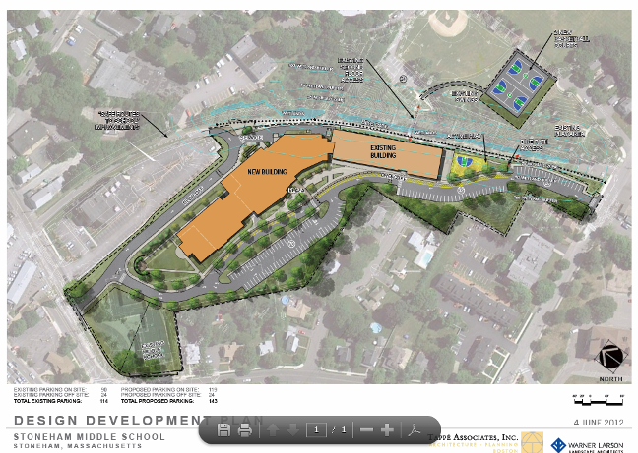

Picture 1

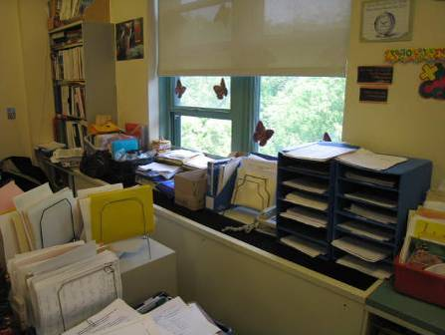

Classroom univent (note items on top and closely in front of unit)

Picture 2

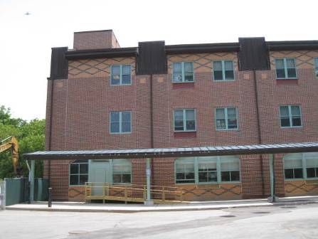

Classroom univent air intake (arrow) located >40 feet from construction side

Picture 3

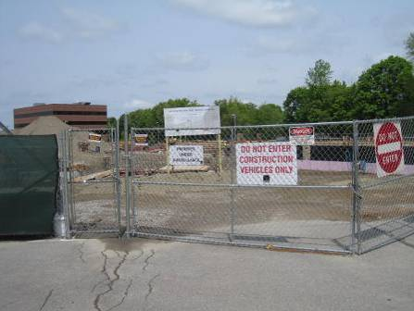
Stoneham Central School construction site

Picture 4

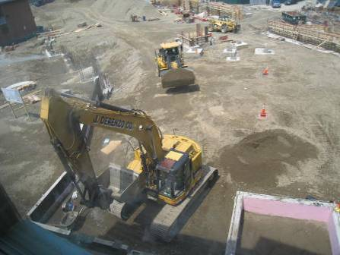

Stoneham Central School construction site

Picture 5

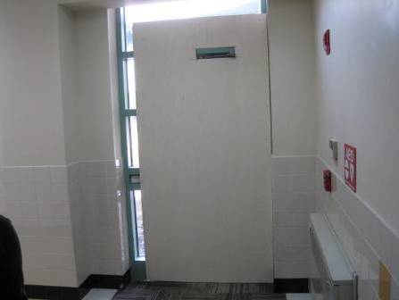

Wood construction barrier over door on west side of Central Elementary School

Picture 6

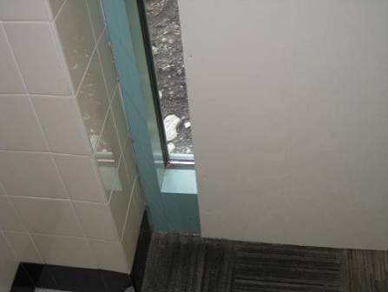

Light visible beneath construction barrier over door

Picture 7

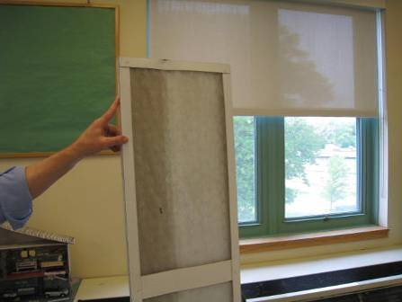

Mesh-type filter used in Central Elementary School univents

Location | Carbon  Dioxide  (ppm) | Carbon Monoxide  (ppm) | Temp  (°F) | Relative  Humidity  (%) | TVOCs  (ppm) | PM2.5  (ug/m³) | Occupants  in Room | Windows  Openable | Ventilation |  |  | Remarks
 |  |  |  |  |  |  |  |  | Intake | Exhaust |  | Remarks
Background (outdoors away from building) | 385 | ND | 79 | 54 | ND | 10 |  |  |  |  |  | Partly cloudy and hazy
Background (non-construction side of building) | 362 | ND | 77 | 59 | ND | 12
Background (construction side of building) | 379 | ND | 77 | 53 | ND | 12-120 |  |  |  |  |  | Backhoe and other equipment operating, slight odor of diesel, PM2.5 readings mostly below 20 with some momentary higher readings
107 (room closest to construction) | 643 | ND | 77 | 54 | ND | 23 | 0 | Y closed | Y, UV on |  | Y on | Carpeted, DEM, sink, PF dusty
108 (across hallway from 107) | 549 | ND | 75 | 61 | ND | 16 | 1 | N | Y on |  | Y | Carpeted
Hallway between 107 and 108 | 608 | ND | 75 | 61 | ND | 16 | 0 | N | N |  | N | Door to outside sealed, some light visible beneath it
209 | 456 | ND | 74 | 62 | ND | 18 | 0 | Y closed | Y UV on |  | Y on | Carpeted, items on UV, no dust on sills from outside construction
209A | 420 | ND | 76 | 61 | ND | 19 | 0 | Y closed | Y on |  | Y | Intake is ceiling-mounted, area rug, DEM
209 Hallway | 571 | ND | 76 | 61 | ND | 20 | ~20 passing through | Y closed | N |  | N | Tile floor
309 Hallway | 564 | ND | 75 | 61 | ND | 20 | 0 | N | N |  | N | Tile floor
309A | 481 | ND | 76 | 60 | ND | 23 | 0 | Y closed | Y |  | Y | Carpet
309 | 437 | ND | 76 | 58 | ND | 20 | 0 | Y open | Y UV |  | Y | Items on UV, carpet
306 | 610 | ND | 76 | 60 | ND | 21 | 24 | Y closed | Y UV off |  | Y | Items, sink
Art (302) | 530 | ND | 76 | 60 | ND | 15 | 0 | Y closed | Y UV on |  | Y
Gym | 613 | ND | 75 | 60 | ND | 14 | 8 | N | Y |  | Y | Wood floor

