INDOOR AIR QUALITY PREOCCUPANCY ASSESSMENT

Central Elementary School
New Stoneham Middle School Construction Project
36 Pomeworth Street
Stoneham, Massachusetts

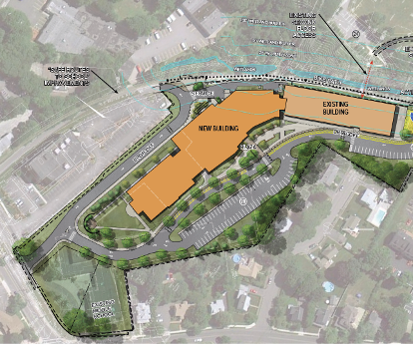

Prepared by:
Massachusetts Department of Public Health
Bureau of Environmental Health
Indoor Air Quality Program
October 2013

Background/Introduction
In response to a request from Dr. Les Olson, Superintendent of Stoneham Public Schools (SPS), the Massachusetts Department of Public Health (MDPH), Bureau of Environmental Health (BEH) provided assistance and consultation regarding indoor air quality (IAQ) at the Central Elementary School (CES), 36 Pomeworth Street, Stoneham, Massachusetts. Concerns related to renovation/construction activities at the school and any potential health impacts prompted the request for an inspection prior to the reopening of school for the new school year. The BEH/IAQ program had previously visited the school and issued a report in June 2013 based on testing/observations made at that time. A summary of the actions on construction-related recommendations from that report is included as Appendix A.
Over the summer of 2013, construction and renovation activities were conducted on both the interior and exterior of the school. Dr. Olson contacted the BEH/IAQ program for assistance and/or recommendations that could be made to mitigate any impacts from renovation/construction activities before the school was opened for teachers and students at the beginning of the school year.
On August 27, 2013, Ruth Alfasso, Environmental Engineer/Inspector, from BEH’s IAQ Program visited the CES to conduct a pre-occupancy assessment. During the assessment, Ms. Alfasso was accompanied by Dr. Olson. At the completion of the assessment, BEH/IAQ staff provided verbal recommendations to improve on methods to mitigate construction impacts in occupied areas. These recommendations are detailed later in this report.
The CES is a three-story school building that was originally completed in 2002. The current building/renovation project involves the construction of a large addition on the west side of the CES (Figure 1), which will connect the existing Middle School to the CES forming one consolidated school serving grades 5 through 8. The project began in April of 2013 and is scheduled for completion sometime in 2015. The SPS created a website called “Building the New Stoneham Middle School” to inform the public of the schedule and progress of construction activities, which can be accessed at http://sdcstoneham.com/project-schedule/.

Methods
Air tests by MDPH for carbon monoxide and relative humidity were taken with the TSI, Q-TRAK™ IAQ Monitor, Model 7565. Air tests for airborne particle matter with a diameter less than 2.5 micrometers (PM2.5) were taken with the TSI, DUSTTRAK™ Aerosol Monitor Model 8520. Screening for total volatile organic compounds (TVOCs) was conducted using a RAE systems MiniRAE 2000 Photo Ionization Detector (PID). MDPH staff also performed a visual inspection of the building with a focus on areas abutting the construction zone to assess isolation of occupied school areas.

Results
The school building will serve 345 students in grades K through 5 during the 2013/2014 school year and has employee population of approximately 60. Tests were taken with the building unoccupied, apart from service personnel who were performing cleaning and pre-opening activities, including floor buffing, furniture moving and other operations. Results appear in Table 1.

Discussion

Construction/Renovation Concerns
As indicated by Appendix A, the recommendations made by the BEH/IAQ program in the June 2013 report have been and/or will be acted on.
Renovation activities can produce a number of pollutants, including dirt, dust, particulate matter, and combustion products such as carbon monoxide from construction equipment. Materials generated from construction activities can settle on horizontal surfaces in classrooms. Dusts can be irritating to the eyes, nose and respiratory tract. At the time of the BEH/IAQ site visit, heavy construction activities were being conducted along the west side of the school (Picture 1). Windows along the west wall were closed and appeared to be tight, with no obvious signs of accumulated dust and debris along interior windowsills/flat surfaces adjacent to construction activities.
BEH/IAQ staff inspected areas that had containment barriers installed between the construction areas and areas to be occupied. Since the previous visit, a barrier composed of plywood and other construction materials had been erected at the western end of the first floor hallway where a door had originally existed, leading to the construction area. This barrier appeared solid, had been painted over, and no light/drafts could be seen/detected around it (Picture 2). Windows in upper floor hallways on the same side of the building had similarly-installed painted plywood barriers, which also appeared to be tightly constructed (Picture 3).
Other remodeling had also occurred in rooms abutting the construction zone to protect these areas and allow for connection to the new wing when the construction is complete. These renovations also included installation of an exhaust hood (Picture 4) to be used when a kiln is installed in the room. This hood should be completely sealed until it is needed to eliminate it as a pathway for contaminants into the building.

Microbial/Moisture Concerns
There were concerns reported to BEH/IAQ staff regarding the discovery of mold-colonized materials during renovation activities in two classrooms on the first floor. Reportedly, mold-colonized gypsum wallboard (GW) was discovered behind the area of existing sinks. Mold-contaminated materials were removed and replaced during the renovation. The source of the moisture resulting in conditions leading to mold growth could not be determined; however it was suspected that contact with the slab had led to condensation on the GW. It is also possible that condensation from cold water lines to the sink had led to this condition. Therefore, it is also possible that other areas of mold-contaminated GW will be discovered if a wall is opened for further renovation or plumbing work. Note that the walls are reportedly continuous to the decking of the floor above, so pathways do not exist for migration of odors or mold spores into occupied areas unless the walls are penetrated. Care should be taken whenever wall penetrations are made to ensure that the work is done when rooms are unoccupied. Preparations for removing mold-colonized GW should be made beforehand, particularly on the first floor and adjacent to sinks. No moldy odors or moist/mold-contaminated materials were noted at the time of the visit.
Conditions that may lead to moisture condensation and water damage exist if a building is partially provided with HVAC cooling. It is important to keep doors closed between areas with and without air conditioning. Use of air conditioning can reduce the temperature of both the air and surfaces inside the room such as floors and furniture, particularly items made of metal which conduct heat rapidly. If hot, humid air from an unconditioned space is allowed to enter an area with chilled air, condensation of moisture on surfaces may occur, leading to water damage.
Relative humidity measurements were conducted in the building during the August 27, 2013 visit. Relative humidity measurements ranged from 55 to 61 percent in areas surveyed (Table 1), which were within or very close to the upper end of the MDPH recommended comfort range. The MDPH recommends a comfort range of 40 to 60 percent for indoor air relative humidity. Note that relative humidity in excess of 70 percent for extended periods of time can provide an environment for mold and fungal growth in building materials (ASHRAE, 1989). Humidity was reflective of outdoor conditions on the day of assessment.

IAQ Evaluations/Air Testing
The primary purpose of air testing at the school was to identify and reduce/prevent pollutant pathways. Air monitoring was conducted in areas that may be directly impacted when occupied due to close proximity to renovation sites and in other areas away from the construction area for comparison. Please note, air measurements are only reflective of conditions present at the time of testing, which would be influenced by activities occurring inside, such as furniture-moving and floor cleaning as well as atmospheric conditions outside.
Indoor air quality can be negatively influenced by the presence of respiratory irritants, such as products of combustion. The process of combustion produces a number of pollutants. Common combustion emissions include carbon monoxide, carbon dioxide, water vapor and smoke (fine airborne particle material). Of these materials, exposure to carbon monoxide and particulate matter with a diameter of 2.5 micrometers (μm) or less (PM2.5) can produce immediate, acute health effects upon exposure. To determine whether combustion products (e.g., construction vehicle exhausts) were present in the indoor environment, BEH/IAQ staff obtained measurements for carbon monoxide and PM2.5.

Carbon Monoxide
Carbon monoxide is a by-product of incomplete combustion of organic matter (e.g., gasoline, wood and tobacco). Exposure to carbon monoxide can produce immediate and acute health affects. Several air quality standards have been established to address carbon monoxide and prevent symptoms from exposure to these substances. The MDPH established a corrective action level concerning carbon monoxide in ice skating rinks that use fossil-fueled ice resurfacing equipment. If an operator of an indoor ice rink measures a carbon monoxide level over 30 ppm, taken 20 minutes after resurfacing within a rink, that operator must take actions to reduce carbon monoxide levels (MDPH, 1997).
The American Society of Heating Refrigeration and Air-Conditioning Engineers (ASHRAE) has adopted the National Ambient Air Quality Standards (NAAQS) as one set of criteria for assessing indoor air quality and monitoring of fresh air introduced by heating, ventilating and air conditioning (HVAC) systems (ASHRAE, 1989). The NAAQS are standards established by the US EPA to protect the public health from six criteria pollutants, including carbon monoxide and particulate matter (US EPA, 2006). As recommended by ASHRAE, pollutant levels of fresh air introduced to a building should not exceed the NAAQS levels (ASHRAE, 1989). The NAAQS were adopted by reference in the Building Officials & Code Administrators (BOCA) National Mechanical Code of 1993 (BOCA, 1993), which is now an HVAC standard included in the Massachusetts State Building Code (SBBRS, 2011). According to the NAAQS, carbon monoxide levels in outdoor air should not exceed 9 ppm in an eight-hour average (US EPA, 2006).
Carbon monoxide should not be present in a typical, indoor environment. If it is present, indoor carbon monoxide levels should be less than or equal to outdoor levels. Outdoor carbon monoxide concentrations were non-detect (ND) at the time of assessment (Tables 1). No measurable levels of carbon monoxide were detected inside the building during the assessment (Table 1). However, as mentioned in the previous MDPH report, under certain wind and weather conditions the building may be susceptible to exhaust entrainment from construction vehicles/equipment. For this reason, BEH/IAQ staff recommended installing carbon monoxide detectors in classrooms adjacent to the construction area, which has reportedly been done.

Particulate Matter
The US EPA has established NAAQS limits for exposure to particulate matter. Particulate matter includes airborne solids that can be irritating to the eyes, nose and throat. The NAAQS originally established exposure limits to PM with a diameter of 10 μm or less (PM10). In 1997, US EPA established a more protective standard for fine airborne particulate matter with a diameter of 2.5 μm or less (PM2.5). The NAAQS has subsequently been revised, and PM2.5 levels were reduced. This more stringent PM2.5 standard requires outdoor air particle levels be maintained below 35 μg/m³ over a 24-hour average (US EPA, 2006). Although both the ASHRAE standard and BOCA Code adopted the PM10 standard for evaluating air quality, MDPH uses the more protective PM2.5 standard for evaluating airborne PM concentrations in the indoor environment.
Outdoor PM2.5 concentrations the day of assessment ranged from 51 to 53 μg/m³. Outdoor levels were very similar both upwind of and close to the construction zone. PM2.5 levels measured inside the building ranged from 50-65 μg/m³ (Table 1). All levels of PM2.5 measured during the assessment were above the NAAQS PM2.5 level of 35 μg/m³. Note that particulate levels outdoors on the day of assessment were elevated throughout eastern Massachusetts due to hot, humid weather conditions; according to AirNow (http://www.airnow.gov), a website run by the USEPA, PM2.5 levels statewide were within the “moderate” category, as defined by PM2.5 levels of between 50 and 100 μg/m³.
Levels of PM2.5 indoors were likely influenced both by outdoor levels (through open doors) and by activities that were occurring indoors, including floor buffing, and the movement of furniture. Frequently, indoor air levels of particulates (including PM2.5) can be at higher levels than those measured outdoors. A number of mechanical devices and/or activities that occur indoors can generate particulate during normal operations. Sources of indoor airborne particulates may include but are not limited to particles generated during the operation of fan belts in the HVAC system, use of stoves and/or microwave ovens in kitchen areas; use of photocopiers, fax machines and computer printing devices; operation of an ordinary vacuum cleaner and heavy foot traffic indoors.

Volatile Organic Compounds
Indoor air concentrations can be greatly impacted by the use of products containing volatile organic compounds (VOCs). VOCs are carbon-containing substances that have the ability to evaporate at room temperature. Frequently, exposure to low levels of total VOCs (TVOCs) may produce eye, nose, throat and/or respiratory irritation in some sensitive individuals. For example, chemicals evaporating from a paint can stored at room temperature would most likely contain VOCs. In an effort to determine whether VOCs originating from construction/renovation activities were migrating into occupied areas of the building, air monitoring for TVOCs was conducted. Outdoor air samples were taken for comparison. Outdoor TVOC concentrations were ND. No measurable levels of TVOCs were detected in the building during the assessment (Table 1).

Other Conditions
Univents were inaccessible, but, as indicated in Appendix A, filters with a higher dust spot efficiency have reportedly been installed in univent cabinets.
It was also reported that the chiller for the building was in the process of being replaced and that full air conditioning services would be restored by the spring of 2014. Boiler service for heating was expected to be completed before the beginning of the heating season (mid-October, 2013). In the meantime, indoor temperatures will be cooled in most rooms through the use of window-mounted air conditioners (ACs). Note that ACs are equipped with an integral filter, which needs to be cleaned periodically to allow proper functioning. Several of these filters were examined during the visit and found to be dusty and in need of cleaning (Picture 5). It was later reported that cleaning of all AC units was to be conducted prior to the first day of school. It is also important to ensure that windows housing the ACs are properly sealed to prevent the ingress of moisture, unconditioned air, dust and pests.

Conclusions/Recommendations
In view of the findings at the time of the visit recommendations were made verbally at the time of the visit, and are reiterated below:
- Continue to follow recommendations made in the previous report for both construction and occupied operations.
- Ensure that items are cleaned prior to occupancy, including floors, stored furniture, classroom items and window AC filters. Increase cleaning as needed to control construction-related dusts and debris.
- Prepare for the potential to encounter mold-colonized GW when performing wall penetrations, including performing work when areas are unoccupied when possible and being prepared to remove and replace GW as needed.
- Ensure that doors between air conditioned and unconditioned areas are kept closed while air conditioning is in operation.
- Keep the hood/ductwork for the kiln closed/sealed until it is needed.
- If further assistance is required, please contact the BEH/IAQ Program.

References
ASHRAE. 1989. Ventilation for Acceptable Indoor Air Quality. American Society of Heating, Refrigeration and Air Conditioning Engineers. ANSI/ASHRAE 62-1989.
BOCA. 1993. The BOCA National Mechanical Code/1993. 8th ed. Building Officials and Code Administrators International, Inc., Country Club Hill, IL.
MDPH. 1997. Requirements to Maintain Air Quality in Indoor Skating Rinks (State Sanitary Code, Chapter XI). 105 CMR 675.000. Massachusetts Department of Public Health, Boston, MA.
SBBRS. 2011. Mechanical Ventilation. State Board of Building Regulations and Standards. Code of Massachusetts Regulations, 8th edition. 780 CMR 1209.0.
US EPA. 2006. National Ambient Air Quality Standards (NAAQS). US Environmental Protection Agency, Office of Air Quality Planning and Standards, Washington, DC. http://www.epa.gov/air/criteria.html.
Figure 1
Site Plan of the New Stoneham Middle School Construction/Renovation Project
(Arrows indicate the position of univent fresh air intakes)

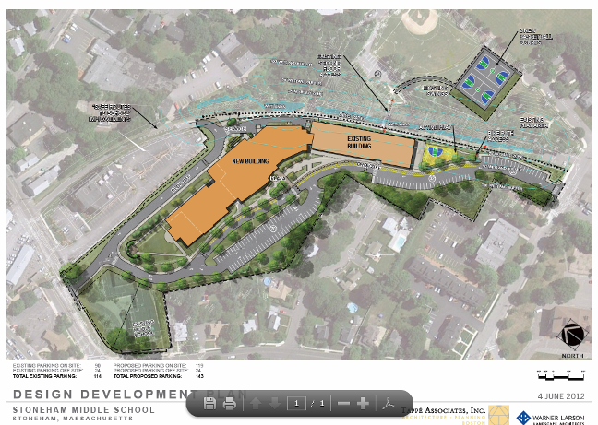
Picture 1

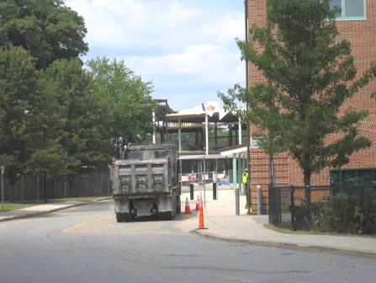

View of Central Elementary School showing construction zone next to existing building

Picture 2

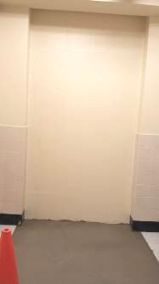

Constructed barrier at location of former door

Picture 3

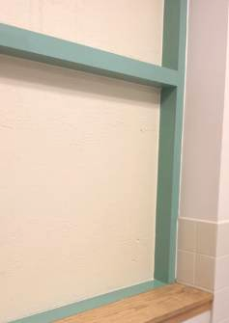

Constructed barrier at location of former hallway window

Picture 4

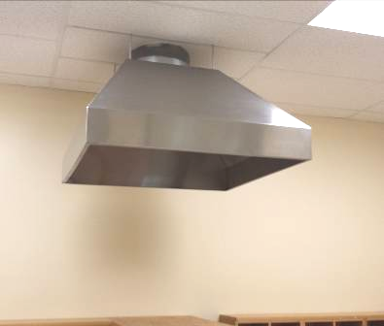

New hood for planned kiln, not to be used this school year

Picture 5

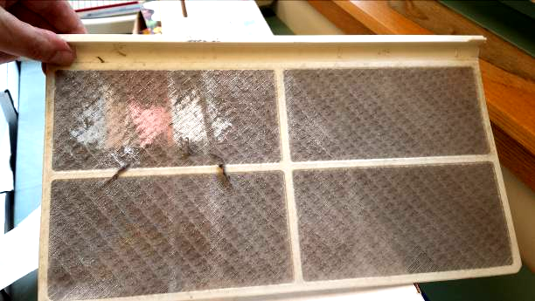

Dirty filter from window air conditioner

Location | Carbon Monoxide  (ppm) | Relative  Humidity  (%) | TVOCs  (ppm) | PM2.5  (µg/m³) | Occupants  in Room | Windows  Openable | Remarks
Background, upwind of construction/building | ND | 65 | ND | 53 |  |  | Warm and humid, very low wind
Front of building adjacent to construction site | ND | 55 | ND | 51 |  |  | Vehicle unloading material
3rd floor hallway | ND | 61 | ND | 61 | 0 | N
2nd Floor Hallway | ND | 59 | ND | 50-65 | 0 | N
1st floor hallway | ND | 55 | ND | 50-65 | 0 | N

Actions on MDPH Construction Recommendations, Stoneham Central Elementary School, 36 Pomeworth Street, Stoneham, MA

The following is a status report of action(s) taken in response to recommendations made in the June 2013 MDPH IAQ report based on reports from school officials and BEH/IAQ staff observations.
- Comply with 963 CMR 2.04(2) (2) Design and Construction Standards: Indoor Air Quality – Massachusetts School Building Authority. “Eligible Applicants shall implement containment procedures for dusts, gases, fumes, and other pollutants created during construction of an Approved Project if the building is occupied by students, teachers or school department staff while such renovation and construction is occurring. Such containment procedures shall be consistent with the “IAQ Guidelines for Occupied Buildings Under Construction” published by the Sheet Metal and Air Conditioning Contractors National Association, Inc. (SMACNA), in effect at time of project approval. All bids and proposals received for an Approved Project shall include the cost of planning and execution of containment of construction/renovation pollutants consistent with such SMACNA guidelines” (MSBA, 2010).
- Action: This is reportedly being done in accordance with relevant laws and regulations.
- Seal construction barriers on all sides (e.g., with caulking or polyethylene plastic and duct tape). This includes sealing the barriers on both the construction side, as well as the occupied side to provide a dual barrier. Ensure integrity of barriers by monitoring for light penetration and drafts around seams.
- Action: The building has been sealed along the construction side using plywood and other structural materials. Seams were found tightly sealed and painted with no light visible around them.
- Consider changing HVAC filters more regularly in areas impacted by construction/ renovation activities, including the rooftop AHU as needed.
- Action: This is reportedly being done. More attention is needed for portable air conditioner filters.
- Consider increasing the dust-spot efficiency of univent filters, particularly adjacent to the construction zone. Prior to any increase of filtration, air handling equipment should be evaluated by a ventilation engineer as to whether it can maintain function with more efficient filters.
- Action: Pleated filters are reportedly being used in AHUs and univents.
- Consider adding carbon monoxide (CO) detectors to classrooms near the construction zone in order to rapidly detect any infiltration of carbon monoxide into occupied areas.
- Action: CO detectors have been added.
- Develop a notification system to provide building occupants a means to report construction/renovation related odors and/or dust problems to the building administrator. Have these concerns relayed to the contractor in a manner to allow for a timely remediation of the problem.
- Action: This will reportedly be instituted when school begins.
- Continue to disseminate scheduling information to all affected parties through meetings, newsletters and/or weekly bulletins such as the “Building the New Stoneham Middle School” website.
- Action: The “Building the New Stoneham Middle School” website is being updated regularly.
- Ensure faculty is aware of construction activities that may be conducted in close proximity to their classrooms. In certain cases, HVAC equipment may need to be deactivated periodically and windows in classrooms adjacent to construction activities closed to prevent unfiltered air, vehicle exhaust and/or excessive noise from entering the building. For this reason, prior notification(s) should be made.
- Action: This will reportedly be done.
- As per discussion with school officials, if possible continue with plans to leave first floor classrooms directly adjacent to construction activities vacant during the forthcoming school year to provide an additional buffer zone.
- Action: Reportedly, these areas will reportedly remain vacant during construction. In addition, some of the affected classrooms have been reconfigured as a part of the renovation which will also serve to buffer them from construction impacts.
- Relocate susceptible persons and those with pre-existing medical conditions (e.g., hypersensitivity, asthma) away from areas of renovations, if possible.
- Action: This will reportedly be done as needed.
- Schedule projects that produce large amounts of dusts, odors, and emissions during unoccupied periods or periods of low occupancy whenever possible.
- Action: This is reportedly being conducted; significant progress was made on both construction and interior renovations to the existing building over the unoccupied summer period.
- Cover dirt/debris piles with tarps or wet down to decrease aerosolization of particulates, when possible.
- Action: Summertime renovation activities have progressed to the point where significant piles of materials are not expected to be needed/generated.
- Ensure all Material Safety Data Sheets (MSDS) for construction materials used during renovations are kept in an area that is accessible to all individuals during periods of building operations as required by the Massachusetts Right-To-Know Act (MGL, 1983). Provide proper ventilation and allow sufficient curing time as per the manufacturer’s instructions concerning these materials.
- Action: This is reportedly being conducted.
- Implement prudent housekeeping and work site practices to minimize exposure to renovation pollutants. Consider increasing the number of full-time equivalents or work hours for existing staff (e.g., before school) to accommodate increases in dirt/dust accumulation due to construction/renovation activities. To control for dusts, a high efficiency particulate air filter (HEPA) equipped vacuum cleaner in conjunction with wet wiping/mopping of all surfaces is recommended.
- Action: HEPA vacuuming and increased cleaning are reportedly being conducted.

