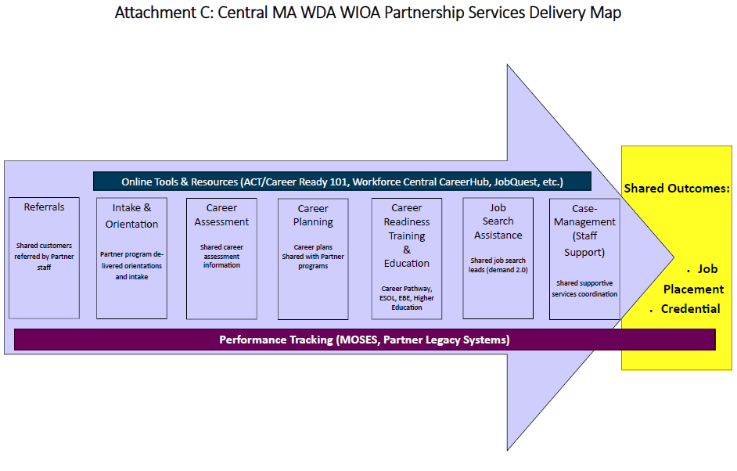

Attachment C: Central MA WIOA Partnership Services Delivery Map