Office of the General Counsel
Department of Public Health
250 Washington Street
Boston, MA 02108

July 28, 2023

To whom it may concern,

As the Region 2 EMS Council, it is my responsibility to represent the opinions and needs of the services in greater central Massachusetts. Please accept this written testimony as a reflection from most of those emergency medical services (EMS) agencies within our 76-community region. To provide evidence that the opinions expressed here are that of the majority, the regional office conducted a short poll to collect information from the EMS agencies we represent regarding the proposed mandated vaccines. The results of that poll are included on the following pages, and I think they speak volumes about the general position of this region. The overarching consensus shows that a vaccine mandate will most certainly have a negative impact on the workforce and EMS, which is already at a critically low level.
Based on prior knowledge of the department demographics represented by this poll, I can also assure you that these people are not “anti-vaxers.” The majority of the staff and respondents are vaccinated. They assisted in that vaccination of residences and supported that endeavor. What they do not support is the mandate of such. During the initial wave of COVID, hospital staff attended to sick and dying patients when there was no vaccine option. These same providers were later fired if they would not get vaccinated. EMS should not go down that same detrimental path. Over the last year of the pandemic, all providers were required to use the same personal protection equipment (PPE) whether they were vaccinated or not. Requirements for PPE to protect healthcare providers and patients are completely acceptable. Forcing someone to have a substance injected into their body is not.
Thank you for taking time to review the following graphs and quotes from the responses across Region 2.

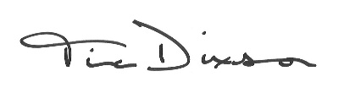
Respectfully submitted,

Tina Dixson
Executive Director

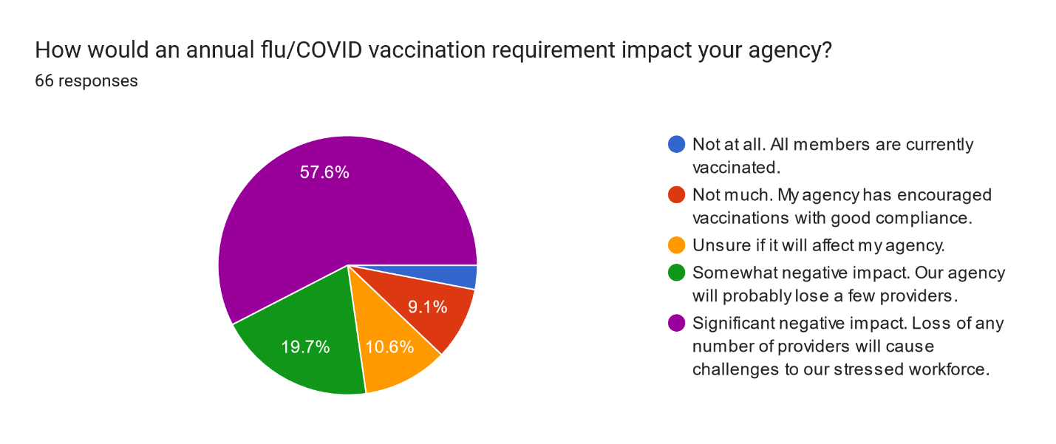
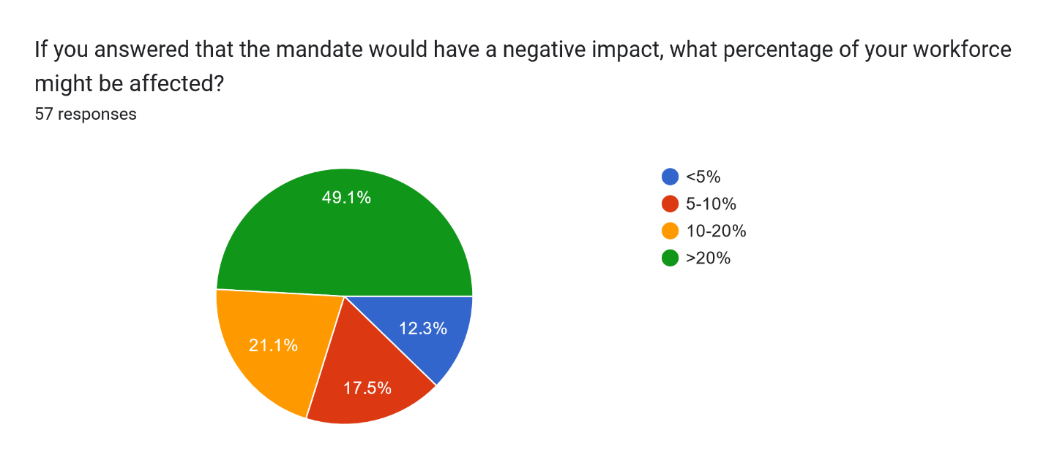
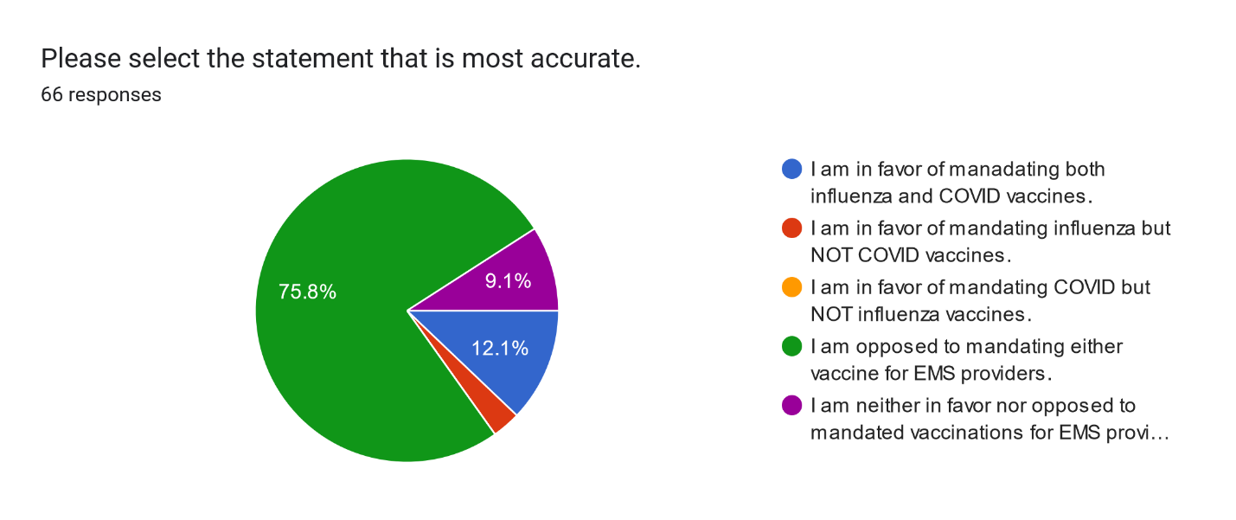
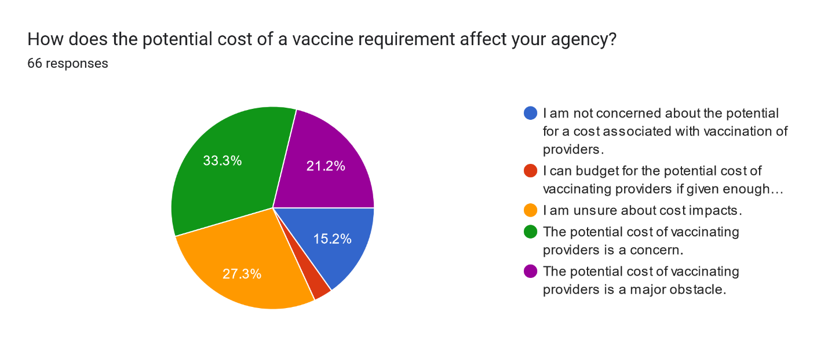
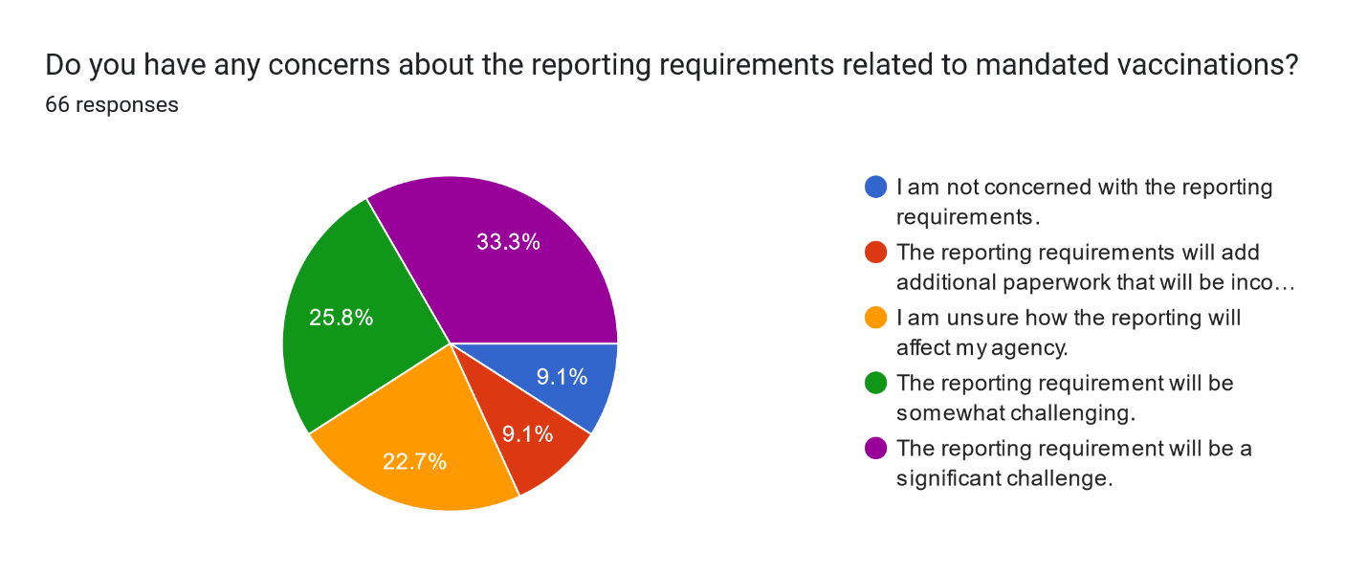
31 Respondents opted to comment in the open text field:
I have additional concerns expressed below.
- Smaller services do not have regular access work-health providers to administer the vaccines. The potential cost of contracting for these services is more than just the cost of the vaccine itself (once it becomes not covered).

- all mandates for covid vaccinations have been lifted and I feel this is the person’s tchoice and would greatly affect my agency.

- I am opposed strongly to this proposal. I do not think it benefits patients and certainly impacts services. As we saw with the pandemic the vaccines were far less than effective than reported and carried negative side effects. If this goes through, I know I will lose my second in command and senior lieutenant as well as a number of call and career personnel.
- This is an issue with unions, it would force a change in labor conditions and need to be impact bargaining.

- We will lose a lot of staff. The vaccine doesn’t work it’s making healthy people sick employees need rights, it’s hard enough to get staff as is.

- It should be sole discretion of the individual to get their own vaccinations under their PCP’s recommendations. This WILL reduce an already shorthanded workforce. There are not many people jumping to become EMS providers, and this will make our situation absolutely worse. Although I have been out of the union for some time, how about asking the IAFF/PFFM unions on this issue? EMS has already suffered enough, give it a rest. We will and do use all the appropriate PPE precautions when advised. Thank you.

- I am opposed, why would we create a self-imposed harm and drive providers away. Seems like this is a personal medical decision that should be made by a person and their Dr. I do not see an upside to this.

- I am adamantly opposed to any vaccine mandates. This is a personal choice that should not be mandated. If the state wants to require masking or other means of mitigation that is fine, but mandating vaccines steps over the line. We already have staffing shortages throughout the EMS industry, this will only make that situation worse.

- This is a contractual issue in an Agency working under a Collective Bargaining Agreement. It could create a significant cost during bargaining. It could lead to legal costs if discipline is administered, and it is grieved.

- The language in the draft seems to require services to procure their own vaccine in certain circumstances. This would be a substantial burden on some services, especially BLS-only.

- This amendment should it pass will have an extremely adverse effect on the pre-hospital EMS service for my community of Barre, New Braintree, and Hardwick. My EMS service will lose close to 50% of my work force and will most likely have to cease operations as we will not be able to meet the state requirements of staffing an ALS ambulance.

- Where will the state's interference in resident's lives end?

- Mandatory vaccines have not been proven scientifically to have a positive effect on patient care. More mandates such as this will only inhibit further recruitment into an already dwindling workforce. The state should focus more efforts on expanding the scope of practice to positively impact patient care rather than looking for more ways to limit the providers.

- There are shortages of EMTs and paramedics. This requirement is not going to make a positive impact. This may cause litigation and further negatively affect the EMS system.
- If it's mandated, we could lose the little staff we already have.

- We are healthcare providers; vaccinations should be mandatory.

- All measures have been removed country wide thus vaccination must be a personal choice and a decision between employees and their personal doctor. We could lose members because they are unable to receive the vaccine. Waivers have historically been difficult to manage and impact employers greatly.

- It should be the choice of the provider if they want the vaccine.

- Vaccination mandates have already failed at the national level and have led to significant cost to personnel and financially. I have been vaccinated for both but mandating the COVID vaccine which is experimental and by all measures highly ineffective is undefendable.

- This mandate would stress an already stressed workforce and could prove to significantly reduce an already limited workforce.

- This was a complete disaster during the pandemic. We saw entire fire departments and police departments oppose the vaccination. Especially now where there have been so many unexplainable cardiac issues to those vaccinated at an abnormally young age, I feel that Unions will resist this.

- The Covid vaccine doesn’t work.

- This will be fought by the union employees and create impact bargaining problems.

- I work with people who have not gotten any shots and have not had Covid and people who have got shots have had it does not work.

- Unsure how in this time of being short of providers this would benefit anyone.

- I believe that this is a vast overreach by mandating healthcare treatments. We are adults that work in the medical field. We can make our own decisions, and both “vaccines” have very poor efficacy after actually looking at the information and one having very severe side effects in people with no rhyme or reason. Again, I’m strongly against this. Mandating this is a slap in the face to an already overworked, underappreciated, and ever shrinking population of people willing to step up and do the job.

- Again, the State is trying to mandate an unfunded act that forces people to obtain a vaccination that they may not want to and have never had to. This type of mandate will only stress an already taxed EMS system. I am adamantly against this type of mandate, and this has already been tried by the Commonwealth and lost in a court of law. DHP/OEMS needs to focus on finding ways to train more paramedics rather than focus on BS mandates.
- My concerns would be that there seems to be some departments if not a lot of departments that are having a difficult time hiring new employees to fill vacant positions they currently have and are expected to have in the near future. And by requiring these 2 vaccines especially the Covid vaccine departments will I believe have a more difficult time recruiting new members therefore having vacant positions that need to be filled for a longer time. Also, it might affect the employees who are getting close to there maximum retirement years of service and causing them to have to retire early and not get a full retirement benefit after spending more than a 3rd of their life doing the job. Or these employees would be let go and not ever obtain there full retirement. I also believe that the Mass Fire Academy required all employees to be vaccinated for Covid a few years ago as well as State Police or employees would be terminated. I believe that at least the Mass Fire Academy has now dropped those requirements and offered employees a chance to be rehired again even though they are still not vaccinated, and they are not required to be.

- With the end of the pandemic and all vulnerable populations vaccinated, it will severely impact our recruiting and retention efforts.

- My concerns lie in how this information will be used. There are no current protections for employees that may decline vaccination. It also does not address how an agency/department must handle work-acquired illnesses if they are or are not vaccinated. Can an agency refuse workers' compensation due to vaccination status? If this continues to be considered there needs to be additional language added to address these inevitable issues.

- This is another unfunded mandate that will no doubt have an impact on the fire union and will create another mess that ultimately, we will have to pay for. It is hard enough to hire and retain personnel already without adding another mandate on to the ever-growing list.

