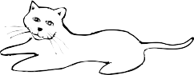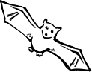

STAY AWAY FROM STRAYS
Stray pets and wild animals can give you rabies.

This Certificate is Presented to

for completion of an educational program on rabies awareness and prevention.

Teacher Date School

