 | Commonwealth of Massachusetts  City/Town of  Certificate of Compliance  Form 3
 | DEP has provided this form for use by local Boards of Health. Other forms may be used, but the information must be substantially the same as that provided here. Before using this form, check with the local Board of Health to determine the form they use.
 | This is to Certify that the following work on an On-Site Sewage Disposal System
Important: When filling out forms on the computer, use only the tab key to move your cursor - do not use the return key.  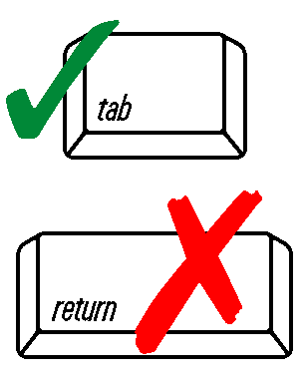 | Construction of a new system  Repair or replacement of an existing system  Repair or replacement of an existing system component
 | Has been done in accordance with Title 5 and the Disposal System Construction Permit (DSCP):
 | DSCP Number | DSCP Date
 | Facility Owner
 | Street Address or Lot #
 | City/Town | State | Zip Code
 | Designer Information:
 | Name | Name of Company
 | Signature | Date
 | Installer Information:
 | Name | Name of Company
 | Signature | Date
 | Use of this system is conditioned on compliance with the provisions set forth below:
 | The issuance of this certificate shall not be construed as a guarantee that the system will function as designed.
 | Approving Authority
 | Signature | Date

