 | Massachusetts Department of Environmental Protection  Bureau of Air & Waste  Hazardous Waste  HW ETL Certification | Application #  Facility ID (if known)

Important: When filling out forms on the computer, use only the tab key to move your cursor - do not use the return key.  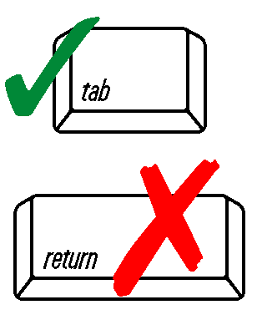 | This form is to be completed and signed by the Authorized Representative for the location where the emergency treatment will take place and the generator of the waste to be treated.  Pursuant to 310 CMR 30.86, this form must be attached to the application for an Emergency Treatment License.  The Emergency Treatment License issued by MassDEP is only valid for a period necessary to abate the emergency, and in no case shall exceed a period of 30 days from the effective date of the MassDEP written approval. A public notice is required in compliance with the notice provisions of 310 CMR 30.833 or 30.834, whichever is applicable.  MassDEP may terminate the Emergency Treatment License at any time it deems such action appropriate to protect public health, safety, or welfare, or the environment, or when MassDEP determines that the emergency has been abated.  The applicant must receive a written approval from MassDEP before any treatment may take place.

Location Where Emergency Treatment Will Take Place
Facility Name
Facility Location (Physical Address, Not Mailing Address)
City/Town | MA  State | ZIP Code
Telephone Number | EPA I.D. Number | Generator Status (LQG,SQG, VSQG)
Generator of the Waste to be Treated

Generator Name, if Different From Above (Doing Business As/Company Name)
Mailing Address
City/Town | State | ZIP Code
Telephone Number

Certification
I certify under penalty of law that I have personally examined and am familiar with the information submitted in this document and all attachments and that, based on my inquiry of those individuals immediately responsible for obtaining the information, I believe that the information is true, accurate, and complete. I am aware that there are significant penalties for submitting false information, including possible fines and imprisonment.

Name of Company that Generated the Hazardous Waste being Treated
Print Name of Authorized Representative
Signature Authorized Representative
Position/Title
Date (MM/DD/YYYY)

