The Commonwealth of Massachusetts
Executive Office of Health and Human Services
Department of Public Health
250 Washington Street, Boston, MA 02108-4619
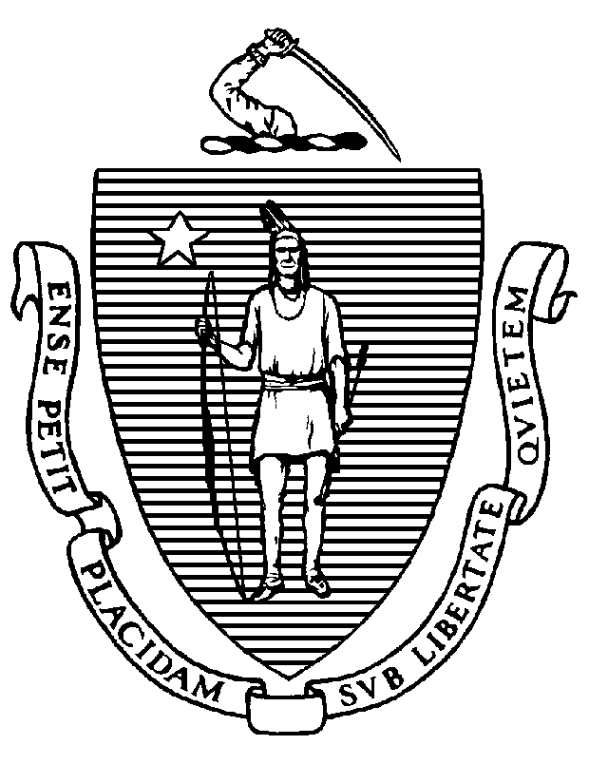

KATHLEEN E. WALSH
Secretary
ROBERT GOLDSTEIN, MD, PhD Commissioner

Tel: 617-624-6000
www.mass.gov/dph

MAURA T. HEALEY
Governor
KIMBERLEY DRISCOLL
Lieutenant Governor

Certified Health Officer (CHO) through Another State or Jurisdiction Application Checklist

Coming Soon

For questions regarding the application process or credentialing requirements, please contact the Office of Local and Regional Health, Workforce Development Credentialing Coordinator by telephone at (413) 923-3107 or by email at RS.CHO@Mass.gov.

