How to change your password for the online PCA New Hire Orientation
Step | Instruction | Screen Shot
1 | From the main menu, click on the Toggle Main Menu in the upper right corner to expand the selection.
2 | Click on “Edit Profile” | 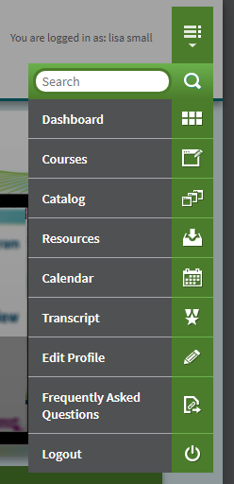
3 | This page opens after you click on “Edit Profile”. From here, click on “Change Password”. | 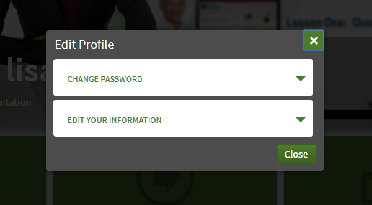
4 | This is the “Change Password” screen.  Follow the prompts and click on “Update”. | 