Chilcoat CPDD Poster_Layout 1 6/9/15 11:38 AM Page 1

**Changes in age-specific rates of doctor-shopping for opioids following introduction of reformulated OxyContin® tablets**



|  |  |  |  |  |  |
| --- | --- | --- | --- | --- | --- |
|  | **At Least:** | | | | |
| **At Least:** | **1**  **Pharmacy** | **2**  **Pharmacies** | **3**  **Pharmacies** | **4**  **Pharmacies** | **5**  **Pharmacies** |
| **1 Prescriber** | **-2%**  **(-2, -1)** | **0%**  **(-1, -1)** | **-43%**  **(-46, -41)** | **-72%**  **(-76, -67)** | **-81%**  **(-89, -67)** |
| **2 Prescribers** | **5% (4, 6)** | **-4%**  **(-5, -2)** | **-50.2%**  **(-53, -47)** | **-75%**  **(-80, -69)** | **-80.8%**  **(-90, -63)** |
| **3 Prescribers** | **-32%**  **(-35, -29)** | **-44%**  **(-47, -40)** | **-58%**  **(-62, -54)** | **-78%**  **(-83, -71)** | **-75%**  **(-88, -48)** |
| **4 Prescribers** | **-67%**  **(-74, -58)** | **-69%**  **(-76, -60)** | **-74%**  **(-81, -64)** | **-73%**  **(-82, -59)** | **-82%**  **(-93, -52)** |
| **5 Prescribers** | **-78%**  **(-90, -52)** | **-73.41%**  **(-88, -41)** | **-77.21%**  **(-90, -46)** | **-73%**  **(-89, -35)** | **-75%**  **(-92, -24)** |

H. Chilcoat, P. Coplan, N. Sessler, V. Harikrishnan

Purdue Pharma L.P., Stamford, CT



|  |  |  |  |  |  |
| --- | --- | --- | --- | --- | --- |
| BACKGROUND |  | METHODS (CONT.) |  |  | RESULTS (CONT.) |
| ■ In August 2010, Purdue Pharma introduced a reformulated extended-release oxycodone (OxyContin®) in |  | ■ Doctor shopping threshold |  | **Figure 2. Changes in rates of doctor-shopping by age group** | **Table 3. Change in Rates of doctor-shopping (95% CI) for OxyContin Before Versus** |
| the US, which is intended to deter crushing and forms a gel when dissolved to deter abuse. |  | – Sum total number of unique prescribers and pharmacies across all overlap events in six-month period |  | **before versus after reformulation of OxyContin** | **After Reformulation by Shopping Threshold** |
| ■ The introduction of reformulated OxyContin has resulted in declines in indicators of diversion: |  | – If number of prescribers/pharmacies reaches a specified threshold then patient is coded as positive for |  |  |  |
| • 60% reduction in reports of drug diversion by law enforcement |  | doctor shopping |  |  |  |

• 80% reduction in prescriptions for high dosage OxyContin prescriptions by potentially problematic prescribers



■ Is there a similar decline in diversion through “doctor-shopping” and how do changes in rates of doctor- shopping vary by age?

DOCTOR-SHOPPING



■ Obtaining prescriptions from multiple prescribers and/or pharmacies:

• For personal abuse

• For distribution to others who intend to abuse the drugs

• Generally involves multiple overlapping prescriptions from more than one prescriber and multiple pharmacies (Cepeda et al., 2012, Journal of Clinical Pharmacology)

– Initial threshold = at least 2 prescribers and 3 pharmacies (Cepeda et al., 2012, Journal of Clinical

Pharmacology

– All combinations of prescribers and pharmacies examined

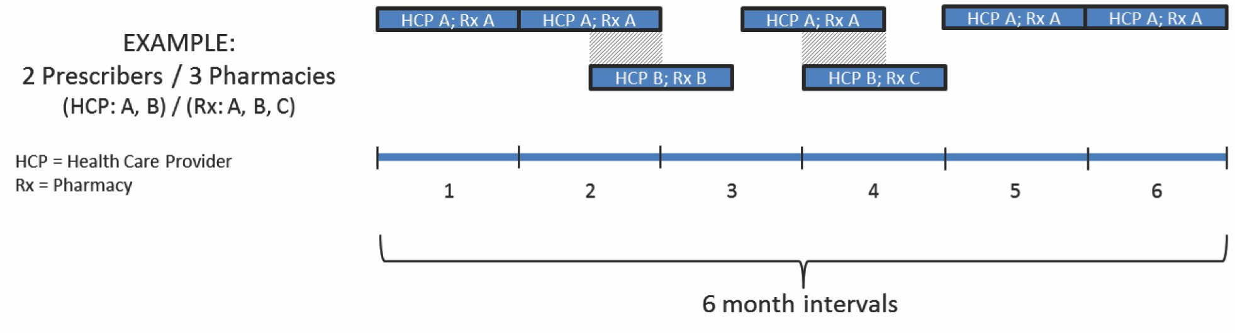

■ Doctor shopping rate

– Number of doctor shoppers/number of individuals with a prescription of specified product in specified time interval

**Figure 1. Doctor-shopping example of a patient with two overlap events involving prescriptions from 2 unique prescribers and**

**3 unique pharmacies in a six-month period**

OBJECTIVES



■ To characterize and estimate changes in age-specific rates of doctor-shopping for OxyContin and other opioids before versus after introduction of OxyContin reformulated with abuse deterrent properties in Aug

2010

■ To compare rates of doctor-shopping for OxyContin and other single-entity (SE) opioid products, often abused through non-oral routes (eg, snorting and injecting), and combination opioid products (with acetaminophen [APAP]), often abused orally by ingesting intact tablets

■ To estimate changes in doctor shopping by additional characteristics associated with abuse/diversion

– Cash payment

RESULTS



**Table 1. IMS: Rate of Doctor-shopping for OxyContin by Time Period**

SUMMARY



■ Declines in rates of doctor-shopping from 1 year before (July 2009 to June 2010) to 2.5 years after reformulation (January 2011 to June 2013) were of larger magnitude for OxyContin than other opioids.

■ Factors that have been previously shown to be associated with doctor-shopping and abuse (Cepeda et

– High dosage strength

■ To compare the magnitude in change of doctor-shopping rates for more versus less sensitive thresholds defining doctor-shopping

**Pre-**

**Reformulation**



**Transition**

**Post-**

**Reformulation**

**Figure 3. Changes in rates of doctor-shopping for Oxycontin for overlap events that**

al., 2012, Journal of Clinical Pharmacology; Coplan et al., 2013, Pharmacoepidemiology and Drug Safety)

had larger declines in rates post-reformulation

– 18-29 years old

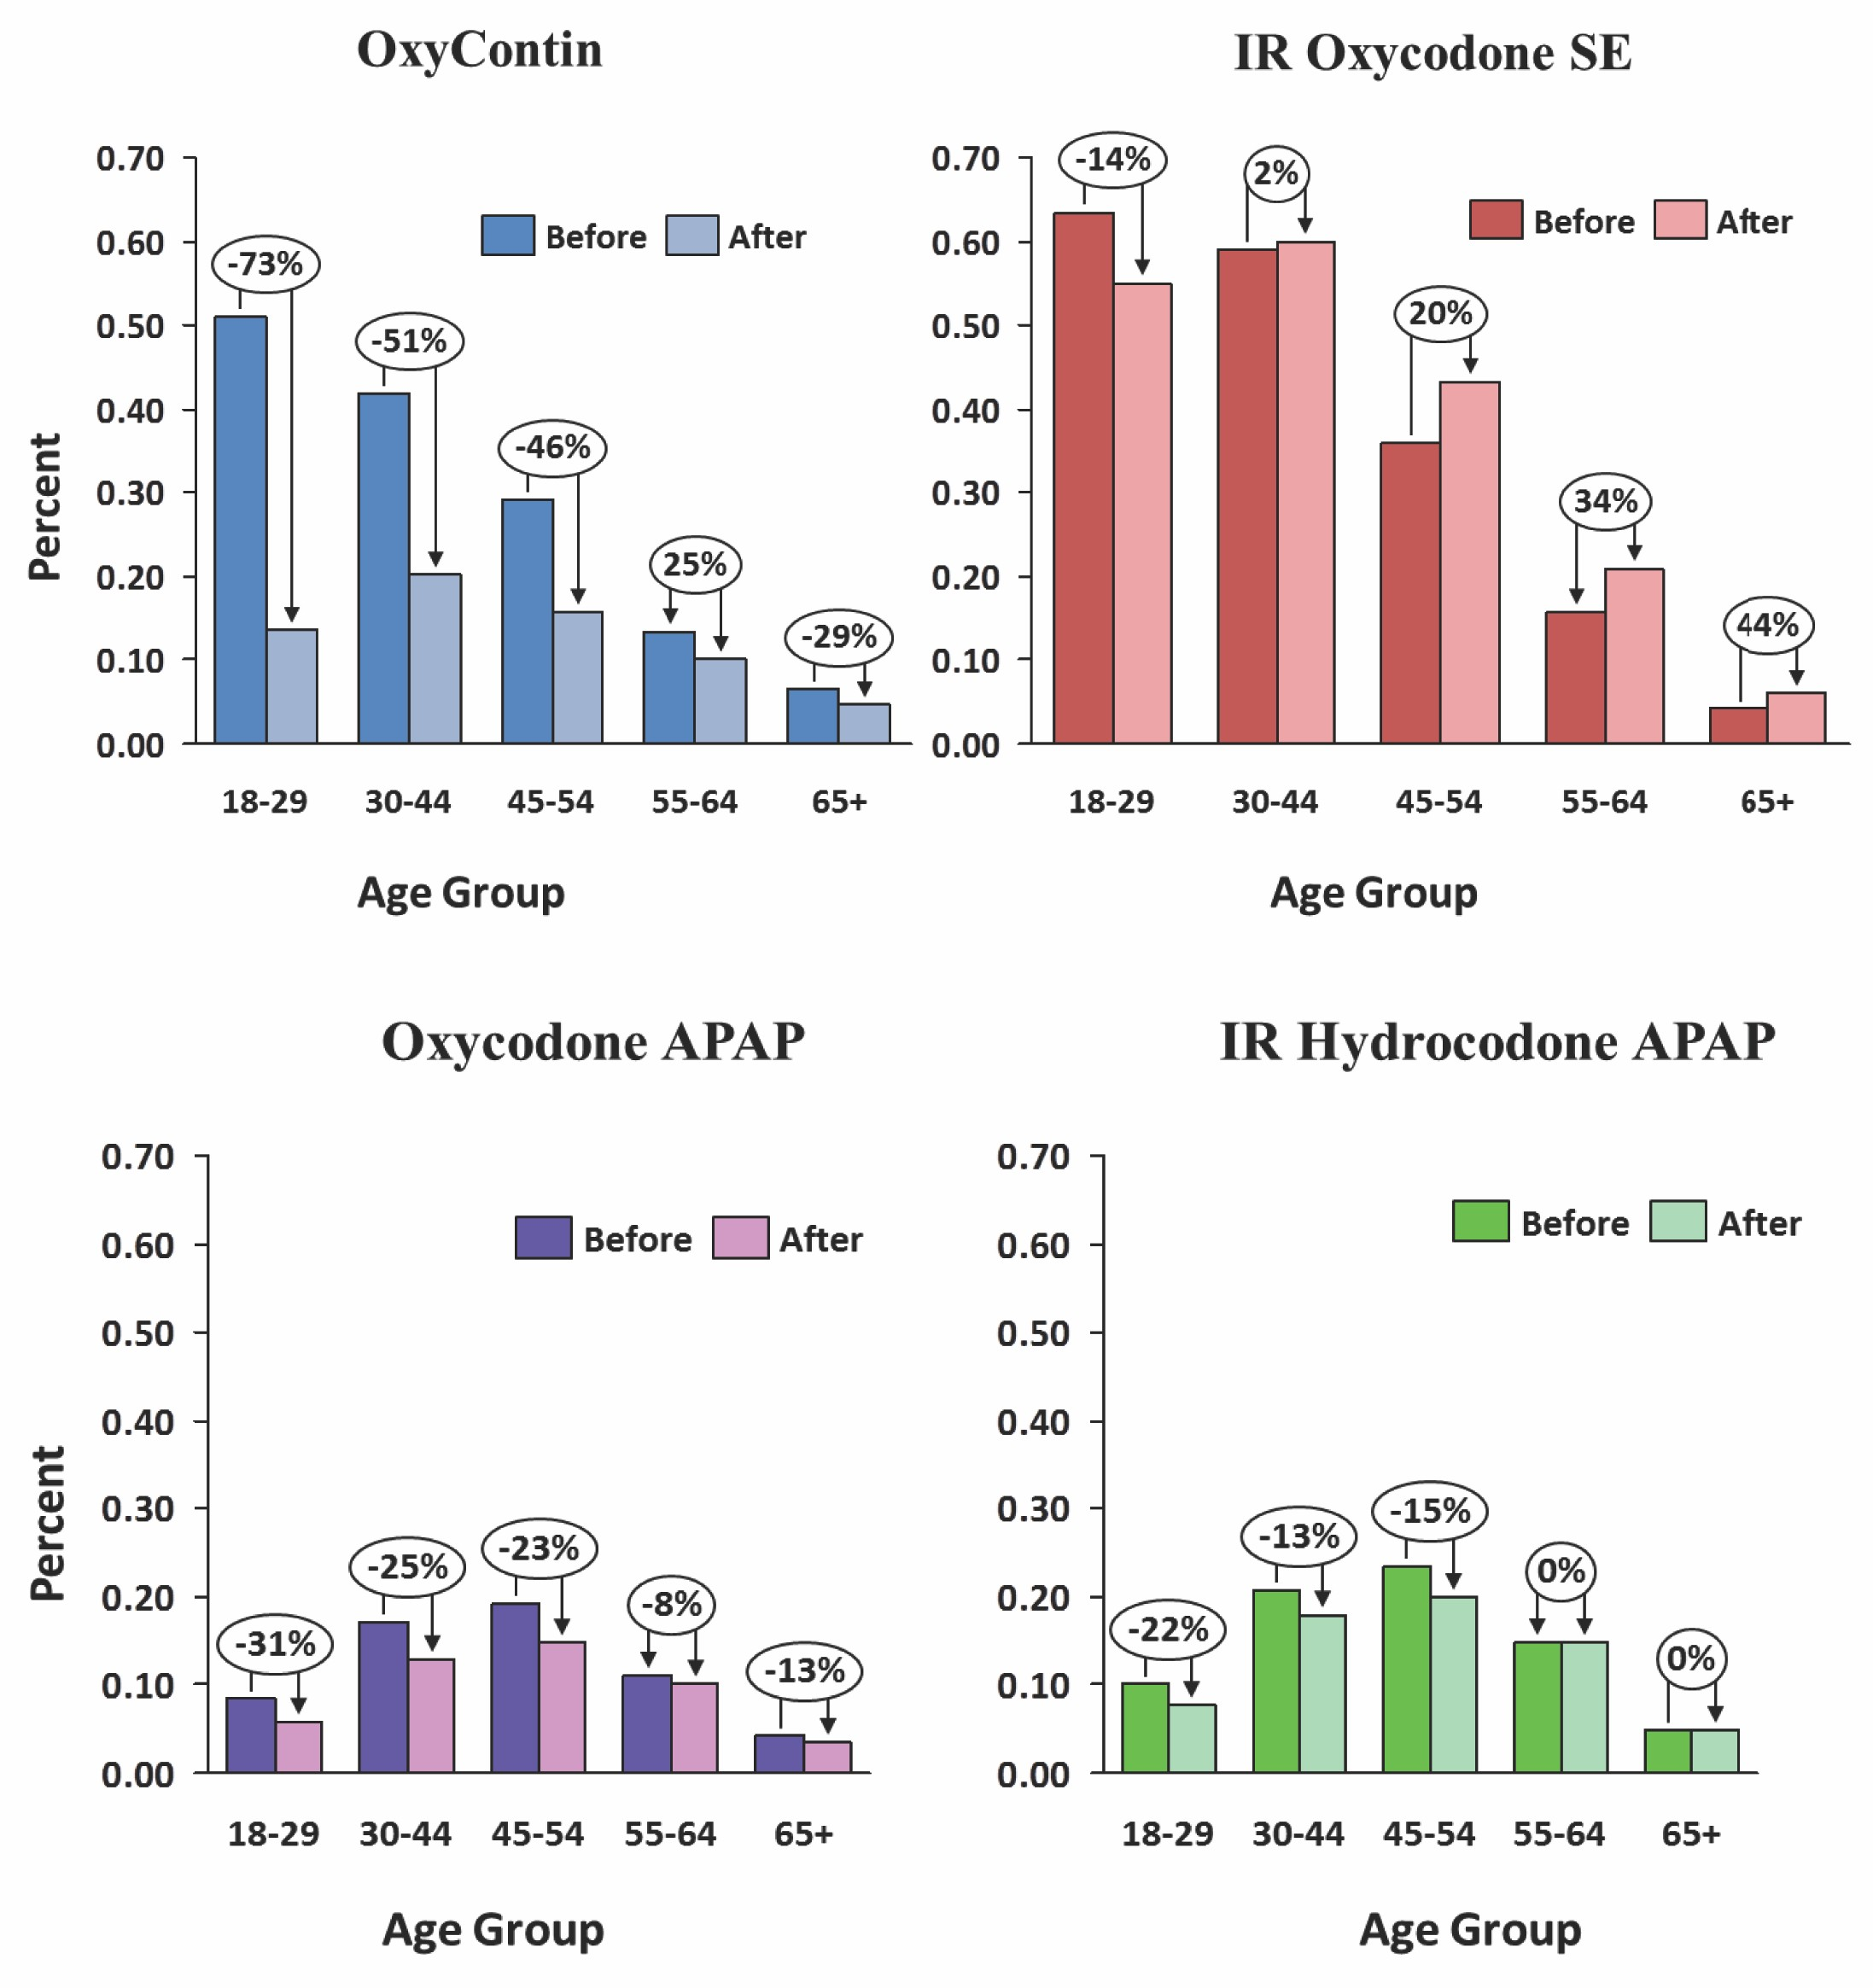

METHODS



**Number of OxyContin**

**Patients Included in Study**

**Number of Patients with**

849,860 447,569 2,130,955

**involve at least one cash payment, 80 mg dosage strength, and both cash payment**

**and 80 mg dosage strength: a) All ages and b) 18-29 year olds**

– Cash payment

– High dosage strength

■ The age-specific profile of doctor-shopping rates of OxyContin was consistent with that of other single



■ Data Source: IMS LRx database

– Patient de-identified data from sample of IMS Health retail universe

– Direct feeds from retail pharmacies

– Encryption algorithm to de-identify and assign each patient a unique ID

– Covers approximately 65% of all retail prescriptions filled in the US

– More than 150 million unique de-identified patients

– More than 1 million prescribers

■ Estimated rates of doctor shopping in six-month intervals before and after introduction of ORF

– Pre-reformulation: July 2009 to June 2010

– Transition: July to December 2010

– Post-reformulation: January 2011 to June 2013

■ For each six-month calendar period (January-June, July-December), identify all possible “overlap” events for OxyContin and comparator products:

– Start date of each prescription and days supply

– Overlapping prescriptions are determined by multiple prescriptions for the same patient where number of days supply of the prescriptions overlap by at least one day

– Comparators include: Immediate-release (IR) single entity (SE) oxycodone, IR oxycodone/APAP, IR

hydrocodone/APAP

0 13% 0 10% -23 (-25 -21) 0 772 (0 755 0 789) 0 65

■ For each overlap event

– Count number of unique prescribers

– Count number of unique pharmacies

**2+ Prescribers/** 2,087 977 2,606

**3+ Pharmacies**

**Number of**

**3 Ph i**

**Doctor-shopping rate** 0.25% 0.22% 0.12%

**Table 2. Changes in Rates of Doctor-shopping for OxyContin and Opioid Comparators**



|  |  |  |  |  |  |  |  |  |
| --- | --- | --- | --- | --- | --- | --- | --- | --- |
|  | **Pre- Post-**  **period period Percent Ratio of Ratio of (July’09 – (Jan’11 – change Relative Risk Relative Relative Risk June’10) June’13) (95% CI) (95% CI) Risk (95% CI)** | | | | | | |  |
| **All Doctor-Shopping Events** | | | | | | |
| **OxyContin** | 0.25% | 0.12% | -50 (-53, -47) | 0.498 (0.470, 0.528) |  |  |
| **IR SE**  **oxycodone** | 0.34% | 0.36% | 5 (2, 9) | 1.053 (1.022, 1.085) | 0.47 | 0.473 (0.443, 0.505) |
| **Oxycodone**  **APAP** | .13% | .10% | 23 - , - | 0. ( .755, .789 | 0. | 0.645 (0.606, 0.686) |
| **Hydrocodone**  **APAP** | 0.15% | 0.13% | -13(-14, -12) | 0.866 (0.856, 0.876) | 0.58 | 0.575(0.542, 0.609) |
|  | | | | | | | | |

**(at least 2 prescribers and 3 pharmacies)**

**All Ages**

**18-29 Years Old**

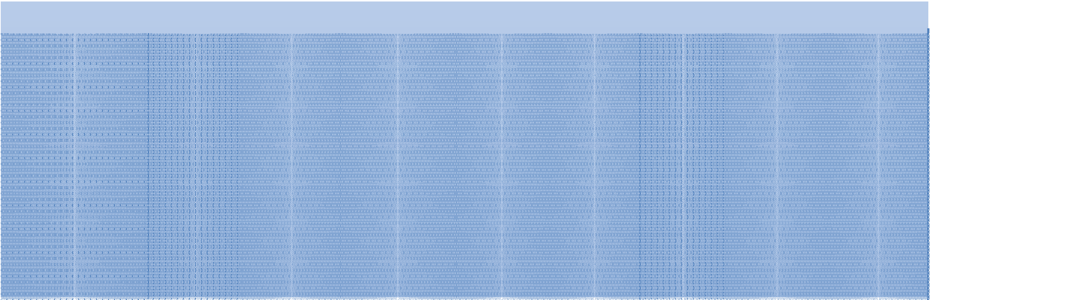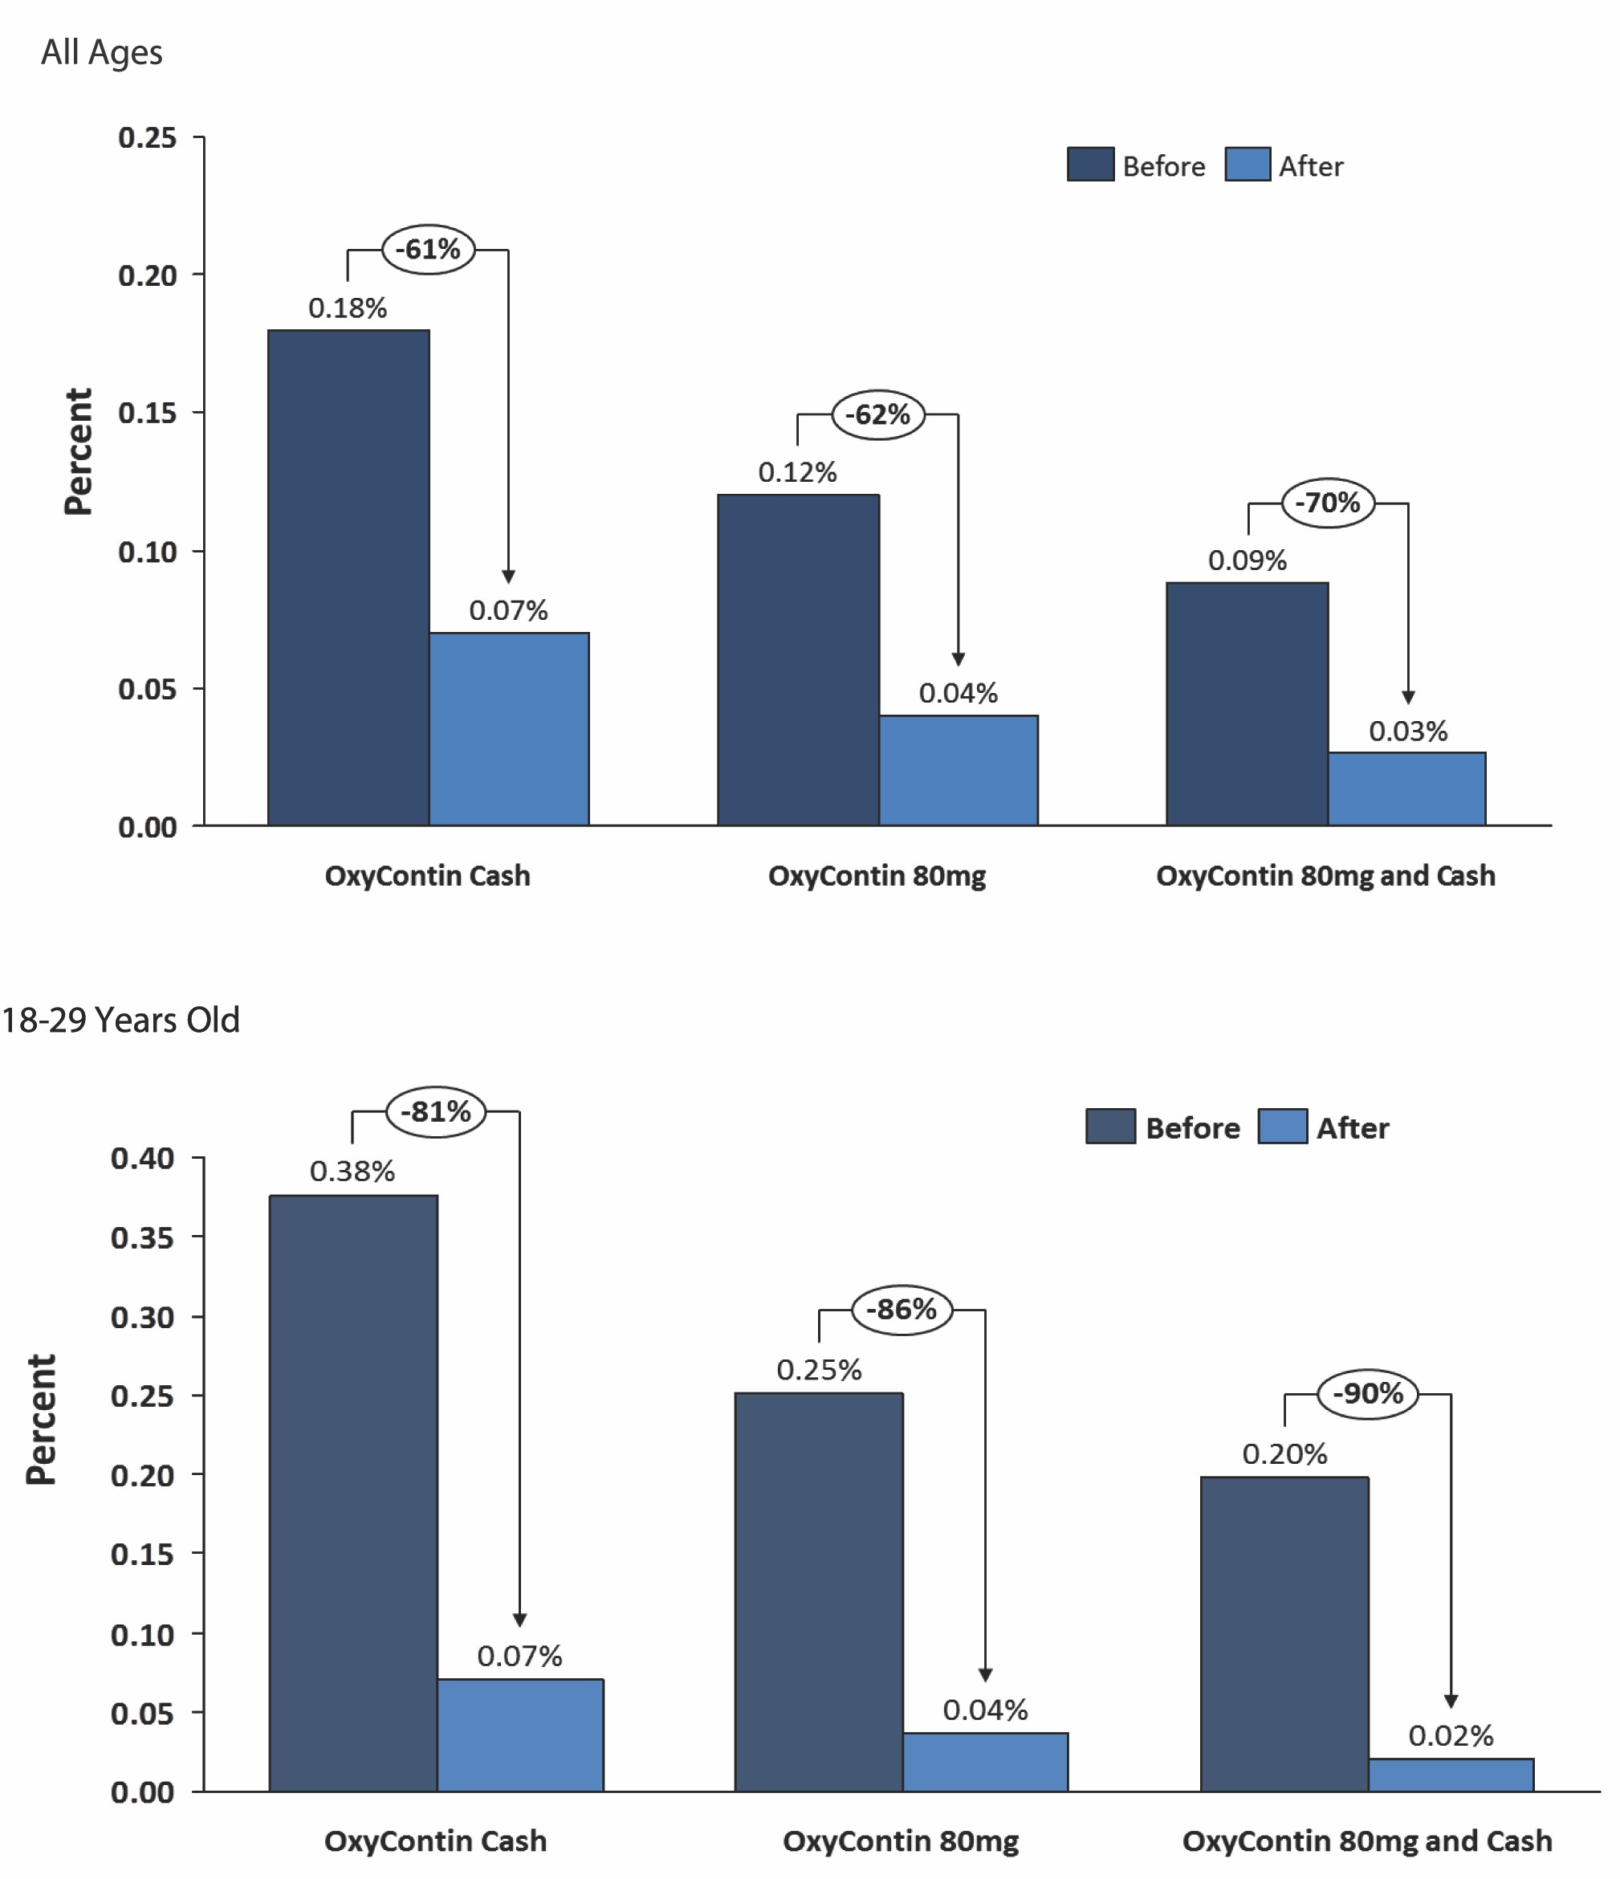

entity opioids (IR single entity oxycodone) before reformulation but was more similar to opioid combination products (hydrocodone and oxycodone with APAP) after reformulation

■ Magnitude of decline in doctor-shopping rates increased as threshold for doctor-shopping increased

CONCLUSIONS



■ Larger declines for characteristics associated with abuse and diversion supports construct validity of changes in rates of doctor-shopping for reformulated OxyContin.

■ The reduction in doctor-shopping supports the hypothesis that the reformulation of OxyContin deters abuse.

Disclosure Statement

This study was funded by Purdue Pharma and Chilcoat, Coplan, Sessler, and Harikrishnan are employees of

Purdue Pharma L.P.

Presented at the College on Problems of Drug Dependence 77th Annual Scientific Meeting, Phoenix, AZ, June 13-18, 2015