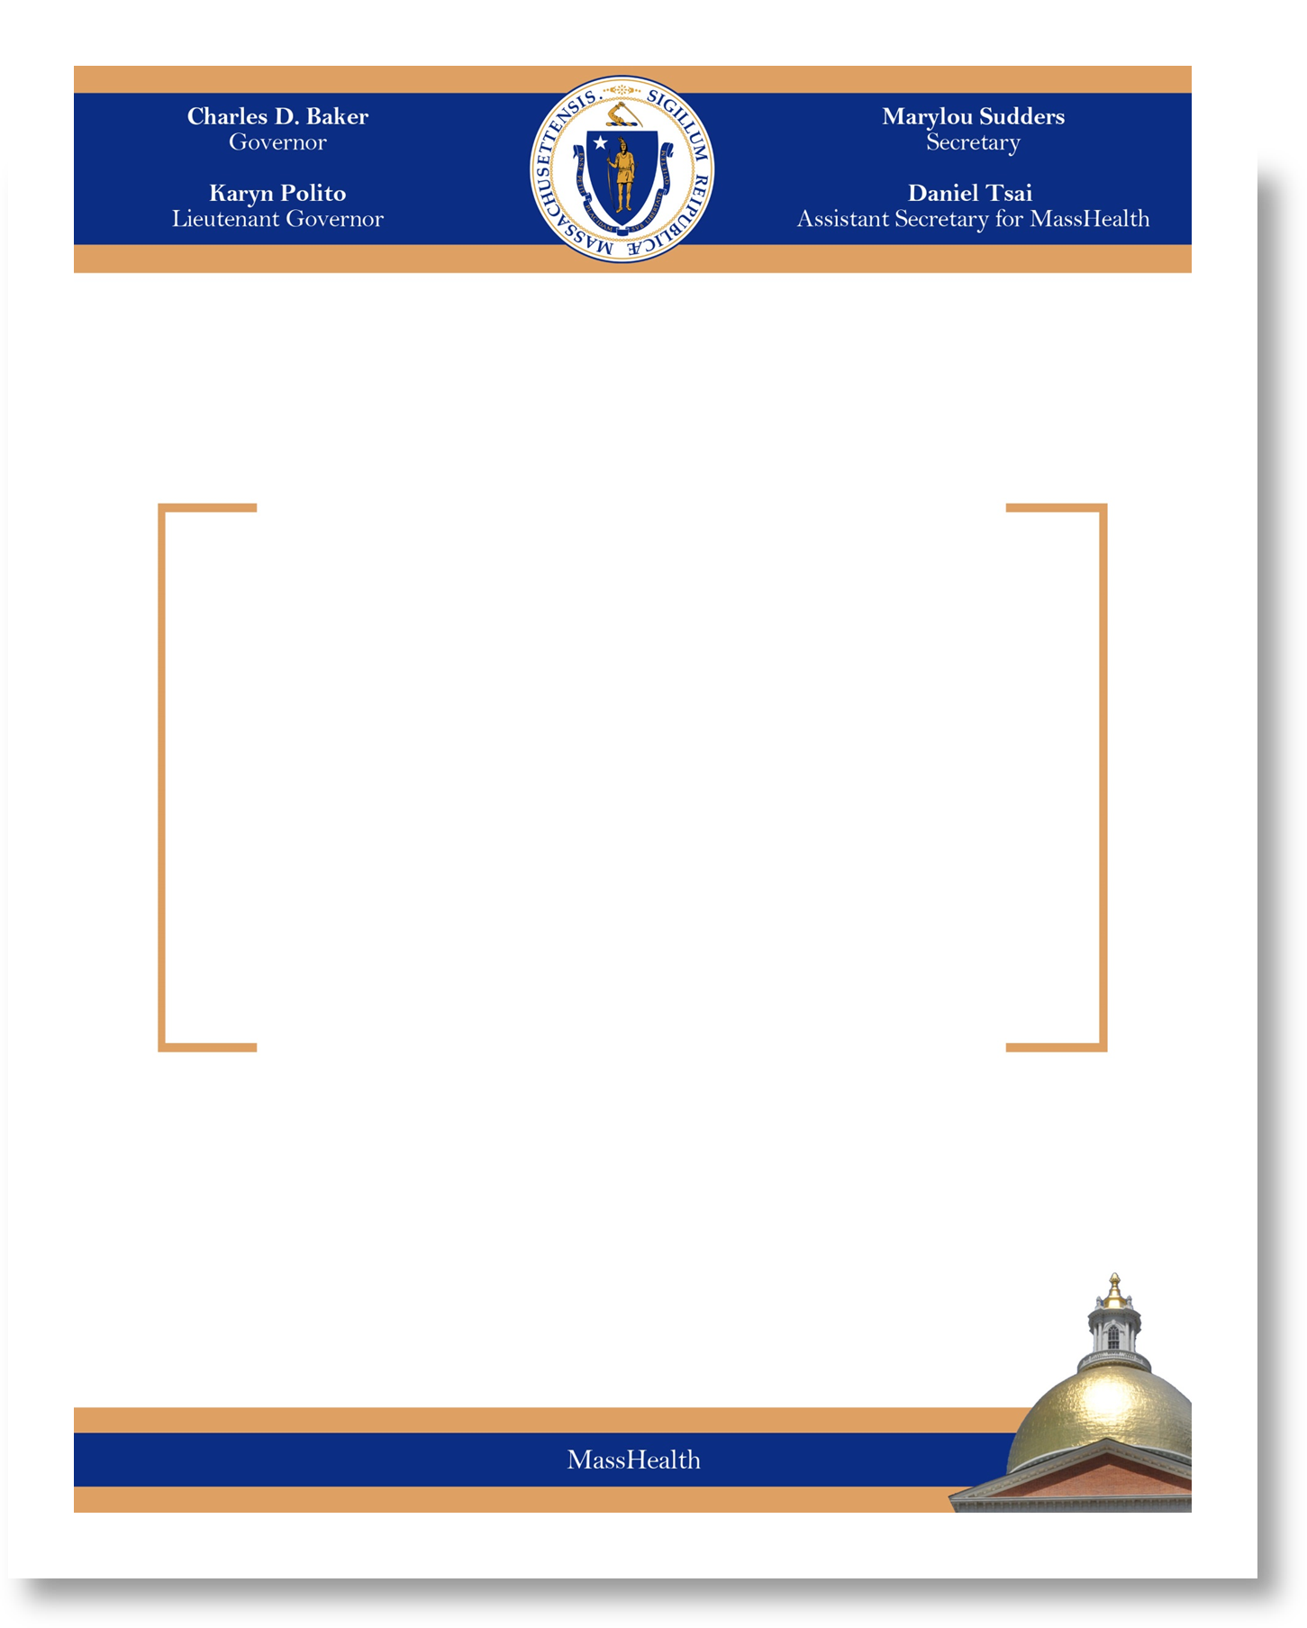

MassHealth Chapter 171 Annual Family Support Plan for Fiscal Year 2015

October 28, 2015

