MAURA T. HEALEY

Governor

KIMBERLEY DRISCOLL

Lieutenant Governor

July 8th, 2024

The Commonwealth of Massachusetts

Executive Office of Health and Human Services Department of Public Health

250 Washington Street, Boston, MA 02108-4619

KATHLEEN E. WALSH

Secretary

Robert Goldstein, MD, PhD

Commissioner

**Tel: 617-624-6000**

[**www.mass.gov/dph**](http://www.mass.gov/dph)

Steven T. James House Clerk

State House Room 145 Boston, MA 02133

Michael D. Hurley Senate Clerk

State House Room 335 Boston, MA 02133

Dear Mr. Clerk,

Pursuant to Chapter 208 of the Acts of 2018, please find enclosed a report from the Department of Public Health titled “*Outcomes of the Medications for Opioid Use Disorder (MOUD) in Correctional Facilities Pilot Program.”*

Sincerely,

Robert Goldstein, MD, PhD Commissioner

Department of Public Health

*(this page has intentionally been left blank)*



**Outcomes of the Medications for Opioid Use Disorder (MOUD) in Correctional Facilities Pilot Program**

**June 2024**

# Legislative Mandate

The following report is hereby issued pursuant to Chapter 208 of the Acts of 2018 as follows:

SECTION 98. (a) Notwithstanding any general or special law to the contrary, there shall be, subject to appropriation, a pilot program for the delivery of medication-assisted treatment for opioid use disorder at the county correctional facilities located in Franklin, Hampden, Hampshire, Middlesex and Norfolk counties. The pilot program shall be implemented by the department of public health, in collaboration with the executive office of public safety and security, the office of Medicaid, and the county sheriffs who have jurisdiction over the county correctional facilities located in Franklin, Hampden, Hampshire, Middlesex and Norfolk counties.

1. A county correctional facility participating in the pilot program shall:
   1. maintain or provide for the capacity to possess, dispense and administer all drugs approved by the federal Food and Drug Administration for use in medication-assisted treatment for opioid use disorder; provided, however, that a facility shall not be required to maintain or provide a drug that is not also included as a MassHealth covered benefit;
   2. provide medication-assisted treatment to a person in the custody of the facility, in any status, who was receiving medication-assisted treatment for opioid use disorder through a legally authorized medical program or by a valid prescription immediately before incarceration; provided, however, that treatment shall not be involuntarily changed or discontinued except upon a determination by a qualified addiction specialist, as defined in section 1 of chapter 127 of the General Laws, that the treatment is no longer appropriate;
   3. provide medication-assisted treatment not less than 30 days prior to release to a sentenced inmate in the custody of the facility for whom such treatment is determined to be medically appropriate by a qualified addiction specialist;
   4. provide, as part of the facility’s opioid use disorder treatment program, behavioral health counseling, as defined in section 1 of chapter 127 of the General Laws, for individuals consistent with current therapeutic standards for these therapies in a community setting; provided, however, that those standards shall be consistent with the safety and security requirements of the facility;
   5. not use incentives, rewards or punishments to encourage or discourage a person’s decision to receive medication-assisted treatment while in the custody of the facility;
   6. make every possible effort to directly connect, prior to release, a person in the custody of the facility who is receiving medication-assisted treatment to an appropriate provider or treatment site in the geographic region in which the person will reside upon release;

provided, however, that if such connection is not possible, the facility shall document its efforts in the person’s record;

* 1. request reinstatement or apply for MassHealth benefits for a person in the custody of the facility who is receiving medication-assisted treatment not less than 30 days before that person’s release; and
  2. provide a status report every 6 months, in a format determined by the commissioner of public health, to the secretary of public safety, the commissioner of public health, the joint committee on public safety and homeland security and the joint committee on mental health, substance use and recovery, which shall include following information: (i) the cost to the facility of providing medication-assisted treatment, behavioral health counseling and post-release case management for opioid use disorder; (ii) the type and prevalence of medication-assisted treatment provided for opioid use disorder; (iii) the number of persons in the custody of the facility, in any status, who continued to receive the same medication- assisted treatment as they received prior to incarceration; (iv) the number of persons in the custody of the facility, in any status, who voluntarily changed or discontinued medication-assisted treatment for opioid use disorder that they received prior to incarceration; (v) the number of persons in the custody of the facility, in any status, who changed or discontinued medication-assisted treatment for opioid use disorder that they received prior to incarceration due to a determination by a qualified addiction specialist;

(vi) the number of persons in the custody of the facility, in any status, who received medication-assisted treatment for opioid use disorder during the 30 days before their release; (vii) a summary of facility practices and any changes to those practices related to medication-assisted treatment and behavioral health counseling for opioid use disorder;

(viii) a list of program participants, which shall be provided to the department of public health in order to track aggregated outcome data post release; and (ix) any other information requested by the commissioner related to the provision of medication-assisted treatment for opioid use disorder.

1. A county sheriff with jurisdiction over a county correctional facility participating in the pilot program shall, in consultation with the commissioner of public health, the secretary of public safety and security, the director of Medicaid, the Association for Behavioral Healthcare, Inc., the Advocates for Human Potential, Inc., and other county sheriffs who have jurisdiction over the county correctional facilities participating in the pilot program, develop an implementation plan for the pilot program in their facility. An implementation plan shall consider: (i) best practices for the delivery of medication-assisted treatment and behavioral health counseling for opioid use disorder; (ii) uniform guidelines to ensure the safety and security of correctional facility personnel and people in the custody of the facility during the administration of medication-assisted treatment and behavioral health counseling; (iii) the projected cost of providing medication-assisted treatment and behavioral health counseling; (iv) health insurance coverage, including Medicaid; (v) protocols for technical medical assistance that may be required by the department of public health, including appropriate personnel and physical space to safely administer

medication-assisted treatment; (vi) the availability of appropriate community services after release, including a process for directly connecting a person upon release to an appropriate provider or treatment site in the geographic region in which the person will reside upon release in order to continue treatment; (vii) appropriate metrics for evaluating and tracking pilot program outcomes; and (viii) any other information necessary to implement the pilot program.

The commissioner of public health shall evaluate and approve, pursuant to section 7 of chapter 111E, implementation plans for a pilot program under this section. The commissioner of public health shall send copies of approved implementation plans to the senate and house committees on ways and means, the joint committee on mental health, substance use and recovery and the joint committee on public safety and homeland security not less than 30 days before the implementation of the pilot program.

1. The pilot program under this section shall be implemented not later than September 1, 2019.
2. After implementation of the pilot program, the commissioner of public health shall submit a report regarding outcomes for the pilot program not later than September 1, 2020, and annually thereafter for the next 3 years, to the senate and house committees on ways and means, the joint committee on mental health, substance use and recovery and the joint committee on public safety and homeland security. The report shall include, to the extent possible, a comparison between people in custody who did not receive medication-assisted treatment for opioid use disorder and those who did, reported separately for each medication type, in order to determine the impact of the treatment programs on the following: (i) retention in treatment after release, including regions where direct connection to treatment was less likely; (ii) substance use and relapse after release;

(iii) rates of recidivism; (iv) rates of nonfatal and fatal overdose; and (v) other outcome measures identified by the commissioner of public health.

1. Notwithstanding any general or special law to the contrary, the department of public health shall establish protocols that ensure that medication-assisted treatment provided under this section meets the following criteria: (i) consent provided to receive medication- assisted treatment is voluntarily given by the person in custody; (ii) that consent is recorded on a consent form signed by the person in custody; and (iii) consent is given after a written and verbal explanation of the following information: (A) the nature of federal Food and Drug Administration-approved medication used in substance use disorder treatment, including benefits and risks; (B) available alternative treatment options, including benefits and risks; (C) the need for the person in custody to inform the qualified addiction specialist, as defined in section 1 of chapter 127 of the General Laws, of medical conditions, including pregnancy, and medications that the person in custody is currently taking; (D) acknowledgement that the person in custody may withdraw voluntarily from treatment and discontinue use of medications; and (E) the options following termination of treatment, including detoxification. The department of public health shall establish the

protocols not later than March 1, 2019, and shall make the protocols publicly available on its website and forward a copy of the protocols to the joint committee on mental health, substance use and recovery.

1. The commissioner of public health may promulgate regulations and guidelines necessary to implement the pilot program under this section.

# Executive Summary

This report includes the results of the outcomes analysis of the program to pilot medications for opioid use disorder (MOUD) in correctional facilities.

Results of the outcome analysis indicate that people with an opioid use disorder (OUD) who were treated with MOUD in a county correctional facility as part of the pilot program had better outcomes than people who were not treated with MOUD during their incarceration. Specifically, people treated with MOUD during incarceration were:

* more likely to receive MOUD in the community after release;
* 50% less likely to experience death from any cause;
* less likely to experience an opioid-related overdose; and
* less likely to be re-incarcerated.

Under [*105 CMR 164.00: Licensure of substance use disorder treatment programs*](https://www.mass.gov/regulations/105-CMR-16400-licensure-of-substance-use-disorder-treatment-programs?_gl=1%2A161brmj%2A_ga%2AMTA4NzEwNjAzMS4xNjE4NTk2MDY0%2A_ga_MCLPEGW7WM%2AMTcxMzk2MjY1My4yOTIuMC4xNzEzOTYyNjUzLjAuMC4w)and in alignment with the federal Americans with Disabilities Act, all state and county correctional facilities are now required to offer medications for addiction treatment (including but not limited to medications for opioid use disorder, or MOUD) to all incarcerated people with substance use disorder who meet the medical necessity criteria for such medications.

We were able to conduct this analysis because of the availability of the Massachusetts Public Health Data Warehouse1 (PHD), which combines individually linkable data across 24 state and county data sources combined with three community level datasets. The PHD has been critical for generating insight on public health priorities in Massachusetts that are not available from single sources of data. The PHD includes data related to public health, health care, public safety, the criminal/legal system, and the Social Determinants of Health.

Continuing to provide accurate and detailed data analyses related to the opioid crisis in Massachusetts is critical to ensuring the ongoing appropriate allocation of resources and access to care. We present this report so approaches to end the epidemic can continue to be prioritized effectively.

1 <https://www.mass.gov/public-health-data-warehouse-phd>

# Introduction

Opioid-related overdose deaths rates are at an all-time high in Massachusetts.2 Nonfatal opioid-related overdose rates have decreased since 2017, but still remain very high3.

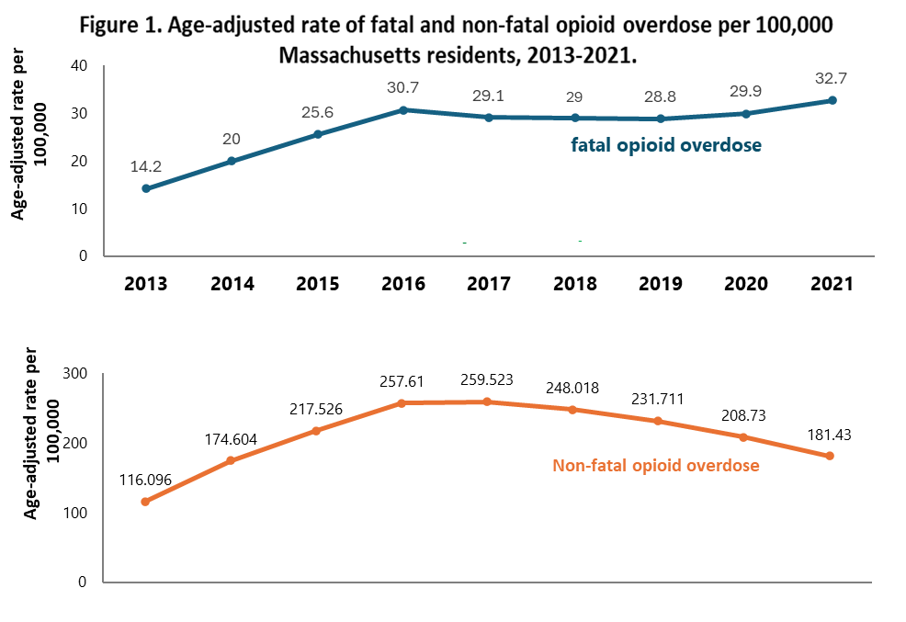

The risk of opioid-related overdose is high among people released from incarceration, especially in the immediate post-release period4,5. Despite this high risk, most county correctional facilities (e.g., jails) and prisons in the United States have not routinely provided medications for opioid use disorder (MOUD) during incarceration or upon release6 even though MOUD have been shown to save lives7.

2 [Massachusetts Department of Public Health (2023, December). Data Brief: Opioid-Related Overdose Deaths Among](https://www.mass.gov/doc/opioid-related-overdose-deaths-among-ma-residents-december-2023/download) [Massachusetts Residents](https://www.mass.gov/doc/opioid-related-overdose-deaths-among-ma-residents-december-2023/download)

3 [Massachusetts Department of Public Health (2023, December). Data Brief: Characteristics of non-fatal opioid-related](https://www.mass.gov/doc/characteristics-of-non-fatal-overdose-among-ma-residents-2013-2021/download) [overdoses among Massachusetts residents, 2013-2021.](https://www.mass.gov/doc/characteristics-of-non-fatal-overdose-among-ma-residents-2013-2021/download)

4 [Massachusetts Department of Public Health. (2016, September 15). *An Assessment of Opioid- Related Deaths in*](https://www.mass.gov/doc/chapter-55-2016-legislative-report-0/download)[*Massachusetts*](https://www.mass.gov/doc/chapter-55-2016-legislative-report-0/download)[*(2013 – 2014)*. Mass.gov.](https://www.mass.gov/doc/chapter-55-2016-legislative-report-0/download)

5 [Massachusetts Department of Public Health. (2017, August 16). *An Assessment of Fatal and Nonfatal Opioid Overdoses in*](https://www.mass.gov/files/documents/2017/08/31/legislative-report-chapter-55-aug-2017.pdf)[*Massachusetts (2011 – 2015)*. Mass.gov.](https://www.mass.gov/files/documents/2017/08/31/legislative-report-chapter-55-aug-2017.pdf)

6 <https://bjs.ojp.gov/document/oudstlj19.pdf>

7 [National Academies of Sciences, Engineering, and Medicine; Leshner AI, Mancher M, eds. *Medications for Opioid Use*](https://nap.nationalacademies.org/catalog/25310/medications-for-opioid-use-disorder-save-lives)[*Disorder Save Lives*. The National Academies Press; 2019](https://nap.nationalacademies.org/catalog/25310/medications-for-opioid-use-disorder-save-lives)

Under Chapter 208 of the Acts of 2018 (CARE ACT), the following five county correctional facilities volunteered to participate in a pilot program offering broad access to the three FDA- approved types of MOUD (buprenorphine, methadone, and naltrexone) to eligible individuals living within their House of Correction and Jail facilities:

* Franklin County
* Hampden County
* Hampshire County
* Middlesex County
* Norfolk County

The following two additional county's facilities were later added to this pilot program in the Fiscal Year 2019 supplemental budget:

* Essex County
* Suffolk County

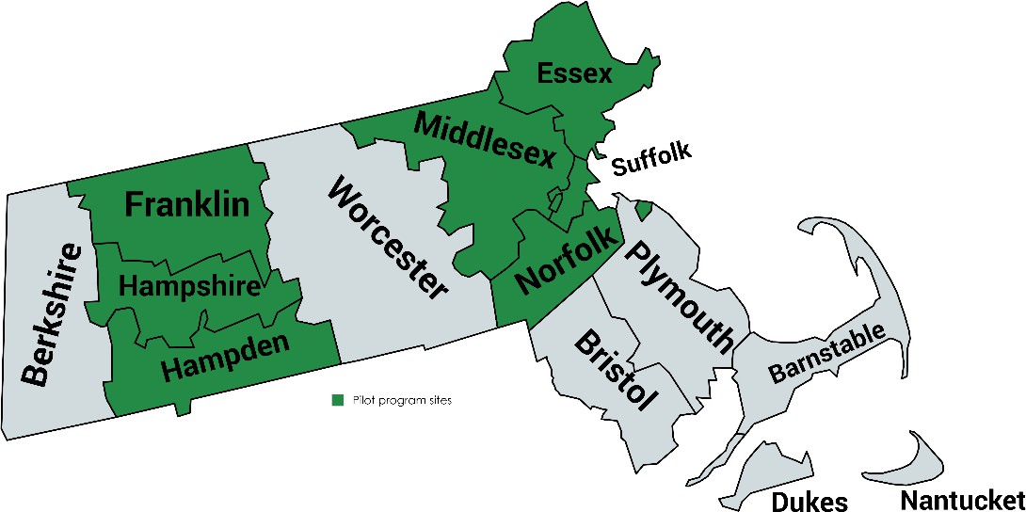

Correctional facilities began implementation of their MOUD program on September 1, 2019.

The Massachusetts Department of Public Health is funded through a subcontract with Baystate Medical Center to serve as a partner on the National Institute of Health funded Justice Community Opioid Innovation Network (JCOIN) research grant. The JCOIN grant provided support for data collection and analysis.

# Methods

We included all individuals with an opioid use disorder (OUD) who were incarcerated at a participating county correctional facility between September 2019 and December 2020 and released before July 2021, ensuring at least 6 months of post-release data. Individuals were classified as being in the “Received MOUD” group (i.e., had OUD and were treated with MOUD during incarceration) or in the “Did Not Receive MOUD” group (i.e., had OUD and were not treated with MOUD during incarceration) based on their first incarceration during the study timeframe. Reasons why people did not receive MOUD include not being on MOUD in the community at jail intake, being detained for too short a period to start MOUD, having a medical condition not appropriate for MOUD, expected transfer to a facility where MOUD was not available, lack of availability of MOUD at jail entry, and having a history of medication diversion. While some of the reasons are not qualifying exceptions under the original legislative mandate and/or current applicable laws and regulations, they do highlight very real barriers correctional facilities face in implementing MOUD in these settings and can inform future implementation strategies and support needed to address these challenges. We used multiple linked datasets from the Massachusetts Public Health Data Warehouse (PHD) to examine post-release MOUD treatment, nonfatal and fatal opioid-related overdoses, reincarceration, and all-cause mortality.

We examined the socio-demographic characteristics, adjudication status, treatment history, and outcomes of people with OUD who did (n=2,723; 43%) and did not (n=3,660; 57%) receive MOUD treatment while incarcerated in the 7 participating county correctional facilities (Figure 2). Table 1 describes the distribution of baseline characteristics by study group (Received MOUD and Did Not Receive MOUD). Continuous measures are reported using means, standard deviations, medians, and percentiles. Categorical measures are reported using frequencies and percentages.

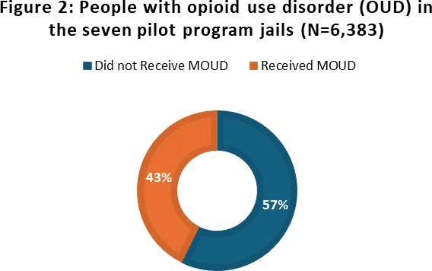

Next, we examined patient outcomes by study group. We also examined outcomes for each type of MOUD received.

Last, we used logistic regression and Cox proportional hazards models to assess whether receipt of MOUD treatment during incarceration was associated with outcomes. We used propensity

score weights to adjust for selection effects that might have introduced confounding bias. Because MOUD treatment was not randomly assigned, those who received MOUD were different from those who did not receive MOUD in ways that might also affect their outcomes. The propensity score represents the likelihood of a participant receiving MOUD during their county correctional facility stay. Based on existing literature and imbalances found in baseline measures, we included the following factors in a model estimating propensity scores: age, race, sex, veteran status, education level, history of homelessness, history of overdose, MOUD at county correctional facility entry, county where incarcerated, adjudication status, and days incarcerated. Re-weighting participants according to their propensity scores produced a statistical sample in which the two treatment groups (those who did and did not receive MOUD) had very similar characteristics.

# Results

|  |  |  |
| --- | --- | --- |
| **Table 1. Demographics and baseline measures** | | |
| **Received MOUD** (N=2,723) | | **Did Not Receive MOUD** (N=3,660) |
| **Adjudication status** N (%) |  |  |
| Pre-trial | 1,754 (64.4) | 2,981 (81.5) |
| Sentenced | 938 (34.5) | 501 (13.7) |
| Safekeep | 22 (0.8) | 158 (4.3) |
| Unknown/Missing | * | 20 (0.6) |
| **MOUD at entry1** N (%) |  |  |
| No | 748 (27.5) | 3,032 (82.8) |
| Yes | 1,975 (72.5) | 628 (17.2) |
| **Pre-incarceration overdose** N (%) |  |  |
| No | 1,484 (54.5) | 2,354 (64.3) |
| Yes | 1,239 (45.5) | 1,306 (35.7) |
| **MOUD type at enrollment** N (%) |  |  |
| Methadone | 699 (25.7) | -- |
| Buprenorphine | 1,855 (68.1) | -- |
| Naltrexone | 169 (6.2) | -- |
| **Days incarcerated** median [IQR] | 51 [14, 140] | 17 [2, 63] |
| **Age** median [IQR] | 36 [31, 42] | 35 [29, 43] |
| **Race/Ethnicity** N (%) |  |  |
| White non-Hispanic (nH) | 2,044 (75.1) | 2,137 (58.4) |
| Black nH | 158 (5.8) | 596 (16.3) |
| Asian/PI nH | * | 15 (0.4) |
| American Indian/Other nH | 16 (0.6) | 29 (0.8) |
| Hispanic (any race) | 500 (18.4) | 883 (24.1) |
| **Sex** N (%) |  |  |
| Male | 2,028 (74.5) | 2,744 (75.0) |
| Female | 695 (25.5) | 916 (25.0) |
| **Education** N (%) |  |  |
| HS or less | 1841 (67.6) | 2275 (62.1) |
| 13+ years | 589 (21.6) | 822 (22.5) |
| Missing/Not collected | 293 (10.8) | 563 (15.4) |
| **History of homelessness** N (%) |  |  |
| No | 838 (30.8) | 1,266 (34.6) |
| Yes | 1,884 (69.2) | 2,189 (59.8) |
| Unknown | * | 206 (5.6) |
| **Veteran** N (%) |  |  |
| No | 2,444 (89.8) | 3,299 (90.1) |
| Yes | 279 (10.2) | 361 (9.9) |
| * = value suppressed due to small cell size (1-10)  1PHD record of MOUD within 14 days of county correctional facility entry or self-report | | |

|  |  |  |  |  |  |
| --- | --- | --- | --- | --- | --- |
| **Table 2. Post-release outcomes** | | | | | |
|  | **Buprenorphine**  N=1,855 | **Methadone**  N=699 | **Naltrexone**  N=169 | **All MOUD**  **Types**  N=2,723 | **Did Not Receive MOUD**  N=3,660 |
| **MOUD**  **initiation/coverage** | **N (%)** | **N (%)** | **N (%)** | **N (%)** | **N (%)** |
| Coverage1 post-release |  |  |  |  |  |
| Within 30 days | 1,495 (80.6) | 606 (86.7) |  | 2,171 (79.7) | 876 (23.9) |
| 75% of 1st 90 days | 902 (48.6) | 419 (59.9) |  | 1,350 (49.6) | 442 (12.1) |
| At 180 days | 953 (51.4) | 420 (60.1) |  | 1,423 (52.3) | 750 (20.5) |
| 1st MOUD type, post- release |  |  |  |  |  |
| None | 182 (9.8) | 43 (6.2) | 40 (23.7) | 265 (9.7) | 1,669 (45.6) |
| BUP | 1,574 (84.9) | 60 (8.6) | 27 (16.0) | 1,661 (61.0) | 1,206 (33.0) |
| MTD | 80 (4.3) | 592 (84.7) | 12 (7.1) | 684 (25.1) | 482 (13.2) |
| NTX | 19 (1.0) | * | 90 (53.3) | 113 (4.2) | 303 (8.3) |
| **Death** | | | | | |
| Deaths2 | 77 (4.2) | 18 (2.6) | * | 102 (3.8) | 197 (5.4) |
| **Overdose** | | | | | |
| OD in first 30 days post- release |  |  |  |  |  |
| Any | 73 (3.9) | 19 (2.7) | * | 94 (3.5) | 193 (5.3) |
| Fatal | * | * | * | * | 17 (0.5) |
| Non-fatal | 64 (3.5) | 18 (2.6) | * | 84 (3.1) | 177 (4.8) |
| OD in first 180 days |  |  |  |  |  |
| Any | 215 (11.6) | 66 (9.4) | 21 (12.4) | 302 (11.1) | 468 (12.8) |
| Fatal | 26 (1.4) | * | * | 33 (1.2) | 51 (1.4) |
| Non-fatal | 194 (10.5) | 62 (8.9) | 19 (11.2) | 275 (10.1) | 425 (11.6) |
| **Reincarceration** | | | | | |
| Within 180 days | 437 (23.6) | 141 (20.2) | 38 (22.5) | 616 (22.6) | 1,005 (27.5) |
| * = value suppressed due to small cell size (1-10)  1Coverage includes continuations of MOUD into the post-incarceration period not associated with MOUD given in a county correctional facility. Routine NTX admin shortly before release extends coverage into post-release period delaying initiation in the community, these results cannot be directly compared with BUP/MTD  2All cause, all follow up time | | | | | |

Compared to people who did not receive MOUD during incarceration, more people who did receive MOUD during incarceration received MOUD in the community after release for all three measures that we assessed: coverage within 30 days of release, coverage for 75% of the first 90 days, and coverage at 180 days. Coverage post-release was higher for those who received methadone in a county correctional facility than those who received buprenorphine. People who received naltrexone were the most likely NOT to receive MOUD in the community (23.7%) compared with buprenorphine (9.8%), and methadone (6.2%). Among people in the MOUD group, the majority received the same type of MOUD in the community, however, this was

lower for those who received naltrexone (70%) compared with those who received methadone (91%) or buprenorphine (94%), suggesting that patients might prefer methadone or buprenorphine over naltrexone. Among those who did not receive MOUD during their county correctional stay, the most common type of MOUD received in the community after release was buprenorphine (61%), followed by methadone (24%) and naltrexone (15%).

A lower proportion of people in the MOUD group experienced a death from any cause (3.8%) than those who did not receive MOUD (5.4%). A lower percentage of people who received MOUD experienced an opioid-related overdose within 30 (3.5% vs. 5.3%) or 180 (11.1% vs.12.8

%) days of release than people who did not receive MOUD. A lower percentage of people who received MOUD (22.6%) were re-incarcerated within 18- days than people who did not receive MOUD. (27.5%).

Figure 3 shows that in the propensity score adjusted models, people in the MOUD group were significantly more likely to receive MOUD in the community after release compared to those who did not receive MOUD during incarceration. Specifically, for people in the MOUD group the odds of receiving MOUD in the community within 30 days after release were 3.2 times higher, the odds of receiving MOUD in the community for at least 75% of the first 90 days were 2.2 times higher, and the odds of receiving MOUD at 180 days were 1.7 times higher.

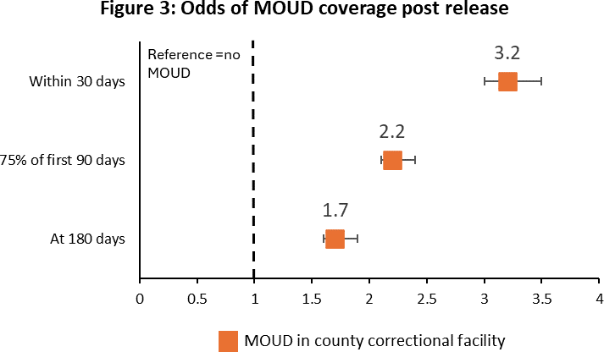

Figure 4 shows that people in the MOUD group experienced more than a 50% reduction in all- cause mortality compared with people in the Surveillance group.

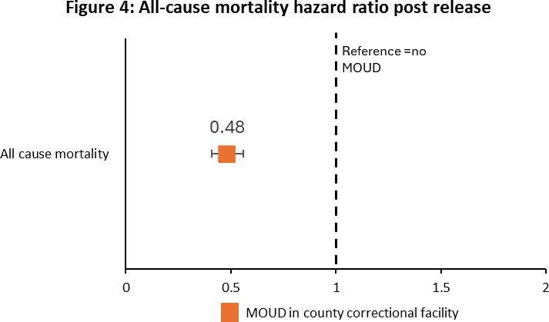

Figure 5 shows that the MOUD group had 49% lower odds of experiencing a nonfatal opioid- related overdose and 45% lower odds of experiencing any opioid-related overdose (nonfatal or fatal) within 30 days of release from incarceration compared with people in the Surveillance group. These reductions decreased when looking out to 180 days post release but remained significant. There was no significant difference in the odds of experiencing a fatal opioid-related overdose in either the first 30 or the first 180 days by MOUD receipt status. However, the number of fatal opioid-related overdoses in the MOUD group was small (n<11).

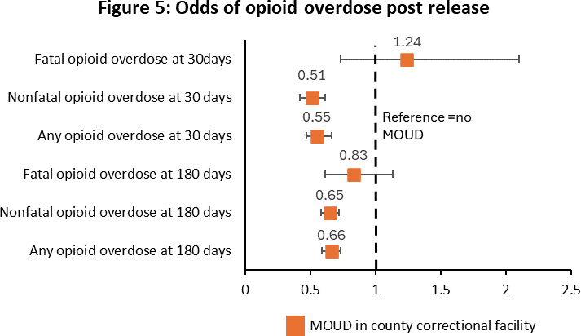

Figure 6 shows that people in the MOUD group had 22% lower odds of being reincarcerated with 180 days of release compared with those who did not receive MOUD while incarcerated.

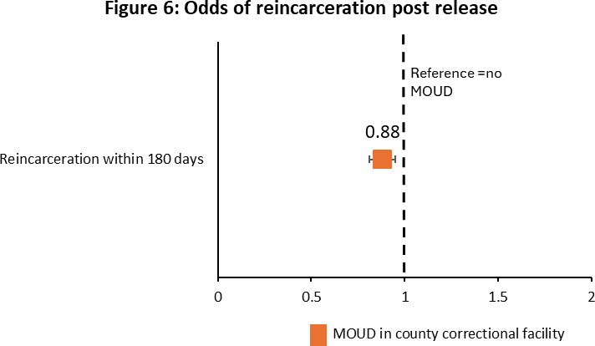

# Conclusion

Overall, 43% of people who were eligible to receive MOUD in one of the pilot county correctional facilities did receive MOUD during incarceration. There were differences by group in sociodemographic characteristics, justice status and treatment history. Notably, more of those who were treated with MOUD had an adjudication status of sentenced (34.5%) than those who did not receive MOUD (13.7%). Also, people treated with MOUD in the county correctional facility were more likely to be non-Hispanic white (75.1% vs. 58.4%) and they were more likely to have been in MOUD treatment at the time of their entry (72.5% vs. 17.2%), suggesting potential disparities in access to this life saving treatment that are worth further study/consideration.

After adjusting for these and other baseline differences between the two groups, results indicate that people treated with MOUD during incarceration had better post-release outcomes than people who were not treated with MOUD, as indicated by a greater likelihood of being treated with MOUD in the community after release and a lower likelihood of experiencing an opioid-related overdose or re-incarceration.

It is important to note that this study period overlapped with the COVID-19 pandemic, which might have impacted our outcomes.

Based on these results, all county correctional facilities should prioritize providing MOUD at jail entry to all incarcerated people with opioid use disorder.