Data Brief
An Assessment of Opioid-Related Overdoses in Massachusetts 2011-2015

Massachusetts Department of Public Health RELEASED: August 2017

Background
Chapter 55 of the Acts of 2015 (Chapter 55) was passed by the Massachusetts Legislature and signed into law by Governor Charles D. Baker in August 2015. This law permitted the linkage and analysis of different government data sets to better understand the opioid epidemic, guide policy development, and help make programmatic decisions. Chapter 55 resulted in an in-depth report examining the factors driving the opioid crisis in Massachusetts. The law was reauthorized in Chapter 133 of the Acts of 2016, enabling this unprecedented analysis to continue supporting the Commonwealth’s data-driven response to the opioid epidemic. This data brief highlights key findings from the second Chapter 55 report released in August 2017.
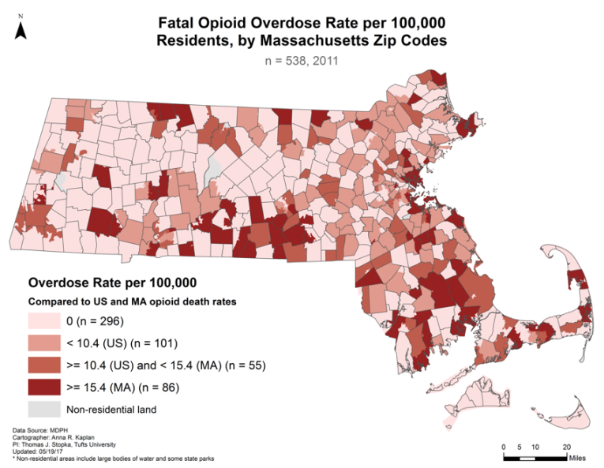
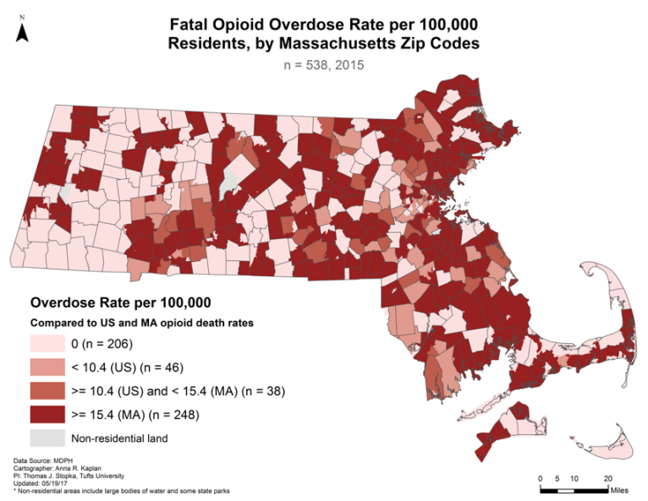
In the twelve months since the first Chapter 55 report was released in September 2016, nearly 2,000 Massachusetts residents have died of opioid-related overdoses. The total number of deaths has increased five-fold in the last 20 years, but the rate of increase of opioid-related overdose deaths was particularly sharp between 2013 and 2014. The maps below show a graphic depiction of the increasing and spreading opioid crisis in Massachusetts between 2011 and 2015 (the darkening area on the maps below).
Increasing and Spreading Opioid-Related Overdose Death Rates in Massachusetts from 2011 to 2015

2011 2015

What is especially notable is the epidemic’s rapid and insidious geographic spread throughout the Commonwealth. Almost every community is affected. Opioid-related overdose deaths and nonfatal opioid-related overdoses are highest among younger males, but all population subgroups have seen increases in recent years. Individuals released from incarceration are also at high risk of death upon re-entering the community, but so too are individuals experiencing homelessness, veterans, mothers with opioid use disorder, and individuals with serious mental illnesses.

Percentage of Massachusetts population with opioid use disorder is 4.4%
Key Finding: Using only data specifically coded for opioid use disorder (OUD), it is estimated that approximately 4.4% of Massachusetts residents age 11 and older have opioid use disorder in 2015. By way of comparison, 8% of adults in Massachusetts have been diagnosed with diabetes.

Nonfatal overdoses increased by 200 percent
Key Finding: Multiple naloxone administrations by EMTs were up 27% from 2013 to 2015, which aligns with the time period during which the presence of illicit fentanyl sharply increased in the drug supply system.
Key Finding: Nonfatal overdoses recorded by emergency medical services (EMS), hospitals, and bystander interventions increased by about 200% between 2011 and 2015. The total number of nonfatal overdoses between 2011 and 2015 exceeded 65,000.ii

Nonfatal overdoses increase risk of fatal overdose
Key Finding: Of the Massachusetts residents who had a nonfatal overdose (NFO) between 2011 and 2015, 6.2% had a fatal opioid-related overdose within one year following the initial overdose; 9.3% of the residents sampled had a fatal opioid-related overdose within two years following the initial nonfatal overdose.
Key Finding: Repeat overdoses were common in the cohort, with 14.9% having one or more repeat overdoses during the one-year follow-up period and 19.1% during the two year follow-up period.

Continued prescription opioid use increased risk of fatal overdose
Key Finding: 1.1 million people who filled opioid prescriptions in 2011 were analyzed over time. Of these, over 40,000 persons were prescribed opioids for the entire year, over 120,000 had more than six months of prescribed opioids, and over 220,000 persons had over three months of prescribed opioids.
Key Finding: Compared to the general population, those who received three months of prescribed opioids in 2011 were 4 times as likely to die from an opioid-related overdose within one year, and 30 times as likely to die of an opioid-related overdose within five years.

Time from initial prescription to overdose death
Key Finding: The proportion of the OUD population dying each year from opioid-related overdoses has nearly doubled between 2011 (0.40%) and 2015 (0.68%).
Key Finding: For those who died, the mean length of time from initial prescription to opioid-related overdose death was 36 months. Almost half of the individuals who died of an opioid-related overdose during the study period were at one time classified as opioid naïvei during the study period. Risk for fatal and nonfatal opioid overdose grows as use continues.

Population at Risk: Homeless Individuals
Key Finding: It is estimated that roughly one in every 25 adults in Massachusetts has been homeless at some point between 2011 and 2015. The risk of opioid-related overdose death for persons who have experienced homelessness is up to 30 times higher than it is for the rest of the population.

Population at Risk: Incarcerated Individuals
Key Finding: Compared to the rest of the adult population, the opioid-related overdose death rate is 120 times higher for persons released from Massachusetts prisons and jails.
Key Finding: Nearly one of every 11 opioid-related overdose deaths were persons with histories of incarceration in Massachusetts jails and prisons.
Key Finding: In 2015, nearly 50% of all deaths among those released from incarceration were opioid-related.

Population at Risk: Individuals with Serious Mental Illness
Key Finding: Roughly one in four persons ages 11 and older in the MassHealth population were identified as having a serious mental illness.
Key Finding: The risk of fatal opioid-related overdose is six times higher for persons diagnosed with a serious mental illness (SMI) and three times higher for those diagnosed with depression.

Population at Risk: Pregnant and Postpartum Mothers with Opioid Use Disorder
Key Finding: Rates of opioid-related overdose decrease during pregnancy and are lowest during the second and third trimesters, but significantly increase in the postpartum period, with the highest rates 6 months—1 year after delivery.
Key Finding: 82% of mothers with an opioid-related overdose during pregnancy or the first year postpartum had a diagnosis of depression during the study period. 63% of mothers with OUD that did not have an opioid-related overdose, and 18% of mothers without evidence of OUD, had a diagnosis of depression during the study period.
Key Finding: 79% of mothers with an overdose during pregnancy or the first year postpartum had a diagnosis of anxiety during the study period compared with 62% of mothers with OUD and 18% of mothers without evidence of OUD.
Key Finding: More than a third (38.3%) of deaths among women delivering a live birth between 2011 and 2015 were fatal opioid-related overdoses, compared to a fifth (19.9%) among women who did not deliver a live birth.

To be categorized as opioid naïve, the individual’s records had to show a period of six months or more without an opioid prescription before their first opioid prescription. Patients excluded from the group include those who: (1) had any advanced cancer (other than non-melanoma skin cancer); (2) had a substance use disorder diagnosis in the six months preceding their first opioid prescription; or (3) whose first prescription was for any buprenorphine formulation indicated for treatment of substance use disorder.
Linking data across multiple data systems along with the use of logical estimates of missing data has allowed DPH to determine likely counts for nonfatal opioid overdoses between 2011 and 2015. Nonfatal opioid overdoses in Massachusetts have increased by ~300% in four years.

