CHAPTER III
VENTILATION SYSTEMS DESCRIPTION AND OPERATIONS FOR INDOOR AIR QUALITY REPORTS
September 2015

III. VENTILATION SYSTEMS .............................................................................................3
A. Gravity/Natural Ventilation Systems 3
B. Unit Ventilator (Univent) 4
1. Unit Exhaust 4
2. Fan Coil Unit 5
C. Air Handling Systems 5
D. Dedicated Exhaust Vents 5
E. Operation, Maintenance, and Balancing 6
1. Thermostats 6
2. Filters 7
3. Balancing 8
References 9

III. VENTILATION SYSTEMS

Gravity/Natural Ventilation Systems
In some older (pre 1940s) buildings, ventilation is provided through building design that uses convection, heating, and wind to provide fresh air to the building interior. These systems rely on heated air rising to distribute warm air to the inside of classrooms and offices, sometimes from mixing/mechanical rooms on the lower level of the building. Exhaust vents in these systems are located high up on walls or in the ceiling and are directed to the outside wall or roof of the building. Air in the room is further warmed by occupants so between the heated air rising, and the effect of wind drawing air from the exhaust vents on the outside of the building, air circulates through the room.
Fresh air can also be also provided by openable windows in buildings. To provide for circulation, either hallway doors are opened, or windows, called transoms, located above hallway doors are used (Picture 1). Transoms enable occupants to close hallway doors while maintaining a pathway for airflow into the rooms. This design allows for airflow to enter an open window, pass through a room, through an open door or transom on the windward side of the building to the hallway, and subsequently pass through the open transom and window on the opposite side of the room on the leeward side (opposite the windward side) (Figure 1). This system fails if the windows or transoms are closed (Figure 2).
Very little control over temperature and ventilation in natural ventilation systems is possible. In addition, there is no filtration of incoming air.

Unit Ventilator (Univent)
Many schools and older municipal buildings use unit ventilator (univent) systems. A univent is designed to draw air from outdoors through a fresh air intake located on the exterior wall of the building (Picture 2). Return air is drawn through an air intake located at the base of each unit where fresh and return air are mixed, filtered, heated (and sometimes cooled) and provided to classrooms through an air diffuser located on the top of the unit (Figure 3, Picture 3). For univents to provide fresh air as designed, they must remain free of obstructions such as furniture placed in front of them or items placed on top. Importantly, these units must remain on and be allowed to operate while rooms are occupied.
Rooms with univents may have wall-mounted exhaust vents (Picture 4), ceiling-mounted exhaust vents or exhaust vents located in closets (Picture 5) to remove stale air. These are typically ducted to fans on the roof. These fans must operate continuously during occupied hours. Wall and closet exhausts are frequently found obstructed by items or furniture.
    - Unit Exhaust
Some univents are paired with unit exhaust systems, which look similar to univents and remove stale air through another vent in the outside wall. They must operate whenever univents are operating and remain free of obstructions.
    - Fan Coil Unit
Fan coil units (FCUs) are similar to univents except that they are not connected to an outside/fresh air supply. They provide filtration, heating/cooling and recirculation of air. They must also be free from obstructions and operating during occupied periods.

Air Handling Systems
Fresh air for most offices, common areas in schools, and other locations is provided by air handling units (AHUs). These may be located in mechanical rooms, on the roof, on the side of a building (Picture 6) or in the basement. Outside air is drawn into AHUs from vents open to the exterior, filtered, heated/cooled and ducted to supply diffusers, typically wall or ceiling-mounted (Picture 7), but occasionally installed in floors. Additional heating/cooling may be provided by supplemental units located in ceilings.
Return air is typically drawn back into ceiling/wall/floor vents (Picture 8) and is returned to the AHU via a plenum system or ductwork. If a plenum system is used, the entire space between the ceiling tiles and the upper ceiling becomes part of the air handling system. This makes it very important that the ceiling tile system does not have missing tiles, holes or other interruptions.

Dedicated Exhaust Vents
Exhaust ventilation in restrooms is typically provided by exhausts vented directly to fans on the roof. Note that many restroom exhausts operate only when the light switch is turned on; this may not provide sufficient exhaust ventilation to prevent restroom-generated odors and moisture from building up and/or penetrating occupied areas. It is preferable to have restroom exhausts on at all times the building is likely to be occupied.
Other areas should have dedicated exhaust vents that do not return to the building systems, including: kitchen areas, kiln rooms, rooms where chemicals are used such as art rooms and workshops, and areas with a concentration of heavily-used office equipment such as copy rooms.
In fire/emergency response stations, specialized exhaust hoses (e.g., plymovents) attach to vehicle exhaust pipes to remove those pollutants directly outside. These should be used whenever vehicles are operating inside, and need to be maintained in accordance with manufacturer’s instructions.
Chemical hoods in science classrooms and laboratories also exhaust air directly from the building. They need special testing and yearly certification to ensure they are in proper working order and used in accordance with manufacturer’s instructions.
Specialty exhaust or filtration equipment such as a wood dust collector, task-based shop exhausts or spray booths may be present in vocational schools and similar environments. They should be used in accordance with good work practices and kept in good repair.

Operation, Maintenance, and Balancing
    - Thermostats
Many thermostats, including digital and analog types, have fan settings of “off”, “auto” and “on”. When set to the fan “auto” setting (Picture 9), the HVAC system only supplies fresh air when the temperature is not at the set point; this can lead to complaints about lack of fresh air. To maximize air exchange, the MDPH recommends that both supply and exhaust ventilation operate continuously during periods of occupancy. The thermostat should be in the “on” position for continuous operation.
    - Filters
Univents and air handling units (AHUs) are equipped with filters to remove particulate matter from both outside and recirculated air. Filters should be changed regularly, typically 2 to 4 times a year, and should fit properly into the univent with no gaps. Univent/AHU cabinets should be free of gaps around pipes that can let unfiltered air from adjacent areas (including basements, crawls spaces and the interior or walls) into occupied spaces and should be cleaned of debris whenever filters are changed.
All filters should be of an appropriate dust spot efficiency. The dust spot efficiency is the ability of a filter to remove particulate matter of a certain diameter from air passing through the filter. Filters that have been determined by ASHRAE to meet its standard for a dust spot efficiency of a minimum of 40 percent are sufficient to reduce many airborne particulates (Thornburg, 2000; MEHRC, 1997; ASHRAE, 1992). In univents, a disposable filter in a cardboard backing is recommended rather than cut-to-fit filter material which is more time consuming to install and often does not fit properly. In AHUs, pleated filters with a Minimum Efficiency Reporting Value (MERV) dust-spot efficiency of 9 is normally be recommended; this type of filter will remove common air particles such as pollen.
In some situations, such as an area with high outdoor diesel pollution, installation of a filter with a MERV rating of 11 or higher in fresh air intakes of the HVAC system may be necessary. Increasing filtration, however, can reduce airflow (called pressure drop), which can subsequently reduce the efficiency of the unit due to increased resistance. Prior to any increase of filtration, each AHU should be evaluated by a ventilation engineer to ascertain whether it can maintain adequate function with more efficient filters.
    - Balancing
To have proper ventilation with a mechanical supply and exhaust system, the systems must be balanced to provide an adequate amount of fresh air to the interior of a room while also removing stale air from the room. It is recommended that HVAC systems be re-balanced every five years to ensure adequate air systems function (SMACNA, 1994).
In many cases, systems are designed and balanced assuming that classroom and office doors will be closed. With doors open, systems may short-circuit and draw air directly from supply systems into return systems instead of exhausting stale air from rooms.

References
ASHRAE. 1992. Gravimetric and Dust-Spot Procedures for Testing Air-Cleaning Devices Used in General Ventilation for Removing Particulate Matter. American Society of Heating, Refrigeration and Air Conditioning Engineers. ANSI/ASHRAE 52.1-1992.
MEHRC. 1997. Indoor Air Quality for HVAC Operators & Contractors Workbook. MidAtlantic Environmental Hygiene Resource Center, Philadelphia, PA.
SMACNA. 1994. HVAC Systems Commissioning Manual. 1st ed. Sheet Metal and Air Conditioning Contractors’ National Association, Inc., Chantilly, VA.
Thornburg, D. 2000. Filter Selection: a Standard Solution. Engineering Systems 17:6 pp. 74-80.

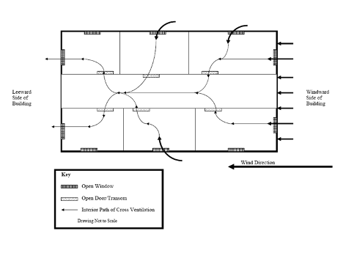

Figure 1: Airflow with Transoms/Doors Open
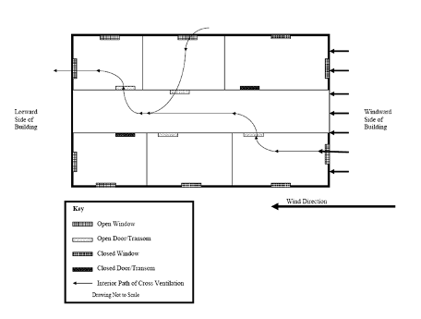
Figure 2: Airflow with Transoms/Doors Closed

Figure 3

Unit Ventilator (Univent)
Fan
Mixed Air

Air Diffuser
Outdoors
Indoors
Heating/Cooling Coil
Filter
Air Mixing Plenum
Return Air
Outdoor Air
Air Flow Control Louvers
Air Flow
= Fresh air return
= Mixed air
Picture 1

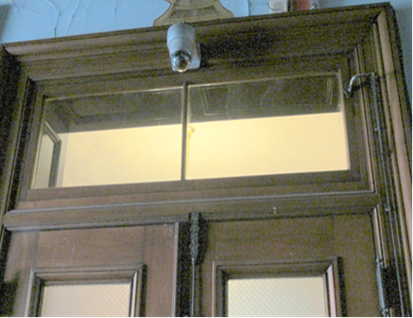

Transom (closed) (Holyoke City Hall)
Picture 2

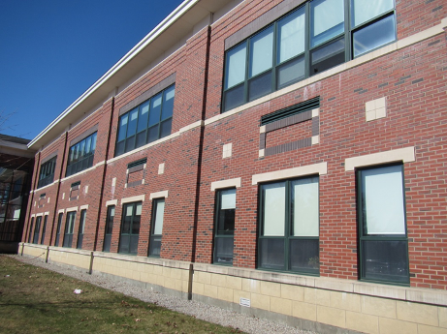

Univent fresh air intakes on side of building (Oxford High School)

Picture 3

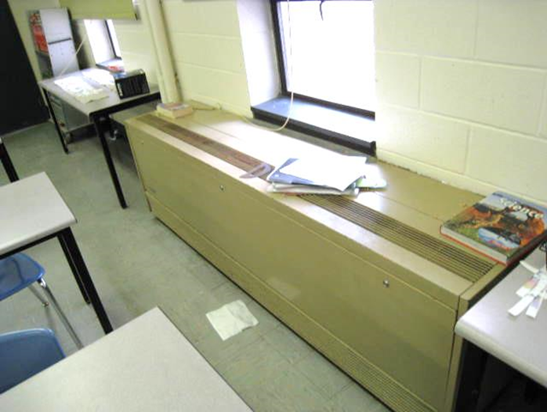

Unit ventilator in a classroom (North Reading Middle School)

Picture 4

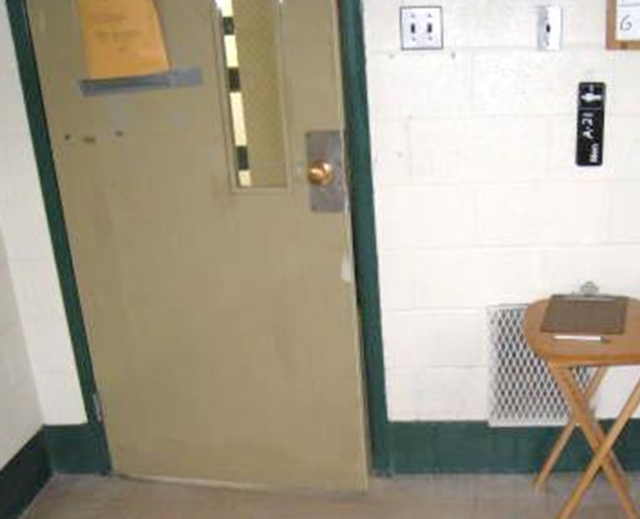

Wall-mounted exhaust vent (North Reading Middle School)

Picture 5

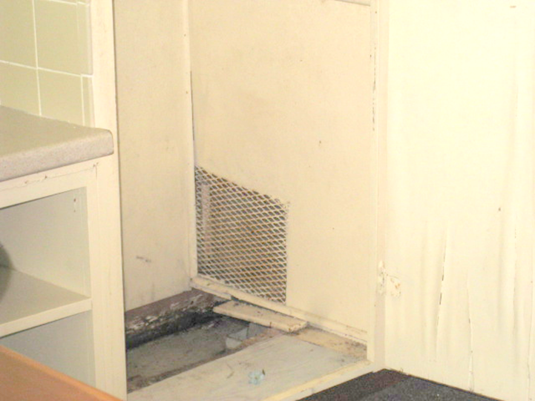

Exhaust vent in closet (Monson Town Offices)

Picture 6

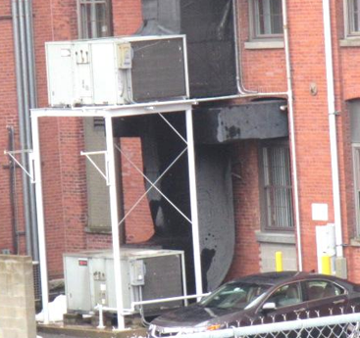

Air handling units on the outside of a building (Fall River DCF)
Picture 7

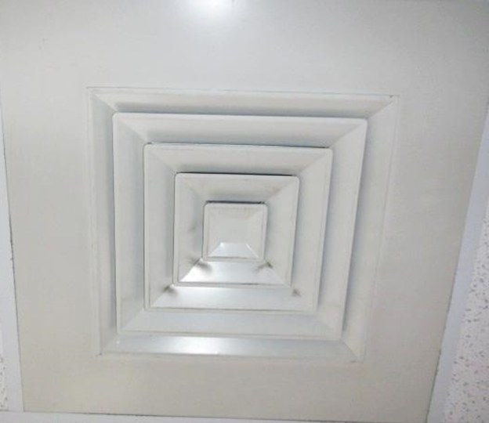

Typical supply vent (Boston Schrafft Building)

Picture 8

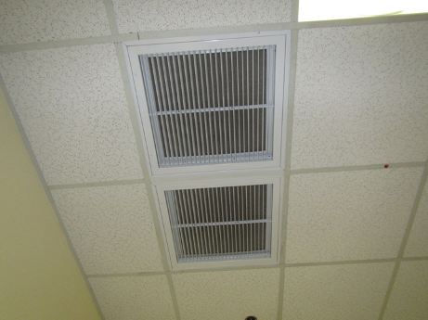

Ceiling mounted exhaust vent (Boston Schrafft Building)
Picture 9

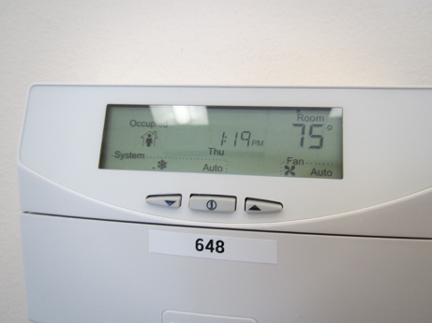

Electronic thermostat in automatic setting (Boston Schrafft Building)

