

**- DATA BRIEF -**

**Characterizing Massachusetts Workers in Select COVID-19 Essential Services:**

**Food Stores and Urban Transit**

Massachusetts Department of Public Health FEBRuary 2021

**PURPOSE**

Information in this data brief, and in the companion data brief on healthcare workers, could help policy makers and public health practitioners target efforts to prevent coronavirus disease 2019 (COVID-19) among Massachusetts workers and their communities, with the goal of reducing health inequities.

Data on the nature of work (e.g., job duties), job-related benefits (e.g., health insurance), demographics, and the underlying health of Massachusetts workers across industries and occupations may be useful to assess the relationship between work and potential health impacts from the pandemic. Such data for COVID-19 cases will also be crucial but are not yet consistently available. As a first step in identifying potential inequities linked to work, we used existing data sources to examine select characteristics of Massachusetts workers in two essential service groups ─ food stores and in urban transit. Workers in these groups have frequent exposure to the public and may not be provided with personal protective equipment or adequate infection control measures at work.

**BACKGROUND**

The COVID-19 pandemic is unprecedented in recent times. As of December 12, 2020, there were 285,725 cases among Massachusetts residents.1 The pandemic is exacerbating existing health inequities. Older adults, people with certain underlying medical conditions (e.g., cardiovascular disease, diabetes mellitus, chronic lung disease), and communities of color ─ populations already considered vulnerable to a number of health threats ─ are bearing a disproportionate burden of COVID-19.1-5 In an effort to curb the spread of coronavirus in Massachusetts, on March 10, 2020 Governor Baker ordered non-essential businesses to close or facilitate teleworking, while industries designated “COVID-19 essential services” maintained operations.6

While the physical, mental and emotional health of many adults across the Commonwealth have been impacted by the pandemic, certain groups may be disproportionately affected by virtue of their jobs. Many essential workers have continued to leave home to do their jobs, as required, putting them at risk of infection and of transmitting coronavirus to their families and communities. Studies have found higher rates of COVID-19 in Massachusetts communities with greater percentages of workers in essential services.5,7 Statewide, although adults aged 70 years and older have a higher rate of COVID-19 hospitalization and death, those aged 20-69 have higher rates of infection and comprise approximately 90% of adult cases.1 Workplaces may play an important role in transmission of coronavirus and in perpetuating inequities, and therefore are a key target for prevention.8

**METHODS**

Census Industry Codes (CIC) were used to define the following essential service groups: food stores (CIC 4970 Grocery Stores, 4980 Specialty Food Stores, 5090 Gas Stations [includes those with convenient stores]); and urban transit (CIC 6180 Bus Service and Urban Transit). Data from the U.S. Bureau of Labor Statistics’ 2016-2018 Quarterly Census of Employment and Wages and 2018 Occupational Employment Statistics were used for Massachusetts-specific information on the number of establishments in each group and wages for select occupations, respectively.9,10 We used the National Institute for Occupational Safety and Health’s Employed Labor Force system to access 2016-2018 Current Population Survey data for weighted estimates of the total numbers of workers and demographic characteristics (race/ethnicity, sex, age).11 Data from the 2012-2018 Massachusetts Behavioral Risk Factor Surveillance System were used for prevalence estimates of having one or more high risk underlying medical conditions and select healthcare access indicators (flu vaccination, no health insurance, cost as a barrier to care, has a personal healthcare provider).12

**RESULTS**

***Employment Characteristics***

**Table 1. Select employment characteristics for workers in food stores and urban transit, Massachusetts**



|  |
| --- |
| a CIC=Census Industry Code. b Data Source: 2016-2018 Quarterly Census of Employment and Wages; Establishment  = a single economic unit (e.g. a store), typically at one location, that produces goods or services. c Data Source: 2016-2018 Current Population Survey; Weighted estimates. d COC= Census Occupation Code; Three leading occupations for respective essential service group. Note: Taxi drivers and chauffeurs (COC 9140) within urban transit (CIC 6180) include shuttle or vanpool drivers, but not taxi drivers who are restricted to the Taxi and Limousine Service industry (CIC 6190). e Data Source: 2018 Occupational Employment Statistics; Wage data is for specific occupation across all industries. |

***Demographic Characteristics***

**Figure 1. Three-year average annual percent of workers in food stores and urban transit by race/ethnicity, Massachusetts** 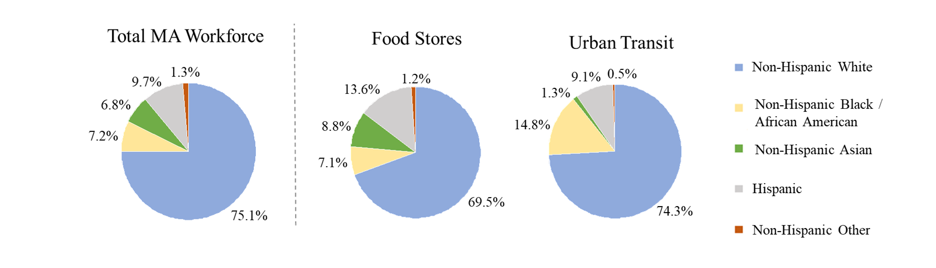

Data Source: 2016-2018 Current Population Survey; Weighted estimates of average annual numbers of workers are: Total MA Workforce, N=3,560,000; Food Stores, N=79,000; Urban Transit, N=22,000.

**Figure 2. Three-year average annual percent of workers in food stores and urban transit by sex, Massachusetts**

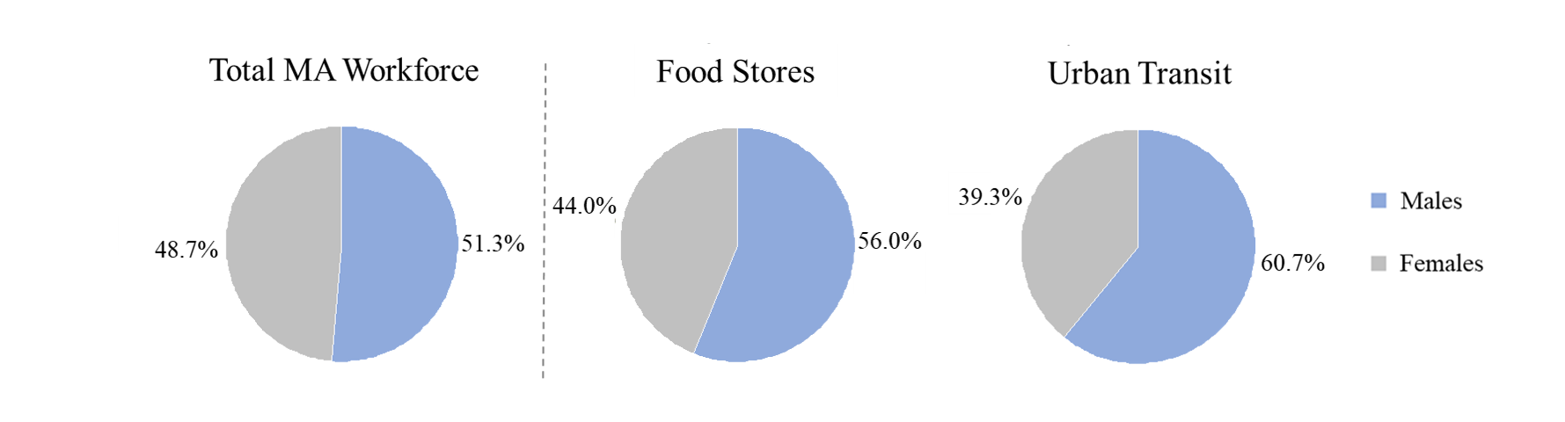

Data Source: 2016-2018 Current Population Survey; Weighted estimates of average annual numbers of workers are: Total MA Workforce, N=3,560,000; Food Stores, N=79,000; Urban Transit, N=22,000.

**Figure 3. Three-year average annual percent of workers in food stores and urban transit by age group, Massachusetts**

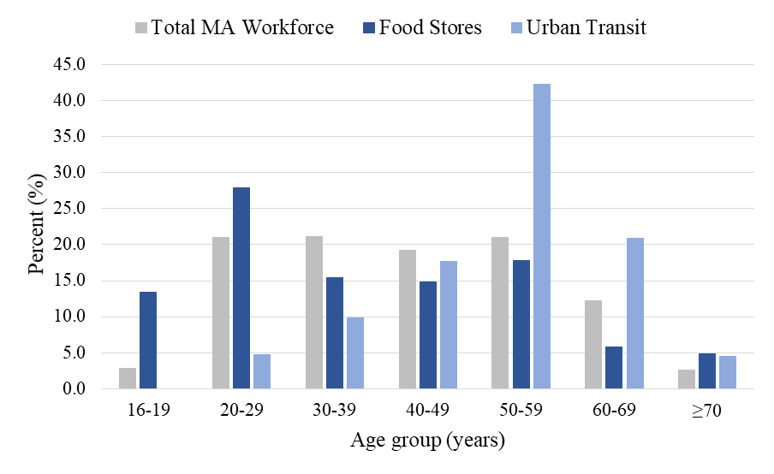

Data Source: 2016-2018 Current Population Survey; Weighted estimates of average annual numbers of workers are: Total MA Workforce, N=3,560,000; Food Stores, N=79,000; Urban Transit, N=22,000.

***Indicators Related to Health and Healthcare Access***

**Figure 4. Percenta of workers with one or more high-risk underlying medical conditions and select healthcare access indicators, food stores (A) and urban transit (B) vs. all other, Massachusettsb**

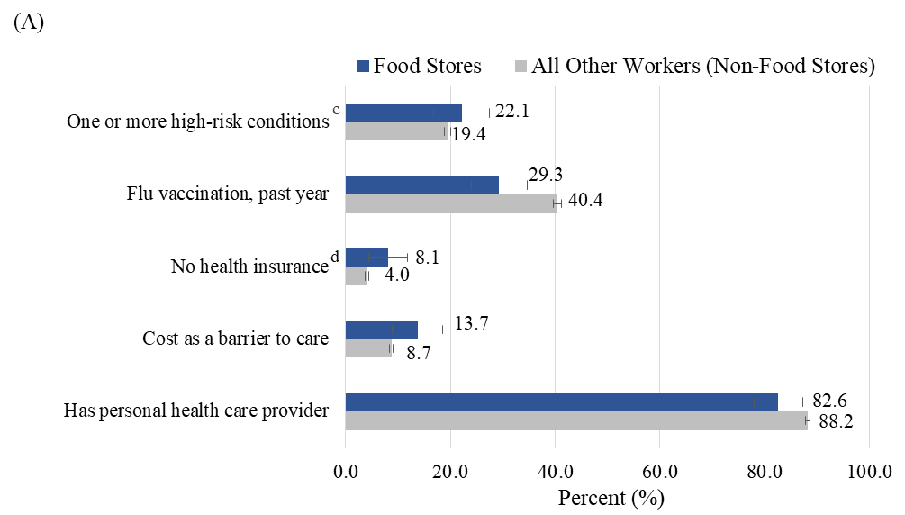

Data Source: 2012-2018 Massachusetts Behavioral Risk Factor Surveillance System

a Percents are weighted to represent the Massachusetts adult population.

b Error bars are 95% confidence intervals

c Includes those with current asthma, and those ever told they had chronic obstructive pulmonary disease (COPD), diabetes, myocardial infarction, coronary heart disease, stroke, or kidney disease.

d No health insurance: includes ages 18-64 years; estimate for urban transit unreliable due to insufficient data and therefore not presented.

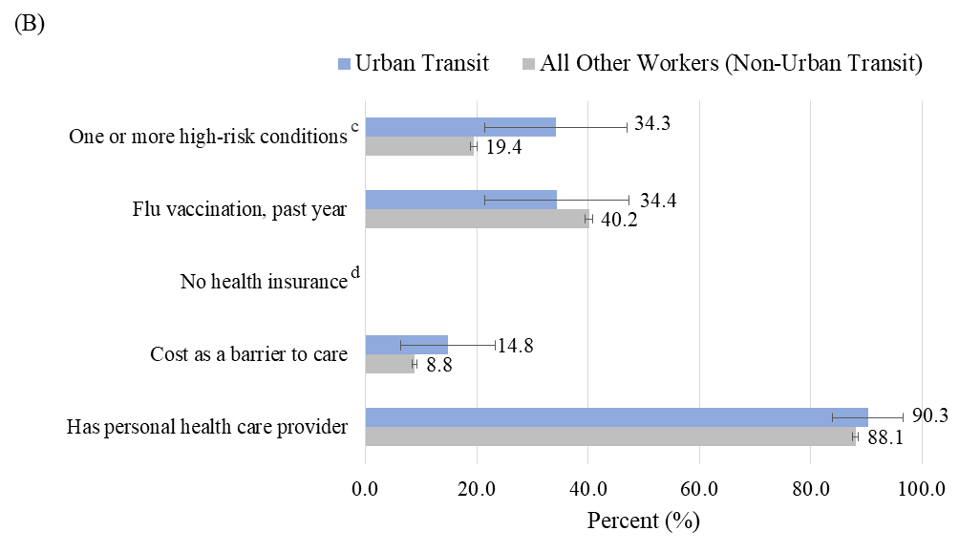

**SUMMARY OF FINDINGS**

***Food Stores***

On average, each year from 2016-2018, there were an estimated 79,000 people working in more than 5,000 food stores across Massachusetts (Table 1). An estimated 13.6% of food store workers were Hispanic and 8.8% were non-Hispanic Asian, compared with 9.7% and 6.8% of the total workforce, respectively (Figure 1). More than half (56.0%) were male (Figure 2). Food stores employed a higher than average percentage of young workers ─ an estimated 41.3% were under age 30 years compared with 23.9% of all Massachusetts workers (Figure 3). Only 28.4% of food store workers were aged 50 and older compared with 35.8% of all workers.

Workers in food stores were no more likely than other workers to have underlying medical conditions associated with COVID-19 complications, which may be due in part to the higher proportion of younger workers in this group (Figure 4A). However, they were more likely to indicate problems accessing healthcare. They were more likely to have no health insurance (8.1% vs. 4.0%) and to report cost as a barrier to care (13.7% vs. 8.7%), and less likely to have a personal healthcare provider (82.6% vs. 88.2%). Only 29.3% reported receiving a flu vaccination in the past year.

Furthermore, median incomes for the three leading occupations (59% of the total) were lower across the board than that for all Massachusetts workers (Table 1). Cashiers, who made up one-third (33.3%) of food store workers and were the leading occupation, had the lowest median income at $11.92 per hour or $24,800 per year. Whereas most food store workers were male, 62.0% of cashiers were female; 13.9% were Hispanic and 11.8% non-Hispanic Asian (data not shown). Workers in this low-wage occupation group have frequent contact with the public, which puts them at increased risk of exposure to coronavirus.13 They also may not have sufficient paid sick leave or be able to afford unpaid time off, and therefore be unable to stay home if they become sick, putting coworkers and customers at risk.

***Urban Transit***

On average, each year from 2016-2018, an estimated 22,000 workers in Massachusetts were employed in urban transit (Table 1). Non-Hispanic Black/African American workers were overrepresented, comprising 14.8% of urban transit workers compared with just 7.2% of the state’s workforce (Figure 1). The majority (60.7%) of urban transit workers were male (Figure 2). An estimated two-thirds were aged 50 years and older; 25% were aged 60 and older (Figure 3).

Urban transit workers were more likely than other workers to report having at least one underlying medical condition that may put them at increased risk of severe COVID-19 disease (34.3% vs. 19.4%) (Figure 4B). Yet, only one-third reported having received a flu vaccination in the prior year. An estimated 14.8% of urban transit workers reported cost as a barrier to care compared with 8.8% of all others, despite a high proportion (90.3%) having a personal healthcare provider. Together these findings may reflect gaps in health insurance coverage, and/or greater healthcare costs for older workers with underlying medical conditions.

Bus drivers, the leading occupation in urban transit, comprised 72.7% of all workers in this essential services group (Table 1). They earned a median income of $51,680 per year, which was slightly higher than that for all Massachusetts workers. The demographic profile for bus drivers was similar to that of all urban transit workers, although a slightly higher proportion (17%) were non-Hispanic Black/African Americans (data not shown). These workers are exposed to the public in an enclosed environment with restricted airflow and limited access to handwashing.14 Physical distancing and mask wearing among passengers may be difficult to enforce. Attempting to do so by drivers may put them at increased risk of verbal or physical abuse.

**CONCLUSION**

Work is an important social determinant of health and risk factor for coronavirus infection, especially for certain groups of workers.8,14-17 The workplace may be a source of infection for workers and for local community transmission, and therefore is a key target for prevention.7 In fact, the majority of COVID-19 cases identified in the first two weeks of the Massachusetts epidemic were part of a work-related cluster.1 Importantly, income and job-related benefits like health insurance or paid sick leave may influence whether infected workers access care or transmit the virus within the workplace and beyond.

Structural racism plays a role in people of color being disproportionately employed in jobs with hazardous physical and/or psychosocial working conditions, and underpins the observed racial inequities in COVID-19 risk.14,18 Findings described in this data brief showed that workers of color were overrepresented in the two essential service groups examined. Nationally, a recent study showed that Black workers were more likely than White workers to be employed in essential services overall (38% vs. 27%) and in occupations with close proximity to other people (e.g. bus drivers).14 In Massachusetts, rates of coronavirus infection for non-Hispanic Black and Hispanic residents are more than three times the rate for non-Hispanic White residents.19 Rates of hospitalization and death from COVID-19 are also substantially higher for these groups. The racial disparities in deaths are most striking for those under age 70. While information about work for COVID-19 cases is not yet consistently available, communities in Boston and Chelsea with high proportions of both essential workers and people of color among their residents have been most impacted.5 In addition to work, community-level factors, such as housing conditions and outdoor air pollution, may contribute to racial inequities in COVID-19.20

In conclusion, the risk of COVID-19 is not borne equally across all people in the Commonwealth. Work in jobs with close proximity to the public that lack adequate personal protective equipment and infection control may put some groups at greater risk of exposure to coronavirus and contribute to inequities. Thus, it is critical that public health surveillance systems collect information on industry and occupation as well as race/ethnicity and other demographic variables for COVID-19 cases. Understanding the risk and burden among various occupational groups can help policy makers and public health practitioners, as well as employers, develop and implement targeted workplace interventions to prevent infection of workers and secondary spread to their homes and communities.

**REFERENCES** (Note: all links accessed January 2021)

1. MA Department of Public Health COVID-19 Response Reporting. [www.mass.gov/info-details/covid-19-response-reporting](http://www.mass.gov/info-details/covid-19-response-reporting)
2. Stokes EK, et al. Coronavirus Disease 2019 Case Surveillance — United States, January 22–May 30, 2020. MMWR. ePub: 15 June 2020.
3. Garg S, et al. Hospitalization rates and characteristics of patients hospitalized with laboratory‐confirmed coronavirus disease 2019—COVID‐NET, 14 states, March 1–30, 2020. MMWR. 2020;69:458‐464.
4. Killerby ME, et al. Characteristics Associated with Hospitalization Among Patients with COVID-19 – Metropolitan Atlanta, Georgia, March–April 2020. MMWR. ePub: 17 June 2020.
5. ACLU of Massachusetts. “Data Show COVID-19 Hitting Essential Workers and People of Color Hardest.” April 8, 2020. Available: [www.aclum.org/en/publications/data-show-covid-19-hitting-essential-workers-and-people-color-hardest](http://www.aclum.org/en/publications/data-show-covid-19-hitting-essential-workers-and-people-color-hardest)
6. Massachusetts COVID-19 Essential Services. [www.mass.gov/info-details/covid-19-essential-services](http://www.mass.gov/info-details/covid-19-essential-services)
7. Hawkins D. Social Determinants of COVID-19 in Massachusetts, United States: An Ecological Study. J Prev Med Public Health 2020; 53(4): 220-227.Published online: June 24, 2020
8. Lan FY, et al. Work-related COVID-19 transmission in six Asian countries/areas: a follow-up study. PLOS ONE; online May 19, 2020.
9. U.S. Bureau of Labor Statistics 2016-2018 Quarterly Census of Employment and Wages. [www.bls.gov/cew/](http://www.bls.gov/cew/)
10. U.S. Bureau of Labor Statistics 2018 Occupational Employment Statistics. [www.bls.gov/oes/2018/may/oes_ma.htm](http://www.bls.gov/oes/2018/may/oes_ma.htm)
11. Current Population Survey, 2016-2018. [wwwn.cdc.gov/Wisards/cps/cps_links.aspx](https://wwwn.cdc.gov/Wisards/cps/cps_links.aspx)
12. Massachusetts Behavioral Risk Factor Surveillance System, 2012-2018. [www.mass.gov/behavioral-risk-factor-surveillance](http://www.mass.gov/behavioral-risk-factor-surveillance)
13. ONet Summary Report for Cashiers. [www.onetonline.org/link/summary/41-2011.00](http://www.onetonline.org/link/summary/41-2011.00)
14. Hawkins D. Differential occupational risk for COVID-19 and other infection exposure according to race and ethnicity. AJIM. 2020;1–4.
15. Landsbergis P, et al. The Key Role of Work in Population Health Inequities. AJPH. 2018;108(3):296-7.
16. Dyal JW, et al. COVID-19 Among Workers in Meat and Poultry Processing Facilities – 19 States, Apr 2020. MMWR. 2020;69:557–561.
17. Mosites E, et al. Assessment of SARS-CoV-2 Infection Prevalence in Homeless Shelters – Four U.S. Cities, March 27–April 15, 2020. MMWR. 2020;69:521–522.
18. Krieger N. Workers are people too: societal aspects of occupational health disparities—an ecosocial perspective. AJIM. 2010;53(2):104‐115.
19. COVID-19 Health Equity Advisory Group Recommendations. June 19, 2020. [www.mass.gov/orgs/covid-19-health-equity-advisory-group](http://www.mass.gov/orgs/covid-19-health-equity-advisory-group)
20. Hoang U and Jones NR. Is there an association between exposure to air pollution and severity of COVID-19 infection? April 29, 2020. Available: [www.cebm.net/covid-19/is-there-an-association-between-exposure-to-air-pollution-and-severity-of-covid-19-infection/](http://www.cebm.net/covid-19/is-there-an-association-between-exposure-to-air-pollution-and-severity-of-covid-19-infection/)