INDOOR AIR QUALITY ASSESSMENT

MBTA Engineering Building
Buildings 2 and 3
21 Arlington Ave.
Charlestown, MA

Prepared by:
Massachusetts Department of Public Health
Bureau of Environmental Health
Indoor Air Quality Program
January 2023

BACKGROUND
Building: | MBTA Engineering Building,  Buildings 2 and 3
Address: | 21 Arlington Ave. Charlestown, MA
Assessment Requested by: | Kevin Murphy, CIH, CSP  MBTA Safety Department
Reason for Request: | Mold and health concerns, as well as a follow-up to a previous visit
Date of Assessment: | December 8, 2022
Massachusetts Department of Public Health/Bureau of Environmental Health (MDPH/BEH) Staff Conducting Assessment: | Ruth Alfasso, Environmental  Engineer/Inspector, and Michael  Feeney, Director, Indoor Air Quality  (IAQ) Program. They were  accompanied by Sarah Yiu, MPH,  Industrial Hygienist, Occupational  Health Surveillance Program (OHSP),  MDPH
Building Description: | This building is a former warehouse converted to 2 floors of office space. It is attached by an open entry to Building 3 and has a basement which is used for utilities.
Windows: | Originally designed to be openable, some are not openable due to poor condition.

This building was visited by the IAQ program in 2019, and that report is available upon request.

METHODS
Please refer to the IAQ Manual for methods, sampling procedures, and interpretation of results (MDPH, 2015).

RESULTS AND DISCUSSION
The following is a summary of indoor air testing results (Table 1):
- Carbon dioxide was below the MDPH guideline of 800 parts per million (ppm) in most areas visited, indicating adequate fresh air in the space for the occupancy.
- Temperature was within or slightly above the recommended comfort range of 70°F to 78°F.
- Relative humidity was below the recommended range of 40% to 60% in all areas assessed.
- Carbon monoxide levels were non-detectable (ND) in all areas assessed.
- Fine particulate matter (PM2.5) concentrations were below the National Ambient Air Quality Standard (NAAQS) level of 35 μg/m³ in all areas tested.
- Total volatile organic compounds (TVOCs) were ND in all areas tested.

Ventilation
A heating, ventilating, and air conditioning (HVAC) system has several functions. First, it provides heating and, if equipped, cooling. Second, it is a source of fresh air. Finally, an HVAC system will dilute and remove normally occurring indoor environmental pollutants by not only introducing fresh air, but also filtering the airstream and ejecting stale air to the outdoors via exhaust ventilation. Even if an HVAC system is operating as designed, point sources of respiratory irritation may exist and affect symptoms in sensitive individuals. The following analysis examines and identifies components of the HVAC system and likely sources of respiratory irritant/allergen exposure due to water damage, aerosolized dust, and/or chemicals found in the indoor environment.
The ventilation system should be on and operating to supply fresh air continuously during occupied periods. Without adequate fresh air supply and removal of stale air, common indoor air pollutants can build up and cause irritation.
The second floor of Building 2 and some areas on both floors of Building 3 have fresh air supplied by ceiling-mounted vents (Picture 1) which likely connect to air handling units (AHUs) on the roof. Ceiling-mounted return vents (Picture 2) return air to the HVAC system. No vents were noted on the first floor in Building 2. This HVAC configuration may be a holdover from the previous use as a warehouse. The warehouse was subsequently divided into two complete floors with no HVAC system installed on the first floor of Building 2.
Note that several areas on the ceiling of the second floor of Building 2 had metal covers (Picture 3), likely covering supply vents. In Office 216, there was the sensation of a draft, and many of the ceiling tiles were pushed outwards (Picture 3). This suggests that the airflow being supplied by AHU is not evenly distributed in the office and/or that there is an opening from a supply duct in the ceiling plenum near Office 216. This not only exacerbates airflow control issues but can push dust and debris from above the ceiling tiles into occupied space. The vents in this portion of the building should be examined for location and continuity. A good time to do this is while the nearby offices are being renovated, with the ceiling plenum deliberately open to the room.
Wherever possible, occupied space should have both a supply vent for fresh air, and a return vent to remove stale air and provide for air exchange. For some offices, the nearest return vents are in the main open area. In such cases, doors should be kept open when occupied, or provided with an undercut for air circulation. At least one door had a transfer air vent, which is an old method of allowing air movement between areas that is no longer allowed in new buildings due to fire codes.
Supplemental heat is provided by steam radiators in areas near the exterior walls. Many areas on both floors had window-mounted air conditioners (WACs, Picture 4) or wall-mounted ductless air conditioners (Picture 5) to provide cooling. Even given the chilly outdoor temperatures, some of the WACs and ductless units were in use (Table 1) indicating that temperature control is an issue in this building. One source of excess heat to the building is from solar heating through windows. Shades or blinds in areas along the southern facing walls of the building may reduce heat-related discomfort.
Windows in some areas were open to provide fresh air. Also note that WACs can be used in the fan-only mode to introduce fresh air even when cooling is not needed. Ductless ACs do not provide any fresh air, and only recirculate it.
Since there is no supply of fresh air in the lower level of Building 2 and other areas in the building, opening windows and/or the use of WAC in fan-only mode should be encouraged. Occupants report that some windows are in too poor of shape to be readily opened, and examination suggests that some, if opened, would be difficult to close tightly. When windows are opened for fresh air, they should be tightly closed when the room is unoccupied. Occupants should also be aware of weather and outdoor conditions. During heavy rain, or hot, humid weather when air conditioning is operating, windows should not be opened as this may lead to condensation and water damage. In addition, this building is located in an area with high traffic of buses and other vehicles, which may be a source of pollutants such as particulates and carbon monoxide.
It is recommended that HVAC systems be re-balanced every five years to ensure adequate air systems function (SMACNA, 1994). It is not known when the last time these systems were balanced or if they are able to be balanced given the current condition and configuration.
Filters on AHUs and other HVAC equipment should be changed in accordance with manufacturer's instructions, 2-4 times a year or more often when in a high-pollutant area. Select filters with the highest minimum efficiency rating value (MERV) that can be used with the equipment. Filter efficiency is important in protecting occupants from outdoor pollutants in a high-traffic area.
WACs and ductless AC filters should be cleaned or changed in accordance with the manufacturer's instructions, as well as portable air purifying equipment with high efficiency particulate arrestance (HEPA) filters.

Microbial/Moisture Concerns
The previous visit was prompted by reports of water damage due to steam leakage in the building. Since that time, the steam leaks have been repaired, and most of the water-damaged ceiling tiles moistened due to contact with steam have been replaced. Some water-damaged ceiling tiles were noted in rooms and hallways (Picture 6, Table 1). In two areas, ceiling tiles had been removed and replaced with a ceiling tile leak diverter (sometimes known as a “kite tile”, Picture 7). These collect water that would moisten ceiling tiles and divert it to a receptacle until the leak can be fixed. Based on the locations of these tiles, the water leak may be from the building envelope/roof at the junction where two parts of the building meet. Roofing and the related flashing should be examined and repaired to stop the leaks. Until the leak is fixed, the collection receptacles should be emptied and cleaned regularly to prevent odors from stagnant water.
Other water-damaged tiles should also be replaced once leaks have been repaired. None of the water-damaged ceiling tiles had dark staining or other indications of mold growth.
Water damage to windowsills and paint on both the interior and exterior of the buildings were also noted (Pictures 8 and 9). This indicates that the building envelope is deteriorating, which will allow water entry and continuing water damage. Note that a portion of the exterior of Building 2 (Picture 9) appears to be covered with an Exterior Insulation and Finish System (EIFS), which is a type of exterior cladding with multiple layers. Older forms of EIFS, such as those used in the 1980s, were designed to repel water, but often lacked a means to drain or evaporate water that had penetrated through the exterior layers. If not properly installed and meticulously maintained, such systems can allow rainwater to penetrate into the interior of a building (Lstiburek, 2007).
While a large amount of ivy had been removed from the side of Building 3 since the 2019 visit, ivy was still found clinging to the rear wall. Ivy can damage brick and mortar, making it more likely to leak, and can prevent walls from drying after rain.
Some occupants reported concerns with the condition of the basement. The basement appears to be used for storage and is not considered to be an occupied space. As mentioned above, in the past, a steam leak had moistened areas of the basement and first floor. However, significant clean-up of the basement had occurred recently, and no moldy materials were found at the time of the assessment (Pictures 10 and 11). Photos forwarded to the DPH IAQ Program by MA Department of Labor Standards (MDLS) appear to depict basement conditions that existed prior to the clean out (Picture 12). A slight draft of outdoor air was noted during examination of the basement. Basement air may enter occupied space via cracks and holes in the interior basement access door. To minimize the chance of any odors or particulates from the basement entering occupied space, the door to this area should be made as airtight as possible by repairing the frame around the door and using weatherstripping to close gaps. The basement access door should be kept closed. A variety of ducts and other openings that may be the source of drafts were noted. All should be permanent sealed with and appropriate, mold-growth resistant material.
Water coolers and small refrigerators were noted in carpeted areas (Table 1). Spills/leaks from water dispensers and refrigerators can moisten carpet, leading to odors and microbial growth if not dried promptly. Water damage was also noted underneath the sink in the kitchen. The area under sinks can be a moist environment due to leaks and condensation. No porous materials should be stored there to prevent water damage. Condensate drains and pumps from ductless AC units should be monitored periodically for leaks and clogs to prevent water damage.
Office plants (Picture 13) should be kept in good condition, not overwatered, and placed on waterproof drip pans to prevent water damage and pest issues.

Other IAQ Concerns
Exposure to low levels of total volatile organic compounds (TVOCs) may produce eye, nose, throat, and/or respiratory irritation in some sensitive individuals. Although no measurable levels of TVOCs were detected, BEH/IAQ staff examined rooms for products containing VOCs. BEH/IAQ staff noted hand sanitizers, cleaning products, dry erase materials, and candles in use within the building (Table 1). All of these products have the potential to be irritants to the eyes, nose, throat, and respiratory system of sensitive individuals.
This building has a kitchen which includes a stove and oven. This room appears to have a direct-vented exhaust (Picture 14). A strong odor of food in the room during the assessment suggests that this vent is not operating. This vent should be on and operating whenever cooking is taking place, particularly if the stove or oven is used, to remove odors and smoke.
In some rooms, wall-mounted air purifying system (CID 75K) manufactured by AIRPHX were noted (Picture 15). According to the company webpage, the technology reportedly used by these units is a cold plasma that produces and emits hydrogen peroxide (H₂O₂), which is a skin and eye irritant. The Occupational Safety and Health Administration (OSHA) set a permissible exposure limit (PEL) of 1 part per million (ppm) over an 8-hour time weighted average (OSHA, 2020). No information concerning the rate of productions of H₂O₂, ventilation requirements, emergency actions or worker exposure safety information could be located regarding this device.
In addition, no information is available as to whether H₂O₂ can act in a similar fashion as ozone generators to produce respiratory irritation or possibly interact with other airborne constituents to make additional irritating or toxic byproducts (US EPA, 2003). The IAQ Program recommends not using this device when the building is operating or to deactivate these devices until further information regarding emissions, efficacy and other recommendations can be located and/or established by an independent device standard setting agency.
A few areas of the building are being renovated, including new wallboard, new furnishings, and new ventilation ducts (Picture 16). Renovation can produce dusts and odors which can migrate into occupied areas if not appropriately mitigated. The guidance in the document “Construction and renovation generated pollutants in occupied buildings” should be followed to protect occupants from exposure to renovation pollutants. This includes isolation of the renovation area, use of negative pressure to prevent pollutant migration, and communication with occupants regarding activities and schedules.
Some areas of the building had carpeting. Carpets and area rugs should be vacuumed regularly with a HEPA-filter-equipped vacuum cleaner and cleaned annually (or semi-annually in soiled/high traffic areas) in accordance with Institute of Inspection, Cleaning and Restoration Certification (IICRC) recommendations (IICRC, 2012).

CONCLUSIONS/RECOMMENDATIONS
In view of the findings at the time of the visit, the following recommendations are made. These recommendations are separated into short-term and long-term recommendations that may require planning and capital funds to achieve.

Short-term recommendations

Ventilation recommendations
- Operate supply and exhaust ventilation where available in all areas during occupied periods. This includes exhaust ventilation in restrooms/kitchens.
- Investigate the condition of ductwork, particularly in and near Room 216 to ensure there are no open ducts inside the ceiling plenum.
- Unblock covered ducts. If possible, move ducts that are cause drafts or relocate occupants.
- If possible, have the HVAC system balanced in accordance with SMACNA recommendations.
- Use WAC and openable windows for fresh air, particularly on the first floor of Building 2. Ensure any open windows are closed tightly at the end of the day or when areas/offices are unoccupied. Avoid opening windows during freezing conditions, as well as during heavy rain or when air conditioning is in use, as this may lead to condensation on chilled surfaces.
- Ensure filters are replaced on HVAC units at least twice a year. Use the best quality/highest minimum efficiency reporting value (MERV) rated filters that can be used with current equipment. If filters are found very soiled when changed, consider changing more frequently.
- Clean filters on WACs regularly.
- Consider installing curtains or blinds in areas where solar heating occurs.
- Unplug and remove the AIRPHX units. Ensure other air purifying units used in the building are maintained in accordance with manufacturer’s instructions, including filter changes.

Water damage recommendations
- Investigate the sources of leakage that is moistening ceiling tiles, and repair roof/building envelope. Until the leaks are repaired, continue to empty the collection vessels, and keep them clean to prevent odors.
- Replace water-damaged ceiling tiles after leaks are repaired.
- Ensure the interior basement door and frame are as airtight as possible, including use of weatherstripping. Keep the door closed.
- Permanently seal any pipes vents or other openings that exist in the basement on both ends to eliminate outdoor air drafts.
- Remove the remaining ivy from the rear wall of Building 3.
- Periodically monitor drains from ductless AC units for clogs and leaks, and repair promptly.
- Consider moving water dispensers and small refrigerators to areas without carpeting or use a mat underneath.
- Avoid storing items under sinks. Clean/repair the cabinet under the kitchen sink to remove water-damaged materials.
- Keep indoor plants in good condition, avoid overwatering, and ensure they are on waterproof drip trays.

Other recommendations
- Discontinue the use of the AIRPHX CID 75K devices when the building is occupied until conditions regarding emissions, use in occupied space and other health and safety information is established.
- Follow the guidance in https://www.mass.gov/service-details/construction-and-renovation-generated-pollutants-in-occupied-buildings to reduce the impact of renovation pollutants on occupants.
- Use VOC-containing products in areas with good ventilation.
- Avoid the use of scented products such as candles.
- Keep cooking equipment clean and in good condition to prevent odors, smoke, and pests.
- Clean carpeting frequently in accordance with IICRC recommendations (IICRC, 2012) using a HEPA-filter equipped vacuum.
- For buildings in New England, periods of low relative humidity during the winter are often unavoidable. Therefore, scrupulous cleaning practices should be adopted to minimize common indoor air contaminants whose irritant effects can be enhanced when the relative humidity is low. To control for dusts, a high efficiency particulate arrestance (HEPA) filter equipped vacuum cleaner in conjunction with wet wiping of all surfaces is recommended. Avoid the use of feather dusters. Drinking water during the day can help ease some symptoms associated with a dry environment (throat and sinus irritations).
- Refer to resource manual and other related IAQ documents located on the MDPH’s website for further building-wide evaluations and advice on maintaining public buildings. These documents are available at: http://mass.gov/dph/iaq.

Long-term recommendations
- Consider a plan to renovate the building envelope on both Buildings, including replacement of damaged windows and repair to siding and flashing to reduce water infiltration.
- Consider adding supply and return ventilation to the lower floor of Building 2.

REFERENCES
IICRC. 2012. Institute of Inspection, Cleaning and Restoration Certification. Carpet Cleaning: FAQ.
Lstiburek, Joseph. 2007. “BSD-146: EIFS – Problems and Solutions”. Building Science Corporation. July 11, 2007. Available at: https://www.buildingscience.com/documents/digests/bsd-146-eifs-problems-and-solutions
MDPH. 2015. Massachusetts Department of Public Health. Indoor Air Quality Manual: Chapters I-III. Available at: https://www.mass.gov/lists/indoor-air-quality-manual-and-appendices.
OSHA. 2020. Hydrogen peroxide. OSHA Occupational Chemical Database. Occupational Safety and Health Administration. https://www.osha.gov/chemicaldata/630. Last Updated 12/31/2020.
SMACNA. 1994. HVAC Systems Commissioning Manual. 1st ed. Sheet Metal and Air Conditioning Contractors’ National Association, Inc., Chantilly, VA.
US EPA. 2003. “Ozone Generators that are Sold as Air Cleaners: An Assessment of Effectiveness and Health Consequences”. US Environmental Protection Agency, Office of Air and Radiation, Indoor Environments Division, Washington, D.C. https://www.epa.gov/indoor-air-quality-iaq/ozone-generators-are-sold-air-cleaners last updated on March 17, 2016

Picture 1
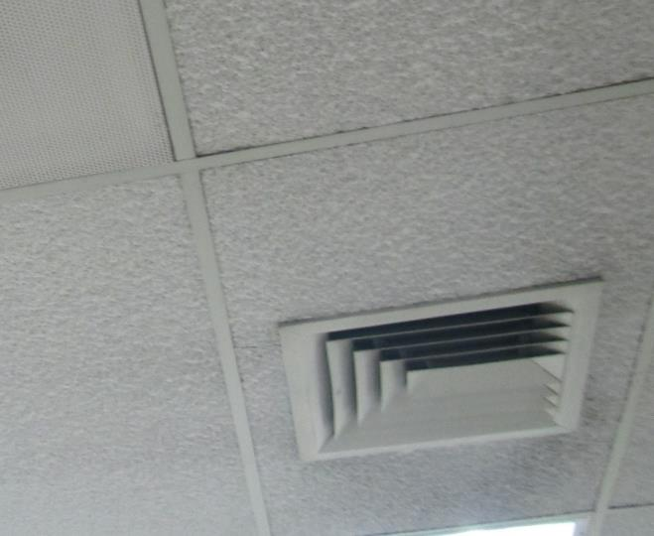
Ceiling-mounted supply vent
Picture 2
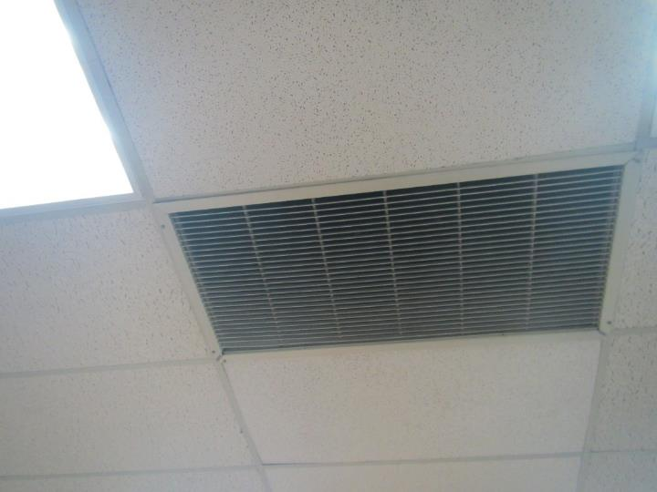
Ceiling-mounted return vent
Picture 3
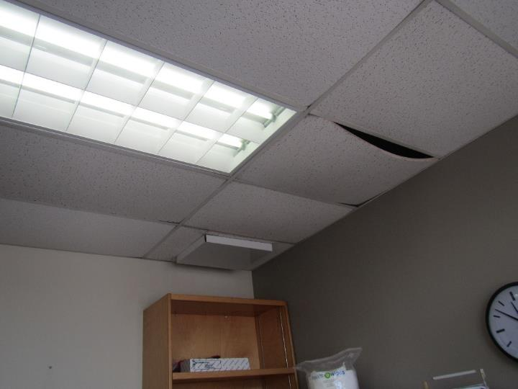
Blocked vent (arrow) and pushed out/bowed ceiling tiles
Picture 4
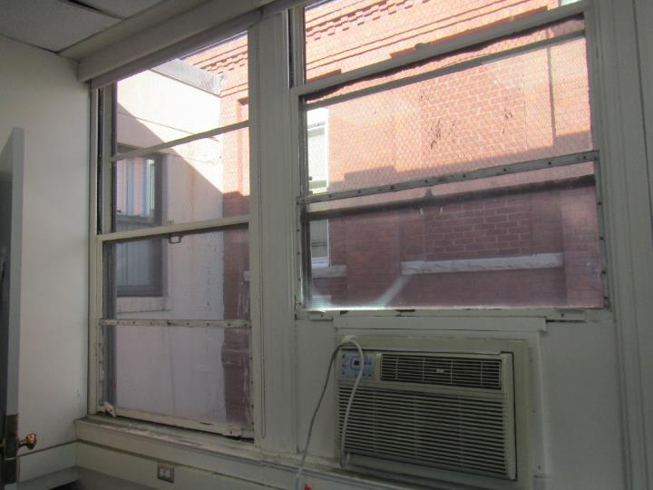
Window air conditioner, note poor condition of windows
Picture 5
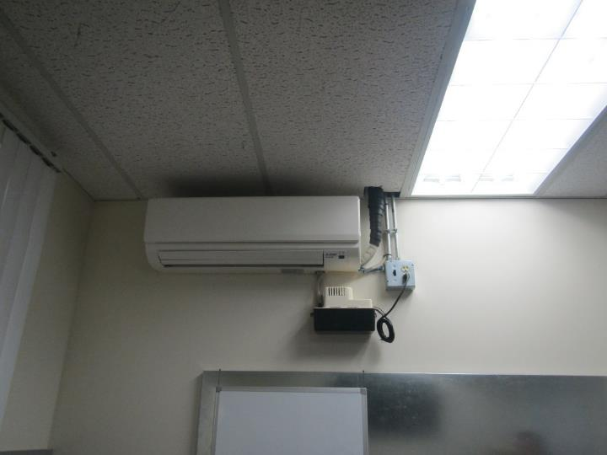
Ductless air conditioner, note condensate pump below unit
Picture 6
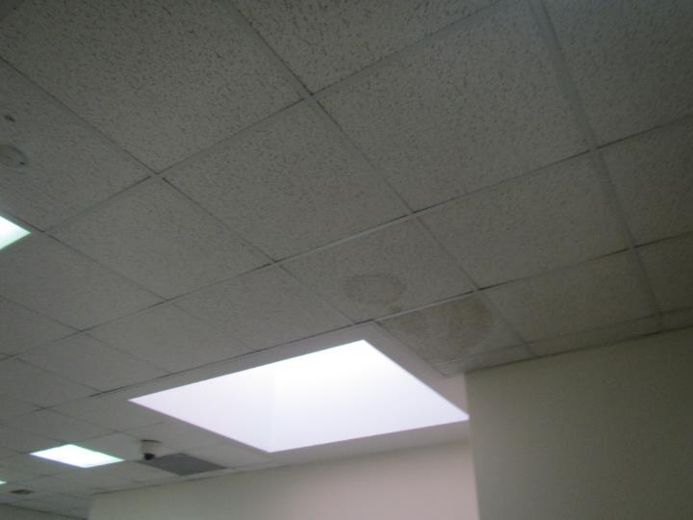
Water-damaged ceiling tiles
Picture 7
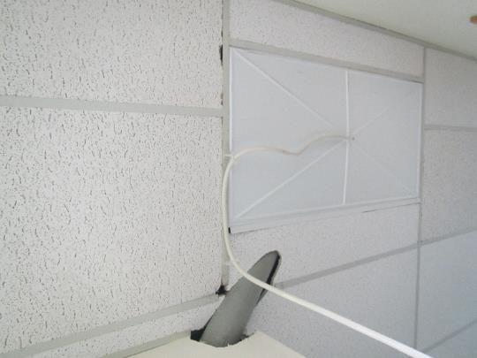
Ceiling leak diverter tile
Picture 8
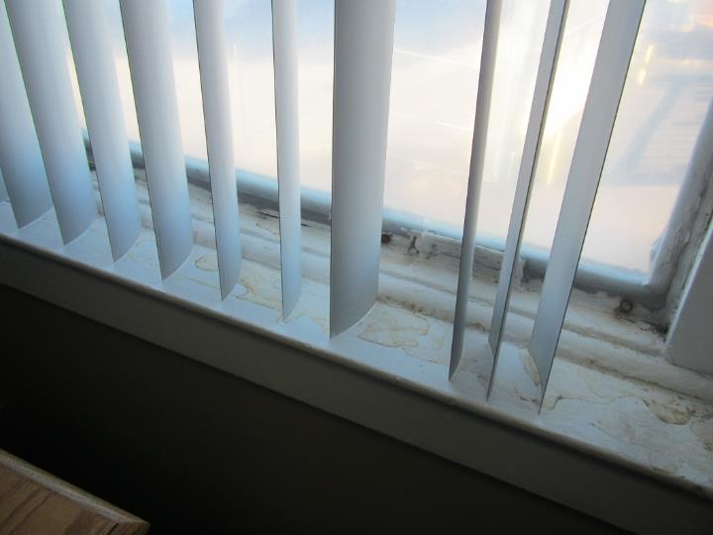
Water-damaged windowsill
Picture 9
Damaged paint, siding, and windowsills on the exterior of Building 2
Picture 10
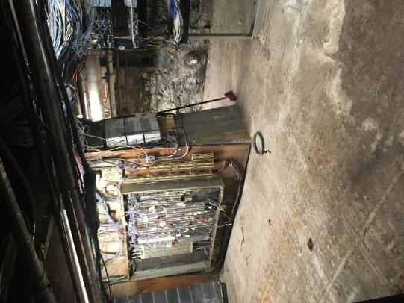
Basement condition found during visit
Picture 11
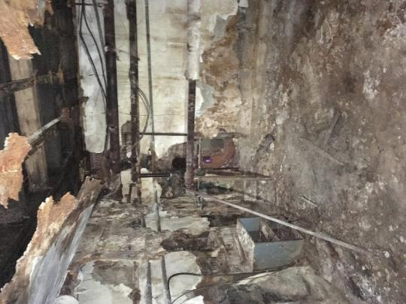
Basement condition at time of the
assessment, note no stored paper, cardboard, or similar materials
Picture 12
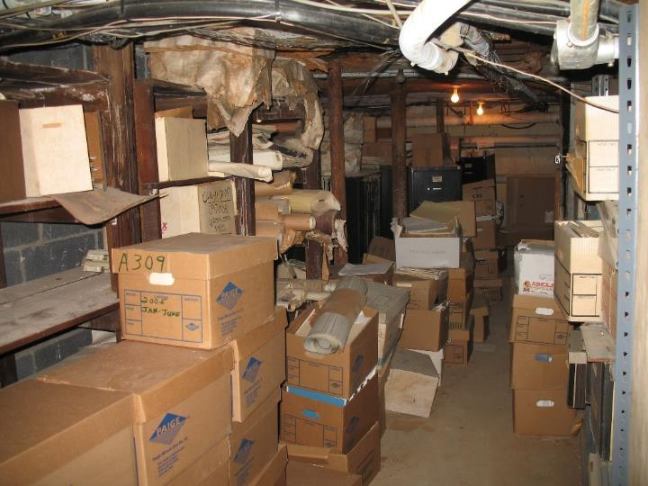
Photo of basement area at some point before visit, forwarded from MDLS
Picture 13
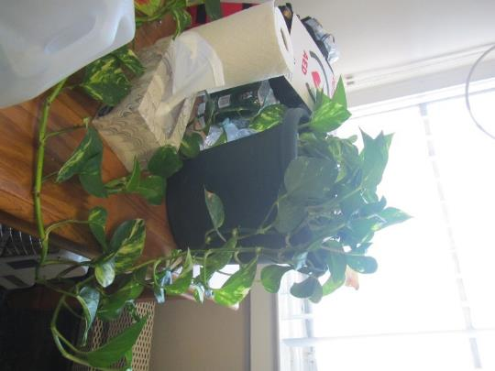
Plant on a desk
Picture 14
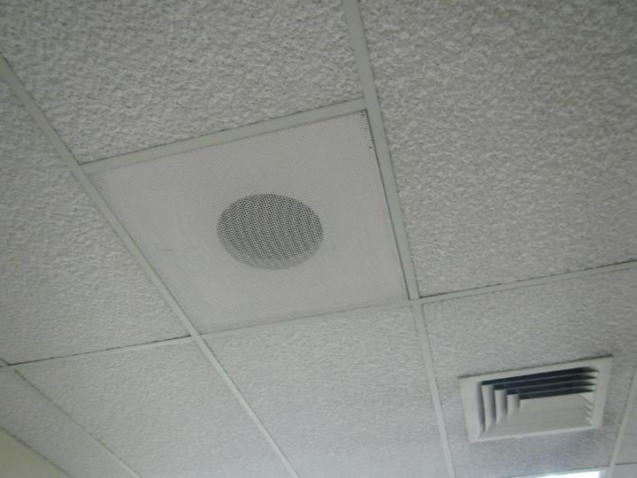
Direct-vent style exhaust in the kitchen
Picture 15
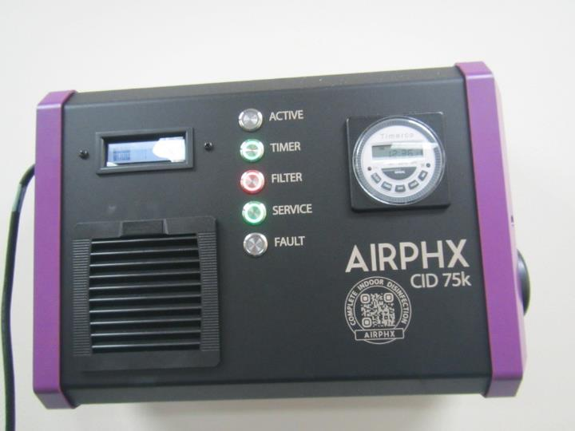
Wall-mounted air cleaning device
Picture 16
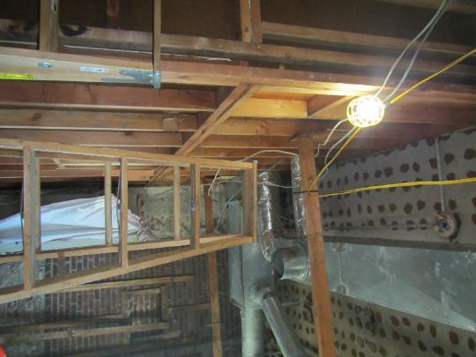
Renovation area

Location | Carbon  Dioxide  (ppm) | Carbon Monoxide  (ppm) | Temp  (°F) | Relative  Humidity  (%) | PM2.5  (µg/m³) | TVOCs  (ppm) | Occupants in Room | Windows  Openable | Ventilation |  | Remarks
 |  |  |  |  |  |  |  |  | Intake | Exhaust
Background | 406 | 0.7 | 58 | 38 | ND
Building 2, 2nd floor
Conference | 562 | ND | 78 | 35 | ND | ND | 2-6 | N | Y | Y | Plants, CT removed and replaced with “kite tile”, NC, wall-mounted AP
202 | 580 | ND | 78 | 34 | ND | ND | 0 |  | Y | N | WAC, NC, 1 WD CT, heater
210 | 554 | ND | 77 | 33 | ND | ND | 0 |  | Y | Y | WAC, DEM, carpet, HS
209 | 586 | ND | 76 | 35 | ND | ND | 1 | Y | Y | Y | WAC – on, 1 WD CT, NC
Kitchen | 566 | ND | 77 | 36 | ND | ND | 0 | N | Y | Y | Exhaust vent looks like direct vent, NC, microwave and toaster, food odor, full-size stove and oven
208 | 570 | ND | 78 | 29 | ND | ND | 0 |  | N | N | WAC
207 | 549 | ND | 78 | 32 | ND | ND | 0 | N | N | N | WAC, NC, microwave
206 | 585 | ND | 79 | 33 | ND | ND | 0 |  | Y | N | Carpet, refrigerator on carpet, WAC – on
205 | 548 | ND | 81 | 36 | ND | ND | 0 |  | Y |  | WAC, NC, solar heating, AP or white noise generator
204 | 511 | ND | 79 | 35 | ND | ND | 0 |  | Y | N | WAC, NC, DEM
203 | 526 | ND | 79 | 37 | ND | ND | 0 |  | Y | Y | DEM, WAC, carpet, transfer sir vent in door
211 | 519 | ND | 79 | 36 | ND | ND | 0 | N | Y | Y | Ductless AC, refrigerator on carpet, WD CT and kite tile
214 | 438 | ND | 76 | 31 | 5 | ND | 2 | Y | Y | Y? | NC, food, microwave, fridge
216 | 419 | ND | 75 | 30 | 3 | ND | 1 | Y | Y |  | WAC, AT, pushed and bowed tiles, room feels cold and drafty, NC
217 | 417 | ND | 75 | 30 | ND | ND | 0 |  | Y | N | CP, NC
220 | 424 | ND | 76 | 30 | ND | ND | 2 | Y | Y |  | 3 MT
221 | 444 | ND | 78 | 29 | ND | ND | 0 | Y | Y | N | 5 MT, window AC, NC, under renovation
Cubes near offices | 421 | ND | 77 | 29 | ND | ND | 0 | N | Y | Y | 1 MT, bowed CT, NC
Front of cube area | 458 | ND | 75 | 31 | ND | ND | 2 | N | Y | Y | NC
214 | 423 | ND | 75 | 31 | ND | ND | 0 | N | Y | N | Carpet, DEM, WAC, food
218 | 439 | ND | 75 | 31 | ND | ND | 0 | Y | Covered | N | AT, DEM, WAC, carpet
219 | 442 | ND | 75 | 31 | ND | ND | 0 |  | Y | N | WAC, carpet, DEM
Silva cube area | 431 | ND | 75 | 30 | ND | ND | 0 | N | Covered | Y | NC, 5 MT, DEM
Nair cube area | 445 | ND | 75 | 32 | ND | ND | 2 | N | Y | Y | NC, bowed tiles
Walters cube area | 438 | ND | 74 | 31 | ND | ND | 2 |  | Y | Y | NC, laminator, items
King cube area | 420 | ND | 75 | 30 | ND | ND | 1 | N | Y | y | WAC, DEM, PF
Building 2, first floor
101 main area | 494 | ND | 79 | 31 | ND | ND | 1 |  | N | N | Ductless AC, NC, tools
106 | 498 | ND | 79 | 30 | ND | ND | 0 | N | N | N | WAC, peeling paint on wall, NC
104 | 532 | ND | 80 | 33 | ND | ND | 0 |  | N | N | Renovations, NC, MT
105 | 574 | ND | 82 | 34 | 1 | ND | 0 |  | N | N | NC
107 | 508 | ND | 80 | 29 | ND | ND | 1 | Y | N | N | WAC on
111 | 396 | ND | 74 | 26 | ND | ND | 0 | Y open | N | N | WAC, plant, NC, DEM
102 | 435 | ND | 73 | 34 | ND | ND | 2 |  | N | N | NC, ductless AC on
118 | 472 | ND | 74 | 29 | ND | ND | 0 | Y | N | N | Drafty – window open?
120 | 890 | ND | 73 | 33 | ND | ND | 3 | Y | N | N | CF, WAC – on, food, candles, plant, a WD CT, NC
119 | 635 | ND | 75 | 39 | ND | ND | 1 |  | N
123 conference | 533 | ND | 77 | 32 | ND | ND | 0 | N | N | N | CF, WAC
Women’s restroom | 587 |  | 80 | 32 | ND | ND | 0 | N | N | Y | Large exhaust in window – on, CP, AF
125 main | 534 | ND | 79 | 34 | ND | ND | 0 | N | N | Y | Big printer
125 A | 638 | ND | 79 | 36 | ND | ND | 0 | N | N | N | WAC, NC
125 B | 721 | ND | 79 | 35 | ND | ND | 0 | N | N | N | WAC – on, paint, plants
126 main | 540 | ND | 78 | 35 | ND | ND | 0 | N | N | N | Ductless AC, AP
126 office | 813 | ND | 77 | 36 | ND | ND | 1 |  |  | N
Building 3
105 | 530 | ND | 75 | 38 | ND | ND | 0 |  |  |  | Renovation
202 main | 455 | ND | 73 | 34 | ND | ND | 1 |  |  |  | NC
202C | 512 | ND | 73 | 35 | ND | ND | 0 | Y | N |  | NC
202 cubes | 470 | ND | 73 | 33 | ND | ND | 1 |  | N |  | Wall-mounted AP
Conference | 439 | ND | 72 | 33 | ND | ND | 0 | Y | N |  | 2 WD CT, carpet is worn
2C1L |  |  |  |  |  |  | 0 |  |  |  | Many boxes on floor in a pile
Women’s restroom |  |  |  |  |  |  | 0 | Y | Y | Y | 1 MT, 1 WD CT
Police area main | 512 | ND | 73 | 36 | ND | ND | 1 | N | Y | Y | WD-CT, NC

OSHA sets permissible exposure limits (PELs) to protect workers against the health effects of exposure to hazardous substances. PELs are regulatory limits on the amount or concentration of a substance in the air.

