**INDOOR AIR QUALITY ASSESSMENT**

**Charlton Elementary School**

**9 Burlingame Road**

**Charlton, MA**

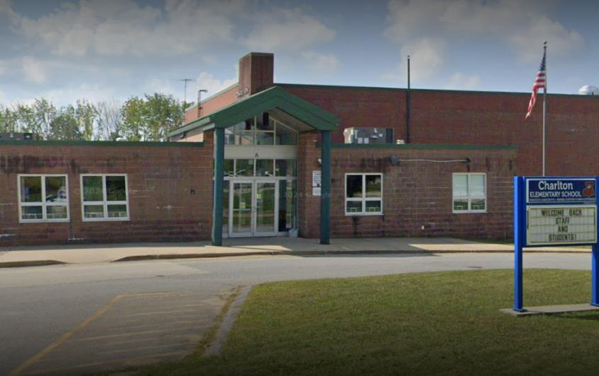

Prepared by:

Massachusetts Department of Public Health

Bureau of Climate and Environmental Health

February 2025

# BACKGROUND

|  |  |
| --- | --- |
| Building: | Charlton Elementary School (CES) |
| Address: | 9 Burlingame Road, Charlton, MA |
| Requestor: | Joe Caron, Facilities Director, Dudley-Charlton Regional School District |
| Reason for Request: | Concerns about health issues and indoor air quality (IAQ) in a kindergarten classroom |
| Dates of Assessment: | February 19, 2025 |
| Massachusetts Department of Public Health/Bureau of Climate and Environmental Health (MDPH/BCEH) Staff Conducting Assessment: | Ruth Alfasso, Environmental Engineer/Inspector, Division of Environmental Health Regulations and Standards (DEHRS) |
| Building Description: | Charlton Elementary School is a brick building with a flat roof originally constructed in the 1950s. Several renovations have been conducted, most recently in 2006. A single kindergarten classroom was examined during this assessment. |
| Windows: | Openable in the room examined |

# METHODS

Please refer to the IAQ Manual for methods, sampling procedures, and interpretation of results (MDPH, 2015).

**RESULTS AND DISCUSSION**

The following are the indoor air testing results in the room examined:

* ***Carbon dioxide*** was measured at 495 parts per million (ppm) which is below the MDPH guideline of 800 ppm. Note that the school was unoccupied apart from maintenance personnel, and the univent and exhaust vent were operating.
* ***Temperature*** was 63°F, which is below the recommended range of 70°F to 78°F, but warm enough to prevent frozen pipes or other issues during vacation week.
* ***Relative humidity*** was 12.5 %, which is below the recommended range of 40% to 60%. Low relative humidity is common during the heating season.
* ***Carbon monoxide*** levels were non-detectable (ND).
* ***Fine particulate matter (PM2.5)*** concentrations were also ND in the area testing which is below the National Ambient Air Quality Standard (NAAQS) level of 35 μg/m3.

## Ventilation

A heating, ventilating, and air conditioning (HVAC) system has several functions. First it provides heating and, if equipped, cooling. Second, it is a source of fresh air. Finally, an HVAC system will dilute and remove normally occurring indoor environmental pollutants by not only introducing fresh air, but by filtering the airstream and ejecting stale air to the outdoors via exhaust ventilation. Even if an HVAC system is operating as designed, point sources of respiratory irritation may exist and cause symptoms in sensitive individuals.

Fresh air in the classroom examined is provided by a unit ventilator (univent, Picture 1). A univent draws air in from a vent on the outside of the building (Picture 2), heats it, and delivers it to the classroom through a vent in the top (Figure 1). A vent along the bottom front of the unit draws some air back into the univent to mix with fresh air.

The univent in this classroom appears to be original in the building, and thus over 60 years old. Function of equipment of this age is difficult to maintain since compatible replacement parts are often unavailable. According to the American Society of Heating, Refrigeration and Air-Conditioning Engineers (ASHRAE), the service life for a unit heater is 20 years, assuming routine maintenance of the equipment (ASHRAE, 1991).

Despite the age of the univent, it was in good condition and had recently been cleaned. A filter with a minimum efficiency reporting value, or MERV rating, of 8 was installed in this unit (Picture 3). MERV 8 filters are the minimum recommended by the MDPH DEHRS because they are adequate to filter out pollen and mold spores. Facility staff noted that higher MERV filters would not be able to be used by this equipment. Filters are reportedly changed 4 times a year, and the filter in this unit was marked that it had last been changed in late December (over the holiday break).

Exhaust vents are located inside the classroom closet on the wall closest to the door (Picture 4). While this vent was on and operating, it was found mostly blocked by items and furniture which can limit the ability of the exhaust vent to work. This location of a vent is difficult to keep free of items, so staff should be reminded to keep this vent unblocked for improved air circulation.

Note that the CES is not equipped with any form of central air conditioning. Windows are openable in the classroom examined. Openable windows can be used for fresh air whenever outside conditions are suitable. Windows should be kept closed during extreme cold, heavy rain, and poor outdoor air quality such as high pollen counts or wildfire smoke. If a portable or window air conditioner is used in this classroom during hot weather, windows should be kept closed when it is operating to prevent condensation.

To have proper ventilation with a mechanical ventilation system, the system must be balanced after installation to provide an adequate amount of fresh air to the interior of a room while removing stale air from the room. It is recommended that HVAC systems be re-balanced every five years to ensure adequate air systems function (SMACNA, 1994). Information regarding balancing was not available at the time of this visit.

## Water Damage Issues

Concerns regarding mold and health concerns in this classroom prompted the request for an assessment. No history of a leak was reported in this classroom. No signs of water damage or mold growth were noted during the assessment including: no stained ceiling tiles, no water stains on carpeting, and no musty or moldy odors.

Several conditions were noted that could lead to water damage and associated odors. The classroom has a sink, and large amounts of items were noted in a cabinet under it including porous items (Picture 5). A cabinet under a sink can be a moist environment and large amounts of items in it can make detecting leaks more difficult. In addition, classroom sinks can be subject to dry drain traps. If a fixture is not used for several weeks, the water in the p-trap that forms an airtight seal between the sewer and the inside of the building can dry out, which will allow sewer gases and associated moisture and odors into occupied spaces. Classrooms that are not used over vacations, particularly summer vacation, can dry out.

This room is on the first floor of a building built in the 1950s. It may not be insulated underneath between the floor and the soil. Therefore, during hot, humid weather, the ground may be cold enough to develop condensation. Porous items on the floor, including carpeting and classroom materials, may become water-damaged and mold-colonized. Wall-to-wall carpeting is generally not recommended for classrooms, especially on the first floor due to this and potential other issues. However, the carpeting in this room did not have odors and showed no other signs of water damage.

One indication that this room was exposed to high humidity in the past is that the portion of ceiling tiles that are suspended rather than adhered to the ceiling are bowing or sagging in their frames (Picture 6). While bowed ceiling tiles may indicate past high humidity, they are not mold-colonized. Pictures were taken above the ceiling tile grid and showed an open space with no sign of water damage or pest activity above the tiles.

There are trees outside the area examined. If windows are opened, pollen and mold spores can enter. In addition, trees can clog roof drains and prevent walls from drying, making water damage more likely.

### Mold testing recommendations

Note that the MDPH DEHRS does not recommend testing for mold in public buildings. More information on the reasons behind this can be found at: <https://www.mass.gov/info-details/guidance-regarding-testing-for-mold-in-water-damaged-public-buildings>.

## Other IAQ Concerns

Both wall-to-wall carpeting and area rugs were found in the classroom. Some of the carpeting had become stained due to painting activities (Picture 7). Carpeting should be cleaned annually (or semi-annually in soiled/high traffic areas) in accordance with the Institute of Inspection, Cleaning and Restoration Certification (IICRC) recommendations, (IICRC, 2012). Regular cleaning with a high efficiency particulate air (HEPA) filtered vacuum in combination with an annual cleaning will help to reduce accumulation and potential aerosolization of materials from carpeting. Area rugs were also present (Pictures 7 and 8). Area rugs should be cleaned periodically and should be stored rolled up in a climate-controlled area over the summer.

Cleaners and sanitizers were found in the classroom. Teachers should only use products supplied by or approved by the school and products should be kept out of the reach of children. Products such as air fresheners and heavily scented products should not be used, as many people can be sensitive to fragrances.

**CONCLUSIONS/RECOMMENDATIONS**

No obvious sources of odors or health issues in the room examined were noted during this assessment. Several recommendations are made to improve and maintain good IAQ:

## Ventilation recommendations

1. Continue to change filters in univents 2 to 4 times a year. Clean out any dust or debris from the univent cabinets during filter changes.
2. Remove blockages from in front of exhaust vents and ensure univents have clear space in front and on top.
3. Ensure supply and exhaust ventilation is operating during all occupied periods.
4. Have the HVAC system balanced every 5 years in accordance with SMACNA recommendations (SMACNA, 1994).

## Water damage recommendations

1. Remove porous items from underneath the sink.
2. Trim trees and plants away from the building at least 5 feet, particularly near windows.
3. Ensure all drain traps are kept wetted during long breaks by pouring water down them every few weeks.
4. Avoid storing porous items on the floor during humid weather or over the summer. Roll up and store any area rugs in a climate-controlled area to prevent condensation and mold growth.

## Other recommendations

1. Use only school supplied or approved cleaning products and keep them away from children.
2. Clean carpets regularly using a HEPA filter equipped vacuum cleaner. Have carpets deep cleaned at least once a year. Ensure that humidity during deep cleaning is low enough that carpeting will dry quickly.
3. Use waterproof mats or disposable/washable materials under messy crafts.

# REFERENCES

ASHRAE. 1991. ASHRAE Applications Handbook, Chapter 33 “Owning and Operating Costs”. American Society of Heating, Refrigeration and Air Conditioning Engineers, Atlanta, GA.

IICRC. 2012. Institute of Inspection, Cleaning and Restoration Certification. Carpet Cleaning: FAQ. Retrieved from <https://iicrc.org/>.

MDPH. 2015. Massachusetts Department of Public Health. Indoor Air Quality Manual: Chapters I-III. Available at: <https://www.mass.gov/lists/indoor-air-quality-manual-and-appendices#indoor-air-quality-manual->.

SMACNA. 1994. HVAC Systems Commissioning Manual. 1st ed. Sheet Metal and Air Conditioning Contractors’ National Association, Inc., Chantilly, VA.

**Figure 1**

**Unit Ventilator (Univent)**

Mixed Air

Air Diffuser

**Outdoors Indoors**

Fan

Heating/Cooling Coil

Air Mixing Plenum

Filter

Outdoor Return

Air Air

Air

Flow

Control

Louvers

**Air Flow**

= Fresh Air/Return Air

= Mixed Air

**Picture 1**

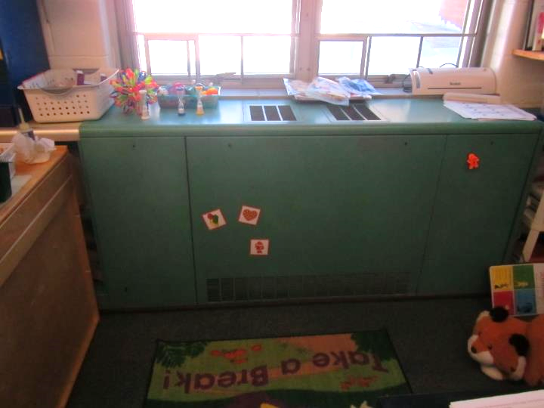

**Unit ventilator (univent) in the classroom**

**Picture 2**

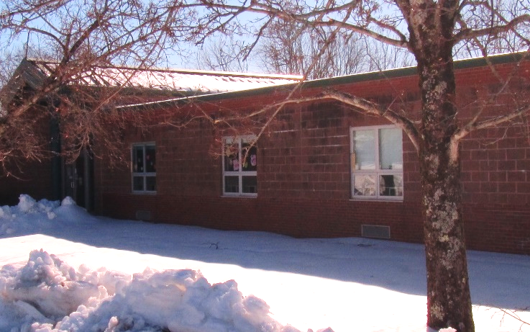

**Univent air intake (arrow)**

**Picture 3**

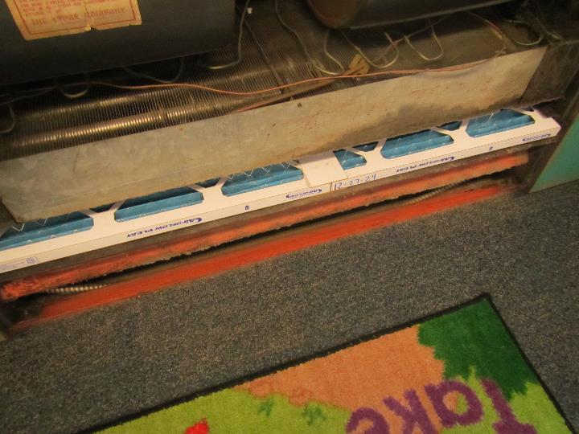

**MERV 8 filter in univent, note date of last filter change of 12-27-24**

**Picture 4**

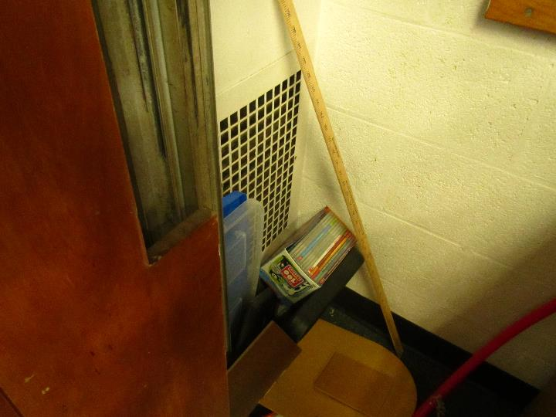

**Exhaust vent, items had to be moved inside closet to access vent**

**Picture 5**

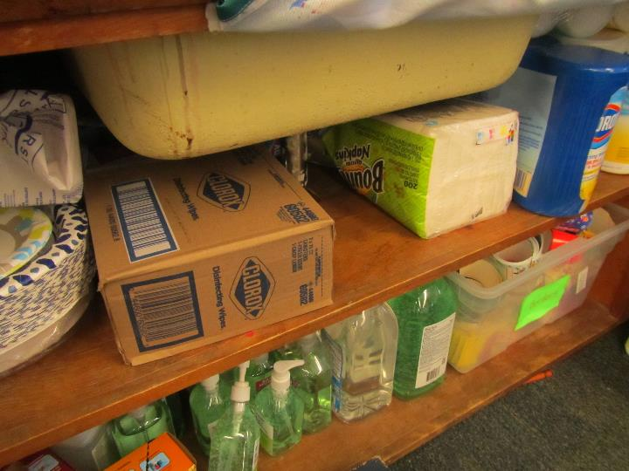

**Large amounts of items, including porous items, stored under the sink**

**Picture 6**

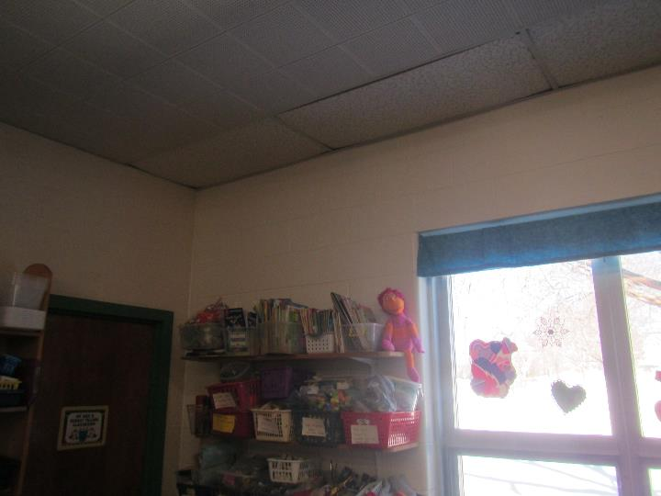

**Bowed, poorly fitted, ceiling tiles in the area above the windows**

**Picture 7**

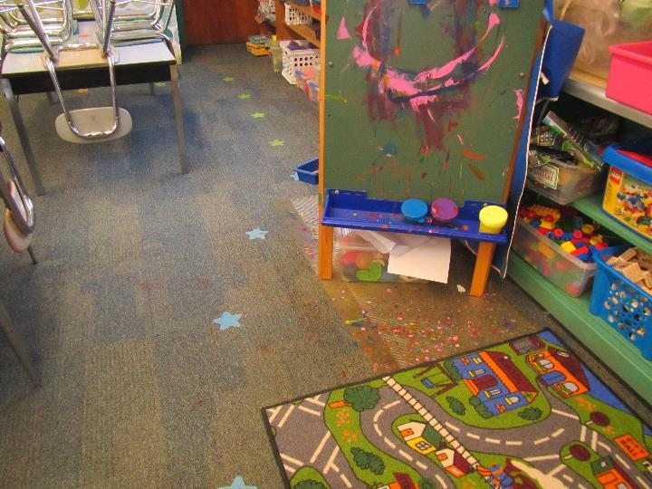

**Paint spilled on carpet, also note one area rug**

**Picture 8**

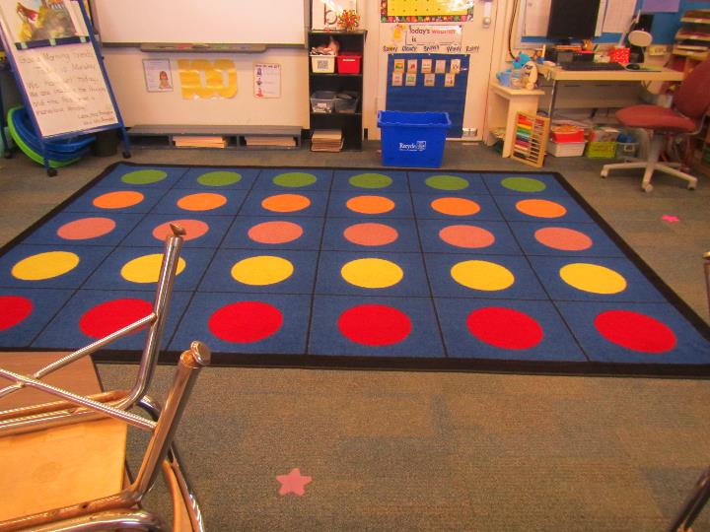

**Large area rug in the classroom**