Commonwealth of Massachusetts
Executive Office of Health and Human Services

Office of Medicaid
www.mass.gov/masshealth
MassHealth
Transmittal Letter CHC-108
November 2016

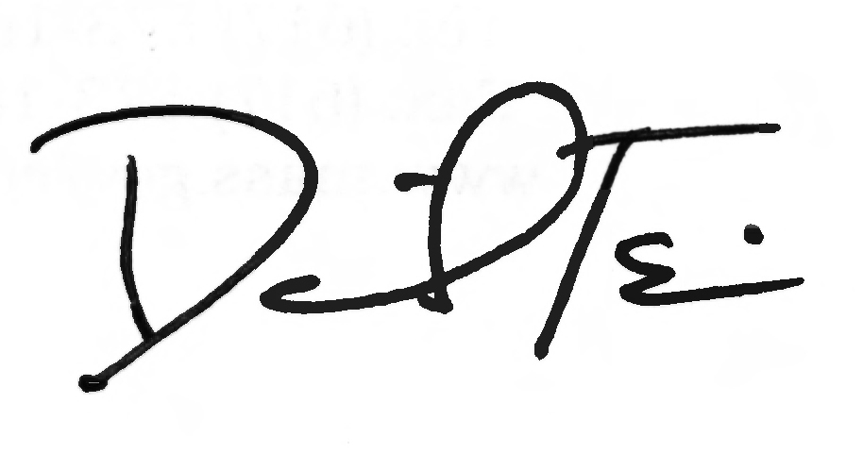
TO: Community Health Centers Participating in MassHealth

FROM: Daniel Tsai, Assistant Secretary for MassHealth

RE: Community Health Center Manual (Code Update)

This letter transmits an update to the 2016 HCPCS codes in the Community Health Center Manual.

The following text has been added to Subchapter 6, Section 604, which lists visit and vaccine service codes that are payable under MassHealth.

Service Code Special Requirement or Limitation 99213 Use for medication management visit.

Providers must use this new code to obtain reimbursement for services provided on or after January 1, 2016. Providers should follow the billing instructions in the provider manual when resubmitting denied claims.

MassHealth Website

This transmittal letter and attached page are available on the MassHealth website at www.mass.gov/masshealth.

Questions

If you have any questions about this transmittal letter, please contact the MassHealth Customer Service Center at 1-800-841-2900, e-mail your inquiry to providersupport@mahealth.net, or fax your inquiry to 617-988-8974.

NEW MATERIAL
(The pages listed here contain new or revised language.)

Community Health Center Manual

Pages 6-9 and 6-10

OBSOLETE MATERIAL
(The page listed here is no longer in effect.)

Community Health Center Manual

Pages 6-9 and 6-10 — transmitted by Transmittal Letter CHC-106

604 Payable Visit and Vaccine Service Codes

This section lists visit and vaccine service codes that are payable under MassHealth.

When claiming payment for visits or vaccines, a CHC must bill according to the following service codes.
A visit during which a member sees more than one professional for the same medical problem or general purpose must be claimed as only one visit. (See 130 CMR 405.421 for other requirements.)

- The following visit and associated service codes have special requirements or limitations.

Service
Code Modifier Special Requirement or Limitation

D9450 Use only for dental enhancement fee. This code may only be billed once per date of service for each member receiving dental services on that date. The dental enhancement fee may not be billed for a fluoride varnish application separately or in addition to a medical visit.
J3490 Use for injectable and infusible drugs and devices supplied in the clinic. Do not use for medications and injectables related to family planning services. (IC)
T1015 Use for individual medical visit.
T1015 HQ Use for group clinic visit.
90791 Use for psychiatric diagnostic evaluation.
90792 Use for psychiatric diagnostic evaluation with medical services.
90832 Use for psychotherapy, 30 minutes with patient and/or family member.
90834 Use for psychotherapy, 45 minutes with patient and/or family member.
90836 Use for psychotherapy, 45 minutes with patient and/or family member when performed with an evaluation and management services (list separately in addition to the code for primary procedure).
90837 Use for psychotherapy, 60 minutes with patient and/or family.
90853 Use for group psychotherapy (other than of a multiple-family group) (per person not to exceed 10 clients).
90882 Environmental intervention for medical management purposes on a psychiatric patient’s behalf with agencies, employers, or institutions.
99050 Use for urgent care Monday through Friday from 5:00 p.m. to 6:59 a.m., and Saturday 7:00 a.m. to Monday 6:59 a.m. This code may be billed in addition to the individual medical visit.
99188 Covered for children younger than age 21. The CHC may bill for a medical visit in addition to the fluoride varnish application only if fluoride varnish was not the sole service, treatment, or procedure provided during the visit.
99213 Use for medication management visit.
99402 Use for HIV counseling visits.
- This section lists evaluation and management visit service codes that are payable under MassHealth.

99218
99219
99220
99221
99222
99223
99224
99225
99226
99231
99232
99233
99238
99239
99304
99305
99306
99307
99308
99309
99310
99324
99325
99326
99327
99334
99335
99336
99337
99341
99342
99343
99345 (IC)
99347
99348
99349
99350 (IC)
99460
99462

604 Payable Visit and Vaccine Service Codes (cont.)

(C) This section lists evaluation and management visit service codes that are payable under MassHealth.
The following vaccine administration service codes are payable in addition to the evaluation and management visit service codes in this Section 604(B), provided that the vaccine administration is a medically necessary, separately identifiable service. Under these circumstances, the CHC may append modifier 25 to the evaluation and management visit service code. See MassHealth All Provider Bulletin 236 for additional information.

90460
90461
90471
90472
90473
90474

(D) The following vaccine service codes have special requirements or limitations.

Service
Code Special Requirement or Limitation

90260 Meningococcal recombinant protein and outer membrane vesicle vaccine, serogroup B (men), 2 dose schedule for intramuscular use.
90621 Meningococcal recombinant lipoprotein vaccine, serogroup B (MenB), 3 dose schedule, for intramuscular use.
90625 Cholera vaccine, live, adult dosage, 1 dose schedule for oral use.
90630 Covered for adults >19; available free of charge through the Massachusetts Immunization Program for children younger than 19 years of age. (IC)
90632 Covered for adults >19; available free of charge through the Massachusetts Immunization Program for children younger than 19 years of age.
90636 Covered for adults >19; available free of charge through the Massachusetts Immunization Program for children younger than 19 years of age. (IC)
90649 Covered for members aged 19 to 26; available free of charge through the Massachusetts Immunization Program for children younger than 19 years of age.
90650 Covered for members aged 19 to 26; available free of charge through the Massachusetts Immunization Program for children younger than 19 years of age.
90651 Covered for members aged 19 to 26; available free of charge through the Massachusetts Immunization Program for children younger than19 years of age. (IC)
90654 Covered for adults >19; available free of charge through the Massachusetts Immunization Program for children younger than 19 years of age. (IC)
90655 Only for privately purchased vaccine; vaccine must not otherwise be available free of charge through the Massachusetts Immunization Program.
90656 Covered for adults >19; available free of charge through the Massachusetts Immunization Program for children younger than 19 years of age.
90657 Only for privately purchased vaccine; vaccine must not otherwise be available free of charge through the Massachusetts Immunization Program.
90658 Covered for adults >19; available free of charge through the Massachusetts Immunization Program for children younger than 19 years of age.
90660 Covered for adults >19; available free of charge through the Massachusetts Immunization Program for children younger than 19 years of age.
90661 Covered for adults >19; available free of charge through the Massachusetts Immunization Program for children younger than 19 years of age. (IC)

