Using your social media presence to promote the MA Community Health Equity Survey

Pointers for social media
You can use any combination of posts below that speak to the communities with which you work, and you can also create your own posts that encourage people to take the survey.

You can also generate social media discussion and attention to the survey by posting YOUR ANSWER (as a community leader or community member) to the question, “What makes our community healthy & strong?”

Examples:

Local businesses and our diverse immigrant cultures make our community health and strong. What do YOU think makes our community healthy & strong?
#yourvoiceMA #healthsurveyMA

What makes our community healthy & strong? Neighbors who take care of each other. What’s YOUR answer?
#yourvoiceMA #healthsurveyMA

All posts should include a web link:
Audiences whose preferred language is not English should be pointed directly to the survey where they can select their language:
redcap.link/ches

English-speaking audiences can be pointed to:
Mass.gov/Healthsurvey
Or
redcap.link/ches

Graphics for social media posts
You can use this graphic, available in 11 languages (shown below in English and Haitian Creole), or create your own:
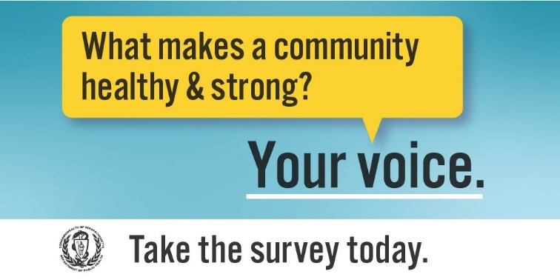
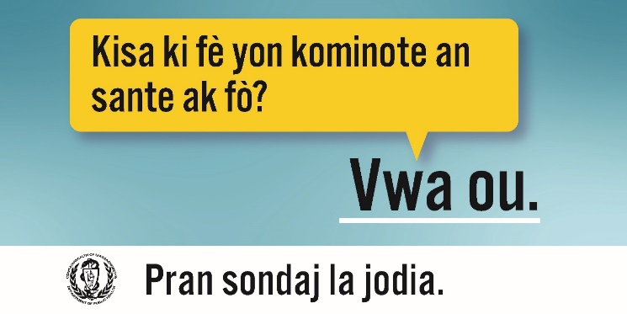

Sample posts for all audiences

What makes our community healthy & strong? Your voice. Re-post with your answer!
#yourvoiceMA #healthsurveyMA

What makes our community healthy & strong? Your voice. Take the MA Health Equity Survey TODAY at Mass.gov/Healthsurvey!

State & local decisions impact the health of you, your family, and community. Make sure decisionmakers understand your values, needs, and hopes for the future. Take the MA Health Equity Survey TODAY!

To improve the health of ALL, we need to center the voices of people and communities that have been long denied an equal chance at health. Make your voice heard and take the MA Health Equity Survey TODAY.

Posts for Communities of Focus audiences [Recommended for use in combination with social media posts above]

Older adults
Staying healthy and active in our communities as we age is more important than ever. Share your experience and insight to help all older adults in MA enjoy full and vibrant lives. Take the MA Health Equity Survey TODAY!

Immigrants
Share your unique and valuable perspective, and help support the immigrant community in Massachusetts. Take the MA Health Equity Survey TODAY!

Parents and caregivers of children and youth with special health needs
Caregiving can be meaningful, and sometimes challenging. By sharing your story, you can help create solutions that benefit your entire family. Take the MA Health Equity Survey TODAY!

Being a caregiver as a young person develops can be full of surprises. When you share this experience, you’re helping other caregivers in your shoes. Take the MA Health Equity Survey TODAY!

Pregnant people and parents of young children
Pregnancy and parenting are personal experiences that change us forever. When you take the MA Health Equity Survey, you’re helping pregnant people, children, and families to be healthy and thrive. Take the survey NOW!

People with disabilities
Our experiences are unique and diverse. Your answers can help increase accessibility, representation, and participation in all aspects of life for people with disabilities. Make your voice heard and take the MA Health Equity Survey today.

People identifying as LGBTQ+
Systems of oppression, including heteronormativity, heterosexism, and transphobia, have excluded LGBTQ+ folks, with devastating effects on our health and well-being. Make a difference today by taking the MA Health Equity Survey.

Everyone in the LGBTQ+ community has a unique story to tell. Elevating the diverse experiences of your community will shape our future health. Make your voice heard and take the MA Health Equity Survey today.

People of color (American Indian/Alaska Native, Asian American and Pacific Islander, Black, Hispanic/Latine/a/o residents)
Racism has created huge barriers to health and well-being in the past and present. While communities of color have historically been left out of the conversation, the Community Health Equity Survey is an important opportunity for diverse groups to be represented and heard. Share your experience by taking the survey today.

Tribal and Indigenous communities have historically been made invisible in many ways, but culture, language, and values are a source of strength. Make sure that Indigenous voices in Massachusetts are heard by taking the MA Health Equity Survey today.

The history and experience of Asian-American and Pacific Islanders varies from community to community in Massachusetts. When you answer the MA Health Equity Survey, you help to represent your community’s strengths, values, and hopes. Take the survey TODAY!

Our Hispanic and Latine/a/o communities have historically faced racism, xenophobia, and fear of deportation. Help ensure that Latinx families and communities stay healthy and stay together. Share your experience by taking the MA Health Equity Survey TODAY. Your answers are anonymous.

COVID-19 and the continued impacts of racism have taken a huge toll on Black Massachusetts residents. While Black communities have mobilized in mutual strength and support, it’s important to shine a light on the systems and structures that continue to impact our health. With your response, you’re ensuring that Black experiences NOW are shaping our health in the FUTURE. Take the MA Health Equity Survey TODAY.

People whose primary language is not English
The MA Health Equity Survey is available in 11 languages to ensure that many voices and experiences are represented and heard. Make your voice heard and take the survey TODAY!

Rural residents
Rural communities across Massachusetts are home to diverse populations with their own cultures, values, and strengths. Make sure that rural voices are heard by taking the MA Health Equity Survey TODAY!

Veterans
The service and experience of veterans is diverse and valued. You’ve earned the respect and support that you deserve. When you respond to the MA Health Equity Survey, you’re helping to support the veteran community - especially for vets who might face challenges in life and work. Take the survey TODAY.

Parents under 25
Being a young parent comes with its own challenges, joys, and needs. By sharing your story, you can help create solutions that benefit your entire family. Make your voice heard and take survey TODAY!

Youth and young adults (ages 14-17 and 18-24)
Young people are the future – and are still often left out of the conversation. You have dreams, worries, and ideas to offer. With your survey response, you’re shaping your own future health – and the future for all young people. Make your voice heard and take MA Health Equity Survey TODAY!

