# Background/Introduction

**INDOOR AIR QUALITY/MOLD ASSESSMENT**

**Soldiers’ Home in Chelsea**

**Quigley Building**

**100 Summit Ave  
Chelsea, MA 02150**

Soldiers’ Home in Chelsea, Quigley Building


Prepared by:

Massachusetts Department of Public Health

Bureau of Environmental Health

Indoor Air Quality Program

December 2014

At the request of Deborah Coleman, Director, Office of Leasing and State Owned Property at the Executive Office of Health and Human Services, the Massachusetts Department of Public Health (MDPH), Bureau of Environmental Health (BEH) provided assistance and consultation at the Lawrence F. Quigley Memorial Hospital (QH) located at the Soldiers’ Home Campus, 100 Summit Avenue, Chelsea, Massachusetts. On September 8, 2014, a visit was made to the QH by Sharon Lee, an Environmental Analyst within BEH’s Indoor Air Quality (IAQ) Program. The assessment was prompted by employee concerns regarding mold, moisture and general IAQ related to ventilation equipment. At that time, BEH/IAQ staff conducted a preliminary evaluation of indoor environmental conditions that may be contributing to staff concerns regarding mold. During the assessment, BEH/IAQ staff were accompanied by Bob Maniatis, Director of Facilities Management, and Shawn Kraft, Director of Support Services.

The QH is a long-term-care residential facility. The building was constructed circa 1950 and additions were made to the building during the 1960s and 1970s. A fire protection renovation that added a sprinkler system, fire alarms and some ventilation equipment was completed in 2007.

# Methods

Air tests for carbon dioxide, carbon monoxide, temperature, and relative humidity were taken with the TSI, Q-Trak, IAQ Monitor 7565. BEH/IAQ staff also performed a visual inspection of building materials for water damage and/or microbial growth.

# Results

The QH has 300 staff members and 172 residents. BEH staff observed conditions in a single resident room, several staff offices, a community room, and a large residential wing. Tests were taken during normal operations. Results appear in Table 1.

# Discussion

## Ventilation

It can be seen that carbon dioxide levels were below 800 parts per million (ppm) in all areas tested, indicating adequate air exchange at the time of the assessment (Table 1). Ceiling-mounted air-handing units (AHUs) provide conditioned fresh air to patient wings (Picture 1). Fresh air and air returned from the occupant space are mixed, filtered, heated or cooled, and provided to the occupant space via air diffusers (Picture 2).

Conditioned air to offices, storage areas and patient rooms in the main portion of the building is provided by wall-mounted fan-coil units (FCUs). Air from a room is drawn through a return vent located at the base of the FCU; air is then filtered, conditioned (e.g., heated or cooled), and provided to the room through an air diffuser located at the top of the unit (Picture 3; Figure 1). The purpose of FCUs is to provide conditioned air. These units do not introduce fresh air, which is necessary to dilute normally occurring indoor pollutants. The use of openable windows is the sole means of providing fresh air to these areas of building.

Ceiling-mounted return vents (Picture 4) are located in storage rooms off of offices and in common rooms. These return vents are ducted to penthouse exhaust fans that remove stale air and airborne materials from the building. Please note, at the time of the assessment, a strong draw of air was observed from the exhaust vents located in the office storage rooms. The doors to these storage areas are also undercut; this would indicate that the exhaust vent is designed to draw air from the office, under the door and into the exhaust where it is removed from the building. Since the doors to the storage rooms are in close proximity to the hallway, air from the hallway areas is also removed through these return vents.

Minimum design ventilation rates are mandated by the Massachusetts State Building Code (MSBC). Until 2011, the minimum ventilation rate in Massachusetts was higher for both occupied office spaces and general classrooms, with similar requirements for other occupied spaces (BOCA, 1993). The current version of the MSBC, promulgated in 2011 by the State Board of Building Regulations and Standards (SBBRS), adopted the 2009 International Mechanical Code (IMC) to set minimum ventilation rates. **Please note that the MSBC is a minimum standard that is not health-based**. At lower rates of cubic feet per minute (cfm) per occupant of fresh air, carbon dioxide levels would be expected to rise significantly. A ventilation rate of 20 cfm per occupant of fresh air provides optimal air exchange resulting in carbon dioxide levels at or below 800 ppm in the indoor environment in each area measured. MDPH recommends that carbon dioxide levels be maintained at 800 ppm or below. This is because most environmental and occupational health scientists involved with research on IAQ and health effects have documented significant increases in indoor air quality complaints and/or health effects when carbon dioxide levels rise above the MDPH guidelines of 800 ppm for schools, office buildings and other occupied spaces (Sundell et al., 2011). The ventilation must be on at all times that the room is occupied. Providing adequate fresh air ventilation with open windows and maintaining the temperature in the comfort range during the cold weather season is impractical. Mechanical ventilation is usually required to provide adequate fresh air ventilation.

Carbon dioxide is not a problem in and of itself. It is used as an indicator of the adequacy of the fresh air ventilation. As carbon dioxide levels rise, it indicates that the ventilating system is malfunctioning or the design occupancy of the room is being exceeded. When this happens, a buildup of common indoor air pollutants can occur, leading to discomfort or health complaints. The Occupational Safety and Health Administration (OSHA) standard for carbon dioxide is 5,000 parts per million parts of air (ppm). Workers may be exposed to this level for 40 hours/week, based on a time-weighted average (OSHA, 1997).

The MDPH uses a guideline of 800 ppm for publicly occupied buildings. A guideline of 600 ppm or less is preferred in schools due to the fact that the majority of occupants are young and considered to be a more sensitive population in the evaluation of environmental health status. Inadequate ventilation and/or elevated temperatures are major causes of complaints such as respiratory, eye, nose and throat irritation, lethargy and headaches. For more information concerning carbon dioxide, please see [Appendix A](http://www.mass.gov/eohhs/docs/dph/environmental/iaq/appendices/carbon-dioxide.doc).

Indoor temperature measurements at the time of the assessment ranged from 72°F to 77°F (Table 1), which were within the MDPH recommended comfort range. The MDPH recommends that indoor air temperatures be maintained in a range of 70°F to 78°F in order to provide for the comfort of building occupants. In many cases concerning indoor air quality, fluctuations of temperature in occupied spaces are typically experienced, even in a building with an adequate fresh air supply.

Indoor relative humidity measurements at the time of the assessment ranged from 51 to 58 percent (Table 1), which were within the MDPH recommended comfort range. The MDPH recommends a comfort range of 40 to 60 percent for indoor air relative humidity. Humidity levels in the building would be expected to drop during the heating season. The sensation of dryness and irritation is common in a low relative humidity environment. Low relative humidity is a very common problem during the heating season in the northeast part of the United States.

## Microbial/Moisture Concerns

It was reported to BEH/IAQ staff that building staff were concerned about mold growth in the building. The purpose of this assessment was to conduct a focused examination of areas of concern for sources of moisture/conditions that can contribute to mold growth. In order to become colonized with mold, a material must be exposed to water and remain moist. If sufficiently moistened, porous materials such as GW can support mold growth (US EPA, 2001). In addition, relative humidity in excess of 70 percent for extended periods of time can provide an environment for mold and fungal growth in building materials (ASHRAE, 1989).

Occupants reported concerns of mold in the storage rooms. Dust and fine debris was observed around exhaust vents (Picture 4). As previously discussed, a strong draw of air was noted in the storage rooms. The debris observed around the exhaust vent is likely the result of the strong draw of air. Such debris typically consists of human skin cells, dirt, and mold spores. Since there is no active water source, these mold spores will remain dormant. At the time of the assessment, MDPH/BEH staff recommended cleaning vents and conducting a thorough cleaning of the storage closets.

At the time of the assessment, BEH/IAQ staff examined the condition of FCUs in offices and common areas including the interior of FCUs in a few locations. In the majority of areas assessed, plant debris and other materials were observed within the FCUs (Picture 5). BEH/IAQ staff also observed items and plants on top and in front of the FCUs (Picture 6). Materials placed above or in close proximity to the FCU can fall in through the supply registers onto the coils. When the FCU is operating, these materials can be re-distributed to the occupied space. Plants can be a source of pollen and mold, which can be respiratory irritants to some individuals. Plants should be properly maintained and equipped with non-porous drip pans. Plants should also be located *away* from ventilation sources to prevent the entrainment and/or aerosolization of dirt, pollen or mold.

According to Mr. Maniatis and Mr. Kraft, the Facilities Management and Support Services Program recently implemented a program that includes cleaning and maintenance, which should help prevent aerosolization of debris that has collected within the FCUs. However, staff should also remain vigilant and remove items located directly on, in front of, or hanging above the FCUs.

Water-damaged ceiling tiles were observed in some locations in the building. Of note are water-damaged ceiling tiles in the East Wing (Picture 7). These stained ceiling tiles are in close proximity to the AHU that provides conditioned air to the space. It is likely that condensation is forming on the metal frame supporting the ceiling tile. This may occur when warm, moist air rises and comes in contact with the metal frame, which is cooled by conditioned air supplied by the AHU. Over time, ceiling tiles can become wet and serve as a source for mold growth.

The US Environmental Protection Agency (US EPA) and the American Conference of Governmental Industrial Hygienists (ACGIH) recommend that porous materials (e.g., carpeting, gypsum wallboard) be dried with fans and heating within 24 to 48 hours of becoming wet (US EPA, 2001; ACGIH, 1989). If not dried within this time frame, mold growth may occur. Once mold has colonized porous materials, they are difficult to clean and should be removed/discarded.

## Other IAQ Evaluations

Indoor air quality can be negatively influenced by the presence of respiratory irritants, such as products of combustion. The process of combustion produces a number of pollutants. Common combustion emissions include carbon monoxide, carbon dioxide, water vapor, and smoke (fine airborne particle material). To determine whether combustion products were present in the indoor environment, BEH/IAQ staff obtained measurements for carbon monoxide.

### Carbon Monoxide

Carbon monoxide is a by-product of incomplete combustion of organic matter (e.g., gasoline, wood and tobacco). Exposure to carbon monoxide can produce immediate and acute health effects. Several air quality standards have been established to address carbon monoxide and prevent symptoms from exposure to these substances. The MDPH established a corrective action level concerning carbon monoxide in ice skating rinks that use fossil-fueled ice resurfacing equipment. If an operator of an indoor ice rink measures a carbon monoxide level over 30 ppm, taken 20 minutes after resurfacing within a rink, that operator must take actions to reduce carbon monoxide levels (MDPH, 1997).

The American Society of Heating Refrigeration and Air-Conditioning Engineers (ASHRAE) has adopted the National Ambient Air Quality Standards (NAAQS) as one set of criteria for assessing indoor air quality and monitoring of fresh air introduced by HVAC systems (ASHRAE, 1989). The NAAQS are standards established by the US EPA to protect the public health from six criteria pollutants, including carbon monoxide and particulate matter (US EPA, 2006). As recommended by ASHRAE, pollutant levels of fresh air introduced to a building should not exceed the NAAQS levels (ASHRAE, 1989). The NAAQS were adopted by reference in the Building Officials and Code Administrators (BOCA) National Mechanical Code of 1993 (BOCA, 1993), which is now an HVAC standard included in the Massachusetts State Building Code (SBBRS, 2011). According to the NAAQS, carbon monoxide levels in outdoor air should not exceed 9 ppm in an eight-hour average (US EPA, 2006).

*Carbon monoxide should not be present in a typical, indoor environment*. If it *is* present, indoor carbon monoxide levels should be less than or equal to outdoor levels. On the day of the assessment, outdoor carbon monoxide concentrations were non-detect (ND) (Table 1). No measurable levels of carbon monoxide were detected inside the building (Table 1).

### Volatile Organic Compounds (VOCs)

Indoor air concentrations can be greatly impacted by the use of products containing volatile organic compounds (VOCs). VOCs are carbon-containing substances that have the ability to evaporate at room temperature. Total volatile organic compounds (TVOCs) can result in eye and respiratory irritation if exposure occurs. For example, chemicals evaporating from a paint can stored at room temperature would most likely contain VOCs. In an effort to identify materials that can potentially increase indoor VOC concentrations, BEH/IAQ staff examined rooms for products containing these respiratory irritants.

Hand sanitizer products may contain ethyl alcohol and/or isopropyl alcohol which are highly volatile and may be irritating to the eyes and nose, and may also contain fragrances to which some people may be sensitive (GOJO, 2007).

### Other Conditions

At the time of assessment, BEH staff inspected interior components of an FCU. Debris was observed within the FCU and in the condensation drip pan (Picture 8). Cabinets should be free and clean of debris. BEH/IAQ staff also observed spaces in the floor around pipes in the FCU cabinet and holes/breaches in the FCU cabinet wall (Pictures 9 and 10). These breaches can allow odors, moisture, and pests from the crawlspace to enter occupied areas. These breaches should be sealed properly to prevent these issues.

Food and food preparation equipment was observed in several areas of the building (Table 1). Food, including crumbs remaining on food preparation equipment can attract pests and cause odors. Food should be kept in tightly-sealed containers, and food preparation areas should be cleaned regularly.

In some areas, a large number of items were observed on floors, windowsills, tabletops and counters. The large number of items provides a source for dusts to accumulate. These items (e.g., papers, folders, boxes, books) make it difficult for areas to be cleaned. Items should be relocated and/or cleaned periodically to avoid excessive dust build up.

As mentioned, dust and debris were observed collected on supply diffusers and return grates in a few areas; these should be cleaned periodically in order to prevent them from serving as a source of aerosolized particulate matter. Dust can be irritating to the eyes, nose and respiratory tract.

# Conclusions/Recommendations

In view of the findings at the time of the visit, the following recommendations are made:

1. Continue with plans to conduct scheduled maintenance and cleaning of HVAC equipment, including regular filter changes.
2. Seal holes/breaches where pipes from univents and sinks penetrate into the crawlspace or wall cavity with appropriate fire-rated sealant to prevent movement of odors/particles from wall cavities and subfloor areas.
3. Ensure storage rooms are cleaned regularly to prevent buildup of dust and debris.
4. Ensure FCUs are free of items placed on top or in front of the unit.
5. Replace water-damaged ceiling tiles as staining becomes apparent.
6. For buildings in New England, periods of low relative humidity during the winter are often unavoidable. Therefore, scrupulous cleaning practices should be adopted to minimize common indoor air contaminants whose irritant effects can be enhanced when the relative humidity is low. To control dusts, a high efficiency particulate arrestance (HEPA) filter equipped vacuum cleaner in conjunction with wet wiping of all surfaces is recommended. Avoid the use of feather dusters. Drinking water during the day can help ease some symptoms associated with a dry environment (throat and sinus irritations).
7. Ensure plants have drip pans and avoid over-watering. Examine drip pans periodically for mold growth. Disinfect with an appropriate antimicrobial where necessary. Do not place plants on or adjacent to FCUs and other ventilation equipment.
8. Ensure that food is stored in tightly-sealed containers and that food preparation equipment is kept clean to avoid smoke, odors and attracting pests.
9. Use the principles of integrated pest management (IPM) to rid this building of pests. Refer to the IPM Guide, which can be obtained at the following Internet address: <http://www.mass.gov/eea/docs/agr/pesticides/publications/ipm-kit-for-bldg-mgrs.pdf>.
10. Reduce, relocate, and/or clean accumulated items on flat surfaces periodically to avoid excessive dust build up.
11. Refer to resource manuals and other related indoor air quality documents for further building-wide evaluations and advice on maintaining public buildings. These materials are located on the MDPH’s website: <http://mass.gov/dph/iaq>.

# References

ACGIH. 1989. Guidelines for the Assessment of Bioaerosols in the Indoor Environment. American Conference of Governmental Industrial Hygienists, Cincinnati, OH.

ASHRAE. 1989. Ventilation for Acceptable Indoor Air Quality. American Society of Heating, Refrigeration and Air Conditioning Engineers. ANSI/ASHRAE 62-1989.

BOCA. 1993. The BOCA National Mechanical Code/1993. 8th ed. Building Officials and Code Administrators International, Inc., Country Club Hill, IL.

GOJO. 2007. Material Safety Data Sheet for Purell® Instant Hand Sanitizer. GOJO Industries, Akron, OH. October 15, 2007.

MDPH. 1997. Requirements to Maintain Air Quality in Indoor Skating Rinks (State Sanitary Code, Chapter XI). 105 CMR 675.000. Massachusetts Department of Public Health, Boston, MA.

OSHA. 1997. Limits for Air Contaminants. Occupational Safety and Health Administration. Code of Federal Regulations. 29 C.F.R 1910.1000 Table Z-1-A.

Sundell, J., H. Levin, W. W. Nazaroff, W. S. Cain, W. J. Fisk, D. T. Grimsrud, F. Gyntelberg, Y. Li, A. K. Persily, A. C. Pickering, J. M. Samet, J. D. Spengler, S. T. Taylor, and C. J. Weschler. 2011. Ventilation rates and health: multidisciplinary review of the scientific literature. Indoor Air, Volume 21: pp 191–204.

US EPA. 2001. Mold Remediation in Schools and Commercial Buildings. US Environmental Protection Agency, Office of Air and Radiation, Indoor Environments Division, Washington, D.C. EPA 402-K-01-001. March 2001.

US EPA. 2006. National Ambient Air Quality Standards (NAAQS). US Environmental Protection Agency, Office of Air Quality Planning and Standards, Washington, DC. <http://www.epa.gov/air/criteria.html>.

**Picture 1**

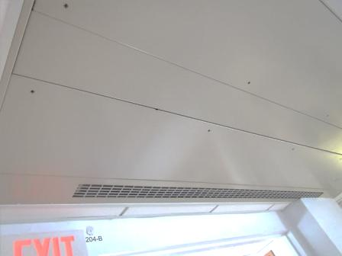

**Air-handling unit (AHU) in patient wing**

**Picture 2**

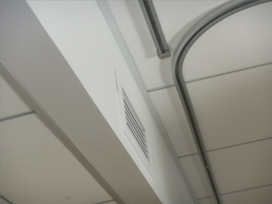

**Fresh air diffuser in patient wing**

**Picture 3**

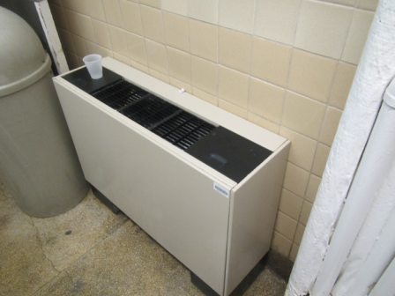

**Fan coil unit (FCU)**

**Picture 4**

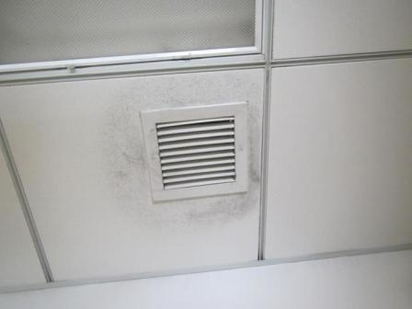

**Return vent in storage room**

**Picture 5**

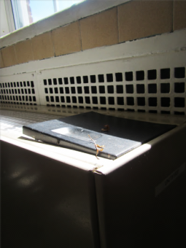

**Plant debris on FCU**

**Picture 6**

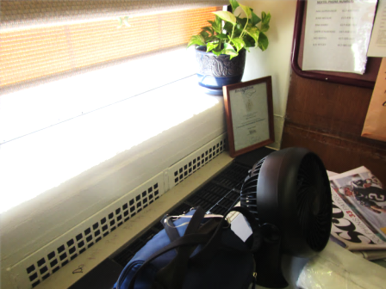

**Plants near FCU, items placed in front of FCU**

**Picture 7**

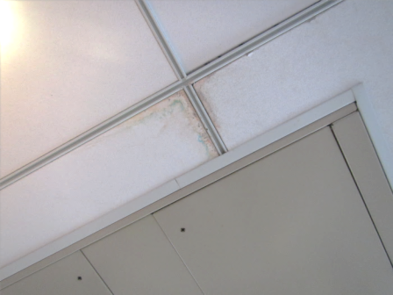

**Water-damaged ceiling tile, note staining around metal ceiling tile supports**

**Picture 8**

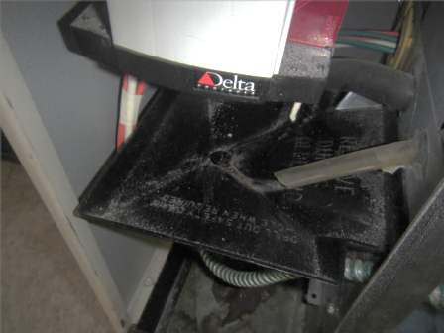

**Debris in condensate drip pan**

**Picture 9**

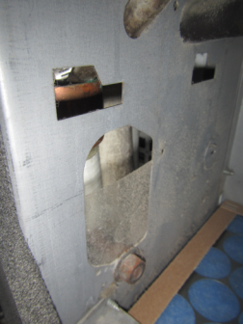

**Holes in cabinet wall allowing draw of air outside the filter**

**Picture 10**

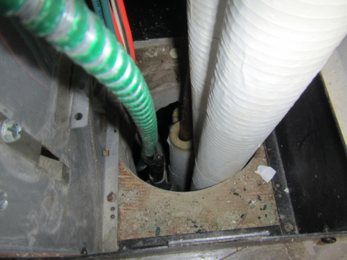

**Breaches around pipes in FCU cabinet**

| **Location/ Room** | **Temp (°F)** | **Relative Humidity (%)** | | **Carbon Dioxide (ppm)** | | **Carbon Monoxide**  **(ppm)** | | **Occupants**  **in Room** | | **Windows Openable** | | **Ventilation** | | | **Remarks** | |
| --- | --- | --- | --- | --- | --- | --- | --- | --- | --- | --- | --- | --- | --- | --- | --- | --- |
| **Supply** | **Exhaust** | |
| Background | | 72 | 59 | 732 | | ND | |  | |  | |  | |  | sunny | |
| 4th floor west, medical storage room | | 73 | 52 | 589 | | ND | | 0 | | Y | | N | | Y  Dust/  debris | FCU - leaves in/around unit | |
| 3rd floor nourishment room | | 76 | 57 | 740 | | ND | | 0 | | N | | N | | Y | DO, cup on FCU, food storage, fridges | |
| 307 – patient room | | 77 | 57 | 785 | | ND | | 1 | | Y | | N | | N | Items on FCU, ajar CT | |
| 306 – nurse’s station | | 75 | 51 | 709 | | ND | | 2 | | Y | | N | | Y  In closet | Food appliances | |
| 316 – family room | | 72 | 57 | 547 | | ND | | 1 | | Y | | N | | Y | Breaches in FCU cabinet wall; breaches around pipes in FCU cabinet | |
| 2nd floor, 2 east ward | | 74 | 58 | 650 | | ND | | 20 | | Y | | Y | | Y |  | |