INDOOR AIR QUALITY ASSESSMENT

Chenery Middle School
95 Washington Street
Belmont, Massachusetts

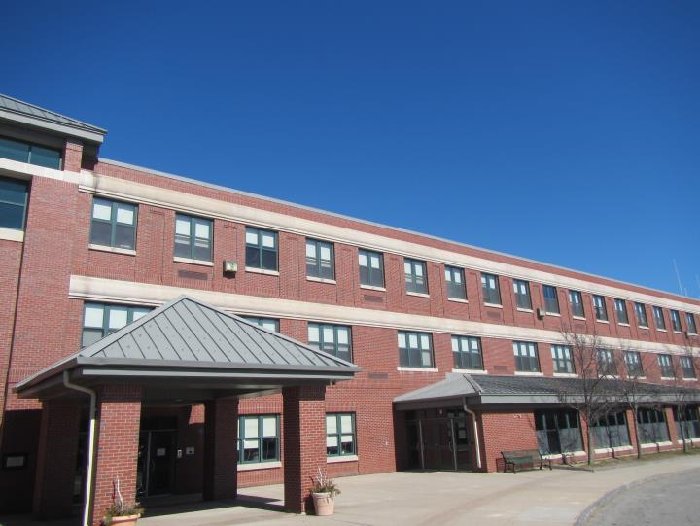

Prepared by:
Massachusetts Department of Public Health
Bureau of Environmental Health
Indoor Air Quality Program
August 2020

Background
Building: | Chenery Middle School, Guidance Office Area
Address: | 95 Washington St., Belmont, MA
Assessment Requested by: | Belmont Health Department and Belmont School Facilities Department
Reason for Request: | Indoor air quality (IAQ) and health
Date of Assessment: | 03/10/20
Massachusetts Department of Public Health/Bureau of Environmental Health (MDPH/BEH) Staff Conducting Assessment: | Ruth Alfasso, Environmental Engineer, IAQ Program
Building Description: | The CMS was built in 1997. The area examined was a suite of interior rooms on the second floor
Building Population: | The school houses approximately 1,400 students and 80 staff, the area examined has approximately 5 regular occupants and frequent visitors.
Windows: | There are no windows in the area examined

Note that this building was previously visited in 2017 with a full report issued at that time. That report can be found at: https://www.mass.gov/info-details/indoor-air-quality-reports-cities-and-towns-b.

Methods
Please refer to the IAQ Manual for methods, sampling procedures, and interpretation of results (MDPH, 2015).

IAQ Testing Results
The following is a summary of indoor air testing results (Table 1).
- Carbon dioxide levels were above 800 parts per million (ppm) in all the areas assessed at the time of the visit indicating that these areas need additional fresh air supply.
- Temperature was within the recommended range of 70°F to 78°F in all the areas assessed.
- Relative humidity was below the recommended range of 40% to 60% in all areas assessed.
- Carbon monoxide levels were non-detectable in all indoor areas assessed.
- Fine particulate matter (PM2.5) concentrations measured were below the National Ambient Air Quality Standard (NAAQS) level of 35 micrograms per cubic meter (μg/m³) in all areas assessed.
- Total Volatile Organic Compounds (TVOC) were not detected (ND) in the areas assessed.

Ventilation
A heating, ventilating and air conditioning (HVAC) system has several functions. First it provides heating and, if equipped, cooling. Second, it is a source of fresh air. Finally, an HVAC system will dilute and remove normally-occurring indoor environmental pollutants by not only introducing fresh air, but by filtering the airstream and ejecting stale air to the outdoors via exhaust ventilation. Even if an HVAC system is operating as designed, point sources of respiratory irritation may exist and cause symptoms in sensitive individuals.
Fresh air for the offices examined is supplied by air handling units (AHU) which draw in air from outside, filter and heat it, and direct it through ceiling-mounted vents (Picture 1). Return air is drawn through ceiling-mounted exhaust vents and returned to the AHU or exhausted from the building.
The carbon dioxide levels measured were above 800 ppm which indicates that optimally there should be more fresh air supplied to the area assessed. A lack of fresh air can allow normally-occurring odors and pollutants to build up and lead to air quality complaints. Facility maintenance staff should ensure that HVAC system settings allow for continuous air circulation during occupied periods, and that dampers/louvers are adjusted to allow fresh air intake.
In order to have proper ventilation with a mechanical supply and exhaust system, these systems must be balanced to provide an adequate amount of fresh air while removing stale air from a room. It is recommended that existing ventilation systems be re-balanced every five years to ensure adequate air systems function (SMACNA, 1994). The date of the last balancing of these systems was not available at the time of the assessment.
The relative humidity readings were below the MDPH recommended comfort range the day of the assessment. The MDPH recommends a comfort range of 40 to 60 percent for indoor air relative humidity. Relative humidity in the building would be expected to drop during the winter months due to heating. The sensation of dryness and irritation is common in a low relative humidity environment. “Extremely low (below 20%) relative humidity may be associated with eye irritation [and]…may affect the mucous membranes of individuals with bronchial constriction, rhinitis, or cold and influenza related symptoms” (Arundel et al., 1986). Low relative humidity is a common problem during the heating season in the northeast part of the United States.

Microbial/Moisture Concerns
No water-damaged materials, water stains, or musty odors were observed in the areas examined in the CMS. Plants were noted in the main office (Picture 2). Plants can be a source of mold, pollen and odors. Plants should be well-maintained and not overwatered and placed on non-porous drip pans to prevent water damage. Plants should be kept away from the airstream of ventilation equipment.

Other IAQ Evaluations
Exposure to low levels of total volatile organic compounds (TVOCs) may produce eye, nose, throat, and/or respiratory irritation in some sensitive individuals. To determine if VOCs were present, BEH/IAQ staff measured TVOCs, and all measurements were non-detect (ND). BEH/IAQ staff also examined rooms for products containing VOCs. BEH/IAQ staff noted hand sanitizers, and dry erase materials in use within the building (Table 1). All of these products have the potential to be irritants to the eyes, nose, throat, and respiratory system of sensitive individuals.
The Institute of Inspection, Cleaning, and Restoration Certification (IICRC) recommends that carpeting be cleaned annually (or semi-annually in soiled high traffic areas) (IICRC, 2012). Regular vacuuming with a high efficiency particulate air (HEPA) filtered vacuum in combination with an annual cleaning will help to reduce accumulation and potential aerosolization of materials from carpeting.
A coffee maker was noted in an office (Picture 2). Food and food preparation equipment should be kept clean to avoid odors, smoke and attracting pests.
Items were observed on some flat surfaces, such as tabletops, counters, bookcases, and desks. Items stored in offices provide a source for dusts to accumulate and make it difficult for custodial staff to clean. Items should be relocated and/or be cleaned periodically to avoid excessive dust build up.

Conclusions/Recommendations
Based on observations at the time of assessment, the following are recommended:

Ventilation Recommendations:
- Operate supply and exhaust ventilation continuously in all areas during occupied periods. Ensure that all thermostats for AHUs allow fans to bring in fresh air continuously not on “auto” setting which typically turns fans on only when the units call for heat/cooling.
- Ensure all HVAC equipment is repaired and maintained properly.
- Inspect fresh air intake louvers for AHUs to ensure an adequate volume of fresh air enters occupied areas.
- Regularly clean supply/return vents to avoid aerosolizing accumulated particulate matter. Continue to change filters on all AHU equipment at least 2 times a year.
- Consider adopting a balancing schedule of every 5 years for all mechanical ventilation systems, as recommended by ventilation industrial standards (SMACNA, 1994).

Water damage recommendations
- Ensure all plants are well-maintained, not overwatered and placed on non-porous drip pans. Ensure plants are not in the airstream of ventilation equipment.

Respiratory irritants recommendations
- For buildings in New England, periods of low relative humidity during the winter are often unavoidable. Therefore, scrupulous cleaning practices should be adopted to minimize common indoor air contaminants whose irritant effects can be enhanced when the relative humidity is low. To control for dusts, a high efficiency particulate arrestance (HEPA) filter equipped vacuum cleaner in conjunction with wet wiping of all surfaces is recommended. Avoid the use of feather dusters. Drinking water during the day can help ease some symptoms associated with a dry environment (throat and sinus irritations).
- Regularly vacuum carpeting with a HEPA-filtered vacuum cleaner and clean carpet annually as recommended by the IICRC.
- Reduce the use of fragrances, harsh or scented cleaning products and dry erase materials in the school, and use in well-ventilated areas since all of these products have the potential to be irritants to the eyes, nose, throat, and respiratory system of sensitive individuals.
- Ensure food preparation equipment is kept clean and food is in sealed containers to prevent smoke, odors and attracting pests.
- Avoid the accumulation of many items on flat surfaces. These items should be relocated and/or be cleaned periodically to avoid excessive dust build up.

Other recommendations
- Continue to address any recommendations from the 2017 report (https://www.mass.gov/info-details/indoor-air-quality-reports-cities-and-towns-b#belmont-).
- Refer to resource manual and other related IAQ documents located on the MDPH’s website for further building-wide evaluations and advice on maintaining public buildings. These documents are available at: http://mass.gov/dph/iaq.

References
Arundel et al. 1986. Indirect Health Effects of Relative Humidity on Indoor Environments. Env. Health Perspectives 65:351-361.
IICRC. 2012. Carpet Cleaning FAQ 4 Institute of Inspection, Cleaning and Restoration Certification. Institute of Inspection Cleaning and Restoration, Vancouver, WA.
MDPH. 2015. Massachusetts Department of Public Health. Indoor Air Quality Manual: Chapters I-III. Available at: http://www.mass.gov/eohhs/gov/departments/dph/programs/environmental-health/exposure-topics/iaq/iaq-manual/.
SMACNA. 1994. HVAC Systems Commissioning Manual. 1st ed. Sheet Metal and Air Conditioning Contractors’ National Association, Inc., Chantilly, VA.

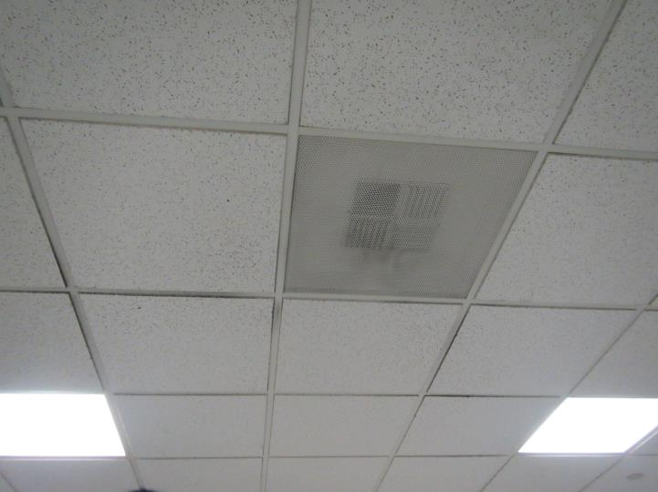
Picture 1
Typical supply vent in offices, note dust
Picture 2
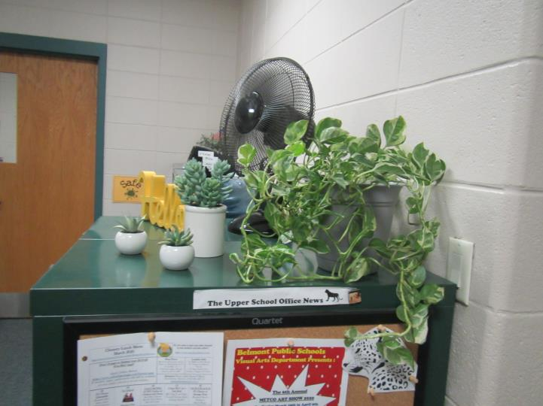
Plants and a personal fan

Location | Carbon  Dioxide  (ppm) | Carbon Monoxide  (ppm) | Temp  (°F) | Relative  Humidity  (%) | PM2.5  (µg/m³) | TVOC  (ppm) | Occupants  in Room | Windows  Openable | Ventilation |  |  | Remarks
 |  |  |  |  |  |  |  |  | Intake | Exhaust
Main | 994 | ND | 70 | 31 | 6 | ND | 1 | N | Y |  |  | HS
Office middle | 895 | ND | 70 | 28 | 5 | ND | 1 | N | Y |  | Y | Carpet
Office leftmost | 908 | ND | 70 | 28 | 5 | ND | 2 | N | Y |  | Y | Carpet
Office rightmost | 831 | ND | 71 | 25 | 5 | ND | 0 | N | Y |  | Y | HS, coffee

