INDOOR AIR QUALITY ASSESSMENT

Chenery Middle School
95 Washington Street
Belmont, Massachusetts

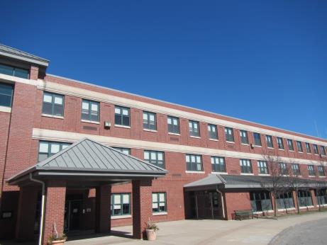

Prepared by:
Massachusetts Department of Public Health
Bureau of Environmental Health
Indoor Air Quality Program
March 2017

Background
Building: | Chenery Middle School (CMS)
Address: | 95 Washington St., Belmont, MA
Assessment Requested by: | Belmont Health Department
Reason for Request: | General indoor air quality (IAQ)
Date of Assessment: | March 3, 2017
Massachusetts Department of Public Health/Bureau of Environmental Health (MDPH/BEH) Staff Conducting Assessment: | Cory Holmes, Sharon Lee, and Jason Dustin, Environmental Analysts, IAQ Program
Building Description: | The CMS was built in 1997.
Building Population: | The school houses approximately 1,400 students and 80 staff.
Windows: | Openable

Methods
Please refer to the IAQ Manual for methods, sampling procedures, and interpretation of results (MDPH, 2015).

IAQ Testing Results
The following is a summary of indoor air testing results (Table 1).
- Carbon dioxide levels were above 800 parts per million (ppm) in a number of areas assessed, indicating inadequate fresh air in these locations.
- Temperature was within the recommended range of 70°F to 78°F in the majority of areas assessed.
- Relative humidity was below the recommended range of 40% to 60% in all areas assessed.
- Carbon monoxide levels were non-detectable in all indoor areas assessed.
- Fine particulate matter (PM2.5) concentrations measured were below the National Ambient Air Quality Standard (NAAQS) level of 35 micrograms per cubic meter (μg/m³) in all areas assessed.
Ventilation
A heating, ventilating and air conditioning (HVAC) system has several functions. First it provides heating and, if equipped, cooling. Second, it is a source of fresh air. Finally, an HVAC system will dilute and remove normally-occurring indoor environmental pollutants by not only introducing fresh air, but by filtering the airstream and ejecting stale air to the outdoors via exhaust ventilation. Even if an HVAC system is operating as designed, point sources of respiratory irritation may exist and cause symptoms in sensitive individuals.
Fresh air in outside classrooms is supplied by unit ventilators (univents) (Picture 1). A univent is designed to draw air from outdoors through a fresh air intake vent located on the exterior wall of the building (Picture 2). Return air is drawn through an air intake located at the base of each unit where fresh and return air are mixed, filtered, heated or cooled and provided to classrooms through an air diffuser located in the top of the unit (Pictures 3 and 4).
Classrooms are equipped with exhaust vents which are ducted to mechanical exhaust fans on the roof. The addition of fresh air on the uninvent/window side of the room coupled with the exhaust vent located on the hallway side of the room is designed to provide a cross flow of air exchange to dilute and remove many commonly found indoor air pollutants.
Other areas of the CMS, such as hallways and common areas are equipped with air handling units (AHUs) which supply fresh air through ceiling-mounted diffusers and bring the air back to the AHU through return vents (Pictures 5 and 6).
It is important to note that the unit ventilators, AHUs, and exhaust fans should be operated continuously during occupied hours or IAQ complaints may result. BEH/IAQ staff noted a number of areas where univents were off or set to the “low” setting. Also, in several areas, the exhaust vents were found to not be functioning. Another factor that may limit the effectiveness of proper air exchange is the control settings for the ventilation equipment. AHU thermostat fan settings of “auto” or automatic controls for univents which shut down the uninvent fans based on temperature set points will greatly limit the fresh air supplied to the classrooms. Lastly, fresh air intake louver settings for AHUs and “economizer” settings for univents may physically limit the volume of air allowed into the classrooms. These settings should be inspected to ensure louvers are open enough to allow adequate fresh air supply to occupied areas.
Inadequate air exchange is reflected in the number of elevated carbon dioxide readings measured in these areas (Table 1). Staff with univents not in service should be encouraged to use windows and open doors to supplement fresh air to the classrooms. Repairs should be made to any ventilation equipment found not to be functioning properly.
In order to have proper ventilation with a mechanical supply and exhaust system, these systems must be balanced to provide an adequate amount of fresh air while removing stale air from a room. The date of the last balancing of these systems was not available at the time of the assessment. It is recommended that existing ventilation systems be re-balanced every five years to ensure adequate air systems function (SMACNA, 1994).
The relative humidity readings were below the MDPH recommended comfort range the day of the assessment. The MDPH recommends a comfort range of 40 to 60 percent for indoor air relative humidity. Relative humidity in the building would be expected to drop during the winter months due to heating. The sensation of dryness and irritation is common in a low relative humidity environment. “Extremely low (below 20%) relative humidity may be associated with eye irritation [and] may affect the mucous membranes of individuals with bronchial constriction, rhinitis, or cold and influenza related symptoms” (Arundel et al., 1986). Low relative humidity is a common problem during the heating season in the northeast part of the United States.

Microbial/Moisture Concerns
BEH/IAQ staff noted some areas of the CMS that were found to have water-damaged ceiling tiles (Picture 7; Table 1). CMS facilities staff reported that most of the water leaks in the building have been repaired and that the staining is historic. The United States Environmental Protection Agency (US EPA) and the American Conference of Governmental Industrial Hygienists (ACGIH) recommend that porous materials be dried with fans and heating within 24 to 48 hours of becoming wet (US EPA, 2008; ACGIH, 1989). If porous materials are not dried within this time frame they should be discarded and replaced.
Some sinks were noted to have gaps between the sink counter and the backsplash (Picture 8). This condition may lead to water damage to porous building materials or stored items.
Plants were observed in several areas (Picture 9). Plants can be a source of pollen and mold, which are respiratory irritants to some individuals. Plants should be properly maintained and equipped with drip pans to prevent water damage to porous materials. Plants should also be located away from air diffusers to prevent the aerosolization of dirt, pollen, and mold.
Refrigerators and water coolers/fountains were noted to be placed over carpeting (Picture 10). Chronic leaks or spills from these items can cause carpet degradation and microbial colonization.
Aquariums and terrariums were observed in a few classrooms (Table 1). These need to be kept clean so that stagnant water and organic matter (e.g., soil, vegetation) do not become a source of odors or microbial growth.

Other IAQ Evaluations
Some univents were found to have items stored on top of or in front of the units (Picture 11). This interferes with the proper functioning of the ventilation. Also, some supply/return vents were noted to have an accumulation of debris (Picture 12). These vents should be cleaned regularly to avoid aerosolization of particulate matter.
The Institute of Inspection, Cleaning, and Restoration Certification (IICRC) recommends that carpeting be cleaned annually (or semi-annually in soiled high traffic areas) (IICRC, 2012). Regular vacuuming with a high efficiency particulate air (HEPA) filtered vacuum in combination with an annual cleaning will help to reduce accumulation and potential aerosolization of materials from carpeting.
Exposure to low levels of total volatile organic compounds (TVOCs) may produce eye, nose, throat, and/or respiratory irritation in some sensitive individuals. To determine if VOCs were present, BEH/IAQ staff examined rooms for products containing VOCs. BEH/IAQ staff noted hand sanitizers, cleaners, air deodorizers, and dry erase materials in use within the building (Picture 13, Table 1). All of these products have the potential to be irritants to the eyes, nose, throat, and respiratory system of sensitive individuals.
Tennis balls had been sliced open and placed on chair footings to reduce noise (Picture 14). Tennis balls are made of a number of materials that are a source of respiratory irritants. Constant wearing of tennis balls can produce fibers and lead to off-gassing of VOCs. Tennis balls are made with a natural rubber latex bladder, which becomes abraded when used as a chair leg pad. Use of tennis balls in this manner may introduce latex dust into the school environment. Some individuals are highly allergic to latex (e.g., spina bifida patients) (SBAA, 2001). It is recommended that the use of materials containing latex be limited in buildings to reduce the likelihood of symptoms in sensitive individuals (NIOSH, 1997; NIOSH, 1998).
Items were observed on a number of flat surfaces, such as windowsills, tabletops, counters, bookcases, and desks (Picture 15). The large number of items stored in offices provides a source for dusts to accumulate and make it difficult for custodial staff to clean. Items should be relocated and/or be cleaned periodically to avoid excessive dust build up.

Conclusions/Recommendations
Based on observations at the time of assessment, the following is recommended:
- Operate supply and exhaust ventilation continuously in all areas during occupied periods. Ensure that all thermostats for AHUs and control settings for unit ventilators allow fans to bring in fresh air continuously not on “auto” setting which typically turns fans on only when the units call for heat/cooling.
- Ensure all HVAC equipment is repaired and maintained properly. Use open windows/doors to supplement fresh air exchange in rooms with non-functioning univents until repairs are made.
- Inspect fresh air intake louvers for AHUs and intake openings/economizer settings for unit ventilators to ensure an adequate volume of fresh air may enter occupied areas.
- Remove and discard water-damaged ceiling tiles or other porous items that were not dried properly within 24-48 hours of becoming wet.
- Regularly clean/vacuum univent cabinets and supply/return vents to avoid aerosolizing accumulated particulate matter. Continue to change filters quarterly as reported.
- Consider placing waterproof mats under refrigerators and water dispensers located on carpeting to avoid water damage and possible microbial colonization.
- Ensure that the gaps between sink counters and backsplashes are sealed with caulking to avoid water damage to porous building materials or stored items.
- Replace tennis balls on chair footings with latex-free glides.
- For buildings in New England, periods of low relative humidity during the winter are often unavoidable. Therefore, scrupulous cleaning practices should be adopted to minimize common indoor air contaminants whose irritant effects can be enhanced when the relative humidity is low. To control for dusts, a high efficiency particulate arrestance (HEPA) filter equipped vacuum cleaner in conjunction with wet wiping of all surfaces is recommended. Avoid the use of feather dusters. Drinking water during the day can help ease some symptoms associated with a dry environment (throat and sinus irritations).
- Regularly vacuum carpeting with a HEPA-filtered vacuum cleaner and clean carpet annually as recommended by the IICRC.
- Eliminate/reduce the use of hand sanitizers, fragrances, harsh or scented cleaning products and dry erase materials in the school since all of these products have the potential to be irritants to the eyes, nose, throat, and respiratory system of sensitive individuals.
- Keep aquariums and terrariums properly maintained to avoid them from serving as sources of odors and microbial growth.
- Plants should be properly maintained and equipped with drip pans to prevent water damage to porous materials. Plants should also be located away from air diffusers to prevent the aerosolization of dirt, pollen, and mold.
- Avoid the accumulation of many items on flat surfaces. These items should be relocated and/or be cleaned periodically to avoid excessive dust build up.
- Consider adopting a balancing schedule of every 5 years for all mechanical ventilation systems, as recommended by ventilation industrial standards (SMACNA, 1994).
- Refer to resource manual and other related IAQ documents located on the MDPH’s website for further building-wide evaluations and advice on maintaining public buildings. These documents are available at: http://mass.gov/dph/iaq.

References
ACGIH. 1989. Guidelines for the Assessment of Bioaerosols in the Indoor Environment. American Conference of Governmental Industrial Hygienists, Cincinnati, OH.
Arundel et al. 1986. Indirect Health Effects of Relative Humidity on Indoor Environments. Env. Health Perspectives 65:351-361.
IICRC. 2012. Carpet Cleaning FAQ 4 Institute of Inspection, Cleaning and Restoration Certification. Institute of Inspection Cleaning and Restoration, Vancouver, WA.
MDPH. 2015. Massachusetts Department of Public Health. Indoor Air Quality Manual: Chapters I-III. Available at: http://www.mass.gov/eohhs/gov/departments/dph/programs/environmental-health/exposure-topics/iaq/iaq-manual/.
NIOSH. 1997. National Institute for Occupational Safety and Health. Alert Preventing Allergic Reactions to Natural Rubber latex in the Workplace. National Institute for Occupational Safety and Health, Atlanta, GA.
NIOSH. 1998. National Institute for Occupational Safety and Health. Latex Allergy A Prevention. National Institute for Occupational Safety and Health, Atlanta, GA.
SBAA. 2001. Latex In the Home And Community Updated Spring 2001. Spina Bifida Association of America, Washington, DC.
SMACNA. 1994. HVAC Systems Commissioning Manual. 1st ed. Sheet Metal and Air Conditioning Contractors’ National Association, Inc., Chantilly, VA.
US EPA. 2008. “Mold Remediation in Schools and Commercial Buildings”. Office of Air and Radiation, Indoor Environments Division, Washington, DC. EPA 402-K-01-001. March 2001. Available at: https://www.epa.gov/mold/mold-remediation-schools-and-commercial-buildings-guide.
Picture 1
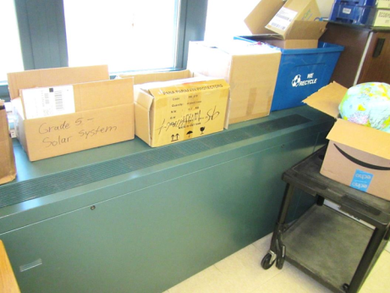
Unit ventilator (uninvent) in classroom
Picture 2
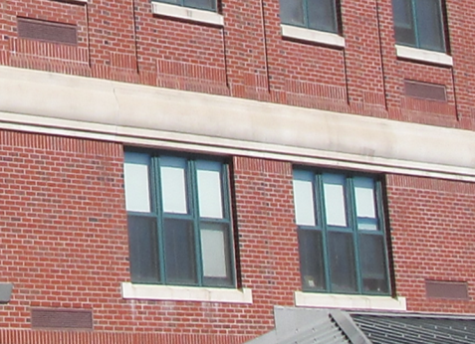
Univent fresh air intake vents
Picture 3
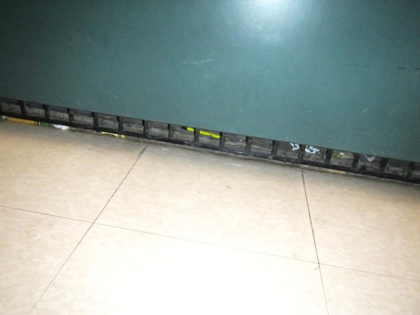
Univent return vent (note dust/debris)
Picture 4
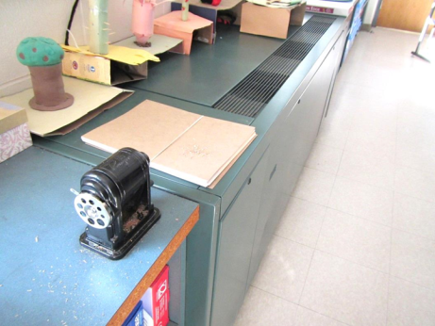
Supply air diffuser (arrow); note pencil sharpener nearby
Picture 5
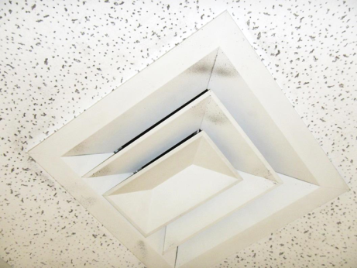
Ceiling-mounted supply diffuser (note dust accumulation)
Picture 6
Ceiling-mounted return vent
Picture 7
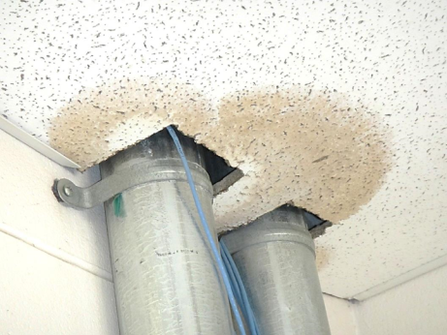
Water-damaged ceiling tile
Picture 8
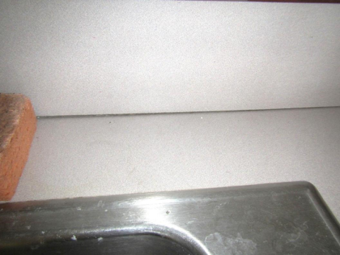
Gap between sink counter and backsplash
Picture 9
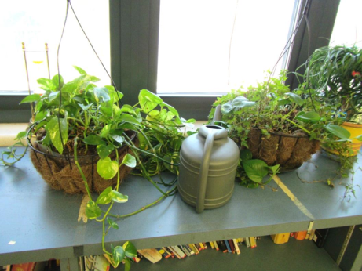
Plants in classroom
Picture 10
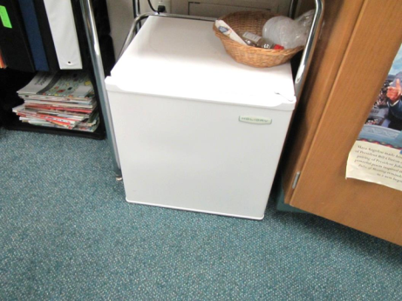
Refrigerator on carpeting
Picture 11
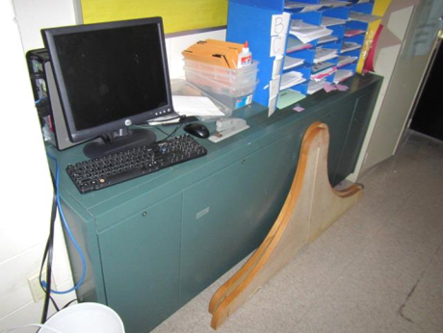
Items blocking uninvent supply vent
Picture 12
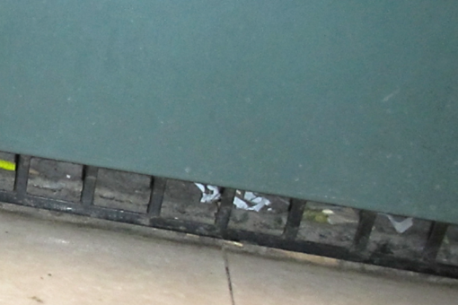
Univent return vent opening showing accumulated dust/debris
Picture 13
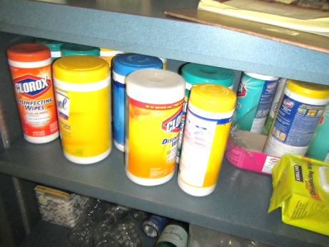
Scented cleaning products in classroom
Picture 14
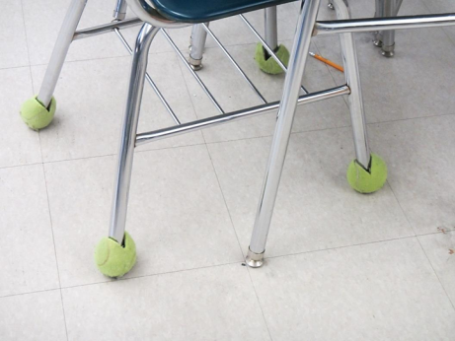
Tennis balls used as chair glides
Picture 15
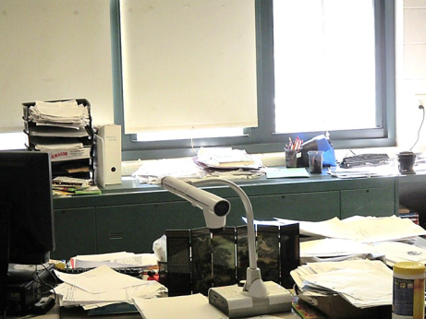
Accumulated items on flat surfaces

Location | Carbon  Dioxide  (ppm) | Carbon Monoxide  (ppm) | Temp  (°F) | Relative  Humidity  (%) | PM2.5  (µg/m³) | Occupants  in Room | Windows  Openable | Ventilation |  | Remarks
 |  |  |  |  |  |  |  | Supply | Exhaust
Background | 324 | ND | 40 | 17 | 11 | ND | - | - | - | Clear, light wind
1st Floor
Main office | 741 | ND | 68 | 23 | 10 | 5 | N | Y | Y | Carpet squares
105 | 1881 | ND | 72 | 25 | 5 | 1 | Y | Y | Y | ~25 occupants gone ~20 mins, tennis balls on chairs
107 | 643 | ND | 73 | 12 | 5 | 1 | Y | Y | Y  Off
109 | 2406 | ND | 73 | 29 | 5 | 21 | Y | Y  Off | Y | Items on UV
111 | 2573 | ND | 74 | 29 | 6 | 12 | Y | Y  Off | Y  Off
113 | 1337 | ND | 75 | 20 | 12 | 27 | Y | Y  Off | Y | DO, tennis balls on chairs
115 | 1033 | ND | 72 | 17 | 4 | 0 | Y | Y  Off | Y  Off | WD CT along windows-painted
117 Wood tech | 1489 | ND | 72 | 23 | 10 | ~30 | Y | Y  Off | Y  Off | Air filtration system
119 | 1751 | ND | 74 | 23 | 14 | 26 | Y | Y  Off | Y | PF (6), items on/front of UV
112 | 854 | ND | 72 | 14 | 7 | 2 | Y | Y  UV items | Y | CPs, fridge, AD
110 | 792 | ND | 72 | 14 | 9 | 0 | Y | Y | Y | WD-CTs
110 (storage) |  |  |  |  |  |  | N | N | N | AT
108 | 625 | ND | 72 | 11 | 7 | 1 | Y | Y | Y
106 | 1560 | ND | 73 | 20 | 10 | 1 | Y  1/6 open | Y  UV items | Y | Items
104 | 856 | ND | 74 | 15 | 10 | 2 | N | Y | Y | DO
102 | 823 | ND | 74 | 14 | 7 | 2 | N | Y | Y | DO
Director’s office | 467 | ND | 74 | 14 | 7 | 2 | N | Y | Y
Principal’s office | 812 | ND | 74 | 14 | 6 | 0 | Y | Y | Y | DO
Main office copy room |  |  |  |  |  |  | N | Y | N | 2 copiers, 1 risograph
Nurse’s clinic | 727 | ND | 74 | 14 | 7 | 1 | N | Y | Y | AD
BASEC office | 567 | ND | 74 | 13 | 7 | 3 | N | Y | Y | PF, DEM
Nurse’s office | 947 | ND | 74 | 16 | 6 | 0 | N | Y | Y
144 (keyboard room) | 388 | ND | 73 | 9 | 6 | 0 | N | Y | Y | AD, DO
143 | 351 | ND | 73 | 8 | 6 | 0 | N | Y | Y
Practice room | 341 | ND | 73 | 9 | 8 | 0 | N | Y | Y
Choir room | 747 | ND | 73 | 14 | 7 | 66 | Y  ½ open | Y | Y | DEM
Band room | 1220 | ND | 75 | 16 | 8 | 100 | Y | Y | Y | DEM
101 | 534 | ND | 72 | 8 | 4 | 4 | Y | Y | Y | minifridge
102 | 2157 | ND | 73 | 23 | 2 | 26 | Y | Y | Y | Univent off, heat control complaints
2nd Floor
2nd floor lower school admin office | 575 | ND | 71 | 14 | 9 | 6 | N | Y | Y | AI, carpet
-Copier room | 582 | ND | 72 | 13 | 8 | 4 | N | Y | Y | Copiers, DEM
-Guidance 1 | 542 | ND | 72 | 12 | 7 | 2 | N | Y | Y | DEM
-Asst. Principal | 546 | ND | 72 | 13 | 6 | 2 | N | Y | Y | DEM
-Guidance 2 (272) | 551 | ND | 74 | 12 | 3 | 4 | N | Y | Y | AI, carpet
233 | 1684 | ND | 76 | 27 | 4 | 14 | Y | Y | Y | HS
231 | 1215 | ND | 76 | 17 | 5 | 24 | Y | Y | Y | CPs, HS, AI
229 | 932 | ND | 73 | 14 | 4 | 14 | N | Y | Y | DEM, AI
227 | 1647 | ND | 76 | 24 | 7 | 26 | Y | Y | Y | Uninvent on low, exhaust not functioning
Library | 752 | ND | 75 | 15 | 5 | 27 | N | Y | Y | Carpet
225 | 1119 | ND | 74 | 14 | 3 | 5 | Y | Y | Y | Exhaust off
226 | 1238 | ND | 74 | 16 | 2 | 4 | Y | Y | Y | Exhaust off, DEM, HS
223 | 855 | ND | 74 | 17 | 2 | 4 | Y | Y | Y | DEM, HS
224 | 1640 | ND | 74 | 20 | 4 | 2 | Y | Y | Y | Items on univent, DEM
221 | 1817 | ND | 75 | 20 | 2 | 3 | Y | Y | Y | HS
222 | 1046 | ND | 76 | 19 | 3 | 2 | Y | Y | Y | DEM
220 | 1046 | ND | 76 | 13 | 3 | 3 | Y | Y | Y | CPs, plants, HS
Tech office | 676 | ND | 77 | 8 | 1 | 2 | Y | Y | Y | WD CT
219 | 1176 | ND | 77 | 15 | 2 | 1 | Y | Y | Y | CPs, DEM, AI, HS
218 | 904 | ND | 76 | 12 | 1 | 0 | Y | Y | Y | CPs, aquarium
216 | 1835 | ND | 74 | 19 | 7 | 3 | Y | Y | Y | Univent off, exhaust off.
217 | 828 | ND | 74 | 13 | 4 | 3 | Y | Y | Y | Tennis balls on chairs, class gone ½ hour
214 | 1222 | ND | 75 | 14 | 2 | 3 | Y | Y | Y | PF, CP, HS, univent on low
215 | 1062 | ND | 74 | 15 | 2 | 3 | Y | Y | Y | AI, plants, CPs, univent on low
Cleaning closet | - | - | - | - | - | - | N | N | N | WD CTs x 5, MT, sink
211 | 940 | ND | 74 | 14 | 3 | 3 | Y | Y | Y | Sink gaps in backsplash, plants
209 | 870 | ND | 74 | 13 | 4 | 2 | Y | Y | Y | PF, CPs
207 | 1448 | ND | 74 | 20 | 5 | 18 | Y | Y | Y
208 | 716 | ND | 74 | 10 | 6 | 2 | Y | Y | Y | Plants
206 | 777 | ND | 74 | 12 | 4 | 3 | Y | Y | Y | Window open, WD light fixture (repaired), CPs, HS
205 | 845 | ND | 74 | 13 | 3 | 3 | Y | Y | Y
203 | 788 | ND | 74 | 12 | 3 | 0 | Y | Y | Y | HS, CP
204 | 729 | ND | 75 | 14 | 2 | 9 | N | Y | Y
202 | 822 | ND | 76 | 13 | 3 | 22 | N | Y | Y | Computer lab
201 | 937 | ND | 75 | 14 | 4 | 2 | Y | Y | Y | HS, DEM
200 | 640 | ND | 74 | 13 | 3 | 3 | Y | Y | Y | CPs, DEM, univent low
235 | 578 | ND | 74 | 10 | 3 | 9 | Y | Y | Y | CPs, HS
3rd Floor
313 Art | 1342 | ND | 79 | 20 | 5 | 23 | Y | Y | Y | 12 WD CT, DO
315 | 646 | ND | 72 | 11 | 5 | 24 | Y | Y | Y | PF, DO
318 | 1086 | ND | 76 | 17 | 5 | 3 | Y | Y  Off | Y | DO, PF
317 | 541 | ND | 73 | 11 | 4 | 13 | Y | Y | Y | DO, PF
319 | 1380 | ND | 77 | 23 | 4 | 2 | Y | Y  Off | Y  Off | 7 occupants gone ~ 20 mins, 1 WD CT-painted
320 | 538 | ND | 75 | 8 | 3 | 0 | Y | Y | Y | 2 WD CT-painted, PF
321 | 1128 | ND | 77 | 17 | 3 | 1 | Y | Y | Y  Off | 19 occupants gone ~ 10 mins
323 | 842 | ND | 76 | 14 | 3 | 1 | Y | Y | Y | 14 occupants gone < 5 mins, 2 WD CT
325 | 1407 | ND | 76 | 22 | 8 | 1 | Y | Y  Off | Y  Off | 22 occupants gone ~5 mins, PF, 2 WD CT
327 | 866 | ND | 76 | 14 | 3 | 0 | Y | Y | Y  Off | PF, loose CT
329 | 1649 | ND | 76 | 25 | 3 | 25 | Y | Y  Off | Y | DO, PF
331 | 1300 | ND | 74 | 24 | 5 | 0 | Y | Y  Off | Y  Off | DO, PF
333 | 1866 | ND | 74 | 29 | 3 | 24 | Y | Y  Off | Y  Off | PF, DO
Girls’ room (opposite stairs) |  | ND | 74 | 15 |  |  | N | N | Y | WD GW (painted)
Boys’ room (opposite stairs) |  | ND | 74 | 15 |  |  | N | N | Y | WD CT
322 | 2358 | ND | 75 | 27 | 8 | 0 | Y | Y | Y  Dusty | CPs, PF, terrarium (turtles), DEM
324 | 2025 | ND | 75 | 26 | 9 | 0 | Y | Y | Y | Terrarium, DEM, PF, DO
332 | 1820 | ND | 74 | 25 | 6 | 1 | Y | Y | Y | PF, DEM, openings in wall, holes in window screen
301 | 1512 | ND | 76 | 20 | 7 | 28 | Y  1/6 open | Y | Y | Window gasket failing, DO, fridge/microwave
303 | 1390 | ND | 76 | 20 | 7 | 21 | Y  1/6 open | Y  UV off | Y | Fridge/microwave
305 | 1963 | ND | 76 | 26 | 13 | 25 | Y | Y  UV off
307 | 2702 | ND | 77 | 28 | 8 | 24 | Y | Y  UV blocked | Y | Plants, PF, DEM
309 | 2043 | ND | 76 | 24 | 9 | 22 | Y | Y  UV off  debris | Y
311 | 1755 | ND | 76 | 20 | 10 | 27 | Y | Y | Y | DO, PF
3rd floor copy room | 642 | ND | 72 | 17 | 6 | 0 | N | Y | Y | 1 photocopier, 2 risographs
Eichenberg | 658 | ND | 72 | 16 | 5 | 0 | N | Y | Y | DEM
Teachers’ room | 330 | ND | 72 | 10 | 6 | 0 | N | Y | Y | PF, 20 computers, thermostat set to air-conditioning
369 | 1328 | ND | 73 | 23 | 10 | 4 | N | Y  Dusty | Y | DEM, 2 WD CT, PS
3rd floor admin office | 947 | ND | 73 | 20 | 7 | 1 | N | Y | Y | Toaster, PF
Culver | 941 | ND | 73 | 19 | 5 | 1 | N | Y | Y | DO
Quinn | 897 | ND | 73 | 18 | 6 | 0 | N | Y | Y | DO
Lewis | 950 | ND | 73 | 20 | 6 | 0 | N | Y | Y | AD, CPs
Office copier area |  | ND |  |  |  |  | N | N | N | Copier, CPs, fridge, DO
306 | 1194 | ND | 74 | 18 | 7 | 9 | N | Y  Off | Y | PF- dusty, 2 WD CT, DEM, DO
304 | 942 | ND | 77 | 14 | 7 | 1 | N | Y  Off | Y | 2 WD CT, DO, DEM, PF-dusty
302 | 696 | ND | 76 | 11 | 6 | 0 | Y  2/4 open | Y | Y | PF, DEM, CT-dusty around supply, DO, CPs
3rd floor girls’ room |  | ND | 75 | 21 |  |  |  |  | Y  Off
3rd floor boys’ room |  | ND | 76 | 20 |  |  |  |  | Y | WD CTs
308 | 1609 | ND | 77 | 21 | 8 | 3 | Y | Y | Y  Dusty | PF, DEM, 2 WD CT, AT, tennis balls on chairs
310 | 1040 | ND | 76 | 15 | 7 | 0 | Y  1/6 open | Y | Y | Window gasket failing, PF, CPs, soda can storage, DO
312 (bookroom) | 875 | ND | 75 | 15 | 7 | 0 | N | Y | Y | WD CTs
314 | 321 | ND | 73 | 8 | 6 | 0 | Y | Y | Y | WD CTs, plants, CPs, items hanging from CT
316 | 689 | ND | 73 | 13 | 7 | 0 | Y | Y  Dusty | Y  Dusty | DEM, failing window gasket
Modular Classes
M1 | 1840 | ND | 70 | 16 | 4 | 29 | Y | Y | Y | DEM, AI
M2 | 1243 | ND | 70 | 14 | 3 | 9 | Y | Y | Y | DEM, AHUs on roof
M3 | 1837 | ND | 70 | 17 | 2 | 19 | Y | Y | Y | DEM
M4 | 1141 | ND | 70 | 18 | 2 | 2 | Y | Y | Y | DEM
M5 | 1043 | ND | 70 | 16 | 3 | 3 | Y | Y | Y | DEM, glues, etc.
M6 | 1214 | ND | 70 | 16 | 2 | 17 | Y | Y | Y | DEM

