SUFFOLK COUNTY
COMMONWEALTH OF MASSACHUSETTS

BOARD OF REGISTRATION IN PHARMACY

In the Matter of )
Cheryl Ann Cristaldi )
PT17777 )

PHA-2019-0100

CONSENT AGREEMENT FOR REPRIMAND

The Massachusetts Board of Registration in Pharmacy ("Board") and Cheryl Ann Cristaldi ("Licensee"), a pharmacy technician licensed by the Board, license number PT17777, do hereby stipulate and agree that the following information shall be entered into and become a permanent part of the Licensee's record maintained by the Board:

- The Licensee acknowledges that the Board opened a Complaint against her Massachusetts pharmacist license related to the conduct set forth in Paragraph 2, identified as Docket Number PHA-2019-0100 ("Complaint").

- The Board and the Licensee acknowledge and agree to the following facts:

  - At all relevant times in 2017, Licensee worked as a pharmacy technician at Preferred Pharmacy Solutions, DS3542, located in Haverhill, Massachusetts.

  - On or about June 3, 2017, August 17, 2017, and October 7, 2017, Licensee increased the dispensed quantity on three prescription refills for phentermine 37.5 mg to obtain approximately 100 additional tablets prematurely, in violation of
M.G.L. C. 94C, § 23(f).

  - On or about August 8, 2017 and October 17, 2017, Licensee increased the dispensed quantity on two prescription refills for clonazepam 1 mg to obtain an additional 60 tablets prematurely, in violation of M.G.L. c. 94C, § 23(f).

- The Licensee acknowledges that the facts described in Paragraph 2 warrant disciplinary action by the Board under M.G.L. c. 12, §§ 42A and 61 and under 247 CMR 10.03(l)(v) & (x).

- The Licensee agrees that the Board shall impose a REPRIMAND on her license based on the facts admitted in Paragraph 2, effective as of the date on which the Board signs this Agreement ("Effective Date").

- The Board agrees that in return for the Licensee's execution and successful compliance with all the requirements of this Agreement, the Board will not prosecute the Complaint.

- The Licensee understands that she has a right to formal adjudicatory hearing concerning the Complaint and that during said adjudication she would possess the right to confront and cross-examine witnesses, to call witnesses, to present evidence, to testify on her own behalf, to contest the allegations, to present oral argument, to appeal to the courts, and all other rights as set forth in the Massachusetts Administrative Procedures Act, M.G.L. c. 30A, and the Standard Adjudicatory Rules of Practice and Procedure, 80I CMR 1.0I et seq. The Licensee further understands that by executing this Agreement she is knowingly and voluntarily waiving her right to a formal adjudication of the Complaint.

- The Licensee acknowledges that she has been at all times free to seek and use legal counsel in connection with the Complaint and this Agreement.

- The Licensee acknowledges that after the Effective Date, the Agreement constitutes a public record of disciplinary action by the Board subject to the Commonwealth of Massachusetts' Public Records Law, M.G.L. c. 4, § 7. The Board may forward a copy of this Agreement to other licensing boards, law enforcement entities, and other individuals or entities as required or permitted by law.

- The Licensee certifies that she has read this Agreement. The Licensee understands and agrees that entering into this Agreement is a voluntary and final act and not subject to reconsideration, appeal or judicial review.


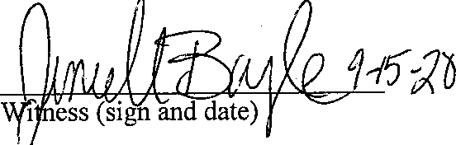
Effective Date of Reprimand Agreement

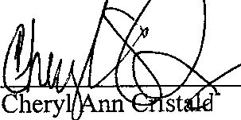
1 ( sign and date)

David Sencabaugh, R. Ph. Executive Director
Board of Registration in Pharmacy

Fully Signed Agreement Sent to Registrant on 10/16/2020 by Certified Mail No. 7019 0700 0000 1846 1671

