
Town of Chesterfield | FY24/25 ACTION GRANT
MVP Planning and Building Assessment
Type 1: Planning, Assessments, Capacity Building, and Regulatory Updates

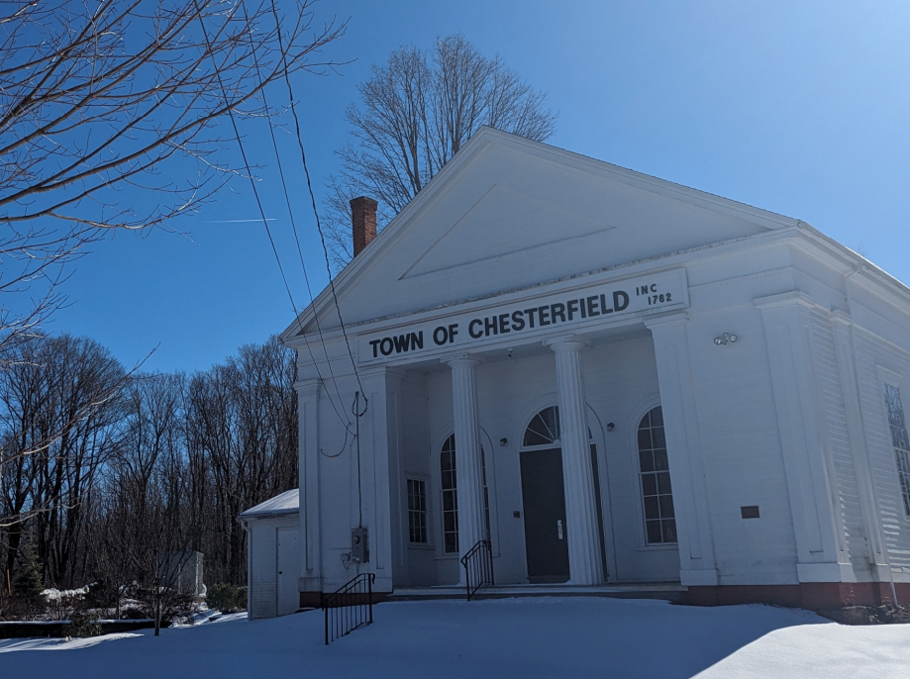 |  | MVP REGION
 |  | Berkshires & Hilltowns
 |  | GRANT AWARD
 |  | $76,000
 |  | MATCH AMOUNT
 |  | $8,700
 |  | MATCH SOURCE
 |  | Town of Chesterfield
 |  | MUNICIPAL DEPARTMENT LEADING PROJECT
 |  | Select Board
Outcomes | Core principles exemplified
Briefly describe the outcomes of your project | List the MVP core principles that your project exemplifies.
A grant coordinating group was formed and provided oversight of grant activities. The town website had an MVP tab added and it was populated with climate resilience-related information. A profile of the town was complete using the Resilience Design Tool. A townwide Winterfest was held to introduce the MVP grant objectives and engage the entire community in climate- related discussions with local and regional environmental groups. Two townwide forums were held to provide residents climate change and climate resilience information. The forums were professionally videotaped and widely distributed. A professional engineering firm assessed 4 muni buildings and two lots for their potential to be made climate resilient. | - Building community capacity for climate resilience  - Utilizing climate change data for a proactive solution  - Achieving broad and multiple community benefits
Community Overview
- What is the population size of your community and where is it located?
- Do you have any Environmental Justice or other Climate Vulnerable communities? (Think about both those who live and work in your town.)
- Other unique traits of your municipality like who the top employers are, geography, history, etc.
Chesterfield is in the foothills of the Berkshires with a population of 1331. It is a rural, homogeneous community with the major identified subgroup being comprised of people >60 years old. It historically has been a farming community. It currently has few independent businesses and most employed individuals work out of town. Town government is widely supported by volunteers.
Project description and goals
- Where was the project located?
- What climate change impacts did the project address?
- What were the specific goals and tasks of the project as stated in your application?
- Did your project meet the goals set forth in your application?
The project was solely located in the Town of Chesterfield. Key concerns were potential adaptations of private homes, municipal buildings, town infrastructure, and the natural environment to weather extremes and climate change. Our specific goals were to identify the threats and opportunities to adapt to climate change, engage the town’s people in dialogue about these threats and opportunities to adapt, and provide educational opportunities to learn about the changing climate. Plans to engage in a townwide dialogue about how to adapt existing or future municipal buildings to climate change got no further than a modest engineering assessment of existing buildings as the proposed municipal effort leading to a townwide consensus regarding how to proceed did not occur. An effort to develop a more robust townwide communication system to facilitate exchange of climate information did not occur as planned but more effective use of existing communication channels did occur. All grant goals were met but in ways not originally planned.
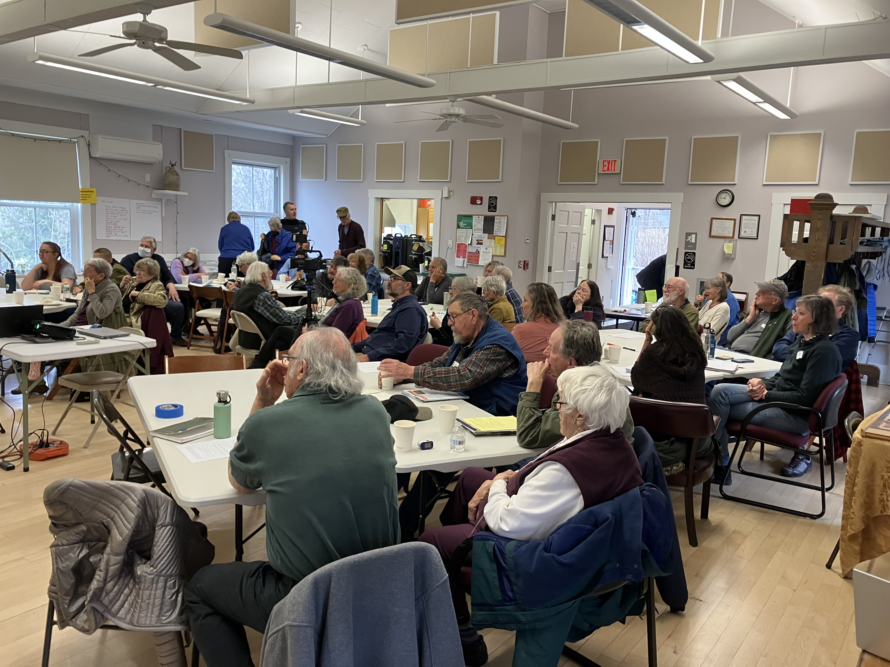
Results and deliverables
- Describe, and quantify (where possible) project results (e.g. square footage of habitat restored or created, increase in tree canopy coverage, etc.). Report out on the metrics outlined in your application.
- Provide a brief summary of project deliverables with web links, if available.
Task 1. An Executive Committee was formed to guide and coordinate grant activities. It was composed of two town volunteers, a Select Board member, and the Chesterfield Director of Emergency Management Services. Monthly reports on grant activities and volunteer hours consumed were submitted. The town website was revised to create an MVP tab to gather climate-related information. MVP meetings were open public meetings and the meeting schedule and meeting minutes were posted on the town’s website. The Climate Resilience Design Standards Tool was use to guide the contracted engineering firm that assessed 4 existing municipal buildings and two lots. A communication database was designed but not implemented due to external factors. Three townwide educational events were designed and implemented to engage and educate the town’s citizens. They included a Winter Fest to introduce MVP goals and objectives and two, half-day educational forums, led by climate experts, about the nature of climate change and how adaptation could be done relative to individual home modifications, the conditions of Chesterfield’s municipal buildings and impacts on the town’s forests, rivers, wildlife and plants. Task 2. An engineering firm with much experience in Chesterfield’s geographic region, assessed four municipal buildings and two empty lots for their potential to be adapted to address extreme weather events and climate change. Several assessments done over previous decades were also reviewed. Only one existing building had reasonable potential for cost-effective, climate-related modifications; the other buildings were judged to have minimal potential for cost-effective modifications due to their existing conditions. One empty lot was considered eligible for new construction. The other was not. Report of these findings to the town’s people by the engineering firm is dependent on the town’s leadership scheduling a series of townwide informational meetings regarding the replacement of one or more municipal buildings. These meetings have not been scheduled and there is no timeline for doing so.

Partners and Other Support
List all project partners and describe their role in supporting/assisting in the project.
The Hilltown Community Development Commission handled the ongoing paperwork expected by the Commonwealth. Tighe & Bond Designer Services, Inc. was chosen to evaluate existing municipal buildings and two empty lots. Although completed quite late, they did so and issued a report about each that will be shared with the town’s residents to allow them to make an informed decision about affordable options for dealing with existing, aged municipal buildings. An unused Town grant was discovered and, at the request of the Action Grant Executive Committee, was re-directed to creating two videos regarding the existing conditions of the Chesterfield Town Offices and Fire Department building. For education of the Town’s people, they are likely to be shown in coordination with the presentation by Tighe & Bond Designer Services regarding the potential of climate adaptation of the two buildings.

Lessons Learned
- What lessons were learned as a result of the project? Focus on both the technical matter of the project and process-oriented lessons learned.
- What is the best way for other communities to learn from your project/process?
Task 1. It takes time for a novel coordinating group of four to learn how to work efficiently together to launch a start-up effort related to climate change. Familiarity with climate-related content and development of operational procedures takes time. Choosing to make the Executive Committee abide by MA. Open Meeting Laws dramatically slowed the entire project. The scope of the project was reasonable but the months-long delay by the Commonwealth in implementing it after being funded significantly influenced the timeline for its achievement. Dependency on an expert, outside organization for the primary project function of municipal building assessment also significantly prolonged the entire process. Some innovative activities such as establishing a Communication Coordinator to facilitate climate-related information dissemination took significant interface with the town’s leadership and overcoming resistance took time. Communication of climate-related content was instead done via two town forums and posting of its presentation videos on the Town website made diverse, climate-change information widely available. Flexible administrative support from the MVP Berkshires and Hilltowns Regional Coordinator helped overcome changes in planned activities. Task 2. Technical engineering assessments, the heart of this task, is specialized language and translating it into information easily understood by the town’s people is crucial for their informed decision-making. This will ultimately be managed outside this project due to external factors.

Website and additional links
The Chesterfield Town website lists the following links to printed and video resources: https://www.townofchesterfieldma.com/boards. Click on Boards and Committees tab. Click on MVP Steering Committee. Choose graphics from the Winter Fest or videos from the two town climate forums. Forum videos are available at: https://vimeo.com/1073343263?share=copy (forum 1) and https://vimeo.com/1080900933 (forum 2).

