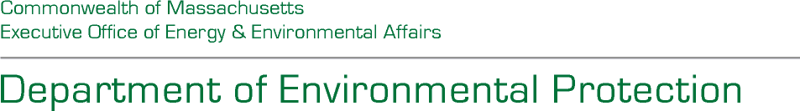Maura T. Healey Governor

Kimberley Driscoll Lieutenant Governor

Rebecca L. Tepper

Secretary

Bonnie Heiple Commissioner

PUBLIC NOTICE

DRAFT HAZARDOUS WASTE FACILITY LICENSE (renewal)

ISSUED PURSUANT TO M.G.L. C. 21C AND 310 CMR 30.000

NAME AND LOCATION OF FACILITY:

Clean Harbors of Braintree, Inc.

1 Hill Avenue

Braintree, MA 02184

FACILITY ID NUMBER: MAD053452637

PROPOSED: Clean Harbors of Braintree, LLC operates an existing hazardous waste storage facility (Facility) under the terms of Hazardous Waste License #5B/19, issued by the Department of Environmental Protection (MassDEP) on November 22, 2019. The company proposes to continue its operation and has applied for a five-year license renewal from MassDEP. A Draft License has been issued by MassDEP. Pursuant to the public participation requirements in 310 CMR 30.800, the public has 45 days to comment on the Draft License.

PUBLIC COMMENT: Any member of the public wishing to comment on the Draft License may file written comments during the public comment period. The comment period will run from August 21, 2025 to October 4, 2025. Members of the public wishing to provide written comments may do so until October 4, 2025. Comments should be submitted to:

Richard Blanchet Deputy Director Business Compliance Division Bureau of Air and Waste 100 Cambridge Street, 8th Floor Boston, MA 02114

James Paterson BranchChief Hazardous Waste Bureau of Air and Waste 100 Cambridge Street, 8th Floor Boston, MA 02114

([james.paterson@mass.gov](mailto:james.paterson@mass.gov) (857-303-6374)

Pursuant to 310 CMR 30.837(1), if during the comment period or within 15 days of the close of the comment period MassDEP receives written notice requesting a public hearing or if MassDEP determines on its own that there is significant public interest in the Draft License, MassDEP will schedule an informal public hearing on the proposed action. Written and oral comments will be accepted at the hearing.

The Fact Sheet describing the licensing process, the company, its operation, and terms and conditions of the Draft License is available for review here MassDEP Public Hearings & Comment Opportunities | Mass.gov. The Draft License may be viewed at Energy and Environmental Affairs ePLACE Portal | Mass.gov and at the Braintree Board of Health, the Thayer Public Library, MassDEP’s Southeast and Boston Offices and the USEPA New England – Region I Office in Boston.

FINAL DECISION: MassDEP will consider all written comments received during the comment period; all comments received at a hearing, if held, and the requirements of the Massachusetts Hazardous Waste Regulations, 310 CMR 30.000. MassDEP will then make a final decision regarding the issuance of a hazardous waste license to Clean Harbors of Braintree, LLC. A notice of the final license decision will be sent to the applicant and to each person who has submitted written comments or has otherwise requested notice of the license decision. If no comments requesting a change in the Draft License are received, a final decision will become effective 21 days after the date of the notice of the decision. The final license decision will be postponed if a request for an adjudicatory hearing before the MassDEP is made within the 21-day period. For additional information regarding the license, contact David Ellis at (857) 292-4616 or Dave.Ellis@mass.gov.

This information is available in alternate format. Please contact Melixza Esenyie at 617-626-1282.

TTY# MassRelay Service 1-800-439-2370 MassDEP Website: [www.mass.gov/dep](http://www.mass.gov/dep)

Printed on Recycled Paper