**INDOOR AIR QUALITY**

**POST-OCCUPANCY ASSESSMENT**

**The Center for Health Information and Analysis (CHIA)**

**501 Boylston Street, 5th floor**

**Boston, MA**

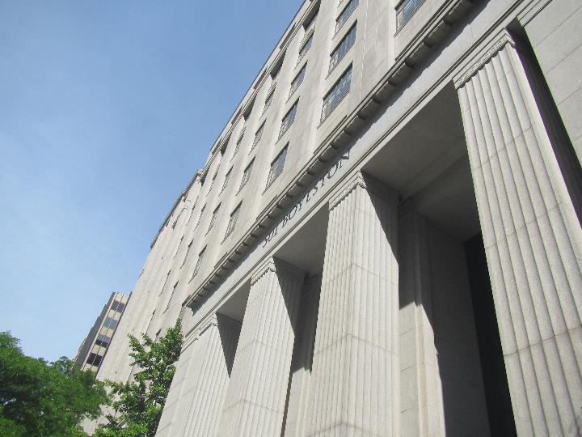

Prepared by:

Massachusetts Department of Public Health

Bureau of Climate and Environmental Health

Division of Environmental Health Regulations and Standards

June 2025

# BACKGROUND

|  |  |
| --- | --- |
| Building: | The Center for Health Information and Analysis (CHIA) |
| Address: | 501 Boylson Street, 5th floor, Boston MA |
| Assessment Requested by: | William McGowan  Project Manager, Division of Capital Asset Management & Maintenance (DCAMM), Office of Leasing  One Ashburton Place, 15th Floor, Boston, MA 02108 |
| Reason for Request: | Post-occupancy indoor air quality (IAQ) assessment. |
| Date of Assessment: | May 28, 2025 |
| Massachusetts Department of Public Health/Bureau of Climate and Environmental Health (MDPH/BCEH) Staff Conducting Assessment: | Ruth Alfasso, Environmental Inspector, Division of Environmental Health Regulations and Standards (EHRS) |
| Building Description: | 501 Boylston Street was originally built in the 1940s as The New England Mutual Life Insurance Building. It is a ten-story granite building. The CHIA offices take most of the 5th floor. Renovations to reduce the overall footprint of the space were conducted recently, including wall installation, some new furnishings, and paint. |
| Windows: | Windows in the space used to be openable but they are now sealed shut. |

# METHODS

Please refer to the IAQ Manual for methods, sampling procedures, and interpretation of results (MDPH, 2015).

# RESULTS AND DISCUSSION

The following is a summary of indoor air testing results (Table 1).

* ***Carbon dioxide*** measurements were below the MDPH guideline of 800 parts per million (ppm) in all areas tested, indicating adequate air exchange at the time of assessment.
* ***Temperature*** was within the recommended range of 70°F to 78°F in all areas.
* ***Relative humidity*** was within the recommended range of 40% to 60% in all areas.
* ***Carbon monoxide*** levels were non-detectable (ND) in all indoor areas tested.
* ***Fine particulate matter (PM2.5)*** concentrations were below the National Ambient Air Quality Standard (NAAQS) level of 35 μg/m3 in all areas tested.
* ***Total Volatile Organic Compounds***were ND in all areas tested.

## Ventilation

A heating, ventilating, and air conditioning (HVAC) system has several functions. First, it provides heating and, if equipped, cooling. Second, it is a source of fresh air. Finally, a HVAC system will dilute and remove normally occurring indoor environmental pollutants by not only introducing fresh air but also filtering the airstream and ejecting stale air outdoors via exhaust ventilation. Even if an HVAC system is operating as designed, point sources of respiratory irritation may exist and affect symptoms in sensitive individuals.

Fresh air is supplied to the CHIA offices through ceiling-mounted supply vents (Pictures 1 and 2) and returned to the system through ceiling-mounted return vents (Picture 3). Note that many supply vents are the same style as the return vents, which makes it important to ensure that each office has one of each.

Thermostats are present in rooms and open areas (Picture 4). A review of product literature for this thermostat suggests that the one shown in Picture 4, and the others viewed, are operating in “occupied” mode, however it is not clear if occupied mode means that the fan is on continuously or if the fan cycles on and off to maintain a certain temperature. Where possible, the fan should be on at all times the floor is occupied to allow for fresh air circulation even when the temperature is at the set point.

Two mechanical rooms are present on the floor but could not be accessed; the air handling units for this floor may be located inside. The HVAC system should be equipped with filters of at least a minimum efficiency reporting value (MERV) of 8 which are adequate for filtering out pollen and mold spores (ASHRAE, 2012). Higher MERV ratings can be used to further reduce airborne particulates if the systems are capable of handling it without a loss of flow or mechanical issues. Filters should be changed at least twice a year, or more frequently if recommended by the manufacturer. The AHUs should be vacuumed/cleaned during filter changes.

Radiators are present along exterior walls in the building. These need to be cleaned periodically as heated dust can create odors.

It is recommended that HVAC systems be re-balanced every five years and after significant renovations to ensure adequate air systems function (SMACNA, 1994). It is not known if the systems were balanced following the renovations.

## Microbial/Moisture Concerns

A single water-damaged ceiling tile was found during the assessment (Picture 5). This did not appear to be mold colonized. It should be replaced so that future leaks can be more easily detected. No other water-damaged materials were found.

Plants were found in several locations (Picture 6; Table 1). Plants can be a source of pollen, odors, and mold, particularly if not well cared for. Plants should be placed on non-porous drip pans that are cleaned periodically and should not be overwatered.

There are a few kitchen/break areas in the suite. Appliances such as refrigerators, toasters, and microwaves should be kept clean to avoid smoke, odors, and attracting pests. Food should be kept in tightly-sealed pest-resistant containers when not in use.

Outside the main CHIA suite is a room equipped with a shower. It is reported that several employees use the shower after an active commute. The exhaust vent in this room should remain on during all occupied periods to remove excess moisture. If the shower will not be used for several weeks, water should be poured down the drain periodically to ensure the trap remains sealed with water.

## Other IAQ Concerns

Testing was conducted for total volatile organic compounds (TVOCs). All measurements were non-detect (ND). An examination was conducted for products that may be a source of VOCs in indoor air. Hand sanitizers, cleaning products, and dry erase materials were found (Picture 7; Table 1). VOCs from these products can build up and lead to irritation of the mucous membranes. In addition, a few areas had a slight odor that may be associated with fresh paint or new furnishings. With sufficient ventilation, these odors will continue to dissipate.

A sticky trap for pest monitoring was noted in a corner of an office (Picture 8). It appears to have been in place for some time and had collected pests and debris. Monitoring/collection traps need to be examined and removed/replaced by a pest contractor to ensure pest control activities are working as intended and to inform any future pest control needs. No other signs of pests were seen during the assessment.

Air purifiers were in use in some offices and conference rooms. Units with HEPA filters with or without carbon filters are good choices for occupied areas. Air purifiers that may produce ozone should not be used (USEPA, 2013). Air purifiers should be maintained, including cleaning and filter changes, in accordance with the manufacturer’s instructions. For best results, place units where the outlet stream will be in the breathing zone of occupants.

Items were noted hanging from the ceiling and from the sides of cubicles in some areas. Hanging items can collect dust and may be difficult to clean. In some areas, cloth was placed over light fixtures (Picture 9) to reduce light intensity or glare. Care should be taken that this is suitable fire-resistant material intended for this use. It also needs to be cleaned periodically and, if it becomes wet due to a leak, it should be replaced.

Boxes and other items were noted on the floor in some areas. While these are likely to be from the recent move during renovations, items should be stored up off the floor to allow for thorough cleaning. In addition, there are a few areas that are behind workstation walls that may collect dust and debris (Picture 10); these should be cleaned periodically.

Wood chips were found in a partly unfinished conference room (Room 555). Once renovations are completed, this area should be cleaned thoroughly before being occupied.

Note that renovations of this suite created a space on the 5th floor that can be used for another tenant in the future. Renovations in nearby parts of the building should be conducted following the guidance in [Construction and renovation generated pollutants in occupied buildings](https://www.mass.gov/info-details/construction-and-renovation-generated-pollutants-in-occupied-buildings).

Finally, most areas of the office are carpeted. Carpets should be cleaned regularly in accordance with Institute of Inspection, Cleaning and Restoration Certification (IICRC) recommendations (IICRC, 2012).

# CONCLUSIONS/RECOMMENDATIONS

In view of the findings at the time of the visit, the following recommendations are made:

## Ventilation recommendations

1. It is recommended that HVAC systems be re-balanced every five years to ensure adequate air systems function (SMACNA, 1994), and particularly after remodeling, which may have changed airflow in this space.
2. Check thermostat/HVAC settings to ensure that “occupied” mode includes airflow even when the temperature is at the set point. Unoccupied mode can be used for intermittent fan and lower-energy heat/cooling settings to save energy on nights and weekends.
3. Ensure that filters are changed at least twice a year in all air handling units and that cabinets are cleaned out with a vacuum during filter changes.
4. Use filters of at least a MERV 8 or higher rating in HVAC equipment.
5. Clean radiators periodically to remove dust and debris, particularly at the beginning of the heating season.

## Water damage recommendations

1. Replace water-damaged ceiling tiles. During replacement, check above the tile for additional water-damaged materials and clean or replace as needed.
2. Keep indoor plants in good condition and place them on waterproof drip pans that can be cleaned/sanitized.
3. Keep refrigerators and other kitchen appliances clean to prevent smoke and odor.
4. Ensure the drain in the shower room is wetted every week to keep the trap seal intact if the shower is not used regularly.
5. Work with your pest control contractor to ensure regular and appropriate service for this space.

## Other recommendations

1. Use VOC-containing products in areas with good ventilation and keep tightly closed when not in use. Avoid products with strong scents and avoid mixing incompatible products.
2. Work with a licensed pest control contractor for any pest monitoring or exterminating needs.
3. HEPA-equipped air purifiers with or without a carbon filter can be used to provide additional filtration. Avoid using units that may contain ozone and keep equipment in good repair including filter changes. Where possible, have the outlet of the unit in the breathing zone of occupants for better function.
4. Ensure hanging items can be cleaned or removed when they become dusty or if they get wet.
5. Ensure cloths used to cover light fixtures are suitable for that use. Ensure they are cleaned, laundered, or replaced periodically when they become dusty or wet.
6. Thoroughly clean Room 555 to remove wood chips and other debris once the room renovation is finished.
7. Reduce the clutter and make sure stored items are kept off the floor.
8. Make sure areas that are behind workstations get cleaned periodically to remove dust and debris.
9. Use guidance in [construction and renovation generated pollutants in occupied buildings](https://www.mass.gov/info-details/construction-and-renovation-generated-pollutants-in-occupied-buildings) to prevent issues when nearby spaces are under renovations.
10. Clean carpeting in accordance with IICRC recommendations (IICRC, 2012); annually (or semi-annually in soiled/high traffic areas).
11. Refer to resource manual and other related IAQ documents located on the MDPH’s website for further building-wide evaluations and advice on maintaining public buildings. These documents are available at: <http://mass.gov/dph/iaq>.

# REFERENCES

ASHRAE. 2012. American Society of Heating, Refrigeration and Air Conditioning Engineers (ASHRAE) Standard 52.2-2012 -- Method of Testing General Ventilation Air-Cleaning Devices for Removal Efficiency by Particle Size (ANSI Approved).

IICRC. 2012. Institute of Inspection, Cleaning and Restoration Certification. Carpet Cleaning: FAQ.

MDPH. 2015. Massachusetts Department of Public Health. Indoor Air Quality Manual: Chapters I-III. Available at: <https://www.mass.gov/lists/indoor-air-quality-manual-and-appendices>.

SMACNA. 1994. HVAC Systems Commissioning Manual. 1st ed. Sheet Metal and Air Conditioning Contractors’ National Association, Inc., Chantilly, VA.

US EPA. 2003. “Ozone Generators that are Sold as Air Cleaners: An Assessment of Effectiveness and Health Consequences”. United States Environmental Protection Agency, Office of Air and Radiation, Indoor Environments Division, Washington, DC. Last updated April 2025. <https://www.epa.gov/indoor-air-quality-iaq/ozone-generators-are-sold-air-cleaners>.

**Picture 1**

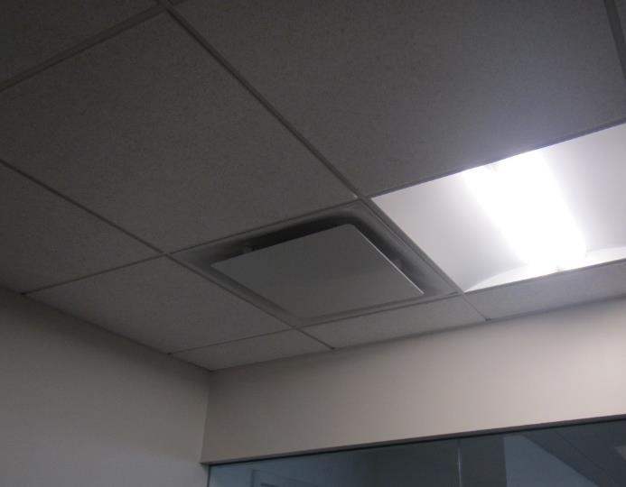

**Supply vent**

**Picture 2**

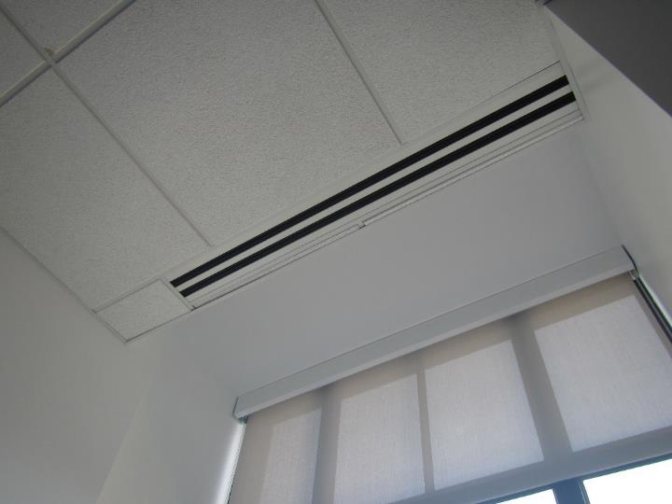

**Style of supply vent used near exterior walls/windows**

**Picture 3**

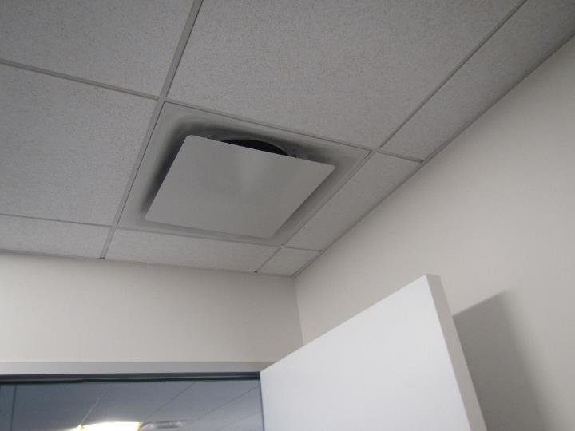

**Return vent, note this is the same style of vent as the supply vent in Picture 1**

**Picture 4**

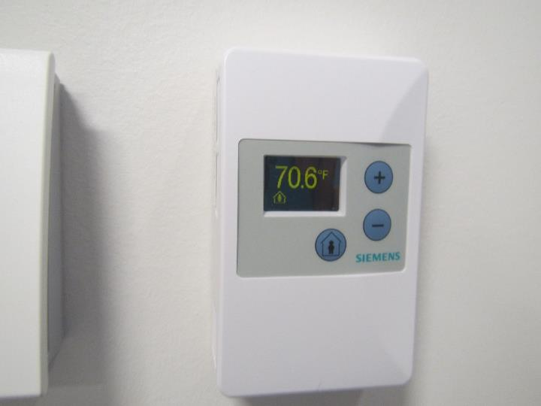

**Thermostat showing occupied setting**

**Picture 5**

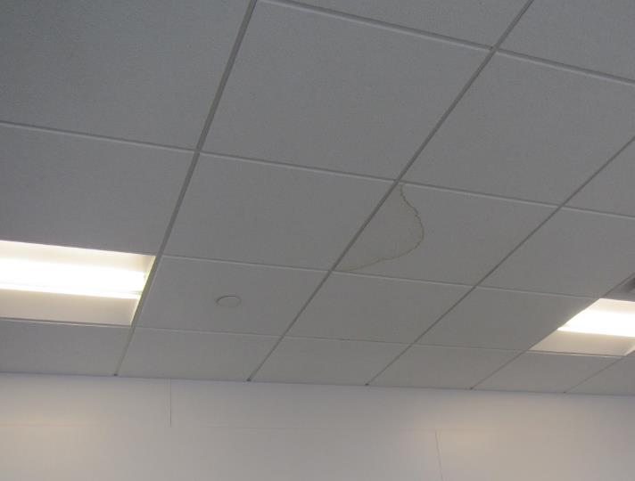

**Water-damaged ceiling tile**

**Picture 6**

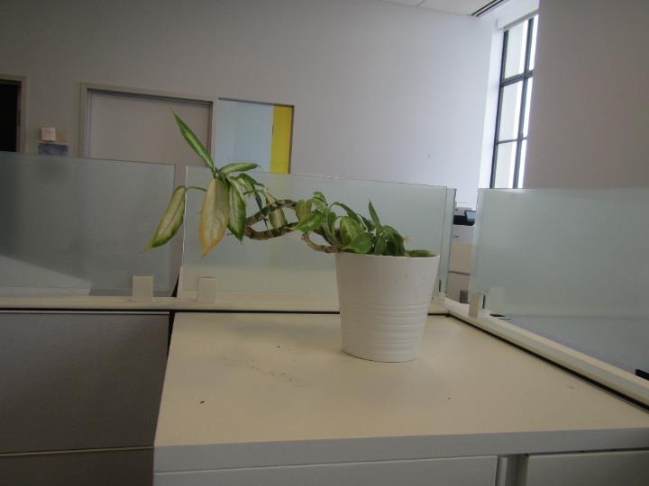

**Plant without a drip pan on a cabinet**

**Picture 7**

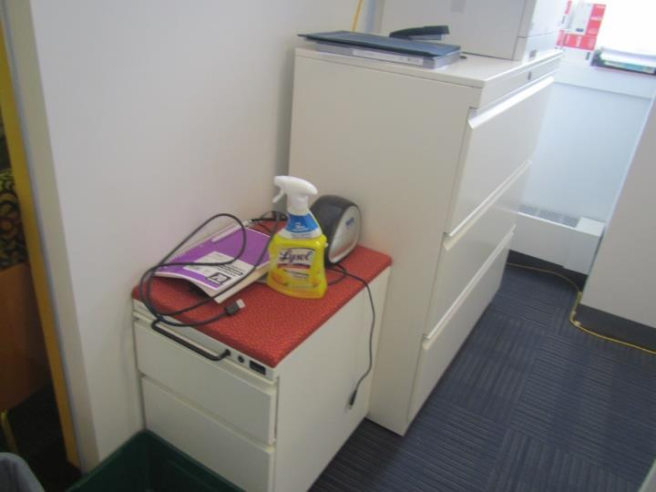

**Cleaning product**

**Picture 8**

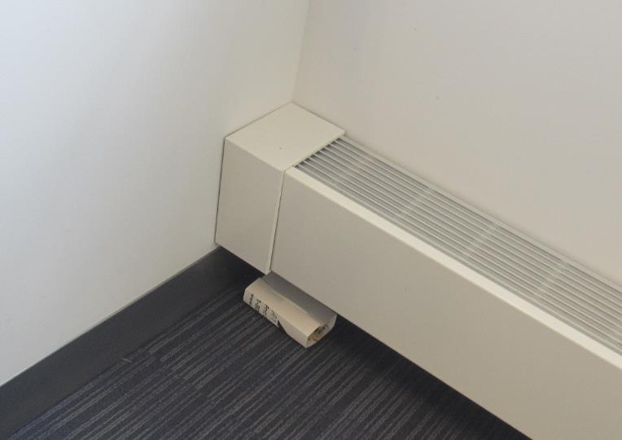

**Sticky pest trap that looks used/old**

**Picture 9**

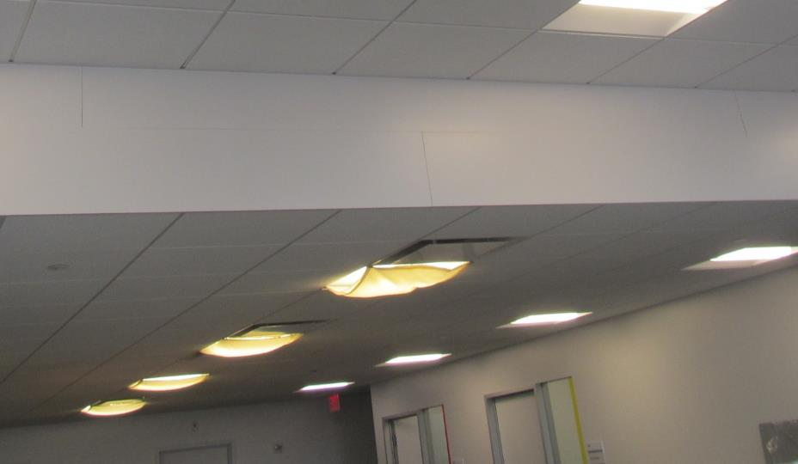

**Cloth hanging from light fixtures**

**Picture 10**

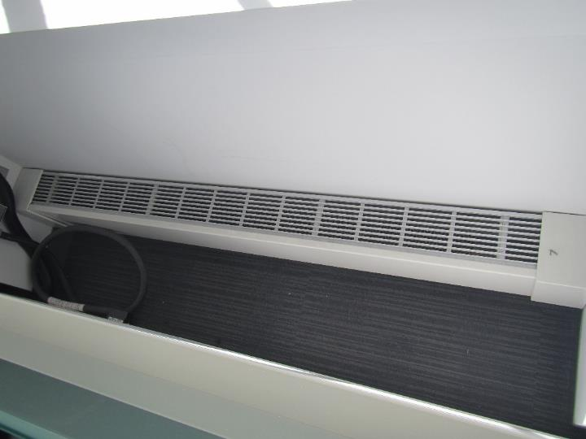

**Area behind workstation walls that may collect dust and debris if not cleaned periodically**

| **Location** | **Carbon**  **Dioxide**  **(ppm)** | **Carbon Monoxide**  **(ppm)** | **Temp**  **(°F)** | **Relative**  **Humidity**  **(%)** | **PM2.5**  **(µg/m3)** | **TVOC**  **(ppm)** | **Occupants**  **in Room** | **Windows**  **Openable** | **Ventilation** | | **Remarks** |
| --- | --- | --- | --- | --- | --- | --- | --- | --- | --- | --- | --- |
| **Supply** | **Exhaust** |
| Background | 458 | ND | 73 | 48 | 6 | 1 |  |  |  |  | Sunny, measurement taken on sidewalk of busy street |
| 559 | 620 | ND | 73 | 44 | ND | ND | 0 | N | Y | Y |  |
| 129 cubes | 632 | ND | 73 | 44 | ND | ND | 0 | N | Y | Y | Missing ceiling tile |
| 562 | 648 | ND | 73 | 45 | ND | ND | 0 | N | Y | Y | DEM |
| 127 cubes | 639 | ND | 73 | 44 | ND | ND | 4 | N | Y | Y |  |
| 591 | 593 | ND | 72 | 45 | ND | ND | 0 | N | Y | Y |  |
| 594 | 592 | ND | 72 | 45 | ND | ND | 0 | N | Y | Y |  |
| 592 | 589 | ND | 72 | 45 | ND | ND | 0 | N | Y | Y |  |
| 593 huddle | 603 | ND | 72 | 46 | ND | ND | 0 | N | Y | Y | Slight “new” odor |
| 595 conference | 620 | ND | 72 | 46 | ND | ND | 0 | N | Y | Y |  |
| 556 | 616 | ND | 72 | 46 | ND | ND | 1 | N | Y | Y | Boxes |
| 113 cubes | 637 | ND | 72 | 46 | ND | ND | 0 | N | Y | Y | Items, boxes, HS |
| 118 cubes | 630 | ND | 72 | 46 | ND | ND | 2 | N | Y | Y | Food, items |
| 555 conference | 602 | ND | 72 | 46 | ND | ND | 0 | N | Y | Y | Wood chips, phone booth not installed (may not fit) |
| 557 | 590 | ND | 71 | 46 | ND | ND | 0 | N | Y | Y |  |
| 98 cubes | 634 | ND | 72 | 47 | ND | ND | 0 | N | Y | Y |  |
| 99 cubes | 627 | ND | 72 | 46 | ND | ND | 2 | N | Y | Y | HS, 1 water-damaged ceiling tile |
| 84 cubes | 620 | ND | 72 | 46 | ND | ND | 1 | N | Y | Y |  |
| 552 | 640 | ND | 71 | 46 | ND | ND | 0 | N | Y | Y | Boxes on floor |
| 88 cubes | 658 | ND | 71 | 47 | ND | ND | 3 | N | Y | Y | Food |
| 550 | 629 | ND | 72 | 47 | ND | ND | 1 | N | Y | Y | Plants, food |
| 502 conference | 610 | ND | 72 | 46 | ND | ND | 0 | N | Y | Y | AP, DEM |
| 596 wellness | 596 | ND | 72 | 46 | ND | ND | 0 | N | Y | Y | Fridge and sink, NC |
| Shower room |  |  |  |  |  |  |  | N |  | Y | Shower is used regularly |
| 501 | 650 | ND | 73 | 45 | ND | ND | 1 | N | Y | Y | Food |
| 503 conference | 621 | ND | 72 | 45 | ND | ND | 0 | N | Y | Y |  |
| Break | 615 | ND | 72 | 45 | ND | ND | 1 | N | Y | Y | Refrigerators, microwaves, toaster, NC |
| 504 conference | 644 | ND | 73 | 45 | ND | ND | 0 | N | Y | Y | AP |
| 513 | 637 | ND | 73 | 45 | ND | ND | 0 | N | Y | Y | DEM |
| 512 | 616 | ND | 73 | 44 | ND | ND | 0 | N | Y | Y | DEM |
| 77 cubes | 668 | ND | 73 | 45 | ND | ND | 3 | N | Y | Y | Plants |
| 73 cubes | 637 | ND | 73 | 44 | ND | ND | 1 | N | Y | Y | Plants, CP |
| 514 | 659 | ND | 73 | 44 | ND | ND | 0 | N | Y | Y | HS |
| 515 | 628 | ND | 73 | 44 | ND | ND | 0 | N | Y | Y | HS, DEM |
| 516 | 630 | ND | 73 | 44 | ND | ND | 0 | N | Y | Y |  |
| 66 cubes | 599 | ND | 73 | 45 | ND | ND | 3 | N | Y | Y | Sunlight |
| 61 cubes | 601 | ND | 73 | 44 | ND | ND | 2 | N | Y | Y |  |
| 518 huddle | 593 | ND | 73 | 44 | ND | ND | 0 | N | Y | Y |  |
| Mini-break area | 614 | ND | 73 | 44 | ND | ND | 1 | N | Y | Y | 2 phone booths, fridge, water dispenser (with mat), photocopier |
| 531 | 591 | ND | 73 | 44 | ND | ND | 0 | N | Y | Y | PF - on, DEM |
| 534 | 562 | ND | 73 | 44 | ND | ND | 0 | N | Y | Y | PF, DEM |
| 535 | 557 | ND | 73 | 44 | ND | ND | 0 | N | Y | Y | PF, DEM |
| 536 | 570 | ND | 73 | 43 | ND | ND | 0 | N | Y | Y | PF |
| 537 | 592 | ND | 73 | 44 | ND | ND | 0 | N | Y | Y | DEM |
| 539 | 558 | ND | 73 | 44 | ND | ND | 0 | N | Y | Y | DEM |
| 1 cubes | 578 | ND | 73 | 45 | ND | ND | 2 | N | Y | Y |  |
| 13 cubes | 572 | ND | 73 | 44 | ND | ND | 2 | N | Y | Y | DEM |
| 22 cubes | 570 | ND | 74 | 44 | ND | ND | 3 | N | Y | Y | DEM |
| 528 | 593 | ND | 73 | 43 | ND | ND | 0 | N | Y | Y |  |
| 530 | 594 | ND | 73 | 44 | ND | ND | 0 | N | Y | Y | DEM, plant, AP/fan |
| 26 cubes | 586 | ND | 73 | 45 | ND | ND | 2 | N | Y | Y |  |
| 55 cubes | 614 | ND | 73 | 44 | ND | ND | 4 | N | Y | Y | Plants |
| 38 cubes | 620 | ND | 73 | 45 | ND | ND | 0 | N | Y | Y |  |
| 33 cubes | 602 | ND | 73 | 45 | ND | ND | 0 | N | Y | Y | Items, plants, food |
| 524 | 599 | ND | 73 | 45 | ND | ND | 0 | N | Y | Y | DEM |
| 525 | 616 | ND | 73 | 45 | ND | ND | 1 | N | Y | Y | DEM |