ODOR INVESTIGATION

Chicopee City Hall
17 Springfield St
Chicopee, Massachusetts

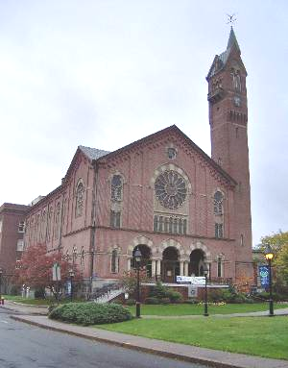

Prepared by:
Massachusetts Department of Public Health
Bureau of Environmental Health
Indoor Air Quality Program
January 2014

Background/Introduction
At the request of David Ladd, Director, Massachusetts State HazMat Response Team, the Massachusetts Department of Public Health (MDPH), Bureau of Environmental Health (BEH) provided emergency response and consultation at Chicopee City Hall (CCH), 17 Springfield Street, Chicopee, Massachusetts. Concerns related to an unidentified odor in the basement and first floor prompted the assessment.
The CCH was originally built in 1871 to house city offices and was expanded with a rear annex in 1929. The original building is composed of brick with a complex ridged roof including a 147-foot tower.
On December 13, 2013, Michael Feeney, Director of BEH’s IAQ Program responded to the incident and arrived on scene at approximately noon. At the time of the incident, odors were detected in the City Clerk’s office, Mayor’s office, first floor hallway and basement. The Chicopee Fire Department (CFD) determined odors were infiltrating into the building via a crawlspace beneath the 1871 section of CCH. Prior to the arrival of BEH/IAQ staff, the CFD had sealed the crawlspace floor hatch with plastic and duct tape and were ventilating the basement with fans. During the course of the incident, it was determined that the source of the odor was fuel that was pumped by a sump pump into the sewer/storm drain system from a house located on Myrtle Street (Figure 1) approximately 1,500 feet to the east, upgradient from CCH.
During the course of this initial visit, Mr. Feeney provided a number of recommendations to mitigate odors on the first floor. These recommendations included:
- Activate the heating, ventilating and air-conditioning (HVAC) system with its return damper closed to maximize pressurization of occupied spaces on the first floor.
- Depressurize the basement by using floor fans to draw odors into the boiler room.
- Seal spaces around a sink drain pipe located in the vault.
- Pour water into floor drains to wet traps to provide a barrier to fuel odors in the sewer/storm drain system.
The combination of ventilation and sealing of pathways led to a significant reduction of odors on the day of the incident.
Mr. Feeney returned to CCH on December 16, 2013 to provide further assistance regarding exhaust/ventilation of odors and the identification of additional odor pathways into the building.

Methods
Screening for total volatile organic compounds (TVOCs) was conducted using a MiniRAE Photo Ionization Detector (PID). Moisture sampling of wainscoting was conducted using a Tramex Moisture encounter Plus.

Results
The CCH has a staff of approximately 100 and can be visited by several hundred people each day. Tests were taken under normal operating conditions.

Discussion

Odors
As noted, the source of the odor appeared to emanate from a crawlspace that contains drainpipes installed when CCH was constructed in 1871. As reported by CCH staff, the basement has flooded after major rain events through the access panel and around door jambs (Picture 1), which indicates that breaches have likely existed in the drainpipes beneath CCH for an undetermined time. It is likely that fuel vapors entered the basement through various breaches in the floor, particularly around doors, the hatchway and outer wall of the vault.
Based on the initial assessment, it appeared that the odors were migrating into occupied areas of the first floor through numerous holes in the basement ceiling (Picture 2). In addition, holes drilled through the vault wall (Picture 3) also served as pathways for odor infiltration.
TVOC sampling was conducted on the first floor. All TVOC levels in the breathing zone and around breaches on the floor were non-detectable. BEH/IAQ staff took measurements in the basement where the odor was noticeable. BEH staff traced the odor to areas along the seam between the vault’s exterior wall and the basement floor as well as around doorframes in the basement. BEH staff measured TVOCs in a range of 2 to 16 ppm at various locations at the base of doors frames and wainscoting along the exterior walls of the vault (Pictures 4 and 5). This indicated that open seams allowed for fuel oil vapors to enter the basement space.
Water-damaged wainscoting (Picture 6) was tested at floor level and found to be saturated. Moisture test results indicate that moisture from the crawlspace appears to be moistening the wainscoting; these results also suggest that this may be a pathway for fuel oil vapors to enter the basement from the crawlspace.

Conclusions/Recommendations
Air testing results and observations made during the assessment indicate that ventilation/isolation methods implemented were successful in preventing pollutant migration into occupied areas in the first floor. However, further steps previously recommended should be taken to seal off pathways for fuel odors. The HVAC system should be activated with the return vents closed/minimized in occupied areas to maximize pressurization until holes and seams are repaired.
The following recommendations should also be implemented in order to reduce the migration of fuel odors and their potential impact on indoor air quality:
- Seal all holes penetrating from the vault into occupied spaces.
- Seal all open seams in the floor between the vault walls and the basement floor. Remove water-damaged wainscoting.
- Repair the leaking pipes in the crawlspace.
- For further building-wide evaluations and advice on maintaining public buildings, see the resource manual and other related indoor air quality documents located on the MDPH’s website at www.mass.gov/dph/iaq.
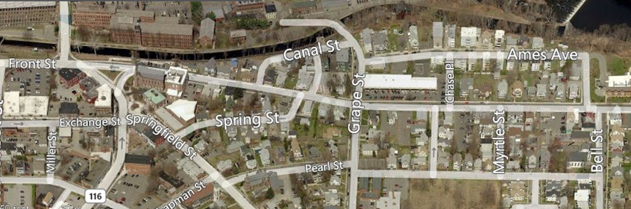
Picture 1
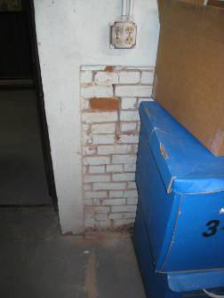
Base of wall showing signs of water damage

Picture 2
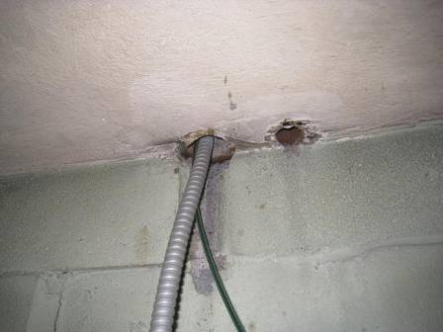
Openings in vault ceiling
Picture 3
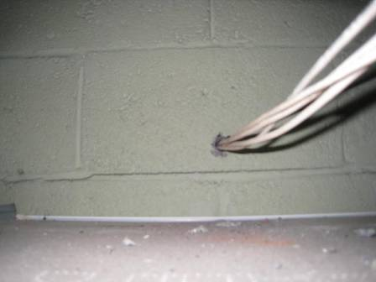
Hole drilled in vault wall, TVOCs measured 15 ppm

Picture 4
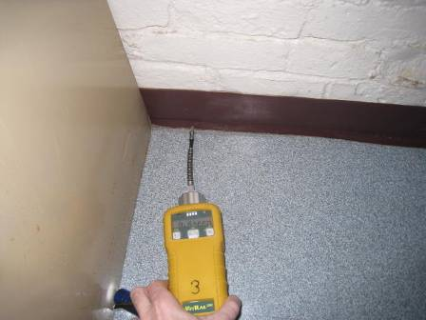
TVOC testing beneath floor coving
Picture 5
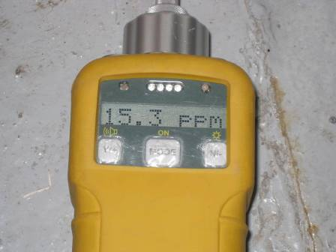
Example of TVOC measurement at floor level

Picture 6
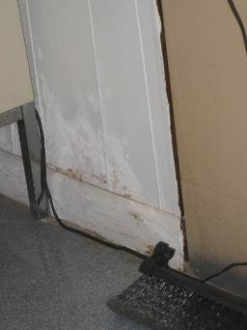
Water-damaged wainscoting along exterior basement vault wall at floor level

