**INDOOR AIR QUALITY ASSESSMENT**

**Chicopee Electric Light**

**Main Office Building**

**725 Front Street**

**Chicopee, Massachusetts**

**Front entrance to Chicopee Electric Light building.
**

Prepared by:

Massachusetts Department of Public Health

Bureau of Climate and Environmental Health

Indoor Air Quality Program

October 2024

# BACKGROUND

|  |  |
| --- | --- |
| Building: | Chicopee Electric Light (CEL) |
| Address: | 725 Front St, Chicopee, MA |
| Assessment Requested by: | Natalie Colberg, Human Resources/Administration Manager |
| Reason for Request: | General indoor air quality, mold, and vehicle exhaust from idling cars/trucks |
| Date of Assessment: | April 26, 2024 |
| Massachusetts Department of Public Health/Bureau of Climate and Environmental Health (MDPH/BCEH) Staff Conducting Assessment: | Michael Feeney, Director, and  Thomas Murphy, Environmental  Analyst, Indoor Air Quality (IAQ) Program |
| Building Description: | CEL office building has a front two-story wing attached to a three-story wing with an indoor parking garage. The building was renovated in 1990 which replaced the heating, ventilating, and air-conditioning (HVAC) system as well as reconfigured various floors in the office space, including installing a computer mainframe room. |
| Windows: | Windows are openable. |

# EXECUTIVE SUMMARY

The CEL was renovated in a manner to place HVAC system fresh air intakes away from sources of products of combustion, such as idling vehicles in the parking lot, exhaust vents from the warehouse/garage and the diesel-fueled emergency generators. As reported by CEL staff, windows are openable, which will then allow for such pollutants to enter the CEL offices when any of these identified sources are present during westerly wind weather.

IAQ staff identified several openings in the garage ceiling and walls that may allow for vehicle exhaust from idling parked cars to enter occupied space. Sealing of such openings with a fire rated foam sealant is recommended as well as installation of weather stripping and door sweeps on all interior garage doors to make each as airtight as feasible. All doors connecting the CEL main office to the 1990 constructed garage and warehouse should remain closed during business hours and equipped with weather stripping and a door sweep(s), if not already done.

Please note, this report identified conditions in the CEL main office area, and no other locations of the CEL campus of buildings, including the adjacent one-story garage and warehouse that were added during the 1990 renovation.

# METHODS

Please refer to the IAQ Manual for methods, sampling procedures, and interpretation of results (MDPH, 2015).

# RESULTS AND DISCUSSION

The following is a summary of indoor air testing results (Table 1).

* ***Carbon dioxide*** measurements were slightly above the MDPH recommended guideline of 800 parts per million (ppm) in roughly half the areas surveyed. Increase in fresh air supply by the HVAC system is recommended.
* ***Temperature*** was within the MDPH recommended range of 70°F to 78°F in areas tested at the time of assessment.
* ***Relative humidity*** was below the MDPH recommended range of 40 to 60% in all areas tested, which is typical in building during the heating season and certain weather conditions.
* ***Particulate matter (PM2.5)*** concentrations measured were below the National Ambient Air Quality (NAAQS) level of 35 μg/m3 in all areas tested.
* *Note that while* ***carbon monoxide (CO)*** *is typically measured during an assessment, equipment issues did not allow for this measurement during the assessment.*

## Ventilation

A heating, ventilating, and air conditioning (HVAC) system has several functions. First it provides heating and, if equipped, cooling. Second, it is a source of fresh air. Finally, an HVAC system will dilute and remove normally occurring indoor environmental pollutants by not only introducing fresh air, but by filtering the airstream and removing stale air to the outdoors via exhaust ventilation. Even if an HVAC system is operating as designed, point sources of respiratory irritants may be present and produce symptoms in sensitive individuals.

It can be seen from the tables that carbon dioxide levels were slightly above 800 parts per million of air (ppm) in roughly half of all areas sampled, indicating mostly adequate air exchange. The original CEL building had fresh air intake vents on exterior walls, presumably connected to unit ventilators (univents). Prior to the renovation, it is possible the exhaust products from idling vehicles outside the garage doors were drawn into the office space when univents were operating. Renovation plans indicate that univents were removed and replaced with a ducted central HVAC system. Univent fresh air intakes were then permanently sealed (Picture 1). The fresh air intake for the retrofitted HVAC system is on the roof of the CEL building, near the east roof edge away from the CEL parking lot and diesel-powered emergency generators (Picture 2). The HVAC air handling unit (AHU) was installed inside an attic space, which is connected by ducts to suspended ceiling-mounted fresh air supply (Picture 3) and ceiling-mounted return vents (Pictures 3 and 4). IAQ staff could not identify the presence of exhaust ventilation systems connected to the general HVAC system. In the experience of the IAQ Program staff, exhaust air ventilation is provided by the operation of restroom exhaust vents, which have transfer air vents that draw air from hallways (Picture 5). Restroom exhaust vents must operate when the building is occupied to both provide exhaust ventilation for offices as well as vent water vapor and odors from restrooms. Exhaust vents had been repaired prior to this visit, as indicated by the presence of broken fan belts on the lower roof of the CEL (Picture 6).

Due to its age, the CEL was not originally constructed to be occupied during hot, humid weather. HVAC systems are designed to heat and cool a predetermined maximum volume of air by AHUs. If the volume of air is exceeded by the introduction of unconditioned air, the ability of the HVAC system equipment to maintain heating and cooling consistently will be impaired, resulting in increased indoor relative humidity as well as temperature complaints. Such conditions exist at the CEL.

Of note are areas where unconditioned air can enter that can both increase the volume of air beyond the design capacity of equipment and/or be a source of unconditioned moist air. As an example, frequent opening of windows during summer months can allow significant amounts of unconditioned hot, moist air to enter the building during extended periods of hot, humid weather.

Also of note was that relative humidity measurements indoors were higher than outdoors on the day of the assessment. Outdoor relative humidity was measured at 24% with a temperature of 57°F (Weather Underground, 2024). Indoor relative humidity was in a range of 30-34% at 71°F to 75°F in various locations. When air is heated, relative humidity percentage should *decrease* rather than increase. These results can indicate:

* a lack of exhaust ventilation to eject moisture from the building and/or
* a source of moisture inside the building.

Without adequate exchange of conditioned air and/or lack of adequate exhaust ventilation, water vapor entering the CEL can build up, which may cause occupant discomfort and moisten building components and stored materials.

## Microbial/Moisture Concerns

Hot humid summers are becoming more frequent due to climate change. Massachusetts has experienced hot, humid, and rainy summers in 2018, 2021, and 2023. July of 2021 was the wettest ever recorded in Massachusetts, and the three-month period from June through August, known as the meteorological summer, was the fourth wettest on record, according to the National Oceanic and Atmospheric Administration’s (NOAA) Centers for Environmental Information (NOAA, 2021). The summer of 2023 was also hot, and wet, being measured as the second rainiest on record (WBUR, 2023). The summer of 2024 has also had significant stretches of hot, humid weather. These conditions are challenging for buildings, particularly those without central air conditioning.

If a building material/component or stored material has a temperature below the dew point, condensation will accumulate on that material. Over time, condensation can collect and form water droplets. If such materials stay moist for greater than 24 hours, mold growth may occur. If unconditioned hot, moist air enters the building, it can have the following effects:

* Increased humidity indoors can cause condensation on cold surfaces, particularly in below-grade space. Such conditions may moisten porous materials that can then become mold colonized. Such materials may include paper, cardboard, latex carpet, books, and other porous materials (Picture 7).
* If the chilled water pipes serving the HVAC system are not sufficiently insulated (adequate R value of insulation), the outside surface can become moistened and, if made of a porous material like paper, become mold colonized.
* Condensation dripping from chilled water pipes can also result in wetting of ceiling tiles, walls and/or floors.
* Condensation on dust and debris on fresh air supply diffuser fins (Picture 8) may result in mold growth.
* Condensation can occur on other uninsulated water pipes, such as those serving fire sprinklers.
* High humidity weakens the material in ceiling tiles, which then sag or bow. This condition was observed in several areas (Table 1).

Of note is that interior hallway fire doors appear to be propped open during business hours. When this occurs, a significant amount of unconditioned air is likely entering the CEL hallways and is then captured by the HVAC system and then redistributed throughout the building, resulting in poor air chilling control during hot, humid weather. If fire doors are also propped open during cold weather months, heat control would also become difficult due to the introduction of large volumes of cold, unconditioned air.

IAQ staff examined the building to identify possible water sources, including breaches in the building envelope and/or other conditions that could provide a source of moisture that can adversely affect indoor air quality. Water-damaged ceiling tiles were noted around windows, indicating infiltration through the window system during wind-driven rains.

As previously noted, the building is configured so significant hot, moist air can readily pass into the interior of the building. Other sources of hot, humid air impacting the main offices include: spaces around the exterior basement doors, spaces in the exterior walls, and other parts of the building envelope around windows and other exterior doors.

Note that both liquid water and water vapor can create conditions conducive to mold growth on porous materials. While leaks or plumbing issues are obvious water sources, high relative humidity alone (>70% for an extended period of time) can also lead to mold growth on susceptible materials even in the absence of liquid water.

It is recommended that porous material be dried with fans and heated within 24 to 48 hours of becoming wet (US EPA, 2008). If porous materials are not dried within this time frame, mold growth may occur. Water-damaged porous materials cannot be adequately cleaned to remove mold growth.

## Other Conditions

The CEL has an indoor parking garage below office space that has a dedicated exhaust system to vent vehicle exhaust from idling vehicles. While an exhaust system does exist, the IAQ Program identified several pathways for vehicle exhaust and other pollutants to move from the parking garage into adjacent/occupied areas. The doors leading from the parking garage have spaces around them. In several areas, holes were made in the garage ceiling and walls to install utilities such as computer cable conduit and plumbing. Gaps around pipes and other spaces (Picture 9) were noted which could be pathways for pollutants to enter occupied space above the garage. The garage ceiling and walls should be properly sealed to avoid the intrusion of particulate matter, odors, and water vapor into occupied areas.

Carpets in the CEL should be cleaned annually (or semi-annually in soiled/high traffic areas) in accordance with Institute of Inspection, Cleaning and Restoration Certification (IICRC) recommendations, (IICRC, 2012). The service life of carpeting is approximately 10-11 years (IICRC, 2002). Old and worn carpeting becomes increasingly difficult to clean and maintain and may be a source of particulate matter to the indoor environment. Regular cleaning with a high efficiency particulate air (HEPA) filtered vacuum in combination with an annual cleaning will help to reduce accumulation and potential aerosolization of materials from carpeting.

CEL staff raised concerns regarding the computer mainframe and the existence of electromagnetic fields (EMF). The following information is available from the MA DPH Radiation Control Program at: <https://www.mass.gov/info-details/electromagnetic-fields-or-emf>

What is EMF?

* Electromagnetic fields (EMF) are a combination of electric and magnetic fields. Electric fields come from electricity, such as when a kitchen appliance is plugged in. Trees, walls, and most objects can block or weaken electric fields. Magnetic fields come from flowing electricity, such as when the appliance is turned on. Power lines produce magnetic fields continuously because current is always flowing through them. Magnetic fields can travel through most objects. The electric and magnetic forces in EMFs are caused by electromagnetic radiation. There are two main categories of EMFs:
  + Higher-frequency EMFs are in the ionizing radiation part of the electromagnetic spectrum and can damage DNA or cells directly. Sources include sunlight and X-rays.
  + Low-to-mid-frequency EMFs are in the non-ionizing radiation part of the electromagnetic spectrum and are not known to damage DNA or cells directly. Sources include electric power lines and appliances, radio waves, microwaves, cell phones, and wireless internet (Wi-Fi). Federal regulations are in place to help limit radiofrequency output from cell phones, and regulators may take action if emission levels are at levels that are hazardous to the user. (https://www.mass.gov/info-details/electromagnetic-fields-or-emf#what-is-emf?-).

# CONCLUSIONS/RECOMMENDATIONS

The CEL has a number of issues related to moisture in the building. Although this is not a school building, the following documents can provide guidance that can be used to reduce the impact of hot, humid weather in buildings, even those equipped with an HVAC system with chilling capacity:

* Mold Growth Prevention during Hot, Humid Weather [https://www.mass.gov/service-details/preventing-mold-Growth-in-massachusetts-schools-during-hot-humid-weather](https://www.mass.gov/service-details/preventing-mold-growth-in-massachusetts-schools-during-hot-humid-weather)
* Remediation and Prevention of Mold Growth and Water Damage in Public Schools [https://www.mass.gov/service-details/remediation-and-prevention-of-mold-Growth-and-water-damage-in-public-schools-and](https://www.mass.gov/service-details/remediation-and-prevention-of-mold-growth-and-water-damage-in-public-schools-and)
* Methods for Increasing Comfort in Non-air-conditioned Schools <https://www.mass.gov/doc/methods-for-increasing-comfort-in-non-air-conditioned-schools/download>

To remedy building problems, two sets of recommendations are made: short-term measures that may be implemented as soon as practicable and long-term measures that will require planning and resources to address overall IAQ concerns:

## Short Term Recommendations

1. Have the building tested for carbon monoxide (CO) during an occupied period when the heating systems are on.
2. Keep all exterior doors closed during hot, humid weather.
3. Keep all doors closed in each air conditioning zone to maintain air temperature and prevent condensation in adjoining areas.
4. Do not store any porous materials on the basement floor.
5. Any water-damaged material should be removed in a manner consistent with recommendations listed in the US EPA’s “Mold Remediation in Schools and Commercial Buildings” (US EPA, 2008).
   * This work should be performed when the building is unoccupied.
   * In addition, due to the age of the building and the presence of asbestos-containing floor tiles, all work should be done in accordance with state and Federal regulations.
   * Monitoring weather for predicted high outdoor relative humidity is recommended to implement the guidelines is highly recommended. This is mostly likely to occur during summer heatwave conditions in New England.
6. Pathways (gaps around utilities, holes, crevices, etc.) in the ceiling to the parking garage should be sealed completely to prevent moisture, particulate matter, and odors from entering occupied areas. Tight-fitting door sweeps or weather stripping should be installed on doors which communicate with engine bays, the attic, or outdoors.
7. Ensure that the parking garage exhaust ventilation system is operating when idling vehicles are present.
8. Install a “No Idling” sign where vehicles are parked inside the garage.
9. Clean carpets in a manner consistent with IICRC recommendations.
10. Request the IAQ Program return during the heating season to assess the warehouse building.
11. Refer to the resource manual and other related indoor air quality documents located on the MDPH’s website for further building-wide evaluations and advice on maintaining public buildings. These documents are available at <http://mass.gov/dph/iaq>.

## Long-term recommendations:

1. Consult a ventilation engineer regarding the function of the AHUs. Due to the configuration, age, and condition of the AHU system, consideration should be given to replacing AHUs.
2. Consult with a building and HVAC engineer to determine the adequacy of supply and exhaust ventilation in the building.
3. Consult a building engineer to examine the feasibility of repairing or replacing the window system.
4. Improve water drainage of ground around foundation wall.
5. Consider replacing carpets with a flooring resistant to water damage/mold growth.

**REFERENCES**

IICRC. 2002. Institute of Inspection, Cleaning and Restoration Certification. A Life-Cycle Cost Analysis for Floor Coverings in School Facilities.

IICRC. 2012. Institute of Inspection, Cleaning and Restoration Certification. Carpet Cleaning: FAQ.

MDPH. 2015. Massachusetts Department of Public Health. Indoor Air Quality Manual: Chapters I-III. Available at: <https://www.mass.gov/lists/indoor-air-quality-manual-and-appendices#indoor-air-quality-manual->.

NOAA. 2021. Summer 2021 neck and neck with Dust Bowl summer for hottest on record. National Oceanic and Atmospheric Administration, 1401 Constitution Avenue NW, Room 5128, Washington, DC 20230 <https://www.noaa.gov/news/summer-2021-neck-and-neck-with-dust-bowl-summer-for-hottest-on-record>

US EPA. 2008. Mold Remediation in Schools and Commercial Buildings. US Environmental Protection Agency, Office of Air and Radiation, Indoor Environments Division, Washington, D.C. EPA 402-K-01-001. <http://www.epa.gov/mold/mold-remediation-schools-and-commercial-buildings-guide>.

WBUR. 2023. “It's been a summer of rain and flooding misery in Mass.” WBUR local news. September 12, 2023. <https://www.wbur.org/news/2023/09/12/summer-flooding-rain-massachusetts>.

Weather Underground, 2024. Windsor Locks, CT Weather History. <https://www.wunderground.com/history/daily/us/ct/windsor-locks/KBDL/date/2024-4-26>

**Picture 1**

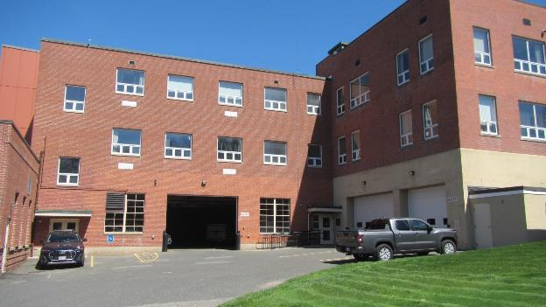

**Sealed univent fresh air intake above garage door (arrow)**

**Picture 2**

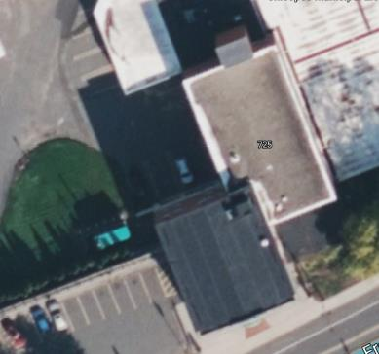

**Rooftop HVAC fresh air intake (Arrow)**

**Picture 3**

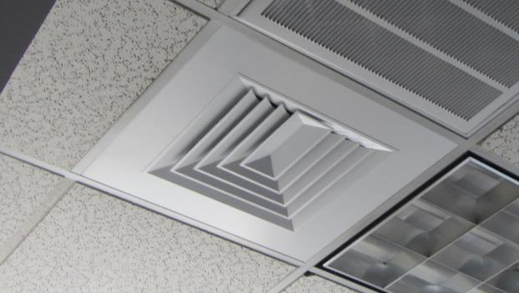

**Fresh air supply vent with return vent next to it**

**Picture 4**

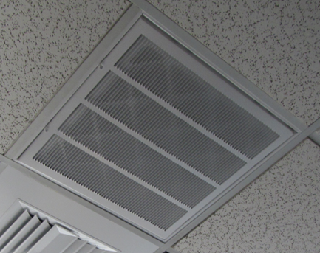

**Return ventilation with installed filter**

**Picture 5**

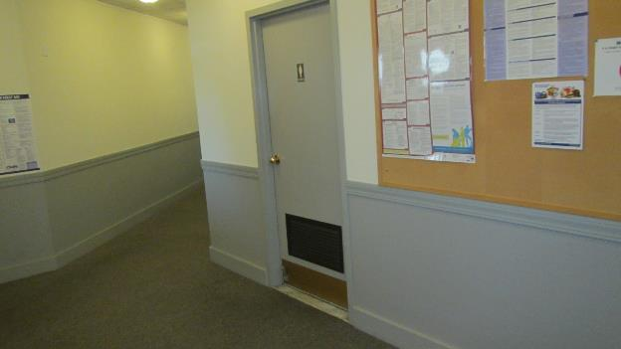

**Transfer air vent for restroom in door**

**Picture 6**

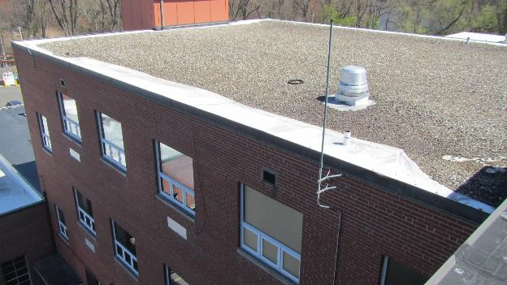

**Exhaust vents, note broken fan belts on roof next to exhaust vent**

**Picture 7**

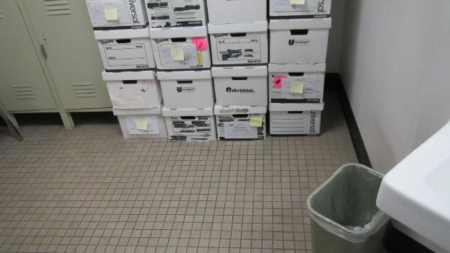

**Cardboard on tile floor**

**Picture 8**

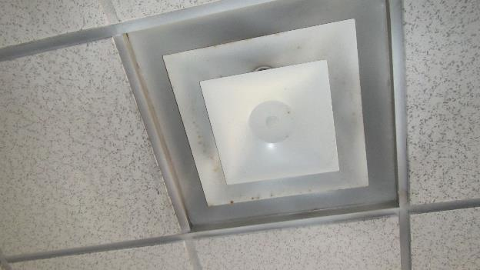

**Debris on fresh air supply vent near openable window. Note corrosion is a sign of open window when HVAC is operating in chilling mode**

**Picture 9**

**Example of space between pipe and ceiling
**

**Example of space between pipe and ceiling**

| **Location/ Room** | **Carbon**  **Dioxide**  **(ppm)** | **Temp**  **(°F)** | **Relative**  **Humidity**  **(%)** | **PM2.5**  **(µg/m3)** | **Occupants**  **in Room** | **Windows**  **Openable** | **Ventilation** | | **Remarks** |
| --- | --- | --- | --- | --- | --- | --- | --- | --- | --- |
| **Supply** | **Exhaust** |
| Background (outdoors) |  | 57 | 24 |  |  |  |  |  |  |
| 1 | 845 | 73 | 32 | ND | 0 | Y | Y | Y | Plants |
| 2 | 865 | 72 | 32 | ND | 1 | Y | Y | Y | Water-damaged ceiling tiles |
| Vault room | 849 | 72 | 33 | ND | 0 | N | N | N |  |
| Photocopier area | 870 | 72 | 32 | ND | 0 | N | N | N | Photocopier  Fax Machine |
| 6 | 787 | 73 | 34 | ND | 0 | Y | Y | Y | Storage room office |
| Break room/kitchen | 762 | 74 | 34 | 1 | 0 | Y | Y | Y | Water-damaged ceiling tiles  Condensation on supply vent |
| 7 | 777 | 73 | 32 | ND | 0 | Y | Y | Y | Large number of crates on desk however staff states they are usually stored on the floor |
| 8 | 777 | 73 | 32 | ND | 0 | Y | Y | Y | Humidifier on desk |
| 9 | 788 | 73 | 31 | ND | 0 | Y | Y | Y | Cardboard boxes on floor  Liquid stain on carpet under coffee maker  Water-damaged ceiling tiles |
| Billing office | 743 | 72 | 33 | ND | 0 | Y | Y | Y | Condensation on supply vent  Humidifier in cubicle space  Plants on desks |
| 2nd floor southwest corner cubicles | 803 | 72 | 31 | ND | 4 | Y | Y | Y |  |
| 18 | 845 | 72 | 30 | ND | 1 | Y | Y | Y | Water-damaged ceiling tile |
| 2nd floor photocopier area | 868 | 71 | 32 | ND | 0 | N | Y | Y |  |
| 19 | 704 | 73 | 31 | ND | 0 | Y | Y | Y | Water-damaged ceiling tiles |
| 20 | 814 | 74 | 32 | ND | 0 | Y | Y | Y |  |
| 21 | 732 | 75 | 30 | ND | 0 | Y | Y | Y | Plants |