 **Beyond Bubbles and Blocks**  

Tips for EI Home Visitors

**Did you Know?**

**The Early Intervention Division** offers a Child Development Institute for Early Intervention Specialists and Supervisors?

UMASS Boston partnered with the EI Division at DPH to create this unique institute. The Child Development Institute (CDI) is a 6-day, 3-hour training geared towards EI Specialists and supervisors. The CDI focuses on child development through the lens of the whole child, with special attention given to cultural perspectives. In addition, the CDI teaches ways to utilize child development information to inform ongoing practices related to IFSP process, documentation, and communication with families. There will be time to connect what is learned in the training to current practice and plan for incorporation of the material in future processes at their individual programs.

# **Why attend the CDI?**

* Colloborate with other EI Specialists in discussions around child development
* Connect child development to the IFSP process
* Recognize the importance of whole child development
* Grow your skills to write clear and understandable developmental summaries that are meaningful to families
* Improve your functional assessment skills and writing of high quality outcomes
* Learn ways to talk about child development with families
* Further individualize transition plans to support the child and family.

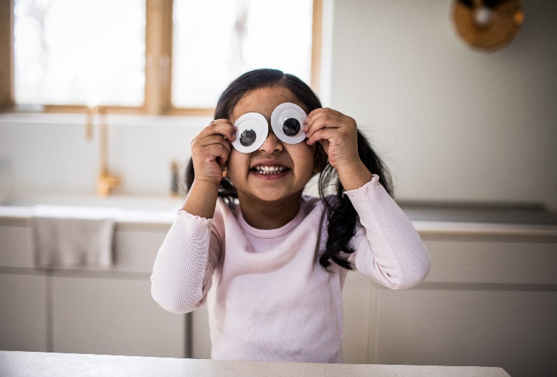

**Register today for the CDI:**

[**https://www.cvent.com/c/calendar/989eaea2-9183-43ca-9654-50e460d66645**](https://www.cvent.com/c/calendar/989eaea2-9183-43ca-9654-50e460d66645)

**Family Engagement Tips**

When a child is transitioning out of EI we have an opportunity to engage families in individualized discussions related to their child, resources, and community. Rather than sharing a broad list of resources with families, EI Specialists should be helping families to understand what resources exist in their communities. This will vary at whatever point transition is occurring and what the individual needs are for a child and family.

For example – will every family benefit from play group at the local library? If so, why? In what ways will the resources (whatever they may be) support development. Additionally, in what ways does development impact the child’s ability to access the resource? How can the family prepare for transition?

Consider these questions the next time you discuss transition with a family.