

**Small Group, Large Group and School Age Child Care Licensing**

**TECHNICAL ASSISTANCE: Child Guidance**

Ask anyone and they will tell you that helping children develop self-control is an enormous challenge and responsibility. Effective Child Guidance practices help children to form strong relationships with others. Positive relationships between adults and children are key to a child’s social and emotional development.

The Department of Early Education and Care supports the tremendous work that is done each day in child care centers, school age programs and family child care homes. It’s your hard work and efforts that make child care programs and family child care homes safe, caring environments where children can grow, discover, play and learn.

The purpose of this technical assistance paper is to help provide additional information and assistance about EEC approved Child Guidance practices. EEC regulations require teachers/providers to develop, and to use child guidance policies in a consistent, reasonable and appropriate way; based on an



understanding of the individual needs and development of a child.1

New research on early childhood development states that children undergo tremendous intellectual, emotional and physical development from birth to age five; and providing safe, loving and enriching environments for children at this stage is crucial to

future development. Two of the key findings from the study From Neurons to Neighborhoods: The Science of Early Childhood Development are: 1) Healthy early development depends on nurturing and dependable relationships; and, 2) How young children feel is as important as how they think particularly with regard to school readiness. The close, consistent relationships established between children and qualified caregivers are the building blocks for further healthy

1 EEC Group Child Care Regulation 7.10(1)

development. Relationships that are created in the earliest years are believed to differ from relationships created in later years because they are formative and constitute a basic structure within which all meaningful developments unfolds.2 The positive relationships and bonds that develop between the caregiver and



the children are the foundation and underpinning to successful experiences in child care and in preparation for school.

### Prevent Problems from the Start

Effective child guidance begins long before problems start. Teachers/providers have to assess their own attitudes and behavior, the program environment, the daily activity schedule, and the rules they expect children to follow. Teachers/providers need to have a working knowledge of child growth and development; model the kind of social skills they want to see; plan how to use the classroom and the outdoor environments to help children learn sharing and cooperation



skills; how to adapt the day’s activities, (including transitions), to be more responsive to the children; and question whether the expectations of the children in their care is realistic.

Once a comprehensive preventative approach is put in place, teachers/providers may have to respond to challenging situations in which they have to physically intervene to stop children from hurting each other, themselves, or destroying the environment. Teachers/providers can’t allow children to “fight it out” or to destroy things.

Child Guidance principles must always be implemented in a consistent, reasonable and appropriate way; based on an understanding of the child’s individual needs.

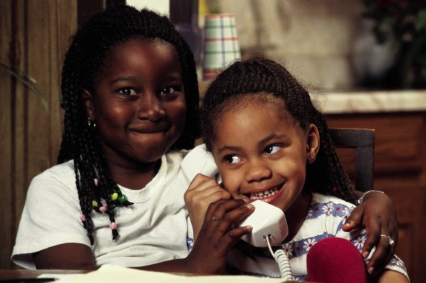

2 *From Neurons to Neighborhoods: The Science of Early Childhood Development*. National Research Council and Institute of Medicine of the National Academies

**Basic Techniques**

Routine child guidance practices should include but are not limited to the following:

• Having a sound understanding about the principles of child growth and development;

• Preparing a stimulating and educational environment with a varied curriculum and plenty of age appropriate play materials;

• Creating consistent routines and planning ways to have smooth transitions, enabling children’s waiting times to be productive;

• Modeling appropriate behaviors and positive attitudes;

• Learning about the child and family history;

• Understanding how individual children respond to different cues, and understanding that no single technique will work for all situations;

• Being clear about rules and being consistent in applying them;

• Providing opportunities for children to learn guidelines for acceptable behavior;

• Resolving problems as they occur and reminding children of the rules when a problem erupts, (when appropriate children should play a role in resolving their problems);

• Recognizing children’s feelings when discussing their unacceptable behavior with them, (separation of one’s disapproval of the behavior from the care and respect for the child);

• Reducing opportunities for problem behaviors before they begin by focusing children away from potential problems and expending efforts towards redirection;

• Helping children learn about natural consequences because appropriate natural consequences appeal to their sense of logic, “When I do this; this is what happens”;

• Teaching children coping mechanisms such as, “Taking a break,” and, “Picking another activity”;

• Helping children “brainstorm” to solve problems and make choices because it helps promote self-esteem and teaches problem solving skills;

• Knowing when to respond to inappropriate behavior and noticing appropriate behavior; and,

• Creating an individual action plan for a child that identifies the child’s challenging behaviors and includes ideas for how the child care teacher/provider and the child’s parents can work to resolve them.

Children may act out in disruptive ways for a variety of reasons, many of which are, in fact, developmentally appropriate. Early childhood professionals should respond to disruptive behavior according to the particular child and situation, but the child guidance goal is always the same. The goal must always be to provide children with support, teach children how to build self-control and keep all of the children in the child care program safe.

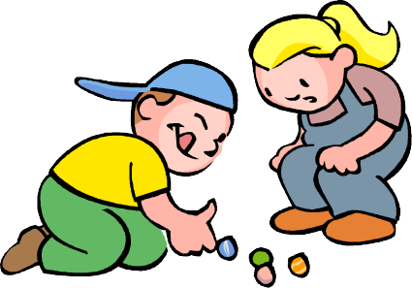

*Effective Ways A Provider May Respond Include*:

* Separate the child from the environment, but have the child remain within the teacher/provider’s immediate and direct supervision until the child is able to regain self-control and re-join the group;
* Have the teacher/provider place him/herself in close proximity to the child until the child is able to regain self-control when the child cannot be removed from the environment. In this instance, the teacher/provider must also remove anything within the child’s immediate reach that is a potential danger to the child or others.
* If necessary, the teacher/provider may use another adult to support and assist in calming the child until the child is able to regain self-control.
* Talk calmly to the child; this is always appropriate.

There is a difference between Child Guidance and punishment. That difference plays a big part in the kind of person each child becomes.

### Positive Child Guidance

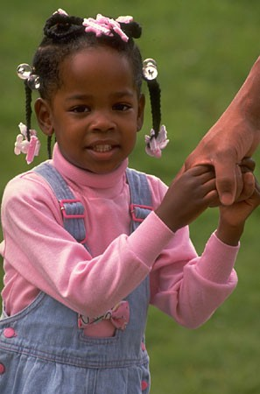

Department of Early Education and Care licensed programs may not use child guidance techniques that use of any form of punitive punishment or physical restraint. Punitive punishment is spanking or use of other physical forms of abuse; subjecting children to cruel or severe punishment such as humiliation, verbal abuse, neglect; depriving children of meals or snacks; force feeding children; and disciplining a child for soiling, wetting, or not using the toilet; or forcing a child to remain in soiled clothing or forcing a child to remain on the toilet, or using any other unusual or excessive practices for toileting and other practices used to motivate the child to become more compliant with the caretaker’s authority and demands. Physical

restraint involves the use of physical force on the child’s person by a caretaker. This is done to control the child’s movements and/or actions in order to motivate the child to become more compliant with the caretaker’s authority and demands.

The Department of Early Education and Care believes that behavioral control is neither logical nor appropriate for children in child care settings. No form of punitive punishment or physical restraint may be used on a child for discipline or for the convenience of others.

### Emergency Situations

Responding to an emergency situation is neither an easy task nor one that should be taken lightly. The best prevention is to know the children based on your experiences with them and the information you have about them from intake information or from the parents. Useful information may include personality and habits of a child, (i.e., If you know that a child is not capable on a given day to join a group activity, then care should be taken to make other program arrangements for the child to avoid becoming involved in a struggle that might lead to a negative behavior).

Dealing with children who act out in disruptive ways that place them in imminent harm or endanger others requires a great deal of skill and tact from the teacher/provider. The teacher/provider must always consider the immediate safety of all the children in the program when responding to situations. A

teacher/provider may only supportively hold a child in rare cases of an emergency where a dangerous threat to a child exists. The teacher/provider may only hold the child long enough to remove him/her from the dangerous situation and when appropriate, return him/her to safety.

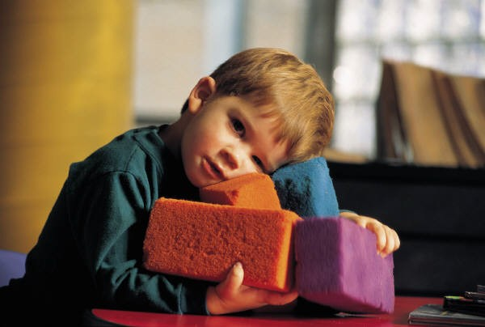

**Supportive holding of children should be considered only in the following situations**:

* The child’s safety is at risk;
* The safety of other children or adults is at risk;
* The child must be moved in order to be safely supervised;
* The child demonstrates a sustained behavior that is highly disruptive and/or upsetting to other children necessitating moving the child.

**Supportive hold should not be implemented unless:**

* The safety of the child and others demands immediate intervention; or,
* All other possible interventions have been attempted prior to supportive holding; and,
* The supportive hold should only be sustained long enough to remove a child from an unsafe environment or keep him/her from hurting self or others.

Touch is key in children’s healthy development, so it does not make sense to adopt a “no-touch” policy when children are hurting – or intend to hurt – other children, adults, themselves, or damage the things around them. When children

behave in dangerous or destructive ways, teachers/providers should physically intervene in a calm, nurturing manner that is responsive to the specific situation and the child’s developing abilities and capacity to



understand. It may take the form of hugs, taking a child by the hand; picking up a child and moving the child to a safe area; and holding a child on one’s lap – familiar ways of touching that acknowledge and affirm the child while interrupting their behavior. Teachers/providers must proceed with the awareness that touch may not be welcomed by a child, especially if the child have been victimized by physical and/or sexual abuse or witnessed domestic violence.

If teachers/providers want to stop children from hurting other children, themselves, adults, or damaging their surroundings; then teachers/providers, themselves, must consistently show respect, self-control, and consideration. Teachers/providers must resist exhibiting anger or frustration that matches the tenor of the child’s negative behavior. If teachers/providers react angrily to a child’s violent behavior, they are not presenting children with an alternative model of how to respond to taxing situations.

When touch is only used as a last resort in child guidance practices, it will invariably convey a negative, punitive message. Physical intervention by a composed, caring adult can be a reassuring, healing experience that helps the child regain control of him/herself.

Occasionally, children may not be able to regain control of their behavior in spite of the teacher’s/provider’s best efforts. The provider should seek help for these instances. These are situations, which may result in one of the following:

* The child’s behavior is so intense that it is likely the child will be isolated and ostracized by the other children if it continues.
* There is a serious possibility of harm to the child, the other children, or staff and it has become extremely difficult for this child/or other children to learn and grow in the program.
* The child's behavior consumes so much of the provider’s time and energy that the provider has considered asking parents to remove the child from the program.

### Where to Find the Help you Need

Fortunately, there are individuals and agencies that can support child care providers in addressing the needs of children who have extraordinary behavioral challenges. *Children with mental health problems need to be referred to mental health services*.



These issues and additional information may obtained from the following:

* Local Community Mental Health Agencies for educational testing, counseling services, therapy and/or behavioral consultation;
* Department of Social Services when an abuse or neglect issue is suspected;
* Local Early Intervention Programs and/or Regional Consultation Teams funded by the Department of Public Health and Department of Early Education and Care for children requiring additional services due to their unique developmental and special needs;
* Child Witness to Violence and local battered women shelters;
* Local Education Authority for children over three years of age for information regarding Special Education Services and CORE evaluations for a child;
* Local Child Care and Resource and Referral agencies for information about customized child care searches and placement information for parents of children with special needs, local training opportunities and information about their resource library and how to access it as well as information about other local resources;
* Regional Department of Early Education and Care Child Care Licensing Specialist for technical assistance regarding child growth and development matters, licensing concerns, licensing regulation or policy interpretations; and,
* Regional Department of Early Education and Care Policy and Training Advisors or Regional Contracting and Monitoring Coordinators for information on subsidy resources including flexible funding for children with disabilities or a mental health diagnosis.

# Developing a Child Guidance Policy



## Key components for a good policy:

The child guidance policy should include the following:

1. The prohibitions in the Department of Early Education and Care regulations
   * Spanking or other corporal punishment of children;
   * Subjecting children to cruel or severe punishment such as humiliation, verbal or physical abuse, neglect, or abusive treatment;
   * Depriving children of meals or snacks;
   * Using methods such as force feeding children; and,
   * Disciplining a child for soiling, wetting, or not using the toilet; or forcing a child to remain in soiled clothing or forcing a child to remain on the toilet, or suing any other unusual or excessive practices for toileting
   * Including a notation in your policy that Department of Early Education and Care does not allow and licensed child care programs to use discipline techniques that require the use of any physical restraint.
2. Child guidance goals that help children with the following:
   * To be safe with themselves and with others;
   * To feel good about themselves;
   * To develop self-control and good coping skills;
   * To appropriately express their feelings;
   * To become more independent;
   * To balance their needs and wants with those of others;
   * To learn new problem-solving skills, including non-violent conflict resolution; and,
   * To learn about conservation – to use equipment, materials, and other resources in caring, appropriate ways.
3. Methods of child guidance that include the following:
   * Plan for appropriate behavior through the environment by arranging furniture and other materials to encourage active learning and independence;
   * Plan daily scheduling that prevents boredom, waiting, hurriedness, with time to relax and enjoy activities;
   * A daily routine with ample opportunity for children to select activities and move between them at their own pace and one that gives children ample notice of transitions ahead of time;
   * Provide children with expectations that are clear, age-appropriate and applied in a consistent way. Allow children to participate in the establishment of rules, policies and procedures where appropriate and feasible;
     + Reinforce positive behavior by recognizing children’s positive actions;
     + Adults model appropriate behavior by being consistent with what the program’s expectations for children;
     + Redirect children toward positive activities by interrupting a child’s negative behavior and steering the child toward an acceptable substitute activity;
     + Teach children new skills and encourage them to discuss and resolve their conflicts on their own or with the adult’s assistance when necessary rather than imposing an adult’s solution on them. Encourage children to express their feelings in words and to resolve problems peacefully;
     + Ignore simple inappropriate negative behavior that is unpleasant;
     + Work in close partnership with parents to address children’s difficulties at home and at the program. Develop shared understanding to develop consistency between home and child care;
     + Observe and document children’s behavior;
     + Meet with parents, keep them informed of their children’s behaviors and document your parent discussions;
     + Assess specialized support services if a child’s behavior continues to be harmful to themselves or others. With written parental permission, refer the family for mental health counseling or other specialized services that can help address the child’s behavior problems. Follow your policy for referrals;
4. Supports that are available to assist child guidance efforts
   * Learn and list community supports available as an addendum to your child guidance policy; and,
   * Include addendum language that requires center based staff, (family child care assistants if your program is family child care), attend community training regarding child guidance/ techniques and good early childhood practices based on their individual needs.



## Test the policy

### Ask yourself and others in your program the following:

1. Is the policy practical?
2. Is the policy age-appropriate for all the children you care for and for your environment?
3. Will center based staff, (or family child care assistant if program is family child care), be able to incorporate the policy and procedures into the daily operations of the program? What training may they need?
4. Is the information in the policy accessible and easy to use?
5. Does the policy do what it’s intended to do regarding the children’s health and safety?