Promoting

Child Passenger Safety
A TOOLKIT FOR PRE-HOSPITAL PROVIDERS

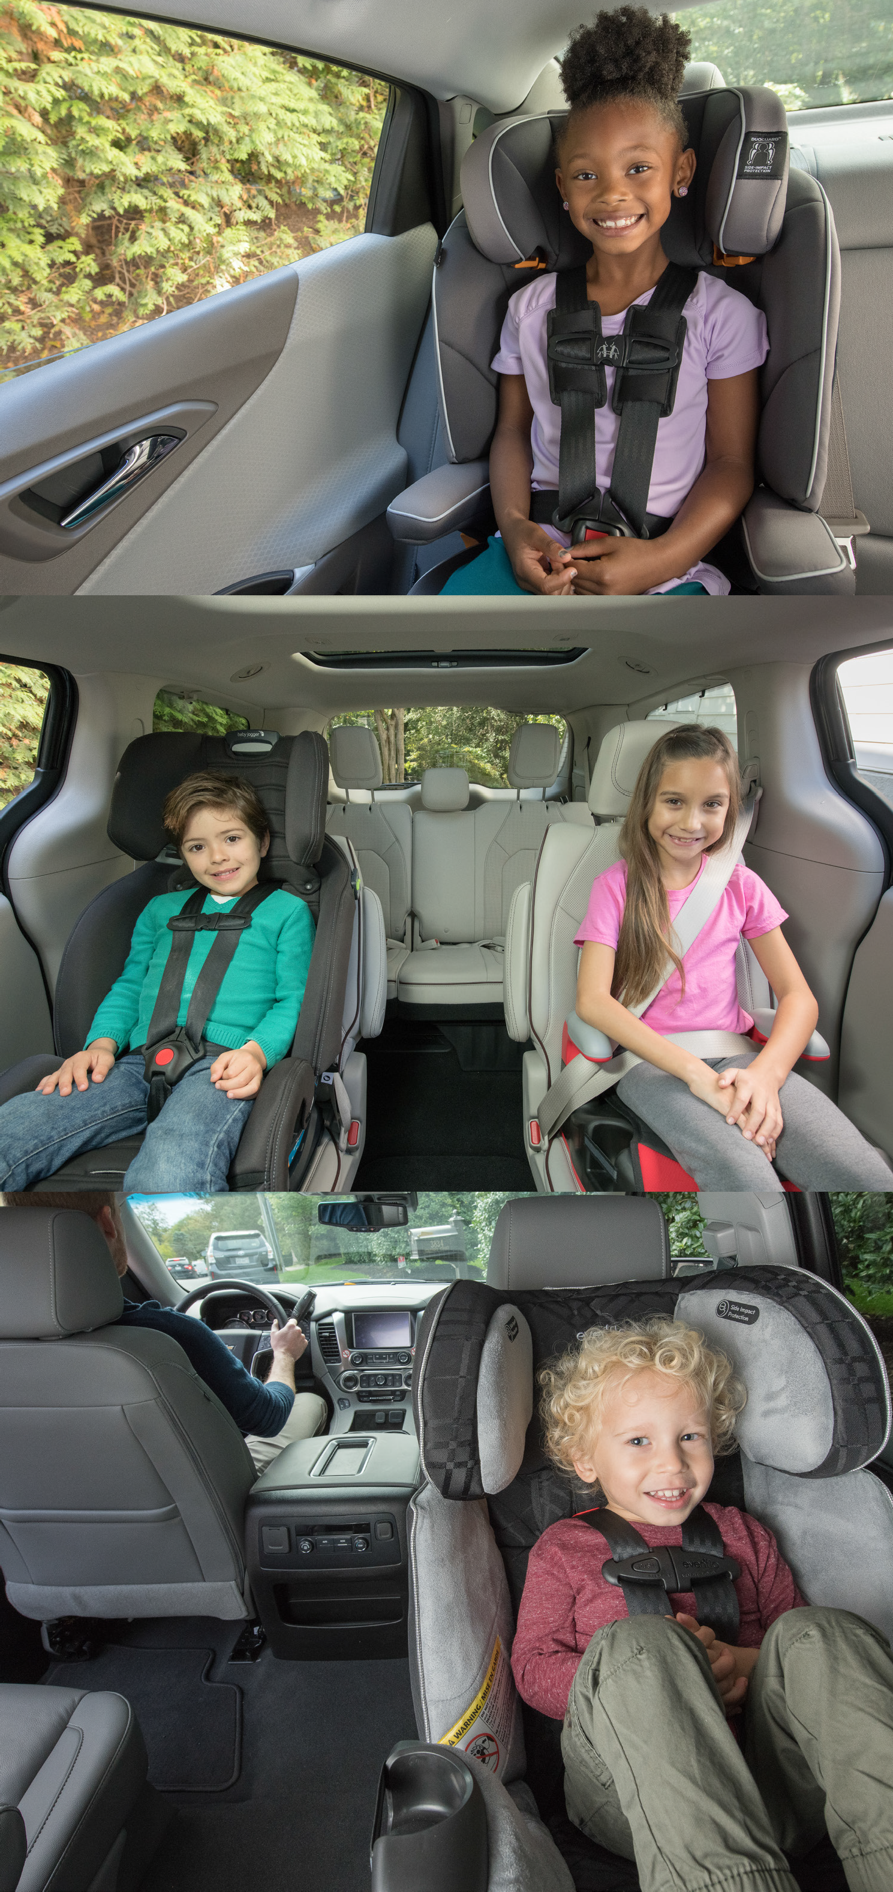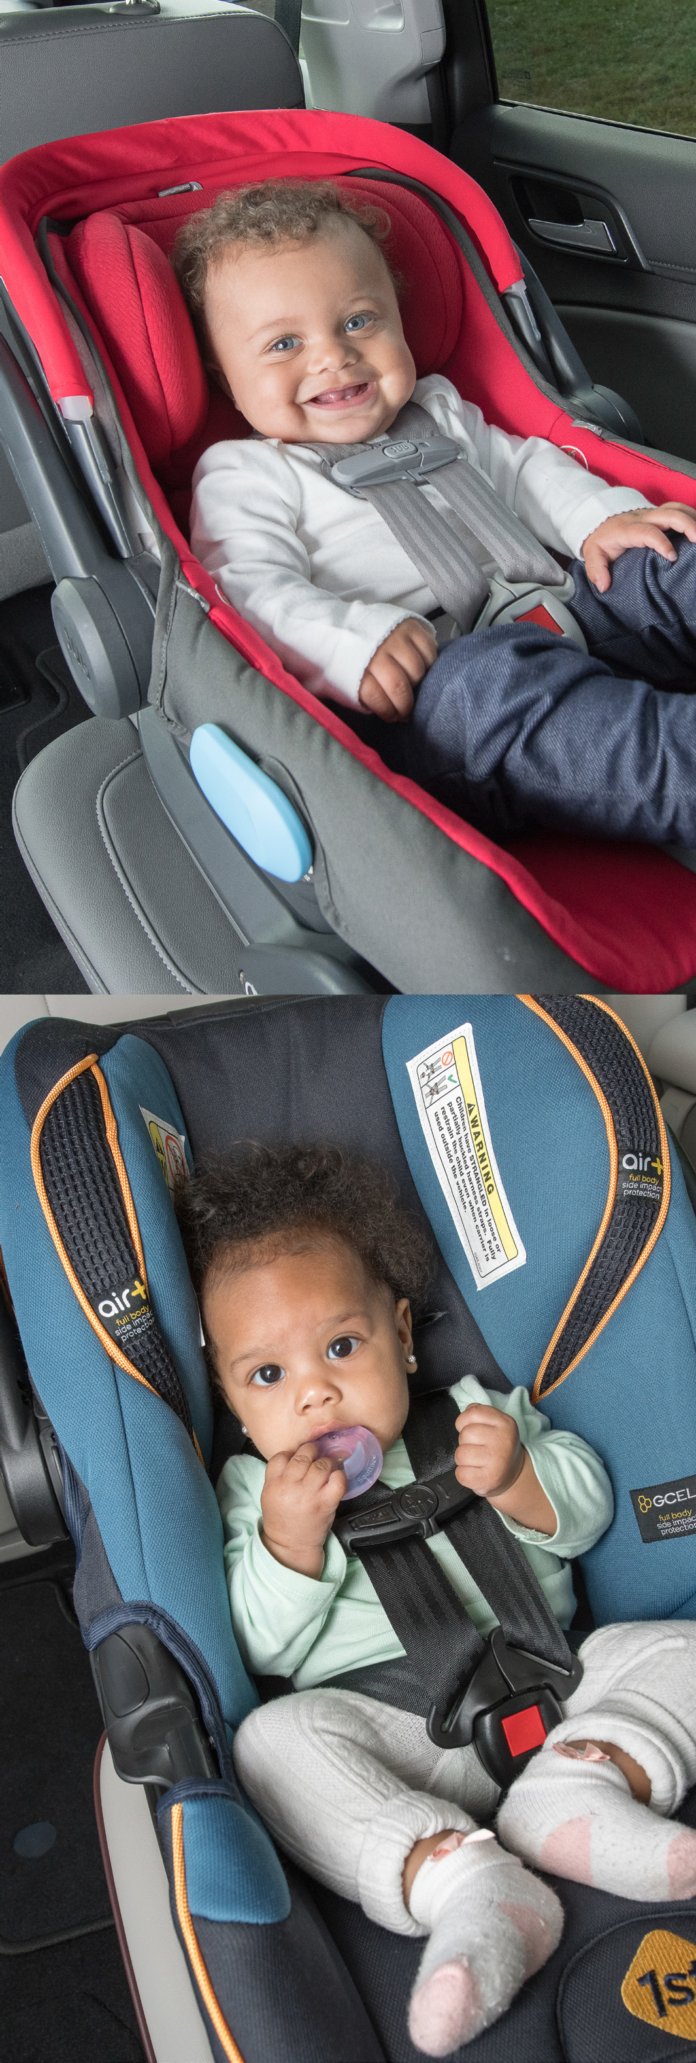

Table of Contents

Purpose and Contents of the Toolkit 4
Child Passenger Injuries: By the Numbers 5
Providing CPS Support for Parents and Caregivers 7
Education about Child Passenger Safety 8
Car Seat Inspections and Installations 15
Car Seat Distribution 20
Event Planning, Logistics, and Operations of a CPS Program 21
Frequently Asked Questions 24
Resources 25
Citations 28

“EMS professionals are reliable, ever-present, and trusted providers. As such, they can play a critical role in community-based injury prevention
efforts, including child passenger safety.
”

Purpose and
Contents of the Toolkit

Emergency Medical Service (EMS) professionals know the devastating consequences of incorrect child restraint use in cars. Motor vehicle crashes are a leading cause of injury and death for children, and
pre-hospital providers are often the first on the scene to help. Many of the most severe injuries pre-hospital providers see among children in car crashes are due to improper seat belt and car seat use.
In 2019, roughly 38% of U.S. children 12 and younger who died in a crash were not buckled up.2 Reasons for improper child restraint use include:
- Limited awareness of the safest way to restrain children in motor vehicles
- Complicated guidelines for choosing appropriate restraints
- Physical challenges related to properly installing car and booster seats
- Financial barriers that limit options and can result in deprioritizing transportation safety
EMS professionals are reliable, ever-present, and trusted providers. As such, they can play a critical role in community-based injury prevention efforts, including child passenger safety. This toolkit is intended to provide information and guidance to EMS personnel and others who want to help parents and caregivers
safely transport children. Here you will find information and resources about establishing Child Passenger Safety (CPS) programs, including inspection and installation stations and educational events.

Please note:
This toolkit does not address the safe transportation of children and infants in an ambulance or other emergency vehicles. To learn more about transporting children, especially children with special health care needs, please refer to the following resources:
- Massachusetts Office of Emergency Medical Services Pre-Hospital Statewide Treatment Protocols
- National Center for the Safe Transportation of Children with Special Health Care Needs
- American Academy of Pediatrics Safe Transportation Policy Statement
- Safe Transportation of Children in Ground Ambulances
- NASEMSO: Safe Transport of Children

Purpose and Contents of the Toolkit | 4

Child Passenger Injuries:
By the Numbers

The rate of non-fatal injuries to children on Massachusetts roadways from 2016-2019 was 316.9 per 100,000 children ages 0-7.2 During that time, MA ambulances transported over 4,000 children ages 0-7 to a hospital for injuries sustained during a crash,3 and MA hospitals and emergency departments treated more than 1,8004 child passengers for those injuries annually.5
In 2019, for crashes where restraint use is known, roughly 38% of U.S. children 12 years old and younger who died in a crash were not properly restrained.6 Appropriate child restraint use can significantly reduce the risk for injury by preventing ejection from the car and other impacts.7,8 Child restraints, including rear-facing car seats, forward-facing car seats, and booster seats are specially designed to secure small children in place and protect their most vulnerable body parts during a crash. It’s essential to ensure that a child is correctly fitted in the appropriate child restraint to provide the most protection from injury during a crash.
Child passenger injuries do not affect all populations equally. There are substantial racial and geographic disparities among child passenger injuries. Between 2016 and 2019, children ages 0-7 in Bristol, Plymouth, and Hampden counties had the highest rates of nonfatal child passenger injuries in MA (403.4, 424.1, and 646.5 per 100,000 children ages 0-7 respectively). Furthermore, Black, non-Hispanic children ages 0-7 suf- fered child passenger injuries at more than four times that of White, non-Hispanic children (866.5 vs. 212.2 per 100,000 children ages 0-7) in MA.9
These inequities are not inherent to a particular race, ethnicity, or geographic region. Such racial and geo- graphic inequities have been driven by long-standing systemic issues including poor road infrastructure, lack of investment in transportation safety, and financial barriers to resources and services. These systemic issues continue to make it challenging for communities of color to access car seats, car seat inspections and installations, and education that can improve health outcomes and reduce child passenger injuries. By understanding the root causes of these disparities, pre-hospital providers can play a key role in addressing child passenger injuries by implementing CPS programs in communities most affected by systemic barriers.

Resource:
The Massachusetts Department of Transportation (MassDOT) collaborates with the Registry of Motor Vehicles to provide timely data about crashes that occur in Massachusetts through an interactive data portal. If you are interested in learning more about crashes, visit MassDOT’s IMPACT Crash Data Portal.

5

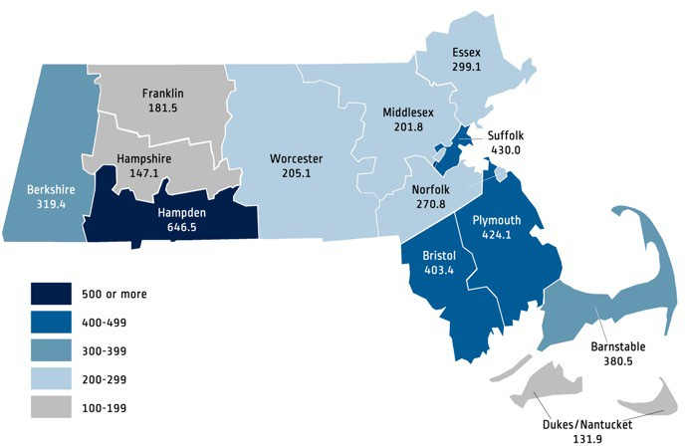
Nonfatal Motor Vehicle Occupant Injury Rates per 100,000 MA Children, Ages 0-7, FY2016-FY2019

In Massachusetts, from 2016-2019:

Over 4,000 MA children ages 0-7 were transported by ambulance following a crash.
Each year, an average of more than 1,800 MA children ages 0-7 were treated for injuries
sustained in a car crash
The rate of child passenger injury was four times as high for Black,
non-Hispanic children ages 0-7 as for White, non-Hispanic children.

Child Passenger Injuries: By the Numbers | 6

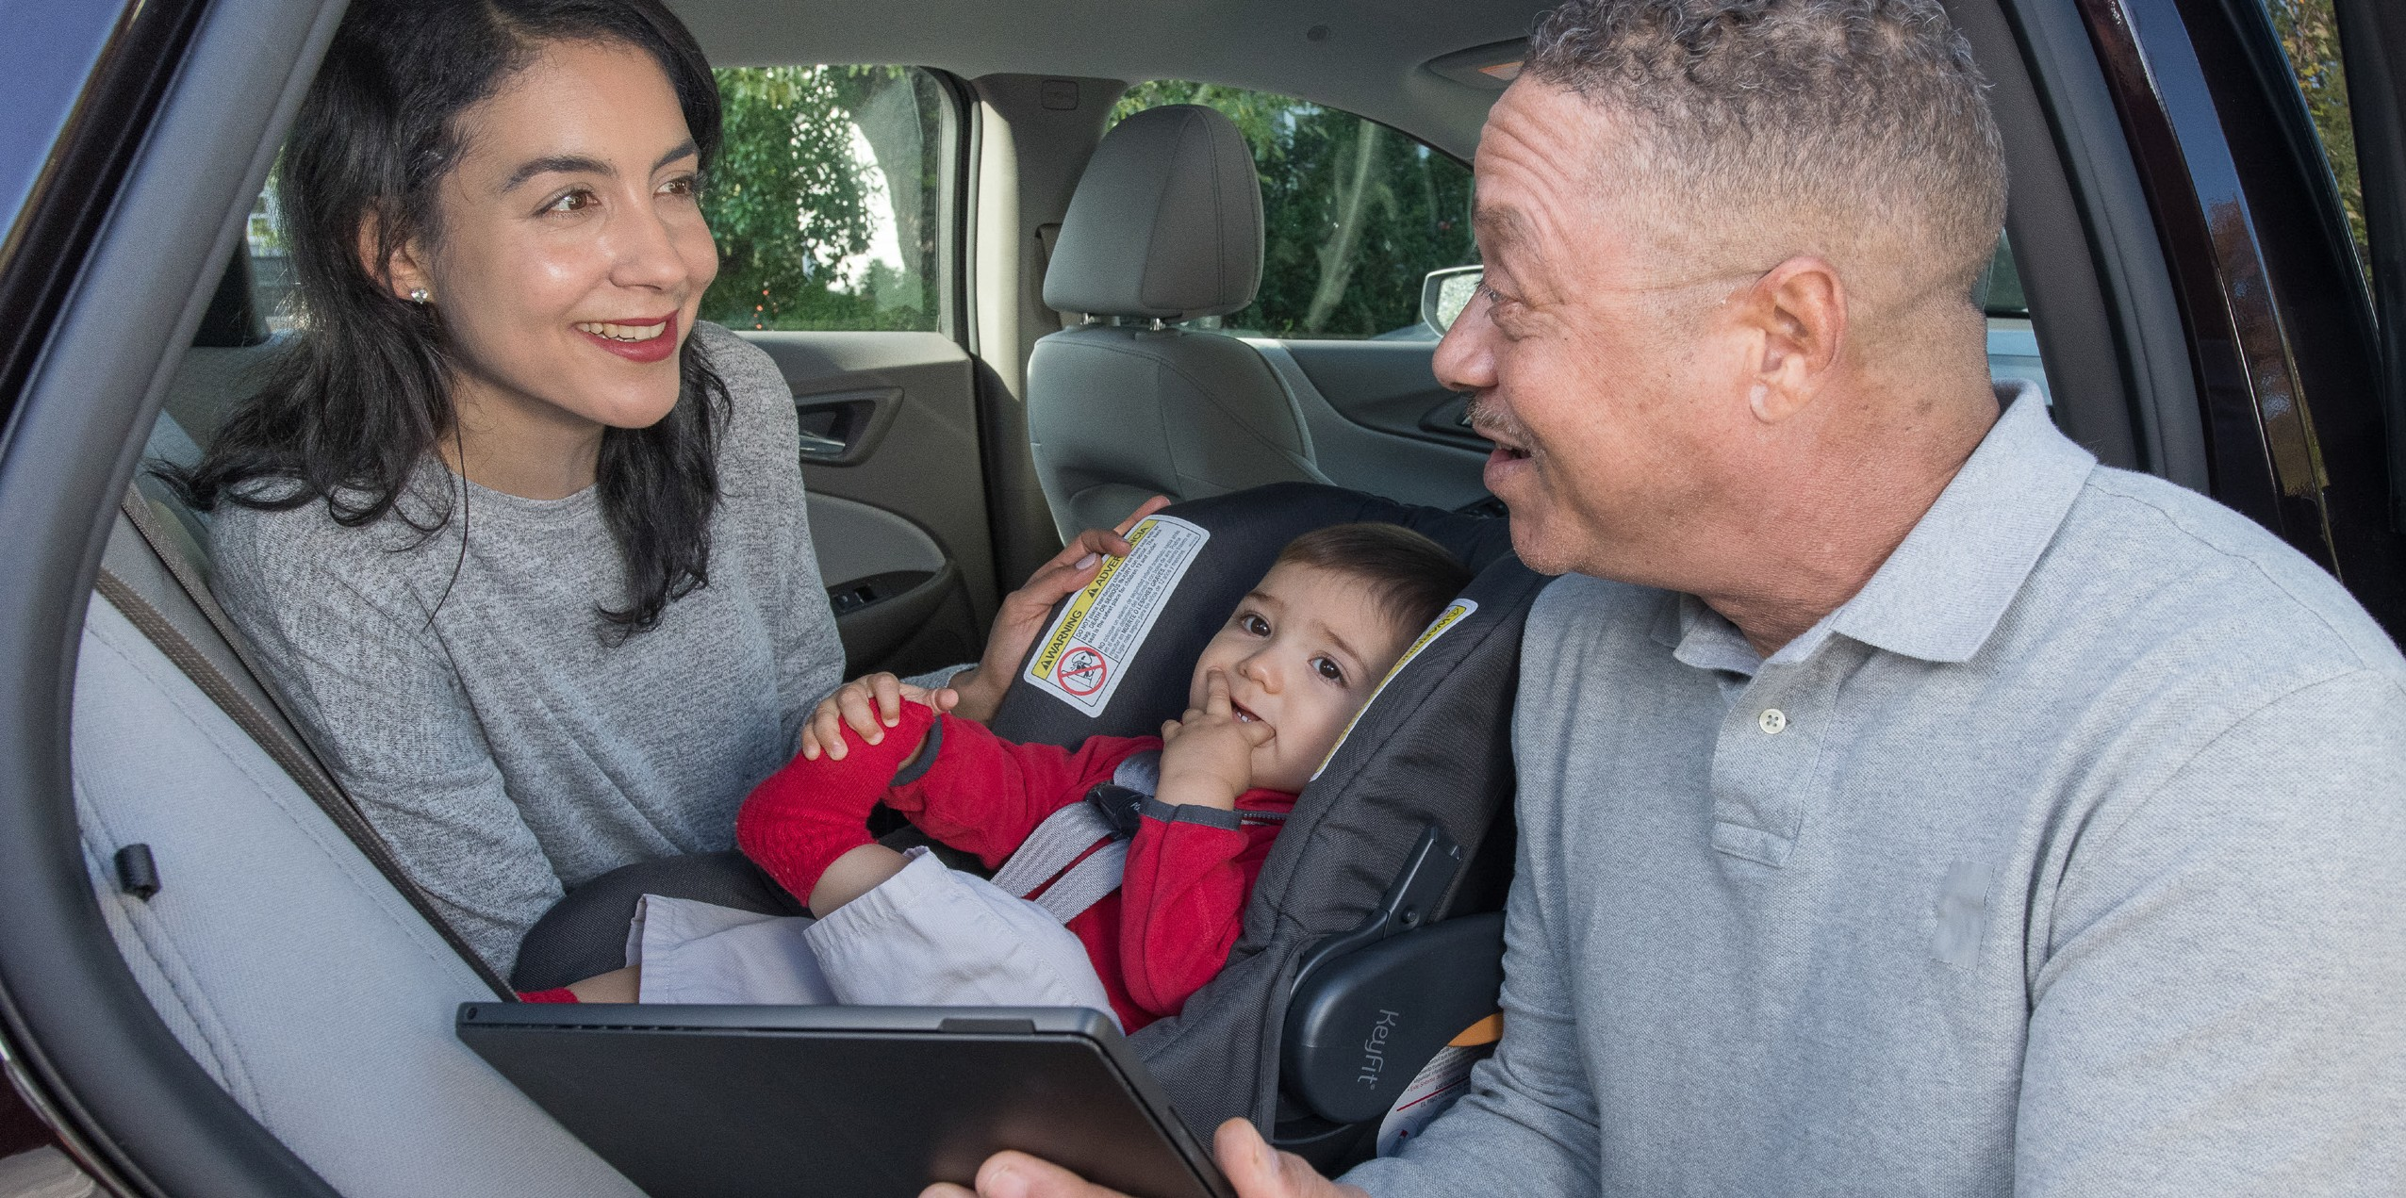
Providing Child Passenger Safety Support for Parents and Caregivers

CPS Programs can range from simple education and awareness events to more elaborate car seat installation and distribution services. Before creating a CPS program, it’s important to understand what CPS needs exist in your area. Ask around and consider conducting formal assessments to determine:
- What organizations in your area already provide CPS services and information?
- What are the needs of parents and caregivers in your area as it relates to CPS?
- Are there specific populations (i.e., neighborhoods, non-English language speakers, etc.) that are in greater need than others?
Once you understand the needs of the community you want to serve, it’s also important to assess your organization’s capacity to meet those needs. Work to evaluate your organization’s budgetary and staffing capacity to help determine the level of services you can provide. Questions to consider include:
- How much staff time can be dedicated to CPS services?
- Does your organization have the physical space to provide CPS services?
- Does your organization have the capacity to promote services or will you need to collaborate with someone?
- Does your organization have a budget to support the staff and materials necessary to provide CPS services?
- Will staff receive over-time pay for services provided?
This section explores options for services that can be provided in a CPS program including education, installations and inspections, and car seat distribution.

Education about
Providing Child Passenger Safety Support for Parents and Caregivers | 8
Child Passenger Safety

One of the most important aspects of a CPS program is interacting with and educating parents and caregivers. It is essential to engage parents and caregivers in one-on-one conversations and provide information in-person when possible. You can offer educational materials, presentations, host tables at health and safety fairs, post on social media, or share information at other community events.
It’s important to consider multiple training formats (i.e., live demonstrations, print materials, videos, etc.) and provide instruction and materials in multiple languages to increase accessibility. No matter the level of service you are providing, it’s important to assess your community’s language and cultural needs. Families seeking CPS education, installations, and resources will come from various socioeconomic, cultural,
racial, and ethnic backgrounds. Therefore, depending on your community’s needs, consider offering print materials, videos, and other resources in multiple languages.
It can also be valuable to have staff or interpreters who can speak in the caregiver’s preferred language when providing instruction. In Massachusetts, the top non-English languages spoken are Spanish, Portuguese, Haitian Creole, Chinese, Vietnamese, and Khmer/Cambodian. For specific guidance and recommendations for developing materials in multiple languages for your CPS program, you can refer to MDPH’s Translation Toolkit. In addition, Safe Kids Worldwide Community Education Outreach Tips provides several strategies for engaging with and educating communities in child passenger safety.
Tips for Educating Caregivers on Car Seat Installation
  - Provide as much hands-on experience as possible
  - Demonstrate the installation and ask caregivers to repeat the process while explaining each step to help reinforce their skills
  - Be positive, encouraging, and provide praise when they do something correctly
  - Keep instruction as simple as possible and avoid using abbreviations
  - Promote best practices while still respecting the parent’s cultural or religious beliefs
  - Ask follow-up and open-ended questions to determine what they need and address challenges
  - Empower the parent or caregiver to feel confident when installing or using their child’s car seat or booster seat in the future
  - Encourage them to come back if they need additional help or when they need to transition their child into the next car or booster seat

Resource:
Learn more about providing Child Passenger Safety education and how to best interact with parents and caregivers in the NHTSA CPS Technician Guide (page 185).

KEY TOPICS AND INFORMATION TO SHARE WITH CAREGIVERS ABOUT BEST PRACTICES THAT PROMOTE CHILD PASSENGER SAFETY

Topic | Key Information | Resources
Massachusetts  Child Restraint Laws | All motor vehicle passengers, including operators, are required to wear a properly adjusted and fastened safety belt.10 Massachusetts General Law Chapter 90, Section 7AA requires every child under age 8 or less than 5’7” to sit in an appropriate child passenger seating system while traveling in a motor vehicle. Proper restraint use provides the greatest degree of safety when traveling in a passenger vehicle. | Car Seat Laws in Massachusetts
 | From age 8 or 5’7” until age 13, child passengers no longer using child passenger restraint systems are required to wear a safety belt, “properly adjusted and fastened according to the manufacturer’s instructions.”11
Selecting a Car Seat | The type of car seat a caregiver should use depends on the child’s age, weight, and height. The following types of car seats should be used in the following life stages:  Birth to 12 Months:  - Rear-facing car seat 1 to 3 Years:  - Rear-facing car seat until the child reaches the weight or height limit of the car seat allowed by the car seat manufacturer  - Forward-facing car seat with a harness until the child reaches the weight or height limit of the car seat allowed by the car seat manufacturer  4 to 7 Years:  - Forward-facing car seat with a harness until the child reaches the weight or height limit of the car seat allowed by the car seat manufacturer  - Booster seat until the age of 8, or preferably until the child reaches the weight or height limit of the car seat allowed by the car seat manufacturer | NHTSA Car Seat Recommendations for Children  Safe Kids Ultimate Car Seat Guide
 |  | 9

Topic | Key Information | Resources
Parents and Caregivers as Role Models | Children whose parents use seatbelts are far more likely to use seatbelts themselves as they grow up. When parents wear their seatbelts and routinely engage their child in seat belt safety, children will perform those same behaviors and make their own safe decisions. In addition, having parents  set expectations early on around safety and taking a pledge with their child to always wear a seatbelt can also help motivate their children to wear a seatbelt. Therefore, encourage parents to start a seat belt safety conversation early, stay involved, and practice consistency with their child for every ride.  Parents can use these tips to motivate their children to buckle up for every ride:  - Always buckle up before moving the car, no matter how short or routine the drive  - Make sure all children and other passengers are properly buckled up  - Emphasize the potential benefits (i.e., earning more time to play) and consequences (i.e., getting hurt in a crash) for buckling up  - Let them know that it’s the law to wear a seat belt. Parents may get a fine from the police if they find their children not wearing a seat belt  - Continue to talk to your child about seat belt safety, and provide praise if you see them buckling up | NHTSA Seatbelt Safety
When to Change a Car Seat and Car Seat Expiration Dates | Car seats have an expiration date because the plastic they are made with can get brittle over time. It’s important to let parents and caregivers know to look for the expiration date and encourage them to get rid of the car seat once it expires.  Parents and caregivers should also discard car seats if they are in a vehicle that sustains a crash. This is because invisible damage can occur that weakens the car seat’s ability to protect a child. Sometimes, car insurance providers will pay for or provide partial reimbursement to replace car seats. In addition, there are retail companies that host car seat trade-in events. At these events, families can bring their car seats to be recycled, and receive gift cards or credit for a new car seat in return. | Safe Kids Buying the Right Car Seat & Expiration Dates

10

Topic | Key Information | Resources
Car Seat Recalls | CPS programs should stay informed with the latest car seat recalls and educate parents on how to register their child’s car seat so they can be notified if their car seat has been recalled.  Parents can register their car seat with the manufacturer by mail using the registration card that came with the car seat or online using the information found on the label of the car seat. In addition, they can also register their car seat online at safercar.gov/parents. CPS programs can share Safe Kids: Is your child riding in a recalled car seat? infographic with parents to help them with registering their car seat.  To find out if their car seat has been recalled, parents can visit NHTSA’s Child Seat Recall Listing and enter the car seat’s brand name, date of manufacture, and model number found on the label of the car seat. In the event of a recall, car seat manufacturers are required to notify all registered owners through first class mail. Parents can also contact the manufacturer to learn about the recall and how to make any necessary repairs. | NHTSA Child Seat Recall Listing  Safe Kids: Is your child riding in a recalled car seat?  Check to Protect: Vehicle Recall Check
Used Car Seats | Caregivers should seek new car seats rather than hand-me-down or used car seats when possible. The history of a used car seat can affect how effective it is in a crash. If the following is not known or cannot be verified, the used car seat should not be used:  - Whether or not the car seat is expired. Advise parents not to used expired car seats.  - Whether or not the car seat was involved in a crash. Crashes can render a car seat ineffective due to micro cracks caused during an impact. Car seats that were in a car during a moderate to severe collision should be discarded and replaced immediately.  - Whether or not the car seat has been recalled.  - How the car seat was cleaned and maintained. For more information see “Proper Car Seat Use & Maintenance” on the next page.  - Whether or not all the original parts and manual are available. Car seats without all the original parts should not be used. | Are Used Car Seats Safe for Baby? NHTSA Car Seat Use After a Crash What To Do With Old Car Seats
 |  | 11

Topic | Key Information | Resources
Reporting Car Seat Defects | CPS programs and parents can report car seat defects to help the manufacturers investigate and correct their mistake and prevent further injury or death among others who own the same product. Individuals can report a car seat defect or other motor vehicle safety problem to NHTSA’s website or their Vehicle Safety Hotline at 888-327-4236. | NHTSA Report a Safety Problem
Proper Car Seat Use and Maintenance | - Remove puffy coats before buckling a baby or child into a car seat. Puffy coats can cause the straps to be too loose and will not protect a child during a crash.  - Be careful when cleaning a car seat. Putting straps and covers in a washing machine or using harsh chemicals can cause the fibers to weaken, which means they could break during a crash. Advise parents to follow manufacturer guidelines for cleaning, avoid harsh cleaners, and never use a washing machine or dishwasher to clean parts. Spot cleaning with mild soap is generally the best practice for washing a car seat. | NHTSA Keep Your Little Ones Warm and Safe in their Car Seats  The Best Ways to Clean Car Seats
Financial Assistance for Purchasing a Car Seat | If your CPS program does not distribute car seats, consider sharing the following information with caregivers:  - Advise caregivers to talk to their health care provider about child passenger safety seats. Health care providers, including community health centers, hospitals and primary care providers, are adept at navigating insurance benefits, which often includes car seats.  - Determine if financial assistance and car seats are available through a program near you. Consider reaching out to an injury prevention  professional or program at a nearby hospital to check if they have a car seat distribution program. | For more information, please contact Mandi Summers at Mandi.Summers@baystatehealth. org or 413-794-6510
The Importance of Correct Car Seat Installation | - Car seats cannot provide the safety and security they are intended to provide if they are not installed correctly  - Programs and services exist to help install car seats correctly | See “Car Seat Inspections and Installations” section (page 15)
 |  | 12

Topic | Key Information | Resources
Heatstroke | It’s important to educate parents to never leave their child alone inside of a car as it puts them in danger of heatstroke. When a child is left inside of a hot car, their body temperature can rise rapidly, and they could die within minutes. Parents can use the following tips to keep their child safe and prevent heatstroke:  - Keep a purse, cellphone, or other personal item in the back seat as a reminder to look before you lock.  - Make it a habit to check the entire car before leaving, and “look before you lock.”  - Never leave a child alone inside of a car, even with the windows open or air conditioning turned on. | NHTSA Heatstroke  National Safety Council: Kids in Hot Cars Training
Backovers | A backover occurs when a car or vehicle is backing out from a driveway or parking space and injures an unattended child because the driver did not notice them. Parents, whether driving or walking with their children around parking lots or driveways, should be cautious and explain to their kids how to be safe around cars. Parents can use the following tips to prevent backover incidents:  - Be aware of small children as you may not see them while backing out  - Make sure to look behind you and check your mirrors while backing out  - Have children stand to the side of the driveway or sidewalk when backing out  - Teach children to not play or run around cars | NHTSA Child Safety
 |  | 13

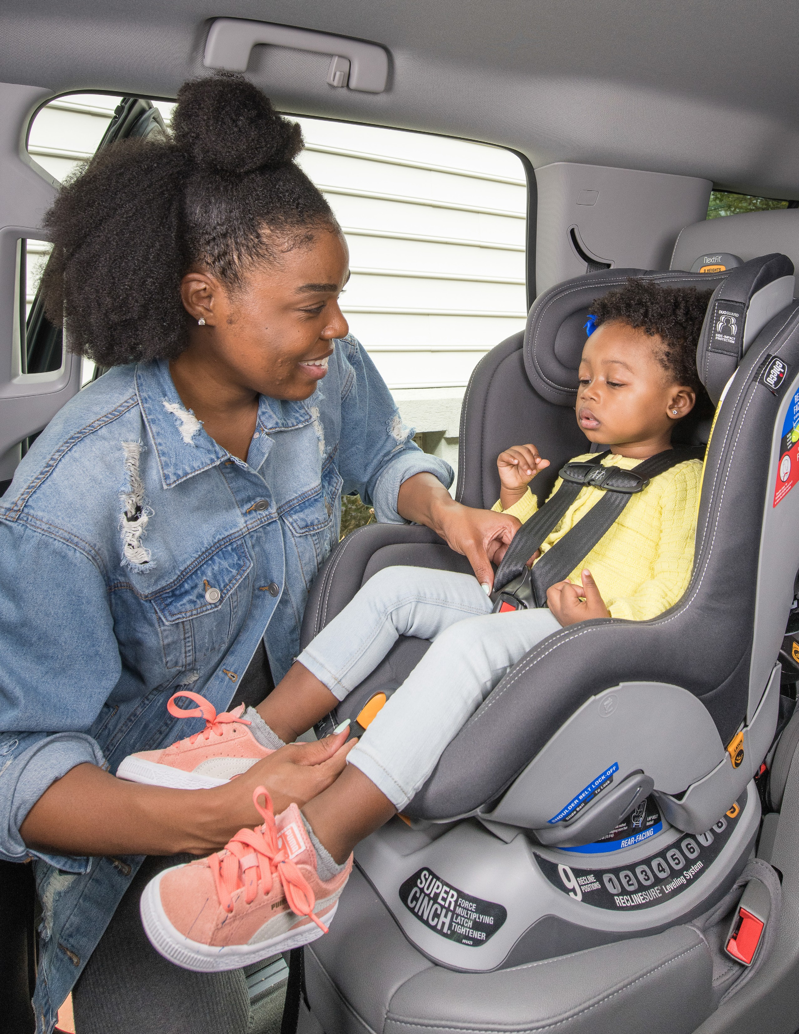

Car Seat Inspections and Installations
CPS inspection stations are locations where parents and caregivers can go to check if their car seat is prop- erly installed or have it installed. CPS inspection stations are implemented by nationally certified CPS tech- nicians (CPSTs) who are trained in the proper use and installation of car seats. To learn more about CPSTs, how to become a CPST, or to find a CPST with whom to partner, see the CPS Certification section (page 22).
CPSTs can provide car seat installation and demonstrations, guide parents through car seat installations, and ensure that a car seat is properly installed. In general, CPS inspection stations can be held either in-per- son as a permanent inspection station, as a mobile inspection station, or online.
Whether it’s a permanent or mobile inspection station, it’s important to ensure that parents and caregivers can access the location. The program should consider any geographic, socioeconomic, or transportation barriers that can make it difficult for families to travel to the inspection station. In addition, make sure there is sufficient shelter for families to be able to conduct in-person inspections in inclement weather.

TYPES OF INSPECTION STATIONS

Permanent Inspection Stations
A stationary location where parents and caregivers can walk-in or schedule an appointment to have their child’s car seat checked or installed. These stations can be hosted indoors or outdoors.

Mobile and Pop-Up Inspection Stations
These stations can be take place anywhere and can be helpful in reaching communities where access might be difficult. Vans, trailers, or other large vehicles can be used to carry necessary equipment for mobile stations, and community-based partner space is key for pop-up inspection stations. These stations can be held at parks, in parking lots, during community events or health fairs or at community centers and other family-friendly and easy access locations.

Virtual or Remote Inspections
If in-person education and inspection events are not possible—for example, because of COVID-19 pandemic closures or lack of accessibility—CPS inspections and education can be provided virtually. Massachusetts encourages use of virtual resources for parent education but does not recommend offering virtual CPS inspections since this method was introduced relatively recently and, as a result, has not been rigorously evaluated.

15

 | Permanent Inspection Stations | Mobile  Inspection Stations | Virtual or Remote Inspection Stations
Benefits | - Hands-on experience with parents and caregivers  - Permanent location makes service promotion easier  - Weather protection if indoors  - Allows for high capacity of parents and caregivers  - Set schedule and walk-in appointments | - Hands-on experience with parents and caregivers  - May increases accessibility for parents and caregivers  - Allows for high capacity of parents and caregiver  - Meets caregivers where they are  - If held in a public space, general car seat information can be  disseminated in addition to holding inspections | - Increases accessibility for some parents and caregivers  - Convenience for parents and caregivers
Challenges | - Inclement weather if outdoors  - Accessibility issues due to transportation  - Requires dedicating consistent staffing and space | - Requires space to store equipment  - Requires coordination and consistently looking for opportunities  - Less reliable dates and time  - Requires promotion  - Flexible options for busy pre-hospital providers | - More difficult to inspect car seat closely and fully  - More difficult to instruct and communicate with parent to install care seat  - Lower capacity for parents and caregivers  - Requires caregivers to have smart technology and access to  broadband internet or cell service
Equipment | - See “Supplies” (page 19) | - See “Supplies” (page 19) | - Smartphone, laptop, tablet
Resources | - NHTSA A Guide to Implementing Child Passenger Safety Inspection Stations | - NHTSA A Guide to Implementing Child Passenger Safety Inspection Stations
 | - National CPS Safety Board, Check Up • National CPS Safety Board, Check Up Events Events

- National CPS Board Virtual Seat Checks
- Safe Kids Worldwide Virtual Car Seat Safety Resources
- Udemy
16

ROLES & STAFFING
It takes a crew to plan, promote, and implement a CPS inspection program. Many inspection stations use
off-duty EMS staff already certified as CPSTs to cover drop-in hours, with additional CPSTs available as ‘back- up’ should off-duty personnel be required to respond to emergency calls. In addition, depending on your community’s needs, you may want to consider staffing CPSTs that can speak languages other than English or interpreters to better communicate and engage with families in their preferred language. It’s also im- portant to determine in advance if staff for drop-in hours will receive over-time pay, especially if you expect high volume wait times. On average, car seat inspections and installations can typically take 30-60 minutes, depending on the car seat and vehicle. Furthermore, it’s important to ensure that the parent feels confident that their child’s seat is installed correctly and that they feel comfortable reinstalling it on their own by the end of their inspection or installation. Parents and caregivers can use the Manufacturers Alliance for Child Passenger Safety Checklist to know what to expect from meeting with a CPST. Below are some of the key roles you will need to fill.

Certified CPSTs:
CPS Technicians (CPSTs) are individuals certified and trained to deliver education on child restraint installation and inspection, and motor vehicle safety. CPSTs are the central role in implementing an inspection station and instructing parents and caregivers on how to select, use, and install their child’s car seat. CPSTs should stay up-to-date on the latest recommendations and best practices for
child passenger safety, as well as car seat and booster seat recalls. After receiving certification, CPSTs will be able to:
- Conduct one-on-one inspections with families
- Examine and correctly install car and booster seats
- Teach parents and caregivers correct seat installation according to the manufacturer and vehicle guidance
- Deliver guidance based on state laws and standards for when and how to select the appropriate car seat for a child’s age, height, weight, and developmental needs
- Discuss how to ensure safety for child and other passengers in and around the vehicle.
For information about CPS Certification, visit Safe Kids National CPS Certification Policies and Procedures Manual.

Technician Proxy
In communities with limited numbers of CPS Instructors, CPSTs can become a Technician Proxy. CPS Technician Proxies review and evaluate seat installation, technical skills, and training communication for CPSTs applying for recertification. Individuals must be certified and active as a CPST for at least six months before becoming eligible to apply as a proxy. Being a Technician Proxy requires especially strong technical and training skills for delivering guidance and helpful feedback
to CPSTs. For information about Technician Proxies, visit Safe Kids National CPS Certification Policies and Procedures Manual.

17

Inspection Coordinator
These coordinators can help manage documentation collected from CPS Inspection events and track CPST Certification. Duties may include scheduling inspection appointments, ordering supplies, filing and gathering data from inspection forms, and maintaining educational materials. This role may also be responsible for marketing and promotional activities (See Promoting the Event or Service, page 21). This coordinator does not need to be a certified CPST, but should have knowledge of CPS and formal training. The roles and responsibilities of this position can be expanded based on program needs.

Scribe/Recorder
The scribe or recorder is responsible for collecting data at the inspection station including information about the driver’s vehicle, passengers, and child restraints. In addition, they can gather information on car seat misuse, corrections made, seats installed, and education provided to the families during inspections. The scribe makes sure all necessary forms are signed by the driver and reviewed by the CPST and filed appropriately for record.

Traffic Coordinator
Depending on the volume of traffic and if the inspection station is held outdoors, the CPS program may enlist a traffic coordinator that helps guide vehicles and families safely throughout the location. This role is typically held by members of law enforcement who have experience with directing traffic and ensuring the public’s safety.

Tips for Finding a Certified Technician Partner
To serve a large jurisdiction or specific populations, EMS agencies can partner with current CPST to host a CPS program. Partnering is a great option if you are not yet certified as a CPST or decide to not pursue CPS certification. As you select a CPST partner, consider:
- Determining how to delegate responsibilities for logistics and format of the inspection event
- Identifying the primary audience for the inspection event to develop tailored messages and outreach
- Selecting CPSTs who have experience working with the primary audience to meet language and cultural needs
- Connecting with MDPH CPS Certification Coordinator to identify potential CPSTs to partner with (Mandi Summers, Mandi.Summers@baystatehealth.org)

Car Seat Inspections and Installations | 18

SUPPLIES
There are several supplies and logistics issues to consider when planning a CPS inspection. Whether it’s a permanent or mobile inspection station, CPS programs should ensure the following are on hand when providing inspection and installation services:
- Access to power for videos and presentations (as necessary)
- Adequate and accessible space for installation
- Availability of a car seat to use in demonstrations, and the car seat’s manufacturers’ instructions
- Clipboards, pens, and pencils
- Current list of child passenger seats
- Demonstration dolls
- Educational materials
- Event signage (as necessary)
- First aid kits, anti-bacterial soap/lotion, and latex gloves
- List of nearby stores where new seats can be purchased
- Print and/or digital car seat inspection forms
- Locking clip
- Tents, traffic cones, and barricades (as necessary)
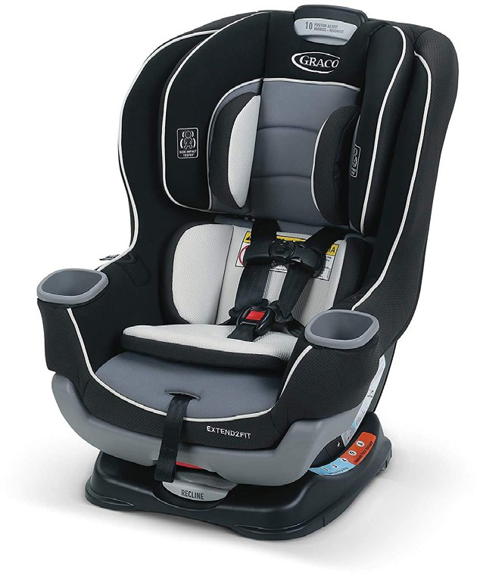
Review NHTSA’s A Guide to Implementing Child Passenger Safety Inspection Stations for additional information.
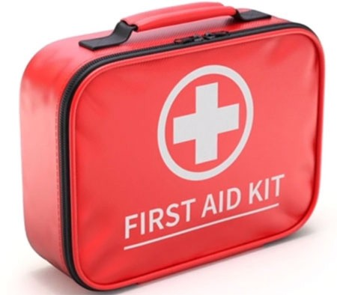
Clipboard

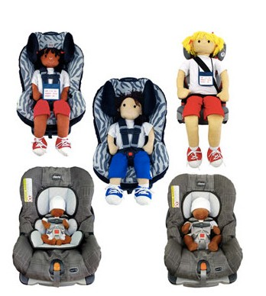Car Seat for Demonstration
First Aid Kit

Locking Clip

Demonstration Dolls

19

Car and Booster Seat Distribution

A major budgetary consideration is whether to purchase a car or booster seats for children in need. If funding is available for car seats, programs can choose to provide free or discounted car or booster seats on an as-needed basis. If providing free or discounted car or booster seats, programs are advised to develop a written policy for criteria and procedures for seat distribution if they provide this service. That policy should include:
- Who is eligible to receive a car or booster seat
- How recipient can request a car or booster seat
- How eligibility will be confirmed
- Expectations for caregivers receiving a car or booster seat, such as participation in an education program, or demonstration of car or booster seat installation
- How car seats will be purchased, stored, and checked for recall or defect
For examples and technical support developing a car or booster seat distribution policy, contact DPH.IPCP@mass.gov.

Tips for Finding Car Seats Near You
If purchasing car seats isn’t right for your program, you can also provide a list of local community resources that offer free or discounted cars seats to families in need. For assistance on finding car seats near you, contact MDPH CPS Certification Coordinator, Mandi Summers, at Mandi.Summers@baystatehealth.org or 413-794-6510.

Car and Booster Seat Distribution | 20

Event Planning, Logistics,
and Operations of CPS Programs

This portion of the guide is intended to help people who are running in-person events for child passenger safety. It provides a review of key aspects related to preparation and delivery of the event, including scheduling, supplies needed, and event promotion.

SCHEDULING
Attention to scheduling and clearly communicating drop-in hours or appointments is essential to establishing strong relationships and a sense of consistency with families. Whether it’s daily, weekly, or monthly, set up and communicate a consistent schedule and process for inspections. In addition, it’s strongly encouraged to create an online or voicemail system to support scheduling appointments appointment reminders.

PROMOTING THE EVENT OR SERVICE
There are a variety of communication channels that CPS programs can use to promote their inspection and education events. Examples include posting information on websites, social media, permanent signage, newspapers, flyers, and community calendars. The following are potential partners who can help you get the word out:
- Recreation departments, YMCAs, Boys and Girls Clubs
- Your local board of health
- Your local police department
- Parent Teacher Organizations
- Local municipality specific social media groups
- Local health care providers such as hospitals, pediatrician practices, and community health centers
- Libraries, churches, local businesses, and community centers
Hosting CPS events at community events such as cultural celebrations, holidays, fairs, and other community-centered events can also help increase promotion and attracting families to your CPS program. In addition, continuous promotion and making sure your contact information is up to date helps parents and caregivers access your program’s services and resources more readily. New child passengers are born
daily, and their parents are new too! For more information on strategies for promoting and planning a health event, visit CDC’s Child Injury Prevention Event Planning Guide.

21

Assuring Continuity of the Program

The following strategies can be used to ensure agencies can successfully sustain and continue to see the benefits of CPS programs:

Employee training and support.
- Select CPSTs who are particularly skilled in training and interacting with community members to serve as coaches that can mentor fellow CPSTs on working with parents and caregivers.
- Allow staff time to complete trainings and maintaining certification, including reallocation of staff responsibilities to support participation in CPS events.

Becoming A Certified Technician
One way to assure continuity of CPS program and assure consistent access to CPST is to make sure someone at the fire or ambulance service is a certified CPST. To become a CPST, individuals must complete a training course. Two approved training providers for Massachusetts CPST courses are:

MA EOPSS Child Passenger Training Opportunities
The MA EOPSS Child Passenger Safety Program currently pays the initial national certification fee of $95 for Massachusetts CPSTs. This program holds CEU update classes, events, and conferences to provide CPSTs with opportunities to get their requirements completed for recertification. Renewal classes are available for CPSTs whose certification lapsed no more than 1 year before the class start date.

Safe Kids National CPS Certification
This Certification is valid for 2 years, after which CPSTs can apply for recertification. CPSTs can become recertified through Safe Kids Worldwide Recertification, which requires:
- Completing required recertification activities – Review the full list of certification requirements
- Registration and payment of recertification fees
Technicians can begin the recertification process 4 months prior to when their certification expires and must complete all recertification requirements by the date of their certification expiration. Active technicians whose certification expires prior to completing the recertification process can repeat the certification course or register for a special Certification Renewal Testing Course. The Certification Renewal Testing Course is designed only for CPSTs actively conducting CPS education and inspections but are unable to complete recertification before expiration.

Becoming a CPS Instructor
CPS Instructors serve as mentors and trainers to new CPSTs. Instructors must complete recertification every two years. The following must be completed to become a CPS Instructor:
- Have been a CPST for at least 6 months
- Complete the Instructors application process
- Complete Certified Instructor candidacy
- Teach at least one 20-hour certification course during instructor candidacy
- Work with a mentor and CPS Instructor to prepare and evaluate certification course instruction
- For more information, visit Safe Kids Become a Certified CPS Instructor.

Assuring Continuity of the Program | 22

Establish organizational structures and practices that support the CPS Program.
- Create and maintain updated job descriptions, program documentation forms, local guidance, or tip sheets for what works in your community
- Identify and maintain updated tips and guidance for CPSTs
- Assign a CPS Inspection Coordinator role. Focus this role as broadly or narrowly as necessary for the agency, level of inspection and education activities offered.
- Apply for Community EMS (CEMS) Certification.

CEMS Certification
Pre-Hospital Provider organizations interested in establishing a CPS Program can apply for certification through the Massachusetts Department of Public Health’s (MDPH) Community EMS Program (CEMS).
To apply, a local public health authority (such as a board of health) must complete the Community EMS application form. It must be completed in partnership with the primary ambulance service in the local jurisdiction. The application, needs to include a detailed description of each program, must be received by DPH at least 30 calendar days prior to the proposed start of CEMS Program operations.

Ensure EMS agency leaders prioritize continuing CPS Program efforts.
Support from EMS agency leaders can include:
- Promoting the program internally and externally to networks and communities
- Maintaining partnerships with local health agencies
- Confirming EMS staff schedules include time for hosting community events
- Sharing data on the impact and results from CPS Inspections with leadership (for example, number of families served, number of seats installed correctly, quotes or feedback from families)

Identify potential funding sources.
CPS Programs do not necessarily require dedicated funding, but it can help support important aspects of your program.
- Identify ways to cover costs for discounted or free seats, providing pamphlets and resources, updating or repairing technology, or using public facilities.
- Contact MDPH for technical assistance and guidance about child passenger safety and available resources.
- Consider partnering with local health departments, businesses, insurance companies, or other organizations as funders.
CPS programs can also seek potential sponsorships from local law enforcement, fire departments, public health facilities, or other local businesses for support and promotion. For larger events, CPS programs can also partner with vehicle manufacturers, insurance companies, and media outlets for broader publicity.
Moreover, securing financial support from multiple sources may provide long-term sustainability for the CPS program. If your agency is allowed to accept donations, make sure to obtain and track adequate documentation and records. You can find available grant opportunities for car seat distribution at MA Traffic Safety Grants.

23
|

Frequently Asked Questions

Will Massachusetts accept CPST certification completed in another state?
Yes, the CPS Technician Certification is a national training curriculum.

Are CPST certification courses eligible for EMS continuing education?
Office of EMS continuing education credits are available for CPS Certification courses applicants Please reach out to the Office of EMS or their Regional EMS Office for more information.

Where can I find CPS technician trainings?
Visit the Safe Kids National CPS Certification website for a list of trainings.

My agency would like to host an inspection event, but we don’t have enough CPSTs. How can we partner or connect with additional CPSTs?
CPSTs, inspectors, and proxies are happy to provide support and mentor new providers. Agencies can connect with CPSTs in other communities by contacting MDPH CPS Certification Coordinator, Mandi Summers, at Mandi.Summers@baystatehealth.org or 413-794-6510, visiting the Safe Kids National CPS website, or by searching through the Massachusetts CPS Technician Facebook
group.

How can we promote our CPS program inspections to communities? Experienced CPSTs and program coordinators encourage posting an email address or voicemail for scheduling appointments on your agency website and sharing with parenting programs. In
addition, see Promoting the Event or Service on page 21.

How can we better manage the flow of inspection requests?
Developing an appointment-based inspection schedule (i.e., weekly or monthly) is especially helpful for agencies with fewer numbers of CPSTs.

Frequently Asked Questions | 24

Resources

CPS Certification
Massachusetts DPH CPS Training opportunities: MA DPH offers CPS training across the state through a collaboration with Baystate Children’s Hospital to certify technicians and instructors. These trainings are available for both initial and continuing education certification needs. Trainings are scheduled by Baystate’s contact person, Mandi Summers, and listed on the DPH website as scheduled. Please contact Mandi.Summers@baystatehealth.org at Baystate Children’s Hospital or call 413-794-6510 for updates on the training schedule.
NHTSA CPS Technician Guide: The National Highway Traffic Safety Administration’s (NHTSA) technician guide serves as an in-depth toolkit for understanding the roles and responsibilities of CPSTs, car seats and seatbelt systems, and interacting with caregivers.
Safe Kids CPS Certification: Safe Kids serves as the national provider for training and certifying board for CPSTs. The program regularly develops and updates the national standards, certification training and testing resources, and maintains a directory of certified technicians.
Safe Kids CPS Recertification: Safe Kids manages the recertification process and records for CPSTs. CPSTs must be recertified every two years to maintain good standing. Recertification includes demonstration of continuing education, demonstrated performance of five types of child car seat checks, hosting community education activities, and recertification fees.
Safe Travel for All Children: The National Center for the Safe Transportation of Children with Special Health Care Needs provides trainings on transporting children with medical or developmental conditions (e.g. Casts, Achondroplasia, Autism Spectrum or other developmental disorders, premature or low birthweight infants, congenital disorders).

CPS Technician Instructor and Proxy Training:
Safe Kids CPS Technician Instructor Certification: Experienced CPSTs who are ready to help others learn how to become technicians can become certified instructors by completing the instructor candidacy process and successfully teach a certification course.
Safe Kids CPS Technician Proxy Application: Anyone who has been CPS-certified for at least six months may apply to be a technician proxy. Technician proxies can review and approve seat checks for recertification.

25

Resources for Managing CPS Programs
CDC Car Seat Graphics: Images comparing correct and incorrect use of car seats, booster seats, and other child restraint systems.
CDC Roadway to Safer Tribal Communities Toolkit: Developed by CDC and Indian Health Services, includes fact sheets, posters and a video aimed at reducing traffic injuries among the American Indian and Alaska Native population. The materials focus on increasing proper child safety seat and seat belt use and decreasing impaired driving.
Kids and Cars: A nonprofit child safety organization that conducts research and provides data on non-traffic automobile fatalities, the dangers of leaving children in or around vehicles, and information for parents. It also provides information on dangers such as heat stroke, power windows, trunk entrapment, vehicles set in motion, and more.
Massachusetts Car Seat Safety: Includes resources and information for parents and caregivers on child car seat safety, identifying and selecting car seats, and finding car seat inspection locations.
Massachusetts CEMS Program: Pre-Hospital Provider organizations interested in establishing a CPS Program can apply for certification through the Massachusetts Department of Public Health’s Community EMS Program (CEMS).
National Digital Car Seat Check Form: This National CPS Board form is a free resource to help CPSTs digitally document car seat checks.
National CPS Certification Policies & Procedures Manual: This manual contains important information regarding Safe Kids policies and procedures for the National CPS Certification Training Program.
Safe Kids CPS Organization Management: Safe Kids offers an online system to help manage and coordinate CPS certification of employees, members and others affiliated with hospitals, police and fire departments, and other agencies.
Safe Kids Ultimate Car Seat Guide: A guide for CPSTs, parents, and caregivers to learn how to choose, install, fit and upgrade a child’s car seat.

Funding Opportunities
MA Traffic Safety Grants: Grants offered by the Office of Grants and Research’s Highway Safety Division including funding for car seat distribution and traffic safety programs.

Resources | 26

Administrative & Policy Resources
American Academy of Pediatrics CPS Policy Statement: This policy statement from the American Academy of Pediatrics was developed to be used by pediatricians with patients during health care visits to encourage awareness and promotion of family use of child car seats.
American Academy of Pediatrics CPS Technical Report: This technical report from the American Academy of Pediatrics provides a summary of the child motor vehicle safety research, from child restraints to other safety practices.
NHTSA: The National Highway Traffic Safety Administration is the US federal agency responsible for promoting child passenger safety. NHTSA promotes public awareness and provides several parent friendly resources.

State CPS Programs
Indiana Big Kid Booster Bash Toolkit: This toolkit for CPSTs provides information on the resources, roles and responsibilities, and strategies for hosting a booster seat-focused inspection event.
Texas Health & Human Services Safe Riders CPS Program: The Texas Department of State Health Services’ Safe Riders Child Passenger Safety Program offers resources and support for parents, child passenger safety technicians, and safety advocates including car seats, car seat inspections, and trainings.

Safe Transportation of Children
American Academy of Pediatrics Safe Transportation Policy Statement
National Center for the Safe Transportation of Children with Special Health Care Needs

CPS Campaign & Promotion Resources
Child Passenger Safety Technician Month Child Passenger Safety Week
NHTSA Traffic Safety Campaign Resources

27

Citations

1 https://www.cdc.gov/transportationsafety/child_passenger_safety/cps-factsheet.html
2 Massachusetts Inpatient Hospital Discharge, Outpatient Emergency Department Discharge, and Outpatient Observation Stay data, fiscal years 2016-2019, Center for Health Information and Analysis
3 Massachusetts Ambulance Trip Record Information System, 2016-2019, MA Department of Public Health
4 “Child Passenger Safety: Get the Facts.” Centers for Disease Control and Prevention, Centers for Disease Control and Prevention, 20 Sept. 2021, https://www.cdc.gov/transportationsafety/child_passenger_safety/ cps-factsheet.html.
5 Massachusetts Inpatient Hospital Discharge, Outpatient Emergency Department Discharge, and Outpatient Observation Stay data, fiscal years 2016-2019, Center for Health Information and Analysis6
6 https://www.cdc.gov/transportationsafety/child_passenger_safety/cps-factsheet.html
7 Arbogast KB, Durbin DR, Cornejo RA, Kallan MJ, Winston FK. An evaluation of forward-facing child restraint systems. Accident Analysis and Prevention 2004;36(4):585-9.
8 Zaloshnja E, Miller TR, Hendrie D. Effectiveness of child safety seats vs safety belts for children aged 2 to 3 years. Archives of Pediatrics and Adolescent Medicine 2007;161:65-8.
9 Massachusetts Inpatient Hospital Discharge, Outpatient Emergency Department Discharge, and Outpatient Observation Stay data, fiscal years 2016-2019, Center for Health Information and Analysis
10 Mass. Gen. Law Ch. 90, § 13A. Available at: https://malegislature.gov/Laws/GeneralLaws/Parti/Titlexiv/ Chapter90/Section13a
11 Mass. Gen. Laws ch. 90, § 7AA. Available at: https://malegislature.gov/laws/generallaws/parti/titlexiv/ chapter90/section7aa
12 https://www.mass.gov/service-details/car-seat-laws-in-massachusetts

Citations | 28

Acknowledgement
Promoting Child Passenger Safety: A Toolkit for Pre-Hospital Providers was produced by the Massachusetts Department of Public Health, in Collaboration with the Northeast and Caribbean Injury Prevention Network (NCIPN), Education Development Center, Inc., Waltham, MA under CDC Cooperative Agreement # CE16-1603, through a contract with the Massachusetts Department of Public Health. The views represented in this toolkit are those of the authors and do not necessarily reflect the views of the Massachusetts Department
of Public Health. This information is based on the most current best practices as of 2021. The resources included in this guide are not meant to be comprehensive, nor are the listings intended as endorsements. Published August 2022.

