Data Brief:
CHILDHOOD LEAD EXPOSURE IN MASSACHUSETTS
June 2016
Massachusetts Department of Public Health | RELEASED: june 2016

Background

Lead Exposure Summary
- Lead exposure is a significant health risk for Massachusetts children
- There is no safe level of lead exposure
- Massachusetts has the 4th oldest housing stock in the country
- BLLs have historically declined; however, most recent data show statewide trends have plateaued
- ~90% of Massachusetts pre-1978 housing stock has yet to report any deleading activity
- In 2015, 3,737 children were identified with BLLs over the CDC’s “reference value”
- Lead exposure is not only an urban issue, but impacts all areas of the state
- Lead disproportionately impacts lower income, minority, and gateway communities
While the Commonwealth has made substantial gains in mitigating the harmful effects of lead exposure through public health interventions over the past 45 years, lead exposure remains a significant health risk for children across the Commonwealth of Massachusetts.
There is no safe level of exposure to lead and even exposure to relatively low levels can cause severe and irreversible health effects, including damage to a child’s mental and physical development. Numerous studies have documented correlations between childhood lead poisoning and future school performance, unemployment, crime, violence, and incarceration, making lead exposure an important social determinant of health.
The Massachusetts Lead Law (see MGL c. 111, §§ 189A-199B and 105 CMR 460.000) requires any dwelling unit where a child under six years of age resides to be deleaded, regardless of a child’s blood lead level (BLL) or whether the property is owner occupied. The law also requires that all children be tested for blood lead between the ages of 9 - 12 months, again at ages 2 and 3, and – if they live in a high-risk community – tested again at age 4.
DPH’s Bureau of Environmental Health enforces the Commonwealth’s lead law and collects and analyzes data based on childhood blood lead screening and environmental (housing) records.

Blood Lead Levels
Current DPH regulation defines lead poisoning in children as a concentration of lead in whole venous blood of 25 µg/dL or greater and initiates activities to bring the child’s home into compliance with the lead law, including mandatory deleading. DPH also provides services (e.g., medical case management and voluntary code enforcement interventions) to families with children identified with BLLs between 10-24 µg/dL. Regardless of BLL, DPH provides education about the dangers of lead exposure and how to prevent it.
Massachusetts has the fourth oldest housing stock in the country, with approximately 71% of housing built before 1978 – the year lead was banned in residential paint. Children are most often exposed to lead through ingestion of dust or soil contaminated by loose or deteriorated lead paint, often on windows and exteriors, or disturbed by unsafe renovation work. Exposure can also occur from lead in water, toys, and other items, such as jewelry.

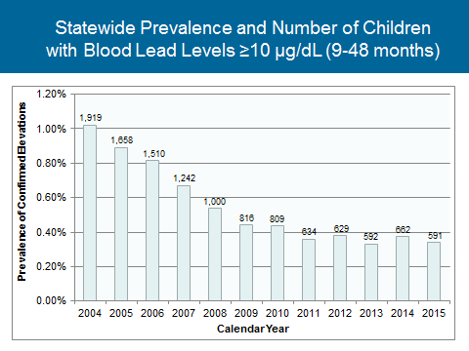
While the BLLs of children in Massachusetts have historically declined, most recent statewide trends have plateaued. This data is underscored by data demonstrating that only ~10% of those Massachusetts homes built prior to 1978 have been reported as inspected and deleaded. With the potential of ~90% of pre-1978 housing still not considered lead safe, children will likely continue to be exposed to high levels of lead in their homes.
Exhibit 1: Statewide Prevalence and Number of Children with
Blood Lead Levels ≥ 10 µg/dL (9-48 months)
Lead screening data from calendar year 2015 indicates that 3,737 children may have BLLs that, according to the federal Centers for Disease Control and Prevention (CDC), require case management (BLLs of 5 to 9 µg/dL); 565 were identified with BLLs prompting immediate DPH intervention and follow up services (BLLs of 10-24 µg/dL); and 64 children were identified with having BLLs legally considered “lead poisoned” pursuant to current Massachusetts regulation (BLL of 25 µg/dL or greater).
Exhibit 1 shows the statewide prevalence of and number of children, per calendar year, with confirmed blood lead levels above 10.

High Risk Communities
Utilizing data, DPH identifies communities with a higher risk of lead poisoning to better target resources to vulnerable children and to reduce health disparities associated with lead exposure. DPH determines risk by looking at rates of newly elevated children, the age of housing, and the presence of low to moderate income families for each of the 351 cities and towns.
Approximately 60% of identified cases of children with elevated blood lead levels live in high-risk communities even though only about one third of Massachusetts children live in those communities. This disparity in the prevalence of elevated childhood blood lead levels has persisted, despite reductions in BLLs overall (see Exhibit 2 below).
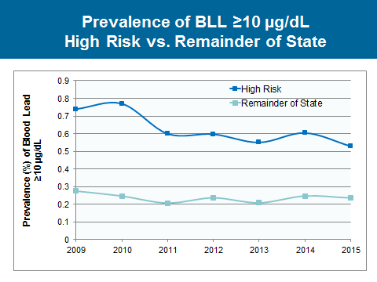
High-risk communities are in every part of the state. In 2015, 22 high-risk communities were identified.
Exhibit 2: Prevalence of Blood Lead Levels ≥ 10µg/dL Comparison of High-Risk Communities and Rest of MA
Communities

- Lynn
- Malden
- Milford
- New Bedford
- North Adams
- Palmer
- Pittsfield
- Somerville
- Southbridge
- Springfield
- Worcester
2015 High-Risk

- Boston
- Brockton
- Chelsea
- Chicopee
- Everett
- Fall River
- Fitchburg
- Haverhill
- Holyoke
- Lawrence
- Lowell

Health Equity Issue
While lead continues to affect children in all communities across Massachusetts, data collected by DPH shows that lead exposure disproportionately impacts gateway and lower income communities with higher minority populations, making lead exposure a critical health equity issue.
While age of housing and poverty play a strong role across much of the state, racial make-up and English language ability are seen to be independently associated with elevated BLLs in central regions and within urban areas. Using modeling of childhood lead data and census tract level social determinants of health, we see that elevated blood lead levels (BLLs) affect certain populations more than others. After adjusting for old housing stock, poverty, and English language isolation, race/ethnicity is a driving factor of lead exposure as seen in the red/orange census tracts.
Exhibit 3: Strength of association between elevated blood lead levels (≥ 5 µg/dL) and racial make-up by census tract
Association
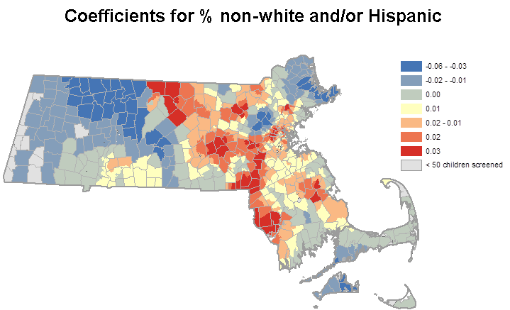
Low

High

For further details about the DPH Bureau of Environmental Health’s Childhood Lead Poisoning Prevention Program, please go to: www.mass.gov/dph/environmental_health.

Advisory Committee on Childhood Lead Poisoning Prevention for the Centers for Disease Control and Prevention. Low Level Lead Exposure Harms Children: A Renewed Call for Primary Prevention. January 2012: http://www.cdc.gov/nceh/lead/acclpp/final_document_030712.pdf
See Lanphear, BP, “The Conquest of Lead Poisoning: A Pyrrhic Victory,” Environmental Health Perspectives, Oct 2007, A484–A485.
See, e.g., Brown, MJ. “Costs and Benefits of Enforcing Housing Policies to Prevent Childhood Lead Poisoning.” Medical Decision Making, 2002, 22:482-492; Gould, E. “Childhood Lead Poisoning: Conservative Estimates of the Social and Economic Benefits of Lead Hazard Control.” Environmental Health Perspectives, 117(7):1162-1167; Reyes, Jessica, “Environmental Policy as Social Policy? The Impact of Childhood Lead Exposure on Crime.” National Bureau of Economic Research, May 2007. Available at http://www.nber.org/papers/w13097.
Blood lead levels include both confirmed and unconfirmed blood lead specimens.

