


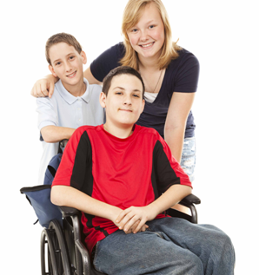



Recommendations for Strengthening Children, Youth, and Family Services in Massachusetts

Children, Youth, and Families (CYF) Advisory Committee Report
January 10, 2012

IT’S ALL ABOUT THE CHILDREN
COMMONWEALTH OF MASSACHUSETTS
EXECUTIVE OFFICE OF HEALTH AND HUMAN SERVICES

Message from Secretary JudyAnn Bigby MD, Executive Office of Health and Human Services

Governor Patrick has made it a priority to improve the Commonwealth’s children, youth, and families service system. The Executive Office of Health and Human Services (EOHHS) engaged in a year-long effort to develop recommendations and solicit as much feedback and input as possible from families, advocates, providers, subject matter experts, legislators, and other interested parties. This report represents the work of many people across the Commonwealth who believe that children and families can be better served in this state and that we share a collective responsibility to ensure that every child has the opportunity to learn and grow in a safe and nurturing environment.

Families have shared with us the need for a family-centric service delivery model that serves the whole child and family in a well-coordinated and effective manner, ensuring that the right service is offered to families at the right time.

The current system is largely fragmented and has created an unintentional burden on individuals and families who have to navigate multiple government agencies to identify and obtain services. The onus should not be on families to figure out how to navigate our system to get the information and services they need.

Historically, the Commonwealth’s systems, structures, and processes have been based on optimizing the effectiveness of individual services, programs, and funding streams agency-by-agency, thus creating silos that limit focus on the whole child and duplicate infrastructure and investments.

Families must navigate through multiple doors, multiple service plans, and multiple approaches for addressing a set of often interrelated needs. We’re doing a good job in our current structure, but without moving toward a more coordinated system of care, we are falling behind. Our current service delivery model consists of specialized responses to specific needs, and we need to think critically about the evolving needs of families and how effective we are in serving those needs. We owe it to our children and families to develop a collaborative and integrative approach.

To fulfill this promise to children and families, Massachusetts will develop a more integrated and holistic system of care that will produce successful outcomes for children, youth, and families. This reformed system will work to:
- Improve the families’ experiences interacting with child- and family-serving agencies;
- Give youth and families more voice and choice in service planning;
- Improve access to and coordination of services for children, youth, and families;
- Ensure accountability for improved outcomes; and
- Reduce administrative complexity to allow for more efficient and effective navigation of the system.

The report of the Children, Youth, and Families (CYF) Advisory Committee outlines a number of recommendations and opportunities for improving the state’s system of care for children in order to achieve the goals outlined above. To ensure that immediate action can be taken to strengthen services, the committee highlights a number of near-term opportunities. The committee recognizes that some of the proposed actions will require more detailed analysis and additional involvement of families and other stakeholders to ensure these steps are implemented in a thoughtful, well-coordinated, and cost effective manner.

Reforming the CYF system is a major undertaking that – to do right – will require years of continued effort, investment, and commitment across state government and amongst our partners to achieve. Accordingly, we are developing structure and capacity at EOHHS to guide and support our collective progress toward this vision. Throughout the implementation effort, we will continue to seek guidance and input from the Advisory Committee as well as families and youth. The involvement of families and youth is vital to our ability to design a system that optimally responds to their needs and helps them achieve personal success.

Reforming the CYF system is a multiyear initiative, but we cannot afford to wait to start this important work. We are committed to moving forward, and the work starts now. All of us need to work together and remember our ultimate focus: It’s all about the children!

I want to thank the members of the Advisory Committee for their time, hard work, and ongoing commitment to the children, youth, and families of Massachusetts.

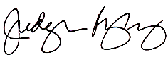

JudyAnn Bigby MD
Secretary, Executive Office of Health and Human Services
Table of Contents
Section 1: Executive Summary 5
Section 2: Call for Action 8
Section 3: Key Inputs to Recommendations 10
Section 4: Vision for the Future 16
Section 5: Key Challenges to be Considered 19
Section 6: Key Priority Areas 23
Access 24
Family-Facing Service Delivery 27
Interagency Coordination 30
People and Talent 33
Data and Technology 35
Family and Community Engagement 37
Section 7: Topics to be Further Developed 39
Section 8: Implementation Considerations and Next Steps 43
Appendix 49
- Advisory Committee Membership List
- Working Group Membership Lists
- Working Group Submissions: Detailed Findings from the Working Groups
- National Study Overview
- National Study
- Working Group Retreat: Participant Packet
- Listening Session Presentation
- Key Child Services and Initiatives

Section 1: Executive Summary

Background
The Commonwealth is committed to developing a more coordinated, integrated, and holistic system of care that will better support children, youth, and families.

Governor Patrick requested that the Executive Office of Health and Human Services (EOHHS) engage in a comprehensive process with stakeholders – including families, advocates, providers, legislators, and others) to identify opportunities for strengthening children’s services and improving service delivery for children, youth, and families in the Commonwealth. EOHHS leadership solicited feedback from families, consumers, providers, advocates, state employees, academics and other practitioners. EOHHS engaged a Children, Youth, and Families (CYF) Advisory Committee, made up of members of each of these stakeholder groups, to develop and prioritize recommendations for the Governor.

The Commonwealth’s current systems, structures, and processes for serving children and youth have been designed based on agency missions to optimize the effectiveness of individual services, programs, and funding streams, thus creating silos that limit the opportunity to address children’s needs without identifying eligibility for a particular program or entitlement. This creates gaps in services, such as the need to fit a child to a program (“square peg in round hole syndrome”) rather than the responding agency or program creating a plan that focuses on the whole child and family and their needs. Services are often funded based on the potential for federal financial participation such as in the Medicaid program and other federal programs, particularly as state funding for non-federally supported services has declined over the years. The primary child serving agencies must focus on their statutory obligations as child welfare and juvenile justice agencies. Children with other needs seek services from specialized programs across state government but families often have trouble finding these programs and understanding how to enter them when they can’t “diagnose” their children’s problems or identify specific needs. Children may receive services from multiple agencies and programs without the benefit of a common approach to their concerns, a shared understanding of core issues and desired outcomes, communication between agencies or providers, or data sharing across agencies and programs. The need for better coordination between health and human services and education is a particular recurring theme.

In order to achieve better access to a range of services for children and to improve outcomes for children and families the Commonwealth must develop a system of care that is more comprehensive, better integrated, and more coordinated across the public and private entities delivering these programs.

Vision for Reform
The CYF Advisory Committee’s vision is that Massachusetts will develop a more integrated and holistic system of care that will produce successful outcomes for children, youth, and families.

This reformed system will work to:
- Improve the experience of families when interacting with child- and family-serving agencies;
- Give youth and families more voice and choice in service planning;
- Improve access to, and coordination of, services provided to children, youth, and families;
- Ensure accountability for improved outcomes; and
- Reduce administrative complexity to allow for more efficient and effective navigation of the system.

Achieving these goals will strengthen children, families, and communities by developing a system that is: holistic, strengths-based and family-driven, responsive to needs, promotes healthy development, community focused, culturally competent, and evidence-based.

Recommendations for Improvement
Through the work of the members of the Advisory Committee, listening sessions across the state and a review of other states’ reform efforts and best practices, Advisory Committee working groups developed recommendations on how to improve services and/or service delivery for children and their families. The recommendations reflect the need for interventions at multiple levels. Although each individual initiative may improve a part of the service delivery system, the collective recommendations complement one another and further advance the administration’s goal of a coordinated and integrated system that serves children and families in a holistic and comprehensive fashion.

The key recommendations and other opportunities for improvement are organized by six priority areas: Access; Family-Facing Service Delivery; Interagency Coordination; People & Talent; Data & Technology; and Family & Community Engagement.

Priority recommendations of note include:
- Improve access to information and resources and simplify families’ interactions with the system;
  - Strengthen and simplify web-based and telephonic systems for information and resources;
  - Establish family access centers in the community;
  - Engage sister EOHHS agencies, Secretariats, and community partners in access centers; and
  - Expand peer specialists, family partners, and cultural/linguistic brokers.
- Enhance the eligibility process;
- Develop a system-wide and cross-agency vision, language, planning, processes, and governance;
- Strengthen coordination across the education system and CYF services;
- Optimize joint local, state, and federal funding;
- Ensure workforce competency;
  - Develop and conduct core CYF training;
  - Develop career paths and workforce development opportunities across the CYF spectrum;
  - Redesign employee evaluation processes and measures to drive desired change;
  - Ensure policies and protocols emphasize prevention and integration, respect for families, trauma-informed care, and cultural competence.
- Coordinate services and plans across CYF programs;
  - Develop data-sharing policies and protocols; and
  - Pursue interoperability of IT systems.
- Define CYF performance outcomes and reporting.

Implementation Considerations
Research and the experiences of other states shows that creating better coordinated and integrated systems of care for children and achieving the vision and goals we have identified for Massachusetts can take years. The recommendations proposed in this report are complex, requiring system-wide practice change, technology enhancements and investment, regulation and funding alignment, and more robust data sharing capabilities and analytics across systems. Not only are they complex, but many of the recommendations are interrelated and, therefore, will need to be sequenced and implemented in a thoughtful, well-coordinated and cost effective manner.

If these recommendations are approved by the Governor, one of the immediate next steps will be the development of an implementation roadmap and detailed project plan that will be used to guide the effort going forward. The roadmap would look at each recommendation and define the desired future end state, analyze what is in place today, and provide the state with a strategy/approach to get “from here to there” in support of the broader CYF vision and goals. Additionally, the roadmap will look at all of the initiatives together and propose a comprehensive implementation approach that includes ‘quick wins’, key milestones, and measures to track ongoing progress.

Accountability for managing and continuing to drive this effort is critical. The Secretary of EOHHS will manage and ensure implementation of the recommendations by establishing a cross-agency leadership structure within the Secretary’s Office that will be lead by the Assistant Secretary of Children, Youth, and Families. The Assistant Secretary will have the authority to require agencies to participate in the redesign of the services and implement changes related to financing, regulations, personnel and other key functions. The Assistant Secretary will also oversee efforts to ensure the coordination of services when multiple agencies/programs are involved in providing services to an individual child or family.

Section 2: Call for Action

Background / Challenges of the current system
The Commonwealth of Massachusetts provides children, youth, and family (CYF) services to thousands of children every year, focused on one of the most vulnerable populations in the state: children, youth, and families who come to state agencies in need of support and services as a result of abandonment, child abuse or neglect, delinquency, mental illness, poverty, substance abuse, and other special needs. The Patrick-Murray Administration has made it a top priority to ensure that the Commonwealth offers optimal support and delivers high-quality and accessible services to all children and families.

While many of the Commonwealth’s CYF programs are viewed as innovative, rank favorably against national benchmarks, and represent positive and meaningful cross agency collaboration, our CYF service delivery model does not always maximize positive and sustainable long term outcomes.
The Commonwealth’s current systems, structures, and processes have been constructed based on agency missions to optimize the effectiveness of individual services, programs, and funding streams, thus creating silos that limit focus on the whole child and duplicate infrastructure and investments. Families must navigate multiple doors, multiple service plans, and multiple approaches for addressing one set of needs.

Call For Action
We have heard from a diverse range of stakeholders - including families we serve, agency staff, and advocates - about the need for a more integrated and coordinated system of services that strengthens families through a respectful approach that is holistic, responsive to each family's unique needs, strengths-based, community-focused, and committed to healthy development.

Feedback from families has taught us a great deal. From continued discussions, we know that families value our services and programs. We also know that there are opportunities for improvement, particularly in the way we engage and support families, as well as how families engage and utilize our services and programs. We have heard the need for a family-centric model that serves the whole child and family in a well-coordinated and effective manner, ensuring that the right support is offered to families in the right place at the right time.

We’re doing a good job in our current structure, but without moving ahead, we’re falling behind. The challenges families face are varied and complex, and our agencies and partners help make a positive difference in the lives of those we serve.
However, our current service delivery model consists of specialized responses to specific needs, and we need to think critically about the evolving needs of families and how effective we are in serving those needs.

Need for Better Coordination
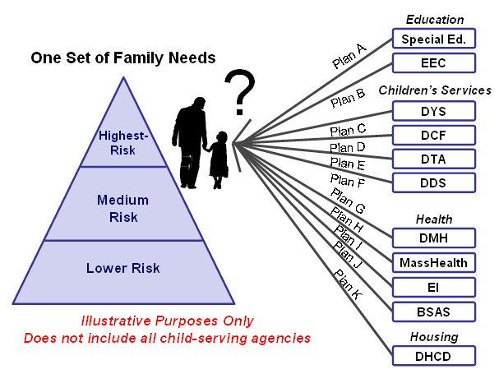
We need to improve each family’s access to services, their overall experience, and how we understand and address each family’s comprehensive needs in a holistic fashion. Today, a child or family served by two or more agencies has multiple service plans that may be duplicative or even conflict, making it difficult for families to navigate the system and prevents our services from being able to look at the ‘whole child.’ Figure 1 outlines the current fragmented model for responding to family needs.
Services, resources, and other supports should be coordinated and integrated where possible in order to achieve better outcomes for children and families.

Figure 1 – Current Approach to CYF

Section 3: Key Inputs to Recommendations

This report was developed through a synthesis of many inputs, reflecting the best thinking for how to strengthen services in Massachusetts. These inputs included:
- Children, Youth, and Families Advisory Committee
- Working Groups
- Public listening sessions
- National research and analysis of CYF reform models
- Other planning efforts

Advisory Committee
Convened in July 2011 and chaired by Secretary Bigby, the Advisory Committee is made up of nearly 70 members of the CYF community, including legislators, parents and families, providers, advocates, educators, academics, practitioners, as well as state executives and agency staff.
Role of the Advisory Committee
- Core entity charged with developing a plan for strengthening services for children, youth and their families
- Met monthly to:
  - Identify the key issues for reform
  - Share experiences
  - Gather input from other states’ experiences
  - Discuss the changes needed to strengthen services in Massachusetts

How the Committee Worked Together
- Divided into four Working Groups to focus on the key issues identified by the collective thinking of the Committee:
  - Access
  - Behavioral Health
  - Education & Human Services
  - Interagency Coordination
- Met regularly outside the Advisory Committee process to analyze and discuss root causes, issues, goals, guiding principles, recommendations, and associated key indicators of success in Massachusetts

Working Groups
The Working Groups were chaired by non-state executives, supported by state personnel, and comprised of interested Advisory Committee members.

Working Group | Chairperson(s) | Staff Support | Charge/Scope
Access | - Michael Weekes | - Margaret Van Gelder  - Chau Ly | How families initially interact with systems and gain access to the services they need, including application, intake and assessment processes, information and referral mechanisms; how procurement and administration of services impact access, and service availability.
Behavioral Health | - John Sargent  - Joe Leavey | - Jack Simons | How to improve access and continuity of care and services to address mental health and substance abuse issues.
Education & Human Services | - Barbara Talkov  - Mary Bourque | - Christine Kenney | How to improve access and collaboration across the human services and education systems.
Interagency Coordination | - Timothy Callahan  - Emily Sherwood | - Ron Benham  - Julia Meehan | How to improve systems and services coordination, including: data-sharing, case management, shared funding streams, opportunities to standardize language and regions across agencies, and continuity of care.

Public Listening Sessions
EOHHS and its partners conducted six public listening sessions across the Commonwealth. More than 100 stakeholders attended, including parents, young people, family partners, peer advocates, providers, local government and legislators, and other CYF stakeholders. Figure 2 depicts the dates and locations for each listening session
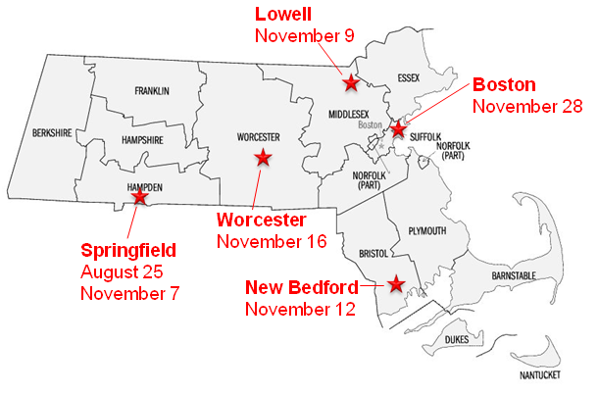
Families across the Commonwealth all agree: “It’s all about the children.” Government and non-government systems can work together in a more coordinated fashion to address the needs of the whole child and family.

Figure 2 – Public Listening Sessions
We heard several key themes:
- State agencies need to be more attentive, responsive, and respectful of parents and youth. Agencies should give parents and youth what they want, not what agencies think they need.
- Agencies need to expand access to services and resources for parents. This includes meeting families in their local neighborhoods and increasing the number of private and community resources available to families.
- Agencies need to strengthen their connections with the education system.
- Stakeholders expressed a desire to have improved access to information and data. This includes centralized online and phone resources, social media, etc. At the same time, we heard concern about the legal and privacy issues pertaining to data sharing; the state will need to work collaboratively with all stakeholders (particularly families) to allow appropriate data sharing while complying with applicable laws and upholding the right of families to limit access to their data.
- Many people highlighted the need to improve services and programs for youth aging out of child serving programs to enable them to transition into adulthood with necessary education, work skills, and life skills.
- Parents requested information, assistance, and training that would allow them to become successful advocates on behalf of their children without having to rely on others.

National Research and Analysis of CYF Reform Models
To inform the planning effort in the Commonwealth, EOHHS studied CYF reform, integration, and organizational models from other states and jurisdictions across the country. This research was made up of three components: interviews and discussions with human service practitioners, a national survey through the American Public Human Services Association (APHSA), and a comprehensive literature review.



Survey
Distributed a 24 question survey to all states through the American Public Human Services Association – included questions about governance, access, education, data-sharing, key success factors to transformation, etc.
Received responses from executive staff in 30 states, providing a wide-ranging diagnostic of children, youth, and family services across the country.
Literature Review
Reviewed recent, relevant industry publications, case studies, and thought leadership related to collaboration across children, youth, and family services.
Analyzed innovative program and service models with an eye toward how to bring the best of other states’ experiences to Massachusetts.
Interviews and Discussions
Obtained perspective of leaders from a range of jurisdictions who have considered or implemented recent reforms that impact their children, youth, and family services.
Interviewed Human Services Secretaries, Commissioners, and Executives from 15 jurisdictions across the country regarding their experience strengthening service delivery for children, youth and families.
Why are states working to improve CYF service delivery systems?
During our research and discussions with other states and jurisdictions, we found that many states and jurisdictions share the aspiration to better integrate and strengthen CYF services. States were very interested and willing to share their lessons learned with us. In fact, when we distributed a memo to the membership of the American Public Human Services Association (APHSA) to introduce our planning effort and ask for input from other states, many states expressed a desire to help. Over the past three months, we obtained perspective from 15 jurisdictions that have considered or implemented recent reforms impacting children, youth, and family services. One of the common themes that we heard during these discussions was a movement from agency and programmatic silos to a more integrated service delivery model. Jurisdictions took different approaches to integration – ranging from IT systems to agency consolidations to cross-training of staff – but a common element across jurisdictions was a relentless focus on developing a service delivery model that serves the whole child and family in a well-coordinated and effective manner.

The discussions with other states were very informative to the process, offering us perspective on how our peers are addressing similar challenges and providing a framework, illustrated in Figure 3, for thinking about how we can strengthen children and families by moving to a more integrated service delivery model.
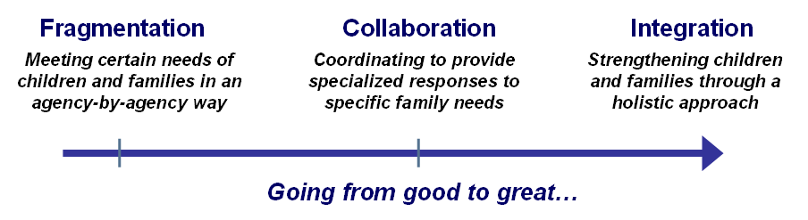
“We’re doing a good job in our current structure, but without moving toward a more coordinated system of care, we’re falling behind.”
- Secretary Bigby

Figure 3 – Moving from Fragmentation to Integration
In addition to our research and discussions with other states, we engaged in a literature review to better understand the perspective of academics and thought leaders on children, youth, and family issues. The literature review supported the perspective that we heard from many states and reinforced the value of integration with the ability to share data, including:
- Less than 6% of youth with a serious mental health condition receive services from only one system and ~40% receive services from three systems. [Howell, James C., Kelly, Marion R., Palmer, James, Mangum, Ronald L. Integrating Child Welfare, Juvenile Justice, and Other Agencies in a Continuum of Services. Child Welfare, Volume LXXXIII, No. 2, March/April 2004.]
- Multi-agency involved foster care youth were more than twice as likely to be heavy users of public systems in adulthood, three times as likely to experience incarceration, and 50 percent less likely to be consistently employed as compared to non-foster care youth. [Culhane, Dennis P., Young Adult Outcomes of Youth Exiting Dependent or Delinquent Care in Los Angeles County, Conrad N. Hilton Foundation, 2011.]
- One attempt to quantify the value of integrated children, youth, and family services to society puts the real benefit to society of high-risk intervention programs to be nearly $2 million per "saved" youth. [Cohen, Mark, The Monetary Value of Saving a High Risk Youth, The Journal of Qualitative Criminology, 14(1), 5-33, 1998.]

Summary Findings from National Perspective
- The Commonwealth is not alone – nearly every jurisdiction has experienced challenges related to access, interagency coordination, data-sharing, integrating behavioral health, and working effectively with education and other government partners.
- There is no silver bullet – states have achieved positive results, including better outcomes and improved experiences for children and families, as well as organizational efficiencies, through a wide variety of reforms.
- Most transformations and reorganizations are focused on driving better outcomes for children.
- In moving from family needs to family outcomes, states typically addressed a complete package of key reform components that work in harmony – including vision and leadership, organizational model, people and talent, enabling infrastructure, and practices and processes.
- Information-sharing and collaboration across silos, regardless of structure, are important elements for effective transformation.
- CYF transformation efforts are major, multi-year change management projects, requiring long-term commitment, leadership, focus, and engagement of a wide range of stakeholders.

Bringing It All Together
EOHHS held an all-day planning session with Working Group Chairs and other stakeholders to identify key opportunities and priority recommendations for the Governor. Based on what we heard from the Working Groups, listening sessions, the national review and survey, and other planning efforts, we consolidated similar recommendations, highlighting where multiple sources suggested the same idea. Through the day-long retreat and subsequent reviews, we then organized the recommendations into key priority areas, activities, and associated implementation considerations, to better serve the children, youth, and families in the Commonwealth. We also gathered suggestions and recommendations related to follow up research / analysis and implementation planning details; we will incorporate these ideas into the process moving forward.

Section 4: Vision for the Future

Vision Statement

Massachusetts will develop a more integrated and holistic system of care that will produce successful outcomes for children, youth, and families.

Goals
- Improve the experience of families when interacting with child- and family-serving agencies
- Give youth and families more voice and choice in service planning
- Improve access to, and coordination of, services provided to children, youth, and families
- Ensure accountability for improved outcomes
- Reduce administrative complexity to allow for better (and easier) navigation of the system

Improving Outcomes for Children, Youth, and Families

Goals | Today… | Tomorrow…
Family (and Youth) Experience | A child, youth, or family enters the “system” through one program or agency, is labeled by that interaction, and may not have all of their needs identified and addressed. | Families and youth receive integrated care and services that are self-directed, strengths-based, culturally appropriate, and holistic.
Family (and Youth) Voice and Choice | Families, youth and young adults occasionally participate in service planning but are not always given a seat at the table for system design and care coordination. | Families, youth and young adults always have a seat at the table to help design the system and to direct appropriate care and services for their own situation.
Access and Coordination | Families have to go back and forth between multiple agencies to get their needs met, creating redundancy, confusion, and risk. | The child and family have their needs assessed, services offered, and outcomes delivered no matter the specific way they connect with the Commonwealth.
Accountability | Families are passed from one part of the system to another without regard to the risks of “falling through the cracks.” Responsibility varies based on “label” and funding. “Not my kid” mentality prevails. | Programs and agencies share accountability for a family’s care and outcomes to ensure families experience a coordinated, supportive system that places the well-being of the family (or youth) as its primary goal.
Reduce Administrative Complexity | Families must navigate a complex system to reach appropriate services. | Families interact with one system of care that is integrated and built from the child up, not the state down.

Guiding Principles

The CYF effort is focused on strengthening children, youth, families, and communities through a system that is:

Holistic – Views child and family needs simultaneously across multiple human service and health domains (e.g., Employment, Education, Housing, Judicial System, Community-based Supports, etc.) and considers the needs of children and youth from birth to young adulthood.

Strengths-based and Family-driven – Addresses families’ needs by including their strengths as integral to the intervention strategy and includes family (or youth) voice at all levels of care planning.

Responsive to Needs – Provides families with access to individualized services, supports, and expertise to strengthen overall family capacity and meets the needs of children and youth from birth to young adulthood.

Promotes Healthy Development – Promotes positive youth development through the developmental trajectory from birth to young adulthood. Guided by the principles of positive youth development, creates an environment focused on prevention and child well-being, enabling youth to grow into adulthood with necessary education, work skills, and life skills as they transition out of child-serving programs.

Community Focused – Offers community supports, including referrals to appropriate private services, to help families safely nurture and raise their children within their own communities.

Culturally Competent – Promotes inclusion while being responsive to the diverse languages, attitudes, backgrounds, and values of families across the Commonwealth.

Evidence-based – Supports the use of effective, evidence-based practices in decision-making and evaluation processes as well as care planning and family support strategies.

Section 5: Key Challenges to be Considered

The Commonwealth provides a diverse array of services for children, youth and families. Although efforts continue to be made to raise awareness of the services available to families through the state and state-funded programs, families and other individuals frequently describe a system that is fragmented, complex, and uncoordinated. Discussions with these families and others with intimate knowledge of the system have raised a number of key challenges to be considered.

Finding the Right Door
The public – including youth, families, service providers, “first responders” (e.g., teachers, police, and health care practitioners), and state case managers – have significant difficulty finding the right door to access the most effective services for their needs. This can be described as the “wrong door” experience. Families that enter the system via a “wrong door” often do not know where to go or whom to contact for information and assistance and, thus, become “stuck” or are bounced around before identifying the correct contact. The “wrong door” also refers to families who enter the system through one agency, often involuntarily, and subsequently struggle to access more supportive services due to the label placed on them as a “consumer” of that agency’s services. The range of family resource and access centers throughout the state should be expanded to ensure that families are able to enter the system easily, consistently receive the right information, and are directed to the right services. Access points must be community-oriented in order to serve people where they live and help reduce the stigma associated with receiving services. These access points do not have to be run by the Commonwealth - family centers could operate out of a local faith-based institution, youth center, library, or another existing community-based entry point. The guiding principles for these centers should be that they be welcoming, family-friendly, and responsive to the needs of children, youth and families in a holistic and comprehensive fashion.

Eligibility versus Need
Stakeholders express a common concern about the conflict between families’ need for information or services and program eligibility requirements. The system is failing to view individuals and families in a holistic manner. Families who want to learn more about supportive services are often required to become eligible before they can access information about those or other services. Eligibility processes can be lengthy and cumbersome, and stringent eligibility requirements can limit access to the timely and helpful services that families need. Furthermore, these eligibility requirements are often based on siloed funding streams rather than on consumer-centric needs. Thus, eligibility becomes the determinant of what a family can access (rather than their needs), and as a result, families may not consistently obtain the information they need. In addition, assessments are often constricted to what the agency has to offer rather than the comprehensive needs of the family. This combination results in a system where families must continuously “fail up” to prove that they need additional support. A system that is more holistic, responsive, and focused on the whole child or family will limit the practice of directing families to less intensive services that do not address the family’s needs.

Information and Available Supports
Information regarding community-based services for children and families is not, and should not be, restricted only to state-funded services. While it is essential that all relevant state-funded services provide information that is accessible to individuals and families, considerable effort should be made to build a system that is inclusive of all community services. In many communities the local food pantry, youth centers, civic groups, senior centers, faith communities, schools and other non-state funded programs and services provide considerable supports to families. Any database of resources developed in response to the need for greater access must include comprehensive and updated information, as well as a plan to update the database on a regular basis.

Cultural and Linguistic Competency
Varying levels of cultural and linguistic competency make it difficult for some families to access the help they need. Some find that the system is not consistently responsive to populations with unique needs. Other families, particularly in suburban and rural areas, have challenges accessing services because of a lack of transportation and technology.

Fragmented Care and Service Experience
Improving the manner in which CYF services are delivered is particularly important to achieving the right outcomes for children, youth, and families. A family’s involvement with more than one service system can be very confusing. Families and youth who need information or help in various domains of their lives can have a difficult time obtaining assistance. When they are able to access a service, it may address one need but not another, resulting in the family needing to go somewhere else for support or get by without assistance. It is clear that our system needs to evolve in order to better serve the complex and evolving needs of families by moving from a fragmented model to a more integrated one.

The Commonwealth’s current systems, structures, and processes have been constructed based on agency missions to support the effectiveness of individual services, programs, and funding streams, thus creating silos that may not have the same long-term objectives for an individual or family and limit focus on the whole child/family. This siloed system is likely to duplicate infrastructure and investments and may not leverage funding in a way that optimizes outcomes and the achievement of shared goals. Furthermore, this system is designed counter to what the child welfare, health, juvenile justice, mental health, and public health fields have learned over the past decades: effective interventions start with a comprehensive understanding of the whole family across life domains (health, nutrition, housing, work, education, safety, mental health, juvenile justice, etc.).

To achieve better outcomes for children and families, the Commonwealth needs to develop a system of care that is better integrated and coordinated. Individuals and families often have multiple service needs that are not sufficiently addressed in a divided system of services. These needs are often defined contextually based on their first entry point in the system. For example, a family that has a child with mental health needs may access state services through one agency, but the parent may have housing and domestic violence issues with which they also need help. While the child receives services through the agency, the adult parent does not receive vital assistance they need in order to fully support the child.

Enhanced data-sharing and enabling technology are critical to better coordination. Government agencies are limited in their view of an individual or family, making it difficult to respond to the individual and/or family in the most effective and appropriate way.

Lastly, it is critical that the Commonwealth develop a system that includes the people and talent needed to design, manage, and deliver the types of coordinated and integrated services that children and families have requested. A skilled workforce, with a shared culture that is person-centered, is a key underpinning to the type of system being envisioned by the Commonwealth. People and talent need to be considered across all of the life domains with which families and children interface, including government and non-government supports and services.

Coordination with the Education System
The connection between the human service and Education systems should be strengthened. There is a need for more coordination and a comprehensive plan for children, youth, and their families that engages both education and human services. Child and family supports offered through the education and human services systems do not always compliment each other, because there does not seem to be a cohesive shared vision for owning children’s futures across these systems. Currently, Individualized Education Programs (IEPs) and Human Service treatment plans are not coordinated. This may be due to the fact that mandates, regulations, and governance of education and human services were not developed with a common vision for addressing the needs of the whole child or family. For example, there is no standard process for approving and funding placement in residential schools across the system, because education authorities and human service providers do not share a common goal or accountability for the whole child. Coordination between schools and human service agencies is also challenging due to limitations around sharing data that is critical to designing support plans and making timely and appropriate decisions about a child’s or family’s needs.

Coordination with Behavioral Health Agencies and Services
With regard to behavioral health, many stakeholders feel that the state is making progress in providing continuity and integration for children and families of children with behavioral health needs. The state’s work in this area includes the Children’s Behavioral Health Initiative (CBHI), including wraparound and Family Partners, as well as plans for the joint DCF/DMH residential treatment reprocurement. However, the system still has much room for further progress. Substance abuse assessments and treatment are often performed independently from mental health assessments and treatment. At the state level, behavioral health considerations are not consistently integrated into the work of agencies. Individuals and families need agencies and professionals to partner with them in their recovery over time and want behavioral health services that are accessible, effective, comprehensive, and respectful. The current system does not foster continuity of care within or across systems, which is particularly important for individuals with behavioral health needs. For example, many of the children involved with our agencies have experienced trauma; agencies cannot effectively serve children if that trauma is not addressed and considered as part of any core service planning.

Voice and Choice
Family and individual voice and choice are critical to shaping a positive experience and fostering better outcomes. Families and youth want integrated care and services that are self-directed, strengths-based, culturally appropriate, and holistic. Families and youth should always have a seat at the table to help direct the services and treatment plans designed for their benefit. Further, children and family voice is central in all aspects of overall service design, planning, and evaluation. As policies are considered, designed, and implemented, representatives of individuals and families who might be impacted should have an opportunity to actively participate in the process. While great efforts have been made by some child-serving agencies to include non-government partners on their leadership teams, this practice should be strengthened and expanded where possible. Stakeholders across the service system must partner with government agencies to ensure that the community is engaged in any reform effort and that the reformed system maximizes outcomes for children and families.

Section 6: Key Priority Areas

Key Priority Areas for Strengthening Services
In response to the challenges outlined in Section 5 and in order to strengthen services within Massachusetts’ system of care, we recommend improvements across the areas of: Access, Family-Facing Service Delivery, Interagency Coordination, People & Talent, Data & Technology, and Family & Community Engagement.

Some Working Groups also suggested additional research / analysis and implementation planning details, which we will incorporate into the process moving forward.

Key Priority Area | We Will… | Page
Access | Improve awareness of services and leverage multiple, connected points of entry to make it easier for families, youth and young adults to navigate the system, access information and services, and avoid falling through the cracks. | 24
Family-Facing Service Delivery | Design and organize our service delivery model in a family-directed, holistic, and integrated manner. | 27
Interagency Coordination | Improve the ways we work together across agencies and programs within EOHHS and with our government partners to optimize our collective resources for sustainable positive outcomes. | 30
People and Talent | Hire, train, and develop staff in new and different ways to maximize impact on children, youth, and families. | 33
Data and Technology | Improve management of, and appropriate connections between, data and technology to improve outcomes for children, youth, and families. | 35
Family and Community Engagement | Strengthen the role, voice, and choice of families and communities in the design and operation of the CYF service delivery system. | 37

Access

What do we want to achieve in order to improve Access?

We will improve awareness of services and leverage multiple, connected points of entry to make it easier for families, youth and young adults to navigate the system, access information and services, and avoid falling through the cracks.
“It is about having no wrong door – these doors can be different, and do not necessarily have to be physical doors or even within EOHHS.”
- Access Working Group
Future CYF System Characteristics:
- Connected points of entry and seamless transfer
- Ease of navigation for families, youth and young adults
- Support to prevent families from falling through the cracks
- Non-traditional methods for entry into the system
- Community-based approach
- Welcoming, non-stigmatized services

“A child’s well being is a shared responsibility with the community… we need to get to a place where you don’t have to label your child as broken to get services.”
- Secretary Bigby

How will we achieve this?

Priority Recommendations:
- Building on existing community-based facilities, establish family access centers that co-locate front-end facilities in communities across the Commonwealth.
- Enhance centralized online and telephonic systems to provide access to information, people, and services (including comprehensive resource guide for services, programs, and supports).
- Enhance the eligibility review process by conducting detailed common eligibility review and alignment of verification requirements.

Key Priorities for Strengthening Services: Access

Priority Recommendation | Description and Key Action Steps | Implementation Considerations
Establish family access centers | - Establish access points within communities that act as an entry way to all of the state’s child and family serving agencies; these may be achieved by co-locating the multiple agency-specific resource centers that exist today or by expanding the capability of these centers to provide support, information, and referral to all visitors, regardless of eligibility and primary agency affiliation. Whether one door or multiple doors, there should be “no wrong door.”  - Wherever possible, develop community-based centers, in cooperation with community partners, that are welcoming, non-stigmatizing, family friendly, and responsive to the holistic needs of children, youth, and families.  - Ensure that facilities are open during convenient hours and staffed with culturally and linguistically appropriate staff.  - Engage community organizations and partners to ensure access centers provide information related to all of the resources available to families in that community (both state and non-state funded); information should be readily available so that families may also be educated on the resources available to them and empowered to navigate the system on their own should they choose to do so.  - Ensure that access points serve as the primary physical “door” to facilitate easily navigated entry to the right services at the right time. | - Leverage work currently underway on HHS Centers where possible.  - Work with communities that currently have multiple agency funded resource centers to explore options for co-location (underway).  - Develop and provide training to existing centers to expand the capability of centers.  - Expand information and referral (I&R) tools to better equip all access points.
Enhance centralized online and telephonic systems | - Develop a comprehensive information and referral system (supported by a database) of up-to-date information about local, state, federal and community resources to make the system easy to navigate; the information and referral system should be accessible by telephone and online.  - Build a system that includes information about services provided by the state and non-state entities (across all areas and developmental stages).  - Ensure information is culturally and linguistically appropriately, as well as aurally and visually accessible.  - Promote information and referral system as the primary virtual “door” to access easily navigated information and services. | - Leverage already-completed feasibility assessment.  - Align existing agency-operated information and referral lines.
Enhance the eligibility review process | - Develop common eligibility rules and a common application/eligibility process, in order to collect basic information from families and individuals only one time.  - Evaluate how eligibility rules create silos and may not necessarily address child, youth, and family needs.  - Seek to align verification requirements across programs.  - Work to remove eligibility as a screen for access or information-sharing. | - Review EOHHS policies and practices related to eligibility and verification.  - Build upon the Common Eligibility System Initiative currently underway in MassHealth to include CYF agencies.

Family-Facing Service Delivery

What do we want to achieve to improve Family-Facing Service Delivery?
We will design and organize our service delivery model in a family-directed, holistic, and integrated manner.
“All people have needs across life domains… People are not fragmented in their needs. The service system should reflect the wholeness of the child, youth or family’s life rather than the fragmentation of service delivery structures. “
- Interagency Working Group
Future CYF System Characteristics:
- Family-directed system
- Holistic approach to the “whole child”
- Coordinated care for all children, youth, and families
- Includes former consumers as navigators and advisors
- Integrated services across programmatic silos

44% of APHSA National CYF Survey respondents indicated that integrated service delivery is their biggest challenge, and requires commitment and focus

How Will We Achieve This?

Priority Recommendations:
- Develop the processes and structure to coordinate and integrate a child and family’s care and services across agencies and programs.
- Develop standardized assessments to obtain a core set of information regarding the needs of the entire family, in order to encourage holistic, family-directed care and services.
- Expand the model of peer specialists, family partners, and cultural/linguistic brokers as navigators through all programs and agencies, to enhance continuity of care and sense of ownership and empowerment.
- Work collaboratively with Housing and Community Development, Early Education and Care, Elementary and Secondary Education, Labor and Workforce Development, and local community partners to ensure that the full range of family service needs and partners are represented at family access centers.

Key Priorities for Strengthening Services: Family-Facing Service Delivery

Priority Recommendation | Description and Key Action Steps | Implementation Considerations
Coordinate and integrate a child and family’s services | - Coordinate services across programs to ensure service and care continuity and reduce the need for families to tell their story multiple times and/or “fail up” (Note: Emphasis would be on service coordination as opposed to case management; coordination would involve liaising with applicable agencies, case managers, and others to ensure a family’s (or youth’s) needs are being addressed in a holistic fashion and that services and plans are coordinated across agencies to optimize resources and maximize outcomes for the family.)  - Reduce duplication/redundancy in services and improve outcomes in a holistic manner.  - Work to address multiple service needs through warm handoffs and a clear path to the appropriate set of access points.  - Design services around the needs of the whole child, youth, and family, rather than piece-meal responses to specific needs. | - Leverage model previously designed for Unified Planning Teams (UPTs).
Standardize assessments | - Align and streamline collection of appropriate information and assessment processes across programs and services.  - Expand assessments beyond what a specific agency has to offer.  - Work to understand and connect assessments of a whole family unit.  - Consider supplemental forms for specific needs/programs. | - N/A
Expand the model of peer specialists, family partners, and cultural/ linguistic brokers | - Provide dedicated navigators for families, youth and young adults to ensure continuity of care over time and across services.  - Work with families to provide a consistent personal advocate who is able to connect the family to the right services; as needed, peer specialists and family partners should work with families to educate them on how to navigate the system more effectively and better direct their services.  - Include former consumers and community-based navigators.  - Ensure peer supports are available to youth, parents, and families as long as needed.  - Ensure families have access to people who can support them before they are in crisis, with peer support available even after the family has achieved initial stability. | - Expand CBHI model around parent partners that exist currently only for the medical system.
Ensure full range of family service needs and partners are represented at family access centers | - Ensure community-based access centers incorporate services across CYF-facing programs and services, including those in the community and across government.  - Expand information and services available at any community access center to more than what one agency or provider offers.  - Connect with community services not provided by the state. | - Leverage HHS centers and DCAM facilities optimization work.

Interagency Coordination

What do we want to achieve to improve Interagency Coordination?
We will improve the ways we work together across agencies and programs within EOHHS and with our government partners.
“The needs of children, youth and families not only cross agencies, they cross secretariats... Needs also cross levels of government and include municipal services.” - Interagency Working Group
Future CYF System Characteristics:
- Shared vision, philosophy, and language
- Joint authority, funding, and decision-making
- Shared accountability for outcomes
- Increased CYF coordination and collaboration across government and community partners
- Strengthened coordination between education and human service systems

“All children need a healthy start – and when they can’t get it at home, we must find a way to provide it for them. Poverty begets a whole host of out-of-school problems that affect the readiness of a child to learn in the classroom. Mental health issues, family violence, housing instability and inadequate nutrition – all are real and present obstacles to student attendance, attentiveness and success.” - Governor Deval Patrick

How Will We Achieve This?

Priority Recommendations:
- Develop system-wide, cross-agency vision, language/definitions, planning, processes, and governance for CYF agencies and programs, including budgeting, outcome management, training goals, curriculum, etc.
- Strengthen coordination across education and CYF services by working with Executive Office of Education and the Readiness Cabinet to implement recommendations related to the joint provision of services to children in the care of the Commonwealth and with other special needs by creating joint policies and regulations for care, funding, data-sharing, etc.
- Evaluate ways to optimize joint local, state, and federal funding for CYF programs and services.

Key Priorities for Strengthening Services: Interagency Coordination

Priority Recommendation | Description and Key Action Steps | Implementation Considerations
Develop system-wide, cross-agency vision, language, planning, processes, and governance | - Enable system-level planning, implementation and evaluation across agencies, including rationalizing agency geographic areas.  - Develop cross-agency definition of family-directed care and services.  - Establish a process for vetting the cross-agency and cross-secretariat financial and service delivery impact of agency policies, decisions, and regulations that would eliminate, reduce or restrict eligibility for a service.  - Develop a shared service philosophy, language, and vision.  - Review service areas across EOHHS agencies for better alignment. | - Expand upon models of excellence, such as the DCF/DMH joint reprocurement.  - Leverage tools in place for cross-agency work, such as the Massachusetts Budget Application.  - Leverage existing outcome frameworks, such as EHSResults and MassGOALS.
Strengthen coordination across education and CYF services | - Work with Executive Office of Education and Readiness Cabinet to implement recommendations that cross Secretariats.  - Review HHS and Education regulations, policies, and mandates for contradictions, redundancies, gaps, areas in need of clarity, and opportunities for innovation.  - Research national organizational structures/models for collaboration between Education and HHS.  - Research and analyze pilots or models that support coordination of IEPs & Service Plans.  - Work within existing entities and forge stronger ties with state- and local-level education authorities.  - Build better partnerships with the schools, so that children and youth have a coordinated and holistic system of care. | - Build on current mandate to review alignment of Education/HHS policies and regulations.
Optimize joint local, state, and federal funding | - Explore opportunities to pool and share funds across programs and services to meet children and family needs more effectively.  - Ensure that funding is not a barrier for access or for services.  - Optimize federal, state, and private sector funding by developing an inventory of the various funding streams (including grant programs, etc.) across the state that intend to serve children. | - Explore potential to fund infrastructure developments with 90/10 Federal Financial Participation (FFP) through the Affordable Care Act (ACA).

People and Talent

What do we want to achieve by improving People and Talent?
We will hire, train, and develop staff in new and different ways to maximize positive impacts on children, youth, and families.
“The most important factor is the capacity of local officials and their staff to take on the challenges of reform, nurture and sustain efforts over a significant period of time, and move beyond the narrow focus of individual programs.”
- Interagency Working Group
Future CYF System Characteristics:
- Employees empowered to drive change
- A workforce that:
  - Understands principles of prevention, integration, and child development
  - Demonstrates respect for families
  - Is culturally competent
- Integration of families and former consumers into the overall CYF system

“It’s all about changing the hearts and minds of your workforce.”
- Executive in the State Department of Children and Families

“Families need more humanity and less bureaucracy.“
– DCF Commissioner Angelo McClain

How Will We Achieve This?

Priority Recommendations:
- Develop career paths and employee development opportunities across the CYF spectrum (e.g., rotational programs, etc.) that are available for consumers in the system.
- Develop and deliver core CYF trainings across the service delivery system, including agencies, providers, family partners, schools, medical system, etc., to support a shared identity and generate greater awareness of the of the various programs and services.
- Redesign employee evaluation process and performance measures to support desired behavior/culture change, as well as engage children, youth, and family feedback in hiring, training, and evaluation processes.
- Develop new policies, protocols, and training for CYF staff that emphasize and encourage prevention, integration, and child development principles, as well as respect for families and cultural competence.

Key Priorities for Strengthening Services: People and Talent

Priority Recommendation | Description and Key Action Steps | Implementation Considerations
Develop career paths and employee development opportunities across the CYF spectrum | - Make the CYF cluster an attractive place to work by providing opportunities across programs and agencies.  - Develop a specific career ladder for individuals who have been through the system and want to contribute. | - Utilize existing employee development initiatives in the Commonwealth, such as MassHR modernization.
Develop and conduct core CYF training | - Develop core set of CYF training materials to provide common base of knowledge.  - Retrain existing employees to adjust mindset toward new model.  - Extend availability of training outside of the CYF cluster, to include providers, physicians, peer mentors, etc. | - Look across existing training within CYF agencies, programs, and providers to develop cross-cutting curriculum.
Redesign employee evaluation processes and performance measures to drive desired behavior / culture change | - Develop metrics and evaluation processes that reinforce behavioral change and desired outcomes.  - Tie employee behavior to agency- and cross-agency metrics for family outcomes. | - TBD
Emphasize and encourage prevention, integration and child development principles, as well as respect for families and cultural competence | - Integrate these key values and focus areas into all people and talent initiatives, including the above areas (e.g., hiring, training, evaluation, etc.).  - Include special emphasis on encouraging inclusion of family voice and choice based on these principles.  - Focus training on evidence-based early childhood development, positive youth development, and strengthening families practices. | - TBD

Data and Technology

What do we want to achieve to improve Data and Technology?
We will improve management of, and appropriate connections between, data and technology to improve outcomes for children, youth, and families.

Data-sharing across programs is possible – although states reported that data-sharing was their second biggest challenge, 88% of respondents in APHSA National CYF Survey indicated that they had at least some ability to share data across programs
Future CYF System Characteristics:
- Data-sharing approach that addresses privacy and security concerns
- Monitoring of program effectiveness and outcomes
- Strong, integrated infrastructure foundation

“Effective data-sharing and technology integration is the table this all sits on.”
- Executive in State Department of Children and Families

How Will We Achieve This?

Priority Recommendations:
- Develop policies, processes, and technology to support appropriate data-sharing, both
  - Between EOHHS CYF agencies and providers
  - Across all child-serving agencies in the Commonwealth
- Develop cross-agency, “whole child” performance outcomes and reporting to enhance management insight and enable continuous quality improvement.
- Evaluate cost / feasibility of moving towards cross-agency interoperability of CYF IT systems.

Key Priorities for Strengthening Services: Data and Technology

Priority Recommendation | Description and Key Action Steps | Implementation Considerations
Develop policies, processes, and technology to support appropriate data-sharing | - Develop processes that facilitate data-sharing across agencies and programs.  - Identify and overcome legal barriers to implementing processes.  - Implement technology to support sharing of information.  - Explore potential for leveraging the work already done around electronic medical and educational records to facilitate data-sharing.  - Work with children, youth, and families to understand and address privacy concerns, allow opt-in/opt-out, and ensure informed consent practices are followed. | - Utilize Information Technology Division’s (ITD) licenses for data-sharing technology.  - Incorporate practices associated with electronic medical records and health information technology (HIT).
Define cross-agency, “whole child” performance outcomes and reporting | - Develop outcome metrics that are tied to service improvement strategies in order to track performance over time (including customer satisfaction data).  - Share performance data across agencies so that services can be improved.  - Establish a continuous quality improvement program in place for ongoing monitoring and refinement of CYF system and services. | - Build on existing performance management programs and capabilities, such as EHSResults and MassGOALS.
Move towards interoperability of CYF IT systems | - Conduct detailed assessment of current and future IT infrastructure opportunities, with particular focus on cross-agency and cross-secretariat interoperability of IT systems.  - Identify gaps and evaluate costs and benefits associated with developing solutions to fill gaps. | - Build from current initiatives and planning activity associated with Integrated Eligibility, State IT consolidation, and the ACA.

Family and Community Engagement

What do we want to achieve to improve Family and Community Engagement?
We will strengthen the role, voice, and choice of families and communities in the design and operation of the CYF service delivery system.

“Children, youth, and family voice is central in all aspects of service design, planning, and evaluation.”
- Access Working Group Guiding Principle programs
Future CYF System Characteristics:
- Families involved in all decisions pertaining to their care
- Understanding of how programs are perceived by children and families
- Former consumers are engaged to support system
- Family input into the broader CYF system

“You need to build from the consumer up, not from the state down.”
- Reggie Bicha, Former Secretary, Wisconsin Department of Children and Families

How Will We Achieve This?

Priority Recommendations:
- Continue ongoing engagement with community stakeholders, including the Advisory Committee (comprised of parents, youth, families, advocates, providers, community leaders, former consumers, etc.).
- Consolidate and coordinate existing advisory committees across the system to streamline stakeholder feedback and maximize family engagement.
- Develop more robust capabilities to collect formal and informal family feedback (including satisfaction levels) to inform design and operation of future model, policies and practices, care coordination, as well as ongoing management.

Key Priorities for Strengthening Services: Family and Community Engagement

Priority Recommendation | Description and Key Action Steps | Implementation Considerations
Continue ongoing engagement with community stakeholders | - Continue to engage families and communities through public listening sessions, advisory committee meetings, and other forums.  - Engage the existing Advisory Committee to bring stakeholder perspectives to issues raised through this planning process and ideas requiring further development. | - Continue existing CYF Advisory Committee structure.  - Explore expansion of MGL Chapter 6A, Section 16F.
Consolidate and coordinate existing advisory committees | - Facilitate dialogue and information-sharing between existing CYF advisory bodies in the state.  - Develop ongoing process for incorporating feedback from advisory committee(s). | - Assess committees associated with CBHI, Readiness Cabinet, agencies, etc.
Develop more robust capabilities to collect formal and informal family feedback | - Strengthen capabilities for collecting and analyzing consumer feedback and satisfaction.  - Engage children, families, and staff to design and deliver surveys or other evaluation instruments.  - Involve children and families in the design and monitoring of services and systems, incorporating customer satisfaction on ongoing basis.  - Measure customer satisfaction for both service recipients and service providers.  - Maintain email and web presence for informal feedback. | - Assess existing formal feedback mechanisms (e.g., MGL Chapter 6A, Section 16F).

Section 7: Topics to be Further Developed

As we implement the priority recommendations to strengthen services for children, youth, and families, we will continue to engage the Advisory Committee to consider additional opportunities for improvement.

Transition-aged youth
Youth who are “aging out” of state systems benefit from a range of supports and services to ensure their successful transition into adulthood. Some youth will move into state adult systems; other youth will transition away from state services. Addressing the challenges of transition-aged youth will require strong state and community partnerships.

Prevention
Fostering the healthy development of all children starts prenatally and continues to adulthood. Children and youth who experience healthy development are more likely to achieve success in school, relationships, and employment. No single agency or organization can do this alone. Prevention strategies that include early identification and response to problems as well as improved coordination and collaboration across child-serving systems and communities are most likely to succeed. Effective prevention will require strengthening the community so that it can better support children, youth, and families before an intervention is required. It requires building partnerships to strengthen communities so that they can provide more and better services and supports. EOHHS, with its partners, should continue to promote the importance of prevention and continue to embed evidence-based prevention methods in its planning to strengthen services for children and families. Additionally, greater investment in effective, evidence-based prevention strategies is needed and should consider the principles of early intervention where appropriate.

Integration with Behavioral Health
Mental health and substance abuse are issues that cross the spectrum of child serving agencies. Many children who are in the protective custody of the Department of Children and Families have experienced trauma, which we know can adversely affect their social and emotional development. The prevalence of mental health and substance abuse histories in youth who are involved in the juvenile justice system is also well-documented. The Department of Mental Health serves children, youth, and adults with serious mental health conditions. Parents of children receiving our services may also have mental health or substance abuse conditions. It is imperative that EOHHS connect its work to improve services and service delivery for children, youth and families with the work of the Children’s Mental Health Executive Committee (of which the Assistant Secretary is a member) and the Children’s Behavioral Health Initiative (CBHI) Advisory Committee; these two bodies can analyze best practices and make recommendations for improvements to services under the direction of the Assistant Secretary.

Disparities
Though much has been learned over the past twenty years, much remains to be done to reduce disparities in the health status of children of different racial and ethnic backgrounds. Also there remains disproportionate minority contact with both the child welfare and juvenile justice systems. Our system of care for children, public health policies and other policies affected by state government must work to address the conditions that contribute to disparities in the overall health status of children. Understanding and addressing the factors that promote overrepresentation, underrepresentation, and disproportionality within our system of care for children will require ongoing collaboration among government and non-government partners. Our health care, social services and education systems must work together more effectively to better serve children. We will continue to focus intently on addressing disparities as part of our work going forward.

Continued collaboration with education
We recognize the challenges of coordinating human services with the 300+ Local Education Authorities (LEAs) across the Commonwealth. However, we must continue to work through these challenges and, with the guidance of the Readiness Cabinet, have developed strategies to partner more effectively with underperforming schools, connecting these schools with the appropriate human services agencies. While there are many examples of effective working relationships between schools and local human services and community-based supports, we must make these relationships stronger across the Commonwealth. All children require a healthy platform that will enable them to attend school and succeed. Children who live in poverty often have a unique set of significant needs that may include mental and physical health issues, housing instability, family violence – all of which impede their abilities to take full advantage of the learning opportunities available to them at school. Schools, and the education system more broadly, although able to address some of their students’ needs, are unable to provide a comprehensive range of services. Therefore, a tighter connection between schools and human service agencies needs to be forged. It is with this goal in mind that EOHHS and EOE will work together to develop a set of strategies for providing the services and supports necessary to ensure all students can achieve positive results in school.

Role of Patient Centered Medical Homes
The Patient-Centered Medical Home (PCMH) model is designed to promote comprehensive, coordinated, patient-centered care delivered by teams of primary care providers, including physicians and nurses. In a PCMH, a primary care provider and members of his or her team coordinate all of a patient's health needs, including management of chronic conditions, visits to specialists, hospital admissions, and reminding patients when they need check-ups and tests. The PCMH model supports fundamental changes in primary care service delivery and payment reforms, with the goal of improving health care quality. PCMH practices must be considered as one of the ways in which we respond to the “whole child” and his/her needs across health, education, human services, and other domains contributing to the well-being and holistic needs of the child and family.

Strategic partnerships – Opportunities to leverage private funding
EOHHS and its government partners will continue to think creatively about strengthening collaborations with our non-government partners locally and nationally, as well as forge new partnerships with other interested parties in the private sector. Through these strategic partnerships, we will explore opportunities for expanding funding for the purposes of investing in opportunities to improve our system of care for children.

Leveraging Existing Initiatives, Collaborations, and Best Practices
As the Commonwealth evolves its system of care for children, it is important that we build upon best practices and the efforts currently underway that have proven to be effective in strengthening children, youth, and families. Further, there are a number of cross-agency, cross-secretariat, and government and private sector partnerships, initiatives and other collaborations in place today that should be considered as we outline future activities.

For instance, the Children’s Behavioral Health Initiative (CBHI) is a good example of an interagency initiative that can serve as a model of how the state better integrates behavioral health considerations into education and human services planning as it pertains to addressing the needs of the whole child. The mission of CBHI is to strengthen, expand and integrate state services into a comprehensive, community-based system of care, to ensure that families and their children with significant behavioral, emotional and mental health needs obtain the services necessary for success at home, school, and in their communities.

Another good example of interagency collaboration is the Child and Youth Readiness Cabinet. The Readiness Cabinet is a state leadership team focused on streamlining state efforts to improve services for children, youth and families and includes the state secretaries of Education, Health and Human Services, Administration and Finance, Housing and Economic Development, Labor and Workforce Development, Public Safety, and the Child Advocate. The Cabinet works to foster and coordinate efforts to enhance the level of cooperation and collaboration across the state departments and agencies that serve children, youth and families. Among other things, the Cabinet works to set the strategic direction for interagency policy planning, development and implementation in order to advance the health, well-being and education of children and youth, and prepare them to be successful and contributing adults.

Lastly, the Office of the Child Advocate (OCA), acting as an independent arm, works to ensure that every child involved with child welfare or juvenile justice agencies in Massachusetts is protected from harm and receives appropriate and effective services delivered in a timely and respectful manner. The OCA represents the commitment of the Governor and the members of the Legislature to improve services provided by state agencies to children, youth, and families in Massachusetts; the OCA will continue to be a partner in ongoing efforts to improve the system of care for children, youth, and families.

These initiatives are just a few examples of government agencies and others working together to improve the quality of life for children, and they should be modeled where possible as we evolve the children’s services system.

Section 8: Implementation Considerations and Next Steps

Accountability for Strengthening Services

We are dedicated to improving the service delivery system based on child and family needs in order to support the execution of key priority areas and ultimately achieve these goals.

What do we want to achieve?
- Programs and agencies share accountability for a family’s care and outcomes to ensure families experience a coordinated, supportive system

How will we achieve this?
- Strengthen the authority and resources of the Assistant Secretary and her team to provide a single point of accountability for better outcomes for children, youth, and families, and to:
  - Coordinate planning and support activities across CYF agencies and other EOHHS agencies
  - Integrate service delivery in terms of front-end access and care coordination
  - Execute key initiatives to support the CYF infrastructure
- Work with our community, sister Secretariats (e.g., Education), and government partners to coordinate implementation
- Continue the momentum of the Advisory Committee

Activities and Responsibilities of a Stronger CYF Organization

Going forward, EOHHS will need to coordinate across, and in some cases integrate the planning of, a series of service delivery and administrative activities in order to implement the Advisory Committee recommendations.
Budgeting / finance
Strategic planning
Training and workforce development
Performance management and reporting
Information technology
Coordinated Planning and Support
Integrated information and referral
Care coordination for complex multi-agency-involved children and families
Oversight to ensure children and families are getting the best of the Commonwealth
Integrated Service Delivery
Development of data-sharing protocols
Strengthening centralized online/phone system
Front-end and back-end facilities co-location
Program management and communications
Execution of Key Initiatives
Cross-agency Activities and Initiatives

Continuing the Momentum to Strengthen Services
Accountability for managing and continuing to drive this effort is critical. Earlier this year, we considered reorganization as a primary and necessary step to achieve our goals. However, after this thoughtful and robust review, we instead recommend the establishment of a cross-agency leadership structure within the Secretary’s Office that would be led by the Assistant Secretary of Children, Youth, and Families. This cross-agency structure can be seen in Figure 4. In addition to having line authority over certain agencies, the Assistant Secretary will have expanded authority to require all EOHHS child-, youth- and family-serving agencies to participate in the redesign of the services and implement changes related to financing, regulations, personnel and other key functions. The Assistant Secretary will also oversee the plan to ensure the coordination of services when multiple agencies/programs are involved in a child’s plan. Further, EOHHS will continue to work to ensure that its efforts to improve services and service delivery for children, youth and families are connected to the other initiatives to improve the delivery system (e.g., CBHI Advisory Committee, Grandparents Commission).

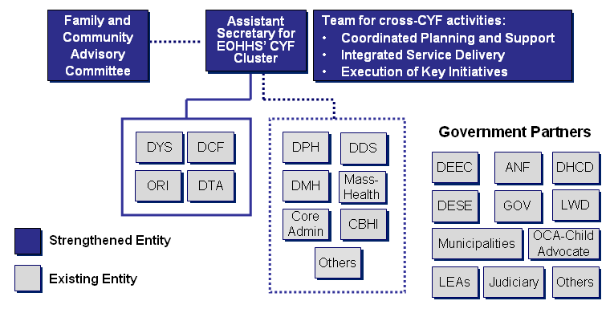
Figure 4 – Model for Strengthening EOHHS’ CYF Services and implementing Advisory Committee recommendations
Building a Stronger EOHHS Organization
The table below provides descriptions of the roles and responsibilities for entities that will be critical for planning and implementing the children, youth, and family reform efforts, including the Advisory Committee; the Assistant Secretary for Children, Youth, and Families; the Assistant Secretary’s team for coordinating implementation; EOHHS’ CYF agencies; other EOHHS agencies; and other government partners. To support effective implementation of the recommendations in this report, some of these entities will have a stronger role in the future. Other entities will be vital in implementation activities and communicating key messages to build awareness and support.

Entity | Role | Key Responsibilities
Family and Community Advisory Committee | Advise on the implementation of recommendations for strengthening CYF services in Massachusetts. | - Provide ongoing feedback on key activities associated with implementing the recommendations through continued Advisory Committee forum.  - Support implementation by communicating and advocating for the role of this program in improving outcomes and experience for families.
Assistant Secretary for CYF Cluster | Direct and execute recommendations to strengthen CYF services. | - Establish objectives, strategic direction and priorities for strengthening services.  - Engage the CYF community in the design and implementation of reform.  - Oversee interaction of CYF team with EOHHS child-, youth- and family-serving agencies.  - Engage with other secretariats and government and community partners.
Team for cross-CYF activities | Coordinate implementation of recommendations. | - Mobilize and coordinate implementation of recommendations.  - Identify and manage cross-initiative area issues and interdependencies.  - Coordinate ongoing communications and change management.
EOHHS Agencies | Facilitate implementation of recommendations at agencies. | - Drive implementation of recommendations into agency operations and culture.  - Coordinate with cross-agency team to plan and execute reform.  - Communicate key messages to build awareness.
Government Partners | Coordinate and collaborate with ongoing CYF activity to deliver the best of the Commonwealth. | - Work with internal stakeholders to align similar and parallel initiatives in partner agencies.  - Identify issues and opportunities for alignment of activity.  - Communicate key messages to build awareness.
Partnering Across the CYF Community
Strengthening services for children, youth, and families will require sustained commitment and engagement from stakeholders across the Commonwealth and across the CYF community – as depicted in Figure 5 below, EOHHS’ child-, youth-, and family-serving agencies represent one component of a larger network of partners and stakeholders that will have a role in strengthening our children, youth, and families service delivery system. Ideally, as these efforts move forward over time, relationships across the CYF community will continue to be strengthened and better aligned to optimally serve children, youth, families.

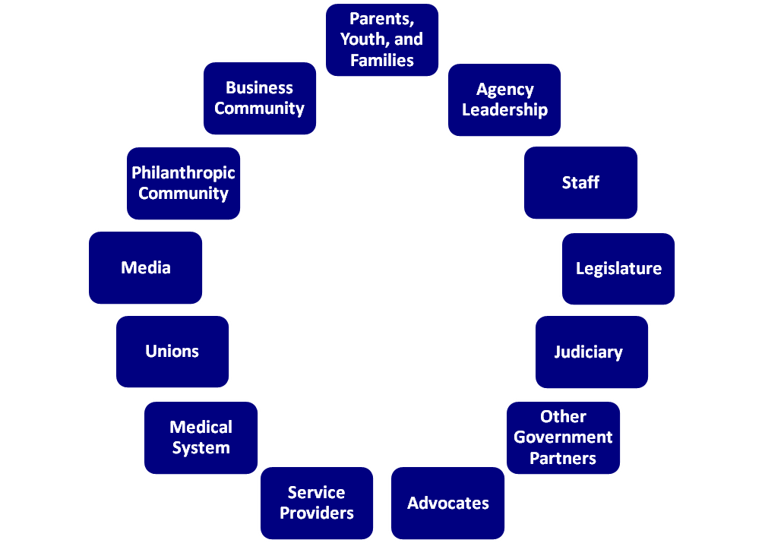
EOHHS’ child, youth, and family serving agencies represent one component of a larger network of partners and stakeholders.
CYF Community

Figure 5 – EOHHS’ Strengthened Child Services Agencies and the Broader CYF Community

High-Level CYF Reform Timeline

Strengthening our CYF system is a long-term, multi-year, fundamental shift in the way we deliver services to children, youth, and families. As outlined in Figure 5, this initiative will require years of continued effort, investment, and commitment across state government and among our partners. Our research and analysis of other state CYF reforms efforts have reinforced the importance of sustained commitment and the reality of multi-year implementation efforts.

To guide this effort, we will need an implementation roadmap that details the specific activities that we need to undertake, the appropriate sequence of those activities, and a rational approach to implementing activities across all of the recommendations – acknowledging links between recommendations, dependencies, and priorities. The roadmap will provide us with a tool to implement recommendations in a thoughtful, well-coordinated, and cost effective manner. As illustrated in the figure opposite, following the submission of this report, the major work effort will be to transition from the development of recommendations (the “what”) to development of an implementation roadmap (the “how”). Ongoing and continuous planning and management is a critical activity to ensure that our approach delivers meaningful positive change for children, youth, and families in optimal ways. Throughout this process, several key stakeholders have cited the success of initiatives in the Commonwealth that have dedicated leadership and resources (e.g., CBHI). This perspective, coupled with findings from the national research, make it clear that ongoing and dedicated management attention is a key factor in the effective implementation of cross-governmental, transformational initiatives.
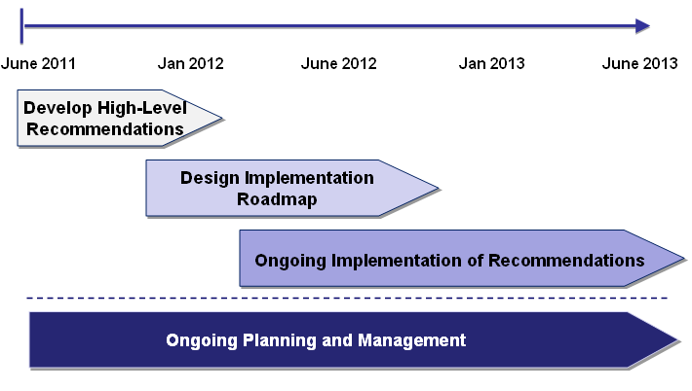
Figure 5 – High-Level Timeline
Immediate Next Steps
Should the recommendations be approved by the Governor, our immediate next steps would include:
- Initiate work on CYF implementation roadmap
- Launch communications campaign to brief staff on the initiative
- Identify near-term resource needs for strengthened CYF team at EOHHS
- Begin regular schedule of CYF meetings to maintain ongoing updates and information sharing with key stakeholders

Appendix

Advisory Committee Membership List

Working Group Membership Lists

Working Group Submissions: Detailed Findings from the Working Groups

National Study Overview

National Study

Working Group Retreat: Participant Packet

Listening Session Presentation

Key Child Services and Initiatives

(Other materials regarding the work of the CYF Advisory Committee are available at http://www.mass.gov/hhs/childservices)

