mass.gov/mcdhh
dl
www.mass.gov/mcdhh

Children Specialists

Boston North Region
Melissa Dowler, M.S. Ed. | Cell | 617-694-9781
600 Washington Street | VP | 617-861-8847
Boston, MA 02111 melissa.dowler@mass.gov

Southeastern Region
Melissa Adams, LCSW, CEIS Cell 617-872-4087

600 Washington Street
Boston, MA 02111 melissa.adams@mass.gov
VP 617-409-7496

Central Region
Betsy Drumm Cell 617-217-8324

167 Lyman Street
Westborough, MA 01581 elizabeth.drumm@mass.gov
VP 508-948-0606

Berkshires/Western Region
Emily Graves-Harrison Cell 857-208-8009

436 Dwight Street, Suite 204
Springfield, MA 01103 emily.graves-harrison@mass.gov
VP 413-276-4524

Director
Peggy Lee, Ed.M.
Cell 617-894-4169

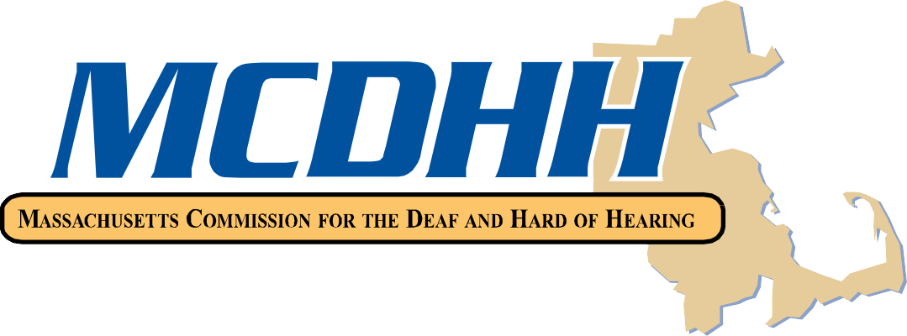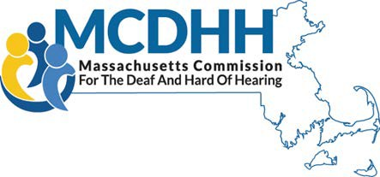margaret.lee@mass.gov VP 617-275-7883

Administrative Assistant
Bonnie Lincoln | Cell | 857-248-7783
bonnie.lincoln@mass.gov | Voice | 617-740-1651
 | VP | 857-288-1998
 | Fax | 617-740-1830

Massachusetts Commission for the Deaf and Hard of Hearing 600 Washington Street, Boston, MA 02111
Toll free numbers: 800-882-1155 (V) 617-326-7546 (VP)

Updated 12/26/2023

