Chip/Tap EBT Card Cashier Training Guide
EBT cards are being upgraded to include chip and tap functionality. These new cards are more secure and help protect benefits from theft. Cashiers play an important role in making the transition smooth for both customers and store staff. This guide summarizes the important information cashiers need to know about the card upgrade.

What cashiers should know:
- Chip/tap EBT cards will be provided to cardholders between July and September 2026.
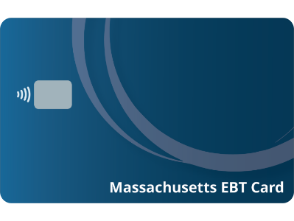
- Chip/tap EBT cards look different.
Figure 1. New Chip/Tap EBT Card Design
Customers will begin using new EBT cards with a visible chip and the tap to pay logo. See Figure 1 for a picture of the new card design.
- Cashiers need to know what instructions to give customers using the new chip/tap EBT card at the Point of Sale (POS), based on your store’s readiness status.
If your store is chip/tap ready, cashiers should tell customers to insert or tap their new card to complete the transaction.
If your store is ECL fallback or magnetic stripe ready, tell your cashiers how many times the customer needs to attempt a chip/tap transaction with their new card before the terminal will prompt them to swipe. If customers ask why they can’t insert or tap their card, explain it’s because of how the cash register system works and not because their new card is “broken” or “defective.”
- A PIN is still required for every transaction.
Just like today, customers must enter their PIN to complete a purchase with a chip/tap EBT card.
- Both old and new EBT cards can be used during the transition.
During the transition period, some customers may still use the old non-chip card while others will begin using the new chip/tap card. Cashiers should accept both card types while the rollout is underway.

Need help?
If you have questions about accepting chip and tap EBT cards, contact your POS provider. They can help confirm that your system is ready and answer technical questions about processing transactions. For additional support, contact DTA.EBT@mass.gov.

