Too much salt can lead to heart attack and stroke.

Too much salt is harmful. Eating too much sodium can increase your blood pressure and put you at risk for a heart attack and stroke. Salt contains sodium, so people often use the two words to mean the same thing.

How much salt should I eat? Many adults should eat no more than 2300 mg of sodium daily. You should be even more careful and eat no more than 1500 mg daily if:

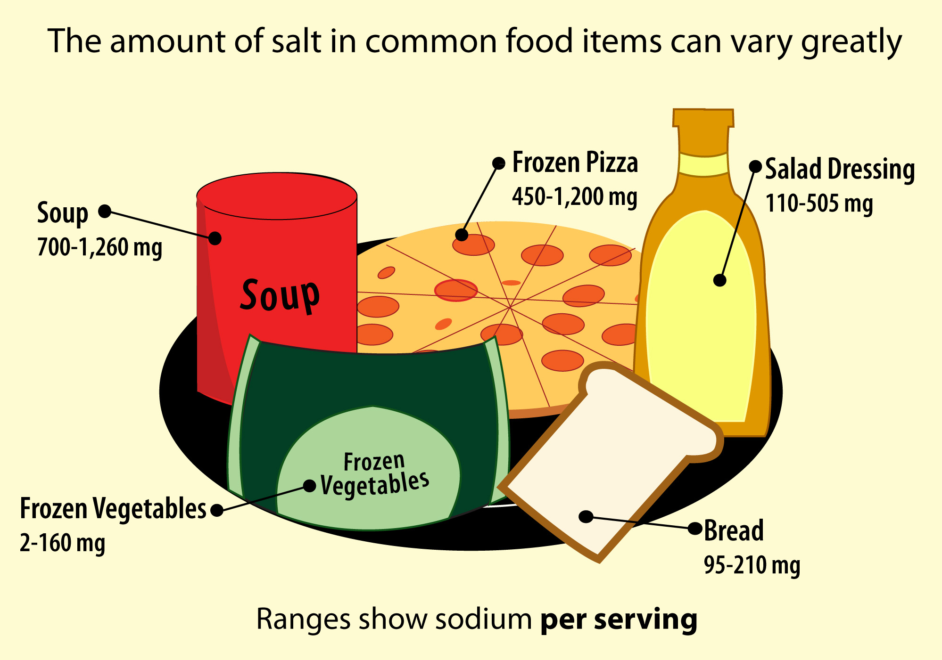
- you are 51 years of age or older
- you are African American
- you have high blood pressure
- you have diabetes
- you have chronic kidney disease

Most restaurant meals and processed foods are packed with salt. Your salt shaker is not the main problem. In fact, only a small amount of the sodium we eat comes from salt added while cooking or eating. Most of the salt we eat — almost 80%! — is already in the food you buy, such as pre-packaged, processed, prepared and restaurant foods.

How can I reduce the amount of sodium I eat?
- Read food labels for sodium:

  - A food with less than 50 mg sodium per serving is very low in sodium
  - A food with more than 250 mg sodium per serving is high in sodium
  - Choose whole meals with no more than 480 mg sodium

- Compare the amount of sodium in different brands. Many foods that appear to be the same have very different sodium levels.

Is sea salt healthier for you than other kinds of salt? No! Sea salt, kosher salt, and table salt all contain the same amount of sodium. One is not healthier for you than the others. How they look and where they come from may be different, but they are the same for your health.

Compare labels.
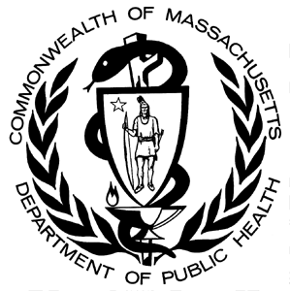
Choose less sodium.
For more information, please visit: www.mass.gov/dph/salt

