Choosing Which Service Method is Best for You

May, 2016

A Guide for Self-Advocates by Self-Advocates

Types of Delivery Models

DDS offers three models of service delivery that allow people receiving services to have choices about how their services are provided.

DDS has developed service delivery options that offer people more decision making and control regarding what services they need (and don't need) and how the services can be provided to best help them.

- The Traditional Model
- The Agency with Choice Model
- The Participant Directed Model

What is the Traditional Service Model?

With traditional services you choose an existing provider and program that fit you best.

Provider agencies offer a range of supports including shared living, community residences, independent supports, group homes, employment and day programs, and family support.

The provider has full responsibility for hiring, training, supervising and paying the staff.

The provider agency manages the budget so that the services in your ISP are fulfilled.

You have the right to change your provider or program at your ISP.

What is AGENCY WITH CHOICE?

AGENCY WITH CHOICE (AWC) helps individuals/families engage in SELF-DETERMINATION. This model can be used for supports to families, individual home supports, individualized day supports and stipends.

- You have a partnership with the agency (co-employment model) that gives you choice, control and authority over how your DDS Budget is managed.

- This partnership provides the benefit of choosing your own staff, developing a schedule and budgeting your funds to meet your needs.

- The agency handles the business side (advertising, hiring, background checks) so you don’t have that burden.

- If you don’t have someone in mind to hire as staff or you need someone to cover a vacation, the agency can suggest staff they already know.

- The AWC provides a monthly financial statement on your spending to keep track of how your DDS funds are being used.

- Partnering with an agency allows you to feel part of a community.
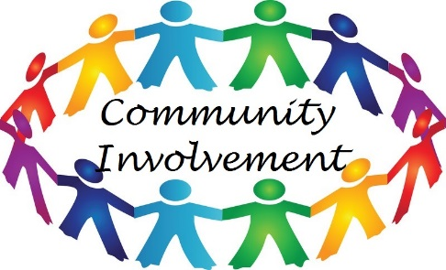

What is The Participant –Directed Program?
In the Participant Directed Program (PDP) you have the most freedom, flexibility and authority to purchase the services and supports you want and need. In this program you decide who you want to work for you and what kind of supports you need to fit your life and goals.
A Support Broker, typically a DDS Service Coordinator, or your personal agent, helps you define your needs and dreams through a person-centered planning process with a team you choose. From this process you create an Individual Service Plans which reflects your goals and needs.

You create and manage your budget with the help of your Support Broker and set up services and supports. The Support Broker then acts on behalf of you to arrange for needed services and provides resource information, and helps you to evaluate your services.

A Fiscal Intermediary (FI) is a business that pays your support bills and pays your staff for you.

The Participant Directed Program offers you the most freedom, flexibility, authority and responsibility to achieve your hopes and dreams. Contact your DDS Service Coordinator if you are interested in this program.

