INDOOR AIR QUALITY ASSESSMENT

Church of the Nativity
4 Green Street
Merrimac, Massachusetts

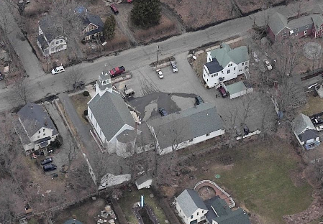

Prepared by:
Massachusetts Department of Public Health
Center of Environmental Health
Emergency Response/Indoor Air Quality Program
January 2007

Background/Introduction
At the request of Eileen Hurley, Chairman, Merrimac Board of Health (MBOH), the Center for Environmental Health (CEH) of the Massachusetts Department of Public Health (MDPH) provided assistance and consultation regarding odors within the Church of the Nativity, 4 Green Street, Merrimac, Massachusetts. The request was prompted by reports of possible crawlspace odors infiltrating the main section of the church.
On December 21, 2006, Michael Feeney, Director of Emergency Response/Indoor Air Quality (ER/IAQ), CEH conducted an indoor environmental assessment of Church of Nativity. Deborah Ketchen, Health Agent, MBOH and Ms. Hurley accompanied Mr. Feeney during the assessment. The visit was conducted specifically to assess possible pathways for crawlspace odors to migrate to the main section of the church. The building is a wood, clapboard structure constructed in the early 1800s.

Methods
The building was evaluated on a cold, overcast day, with an outdoor temperature of 45 º F and relative humidity of 37 percent. Visual observations of the building’s interior, exterior and crawlspace were conducted.

Results/Discussion
As indicated, the building resides over a crawlspace. The building’s heating, ventilating and air condition (HVAC) system consists of a combination furnace/forced hot air air-handing unit (AHU) that is located in the crawlspace (Picture 1). Four floor-mounted heating vents provide tempered air to the main section of the building. The heating vent grates in the floor of the main hall are heavily corroded, indicating the presence of moisture in the ductwork (Picture 2).
The church crawlspace consists of a dirt floor (Picture 3). The crawlspace appears to be subjected to significant water penetration as suggested by a sump pump installed in the area (Picture 4); however, no standing water was observed. Crawlspace air can migrate into the occupied areas via two pathways: the AHU and breaches. Filters are installed in the AHU to remove particulates from the system’s air stream. These filters should be sized to fit flush inside the system. Once placed inside, the filter cabinet is sealed behind a door or, in this case, sheet metal panel held in place by screws. The air filters used in the AHU are larger than those standard to this system, therefore the cabinet cannot be properly sealed (Picture 5). In this condition, crawl space air by-passes the filters, drawn into the AHU and distributed to occupied areas. Please note that the flue damper for the boiler exhaust is located in close proximity to the filter opening (Picture 6). This configuration can draw products of combustion through the flue damper into the AHU via the open filter access.
Flexible duct was added to the AHU, presumably to provide conditioned air to a church wing added after the original construction. This flexible duct is damaged and currently empties air into the crawlspace (Picture 7). In this condition, air escaping from the duct can pressurize the crawlspace and be forced through seams in the floor or walls.
A significant amount of rotted wood and other discarded materials were observed in the crawlspace (Picture 8). If moistened for prolonged periods of times, these materials can serve as media for mold growth. The US Environmental Protection Agency (US EPA) and the American Conference of Governmental Industrial Hygienists (ACGIH) recommends that porous materials be dried with fans and heating within 24 to 48 hours of becoming wet (ACGIH, 1989; US EPA, 2001). If porous materials are not dried within this time frame, mold growth may occur.

Conclusions/Recommendations
The conditions within the crawlspace are presently problematic, but readily repairable. In view of the findings at the time of the inspection, the following recommendations are made:
- Acquire filters of an appropriate size for use in the AHU. Refrain from storing replacement filters in the crawlspace (Picture 8).
- Acquire a new appropriately sized sheet metal panel to affix over the filter access opening.
- Reconnect the flexible duct to its register.
- Consider removing as much wood/cardboard and other materials that can support mold growth from the floor of the crawlspace.
References
ACGIH. 1989. Guidelines for the Assessment of Bioaerosols in the Indoor Environment. American Conference of Governmental Industrial Hygienists, Cincinnati, OH.

US EPA. 2001. Mold Remediation in Schools and Commercial Buildings. US Environmental Protection Agency, Office of Air and Radiation, Indoor Environments Division, Washington, D.C. EPA 402-K-01-001. March 2001.
http://www.epa.gov/iaq/molds/mold_remediation.html

Picture 1

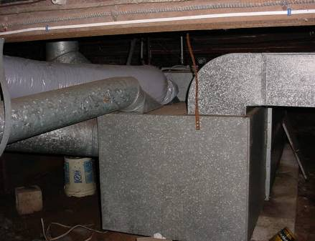

HVAC System Church Crawlspace

Picture 2

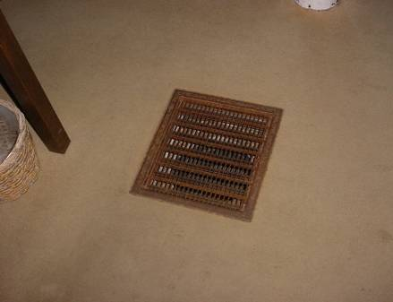

Heat Vent in Floor of Congregation, Note Corrosion

Picture 3

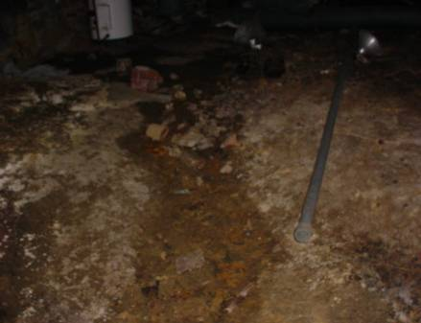

Crawlspace of Church

Picture 4

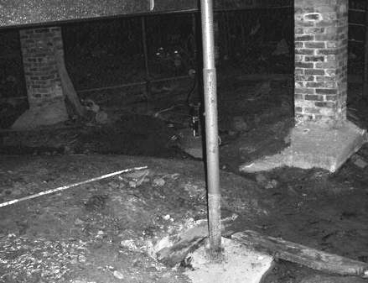

Sump Pump Installed in Floor of Crawlspace
Picture 5

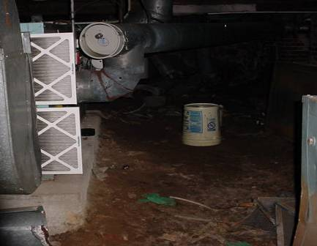

Filter Protruding from the AHU
Picture 6

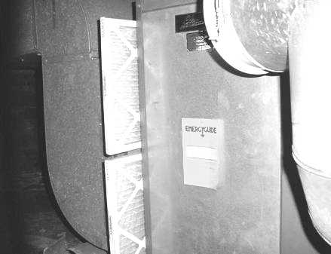

Exhaust Vent in Close Proximity to the Flue Damper

Picture 7

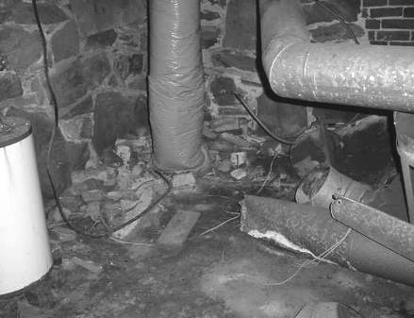

Flexible Duct Terminating on the Floor of Crawlspace

Picture 8

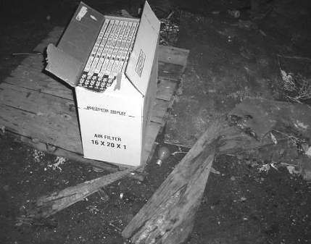

New Filters Stored on Top of Rotting Wood

