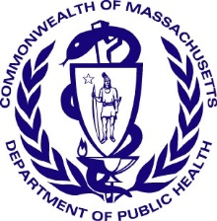
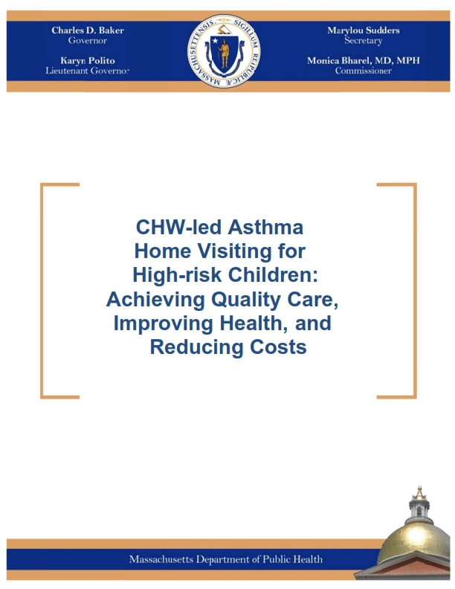CHW-LED ASTHMA HOME VISITING FOR HIGH-RISK CHILDREN: ACHIEVING Quality CARE, IMPROVING HEALTH, AND REDUCING COSTS

The Massachusetts Department of Public Health (DPH) has devoted significant resources to refining and evaluating an evidence-based model linking clinical and home-based care for high-risk children with asthma. This White Paper provides background and guidance to help healthcare providers implement this proven model that incorporates the services of a community health worker (CHW) who, guided by a healthcare team, counsels and supports clients while conducting a series of home visits. It is a companion to a 2015 DPH White Paper titled: “Achieving the Triple Aim: Success with Community Health Workers.”

“So much of asthma management involves the home environment and addressing the triggers—communities we serve have [a] higher incidence of asthma. [Our clients] are living in poverty—and tend to have more triggers for asthma in their homes. We can give them all the meds in the world, but if we are not addressing some of those environmental factors we are never going to get this under control.”
Jody Kenneally,
Pediatric Nurse Practitioner,
East Boston Neighborhood Health Center

The Pediatric CHW-led Asthma Home Visiting Model is among the most promising population health interventions for integration with health care services. The intervention has a robust evidence base, including randomized control trial study designs demonstrating its positive impact on key quality, health, and cost outcomes. Implementing the model can help healthcare practices attain health outcomes required to be successful as part of emerging Accountable Care Organizations (ACOs) and value-based payment arrangements.
The Need
Asthma is a pressing concern.
- The prevalence of asthma in Massachusetts is among the highest reported across the nation. In 2015, 10.2% of adults and 12.1% children currently had asthma. It is the most common chronic disease of childhood.
- Of children aged 18 and younger with asthma in Massachusetts, only 1 in 3 had well-controlled asthma; and fewer than half reported that they had ever been given an Asthma Action Plan by a healthcare provider.
- The total charges for hospital services due to asthma in Massachusetts nearly doubled from $90 million in 2002 to $172 million in 2011.
Inequities in childhood asthma prevalence and control exist based on race, ethnicity and class.
- Prevalence of childhood asthma in MA is higher among Blacks and Hispanic Whites than among non-Hispanic Whites.
- In 2012, the MA hospitalization rates for Hispanics and Black, non-Hispanics were 2.5 and 3.5 times higher than the rate for Whites, respectively.
- In 2012, relative to the rate among White, Non-Hispanics, the age-adjusted rate of Emergency Department (ED) visits in MA were 3.3 times higher among Black, Non-Hispanics and 3.0 times higher among Hispanics.
The Model
- The Pediatric CHW-led Asthma Home Visiting Model is consistent with the best practice guidelines of the National Asthma Education and Prevention Program (NAEPP) overseen by the National Heart, Lung, and Blood Institute (NHLBI) of the National Institutes of Health.
- DPH, together with health care provider partners around the Commonwealth, has developed the protocols and infrastructure for the training and technical assistance for healthcare practices to implement the intervention. These can be found at www.mass.gov/dph/asthma.
The model is designed for and tested primarily with Medicaid-insured high-risk pediatric patients who have uncontrolled or poorly-controlled asthma and recent history of ED use. Asthma presents particular challenges to primary care and specialist practices because patients’ ability to control symptoms are strongly influenced by environmental triggers often found in their homes. Further, asthma self-management requires that affected families understand the chronic nature of the disease, how to reduce triggers, and take different medications with confidence.
Nearly 70% of Massachusetts’ affected children have poorly controlled asthma. As a result children and families suffer reduced activity, lost school and work time, and for those without paid sick leave, lost income. This may create ongoing stress for low-income families, which negatively impacts their health.
To address the myriad of challenges families experience while managing their child’s asthma, the engagement of a specially trained CHW as an asthma home visitor(s) is at the core of the CHW-led Asthma Home Visiting Model.

Pediatric practices around the country have engaged CHWs as part of care teams to serve as asthma home visitors. The evidence supporting the effectiveness of the ”four components” approach to asthma control for children with poorly or uncontrolled asthma has influenced the best practices guidelines of the National Asthma Education and Prevention Program (NAEPP). The components of asthma management include regular assessment and monitoring, patient education, control of environmental factors that contribute to or aggravate symptoms and pharmacological therapy. CHW-led asthma home visiting strengthens implementation of these four essential components. Additionally, the integration of CHWs into clinical care teams offers the advantage of strengthening access for, and communication with, children and families from low-income environments, given CHWs’ shared backgrounds, language, and culture coupled with their knowledge of the local community.

The evidence base for the CHW-led home visiting model with high-risk pediatric asthma patients is extensive:
- One systematic review of seven CHW-led Pediatric Asthma Home Visiting interventions in clinical settings—all randomized controlled trials—found consistent decreases in asthma symptoms, daytime activity limitations, and emergency and urgent care use.
“Our community health worker, William, provides cultural sensitivity that we need to work with our families. It’s really helpful to have him in the department…It boils down to there are major social determinants impacting a patient’s asthma—it’s hard for us to connect with them, or sometimes a family is not showing up—When they finally come, I page William and he comes to the clinic and the patient and parent connect with him right away— and when they see how compassionate he is, they are willing to open the door and let him into their home.”
Laura Grubb, MD, Pediatrics, the Floating Hospital for Children at Tufts Medical Center

- Numerous studies across the country and within the Commonwealth have demonstrated that this model consistently reduces asthma symptom days, improves medication adherence, reduces urgent care and hospitalization, and offers cost savings and/or a positive return on investment.
- The CDC’s 6|18 Initiative prioritizes six high-burden health conditions with 18 evidence-based interventions. For pediatric asthma, CDC calls for utilizing guidelines-based care and intensive self-management education by expanding access to home visits to improve self-management education and reduce home asthma triggers.
- Additional information about the extensive evidence base in support of the health, quality and cost benefits of asthma home visiting can be found at www.mass.gov/dph/asthma.

The Benefits for Quality Improvement and Cost Savings

- The model improves clinical performance on the National Committee for Quality Assurance Healthcare Effectiveness Data and Information Set (HEDIS) measures for asthma. The asthma care indicator includes the percent of people appropriately prescribed medication. Published studies demonstrate improved controller medication adherence, while improvements in the asthma medication ratio were found in the Reducing Ethnic/Racial Asthma Disparities in Youth (READY) study conducted by DPH.
- The model further supports achievement of MassHealth (Massachusetts Medicaid) performance measures for Patient Centered Medical Home and for Accountable Care Organization (ACO) quality reporting.
- The model can reduce the cost of care for patients and lead to a positive return on investment due to reduced asthma-related ED visits and hospitalizations as well as fewer missed office visits.
- Adopting this intervention strengthens health systems’ capacities to provide population health. The model is designed to demonstrably improve outcomes for asthma patients within a practice or within a defined service area.
- The CDC National Prevention Task Force’s economic review of studies of this kind of comprehensive asthma intervention found they represent good value for the money invested, in part based on savings from averted costs of asthma care.

HOW YOU CAN YOU ADOPT AND IMPLEMENT THIS SERVICE MODEL FOR YOUR PRACTICE OR HEALTH SYSTEM
Launching a successful asthma home visiting program can be incredibly rewarding―and yet complex. To ease the process, the Asthma Prevention and Control Program at DPH produced evidence-based tools, trainings, and protocols to support practices. To assist you in deciding whether implementing an asthma home visiting program is right for your practice, below are some answers to commonly asked questions.
What Does the CHW Do During the Home Visit?
The CHW reinforces clinician education for patients and families about asthma self-management, supports environmental trigger reduction, and furthers understanding of how to take medications and follow the asthma action plan created by the clinical provider. CHWs make at least three home visits and offer several low-cost items (such as mattress covers, green cleaning supplies, HEPA vacuum, etc.) when needed to remove the environmental triggers. The CHW also advocates with patients' landlords, and links them to community resources and support as needed.
How Does a Practice or Health System Get Started?
Identifying patients who are being treated for asthma is a first step. This intervention has been shown to be most effective when enrollment is targeted to high-risk pediatric asthma patients. You can find recommended eligibility criteria for pediatric asthma patients in the CHW-led Asthma Home Visiting Protocol available at www.mass.gov/dph/asthma. Assessing the extent and characteristics of your clients needing services will inform your decision and can be used to establish a useful registry of potential enrollees should you proceed.

Piloting a new asthma home visiting program on a small scale may be the best approach for some practices. Starting small allows for the development of the systems infrastructure (i.e., IT capacity, communications, and program workflows), establishing relationships within the team and with referral sites, and gaining organizational ‘buy-in’ necessary for a successful practice-wide program.
Consult the Asthma Prevention and Control Program (APCP) website at www.mass.gov/dph/asthma for detailed information on how to implement each aspect of the intervention, including how to recruit CHWs, training resources, guidance for home visitors, and data collection instruments.

Where Does the Community Health Worker “Sit?”
The model has been successfully implemented and evaluated in diverse settings and there are many available options. CHWs can be located in diverse clinical settings, closely integrated into the primary or specialty care clinical team or in a community-based program, such as local health departments. Clinical settings can include community health centers, hospital-based clinics, private pediatric offices, and clinical provider groups. CHWs can be centrally managed for multiple practices. Regardless of where the CHW is located, strong communication with primary care providers is a key component to the model's success.
How Can an Employer Recruit and/or Train Qualified Staff to Assure the Effectiveness of the Model?
To best prepare CHWs to perform asthma home visits, the DPH Asthma Prevention and Control Program (APCP) recommends CHWs receive both Core Competency and specialized asthma training. You can learn more about core competency trainings at www.mass.gov/dph/chw. The APCP recommends the DPH Asthma Home Visiting Training for Community Health Workers developed with and implemented by the Boston Public Health Commission’s Community Health Education Center. It includes a 4-day CHW training, CHW supervisor training, ongoing CHW support, a field-based mentorship program, and observation-based skills assessment.
How Do We Integrate the Community Health Worker into Our Practice/System?
It is important that high-level clinical staff in the practice place a high value on the CHW asthma home visiting services and intervention. This helps to assure that the clinical team and the CHW are all trained to work together with clear roles, workflows, and responsibilities and that the clinical supervisor of the CHW is allowed sufficient time, resources, and support to make the intervention effective. Successful CHW integration into teams can have many complex factors, but there are models and resources available from APCP and the Office of Community Health Workers to help achieve the integration needed at www.mass.gov/dph/asthma and www.mass.gov/dph/chw.

How Do We Pay for the Intervention?
CHW-led asthma home visiting has been funded through a variety of mechanisms and payment models. Some programs have been supported through grant funding, and some practices have found ways to leverage funds for quality improvement that cover the work of CHWs in asthma home visiting such as applying Determination of Need funding that may be tied to health facility expansion. You can learn more about Determination of Need at www.mass.gov/dph/don. Currently, CHW-led asthma home visits are not routinely covered by health insurance, although some health plans in Massachusetts and elsewhere in the U.S. are beginning to implement reimbursement for these services. Because of the strong cost and quality evidence of this model, there may be opportunities to pay for these services in emerging Accountable Care Organizations (ACOs) and value-based payment arrangements.
What is the Cost of the Intervention?
Based on estimates of existing programs across Massachusetts, the APCP estimates that an average intervention costs approximately $70,000, or $1,500 per participant, reaching 40-60 participants over the course of one year. This estimate includes: salary and fringe for 1 FTE CHW (around $45,000, plus benefits); salary and fringe for 0.2 FTE CHW Clinical Supervisor; and intervention supplies of $150-$200 per participant. This estimate does not include indirect costs, as these vary widely. These costs are aligned with cost estimates generated by the Department of Public Health Office of Community Health Workers.
How can the Asthma Prevention and Control Program Help?
The APCP provides a range of training and technical assistance to programs implementing CHW-led asthma home visiting programs. These services are currently provided free of charge. Trainings offered include a 4-day CHW training, 1.5-day CHW Supervisor training, and Physician Asthma Care Education (PACE) training for clinical providers. The APCP also offers technical assistance in the form of program start-up support, support utilizing the Massachusetts Standardized Asthma Home Visiting Toolkit, and coordination of the Massachusetts Asthma Learning Collaborative, which focuses on quality improvement in the Institute for Healthcare Improvement (IHI) model.
To learn more about the services APCP offers, please visit www.mass.gov/dph/asthma or contact prevention.wellness@state.ma.us

Massachusetts Department of Public Health and Massachusetts Asthma Action Partnership. Strategic plan for asthma in Massachusetts: 2015-2020. Released. May, 2015. p.13.
Pediatric Asthma Bulletin - Massachusetts Department of Public Health. Released 2017, p.8.
Pediatric Asthma Bulletin - Massachusetts Department of Public Health. Released 2017, p.6.
Pediatric Asthma Bulletin - Massachusetts Department of Public Health. Released 2017, p.13.
Pediatric Asthma Bulletin - Massachusetts Department of Public Health. Released 2017, p.17.
US Department of Health and Human Services, National Institutes of Health. National Heart, Lung, and Blood Institute. Guidelines for the diagnosis and management of asthma (EPR-3). 2007. Available at: https://www.healthypeople.gov/2020/tools-resources/evidence-based-resource/expert-panel-report-3-guidelines-diagnosis-and Accessed 10/5/16
Postma J, Karr C, Kieckhefer G. Community health workers and environmental interventions for children with asthma: a systematic review J Asthma 2009;46(6):564 –76.
The 6|18 Initiative: Accelerating Evidence into Action. Available at http://www.cdc.gov/sixeighteen/docs/6-18-factsheet.pdf Accessed on 12/12/16.
Reducing Racial/Ethnic Asthma Disparities in Youth (READY) study preliminary results (unpublished)
Campbell, JD.; Brooks, M.; Hosokawa, P.; Robinson, J.; Song, L.; and Krieger, J. Community Health Worker Home Visits for Medicaid-Enrolled Children With Asthma: Effects on Asthma Outcomes and Costs American Journal of Public Health 2015 105, 11, 2366-2372

